CR23532
CYBER AND DIGITAL FORENSICS
CASE STUDY ASSIGNMENTS – II

B.E. CSE – Cyber Security
Rajalakshmi Engineering College

STUDENT NAME | JAIYANTH T
ROLL NUMBER | 241901037

Five case studies • All 38 questions answered • Diagrams, evidence tables and workflows

Submission Notes
This assignment document answers all five case studies and all 38 questions listed in the supplied CR23532 assignment sheet. The scenarios do not provide actual forensic images, logs, or extracted artifacts; therefore, example timelines and correlation tables are explicitly hypothetical, and tool workflows describe the expected procedure rather than claiming that an examination was performed.
Forensic principle: preserve the original, document every action, verify integrity, analyze a controlled copy, corroborate findings, and report limitations.

Contents
- ASSIGNMENT 2(1) — Suspected Unauthorized Access to a College Server
- ASSIGNMENT 2(2) — Linking a Suspicious File to a User Using File-System Evidence
- ASSIGNMENT 2(3) — Forensic Imaging and Safekeeping of a Suspect Storage Device
- ASSIGNMENT 2(4) — Recovery of Deleted Evidence from Volume Shadow Copies
- ASSIGNMENT 2(5) — Multi-Source Investigation of a Suspected Cyber Incident

ASSIGNMENT 2(1)

Suspected Unauthorized Access to a College Server
Case approach: Apply authorized, repeatable forensic procedures; preserve integrity and distinguish scenario assumptions from verified facts.

1. Identification, Collection, Examination, Analysis, and Presentation phases
Identification. Record the administrator’s complaint, the affected examination files, the server and workstation involved, the suspected time window, relevant accounts, and the USB device. Confirm written authority, scope, and the people permitted to access the evidence. Identify volatile sources (active sessions, running processes, network connections) before they disappear.
Collection. Photograph and label devices; record date, time, location, condition, serial numbers, and the collector. Preserve server logs and relevant account records through authorized, documented exports. Acquire a forensic image of the suspect workstation and USB device using suitable write protection where possible. Hash acquired files/images with a recognised algorithm such as SHA-256, record the values, and maintain chain-of-custody entries.
Examination. Work from verified forensic copies, not the originals. Search file-system records, user profiles, recent-file artifacts, USB connection history, executable/program traces, and server authentication/access logs. Extract relevant files and metadata without changing the master image.
Analysis. Correlate timestamps, account identifiers, source addresses, file paths, USB activity, and file hashes. Test whether the same files were accessed and copied, whether the activity occurred outside normal hours, and whether legitimate administrative tasks or automated processes could explain it. State time-zone and clock uncertainties.
Presentation. Prepare a report with scope, methods, tools/versions, evidence identifiers, hash values, timeline, findings, limitations, and appendices. Explain technical results in plain language and distinguish observed facts from interpretations.

2. Forensic investigation flowchart
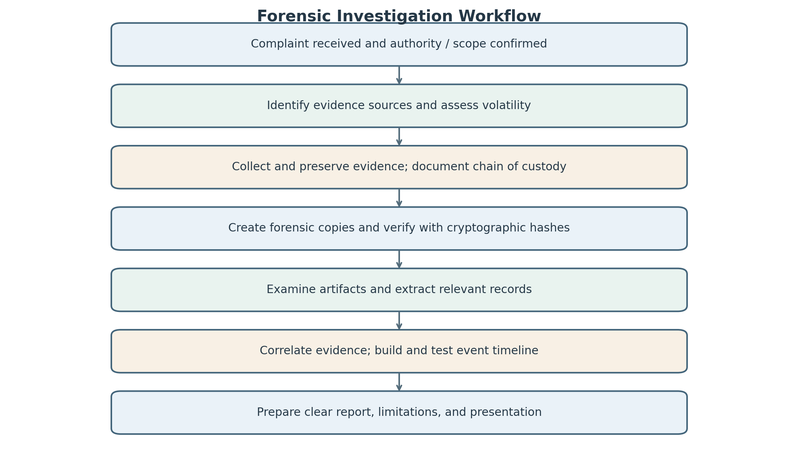
The flowchart below shows the sequence from the initial complaint through evidence preservation, examination, analysis, and presentation. If integrity checks fail or a new lead appears, the team should document the issue and repeat the relevant step on a controlled copy.

3. Potential evidence and investigative value
The value of an item depends on authenticity, integrity, relevance, and how well it can be linked to the event. No single artifact should be treated as conclusive without context.
Evidence item | Potential value | Cautions / interpretation
Administrator complaint | Defines reported incident, affected files, approximate time window, and initial leads. | A report is a starting allegation, not proof of access.
Server access/authentication logs | May show account, source address, access time, and requested resource. | Check completeness, time settings, logging configuration, and account compromise.
Suspect workstation image | May contain user profiles, recent-file traces, logs, executable traces, and USB artifacts. | Association with a device does not identify the human actor.
Recovered USB device | May contain copied files, metadata, file hashes, and traces of transfer. | Files can predate the incident; inspect timestamps and provenance.
Confidential examination files | Content, hashes, metadata, and paths may match server or USB copies. | Matching content supports copying but does not alone establish who copied it.
Operating-system event logs | May establish logons, device connections, process or system events. | Retention and clock accuracy may be limited.
File-system metadata / shortcuts | May indicate file existence, paths, and access-related context. | Metadata can be changed or generated by background processes.

4. Collection and preservation precautions
- Obtain proper institutional/legal authorization and define a narrow scope before accessing systems.
- Photograph the scene and record device state, connections, date/time, identifiers, and who handled each item.
- Do not browse files casually or boot a seized computer unnecessarily; ordinary use can alter logs, timestamps, caches, and other data.
- Use a validated write blocker for storage acquisition where appropriate; if a live system must be examined, document every action and its possible effect.
- Acquire using a recognised tool, preserve error logs, and calculate cryptographic hashes. Verify the acquired image according to the tool’s supported workflow.
- Keep an untouched master image and perform analysis on a working copy. Store evidence in access-controlled, tamper-evident storage.
- Maintain a contemporaneous chain-of-custody record for every transfer, access, copy, and storage event.
- Preserve original logs and exported records; document filtering, conversion, and time-zone settings.
- Do not disclose examination files to unrelated staff. Use secure transfer and retain only material within the authorized scope.

5. Establishing a timeline of suspected access
Create a table of relevant events with the source, original timestamp, time zone, normalized time, event description, and reliability notes. Sources may include server authentication and file-access logs, operating-system event logs, file-system metadata, recent-file records, USB connection artifacts, and the timestamps and hashes of relevant files. Normalize time only after recording the original value and the offset used. Check clock drift, daylight-saving settings, log rotation, delayed logging, and whether timestamps represent creation, modification, access, or collection. Correlate events from independent sources and mark uncertain intervals rather than presenting estimates as exact facts.

6. Final forensic report and non-technical presentation
A defensible report should include: case identifier; author and qualifications; authorization and scope; questions asked; evidence inventory and chain of custody; acquisition methods and tool versions; hash values; examination steps; findings with supporting artifact references; event timeline; interpretation; alternative explanations; limitations; conclusion; and appendices/screenshots where appropriate. For a non-technical authority, use a short executive summary, a simple timeline, a small evidence table, and plain-language explanations. State what the evidence supports, what it does not establish, and any remaining uncertainty. Avoid claiming that a particular person performed an action merely because an account or device is associated with them.

7. Legal and ethical considerations in a college environment
Investigators should act under applicable law, institutional policy, and documented authorization. They should respect student and staff privacy, examine only data relevant to the approved purpose, and restrict access to sensitive examination material. Preserve confidentiality, avoid conflicts of interest, and maintain impartiality even when the suspected user is a student or employee. Evidence must be collected in a reproducible way and handled consistently so that it can be independently reviewed. Any personal or unrelated data encountered should be protected and handled according to the authorized scope and applicable rules. Investigators should not alter, plant, selectively omit, or overstate evidence.

ASSIGNMENT 2(2)

Linking a Suspicious File to a User Using File-System Evidence
Case approach: Apply authorized, repeatable forensic procedures; preserve integrity and distinguish scenario assumptions from verified facts.

8. Hardware and software components to document
Hardware inventory: computer make/model; asset tag; serial number; CPU and RAM where relevant; internal drives and capacity; partition layout; attached USB/storage devices; network adapters; connected peripherals; power state; and visible connections. Photograph labels and connections before disassembly.
Software/environment inventory: operating-system edition, version and build; file systems and volumes; installed applications and security tools; user accounts and privilege levels; system time, time zone, and clock offset if known; relevant browser versions; encryption status; and forensic-tool name/version. Record how each detail was obtained, because inspecting a live system can itself change data. This inventory provides context for interpreting artifacts and reproducing the examination.

9. How storage, operating systems, file systems, and metadata help
Storage devices contain allocated files, deleted-file remnants, partitions, and unallocated space. The operating system provides user profiles, event logs, application records, shortcuts, and account identifiers. File-system structures (for example, NTFS metadata such as file records and timestamps) can reveal names, paths, size, allocation state, and relationships between files. Metadata may include creation/modification times, owner or security identifiers, hashes, and application-specific properties. These artifacts help locate a suspicious executable and reconstruct activity, but timestamps can be copied or altered and ownership does not prove who physically used a computer. Interpret each item with corroborating evidence.

10. Hidden and encrypted files: impact and handling
Hidden files may be omitted from ordinary directory views but can still be present in the file system. Investigators should use forensic tools to enumerate files, inspect attributes, examine directory records, and search relevant locations without changing the source. Encryption may make content unreadable without a key, password, or authorized decryption process; investigators should preserve the encrypted original, document its hash and metadata, and avoid destructive attempts. Search for authorized key material or related evidence only within scope. Record failed access attempts and tool limitations. Do not assume that hidden or encrypted automatically means malicious: legitimate applications and users also use these features.

11. Evidence-linkage table
Use the following matrix as a model. A linkage is stronger when independent artifacts converge on the same user, file, and time window; the table is hypothetical and does not assert that the described activity actually occurred.
Artifact | Possible linkage | Strength / caution
Executable file hash | Compare against known hash or related copy. | Strong file identity if hash is reliable; does not identify the operator.
File path and timestamps | Place the file in a profile or directory and approximate sequence. | Contextual; timestamps can be altered or copied.
User account / SID | Associate artifacts with a profile or account. | Account may be shared, compromised, or used remotely.
USB connection record | Indicate a device was connected to the workstation. | Does not prove a specific file was copied.
Recent-file / shortcut artifact | May record interaction with a named file or path. | Could be stale or generated by another process/user.
Browser or download record | May connect a user profile to a download or related service. | Background activity and sync can mislead.
System / server logs | Correlate logon, access, and file events. | Validate time zone, completeness, and source integrity.

12. ILookIX evidence-import and analysis workflow
1. Confirm authority, case scope, evidence identifiers, and chain-of-custody records.
2. Preserve the original media and create a verified forensic acquisition/image using the approved process.
3. Record the image hash and verify integrity before analysis. Retain a read-only master and work from a separate copy.
4. Open ILookIX in the laboratory environment and create a case using the case identifier. Record the software version and relevant settings.
5. Import or add the acquired evidence in the format supported by the installed version. Confirm the source path, image type, volume selection, and any parsing warnings.
6. Run appropriate file-system and artifact examination: file names/paths, deleted and hidden entries, timestamps, user profiles, browser artifacts, shortcuts, logs, and metadata.
7. Search for the suspicious executable by name, hash, path, and related artifacts. Export relevant results with source references and preserve tool-generated logs.
8. Correlate each artifact with account activity and other evidence; test alternative explanations.
9. Validate important findings independently where possible, document errors and limitations, and include tool/version and reproducible steps in the report.
This is an intended workflow, not a claim that ILookIX was run on the case evidence. Exact menu names and supported formats depend on the installed version.

13. Direct linkage versus supporting/contextual artifacts
A directly linking artifact is closely tied to the specific action being investigated—for example, an authenticated session record tied to a unique account plus a matching file-access event, or a command/history record showing a relevant operation. Even then, it may identify an account or process rather than the human at the keyboard.
A supporting/contextual artifact provides background or corroboration—for example, a file in a user profile, a browser visit, a USB connection record, or a timestamp that overlaps the event. It may show opportunity or association but not prove the user performed the action. Strength comes from multiple independent sources, integrity verification, and consideration of shared accounts, remote access, malware, and automated processes.

14. Limitations and alternative explanations
- Shared computer or credentials: another person may have used the same account or workstation.
- Timestamp uncertainty: clock drift, time-zone conversion, copying, or metadata manipulation can distort sequence.
- Automated activity: a scheduled task, sync client, backup, or security tool may create/access files.
- Malware or remote control: activity may have been performed by malicious software or an external operator.
- Incomplete evidence: logs may be missing, rotated, disabled, or overwritten.
- Tool limitations: parsers may misinterpret uncommon formats or damaged records; validate critical findings.
- Account attribution is not person attribution: a username or owner field alone does not establish who acted.
- Encryption or deleted-data recovery may yield incomplete or ambiguous content.
The conclusion should reflect these limits and avoid attributing intent without supporting evidence.

ASSIGNMENT 2(3)

Forensic Imaging and Safekeeping of a Suspect Storage Device
Case approach: Apply authorized, repeatable forensic procedures; preserve integrity and distinguish scenario assumptions from verified facts.

15. Collection and transport before imaging
1. Confirm authorization, scope, and whether the laptop is powered on, asleep, or off. Do not casually shut down a live system; seek a documented decision because shutdown can destroy volatile evidence while continued operation can also change data.
2. Photograph the laptop, screen, ports, attached USB drive, cables, and surrounding setup. Record date/time, location, condition, make/model, serial numbers, asset tags, and visible damage.
3. Record whether the USB device is attached and its port. Label the laptop and USB separately, assigning unique evidence identifiers.
4. If a live response is justified, record each command/action and its impact. Otherwise, follow the approved seizure procedure and avoid unnecessary interaction.
5. Package each device separately in suitable protective packaging; use anti-static packaging where appropriate and protect against shock, moisture, and electromagnetic risks when relevant.
6. Seal packages with tamper-evident seals and sign/date the seal. Keep passwords or access credentials separate and protected under policy.
7. Complete the chain-of-custody record at collection and every transfer. Transport securely to the laboratory and store in a restricted-access area until acquisition.

16. Physical acquisition and analysis from an image
Physical acquisition aims to capture the addressable contents of a storage device, including allocated files and, where the acquisition method supports it, deleted remnants and unallocated space. It differs from copying only visible files, which can omit file-system structures, deleted records, slack/unallocated areas, and metadata. A forensic image preserves a repeatable snapshot for examination. Investigators normally analyze a verified image because it reduces the risk of changing the original, allows repeated tests on working copies, supports independent review, and provides a stable basis for hash verification. Some devices or encryption states may limit what can be acquired; these limitations must be recorded.

17. IXImager forensic imaging workflow
Preparation: identify and photograph the source; record device identifiers, capacity, connection state, and case number. Confirm that the tool and destination storage are suitable and have sufficient capacity.
Source protection: use a validated hardware/software write-blocking approach appropriate to the interface. Confirm the source selected is the suspect device and the destination is the evidence storage. A mistaken source/destination selection can destroy evidence.
Acquisition: using the installed IXImager version and approved procedure, select the appropriate physical acquisition option, output format, destination, and case metadata. Record start/end times, operator, tool/version, settings, read errors, and any retries. Do not claim specific menu names without verifying the installed version.
Integrity verification: calculate hashes as supported (for example, SHA-256), compare acquisition verification results, and record exact values and any discrepancies. If the tool reports unreadable sectors, document them and do not imply a perfect bit-for-bit capture.
Safekeeping: protect the master image from modification, verify it when transferred or copied, create a working copy for examination, and retain logs and chain-of-custody documentation.

18. Hash values and evidence integrity
A cryptographic hash produces a fixed-length digest from a file or image. The investigator records the hash generated for the acquired image and, where a trustworthy source read and supported procedure permit, compares relevant source and image values. Matching values provide strong evidence that the compared data are identical for practical forensic purposes; they do not independently prove that the original device was authentic or that acquisition was authorized. Hash the master image after acquisition, verify copies before analysis, and record algorithm, tool, date/time, operator, and value. If values differ, stop relying on the copy until the discrepancy is investigated and documented.

19. ASB container and accompanying information
An ASB container, as referenced in the assignment, should be treated according to the specific tool/version and syllabus definition. In a forensic workflow, a container format may package or manage evidence and associated metadata in a structured way. Investigators should verify the format’s capabilities rather than assume it automatically guarantees integrity or compatibility. Accompanying information should include case and evidence identifiers, source device details, acquisition date/time and time zone, operator, tool/version and settings, image/container format, hash algorithm and values, verification results, read errors, chain-of-custody details, storage location, and any encryption/password-handling requirements. Retain original acquisition logs and document any conversion or export.

20. Data carving and when it is necessary
Data carving searches raw data for recognizable file signatures or structures without depending entirely on file-system directory entries. It may help recover files when directory records are deleted, damaged, or unavailable. A carving tool may identify file headers/footers or known patterns in unallocated space. Results can be incomplete, fragmented, duplicated, or falsely identified; filenames, original paths, and timestamps may be absent. Investigators should preserve the source image, record tool/version and settings, hash recovered output, validate file content and structure, and corroborate the result with other artifacts. Carving should supplement—not replace—file-system analysis.

21. Date/time problems and documentation
Digital evidence may use local time, UTC, device time, server time, or application-specific timestamps. Devices can have incorrect clocks, different time zones, daylight-saving settings, delayed log writes, or timestamps altered by copying or software. Some file systems store multiple timestamp types with different meanings. Record each original timestamp exactly as displayed, the source and field name, the assumed time zone/offset, any conversion method, and the normalized time separately. Estimate clock drift only when supported by reference events. Explain uncertainty and avoid claiming that timestamp order alone proves causation.

22. Chain-of-custody table
Complete an entry whenever the evidence is collected, transferred, accessed, imaged, or returned to storage. The sample below is a blank-format illustration; actual names, dates, signatures, and seal numbers must be completed by the responsible personnel.
Date/time + zone | Evidence ID / seal | Released by | Received by | Purpose / location | Signatures / notes
[Enter actual] | LAP-01 / [seal] | [Name] | [Name] | Collection → secure transport | [Signatures]
[Enter actual] | LAP-01 / [seal] | [Name] | [Name] | Evidence intake / storage | [Seal condition]
[Enter actual] | LAP-01 / [seal] | [Name] | [Name] | Imaging in lab | [Tool / image ID]
[Enter actual] | LAP-01 / [seal] | [Name] | [Name] | Return to secure storage | [Seal / access log]

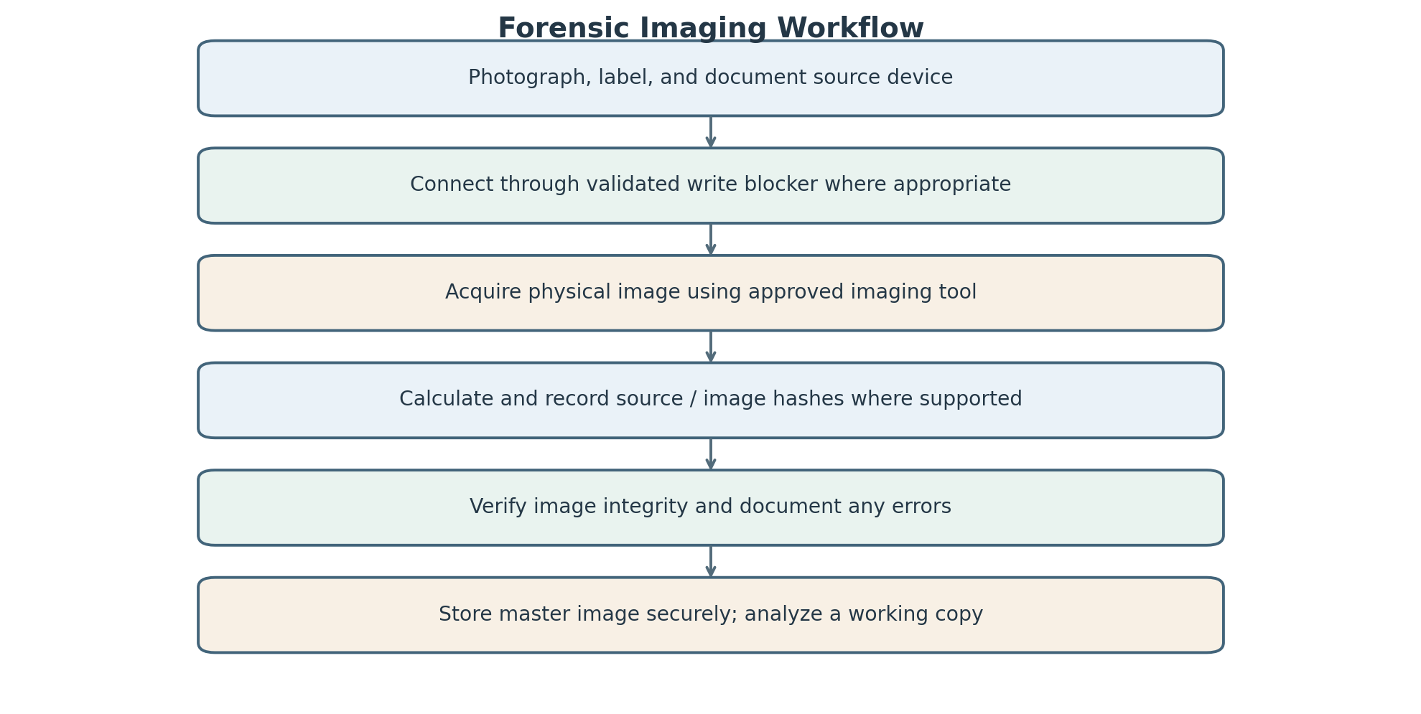

ASSIGNMENT 2(4)

Recovery of Deleted Evidence from Volume Shadow Copies
Case approach: Apply authorized, repeatable forensic procedures; preserve integrity and distinguish scenario assumptions from verified facts.

23. Selecting and categorizing evidence
Begin with the incident question, authorized scope, and a verified forensic image. Identify potentially relevant user accounts, date ranges, file paths, browser artifacts, system events, and available Volume Shadow Copies (VSS). Create a working inventory and categorize evidence by relevance and type before detailed analysis. Preserve a record of items excluded and why; filtering should reduce noise without silently discarding potentially exculpatory or contradictory data. Keep the original image unchanged, record hashes, and document search terms, date ranges, filters, and tool versions so the selection can be reproduced.

24. Evidence classification scheme
Classify artifacts using the table below. Categories can overlap: a user-created document may also be recovered from a shadow copy, so record both its origin/type and recovery status. “Suspicious” is a triage label, not a final conclusion.
Category | Examples | Treatment
User-created files | Documents, spreadsheets, images, scripts. | Record path, owner/profile, metadata, hash, relevance.
System/application files | Logs, configuration files, browser databases, executables. | Interpret in operating-system/application context.
Potentially suspicious files | Unusual executable, renamed file, unexpected script. | Triage using metadata, hash, behavior/context; do not label malicious from name alone.
Deleted/recovered artifacts | Deleted entries, carved files, earlier VSS versions. | Record recovery source, method, completeness, and validation.
Supporting/contextual evidence | Shortcuts, USB history, login events, sync records. | Use for corroboration and alternative-hypothesis testing.

25. Event Analysis and sequence reconstruction
Event Analysis organizes records by event time and type to reconstruct a sequence of activity. Investigators can correlate operating-system logs, application events, browser history, file-system timestamps, user logons, file creation/modification/deletion indicators, and shadow-copy versions. A useful event table records the timestamp as stored, source, event description, relevant user/process, normalized time, and confidence/limitations. Correlation may show that an account logged in, a file changed, and a browser artifact appeared in a related interval. However, missing logs, time skew, background processes, and timestamp semantics must be considered before drawing conclusions.

26. Cloud Analysis and Lead Analysis
Cloud Analysis examines relevant evidence stored or processed by cloud services, subject to authorization. It may help answer which account accessed a service, when a file was synchronized or shared, whether a version or audit record exists, and whether an event is consistent with local-device artifacts. Cloud records may use server-side timestamps and retention policies that differ from the endpoint.
Lead Analysis uses initial findings to identify the next investigative steps. A recovered filename may lead investigators to search for related paths, hashes, account activity, recipients, or other versions. A lead is a direction to test, not proof. Document the question, rationale, authorized next step, and result so the investigation remains focused and reproducible.

27. Volume Shadow Copy analysis
Volume Shadow Copy Service can preserve point-in-time versions of volumes for system restore, backup, or other Windows functions. When shadow copies exist in the acquired image, investigators can identify their timestamps and metadata, mount or parse them with a suitable forensic tool, and compare a file across available versions. Earlier versions may contain content that was later modified or deleted from the live file system. VSS does not guarantee that every deleted file will be recoverable: copies may be absent, incomplete, overwritten, or outside the available image. Preserve the original image and export candidate files to a separate location for validation.

28. Hypothetical file lifecycle timeline
The following is an illustrative timeline only. It demonstrates how a document might be created, changed, copied, deleted, and later recovered from an earlier shadow copy. The times are hypothetical and do not describe actual evidence.
Hypothetical time | Event | Possible artifact | Interpretive note
09:10 | Document created | File-system record and content | Creation timestamp alone does not identify author.
09:35 | Document modified | Changed metadata/content; application trace | Compare versions and hashes.
09:50 | Document copied to another path | Duplicate file and path records | Matching hash supports identical content.
10:05 | Document deleted from live location | Deleted directory entry or file-system record | Deletion does not prove intent.
10:15 | Relevant VSS snapshot remains available | Earlier version in shadow copy | Snapshot time and file timestamps are different concepts.
Later examination | Artifact recovered from VSS | Exported file, hash, extraction log | Validate content and document limitations.

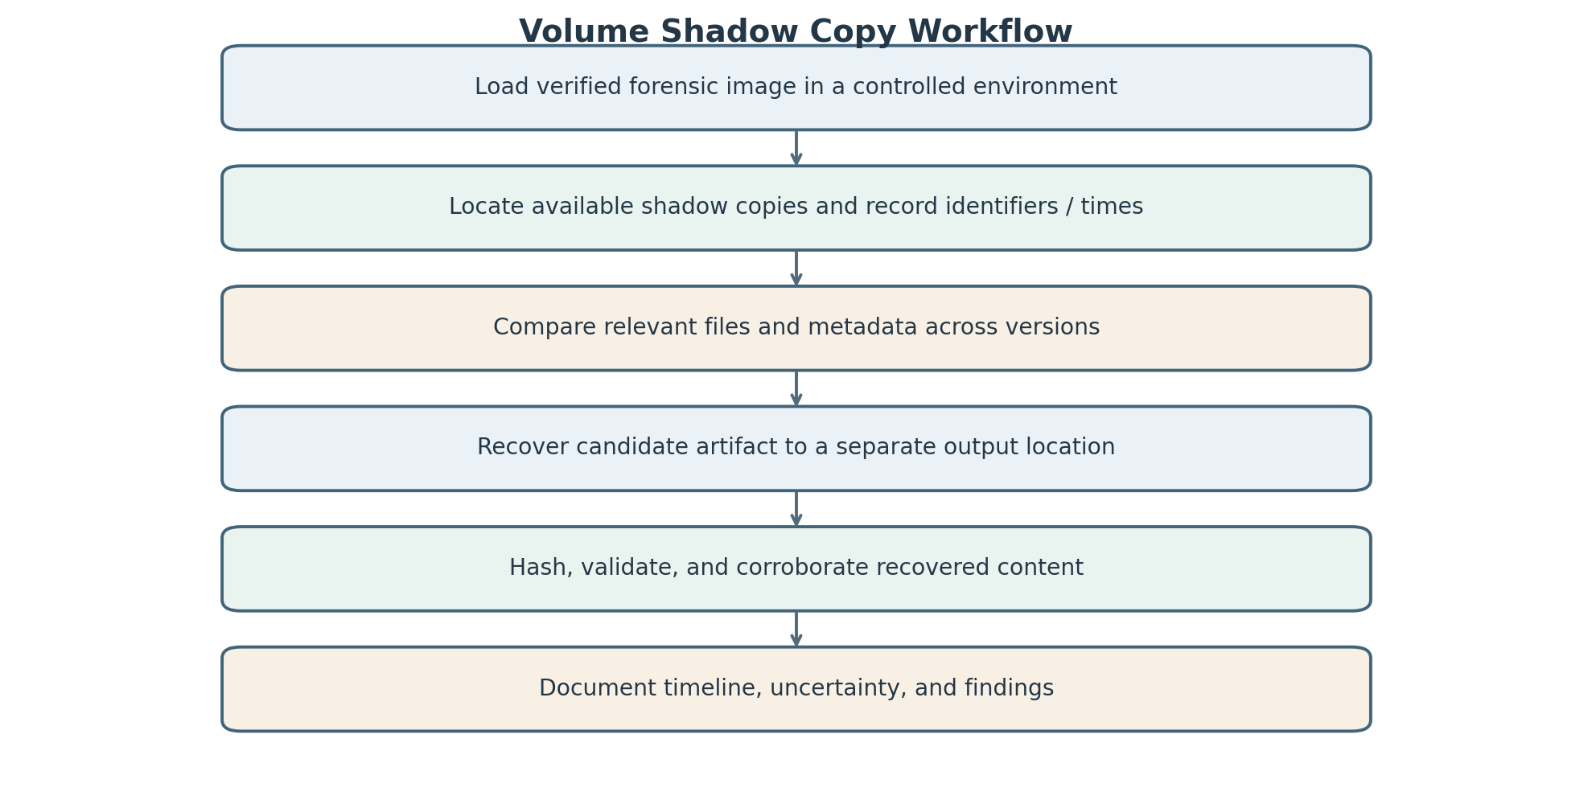

29. Validating a recovered artifact
- Record the source image, shadow-copy identifier, version timestamp, original path if available, and recovery method.
- Hash the recovered output and preserve the tool logs and extraction settings.
- Check file signature, structure, size, and whether it opens or parses consistently; do not rely only on the filename or extension.
- Compare the recovered content with other versions and note exact differences.
- Corroborate relevant facts with independent logs, metadata, account activity, or related files.
- Confirm timestamps and time-zone assumptions; distinguish the shadow-copy time from the file’s internal or file-system timestamps.
- Repeat critical extraction on a working copy or with a second method/tool when feasible.
- Record limitations such as partial recovery, fragmentation, missing metadata, parser errors, or ambiguous attribution.
- Only validated findings should be included, with a clear explanation of what they establish and what remains uncertain.

30. Errors and alternative explanations
Possible issues include incorrect system clocks or time-zone conversion; timestamp changes caused by copying, extraction, restoration, or synchronization; VSS snapshots taken before or after the presumed event; incomplete or overwritten shadow copies; file-system damage; partial recovery or carving false positives; automated backup/sync/security processes; shared accounts; and tools that parse metadata differently. A deletion indicator may not reveal who deleted the file or why. Investigators should state alternative explanations, cross-check sources, preserve original timestamp values, and report uncertainty instead of forcing a single narrative.

ASSIGNMENT 2(5)

Multi-Source Investigation of a Suspected Cyber Incident
Case approach: Apply authorized, repeatable forensic procedures; preserve integrity and distinguish scenario assumptions from verified facts.

31. Potential evidence from Windows and other operating systems
On Windows, potentially relevant evidence includes event logs, user and security records, file-system metadata, shortcut/recent-file artifacts, registry artifacts, scheduled tasks, installed programs, USB history, browser data, and application logs. On macOS, relevant sources may include unified logs, user account records, file-system metadata, browser and application artifacts, and system configuration. On Linux, sources may include authentication/system logs, shell history where available, process/service configuration, package logs, and file metadata. Mobile and other operating systems may provide app data, notifications, device logs, and account/synchronization traces. Availability varies by version, configuration, permissions, retention, encryption, and user activity. Preserve source context and avoid assuming that every artifact exists on every system.

32. Browser artifacts and careful interpretation
Browser evidence can include history, downloads, cache, cookies, saved sessions, autofill data, bookmarks, typed URLs, extensions, and timestamps. It may indicate that a browser profile accessed a site, downloaded a file, or stored data related to a service. Interpretation must be careful because browsers sync across devices, prefetch content, run background requests, retain stale cache, and can be used by multiple people. A visit does not prove that the user read or understood the page, and a URL alone may not show the complete content. Preserve the profile and relevant databases, record extraction method and time settings, and correlate with authentication, download, file-system, and network/cloud records.

33. Email and messaging evidence and correlation
Potential email evidence includes sender/recipient fields, message IDs, headers, timestamps, attachments, delivery records, mailbox audit logs, and server-side access records. Messaging evidence may include conversation records, participant identifiers, message content where available, attachment metadata, delivery/read states, call records, and local notification/database artifacts. Availability depends on the service, device, encryption, retention, and authorization. Correlate message IDs, attachment hashes, recipient accounts, times, and filenames with downloads, browser activity, file-system events, and cloud-sharing records. Preserve original exports and headers where possible; screenshots alone may omit metadata and can be difficult to authenticate.

34. Mobile-phone forensic considerations and challenges
First confirm legal authority, device ownership/identifier, scope, and the appropriate acquisition method. Photograph the device and condition, record make/model, operating-system version, network state, SIM/SD details where accessible, and whether it is locked or powered on. Mobile devices may be encrypted, remotely wiped, cloud-synchronized, or altered by notifications and network activity. Choose a validated, proportionate acquisition approach; isolate network connectivity only when authorized and when the action’s impact is understood. Document every interaction and use a forensic copy where available. Challenges include passcode protection, hardware-backed encryption, app sandboxing, rapidly changing data, proprietary formats, cloud dependencies, deleted data, app updates, and incomplete logs. Do not bypass protections or access unrelated data outside the authorized scope.

35. Internet and cloud evidence sources
Relevant sources may include service-provider login history, IP/session records, audit logs, cloud file versions, sharing permissions, synchronization records, DNS and proxy logs, firewall/VPN records, web-server logs, email-provider records, and account-recovery notifications. These sources can help establish which account or session accessed a service, whether files were shared or synchronized, and whether local-device activity aligns with remote events. Access must be legally and contractually authorized. Preserve provider exports with request details, collection time, account identifiers, time zone, retention caveats, and integrity information. IP addresses and device labels may be shared, dynamic, masked by VPNs, or affected by NAT; they should not be treated alone as proof of a specific person.

36. Cross-source correlation table
This hypothetical matrix illustrates how different artifacts may corroborate an event. It is a model for analysis, not a claim that the artifacts have been collected.
Source | Hypothetical artifact | Correlation question | Caution
Windows computer | Logon event for account A at 20:10 | Does it align with service access? | Account use is not necessarily human identity.
Browser | History/download record at 20:12 | Does URL/file match the incident? | May be prefetch, sync, or shared profile.
Email/messaging | Message with a link or attachment at 20:08 | Does message ID/attachment hash match? | Validate sender, headers, and provenance.
Mobile phone | Notification or app record at 20:09 | Does it relate to the same account/session? | Notification may be incomplete or synced.
Cloud/service | Audit record for resource access at 20:11 | Does server-side record corroborate access? | Check provider time zone, retention, and IP sharing.
USB / local files | Matching file hash at 20:20 | Was a related copy present locally? | Presence alone does not prove transfer direction.

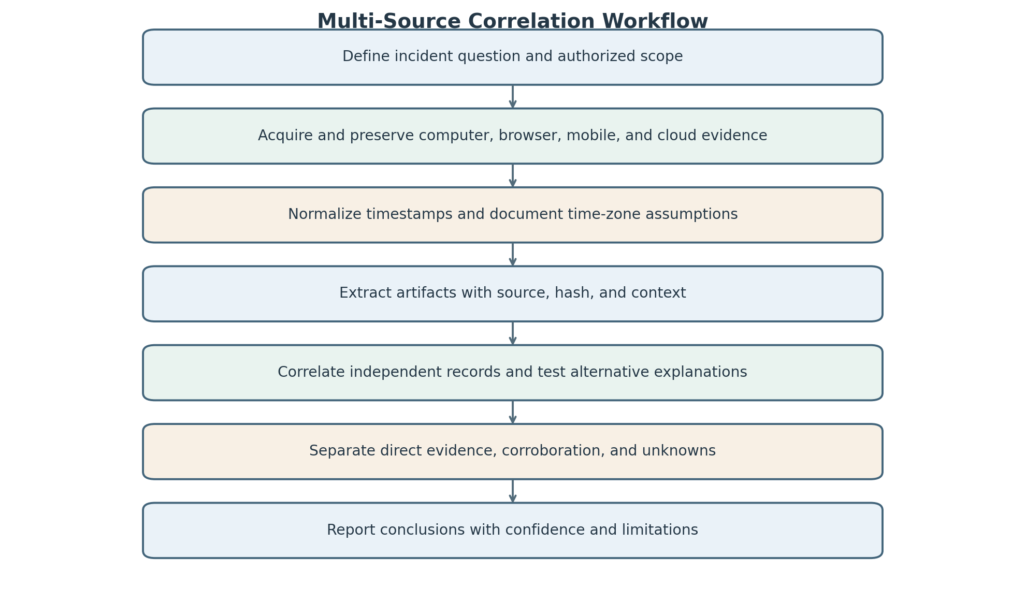

37. Major challenges in distributed digital forensics

1. Different time standards: devices and providers may record local time, UTC, or inaccurate clocks.
2. Encryption and access controls: content may be unavailable without lawful credentials or supported acquisition.
3. Cloud jurisdiction and authorization: data may be held across regions and governed by different rules.
4. Retention and volatility: logs, messages, sessions, and cloud records may expire or be overwritten.
5. Proprietary formats and tool coverage: applications change formats, and parsers may not support every version.
6. Identity attribution: shared devices, credentials, NAT, VPNs, and compromised accounts complicate attribution.
7. Synchronization and duplication: copies may appear on several devices with altered timestamps or incomplete context.
8. Privacy and scope: investigators must avoid unnecessary collection of unrelated personal information.
9. Integrity and provenance: exports and screenshots may lack verifiable origin unless collection is documented.
10. Volume and correlation: many records create noise; automated correlations can produce false matches.
11. Remote change or wipe: connected devices and services may change during examination.
12. Incomplete or conflicting evidence: one source may contradict another, requiring careful qualification rather than selective reporting.

38. Final investigation conclusion: evidence categories and unresolved questions
The final investigation conclusion summarizes the evidence collected, the findings identified, and the questions that remain unanswered. Digital evidence may include file-system data, system logs, metadata, deleted files, browser history, and forensic images. Each category provides useful information for understanding the incident and reconstructing the sequence of events.
The evidence must be preserved using proper forensic procedures, including hash verification, documentation, and chain of custody. Investigators should correlate information from different sources before drawing conclusions and clearly distinguish confirmed findings from assumptions.
Some questions may remain unresolved, such as the exact identity of the attacker, the complete sequence of activities, the original purpose of the incident, or whether any evidence has been permanently deleted. These questions require further investigation and additional supporting evidence.
In conclusion, the investigation should present all confirmed findings, evidence limitations, and unresolved questions objectively. Proper evidence preservation and systematic analysis help ensure that the final conclusion is reliable, transparent, and useful for further investigation or legal proceedings.

Conclusion
Digital forensics plays an important role in investigating cybercrimes by identifying, collecting, preserving, examining, and presenting digital evidence in a systematic and reliable manner. The five case studies discussed in this assignment demonstrate how forensic techniques can be applied to different situations, including cybercrime investigations, data recovery, system analysis, and the examination of digital devices. Each case highlights the importance of following a structured forensic methodology to obtain accurate and meaningful results.
The reliability of digital evidence depends on maintaining its integrity throughout the investigation. Techniques such as creating forensic images, calculating hash values, preserving original evidence, and maintaining a proper chain of custody help ensure that the collected data remains authentic and has not been altered. Proper documentation of every investigative step also improves transparency, repeatability, and the credibility of the findings.
Digital forensic tools and techniques help investigators examine different types of evidence, including files, deleted data, system logs, metadata, and file-system information. Tools such as ILookIX and IXImager can support forensic acquisition and examination, while file carving and Volume Shadow Copy analysis can assist in recovering or identifying useful information. Combining evidence from multiple sources can help investigators develop a clearer understanding of the incident and establish a timeline of relevant activities.
However, forensic investigations may face challenges such as damaged storage devices, encrypted information, deleted or overwritten files, incomplete logs, and limitations in the available evidence. Therefore, investigators must interpret findings carefully, consider alternative explanations, and avoid drawing conclusions that are not supported by the available data. The use of appropriate forensic procedures, validated tools, and systematic analysis helps reduce errors and improve the reliability of the investigation.
Legal and ethical responsibilities are also essential in digital forensics. Investigators must obtain proper authorization, respect privacy, protect confidential information, and follow applicable laws and organizational procedures. All findings should be documented clearly and presented in an objective manner so that other investigators, technical experts, or legal authorities can understand how the conclusions were reached.
In conclusion, digital forensics is an essential field for understanding cyber incidents, recovering digital information, and supporting evidence-based investigations. The effective combination of proper evidence handling, forensic tools, analytical techniques, documentation, and ethical practices helps ensure that digital evidence is trustworthy and useful. These case studies provide a better understanding of how forensic principles are applied in practical situations and emphasize the need for accuracy, integrity, and professionalism throughout the investigative process. The scenarios discussed in this assignment are illustrative case studies, and the conclusions are based on the information presented in each scenario.

