**PLSQL_Exercises**

**Exercise 1: Control Structures**

**Scenario 1:**

**INPUT**

BEGIN

    for res in (

        select c.name,c.customerID,l.loanID,l.InterestRate

        from loans l join customers c on l.customerID=c.customerID

        where trunc(months_between(sysdate,c.dob)/12) > 60 ) loop

        Update loans set InterestRate = res.InterestRate -1

        Where loanID=res.loanID;

    end loop;

END;

**OUTPUT**

--procedure is created and executed:

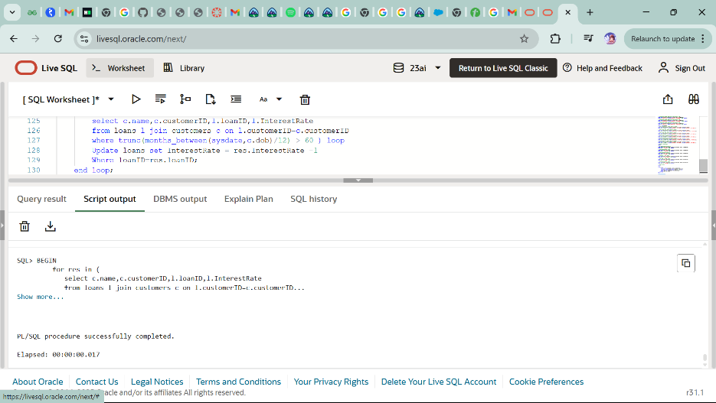

--after executing procedure table LOANS:

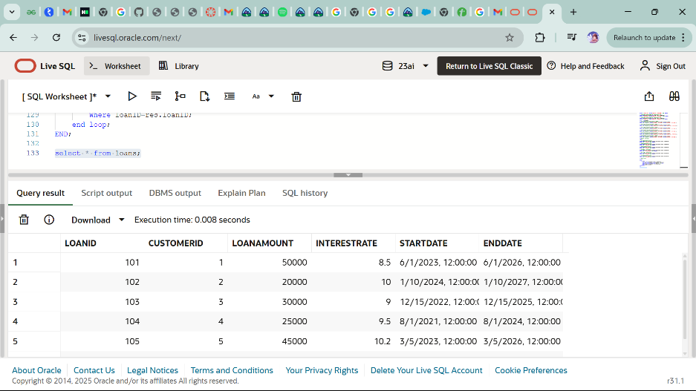

**Scenario 2:**

**INPUT**

ALTER TABLE CUSTOMERS

ADD ISVIP VARCHAR(1);

SELECT * FROM CUSTOMERS;

BEGIN

    for res in( select name , customerID, Balance from customers) loop

    if (res.Balance>10000) then

        Update customers set ISVIP='Y'

        where customerID=res.customerID;

    else

        Update customers set ISVIP='N'

        where customerID=res.customerID;

    end if;

    end loop;

END;

**OUTPUT**

--ISVIP column is added in CUSTOMERS table:

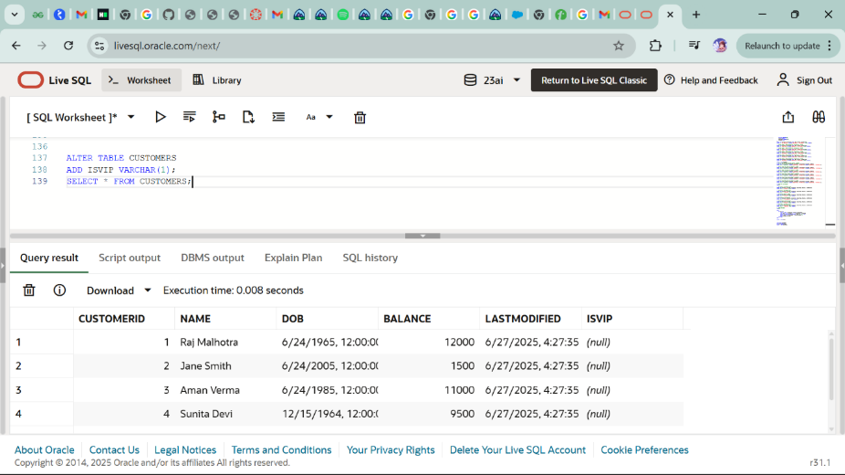

--procedure is created and executed:

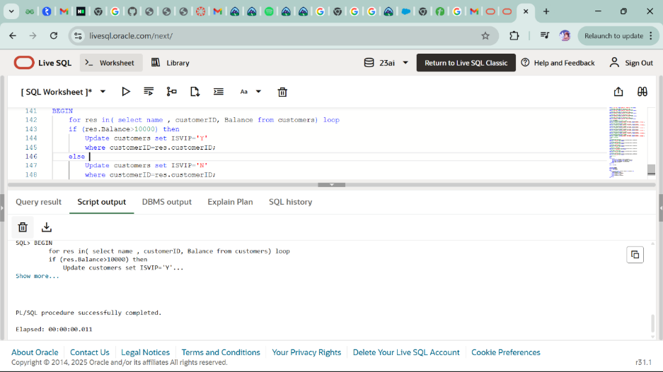

--after procedure execution table CUSTOMERS:

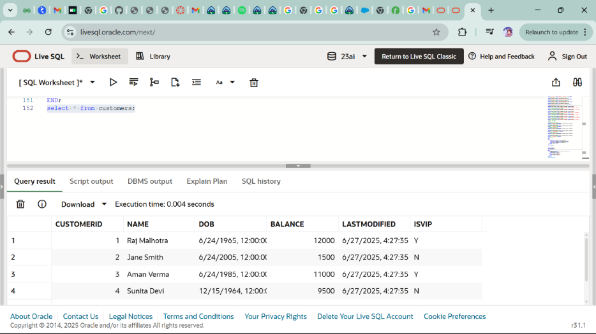

**Scenario 3:**

**INPUT**

SET SERVEROUTPUT ON;

BEGIN

    for res in (select c.name,c.customerID,l.loanID,l.EndDate

    from loans l join customers c on l.customerID=c.customerID

    where l.EndDate between sysdate and sysdate+30

    ) loop

    Dbms_output.put_line('Reminder: Dear ' || res.NAME ||

                             ', your loan is due on ' || TO_CHAR(res.ENDDATE, 'DD-MON-YYYY') ||

                             '. Please ensure timely payment.');

    end loop;

END;

**OUTPUT**

--procedure is created and executed:

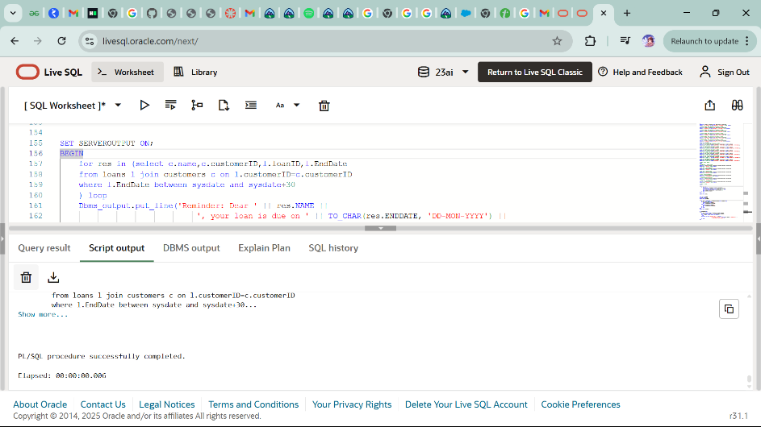

**Exercise 3: Stored Procedures**

**Scenario 1:**

**INPUT**

create or replace procedure ProcessMonthlyInterest is

BEGIN

    update accounts set balance=(0.01*balance)+balance;

END;

--procedure calling

BEGIN

    ProcessMonthlyInterest;

END;

**OUTPUT**

--creating and exceuting the procedure:

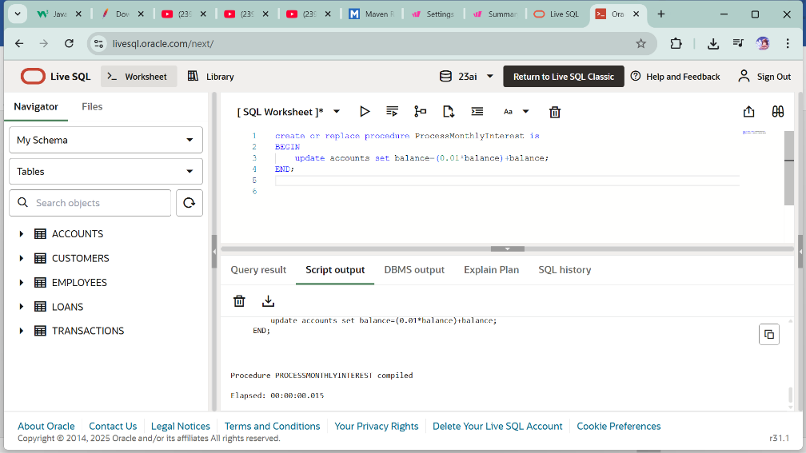

--after exceuting the procedure our ACCOUNTS table:

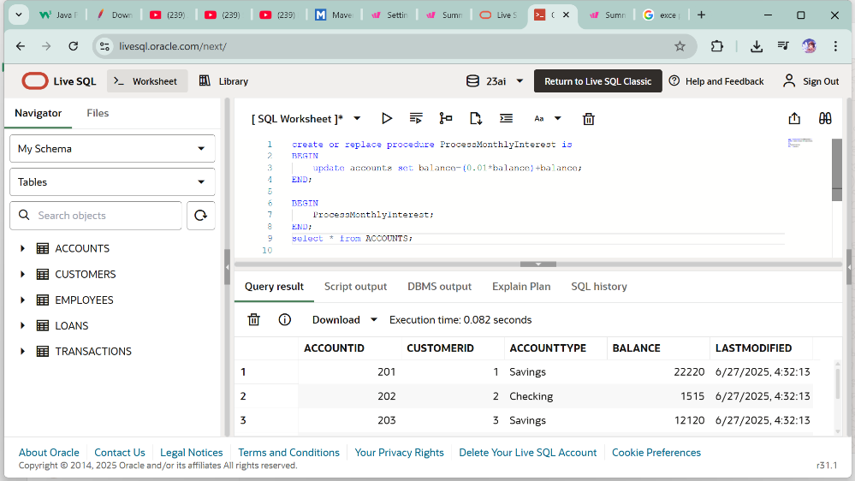

**Scenario 2:**

**INPUT**

create or replace procedure UpdateEmployeeBonus(Employee_Department IN varchar2, bonus_percentage IN number) is

BEGIN

    update employees set salary= salary + bonus_percentage

    where department=Employee_Department;

END;

--procedure calling

BEGIN

    UpdateEmployeeBonus('HR',500);

END;

**OUTPUT**

--before exceuting the procedure our EMPLOYEES table:

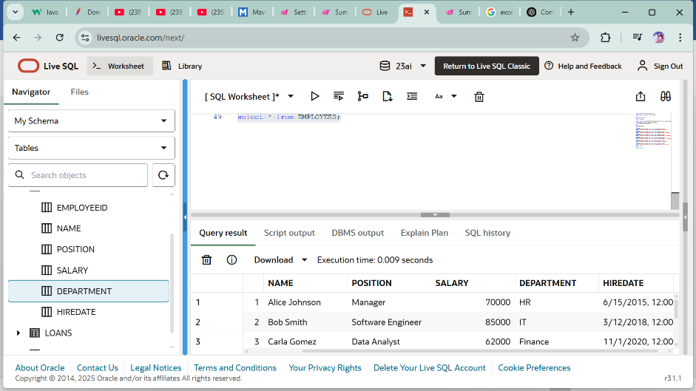

--creating and executing procedure:

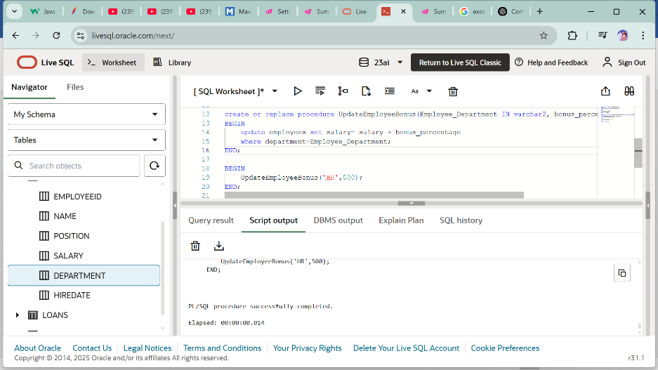

--after exceuting the procedure our EMPLOYEES table:

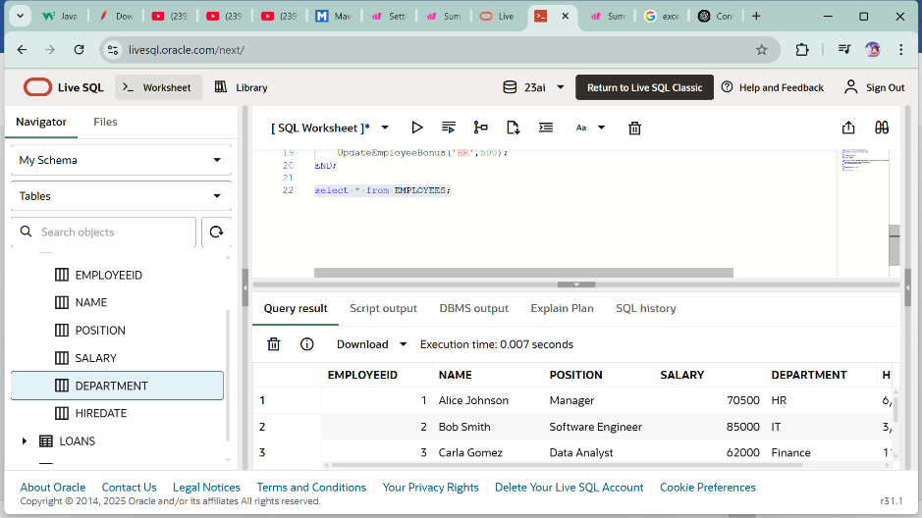

**Scenario 3:**

create or replace procedure TransferFunds(from_account IN number, to_account IN number, amount IN number) IS

v_balance number;

BEGIN

    select balance into v_balance from accounts where ACCOUNTID=from_account for update;

    if v_balance < amount then

        raise_application_error(-20001,'Insufficient balance of source account');

    end if;

        update accounts set balance = balance-amount,lastmodified=sysdate where accountID=from_account;

        update accounts set balance = balance+amount,lastmodified=sysdate where accountID=to_account;

END;

BEGIN

    TransferFunds(201,202,220);

END;

**OUTPUT**

--before exceuting the procedure our ACCOUNTS table:

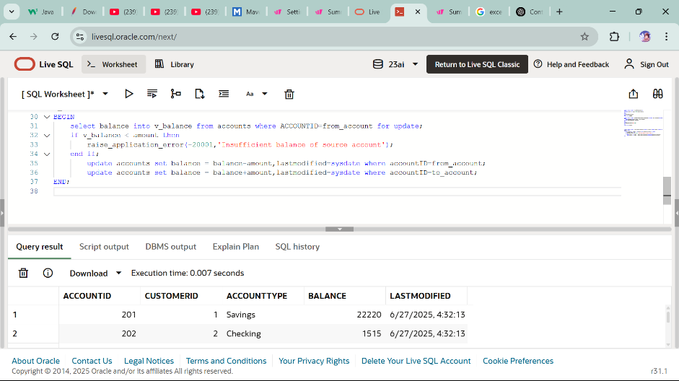

--procedure is created and executed

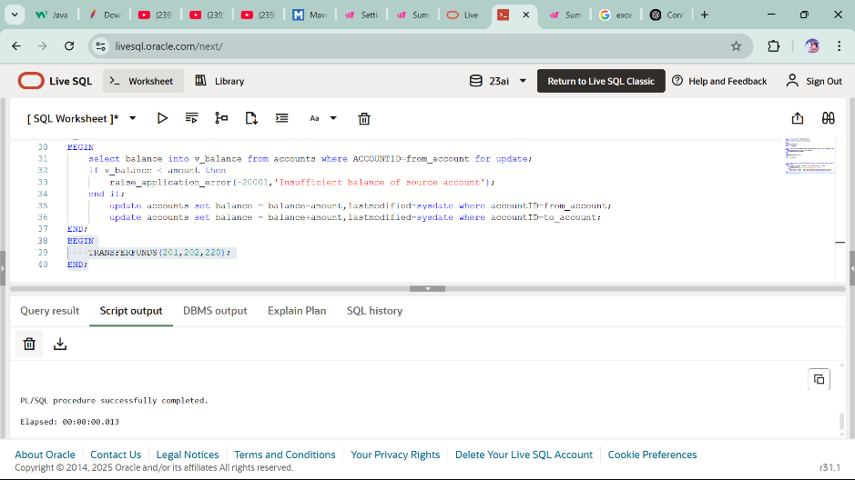

--after exceuting the procedure our ACCOUNTS table:

