1. **ReactJS-HOL**

**// App.js**

function App(){

return(

<h1>Welcome the first session of React</h1>

);

}

export default App;

**//OUTPUT**

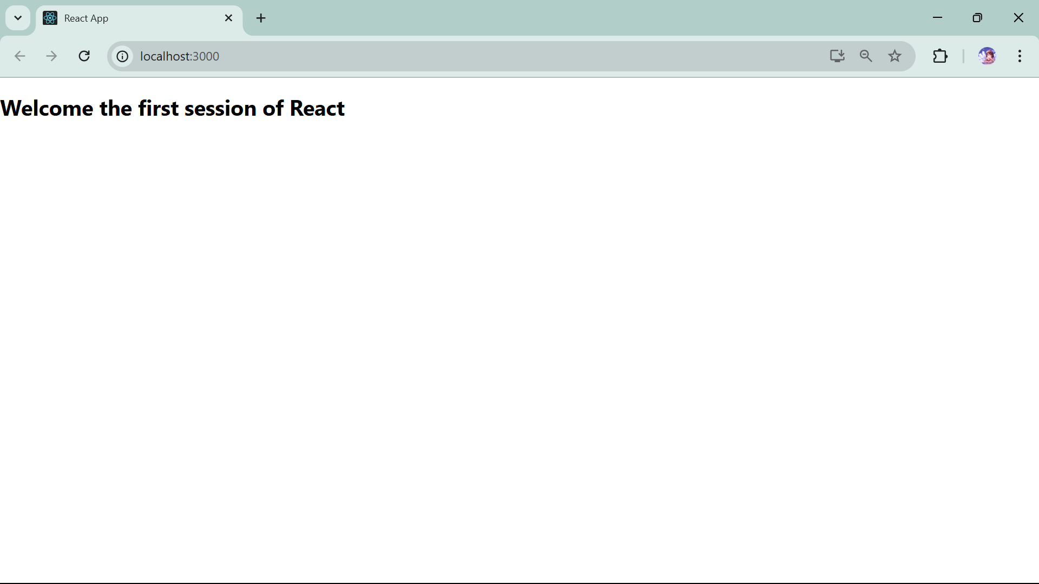

**2. ReactJS-HOL**

**// .enlintrc.js** -> this setting needed so that we can use class keyword

module.exports = {

  parser: "@babel/eslint-parser",

  parserOptions: {

    requireConfigFile: false,

    ecmaVersion: 2020,

    sourceType: "module",

    ecmaFeatures: {

      jsx: true

    }

  },

  plugins: ["react"],

  extends: ["eslint:recommended", "plugin:react/recommended"],

  rules: {

    "comma-dangle": 0,

    "react/jsx-uses-vars": 1,

    "react/display-name": 1,

    "no-unused-vars": "warn",

    "no-console": 1,

    "no-unexpected-multiline": "warn"

  },

  settings: {

    react: {

      version: "detect"

    }

  } };

**//App.js**

import './App.css';

import React from 'react';

import Home from './Components/Home';

import About from './Components/About';

import Contact from './Components/Contact';

function App() {

  return (

    <div className="container">

      <Home/>

      <About/>

      <Contact/>

      </div>

  );

}

export default App;

**//About.js**

import React,{Component} from "react";

class About extends Component {

    render(){

       return( <div>

        <h3>Welcome to the About Page of Student Management Portal</h3>

        </div>);

    }

}

export default About;

**//Contact.js**

import React,{Component} from "react";

class Contact extends Component {

    render(){

       return( <div>

        <h3>Welcome to the Contact Page of Student Management Portal</h3>

        </div>

    );}

}

export default Contact;

**//Home.js**

import React,{Component} from "react";

class Home extends Component {

    render(){

        return (<div>

        <h3>Welcome to the Home Page of Student Management Portal</h3>

        </div>

   ); }

}

export default Home;

**OUTPUT**

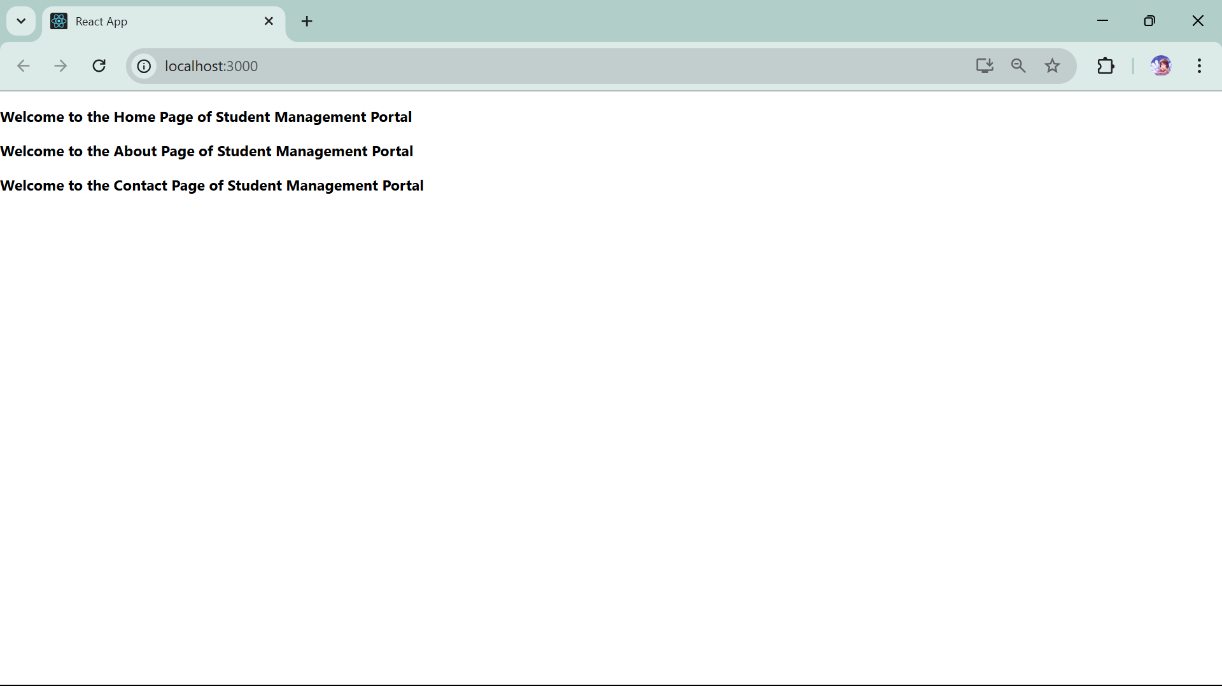

**3. ReactJS-HOL**

**//CalculateScore.js**

import '../Stylesheets/mystyle.css';

const percentToDecimal = (decimal) => {

    return (decimal.toFixed(2) + '%')

}

const calcScore = (total, goal) => {

    return percentToDecimal(total / goal)

}

export const CalculateScore = ({ Name, School, total, goal }) => (

    <div className="formatstyle">

        <h1><font color="Brown">Student Details:</font></h1>

        <div className="Name">

            <b> <span> Name: </span> </b>

            <span>{Name}</span>

        </div>

        <div className="School">

            <b> <span> School: </span> </b>

            <span>{School}</span>

        </div>

        <div className="Total">

            <b> <span>Total:</span> </b>

            <span>{total}</span>

            <span>Marks</span>

        </div>

        <div className="Score">

            <b>Score:</b>

            <span>

                {

                    calcScore(

                        total,

                        goal

                    )

                }

            </span>

        </div>

    </div>

)

**//mystyle.css**

.Name {

    font-weight: 300;

    color: blue;

}

.School {

    color: crimson;

}

.Total {

    color: darkmagenta;

}

.formatstyle {

    text-align: center;

    font-size: large;

}

.Score {

    color: forestgreen;

}

**//App.js**

import {CalculateScore} from '../src/Components/CalculateScore';

function App() {

    return (

        <div>

            <CalculateScore

                Name={"Steeve"}

                School={"DNV Public School"}

                total={284}

                goal={3}

            />

        </div>

    );

export default App;

**OUTPUT**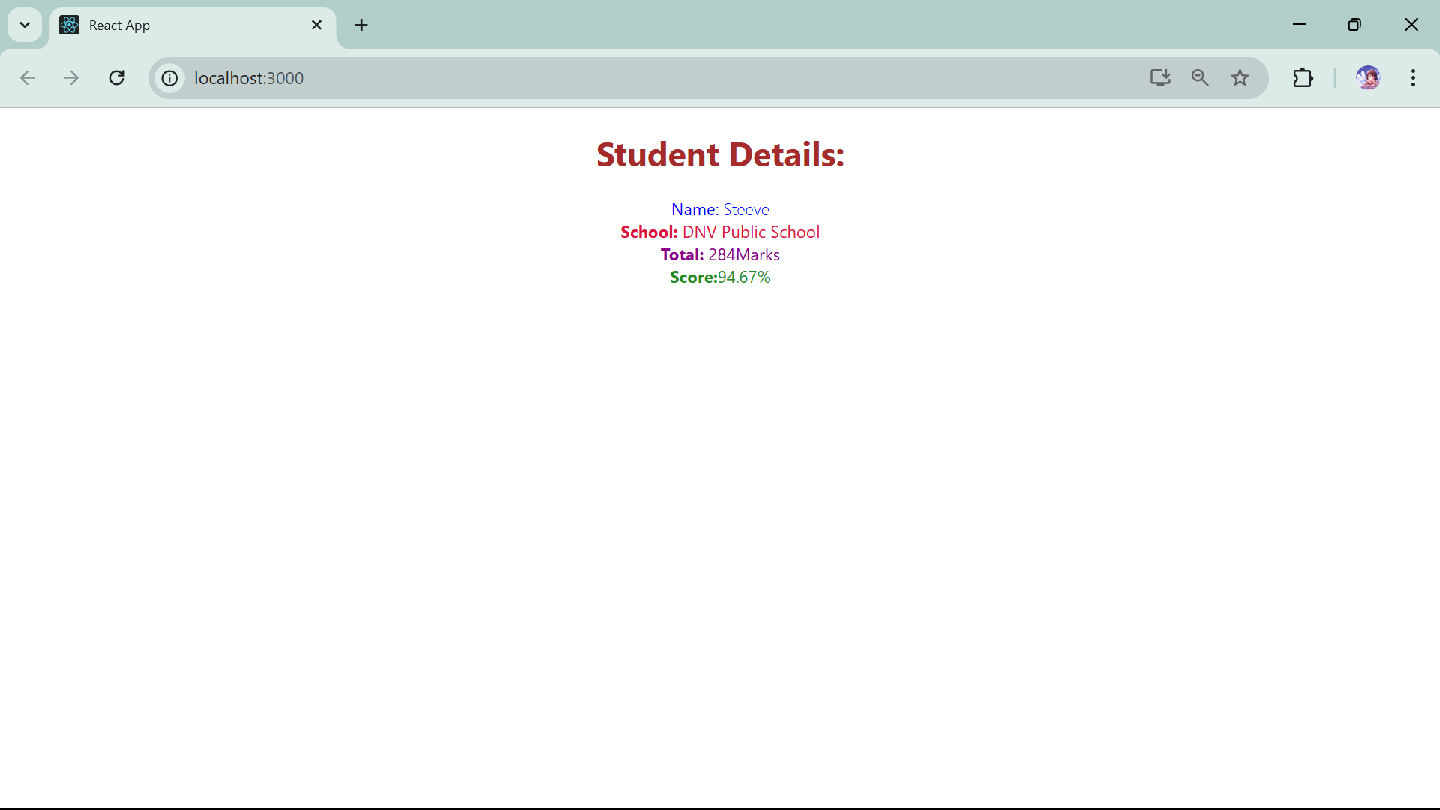

**4. ReactJS-HOL**

**// Post.js**

import React from 'react';

class Post extends React.Component {

  render() {

    const { title, body } = this.props;

    return (

      <div>

        <h3>{title}</h3>

        <p>{body}</p>

        <hr />

      </div>

    );

  }

}

export default Post;

**// Posts.js**

import React from 'react';

import Post from './Post';

class Posts extends React.Component {

  constructor(props) {

    super(props);

    this.state = {

      posts: [],

      hasError: false,

      errorInfo: null

    };

  }

  componentDidMount() {

    this.loadPosts();

  }

  loadPosts() {

    fetch('https://jsonplaceholder.typicode.com/posts')

      .then(res => res.json())

      .then(data => this.setState({ posts: data }))

      .catch(err => {

        alert("Failed to fetch posts");

        console.error(err);

      });

  }

  componentDidCatch(error, info) {

    this.setState({ hasError: true, errorInfo: info });

    alert("Something went wrong in rendering.");

  }

  render() {

    if (this.state.hasError) {

      return <h2>Something went wrong while displaying posts.</h2>;

    }

    return (

      <div>

        <h2>Blog Posts</h2>

        {this.state.posts.map(post => (

          <Post key={post.id} title={post.title} body={post.body} />

        ))}

      </div>

    );

  }

}

export default Posts;

**//App.js**

import React from 'react';

import Posts from './Posts';

function App() {

  return (

    <div className="App">

      <h1>Welcome to BlogApp</h1>

      <Posts />

    </div>

  );

}

export default App;

**OUTPUT**

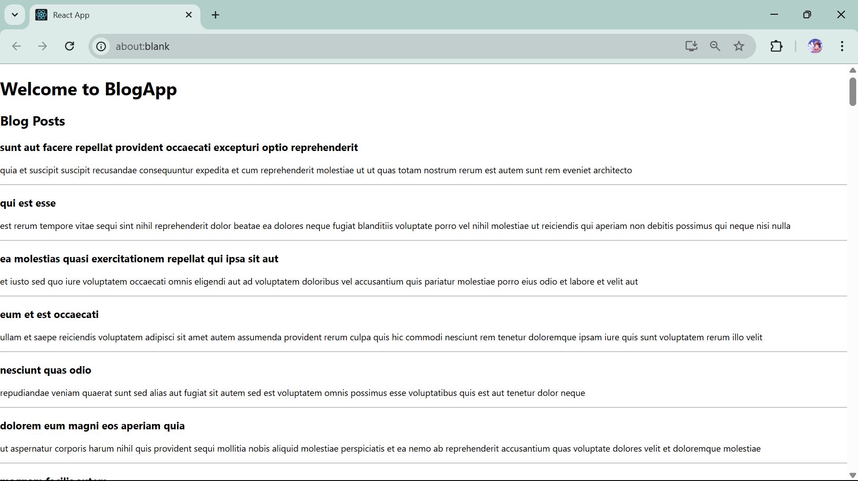

**5. ReactJS-HOL**

**/* CohortDetails.module.css file */**

.box {

  width: 300px;

  display: inline-block;

  margin: 10px;

  padding: 10px 20px;

  border: 1px solid black;

  border-radius: 10px;

}

dt {

  font-weight: 500;

}

**//CohortDetails.js**

import React from 'react';

import styles from './CohortDetails.module.css';

function CohortDetails(props) {

    const statusColor = props.cohort.currentStatus === 'Ongoing' ? 'green' : 'blue';

    return (

        <div className={styles.box}>

            <h3 style={{ color: statusColor }}>

                {props.cohort.cohortCode} -

                <span>{props.cohort.technology}</span>

            </h3>

            <dl>

                <dt>Started On</dt>

                <dd>{props.cohort.startDate}</dd>

                <dt>Current Status</dt>

                <dd>{props.cohort.currentStatus}</dd>

                <dt>Coach</dt>

                <dd>{props.cohort.coachName}</dd>

                <dt>Trainer</dt>

                <dd>{props.cohort.trainerName}</dd>

            </dl>

        </div>

    );

}

export default CohortDetails;

**//App.js**

import logo from './logo.svg';

import './App.css';

import React from 'react';

import { CohortsData} from './Cohort'

import CohortDetails from './CohortDetails';

function App() {

  return (

  <div>

    <h1>Cohorts Details</h1>

    {CohortsData.map(cohort => <CohortDetails cohort={cohort}/>)}

  </div>

  );

}

export default App;

**OUTPUT**

