**9.ReactJS-HOL**

**//cricketapp**

**//App.js**

import { useState } from 'react';

import './App.css';

import IndianPlayers from './components/IndianPlayers';

import ListofPlayers from './components/ListofPlayers';

function App() {

const [flag, setFlag] = useState(true);

  return (

    <div>

      <button  onClick={() => setFlag(!flag)}>

        {flag ? "Flag is True" : "Flag is False"}

      </button>

      {flag ? <ListofPlayers /> : <IndianPlayers />}

    </div>

  );

}

export default App;

**// ListofPlayers.js**

import React from 'react';

export default function ListofPlayers(){

    const players = [

  { name: "Rohit Sharma", score: 45 },

  { name: "Virat Kholi", score: 60 },

  { name: "Bhuvneshwar Kumar", score: 30 },

  { name: "David Miller", score: 75 },

  { name: "Rachin Ravindra", score: 20 },

  { name: "Kane Williamson", score: 90 },

  { name: "Steve Smith", score: 10 },

  { name: "Glenn Maxwell", score: 55 },

  { name: "Ravindra Jadeja", score: 100 },

  { name: "K.L. Rahul", score: 80 },

  { name: "Temba Bavuma", score: 35 }

];

    const player70=[];

    return (

        <div className='container'>

            <h2>List of Players</h2>

            <p>{players.map((items) => {

            return ( <>

                <div>

                <li>Mr.{items.name} <span> {items.score}</span></li>

                </div> </> )

        })}

        </p>

        <h2>List of Players having Scores Less than 70</h2>

        <p>{players.map((items) => {

            {if (items.score<=70)

                player70.push(items)

            return (

                <div>

                <li>Mr.{items.name} <span> {items.score}</span></li>

                </div> )} })}</p>

</div>)}

**//IndianPlayers.js**  
import React from 'react';

export default function IndianPlayers(){

    const indianPlayers = ['Sachin', 'Virat', 'Rohit','Dhoni','Bhuvneshwar','Ravindra Jadeja'];

    const [first, second, third,fourth,fifth,sixth] = indianPlayers;

    const T20players=['First Player','Second Player','Third Player'];

    const RanjiTrophy=['Fourth Player','Fifth Player','Sixth Player'];

    const MergedArray=[...T20players,...RanjiTrophy];

    return( <>

        <div>

            <h1>Odd Players</h1>

            <p>First: {first}</p>

            <p>Thrid: {third}</p>

            <p>Fifth: {fifth}</p>

        </div>

        <div>

            <h1>Even Players</h1>

            <p>Second: {second}</p>

            <p>fourth: {fourth}</p>

            <p>sixth: {sixth}</p>

        </div>

        <div>

            <h1>List of India Players Merged</h1>

            <p>{MergedArray.map((items) => {

            return ( <div>

                <li>Mr.{items}</li>

                </div> )})}</p>

</div></>) }

**OUTPUT**

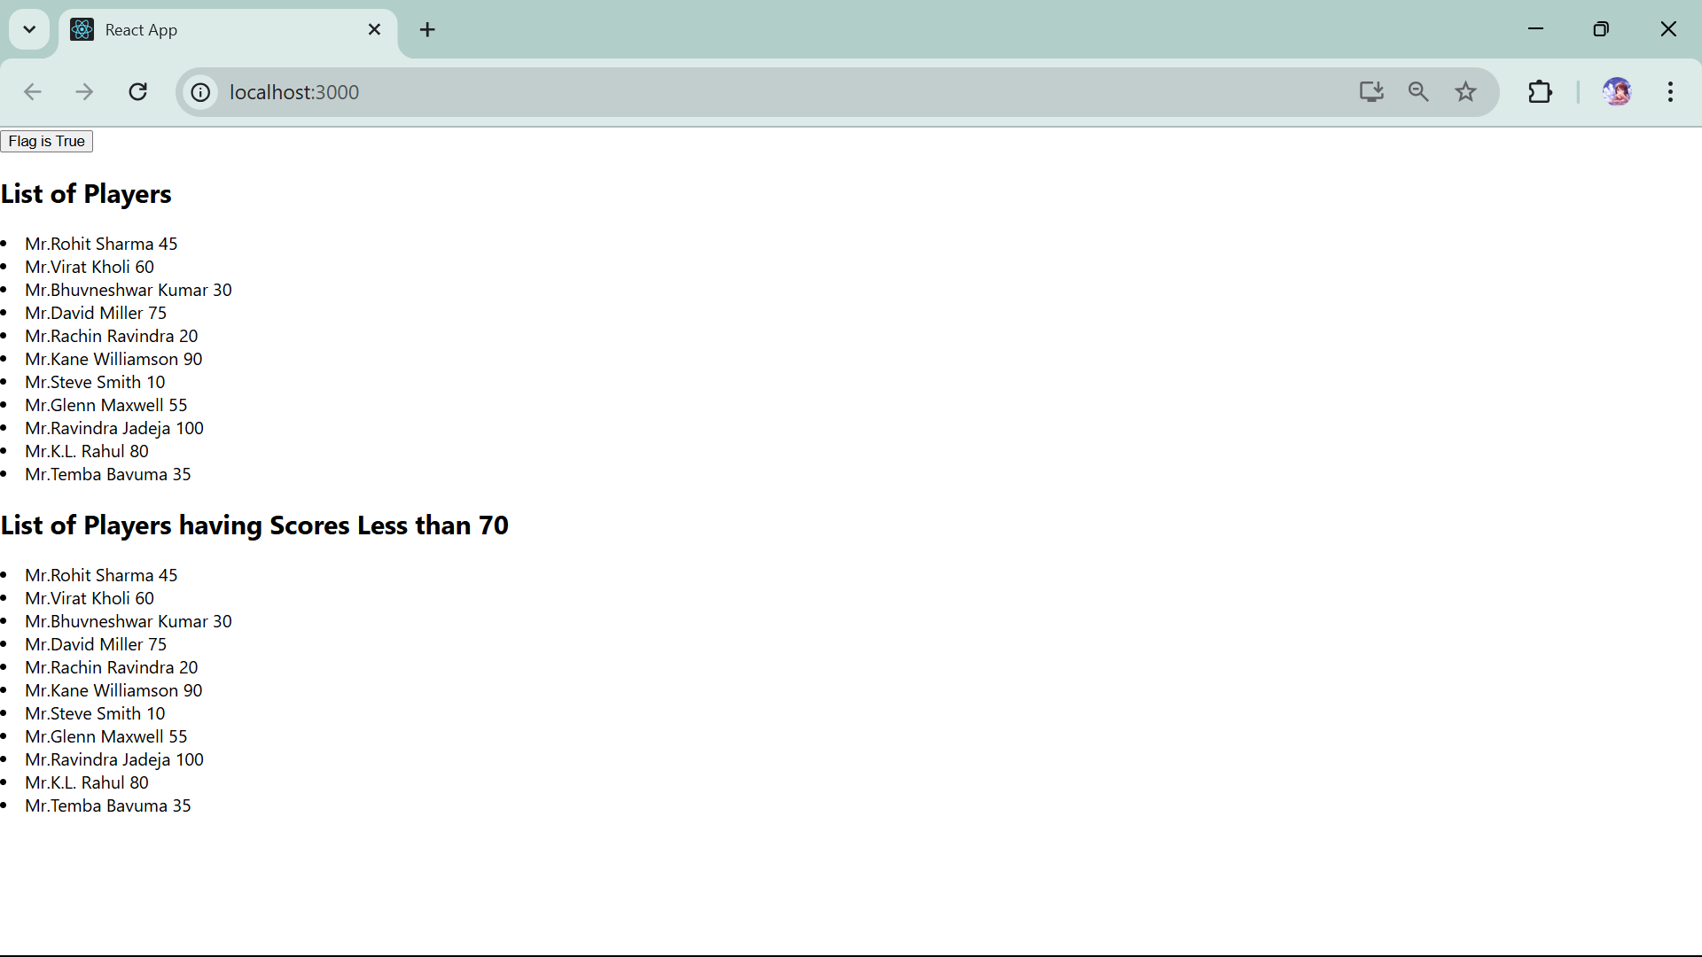

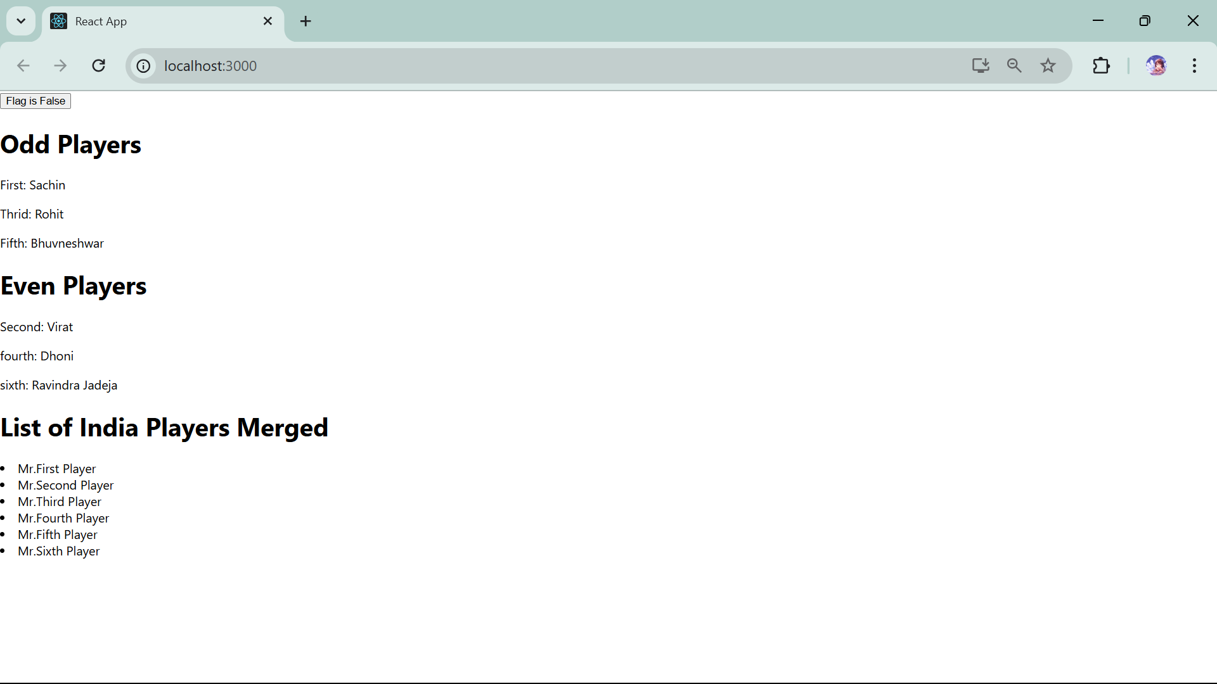

**10.ReactJS-HOL**

**// officespacerentalapp**

**//App.js**

import logo from './logo.svg';

import './App.css';

import Image from './components/Image';

function App() {

  return (

  <>

  <Image/>

  </>

  );

}

export default App;

**//Image.js**-> here we have used static files for image that is stored inside public-> assests->images->office.jpeg

import React from 'react';

const headingElement="Office Space , at Affordable";

const office=[

    {

    name: "Downtown Suite",

    rent: 55000,

    address: "123 Main St, City Center",

    image:"./assests/images/office.jpeg",

  },

  {

    name: "Riverside Workspace",

    rent: 75000,

    address: "456 River Rd, Waterfront",

    image:"./assests/images/download.jpeg",

  },

  {

    name: "Tech Hub Office",

    rent: 62000,

    address: "789 Innovation Dr, Silicon Park",

    image:"./assests/images/office.jpeg",

  },

  {

    name: "Suburban Corner",

    rent: 48000,

    address: "321 Oak Lane, Greenfield",

    image:"./assests/images/download.jpeg",

  },

]

const imageStyle={

    width:"25%",

    height:"25%"

}

const myStyle={

    textAlign:"center",

    color:"black",

    borderBottom: '1px solid',

    padding:"20px"

}

export default function Image(){

return(

        <>

            <h1 style={myStyle}>{headingElement}</h1>

            {office.map((items)=>

            <div style={myStyle}>

            <img src={items.image} style={imageStyle} alt="Office Space"/>

            <h1>Name : {items.name}</h1>

            <h2 style={{ color: items.rent<60000 ? 'red' : 'green'}}>Rent : {items.rent}</h2>

            <h3>Address : {items.address}</h3>

            </div> )}

        </>)}

**OUTPUT**

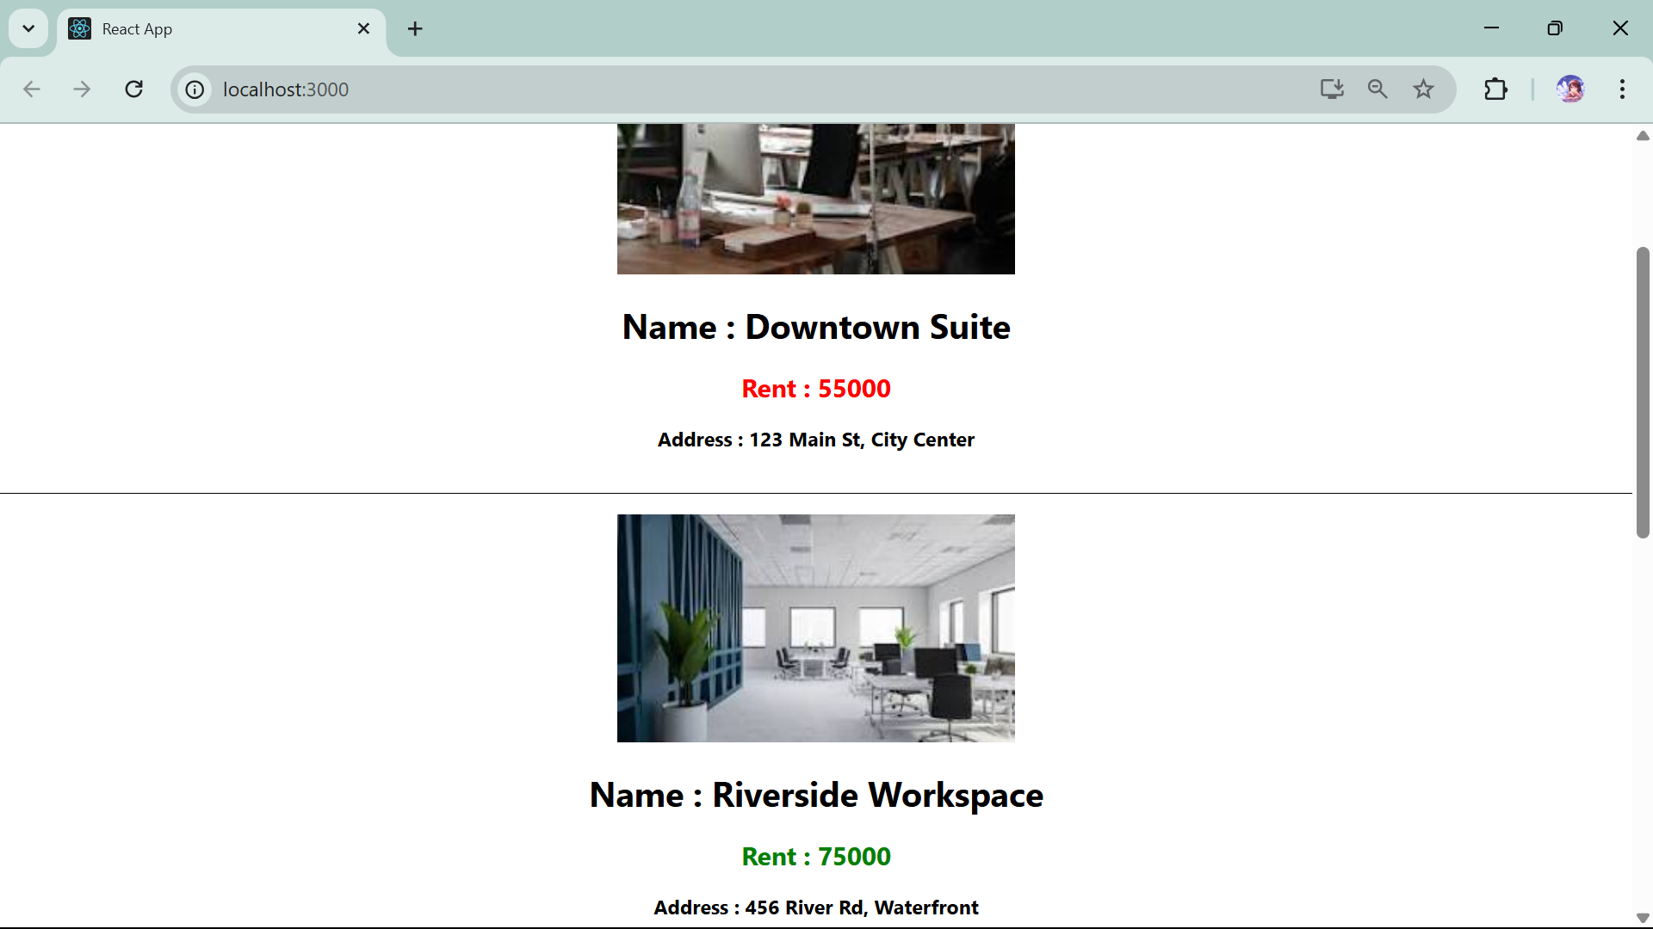

**11.ReactJS-HOL**

**// eventexampleapp**

**//App.js**

import logo from './logo.svg';

import './App.css';

import { useState } from 'react';

import CurrencyConvertor from './components/CurrencyConvertor';

function App() {

  const increment=()=>{

  alert("Hi")

  setCounter(counter+1)

}

const decrement=()=>{

  setCounter(counter-1)

}

const greeting=(message)=>{

  alert(message);

}

const clicked=(event)=>{

  alert("I was clicked");

}

const [counter,setCounter]=useState(0);

  return (

    <>

    <p>Counter : {counter}</p>

    <button onClick={increment}>increment</button>

    <button onClick={decrement}>decrement</button>

    <button onClick={() => greeting("Welcome")}>Say Welcome</button>

    <button onClick={clicked}>OnPress</button>

    <CurrencyConvertor title="Currency Converter"/>

    </>);

}

export default App;

**//CurrencyConvertor.js**

import React, { useState } from 'react';

export default function CurrencyConvertor(props){

    const convertToEuro=()=>{

    if(amount.currency.toUpperCase()==="INR")

    { var new_amt=amount.amt*0.0100;

        amount.amt=new_amt;

        alert("Converting to Euro : "+ new_amt)

        setAmount({amt:0,currency:"INR"});

    }

    else if(amount.currency.toUpperCase()==="EURO"){

        var new_amt=amount.amt*101.01;

        amount.amt=new_amt;

        alert("Converting to Indian Ruppee " + new_amt);

        setAmount({amt:0,currency:"INR"});

    }

    else{

        alert("Invalid Request!");

    }

}

const handleOnChange=(event)=>{

        const { name, value } = event.target;

        setAmount((prev) => ({

            ...prev,

      [name]: value,

    }));

    }

    const [amount,setAmount]=useState({

        amt:0,

        currency:"INR",

    });

    return( <>

        <h1>{props.title}</h1>

        <label>Amount</label>

        <input type="text" name="amt" onChange={handleOnChange} value={amount.amt}/>

        <label>Currency</label>

        <input type="text" name="currency" onChange={handleOnChange} value={amount.currency} />

        <button onClick={convertToEuro}>Convert</button></>

    ) }

//OUTPUT

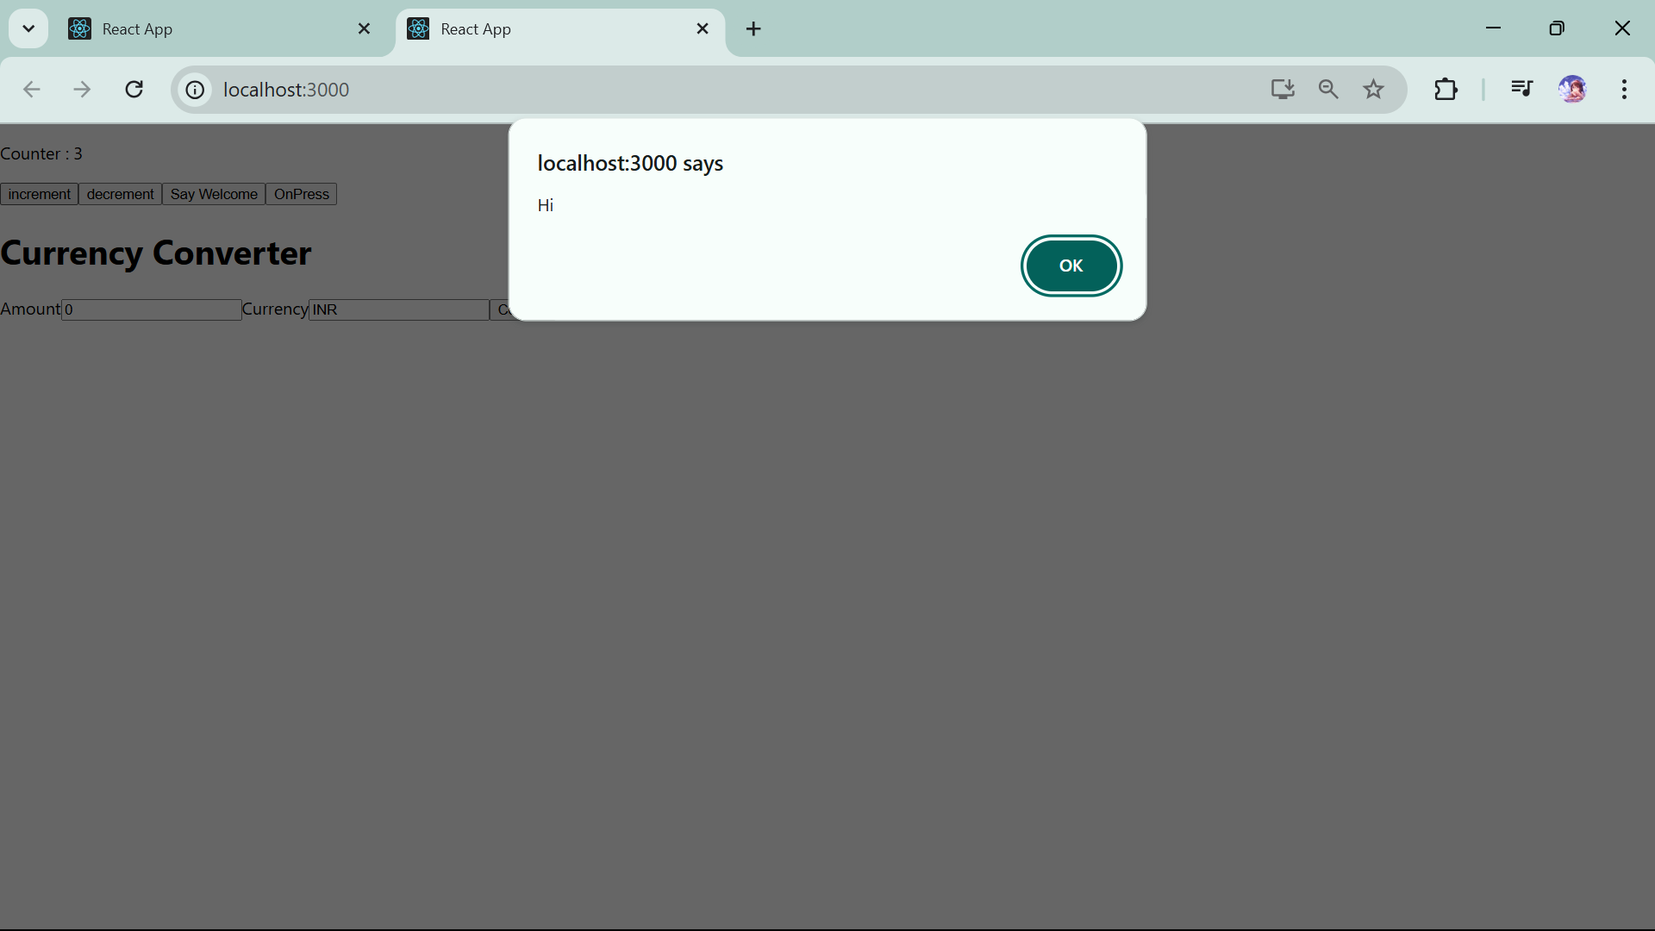

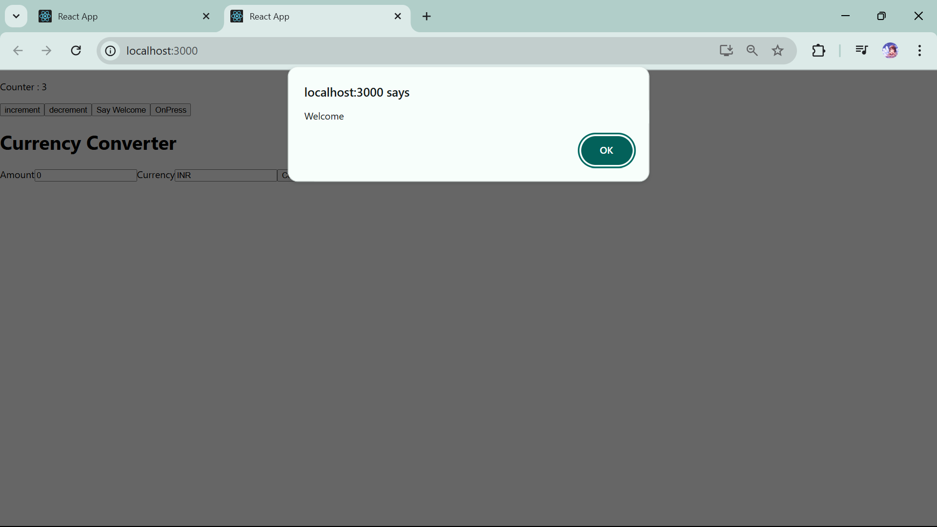

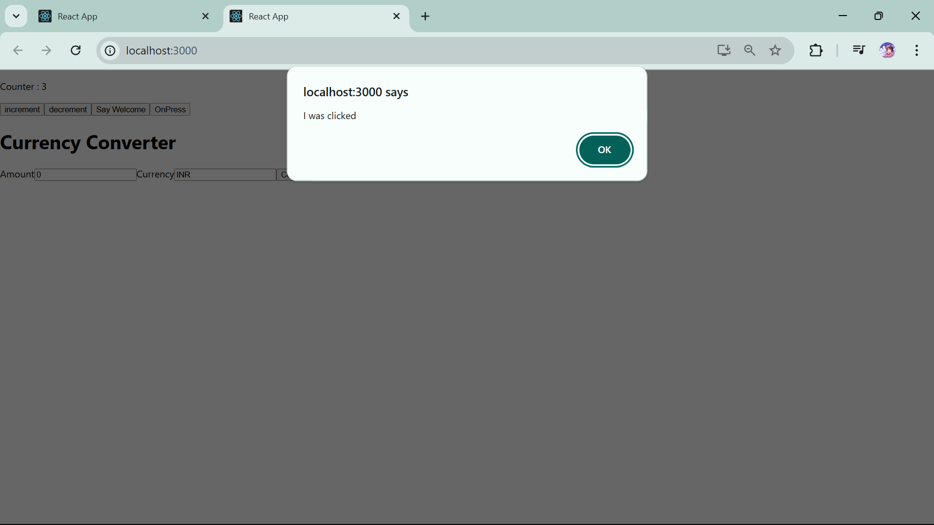

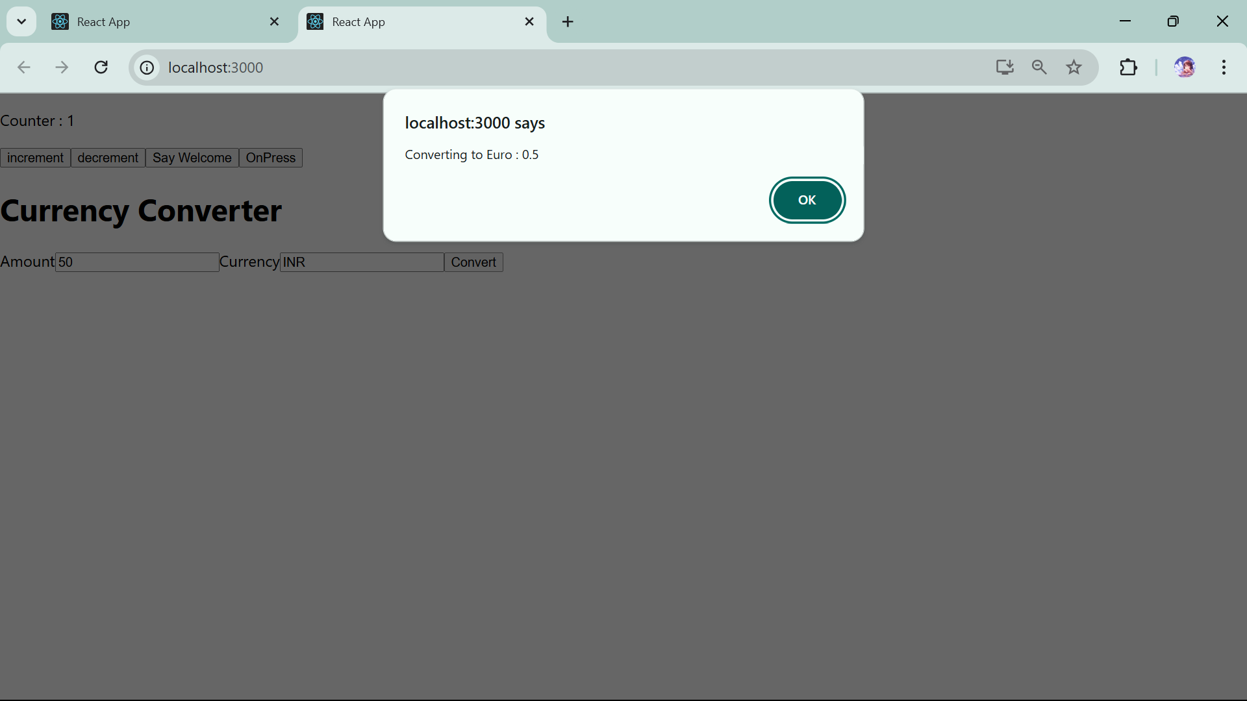

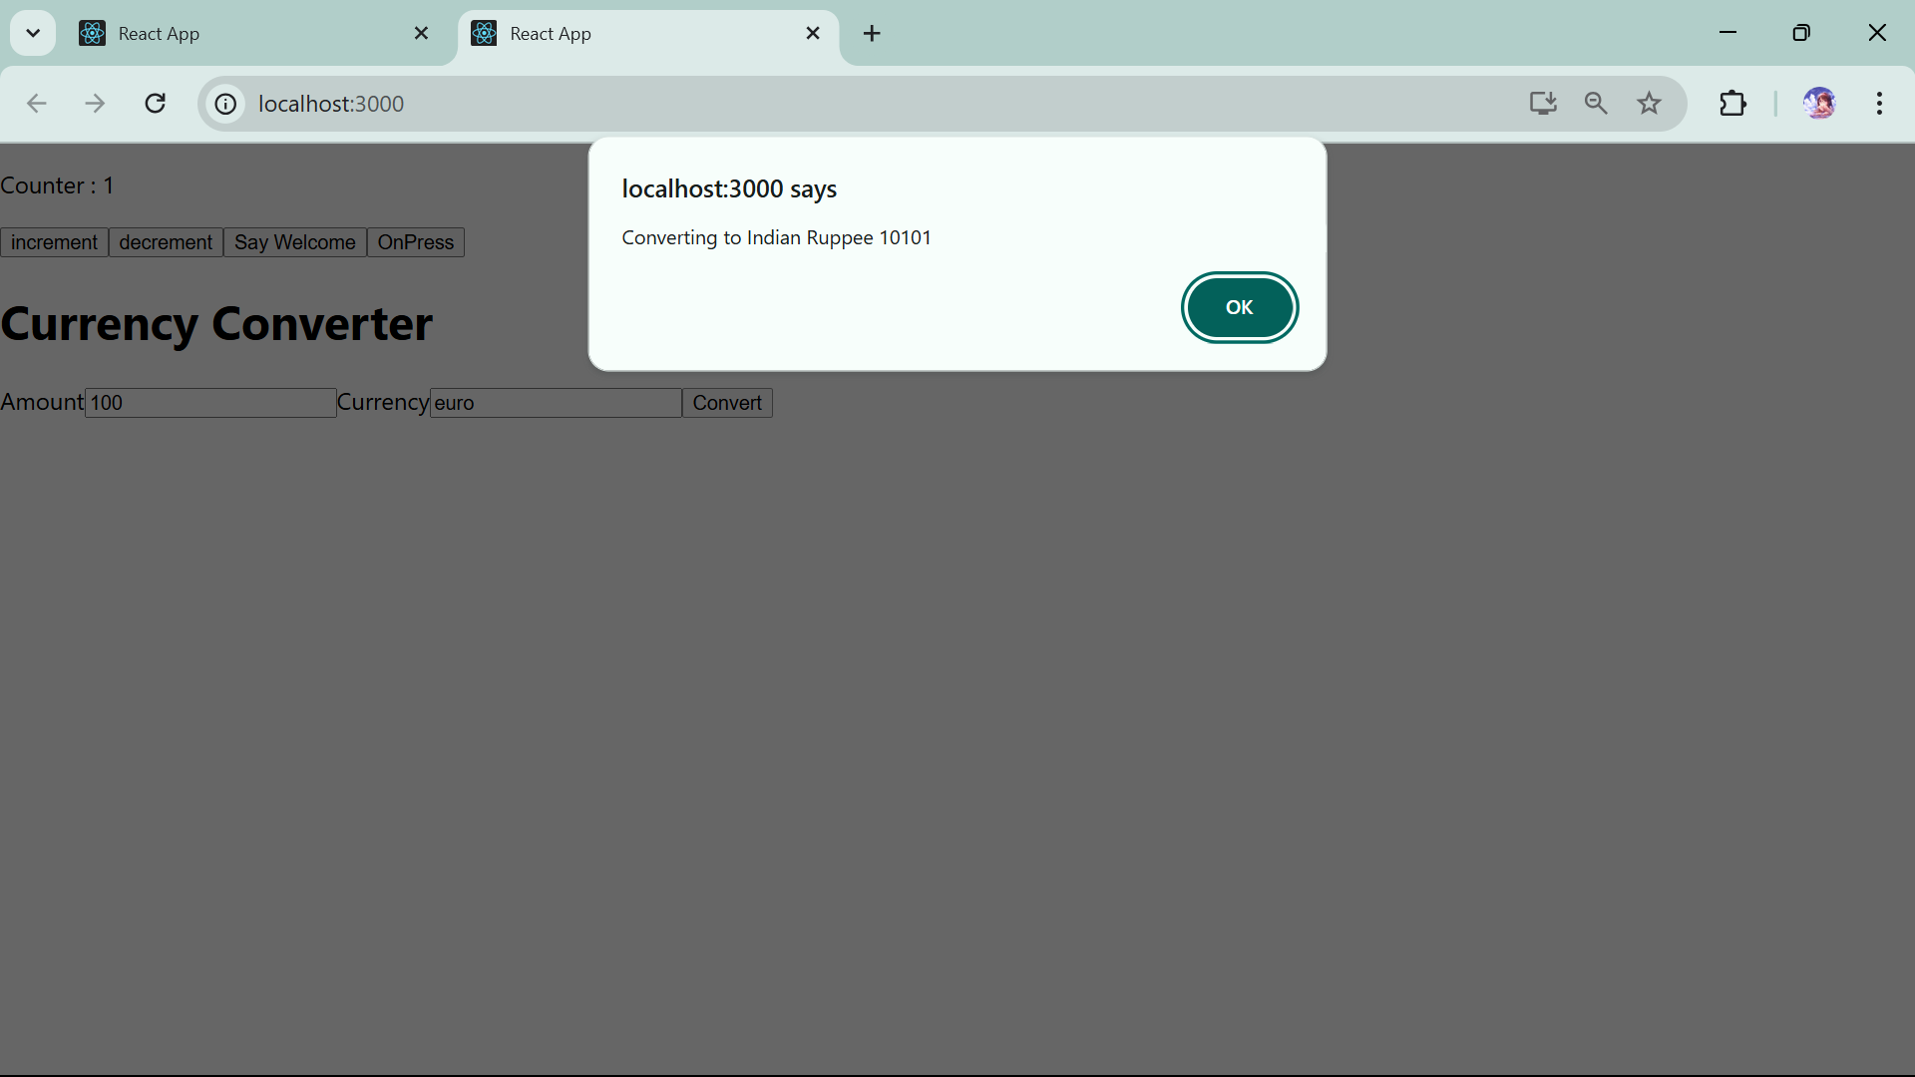

**12.ReactJS-HOL**

**// ticketbookingapp**

**//** **GuestGreetings.js** in components folder

import React from 'react';

export default function GuestGreetings(props){

    return(

        <div style={{textAlign:"center"}}>

        <h1>Guest Page</h1>

        <p>You can only see flights details here but for booking tickets please login first!</p>

        </div>

    );

}

**//** **UserGreetings.js** in components folder

import React from 'react';

export default function UserGreetings(props){

return(

    <div style={{textAlign:"center"}}>

    <h1>Welcome User</h1>

    <p>Here You can book flights tickets and can access many more functionality!</p>

    </div>

)

}

**//App.js**

import logo from './logo.svg';

import './App.css';

import UserGreetings from './components/UserGreetings';

import GuestGreetings from './components/GuestGreetings';

import { useState } from 'react';

function App() {

  const handleLogin=()=>{

    setStatus(true);

  }

  const handleLogout=()=>{

    setStatus(false);

  }

  const [isLoggedIn,setStatus]=useState(false);

  {if(isLoggedIn===true){

    return (

      <>

      <UserGreetings/>

      <button onClick={handleLogout} style={{display: "block", margin: "0 auto"  }}>Logout</button>

      </> )}

  else{

  return(<>

  <GuestGreetings/>

  <button onClick={handleLogin} style={{display: "block", margin: "0 auto" }}>Login</button>

  </> )

  }}}

export default App;

**OUTPUT**

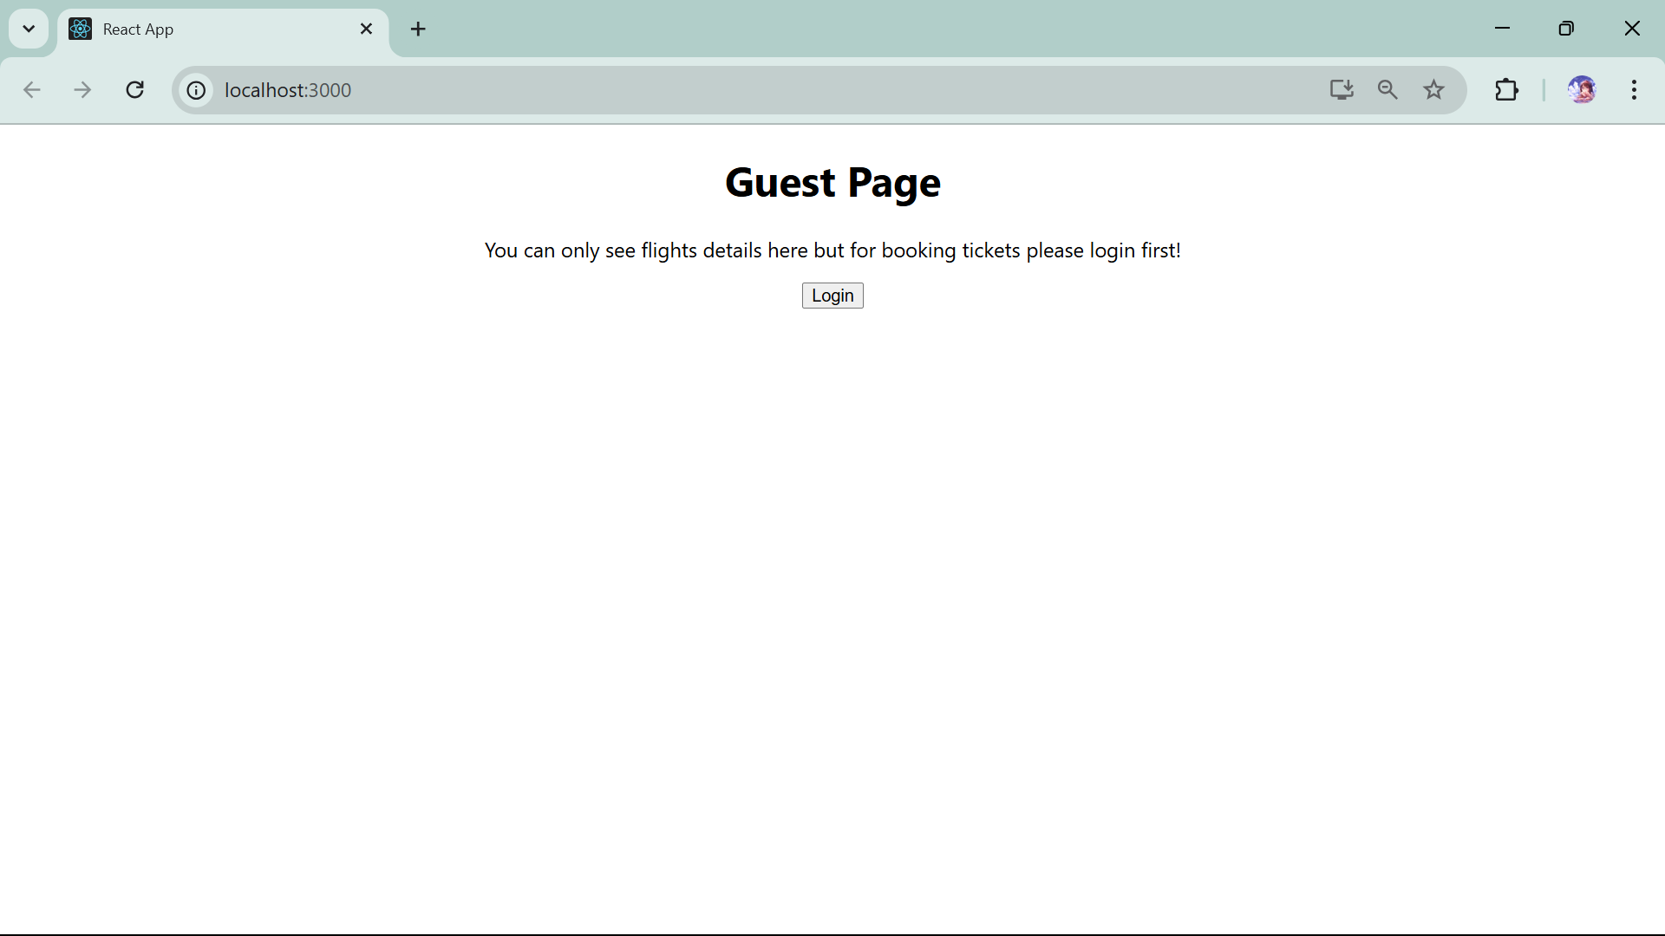

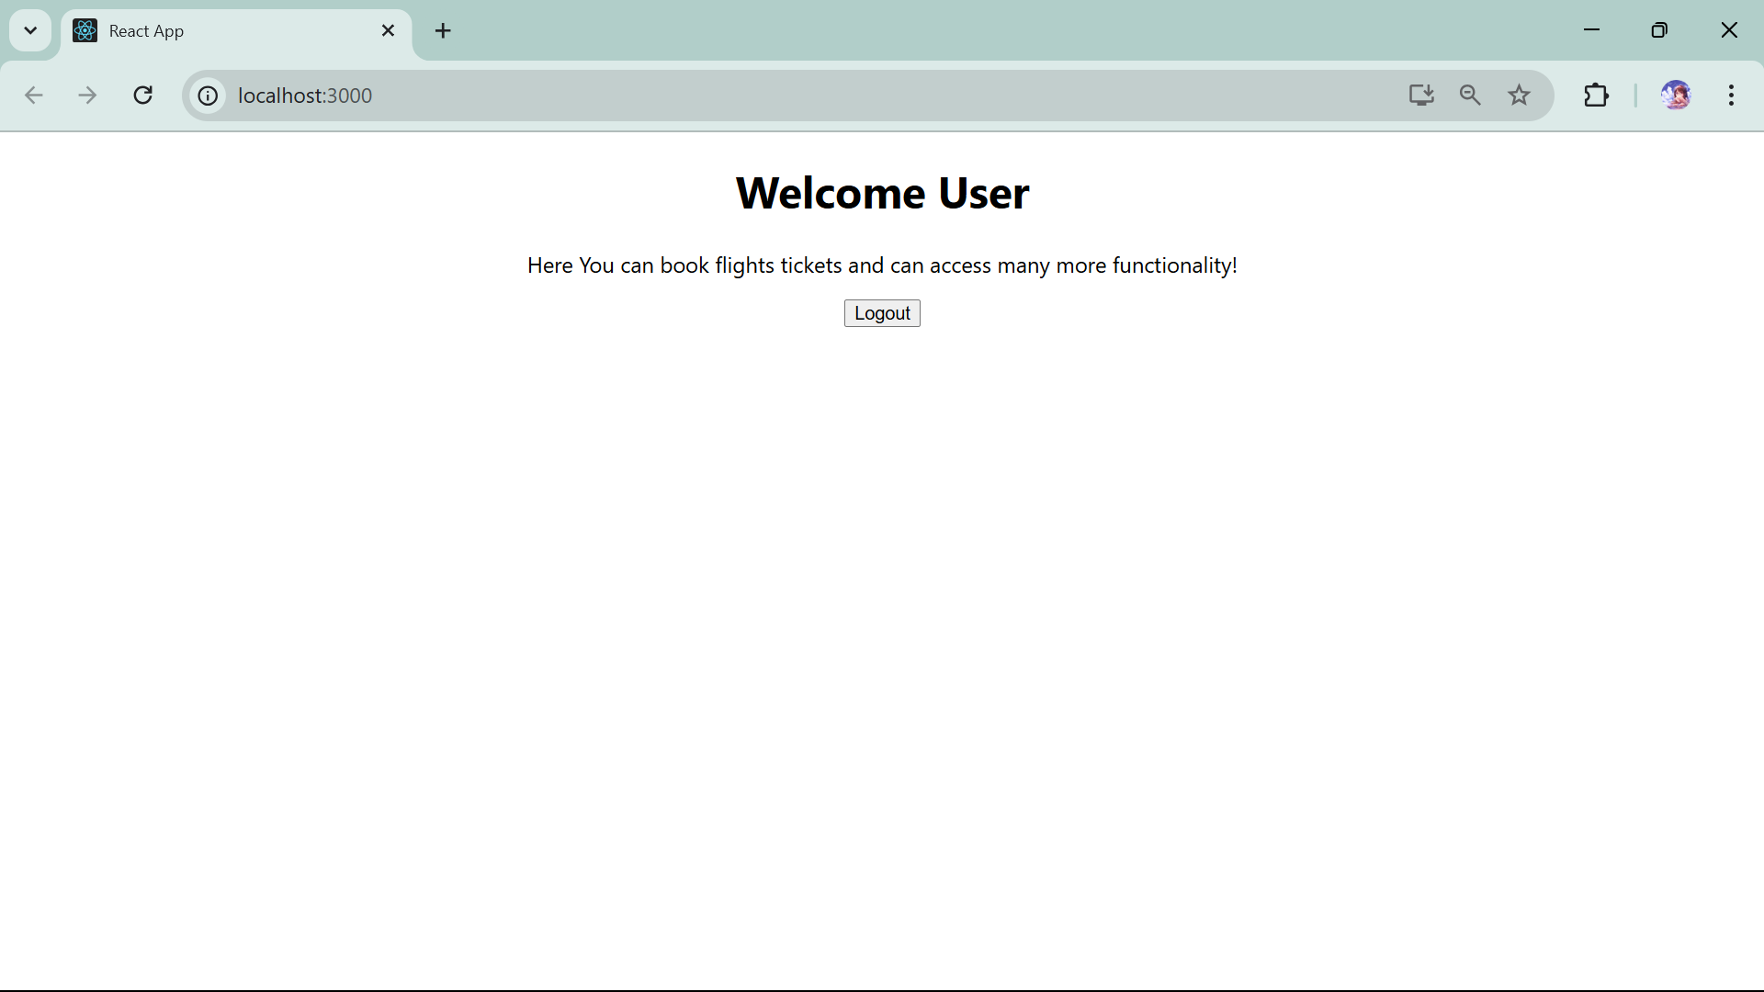

**13.ReactJS-HOL**

**//bloggerapp**

**//App.js**

import logo from './logo.svg';

import './App.css';

import BookDetails from './compnents/BookDetails';

import BlogDetails from './compnents/BlogDetails';

import CourseDetails from './compnents/CourseDetails';

import { useState } from 'react';

function App() {

  const handleBook=()=>{

    setChoice("book");

  }

  const handleBlog=()=>{

    setChoice("blog");

  }

  const handleCourse=()=>{

    setChoice("course");

  }

  const handleAll=()=>{

    setChoice("all");

  }

  const [userChoice,setChoice]=useState("book");

  {if(userChoice==="book"){

    return (<>

      <button onClick={handleBlog} >Blog</button>

      <button onClick={handleCourse} >Course</button>

      <button onClick={handleAll} >All</button>

      <BookDetails/>

      </> )

  }

  else if(userChoice==="course"){

  return( <>

  <button onClick={handleBook} >Book</button>

  <button onClick={handleBlog}>Blog</button>

  <button onClick={handleAll}>All</button>

  <CourseDetails/>

  </>

  )

  }

  else if(userChoice==="blog"){

  return( <>

  <button onClick={handleBook} >Book</button>

  <button onClick={handleCourse} >Course</button>

  <button onClick={handleAll} >All</button>

  <BlogDetails/>

  </>

  ) }

  else{

  return(

  <>

  <button onClick={handleBook} >Book</button>

  <button onClick={handleBlog} >Blog</button>

  <button onClick={handleCourse} >Course</button>

  <BookDetails/>

  <BlogDetails/>

  <CourseDetails/>

  </>

  )

  }

}    }

export default App;

**//CourseDetails.js**

import React from 'react';

const courseDetails=[{

        courseName:"React",

        date:"02/08/2025",

    },

{

        courseName:"Python",

        date:"25/12/2025",

    },

{

        courseName:"Java",

        date:"21/09/2025",

    }]

const myStyle={

    textAlign:"center",

    borderBottom: '2px solid black',

    padding:"5px"}

export default function CourseDetails(){

    return(<>

    <h1 style={myStyle}>Course Details</h1>

    {courseDetails.map((items)=>{

    return(

        <div style={myStyle}>

        <h2>Course Name: {items.courseName}</h2>

        <p>Date: {items.date}</p>

        </div>

    )})}</>)

}

**//BookDetails.js**

import React from 'react';

const bookDetails=[{

        bookName:"React",

        price:"1000",

    },

{

        bookName:"Python",

        price:"2000",

    },

{

        bookName:"Java",

        price:"2200",

    }]

const myStyle={

    textAlign:"center",

    borderBottom: '2px solid black',

    padding:"5px"

}

export default function BookDetails(){

    return(

        <><h1 style={myStyle}>Book Details</h1>

        {bookDetails.map((items)=>{

            return(

                <div style={myStyle}>

                <h2>Book Name: {items.bookName}</h2>

                <p>Price: {items.price}</p>

                </div>

            )

        })}

        </>

)}

//BlogDetails.js

import React from 'react';

const blogDetails=[{

        blog:"React Learning",

        name:"Stephen Biz",

        description:"Welcome to react learning."

    },

{

        blog:"Python Learning",

        name:"Angela Yu",

        description:"Welcome to 100 days of Python learning."

    },

{

        blog:"Installation",

        name:"Jonathan",

        description:"You can use npm to install react."

    }]

const myStyle={

    textAlign:"center",

    borderBottom: '2px solid black',

    padding:"5px"

}

export default function BlogDetails(){

    return(

        <div>

        <h1 style={myStyle}>Blog Details</h1>

        {blogDetails.map((items)=>{

        return(

            <>

            <div style={myStyle}>

            <h2>{items.blog}</h2>

            <h3>Name: {items.name}</h3>

            <h4>Description: {items.description}</h4>

            </div>

            </>

        )})}

        </div>)

}

**OUTPUT**

