信 息 工 程 学 院
Computer Graphics 实习报告
学院:信息工程学院 | 班级:软件工程092 | 姓名:邱海森 | 学号:2009012983 | 成绩:
一、实习题目 :
二、实习过程
1.为屏幕显示定义一个坐标系统：
void init (void)
{
glClearColor (1.0, 1.0, 1.0, 0.0); // Set display-window color to white.
glMatrixMode (GL_PROJECTION); // Set projection parameters.
gluOrtho2D (0.0, 200.0, 0.0, 150.0);
}
- 熟悉绘点函数，并完成课件上的几个例子：
在实验一中已经体现了画点的函数glBegin (GL_POINTS);****glEnd(); 应用方法，所以这里不再详细指出。
3.熟悉画线方法，并熟悉不同的画线状态，并上机实习课件上的几个画线函数的例子；
glBegin (GL_LINES);
glBegin (GL_LINE_STRIP);
glBegin (GL_LINE_LOOP);
上面的三种画线方法也是在实验一中已经用到过的，这里只是指出其使用的方法。
- 在模板中添加代码，实现DDA法和Bresenham法绘制直线图元”
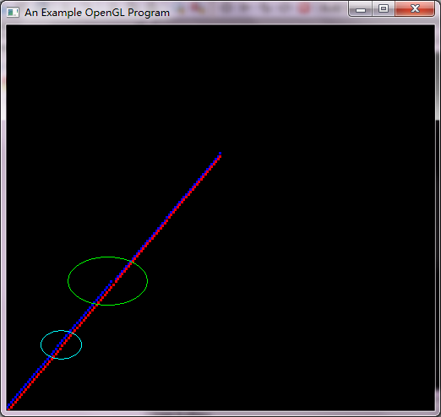
其中蓝色的线为DDA算法画出来的线，而红色为Bresenham法画出的线，我们从图中可以看出，绿色圈出来的地方，DDA算法明显有所跳跃的现象，在浅蓝色圈出来的地方，Bresenham法画的线也有一点间隔，但是总体来看还是红色线代表的Bresenham效果比较好一点。
【注】代码如下程序段，其中void lineBres(int x0,int y0,int xEnd,int yEnd)为Bresenham算法画线，void lineDDA(int x0,int y0,int xEnd,int yEnd)为DDA画线算法：
#include<windows.h>

#ifdef __APPLE__
#include <GLUT/glut.h>
#else
#include <GL/glut.h>
#endif

#include<stdio.h>
#include<stdlib.h>
#include<math.h>

void init (void)
{
glClearColor (1.0, 1.0, 1.0, 0.0); // Set display-window color to white.
glMatrixMode (GL_PROJECTION); // Set projection parameters.
gluOrtho2D (0.0, 200.0, 0.0, 150.0);
}

int round(const float a)
{
return (int)(a+0.5);
}

void lineDDA(int x0,int y0,int xEnd,int yEnd)
{
glColor3f(0.0,0.0,1.0);
glPointSize(3.0f);
int dx = xEnd - x0;
int dy = yEnd - y0;
int steps,k;
float xIncrement,yIncrement,x = x0,y = y0;

if(fabs (dx) > fabs(dy))
steps = fabs(dy);
else
steps = fabs(dx);
xIncrement = (float)(dx)/(float)(steps);
yIncrement = (float)(dy)/(float)(steps);

glBegin(GL_POINTS);
glVertex2i(round(x),round(y));
glEnd();
glFlush();
for (k=0;k<steps;k++)
{
x += xIncrement;
y += yIncrement;
glBegin(GL_POINTS);
glVertex2i(round(x),round(y));
glEnd();
glFlush();
}
}

void lineBres(int x0,int y0,int xEnd,int yEnd)
{
glColor3f(1.0,0.0,0.0);
glPointSize(3.0f);
int dx = fabs(xEnd - x0);
int dy = fabs(yEnd - y0);
int p = 2*dy-dy;
int twoDy = 2*dy,twoDyMinusDx = 2*(dy - dx);
int x,y;

if (x0>xEnd)
{
x = xEnd;
y = yEnd;
xEnd = x0;
}
else
{
x = x0;
y = y0;
}

glBegin(GL_POINTS);
glVertex2i(x,y);
glEnd();
glFlush();

while(x < xEnd)
{
x++;
if (p < 0)
p += twoDy;
else
{
y++;
p += twoDyMinusDx;
}
glBegin(GL_POINTS);
glVertex2i(x,y);
glEnd();
glFlush();
}
}

void pointFun(void)
{
int x0 = 0,y0 = 0,xEnd = 100,yEnd = 100;
//scanf("%d%d%d%d",&x0,&y0,&xEnd,&yEnd);
lineDDA(x0,y0+1,xEnd,yEnd);//调用DDA画线函数
lineBres(x0+1,y0,xEnd,yEnd);//调用Bresenham画线函数
}

int main (int argc, char** argv)
{

glutInit (&argc, argv); // Initialize GLUT.
glutInitDisplayMode (GLUT_SINGLE | GLUT_RGB); // Set display mode.
glutInitWindowPosition (50, 100); // Set top-left display-window position.
glutInitWindowSize (800, 600); // Set display-window width and height.
//glutFullScreen();
glutCreateWindow ("An Example OpenGL Program"); // Create display window.
init(); // Execute initialization procedure.
glutDisplayFunc (pointFun); // Send graphics to display window.
glutMainLoop ( );// Send graphics to display window. // Display everything and wait.
return 0;
}
- 实现Bresenham法绘制圆图元：
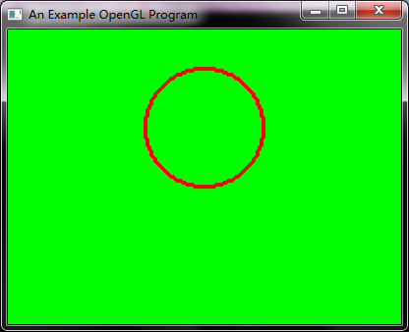
圆方程为非线性的，计算像素与圆的距离必须进行平方运算，Bresenham画圆方法则通过比较像素与圆的距离的方法而避免了平方根运算。
然而，不做平方运算而直接比较距离是可能得。该方法的基本思想是检验两像素间的中间位置以确定该中点是在圆边界值内还是之外。
【注】算法代码如下，其中void circleBresham(GLint xc,GLint yc,GLint radius)为用Bresenham算法画圆的算法，而其中void circleMidpoint(GLint xc,GLint yc,GLint radius)为中点画圆的算法：
#include<windows.h>
#include<math.h>

#ifdef __APPLE__
#include <GLUT/glut.h>
#else
#include <GL/glut.h>
#endif

#include <stdlib.h>

void init (void)
{
glClearColor(0.0, 1.0, 0.0, 0.0); // Set display-window color to white.
glMatrixMode (GL_PROJECTION); // Set projection parameters.
gluOrtho2D (0.0, 200.0, 0.0, 150.0);
}

class screenPt
{
private:
GLint x,y;
public:
screenPt(){
x = y =0;
}
void setCoords(GLint xCoordValue,GLint yCoordValue){
x = xCoordValue;
y = yCoordValue;
}

GLint getx() const
{
return x;
}
GLint gety() const
{
return y;
}
void incrementx()
{
x ++;
}
void decrementy()
{
y--;
}
};

void setPixel(GLint xCoord,GLint yCoord)
{
glBegin(GL_POINTS);
glVertex2i(xCoord,yCoord);
glEnd();
//glFlush();
}

void circleMidpoint(GLint xc,GLint yc,GLint radius)
{
glColor3f(1.0,0.0,0.0);
screenPt circPt;
GLint p = 1 - radius;

circPt.setCoords(0,radius);

void circlePlotPoints(GLint,GLint,screenPt);

circlePlotPoints(xc,yc,circPt);

while(circPt.getx()< circPt.gety())
{
circPt.incrementx();
if (p<0){
p += 2*circPt.getx() + 1;
}
else{
circPt.decrementy();
p += 2*(circPt.getx() - circPt.gety()) + 1;
}
circlePlotPoints(xc,yc,circPt);
}
}

void circleBresham(GLint xc,GLint yc,GLint radius)
{
glColor3f(1.0,0.0,0.0);
screenPt circPt;
//GLint p = 1 - radius;

circPt.setCoords(0,radius);

void circlePlotPoints(GLint,GLint,screenPt);

circlePlotPoints(xc,yc,circPt);

while(circPt.getx()< circPt.gety())
{
GLint x1,x2,y1,y2;
circPt.incrementx();
x1 = circPt.getx();
y1 = circPt.gety();
x2 = circPt.getx();
y2 = circPt.gety()-1;
//if ((x1*x1+y1*y1-radius*radius)<(x2*x2+y2*y2-radius*radius)){

//}
if (fabs(x1*x1+y1*y1-radius*radius)>fabs(x2*x2+y2*y2-radius*radius)){
circPt.decrementy();
// p += 2*(circPt.getx() - circPt.gety()) + 1;
}
circlePlotPoints(xc,yc,circPt);
}
}

void circlePlotPoints(GLint xc,GLint yc,screenPt circPt)
{
setPixel(xc + circPt.getx(),yc + circPt.gety());
setPixel(xc - circPt.getx(),yc + circPt.gety());
setPixel(xc + circPt.getx(),yc - circPt.gety());
setPixel(xc - circPt.getx(),yc - circPt.gety());
setPixel(xc + circPt.gety(),yc + circPt.getx());
setPixel(xc - circPt.gety(),yc + circPt.getx());
setPixel(xc + circPt.gety(),yc - circPt.getx());
setPixel(xc - circPt.gety(),yc - circPt.getx());
}

void pointsFun(void)
{
glPointSize(3.0);
glEnable(GL_POINT_SMOOTH);
glClear(GL_COLOR_BUFFER_BIT);
circleBresham(100,100,30);
glFlush();
}

int main (int argc, char** argv)
{

glutInit (&argc, argv); // Initialize GLUT.
glutInitDisplayMode (GLUT_SINGLE | GLUT_RGB); // Set display mode.
glutInitWindowPosition (50, 100); // Set top-left display-window position.
glutInitWindowSize (400, 300); // Set display-window width and height.
glutCreateWindow ("An Example OpenGL Program"); // Create display window.

init(); // Execute initialization procedure.
glutDisplayFunc (pointsFun); // Send graphics to display window.
glutMainLoop ( );// Send graphics to display window. // Display everything and wait.
return 0;
}
- 顶点阵列和象素阵列绘制图元的方法，用顶点阵列绘制一个长方体，并设置表面颜色：
三种不同面填充模式显示出不同的效果，如下面三幅截图：
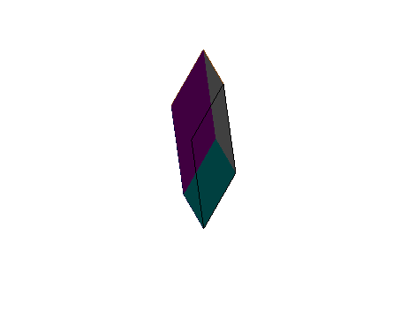
上图通过glPolygonMode(GL_FRONT, GL_LINE);函数的调用，实现了显示前面面上的边线，而下面的面显示为默认的面填充，显示效果为如上图。
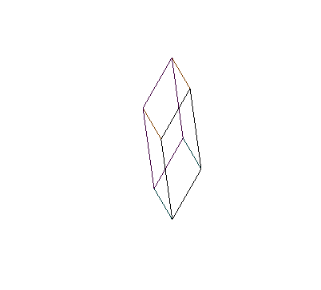
上图通过glPolygonMode(GL_FRONT_AND_BACK, GL_LINE);函数的调用，实现了显示前后面面上的边线，显示效果就是图中的的只显示边线，而没有面填充效果。
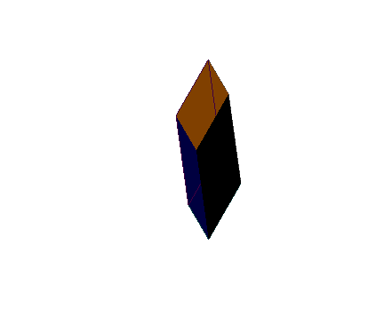
上图通过glPolygonMode(GL_BACK, GL_LINE);函数的调用，实现了显示后面面上的边线，而下面的面显示为默认的面填充，显示效果为如上图。
【注】算法代码如下，其中void quad(GLint n1,GLint n2,GLint n3,GLint n4,GLint index)为画立方体的算法：
#include<windows.h>
#include<math.h>

#ifdef __APPLE__
#include <GLUT/glut.h>
#else
#include <GL/glut.h>
#endif

#include <stdlib.h>

void init(void)
{
glClearColor(1.0,1.0,1.0,0.0);
glMatrixMode(GL_MODELVIEW);//设置当前矩阵模式为视图模型矩阵
glLoadIdentity();
//设置视点的位置，视线的方向和相机的向上方向
gluLookAt(0,0,0, 0,0,-1, 0,1,0); //该设置为默认设置
glScalef(0.3,1.0,0.5); //产生比例变换，分别设置物体在x，y，z方向上缩放因子，根据需要自己可以设置
glRotatef(45,1.0,1.0,1.0);//产生旋转变换，让物体绕（1，1，1）轴旋转45度
glMatrixMode(GL_PROJECTION);//设置当前矩阵模式为投影矩阵
glFrustum(-4,4,-4,4,0,20);////设置场景投影时的可视范围
}
float points[8][3] = {{0,0,0},{0,0.5,0},{0.5,0,0},{0.5,0.5,0},{0,0,0.5},{0,0.5,0.5},{0.5,0,0.5},{0.5,0.5,0.5}};
float colors[6][3] = {{0.25,0,0},{0.25,0.25,0.25},{0,0,0.25},{0.5,0.25,0},{0,0.25,0.25},{0.25,0,0.25}};

void vertexArray(void)
{
glClear(GL_COLOR_BUFFER_BIT);
// glColor3f(1.0,1.0,0.0);
//glPolygonMode(GL_FRONT, GL_LINE);// 设置多边形的显示模式为面填充模式，该设置也是默认设置
glFrontFace(GL_CCW); //设置前面的面的模式为逆时针模式， 该设置也是默认设置
//glShadeModel(GL_SHADE_MODEL);// 默认就是此参数，可忽略，为了明确说明特意指定
/* 指定顶点数组数据和颜色数组，定义顶点的索引数组,并用顶点的索引数组绘制图元*/
/*取消顶点数组和颜色数组*/
void quad(GLint n1,GLint n2,GLint n3,GLint n4,GLint index);
quad(6,2,3,7,1);
quad(5,1,0,4,2);
quad(7,3,1,5,3);
quad(4,0,2,6,4);
quad(2,0,1,3,5);
quad(7,5,4,6,6);
glFlush();
}

void quad(GLint n1,GLint n2,GLint n3,GLint n4,GLint index)
{
glColor3f(0.0,1.0,0.0);
glEnable(GL_POLYGON_OFFSET_FILL);
glPolygonOffset(1.0,1.0);
glDisable(GL_POLYGON_OFFSET_FILL);
glColor3f(colors[index][0],colors[index][1],colors[index][2]);
//glPolygonMode(GL_FRONT_AND_BACK, GL_LINE);
//glPolygonMode(GL_FRONT, GL_LINE);
glPolygonMode(GL_BACK, GL_LINE);
//glColor3f(1.0,1.0,0);
glBegin(GL_QUADS);
glVertex3fv(points[n1]);
glVertex3fv(points[n2]);
glVertex3fv(points[n3]);
glVertex3fv(points[n4]);
glEnd();
}

int main (int argc, char** argv)
{

glutInit (&argc, argv); // Initialize GLUT.
glutInitDisplayMode (GLUT_SINGLE | GLUT_RGB); // Set display mode.
glutInitWindowPosition (50, 100); // Set top-left display-window position.
glutInitWindowSize (600, 500); // Set display-window width and height.
glutCreateWindow ("An Example OpenGL Program"); // Create display window.
init(); // Execute initialization procedure.
glutDisplayFunc (vertexArray); // Send graphics to display window.
glutMainLoop ( );// Send graphics to display window. // Display everything and wait.
return 0;
}
- 理解字符的存储和显示原理，掌握OpenGL的2种字符生成方法，并分别生成不同大小和风格的字符:
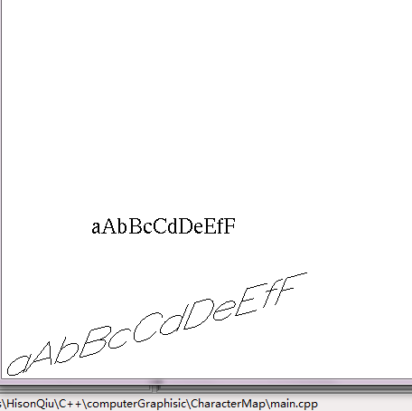
【注】算法代码如下，其中void CharMap(void)为绘制字符的算法，其中的函数段实现了两种绘制字符的不同方法，其中：
glColor3f(0.0,0.0,0.0);
char text[] = {'a','A','b','B','c','C','d','D','e','E','f','F'};
glRasterPos2i(20,40);
for (int k=0;k<12;k++){
glutBitmapCharacter(GLUT_BITMAP_TIMES_ROMAN_24,text[k]);
//glutBitmapCharacter(GLUT_BITMAP_8_BY_13,text[k]);
}为绘制位图的算法，其中的glutBitmapCharacter为绘制位图的库函数，其中的第一个参数为常量，指代要绘制的字体和大小，第二个参数为要绘制的字符数组。
下面的代码段实现了上图中显示的下方比较大的且有旋转的字体：
glScalef(0.1,0.1,0.0);//控制了字体的缩放
glRotatef(300,20.0,20.0,0.0);//控制了字体的旋转
glRasterPos2i(20,40);//控制显示位置
for (int k=0;k<12;k++){
glutStrokeCharacter(GLUT_STROKE_ROMAN,text[k]);
//glutBitmapCharacter(GLUT_BITMAP_8_BY_13,text[k]);
}
源代码如下：
#include<windows.h>

#ifdef __APPLE__
#include <GLUT/glut.h>
#else
#include <GL/glut.h>
#endif

#include <stdlib.h>

void init (void)
{
glClearColor (1.0, 1.0, 1.0, 0.0); // Set display-window color to white.
glMatrixMode (GL_PROJECTION); // Set projection parameters.
gluOrtho2D (0.0, 200.0, 0.0, 150.0);
}
void CharMap(void)
{
glClear (GL_COLOR_BUFFER_BIT); // Clear display window.
// glColor3f (0.0, 0.0, 0.0); // Set line segment color to red.
glColor3f(0.0,0.0,0.0);
char text[] = {'a','A','b','B','c','C','d','D','e','E','f','F'};
glRasterPos2i(20,40);
for (int k=0;k<12;k++){
glutBitmapCharacter(GLUT_BITMAP_TIMES_ROMAN_24,text[k]);
//glutBitmapCharacter(GLUT_BITMAP_8_BY_13,text[k]);
}
glScalef(0.1,0.1,0.0);
glRotatef(300,20.0,20.0,0.0);
glRasterPos2i(20,40);
for (int k=0;k<12;k++){
glutStrokeCharacter(GLUT_STROKE_ROMAN,text[k]);
//glutBitmapCharacter(GLUT_BITMAP_8_BY_13,text[k]);
}
glFlush();
}
int main (int argc, char** argv)
{
glutInit (&argc, argv); // Initialize GLUT.
glutInitDisplayMode (GLUT_SINGLE | GLUT_RGB); // Set display mode.
glutInitWindowPosition (50, 100); // Set top-left display-window position.
glutInitWindowSize (1000, 600); // Set display-window width and height.
glutCreateWindow ("An Example OpenGL Program"); // Create display window.
init ( ); // Execute initialization procedure.
glutDisplayFunc (CharMap); // Send graphics to display window.
glutMainLoop ( );
return 0; // Display everything and wait.
}
- 熟悉OpenGL的显示列表（选做）:
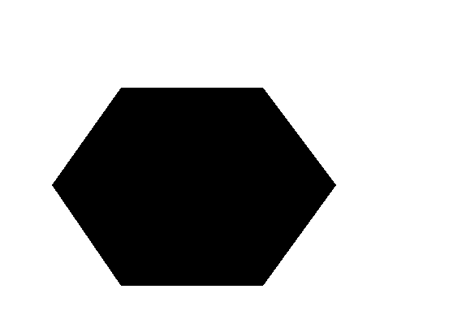
代码如下：
#include<windows.h>
#include<math.h>

#ifdef __APPLE__
#include <GLUT/glut.h>
#else
#include <GL/glut.h>
#endif

#include <stdlib.h>

void init (void)
{
glClearColor (1.0, 1.0, 1.0, 0.0); // Set display-window color to white.
glMatrixMode (GL_PROJECTION); // Set projection parameters.
gluOrtho2D (0.0, 200.0, 0.0, 150.0);
}
void lineSegment (void)//绘制列表的方法
{
glClear (GL_COLOR_BUFFER_BIT); // Clear display window.
// glColor3f (0.0, 0.0, 0.0); // Set line segment color to red.
glColor3f(0.0,0.0,0.0);
const double TWO_PI = 6.2831853;
GLuint regHex;
GLdouble theta;
GLint x,y,k;

regHex = glGenLists(1);
glNewList(regHex,GL_COMPILE);
glBegin(GL_POLYGON);
for(k=0;k<6;k++){
theta= TWO_PI*k/6.0;
x=50+35*cos(theta);
y=50+35*sin(theta);
glVertex2i(x,y);
}
glEnd();
glEndList();

glCallList(regHex);
glFlush();
}
int main (int argc, char** argv)
{
glutInit (&argc, argv); // Initialize GLUT.
glutInitDisplayMode (GLUT_SINGLE | GLUT_RGB); // Set display mode.
glutInitWindowPosition (50, 100); // Set top-left display-window position.
glutInitWindowSize (1000, 600); // Set display-window width and height.
glutCreateWindow ("An Example OpenGL Program"); // Create display window.
init ( ); // Execute initialization procedure.
glutDisplayFunc (lineSegment); // Send graphics to display window.
glutMainLoop ( );
return 0; // Display everything and wait.
}
- 实现根据给定的宽度要求生成不同宽度的线段：
通过设置glLineWidth(3.0);可以看到绘制的线变为默认的三倍宽：
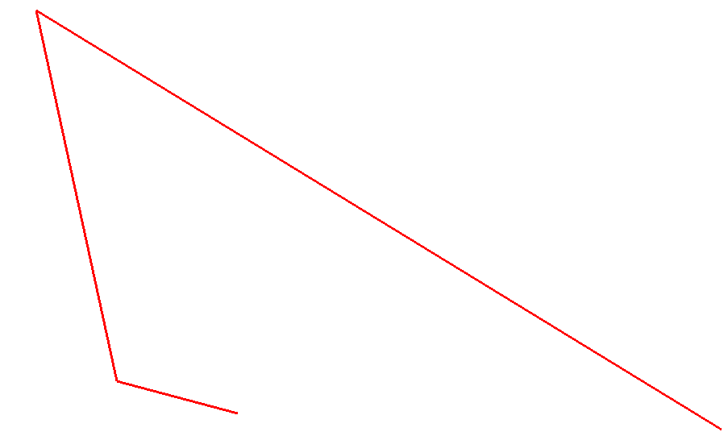
通过设置glLineWidth(10.0);我们看到了线宽变为默认的10.0倍时的效果，可以发现其拼接处出现了拼接不圆滑的现象：
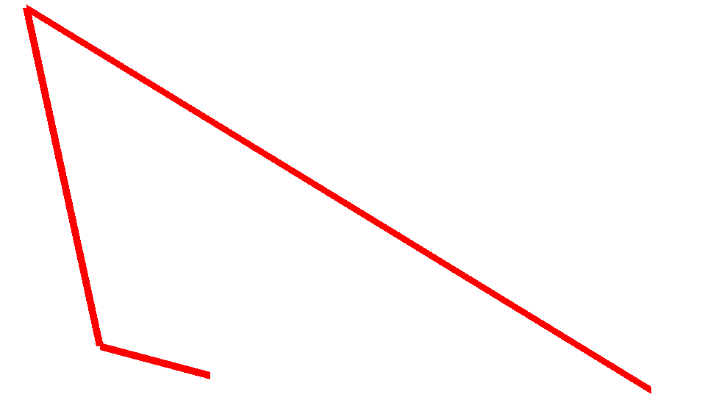
源码如下：
/*
* GLUT Shapes Demo
*
* Written by Nigel Stewart November 2003
*
* This program is test harness for the sphere, cone
* and torus shapes in GLUT.
*
* Spinning wireframe and smooth shaded shapes are
* displayed until the ESC or q key is pressed. The
* number of geometry stacks and slices can be adjusted
* using the + and - keys.
*/
#include<windows.h>
#include<math.h>

#ifdef __APPLE__
#include <GLUT/glut.h>
#else
#include <GL/glut.h>
#endif

#include <stdlib.h>

void init (void)
{
glClearColor (1.0, 1.0, 1.0, 0.0); // Set display-window color to white.
glMatrixMode (GL_PROJECTION); // Set projection parameters.
gluOrtho2D (0.0, 200.0, 0.0, 150.0);
}
void lineSegment (void)
{
glClear (GL_COLOR_BUFFER_BIT); // Clear display window.
// glColor3f (0.0, 0.0, 0.0); // Set line segment color to red.
glColor3f(1.0,0.0,0.0);
//glLineWidth(3.0);
glLineWidth(10.0);
glBegin (GL_LINE_STRIP);
glVertex2i (180, 15); // Specify line-segment geometry.
glVertex2i (10, 145);
glVertex2i(30,30);
glVertex2i(60,20);
glEnd ( );
glFlush();
}

int main (int argc, char** argv)
{
glutInit (&argc, argv); // Initialize GLUT.
glutInitDisplayMode (GLUT_SINGLE | GLUT_RGB); // Set display mode.
glutInitWindowPosition (50, 100); // Set top-left display-window position.
glutInitWindowSize (1000, 600); // Set display-window width and height.
glutCreateWindow ("An Example OpenGL Program"); // Create display window.
init ( ); // Execute initialization procedure.
glutDisplayFunc (lineSegment); // Send graphics to display window.
glutMainLoop ( );
return 0; // Display everything and wait.
}
三、实习总结
在第一次实习的基础上，利用最近学习的画线画点的算法和函数，实现实验中要求的内容，发现其中很多方法的不同，例如DDA算法画线和Bresenham方法画线的各自的优点，也通过这样的动手练习，让自己的动手能力得到了进一步的提高，其中包括了对OpenGL的应用方面的动手和库函数调用的练习。

