A Deliverable 1 Report on

Vertical Farm Control System

**CS3500**

**Software Engineering**

Computer Science

2022-2023

**Group 10**

Jakab-Gyik Sarolta

Smith Deirbhle

Varga Zoltán

Veres Noémi

**University College Cork**

Ireland

Table of contents

Contents

1. Abstract 2

2. Introduction 3

2.1 Background 3

2.2 Different Possible Approaches 3

3. Functions and Requirements 4

3.1 Functions 4

3.2 Requirements 4

4. Design Diagrams 4

4.1 Use Case Diagram 4

4.2 Control System Diagram 5

4.3 Finite State Machine 5

4.4 Block Diagram 5

5.1 References 5

# 1. Abstract

Vertical farms are indoor farms that grow vegetables stacked on the vertical axis. In this manner, more crops can be cultivated on a smaller footprint than in traditional agriculture. The controlled environment offered by an indoor farm eliminates the risk of diseases and insects. Combined with aquaponics it increases 10 times the crop yield compared with traditional agriculture and reduces water consumption by 90% since it is recirculated in the system. Aquaponics means that the roots of the vegetables are placed in water enriched with nutrients instead of soil.

Our team has decided to create a control system for an indoor vertical farm that uses aquaponics. For the sake of simplicity this farm grows butterhead lettuce exclusively but can be extended to manage the environment of other vegetables as well.

*Keywords*: agriculture, energy efficient, environmentally friendly, green farm

# 2. Introduction

## 2.1 Background

Some of the most vital resons why people started experimenting with vertical farming system was connected to the exponential growth of the population and the inefficiency of the traditional agricultural methods. Most places around the world still use the same methods in growing crops then our ancestors did years ago. Which constitutes a major problem: these methods depend on various factor that the farmers cannot control. Insects, diseases, the nutrients in the soil, the general structure of the soil changing from year to year, the limitation of space and other issues.

To address them, vertical farming requires only a fraction of a farm’s space to grow just as many vegetables. The insects and the biochemical materials that farmers use could be avoided. Since they are also harmful for the human body, this is a considerable side effect of traditional agriculture. The consistency of the soil or water that the plants are growing in is controlled by machines, the sensors measuring the nutrient level from time to time, called the EC level (electrical conductivity). This way the soil can provide the ideal environment for all kinds of plants, carefully determined for every species in particular, what would be the range of the EC level that results in the fastest growth.

## 2.2 Different Possible Approaches

These systems, however, do not use soil to plant the seeds in. They use aquaponics, as mentioned above, which come in 6 different forms.

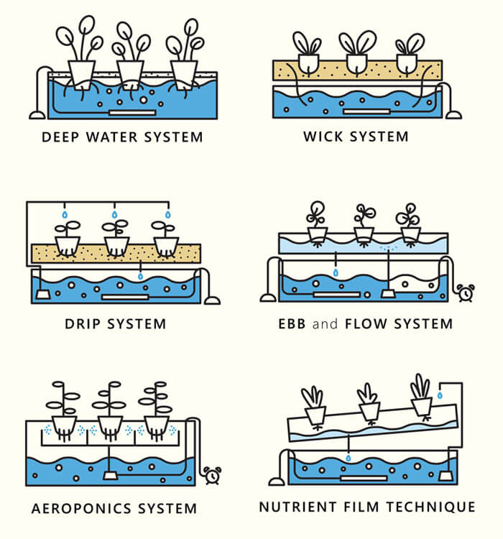

Figure 2.1 Aquaponics in vertical farming systems

1. ***Deep Water system***: the roots of the plants are floating in a nutrient-dense water with oxygen. A container acts as a reservoire for this solution.
2. *Wick system*: does not consume electricity but it uses the wicks of the plants to provide the nutrient-dense water for the plants growing in the soil. The least complex and most energy efficient approach.
3. *Drip system*: the nutrient solution is dripped either to the roots of the plants or to the leaves, coming from above. It depends of the types of plants the farm wants to cultivate.
4. *Ebb and Flow system* (also called flood and drain): the roots of the plants are periodically flooded with nutrient dense water.
5. *Aeroponics system*: the roots of the plants are sprinkled with the nutrient solution.
6. *Nutrient Film technique*: the system works with pipes that hold the nutrient solution for the plants, then the water is collected from them by letting it flow back to the resernoire from these pipes. The pipes are moving; the incline makes the water flow down and then a new amount is pumped of into the pipe. The water is recycled this way; less water consumption.

In this control system the first approach is taken, since it does not require electricity and it is one of the simpler ways to realize the physical structure of the project.

# 3. Functions and Requirements

## Functions

## 3.2 Requirements

# 4. Design Diagrams

## 4.1 Use-Case Diagram

-- I would suggest to swap 3. and 4. as Requirements should be developed from the use cases

The use-case diagram is aimed to graphically capture the systems actors, i.e. the administrator and the actions which can be performed: initialize the system parameters, adjust system parameters, generate reports, receive alerts and reset the system. This diagram provides a structure for our application as it helps to identify components in the design phase. It also helps to capture the requirements which will be presented in detail.

Figure 4.1 Use-case diagram of the Vertical Farm Control System

Now the use cases will be presented.

**Use Case**: initialize the system parameters

**Primary Actor**: administrator

**Main Success Scenario**:

1. The administrator inserts the values for the: time, air temperature, water temperature, nutrient levels, light intensity, light spectrum, humidity, pH level and conductivity level

2. The administrator clicks on the “validate input parameters” button

3. The application validates the data and displays a message informing the administrator to start the system

4. The administrator clicks on the “start” button

5. The application starts the system

**Alternative Sequence**: Invalid values for the setup parameters

The administrator inserts invalid values for the application’s setup parameters

The application displays an error message and requests the administrator to insert valid values

The scenario returns to step 1

**Use Case**: adjust the system parameters

**Primary Actor**: administrator

**Main Success Scenario**:

1. The administrator selects the parameter to edit

2. The administrator clicks on the “Edit” button

3. The administrator enters the new parameter

4. The new parameter is saved

5. A confirmation message is displayed

**Alternative Sequence**: Invalid values for the parameters

The administrator inserts invalid values for the application’s parameters

The application displays an error message and requests the admin to insert valid values

The scenario returns to step 3

**Use Case**: get live status report

**Primary Actor**: administrator

**Main Success Scenario**:

1. The administrator should select the data based on which they want to create the reports

2. The administrator presses the “Generate report” button

3. A report is generated

**Use Case**: receive alerts

**Primary Actor**: administrator

**Main Success Scenario**:

1. The application senses unusual behaviour which requires further action from administrator

2. The application displays an alert message informing the administrator about some specified faults

3. The administrator reads the alert

**Use Case**: reset the system

**Primary Actor**: administrator

**Main Success Scenario**:

1. The administrator should press the “Reset” button

2. The application returns to an initial phase

## 4.2 Control System Diagram

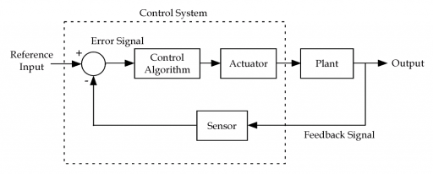

## 4.3 Finite State Machine

## 4.4 Block Diagram

# 5.1 References

1. “IoT based Hydroponic Farms” [Google Scholar]

Retrieved from: <https://ieeexplore.ieee.org/document/8748447>

1. “Nutrient Use in Vertical Farming: Optimal Electrical Conductivity of Nutrient Solution for Growth of Lettuce and Basil in Hydroponic Cultivation” [Google Scholar]

Retrieved from: https://www.mdpi.com/2311-7524/7/9/283/htm