



Java EE 7 Hands-on Lab

With GlassFish 4 Open Source Edition

Version 1.0.4

*Arun Gupta, Java EE & GlassFish Guy*

*blogs.oracle.com/arungupta, @arungupta*

Table of Contents

1.0 Introduction 3

1.1 Software Requirement 3

2.0 Problem Statement 4

2.1 Lab Flow 6

3.0 Walk-through of Sample Application 6

4.0 Show Booking (JavaServer Faces) 13

5.0 Chat Room (Java API for WebSocket) 21

6.0 View and Delete Movie (Java API for RESTful Web Services) 28

7.0 Add Movie (Java API for JSON Processing) 34

8.0 Ticket Sales (Batch Applications for the Java Platform) 40

9.0 Movie Points (Java Message Service 2) 48

10.0 Conclusion 56

11.0 Troubleshooting 57

12.0 Acknowledgements 58

13.0 Completed Solutions 58

14.0 TODO 58

Revision History 58

Appendix 59

Appendix A: Configure GlassFish 4 in NetBeans IDE 59

# 1.0 Introduction

The Java EE 7 platform continues the ease of development push that characterized prior releases by bringing further simplification to enterprise development. It adds new and important APIs such as the REST client API in JAX-RS 2.0 and the long awaited Batch Processing API. Java Message Service 2.0 has undergone an extreme makeover to align with the improvements in the Java language. There are plenty of improvements to several other components. Newer web standards like HTML 5, WebSocket, and JSON processing are embraced to build modern web applications.

This hands-on lab will build a typical 3-tier end-to-end application using the following Java EE 7 technologies:

* Java Persistence API 2.1 (JSR 338)
* Java API for RESTful Web Services 2.0 (JSR 339)
* Java Message Service 2.0 (JSR 343)
* JavaServer Faces 2.2 (JSR 344)
* Contexts and Dependency Injection 1.1 (JSR 346)
* Bean Validation 1.1 (JSR 349)
* Batch Applications for the Java Platform 1.0 (JSR 352)
* Java API for JSON Processing 1.0 (JSR 353)
* Java API for WebSocket 1.0 (JSR 356)
* Java Transaction API 1.2 (JSR 907)

Together these APIs will allow you to be more productive by simplifying enterprise development.

The latest version of this document can be downloaded from [glassfish.org/hol/javaee7-hol.pdf](http://glassfish.org/hol/javaee7-hol.pdf).

## 1.1 Software Requirement

The following software needs to be downloaded and installed:

* JDK 7 from <http://www.oracle.com/technetwork/java/javase/downloads/index.html>.
* NetBeans 7.3 or higher “All” or “Java EE” version from <http://netbeans.org/downloads/>. A preview of the downloads page is shown in Figure 1 and highlights the exact “Download” button to be clicked.   
    
  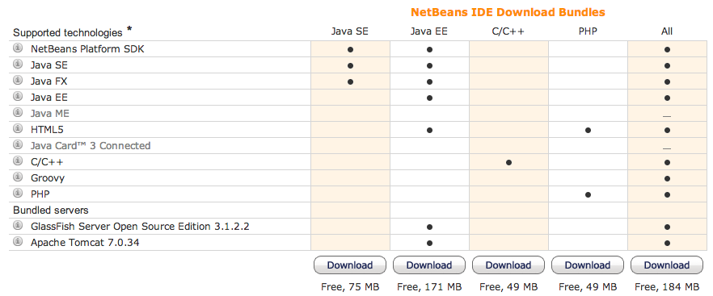

Figure 1: NetBeans Download Bundles

* GlassFish 4 from <http://download.java.net/glassfish/4.0/release/glassfish-4.0.zip>.

Configure GlassFish 4 in NetBeans IDE following the instructions in Appendix A.

# 2.0 Problem Statement

This hands-on lab builds a typical 3-tier Java EE 7 Web application that allows customers to view the show timings for a movie in a 7-theater Cineplex and make reservations. Users can add new movies and delete existing movies. Customers can discuss the movie in a chat room. Total sales from each showing are calculated at the end of the day. Customers also accrue points for watching movies.

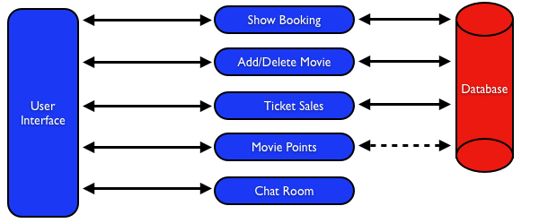

Figure 2: Application Flow

Figure 2 shows the key components of the application. The User Interface initiates all the flows in the application. Show Booking, Add/Delete Movie and Ticket Sales interact with the database; Movie Points may interact with the database, however, this is out of scope for this application; and Chat Room does not interact with the database.

The different functions of the application, as detailed above, utilize various Java technologies and web standards in their implementation. Figure 3 shows how different Java EE technologies are used in different flows.

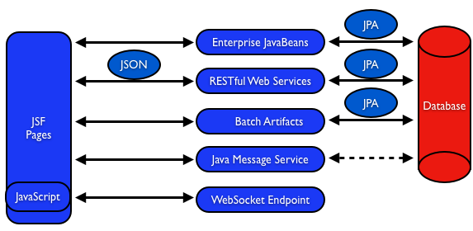

Figure 3: Technologies Used in the Application

Table 1 details the components and the selected technology used in its’ implementation.

|  |  |
| --- | --- |
| **Flow** | **Description** |
| User Interface | Written entirely in *JavaServer Faces* (JSF). |
| Show Booking | Uses lightweight *Enterprise JavaBeans* to communicate with the database using Java Persistence API |
| Add/Delete Movie | Implemented using RESTful Web Services. JSON is used as on-the-wire data format. |
| Ticket Sales | Uses *Batch Applications for the Java Platform* to calculate the total sales and persist to the database. |
| Movie Points | Uses *Java Message Service* (JMS) to update and obtain loyalty reward points; an optional implementation using database technology may be performed. |
| Chat Room | Utilizes client-side JavaScript and JSON to communicate with a *WebSocket* endpoint |

Table 1 Technologies Used in the Application

## 2.1 Lab Flow

The attendees will start with an existing maven application and by following the instructions and guidance provided by this lab they will:

* Read existing source code to gain an understanding of the structure of the application and use of the selected platform technologies
* Add new and update existing code with provided fragments in order to demonstrate usage of different technology stacks in the Java EE 7 platform.

This is not a comprehensive tutorial of Java EE. The attendees are expected to know the basic Java EE concepts such as EJB, JPA, JAX-RS, and CDI. The [Java EE 7 Tutorial](http://docs.oracle.com/javaee/7/tutorial/doc/) is a good place to learn all these concepts. However enough explanation is provided in this guide to get you started with the application.

**Disclaimer**: This is a sample application and the code may not be following the best practices to prevent SQL injection, cross-side scripting attacks, escaping parameters, and other similar features expected of a robust enterprise application. This is intentional such as to stay focused on explaining the technology. It is highly recommended to make sure that the code copied from this sample application is updated to meet those requirements.

# 3.0 Walk-through of Sample Application

**Purpose**: This section will download the sample application to be used in this hands-on lab. A walk-through of the application will be performed to provide an understanding of the application architecture.

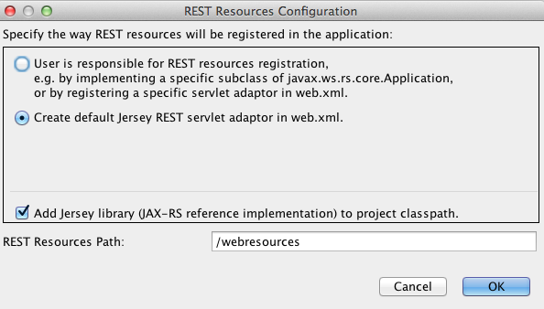

**3.1** Download the sample application from [glassfish.org/hol/movieplex7-starting-template.zip](http://glassfish.org/hol/movieplex7-starting-template.zip) and unzip. This will create a “movieplex7” directory and unzips all the content there.

**3.2** In NetBeans IDE, select “File”, “Open Project…”, select the unzipped directory, and click on “Open Project”. The project structure is shown in Figure 5.

Figure 4: REST Resources Configuration Dialog

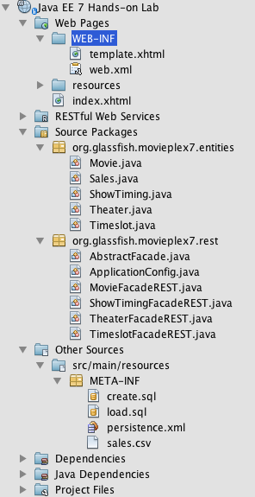Opening the project will prompt to create a configuration file to configure the base URI of the REST resources bundled in the application. The application already contains a source file that provides the needed configuration. Click on “Cancel” to dismiss this dialog.

**3.3** Maven Coordinates: Expand “Project Files” and double click on “pom.xml”. In the “pom.xml”, the Java EE 7 API is specified as a <dependency>:  
  
  
<dependencies>  
 <dependency>   
 <groupId>javax</groupId>   
 <artifactId>javaee-api</artifactId>   
 <version>7.0</version>   
 </dependency>   
</dependencies>

This will ensure that Java EE 7 APIs are retrieved from central Maven repository.

The Java EE 6 platform introduced the notion of “profiles”. A profile is a configuration of the Java EE platform targeted at a specific class of applications. All Java EE profiles share a set of common features, such as naming and resource injection, packaging rules, security requirements, etc. A profile may contain a proper subset or superset of the technologies contained in the platform.

Figure 5: Project Structure

The Java EE Web Profile is a profile of the Java EE Platform specifically targeted at modern web applications. The complete set of specifications defined in the Web Profile is defined in the Java EE 7 Web Profile Specification. GlassFish can be downloaded in two different flavors – Full Platform or Web Profile.

This lab requires Full Platform download. All technologies used in this lab, except Java Message Service and Batch Applications for the Java Platform, can be deployed on Web Profile.

**3.4** **Default Data Source**: Expand “Other Sources”, “src/main/resources”, “META-INF”, and double-click on “persistence.xml”. By default, NetBeans opens the file in Design View. Click on Source tab to view the XML source.   
  
It looks like:

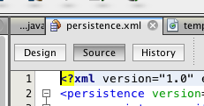

<?xml version="1.0" encoding="UTF-8"?>

Figure 6: "persistence.xml" Source Tab

<persistence version="2.0" xmlns="http://java.sun.com/xml/ns/persistence" xmlns:xsi="http://www.w3.org/2001/XMLSchema-instance" xsi:schemaLocation="http://java.sun.com/xml/ns/persistence http://java.sun.com/xml/ns/persistence/persistence_2_0.xsd">

<persistence-unit name="movieplex7PU" transaction-type="JTA">

<!--

<jta-data-source>java:comp/DefaultDataSource</jta-data-source>

-->

<properties>

<property  
 name="javax.persistence.schema-generation.database.action"   
 value="drop-and-create"/>

<property  
 name="javax.persistence.schema-generation.create-source"   
 value="script"/>

<property  
 name="javax.persistence.schema-generation.create-script-source"

value="META-INF/create.sql"/>

<property  
 name="javax.persistence.sql-load-script-source"   
 value="META-INF/load.sql"/>

<property  
 name="eclipselink.deploy-on-startup"  
 value="true"/>

<property  
 name="eclipselink.logging.exceptions"

value="false"/>

</properties>

</persistence-unit>

</persistence>

Notice <jta-data-source> is commented out, i.e. no data source element is specified. This element identifies the JDBC resource to connect to in the runtime environment of the underlying application server.

The Java EE 7 platform defines a new default DataSource that must be provided by the runtime. This pre-configured data source is accessible under the JNDI name  
  
java:comp/DefaultDataSource

The JPA 2.1 specification says if neither jta-data-source nor non-jta-data-source elements are specified, the deployer must specify a JTA data source or the default JTA data source must be provided by the container.

For GlassFish 4, the default data source is bound to the JDBC resource jdbc/__default.

Clicking back and forth between “Design” and “Source” view may prompt the error shown below:

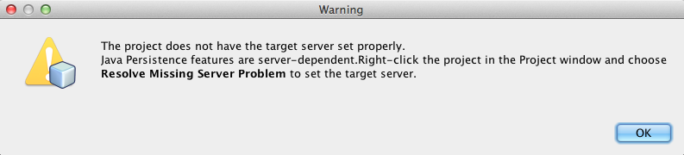

Figure 7: Missing Server Problem Error Message

This will get resolved when we run the application. Click on “OK” to dismiss the dialog.

**3.5** **Schema Generation:** JPA 2.1 defines a new set of javax.persistence.schema-generation.* properties that can be used to generate database artifacts like tables, indexes, and constraints in a database schema. This helps in prototyping of your application where the required artifacts are generated either prior to application deployment or as part of EntityManagerFactory creation. This feature will allow your JPA domain object model to be directly generated in a database. The generated schema may need to be tuned for actual production environment.

The “persistence.xml” in the application has the following javax.persistence.schema-generation.* properties. Their meaning and possible values are explained in Table 2.

|  |  |  |
| --- | --- | --- |
| **Property** | **Meaning** | **Values** |
| javax.persistence.schema-generation.database.action | Specifies the action to be taken by the persistence provider with regard to the database artifacts. | “none”, “create”, “drop-and-create”, “drop” |
| javax.persistence.schema-generation.create-source | Specifies whether the creation of database artifacts is to occur on the basis of the object/relational mapping metadata, DDL script, or a combination of the two. | “metadata”, “script”, “metadata-then-script”, “script-then-metadata” |
| javax.persistence.schema-generation.create-script-source | Specifies a java.IO.Reader configured for reading of the DDL script or a string designating a file URL for the DDL script. |  |
| javax.persistence.sql-load-script-source | Specifies a java.IO.Reader configured for reading of the SQL load script for database initialization or a string designating a file URL for the script. |  |

Table 2: JPA Schema Generation Properties

Refer to the [JPA 2.1 Specification](http://jcp.org/en/jsr/detail?id=338) for a complete understanding of these properties.

In the application, the scripts are bundled in the WAR file in “META-INF” directory. As the location of these scripts is specified as a URL, the scripts may be loaded from outside the WAR file as well.

Feel free to open “create.sql” and “load.sql” and read through the SQL scripts. The database schema is shown in Figure 8.

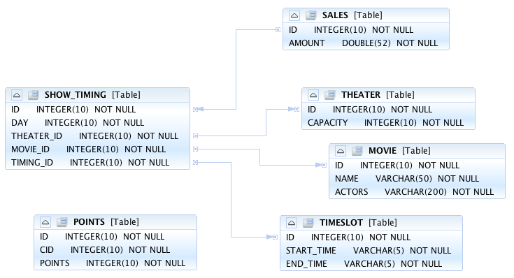

Figure 8: Database Schema

This folder also contains “sales.csv” which carries some comma-separated data used later in the application.

**3.6** **JPA entities, Stateless EJBs, and REST endpoints**: Expand “Source Packages”. The package “org.glassfish.movieplex7.entities” contains the JPA entities corresponding to the database table definitions. Each JPA entity has several convenient @NamedQuery defined and uses Bean Validation constraints to enforce validation.

The package “org.glassfish.movieplex7.rest” contains stateless EJBs corresponding to different JPA entities.

Each EJB has methods to perform CRUD operations on the JPA entity and convenience query methods. Each EJB is also EL-injectable (@Named) and published as a REST endpoint (@Path). The AplicationConfig class defines the base path of REST endpoint. The path for the REST endpoint is the same as the JPA entity class name.

The mapping between JPA entity classes, EJB classes, and the URI of the corresponding REST endpoint is shown in Table 3.

|  |  |  |
| --- | --- | --- |
| **JPA Entity Class** | **EJB Class** | **RESTful Path** |
| Movie | MovieFacadeREST | /webresources/movie |
| Sales | SalesFacadeREST | /webresources/sales |
| ShowTiming | ShowTimingFacadeREST | /webresources/showtiming |
| Theater | TheaterFacadeREST | /webresources/theater |
| Timeslot | TimeslotFacadeREST | /webresources/timeslot |

Table 3: JPA Entity and EJB Class Mapping with RESTful Path

Feel free to browse through the code.

**3.7** **JSF pages**: “WEB-INF/template.xhtml” defines the template of the web page and has a header, left navigation bar, and a main content section. “index.xhtml” uses this template and the EJBs to display the number of movies and theaters.

Java EE 7 enables CDI discovery of beans by default. No “beans.xml” is required in “WEB-INF”. This allows all beans with bean defining annotation, i.e. either a bean with an explicit CDI scope or EJBs to be available for injection.  
  
Note, “template.xhtml” is in “WEB-INF” folder as it allows the template to be accessible from the pages bundled with the application only. If it were bundled with rest of the pages then it would be accessible outside the application and thus allowing other external pages to use it as well.

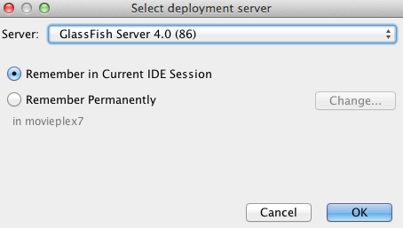**3.8** **Run the sample**: Right-click on the project and select “Run”. This will download all the maven dependencies on your laptop, build a WAR file, deploy on GlassFish 4, and show the URL [localhost:8080/movieplex7](http://localhost:8080/movieplex7) in the browser.

During first run, the IDE will ask you to select a deployment server. Choose the configured GlassFish server and click on “OK”.

Figure 9: Select Deployment Server

The output looks like as shown in Figure 10.

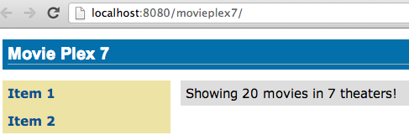

Figure 10: Output from the Packaged Application

# 4.0 Show Booking (JavaServer Faces)

**Purpose**: Build pages that allow a user to book a particular movie show in a theater. In doing so a new feature of JavaServer Faces 2.2 will be introduced and demonstrated by using in the application.

JavaServer Faces 2.2 introduces a new feature called *Faces Flow* that provides an encapsulation of related views/pages with application defined entry and exit points. Faces Flow borrows core concepts from ADF TaskFlow, Spring Web Flow, and Apache MyFaces CODI.

It introduces @FlowScoped CDI annotation for flow-local storage and @FlowDefinition to define the flow using CDI producer methods. There are clearly defined entry and exit points with well-defined parameters. This allows the flow to be packaged together as a JAR or ZIP file and be reused. The application thus becomes a collection of flows and non-flow pages. Usually the objects in a flow are designed to allow the user to accomplish a task that requires input over a number of different views.

This application will build a flow that allows the user to make a movie reservation. The flow will contain four pages:

1. Display the list of movies
2. Display the list of available show timings
3. Confirm the choices
4. Make the reservation and show the ticket

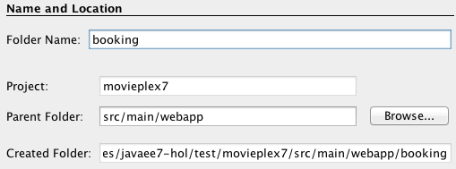

Figure 11: Create a New Folder

**4.1** Items in a flow are logically related to each other and so it is required to keep them together in a directory.   
In NetBeans IDE, right-click on the “Web Pages”, select “New”, “Folder…”, specify the folder name “booking”, and click on “Finish”.

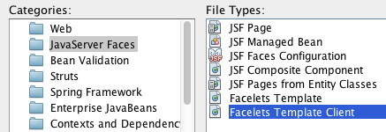

**4.2** Right-click on the newly created folder, select “New”, “Other…”, “JavaServer Faces”, “Facelets Template Client”, and click on “Next >”.

Give the File Name as “booking”. Click on “Browse…” next to “Template:”, expand “Web Pages”, “WEB-INF”, select “template.xhtml”, and click on “Select File”. Click on “Finish”.  
  
In this file, remove <ui:define> sections with “top” and “left” names as these are inherited from the template.

Figure 12: Selecting Facelets Template Client

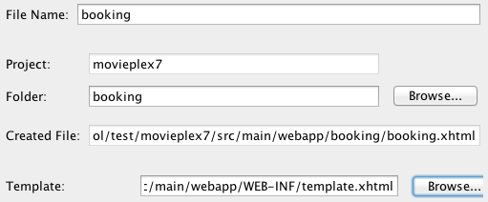

**4.3** “booking.xhtml” is the entry point to the flow (more on this later). Replace the “content” <ui:define> section such that it looks like:

Figure 13: Facelets Template Client File Name

<ui:define name="content">

<h2>Pick a movie</h2>

<h:form prependId="false">

<h:selectOneRadio value="#{booking.movieId}" layout="pageDirection" required="true">

<f:selectItems value="#{movieFacadeREST.all}" var="m" itemValue="#{m.id}" itemLabel="#{m.name}"/>

</h:selectOneRadio>

<h:commandButton id="shows" value="Pick a time" action="showtimes" />

</h:form>

</ui:define>

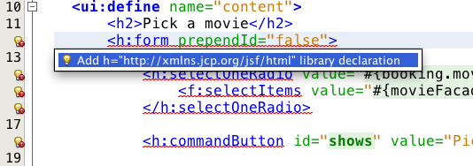The code builds an HTML form that displays the list of movies as radio button choices. The chosen movie is bound to #{booking.movieId} which will be defined as a flow-scoped bean. The value of action attribute on commandButton refers to the next view in the flow, i.e. “showtimes.xhtml” in the same directory in our case.  
  
Click on the hint (shown as yellow bulb) and click on the suggestion to add namespace prefix. Do the same for f: prefix as shown in Figure 14.

Figure 14: Resolve Namespace Prefix/URI Mapping for h: and f:

**4.4** Right-click on “Source Packages”, select “New”, “Java Class…”. Specify the class name as “Booking” and the package name as “org.glassfish.movieplex7.booking”.

Add @Named class-level annotation to make the class EL-injectable. Add @FlowScoped("booking") to define the scope of bean as the flow. The bean is automatically activated and passivated as the flow is entered or exited.

Add the following field:  
  
int movieId;

and generate getters/setters by going to “Source”, “Insert Code…”, selecting “Getter and Setter…”, and select the field.

Add the following convenience method:

public String getMovieName() {

try {

return em.createNamedQuery("Movie.findById", Movie.class).setParameter("id", movieId).getSingleResult().getName();

} catch (NoResultException e) {

return "";

}

}

This method will return the movie name based upon the selected movie. Inject EntityManager in this class by adding the following code:

@PersistenceContext

EntityManager em;

Alternatively, movie id and name may be passed from the selected radio button and parsed in the backing bean. This will reduce an extra trip to the database.

**4.5** Create “showtimes.xhtml” in the “booking” folder following the steps in 4.2. Replace “content” <ui:define> section such that it looks like:

<ui:define name="content">

<h2>Show Timings for <font color="red">#{booking.movieName}</font></h2>

<h:form>

<h:selectOneRadio value="#{booking.startTime}" layout="pageDirection" required="true">

<c:forEach items="#{timeslotFacadeREST.all}" var="s">

<f:selectItem itemValue="#{s.id},#{s.startTime}" itemLabel="#{s.startTime}"/>

</c:forEach>

</h:selectOneRadio>

<h:commandButton value="Confirm" action="confirm" />

<h:commandButton id="back" value="Back" action="booking" />

</h:form>

</ui:define>

This code builds an HTML form that displays the chosen movie name and all the show times. #{timeslotFacadeREST.all} returns the list of all the movies and iterates over them using a c:forEach loop. The id and start time of the selected show are bound to #{booking.startTime}. One command button (value=”Back”) allows going back to the previous page and the other command button (value=”Confirm”) takes to next view in the flow, “confirm.xhtml” in our case.

Typically a user will expect the show times only for the selected movie but all the show times are shown here. This allows us to demonstrate going back and forth within a flow if an incorrect show time for a movie is chosen. A different query may be written that displays only the shows available for this movie; however this is not part of the application.

**4.6** Add the following fields to the Booking class:

String startTime;

int startTimeId;

And the following methods:  
  
public String getStartTime() {

return startTime;

}

public void setStartTime(String startTime) {

StringTokenizer tokens = new StringTokenizer(startTime, ",");

startTimeId = Integer.parseInt(tokens.nextToken());

this.startTime = tokens.nextToken();

}

public int getStartTimeId() {

return startTimeId;

}

These methods will parse the values received from the form. Also add the following method:

public String getTheater() {

// for a movie and show

try {

// Always return the first theater

List<ShowTiming> list =   
 em.createNamedQuery("ShowTiming.findByMovieAndTimingId",   
 ShowTiming.class)  
 .setParameter("movieId", movieId)

.setParameter("timingId", startTimeId)

.getResultList();

if (list.isEmpty())

return "none";

return list

.get(0)

.getTheaterId()

.getId().toString();

} catch (NoResultException e) {

return "none";

}

}

This method will find the first theater available for the chosen movie and show timing.

Additionally a list of theaters offering that movie may be shown in a separate page.

**4.7** Create “confirm.xhtml” page in the “booking” folder by following the steps defined in 4.2. Replace “content” <ui:define> section such that it looks like:

<ui:define name="content">

<c:choose>

<c:when test="#{booking.theater == 'none'}">

<h2>No theater found, choose a different time</h2>

<h:form>

Movie name: #{booking.movieName}<p/>

Starts at: #{booking.startTime}<p/>

<h:commandButton id="back" value="Back" action="showtimes"/>

</h:form>

</c:when>

<c:otherwise>

<h2>Confirm ?</h2>

<h:form>

Movie name: #{booking.movieName}<p/>

Starts at: #{booking.startTime}<p/>

Theater: #{booking.theater}<p/>

<p/><h:commandButton id="next" value="Book" action="print"/>

<h:commandButton id="back" value="Back" action="showtimes"/>

</h:form>

</c:otherwise>

</c:choose>

</ui:define>

The code displays the selected movie, show timing, and theater if available. The reservation can proceed if all three are available. “print.xhtml”, identified by action of commandButton with “Book” value, is the last page that shows the confirmed reservation.

actionListener can be added to commandButton to invoke the business logic for making the reservation. Additional pages may be added to take the credit card details and email address.

**4.8** Create “print.xhtml” page in the “booking” folder by following the steps defined in 4.2 and replace “content” <ui:define> section such that it looks like:

<ui:define name="content">

<h2>Reservation Confirmed</h2>

<h:form>

Movie name: #{booking.movieName}<p/>

Starts at: #{booking.startTime}<p/>

Theater: #{booking.theater}<p/>

<p><h:commandButton id="home" value="home" action="goHome" /></p>

</h:form>

</ui:define>

This code displays the movie name, show timings, and the selected theater.

The commandButton initiates exit from the flow. The action attribute defines a navigation rule that will be defined in the next step.

**4.9** “booking.xhtml”, “showtimes.xhtml”, “confirm.xhtml”, and “print.xhtml” are all in the same directory. Now the runtime needs to be informed that the views in this directory are to be treated as view nodes in a flow. This can be done by adding “booking/booking-flow.xml” or have a class with a method that @Produces @FlowDefinition.

Right-click on “Web Pages/booking” folder, select “New”, “Other”, “XML”, “XML Document”, give the name as “booking-flow”, click on “Next>”, take the default of “Well-formed Document”, and click on “Finish”. Edit the file such that it looks like:

<faces-config version="2.2" xmlns="http://xmlns.jcp.org/xml/ns/javaee"

xmlns:xsi="http://www.w3.org/2001/XMLSchema-instance"

xsi:schemaLocation="

http://xmlns.jcp.org/xml/ns/javaee

http://xmlns.jcp.org/xml/ns/javaee/web-facesconfig_2_2.xsd">

<flow-definition id="booking">

<flow-return id="goHome">

<from-outcome>/index</from-outcome>

</flow-return>

</flow-definition>

</faces-config>

This defines the flow graph. It uses the standard parent element used in any “faces-config.xml” but defines a <flow-definition>.

<flow-return> defines a return node in a flow graph. <from-outcome> contains the node value, or an EL expression that defines the node, to return to. In this case, the navigation returns to the home page.

**4.10** Finally, invoke the flow by editing “WEB-INF/template.xhtml” and changing:

<h:commandLink action="item1">Item 1</h:commandLink>

to

<h:commandLink action="booking">Book a movie</h:commandLink>

commandLink renders an HTML anchor tag that behaves like a form submit button. The action attribute points to the directory where all views for the flow are stored. This directory already contains “booking-flow.xml” which defines the flow of the pages.

**4.11** Run the project by right clicking on the project and selecting “Run”. The browser shows the updated output.  
  
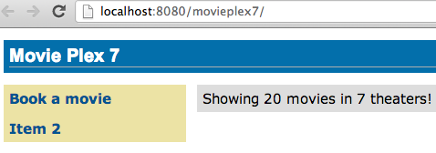

Figure 15: Book a Movie Link

Click on “Book a movie” to see the page as shown in Figure 16.

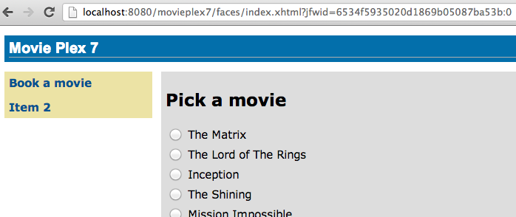

Figure 16: Pick a Movie Page Output

Select a movie, say “The Shining” and click on “Pick a time” to see the page output as shown in Figure 17.

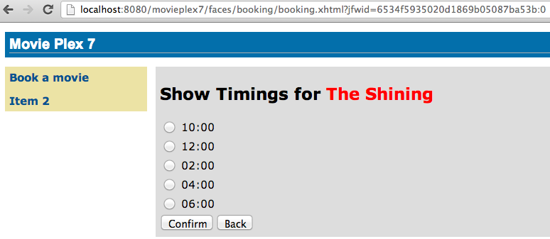

Figure 17: Show Timings Page Output

Pick a time slot, say “04:00” to see the output as shown in Figure 18.

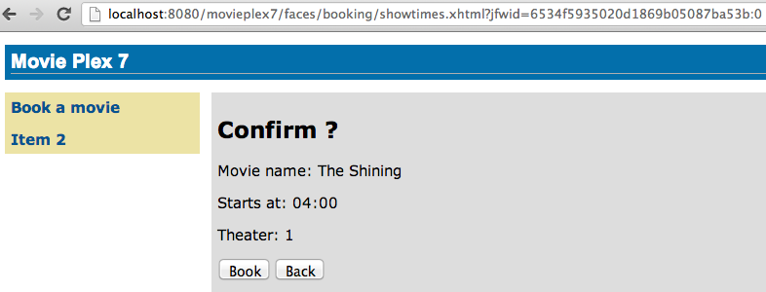

Figure 18: Confirm Booking Page Output

Click on “Book” to confirm and see the output as:

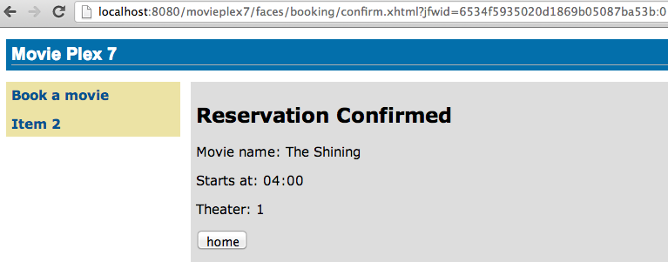

Figure 19: Reservation Confirmed Page Output

Feel free to enter other combinations, go back and forth in the flow and notice how the values in the bean are preserved.

Click on “home” takes to the main application page as shown in Figure 15.

# 5.0 Chat Room (Java API for WebSocket)

**Purpose**: Build a chat room for viewers. In doing so several new features of Java API for WebSocket 1.0 will be introduced and demonstrated by using them in the application.

WebSocket provide a full-duplex and bi-directional communication protocol over a single TCP connection. WebSocket is a combination of [IETF RFC 6455](http://tools.ietf.org/html/rfc6455) [Protocol](http://tools.ietf.org/html/rfc6455) and [W3C JavaScript WebSocket API](http://www.w3.org/TR/websockets/) (a Candidate Recommendation as of this writing). The protocol defines an opening handshake and data transfer. The API enables Web pages to use the WebSocket protocol for two-way communication with the remote host.

[JSR 356](http://jcp.org/en/jsr/detail?id=356) defines a standard API for creating WebSocket applications in the Java EE 7 Platform. The JSR provides support for:

* Create WebSocket endpoint using annotations and interface
* Initiating and intercepting WebSocket events
* Creation and consumption of WebSocket text and binary messages
* Configuration and management of WebSocket sessions
* Integration with Java EE security model

This section will build a chat room for movie viewers.

**5.1** Right-click on “Source Packages”, select “New”, “Java Class…”. Give the class name as “ChatServer”, package as “org.glassfish.movieplex7.chat”, and click on “Finish”.

**5.2** Change the class such that it looks like:

@ServerEndpoint("/websocket")

public class ChatServer {

private static final Set<Session> peers = Collections.synchronizedSet(new HashSet<Session>());

@OnOpen

public void onOpen(Session peer) {

peers.add(peer);

}

@OnClose

public void onClose(Session peer) {

peers.remove(peer);

}

@OnMessage

public void message(String message, Session client) throws IOException, EncodeException {

for (Session peer : peers) {

if (!peers.equals(client))

peer.getBasicRemote().sendObject(message);

}

}

}

In this code:

* @ServerEndpoint decorates the class to be a WebSocket endpoint. The value defines the URI where this endpoint is published.
* @OnOpen and @OnClose decorate the methods that must be called when WebSocket session is opened or closed. The peer parameter defines the client requesting connection initiation and termination.
* @OnMessage decorates the message that receives the incoming WebSocket message. The first parameter, message, is the payload of the message. The second parameter, client, defines the other end of the WebSocket connection. The method implementation transmits the received message to all clients connected to this endpoint.

Resolve the imports. Make sure to pick java.websocket.Session instead of the default.

**5.3** In “Web Pages”, select “New”, “Folder…”, give the folder name as “chat” and click on “Finish”.

**5.4** Create “chatroom.xhtml” in “chat” folder following the steps outlined in 4.2. Replace “content” <ui:define> section such that it looks like:

<ui:define name="content">

<form action="">

<table>

<tr>  
 <td>

Chat Log<br/>

<textarea readonly="true" rows="6" cols="50" id="chatlog"></textarea>

</td>  
 <td>

Users<br/>

<textarea readonly="true" rows="6" cols="20" id="users"></textarea>

</td>

</tr>

<tr>

<td colspan="2">

<input id="textField" name="name" value="Duke" type="text"/>

<input onclick="join();" value="Join" type="button"/>

<input onclick="send_message();" value="Send" type="button"/><p/>

<input onclick="disconnect();" value="Disconnect" type="button"/>

</td>

</tr>

</table>

</form>

<div id="output"></div>

<script language="javascript" type="text/javascript" src="${facesContext.externalContext.requestContextPath}/chat/websocket.js"></script>

</ui:define>

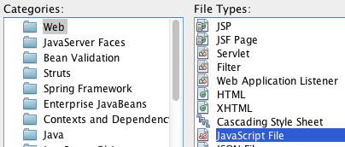The code builds an HTML form that has two textareas – one to display the chat log and the other to display the list of users currently logged. A single text box is used to take the user name or the chat message. Clicking on “Join” button takes the value as user name and clicking on “Send” takes the value as chat message. JavaScript methods are invoked when these buttons are clicked and these are explained in the next section. The chat messages are sent and received as WebSocket payloads. There is an explicit button to disconnect the WebSocket connection. “output” div is the placeholder for status messages. The WebSocket initialization occurs in “websocket.js” included at the bottom of the fragment.

Figure 20: Select JavaScript File Type

**5.5** Right-click on “chat” in “Web Pages”, select “New”, “Web”, “JavaScript File”.   
  
Give the name as “websocket” and click on “Finish”.

**5.6** Edit the contents of “websocket.js” such that it looks like:

var wsUri = 'ws://' + document.location.host

+ document.location.pathname.substr(0,  
 document.location.pathname.indexOf("/faces"))

+ '/websocket';

console.log(wsUri);

var websocket = new WebSocket(wsUri);

var username;

websocket.onopen = function(evt) { onOpen(evt); };

websocket.onmessage = function(evt) { onMessage(evt); };

websocket.onerror = function(evt) { onError(evt); };

websocket.onclose = function(evt) { onClose(evt); };

var output = document.getElementById("output");

function join() {

username = textField.value;

websocket.send(username + " joined");

}

function send_message() {

websocket.send(username + ": " + textField.value);

}

function onOpen() {

writeToScreen("CONNECTED");

}

function onClose() {

writeToScreen("DISCONNECTED");

}

function onMessage(evt) {

writeToScreen("RECEIVED: " + evt.data);

if (evt.data.indexOf("joined") !== -1) {

users.innerHTML += evt.data.substring(0, evt.data.indexOf(" joined")) + "\n";

} else {

chatlog.innerHTML += evt.data + "\n";

}

}

function onError(evt) {

writeToScreen('<span style="color: red;">ERROR:</span> ' + evt.data);

}

function disconnect() {

websocket.close();

}

function writeToScreen(message) {

var pre = document.createElement("p");

pre.style.wordWrap = "break-word";

pre.innerHTML = message;

output.appendChild(pre);

}

The WebSocket endpoint URI is calculated by using standard JavaScript variables and appending the URI specified in the ChatServer class. WebSocket is initialized by calling new WebSocket(…). Event handlers are registered for lifecycle events using onXXX messages. The listeners registered in this script are explained in Table 4.

|  |  |
| --- | --- |
| Listeners | Called When |
| onOpen(evt) | WebSocket connection is initiated |
| onMessage(evt) | WebSocket message is received |
| onError(evt) | Error occurs during the communication |
| onClose(evt) | WebSocket connection is terminated |

Table 4: WebSocket Event Listeners

Any relevant data is passed along as parameter to the function. Each method prints the status on the browser using writeToScreen utility method. The join method sends a message to the endpoint that a particular user has joined. The endpoint then broadcasts the message to all the listening clients. The send_message method appends the logged in user name and the value of the text field and broadcasts to all the clients similarly. The onMessage method updates the list of logged in users as well.

**5.7** Edit “WEB-INF/template.xhtml” and change:

<h:outputLink value="item2.xhtml">Item 2</h:outputLink>

to

<h:outputLink value="${facesContext.externalContext.requestContextPath}/faces/chat/chatroom.xhtml">Chat Room</h:outputLink>

The outputLink tag renders an HTML anchor tag with an href attribute. ${facesContext.externalContext.requestContextPath} provides the request URI that identifies the web application context for this request. This allows the links in the left navigation bar to be fully-qualified URLs.

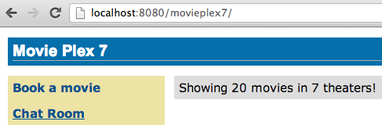**5.8** Run the project by right clicking on the project and selecting “Run”. The browser shows [localhost:8080/movieplex7](http://localhost:8080/movieplex7) as shown in Figure 21.

Figure 21: Chat Room Link

Click on “Chat Room” to see the output as shown in Figure 22.  
  
The “CONNECTED” status message is shown and indicates that the WebSocket connection with the endpoint is established.

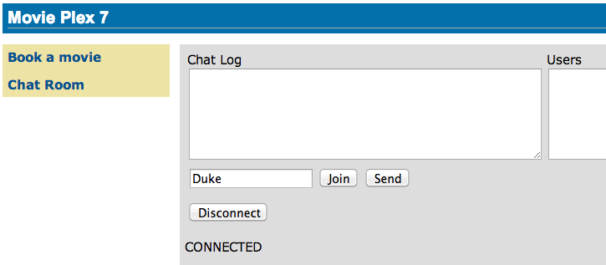

Figure 22: Chat Room Page Output

Open the URI [localhost:8080/movieplex7](http://localhost:8080/movieplex7) in another browser window. Enter “Duke” in the text box in the first browser and click “Join”. Notice that the user list and the status message in both the browsers gets updated. Enter “Duke2” in the text box of the second browser and click on “Join”. Once again the user list and the status message in both the browsers is updated. Now you can type any messages in any of the browser and click on “Send” to send the message.

The output from two different browsers after the initial greeting looks like as shown in Figure 23. Here it shows output from Chrome on the top and Firefox on the bottom.  
  
  
  
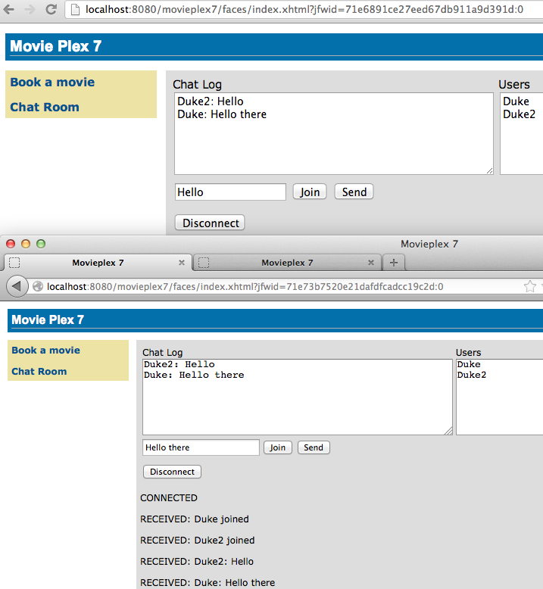

Figure 23: Chat Room Output from Chrome and Firefox

Chrome Developer Tools can be used to monitor WebSocket traffic.

# 6.0 View and Delete Movie (Java API for RESTful Web Services)

**Purpose**: View, and delete a movie. In doing so several new features of JAX-RS 2 will be introduced and demonstrated by using them in the application.

JAX-RS 2 defines a standard API to create, publish, and invoke a REST endpoint. JAX-RS 2 adds several new features to the API:

* Client API that can be used to access Web resources and provides integration with JAX-RS Providers. Without this API, the users need to use a low-level HttpUrlConnection to access the REST endpoint.
* Asynchronous processing capabilities in Client and Server that enables more scalable applications.
* Message Filters and Entity Interceptors as well-defined extension points to extend the capabilities of an implementation.
* Integration with Bean Validation

This section will provide the ability to view all the movies, details of a selected movie, and delete an existing movie using the JAX-RS Client API.

**6.1** Right-click on “Source Packages”, select “New”, “Java Class…”. Give the class name as “MovieClientBean”, package as “org.glassfish.movieplex7.client”, and click on “Finish”.

This bean will be used to invoke the REST endpoint.

**6.2** Add @Named and @SessionScoped class-level annotations. This allows the class to be injected in an EL expression and also defines the bean to be automatically activated and passivated with the session.

The class also needs to implements Serializable because it’s defined in the session scope.

Make sure to resolve the imports by clicking on the yellow bulb or right-clicking on the editor pane and selecting “Fix Imports” (Cmd + Shift + I shortcut on Mac).

**6.3** Add the following code to the class:

Client client;

WebTarget target;

@PostConstruct

public void init() {

client = ClientBuilder.newClient();

target = client  
 .target("http://localhost:8080/movieplex7/webresources/movie/");

}

@PreDestroy

public void destroy() {

client.close();

}

ClientBuilder is the main entry point to the Client API. It uses a fluent builder API to invoke REST endpoints. A new Client instance is created using the default client builder implementation provided by the JAX-RS implementation provider. Client are heavy-weight objects that manage the client-side communication infrastructure. It is highly recommended to create only required number of instances of Client and close it appropriately.

In this case, Client instance is created and destroyed in the lifecycle callback methods. The endpoint URI is set on this instance by calling the target method.

**6.4** Add the following code to the class:

public Movie[] getMovies() {

return target

.request()

.get(Movie[].class);

}

A request is prepared by calling the request method. HTTP GET method is invoked by calling get method. The response type is specified in the last method call and so return value is of the type Movie[].

**6.5** In NetBeans IDE, right-click on the “Web Pages”, select “New”, “Folder…”, specify the folder name “client”, and click on “Finish”.

In this folder, create “movies.xhtml” following the steps outlined in 4.2.

**6.6** Replace the content within <ui:define> with the code fragment shown below:

<h:form prependId="false">

<h:selectOneRadio value="#{movieBackingBean.movieId}" layout="pageDirection">

<c:forEach items="#{movieClientBean.movies}" var="m">

<f:selectItem itemValue="#{m.id}" itemLabel="#{m.name}"/>

</c:forEach>

</h:selectOneRadio>

<h:commandButton value="Details" action="movie" />

</h:form>

This code fragment invokes getMovies method from MovieClientBean, iterates over the response in a for loop, and display the name of each movie with a radio button. The selected radio button value is bound to the EL expression #{movieBackingBean.movieId}.  
  
The code also has a button with “Details” label and looks for “movie.xhtml” in the same directory. We will create this file later.

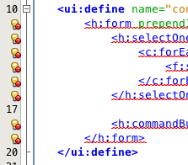

Click on the yellow bulb in the left bar to resolve the namespace prefix-to-URI resolution. This needs to be repeated thrice – for h:, c:, and f: prefixes.

Figure 24: Resolve Namespace Prefix/URI Mapping for h:, c:, f:

**6.7** Right-click on “org.glassfish.movieplex7.client” package, select “New”, “Java Class…”, specify the value as “MovieBackingBean” and click on “Finish”.

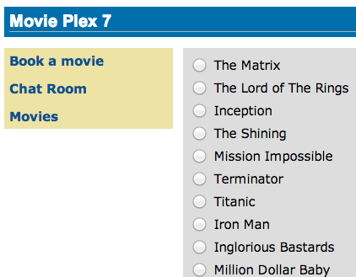

Add the following field:

int movieId;

Add getters/setters by right-clicking on the editor pane and selecting “Insert Code…” (Ctrl + I shortcut on Mac). Select the field and click on “Generate”.

Add @Named and @SessionScoped class-level annotations and implements Serializable.

Figure 25: Movies Page Output

Resolve the imports. Make sure to import javax.enterprise.context.SessionScoped instead of the default javax.faces.bean.SessionScoped.

**6.8** In “template.xhtml”, add the following code in <ui:insert> with name=”left”.  
  
<p/><h:outputLink value="${facesContext.externalContext.requestContextPath}/faces/client/movies.xhtml">Movies</h:outputLink>

Running the project (Fn + F6 shortcut on Mac) and clicking on “Movies” in the left navigation bar shows the output as shown in Figure 25.

The list of all the movies with a radio button next to them is displayed. The output is similar to as shown in 4.12 but it’s using a REST endpoint for querying instead of a traditional EJB/JPA-backed endpoint.

**6.9** In “MovieClientBean”, inject “MovieBackingBean” to read the value of selected movie from the page. Add the following code:

@Inject

MovieBackingBean bean;

**6.10** In “MovieClientBean”, add the following method:

public Movie getMovie() {

Movie m = target

.path("{movie}")

.resolveTemplate("movie", bean.getMovieId())

.request()

.get(Movie.class);

return m;

}

This code reuses the Client and WebTarget instances created in @PostConstruct. It also adds a variable part to the URI of the REST endpoint, defined using {movie}, and binds it to a concrete value using resolveTemplate method. The return type is specified as a parameter to the get method.

**6.11** Create “movie.xhtml” following the steps in 4.2. Change <ui:define> element such that it’s content looks like:

<h1>Movie Details</h1>

<h:form>

<table cellpadding="5" cellspacing="5">

<tr>

<th align="left">Movie Id:</th>

<td>#{movieClientBean.movie.id}</td>

</tr>

<tr>

<th align="left">Movie Name:</th>

<td>#{movieClientBean.movie.name}</td>

</tr>

<tr>

<th align="left">Movie Actors:</th>

<td>#{movieClientBean.movie.actors}</td>

</tr>

</table>

<h:commandButton value="Back" action="movies" />

</h:form>

Click on the yellow-bulb to resolve the namespace prefix-URI mapping for h:. The output values are displayed by calling the getMovie method and using the id, name, and actors property values.

**6.12** Run the project, select “Movies” in the left navigation bar, select a radio button next to any movie, and click on details to see the output as shown in Figure 26.  
  
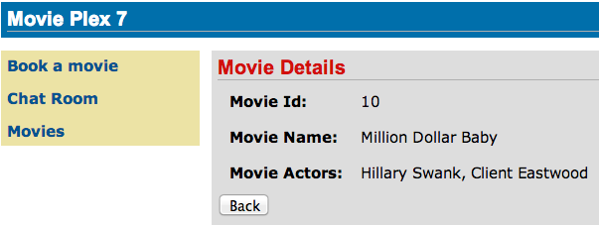

Figure 26: Movie Details Page Output

Click on the “Back” button to select another movie.

**6.13** Add the ability to delete a movie. In “movies.xhtml”, add the following code with the other commandButton.

<h:commandButton  
 value="Delete"  
 action="movies"  
 actionListener="#{movieClientBean.deleteMovie()}"/>

This button displays a label “Delete”, invokes the method deleteMovie from “MovieClientBean”, and then renders “movie.xhtml”.

**6.14** Add the following code to “MovieClientBean”:

@Transactional

public void deleteMovie() {

target

.path("{movieId}")

.resolveTemplate("movieId", bean.getMovieId())

.request()

.delete();

}

This code again reuses the Client and WebTarget instances created in @PostConstruct. It also adds a variable part to the URI of the REST endpoint, defined using {movieId}, and binds it to a concrete value using resolveTemplate method. The URI of the resource to be deleted is prepared and then delete method is called to delete the resource.

The method also specifies @Transactional as a method level annotation. This is a new annotation introduced by JTA 1.2 that provides the ability to control transaction boundaries on CDI managed beans. This provides the semantics of EJB transaction attributes in CDI beans without dependencies such as RMI. This support is implemented via an implementation of a CDI interceptor that conducts the necessary suspending, resuming, etc.

Make sure to resolve the imports.

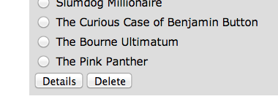Running the project shows the output shown in Figure 27.

Select a movie and click on Delete button. This deletes the movie from the database and refreshes the page.

Figure 27: Delete Button

# 7.0 Add Movie (Java API for JSON Processing)

**Purpose**: Add a new movie. In doing so several new features of Java API for JSON Processing 1.0 will be introduced and demonstrated by using them in the application.

Java API for JSON Processing provides a standard API to parse and generate JSON so that the applications can rely upon a portable API. This API will provide:

* Produce/Consume JSON in a streaming fashion (similar to StAX API for XML)
* Build a Java Object Model for JSON (similar to DOM API for XML)

This section will define a JAX-RS Entity Providers that will allow reading and writing JSON for a Movie POJO. The JAX-RS Client API will request this JSON representation.

JAX-RS Entity Providers supply mapping services between on-the-wire representations and their associated Java types.  Several standard Java types such as String, byte[], javax.xml.bind.JAXBElement, java.io.InputStream, java.io.File, and others have a pre-defined mapping and is required by the specification. Applications may provide their own mapping to custom types using MessageBodyReader and MessageBodyWriter interfaces.

This section will provide the ability to add a new movie to the application. Typically, this functionality will be available after proper authentication and authorization.

**7.1** Right-click on Source Packages, select “New”, “Java Package…”, specify the value as “org.glassfish.movieplex7.json”, and click on “Finish”.

**7.2** Right-click on newly created package, select “New”, “Java Class…”, specify the name as “MovieReader”, and click on “Finish”. Add the following class-level annotations:

@Provider

@Consumes(MediaType.APPLICATION_JSON)

@Provider allows this implementation to be discovered by the JAX-RS runtime during the provider scanning phase. @Consumes indicates that this implementation will consume a JSON representation of the resource.

**7.3** Make the class implements MessageBodyReader<Movie>.

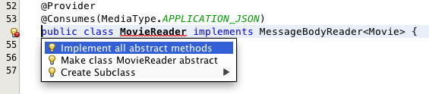

Figure 28: Implement Abstract Methods for MessageBodyReader

Click on the hint (shown as yellow bulb) on the class definition and select “Implement all abstract methods”.

**7.4** Add implementation of the isReadable method as:

@Override  
public boolean isReadable(Class<?> type, Type type1, Annotation[] antns, MediaType mt) {

return Movie.class.isAssignableFrom(type);

}

This method ascertains if the MessageBodyReader can produce an instance of a particular type.

**7.5** Add implementation of the readFrom method as:

@Override  
public Movie readFrom(Class<Movie> type, Type type1, Annotation[] antns, MediaType mt, MultivaluedMap<String, String> mm, InputStream in) throws IOException, WebApplicationException {  
 Movie movie = new Movie();

JsonParser parser = Json.createParser(in);

while (parser.hasNext()) {

switch (parser.next()) {

case KEY_NAME:

String key = parser.getString();

parser.next();

switch (key) {

case "id":

movie.setId(parser.getInt());

break;

case "name":

movie.setName(parser.getString());

break;

case "actors":

movie.setActors(parser.getString());

break;

default:

break;

}

break;

default:

break;

}

}

return movie;

}

This code reads a type from the input stream in. JsonParser, a streaming parser, is created from the input stream. Key values are read from the parser and a Movie instance is populated and returned.

Resolve the imports.

**7.6** Right-click on newly created package, select “New”, “Java Class…”, specify the name as “MovieWriter”, and click on “Finish”. Add the following class-level annotations:

@Provider

@Produces(MediaType.APPLICATION_JSON)

@Provider allows this implementation to be discovered by the JAX-RS runtime during the provider scanning phase. @Produces indicates that this implementation will produce a JSON representation of the resource.

**7.7** Make the class implements MessageBodyWriter<Movie>.

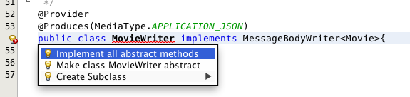

Figure 29: Implement Abstract Methods for MessageBodyWriter

Click on the hint (show as yellow bulb) on the class definition and select “Implement all abstract methods”.

**7.8** Add implementation of the isWritable method as:

public boolean isWriteable(Class<?> type, Type type1, Annotation[] antns, MediaType mt) {

return Movie.class.isAssignableFrom(type);

}

This method ascertains if the MessageBodyWriter supports a particular type.

**7.9** Add implementation of the getSize method as:

public long getSize(Movie t, Class<?> type, Type type1, Annotation[] antns, MediaType mt) {

return -1;

}

Originally, this method was called to ascertain the length in bytes of the serialized form of t. In JAX-RS 2.0, this method is deprecated and the value returned by the method is ignored by a JAX-RS runtime. All MessageBodyWriter implementations are advised to return -1.

**7.10** Add implementation of the writeTo method as:

public void writeTo(Movie t, Class<?> type, Type type1, Annotation[] antns, MediaType mt, MultivaluedMap<String, Object> mm, OutputStream out) throws IOException, WebApplicationException {

JsonGenerator gen = Json.createGenerator(out);

gen.writeStartObject()

.write("id", t.getId())

.write("name", t.getName())

.write("actors", t.getActors())

.writeEnd();

gen.flush();

}

This method writes a type to an HTTP message. JsonGenerator writes JSON data to an output stream in a streaming way. Overloaded write methods are used to write different data types to the stream.

Resolve the imports.

**7.11** In “Web Pages”, “client” folder, create “addmovie.xhtml” following the steps in 4.2. Change <ui:define> element (“top” and “left” elements need to be removed) such that it’s content looks like:

<h1>Add a New Movie</h1>

<h:form>

<table cellpadding="5" cellspacing="5">

<tr>

<th align="left">Movie Id:</th>

<td><h:inputText value="#{movieBackingBean.movieId}"/></td>

</tr>

<tr>

<th align="left">Movie Name:</th>

<td><h:inputText value="#{movieBackingBean.movieName}"/> </td>

</tr>

<tr>

<th align="left">Movie Actors:</th>

<td><h:inputText value="#{movieBackingBean.actors}"/></td>

</tr>

</table>

<h:commandButton value="Add" action="movies"  
 actionListener="#{movieClientBean.addMovie()}"/>

</h:form>

This code creates a form to accept input of id, name, and actors of a movie. These values are bound to fields in “MovieBackingBean”. The click of command button invokes the addMovie method from “MovieClientBean” and then renders “movies.xhtml”.

Click on the hint (show as yellow bulb) to resolve the namespace prefix/URI mapping as shown.

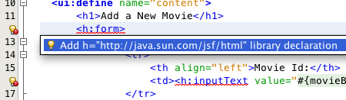

Figure 30: Resolving Namespace Prefix/URI Mapping for h:

**7.12** Add movieName and actors field to “MovieBackingBean” as:

String movieName;

String actors;

Generate getters and setters.

**7.13** Add the following code to “movies.xhtml”

<h:commandButton value="New Movie" action="addmovie" />

along with rest of the <commandButton>s.

**7.14** Add the following method in “MovieClientBean”:

public void addMovie() {

Movie m = new Movie();

m.setId(bean.getMovieId());

m.setName(bean.getMovieName());

m.setActors(bean.getActors());

target

.register(MovieWriter.class)

.request()

.post(Entity.entity(m, MediaType.APPLICATION_JSON));

}

This method creates a new Movie instance, populates it with the values from the backing bean, and POSTs the bean to the REST endpoint. The register method registers a MovieWriter that provides conversion from the POJO to JSON. Media type of “application/json” is specified using MediaType.APPLICATION_JSON.

Resolve the imports.

**7.15** Run the project to see the updated main page as:

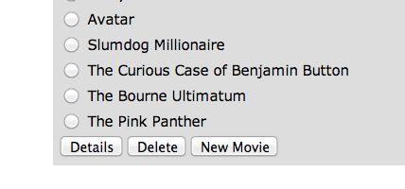

Figure 31: New Movie Button Page Output

A new movie can be added by clicking on “New Movie” button.

**7.16** Enter the details as shown:  
  
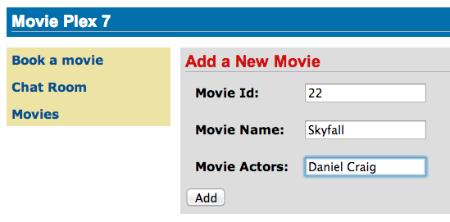

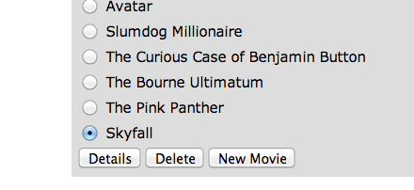Figure 32: Add a New Movie Page Output

Click on “Add” button. The “Movie Id” value has to be greater than 20 otherwise the primary key constraint will be violated. The table definition may be updated to generate the primary key based upon a sequence; however this is not done in the application.

Figure 33: New Movie Added Page Output

The updated page looks like as shown in Figure 33.

Note that the newly added movie is now displayed.

# 8.0 Ticket Sales (Batch Applications for the Java Platform)

**Purpose**: Read the total sales for each show and populate the database. In doing so several new features of Java API for Batch Processing 1.0 will be introduced and demonstrated by using them in the application.

Batch Processing is execution of series of "jobs" that is suitable for non-interactive, bulk-oriented and long-running tasks. Batch Applications for the Java Platform (JSR 352) will define a programming model for batch applications and a runtime for scheduling and executing jobs. The core concepts of Batch Processing are:

* A **Job** is an instance that encapsulates an entire batch process. A job is typically put together using a Job Specification Language and consists of multiple steps. The Job Specification Language for JSR 352 is implemented with XML and is referred as "Job XML".
* A **Step** is a domain object that encapsulates an independent, sequential phase of a job. A step contains all of the information necessary to define and control the actual batch processing.
* **JobOperator** provides an interface to manage all aspects of job processing, including operational commands, such as start, restart, and stop, as well as job repository commands, such as retrieval of job and step executions.
* **JobRepository** holds information about jobs current running and jobs that run in the past. JobOperator provides access to this repository.
* Reader-Processor-Writer pattern is the primary pattern and is called as **Chunk-oriented Processing**. In this, **ItemReader** reads one item at a time, **ItemProcessor** processes the item based upon the business logic, such as calculate account balance and hands it to **ItemWriter** for aggregation. Once the 'chunk' numbers of items are aggregated, they are written out, and the transaction is committed.

This section will read the cumulative sales for each show from a CSV file and populate them in a database.

**8.1** Right-click on Source Packages, select “New”, “Java Package…”, specify the value as “org.glassfish.movieplex7.batch”, and click on “Finish”.

**8.2** Right-click on newly created package, select “New”, “Java Class…”, specify the name as “SalesReader”. Change the class definition and add:

extends AbstractItemReader

AbstractItemReader is an abstract class that implements ItemReader interface. The ItemReader interface defines methods that read a stream of items for chunk processing. This reader implementation returns a String item type as indicated in the class definition.

Add @Named as a class-level annotations and it allows the bean to be injected in Job XML. Add @Dependent as another class-level annotation to mark this bean as a bean defining annotation so that this bean is available for injection.

Resolve the imports.

**8.3** Add the following field:

private BufferedReader reader;

Override open() method to initialize the reader:

public void open(Serializable checkpoint) throws Exception {  
 reader = new BufferedReader(

new InputStreamReader(

Thread.currentThread()

.getContextClassLoader()

.getResourceAsStream("META-INF/sales.csv")));

}

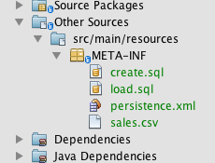

Figure 34: sales.csv

This method initializes a BufferedReader from “META-INF/sales.csv” that is bundled with the application and is shown in Figure 34.

Sampling of the first few lines from “sales.csv” is shown below:

1,500.00

2,660.00

3,80.00

4,470.00

5,1100.x0

Each line has a show identifier comma separated by the total sales for that show. Note that the last line (5th record in the sample) has an intentional typo. In addition, 17th record also has an additional typo. The lab will use these lines to demonstrate how to handle parsing errors.

**8.4** Override the following method from the abstract class:

@Override

public String readItem() {

String string = null;

try {

string = reader.readLine();

} catch (IOException ex) {

ex.printStackTrace();

}

return string;

}

The readItem method returns the next item from the stream. It returns null to indicate end of stream. Note end of stream indicates end of chunk, so the current chunk will be committed and the step will end.

Resolve the imports.

**8.5** Right-click on “org.glassfish.movieplex7.batch” package, select “New”, “Java Class…”, specify the name as “SalesProcessor”. Change the class definition and add:

implements ItemProcessor

ItemProcessor is an interface that defines a method that is used to operate on an input item and produce an output item. This processor accepts a String input item from the reader, SalesReader in our case, and returns a Sales instance to the writer (coming shortly). Sales is the pre-packaged JPA entity with the application starter source code.

Add @Named and @Dependent as class-level annotations so that it allows the bean to be injected in Job XML.

Resolve the imports.

**8.6** Add implementation of the abstract method from the interface as:

@Override

public Sales processItem(Object s) {

Sales sales = new Sales();

StringTokenizer tokens = new StringTokenizer((String)s, ",");

sales.setId(Integer.parseInt(tokens.nextToken()));

sales.setAmount(Float.parseFloat(tokens.nextToken()));

return sales;

}

This method takes a String parameter coming from the SalesReader, parses the value, populates them in the Sales instance, and returns it. This is then aggregated with the writer.

The method can return null indicating that the item should not be aggregated. For example, the parsing errors can be handled within the method and return null if the values are not correct. However this method is implemented where any parsing errors are thrown as exception. Job XML can be instructed to skip these exceptions and thus that particular record is skipped from aggregation as well (shown later).

Resolve the imports.

**8.7** Right-click on “org.glassfish.movieplex7.batch” package, select “New”, “Java Class…”, specify the name as “SalesWriter”. Change the class definition and add:

extends AbstractItemWriter

AbstractItemWriter is an abstract class that implements ItemWriter interface. The ItemWriter interface defines methods that write to a stream of items for chunk processing. This writer writes a list of Sales items.

Add @Named and @Dependent as class-level annotations so that it allows the bean to be injected in Job XML.

Resolve the imports.

**8.8** Inject EntityManager as:

@PersistenceContext EntityManager em;  
  
Override the following method from the abstract class:

@Override

@Transactional

public void writeItems(List list) {

for (Sales s : (List<Sales>)list) {

em.persist(s);

}

}

Batch runtime aggregates the list of Sales instances returned from the SalesProessor and makes it available as List in this method. This method iterates over the list and persist each item in the database.

The method also has a @Transactional annotation. This is a new annotation introduced in the Java Transaction API (JSR 907). It can be used by applications to control transaction boundaries on CDI managed beans, as well as classes defined as managed beans by the Java EE specification such as servlets, JAX-RS resource classes, and JAX-WS service endpoints, declaratively. This provides the semantics of EJB transaction attributes in CDI without dependencies such as RMI. This support is implemented via an implementation of a CDI interceptor that conducts the necessary suspending, resuming, etc.

In this case, a transaction is automatically started before the method is called, committed if no checked exceptions are thrown, and rolled back if runtime exceptions are thrown. This behavior can be overridden using rollbackOn and dontRollbackOn attributes of the annotation.

Resolve the imports.

**8.9** Create Job XML that defines the job, step, and chunk.

In “Files” tab, expand the project -> “src” -> “main” -> “resources”, right-click on “resources”, “META-INF”, select “New”, “Folder…”, specify the name as “batch-jobs”, and click on “Finish”.

Right-click on the newly created folder, select “New”, “Other…”, select “XML”, “XML Document”, click on “Next >”, give the name as “eod-sales”, click on “Next”, take the default, and click on “Finish”.

Replace contents of the file with the following:  
  
<job id="endOfDaySales" xmlns=”http://xmlns.jcp.org/xml/ns/javaee” version=”1.0”>

<step id=”populateSales” >

<chunk item-count=”3” skip-limit=”5”>

<reader ref=”salesReader”/>

<processor ref=”salesProcessor”/>

<writer ref=”salesWriter”/>

<skippable-exception-classes>

<include class=”java.lang.NumberFormatException”/>

</skippable-exception-classes>

</chunk>

</step>

</job>

This code shows that the job has one step of chunk type. The <reader>, <processor>, and <writer> elements define the CDI bean name of the implementations of ItemReader, ItemProcessor, and ItemWriter interfaces. The item-count attribute defines that 3 items are read/processed/aggregated and then given to the writer. The entire reader/processor/writer cycle is executed within a transaction. The <skippable-exception-classes> element specifies a set of exceptions to be skipped by chunk processing.

CSV file used for this lab has intentionally introduced couple of typos that would generate NumberFormatException. Specifying this element allows skipping the exception, ignore that particular element, and continue processing. If this element is not specified then the batch processing will halt. The skip-limit attribute specifies the number of exceptions a step will skip.

**8.10** Lets invoke the batch job.   
  
Right-click on “org.glassfish.movieplex7.batch” package, select “New”, “Session Bean…”. Enter the name as “SalesBean” and click on “Finish” button.

Add the following code to the bean:

public void runJob() {

try {

JobOperator jo = BatchRuntime.getJobOperator();

long jobId = jo.start("eod-sales", new Properties());

System.out.println("Started job: with id: " + jobId);

} catch (JobStartException ex) {

ex.printStackTrace();

}

}

This method uses BatchRuntime to get an instance of JobOperator, which is then used to start the job. JobOperator is the interface for operating on batch jobs. It can be used to start, stop, and restart jobs. It can additionally inspect job history, to discover what jobs are currently running and what jobs have previously run.

Add @Named as class-level annotation and it allows the bean to be injectable in an EL expression.

Resolve the imports.

**8.11** Inject EntityManager in the class as:  
  
@PersistenceContext EntityManager em;

and add the following method:

public List<Sales> getSalesData() {

return em.createNamedQuery("Sales.findAll", Sales.class)  
 .getResultList();

}

This method uses a pre-defined @NamedQuery to query the database and return all the rows from the table.

Resolve the imports.

**8.12** Add the following code in “template.xhtml” along with other <outputLink>s:  
  
<p/><h:outputLink value="${facesContext.externalContext.requestContextPath}/faces/batch/sales.xhtml">Sales</h:outputLink>

**8.13** Right-click on “Web Pages”, select “New”, “Folder…”, specify the name as “batch”, and click on “Finish”. Create “sales.xhtml” in that folder following the steps explained in 4.2.

Copy the following code inside <ui:define> with name=”content”:

<h1>Movie Sales</h1>

<h:form>

<h:dataTable value="#{salesBean.salesData}" var="s" border="1">

<h:column>

<f:facet name="header">

<h:outputText value="Show ID" />

</f:facet>

#{s.id}

</h:column>

<h:column>

<f:facet name="header">

<h:outputText value="Sales" />

</f:facet>

#{s.amount}

</h:column>

</h:dataTable>

<h:commandButton value="Run Job" action="sales" actionListener="#{salesBean.runJob()}"/>

<h:commandButton value="Refresh" action="sales" />

</h:form>

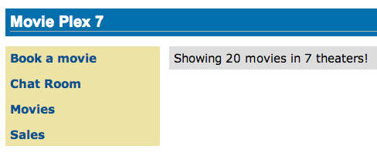  
This code displays the show identifier and sales from that show in a table by invoking SalesBean.getSalesData(). First command button allows invoking the job that processes the CSV file and populates the database. The second command button refreshes the page.

Right-click on the yellow bulb to fix namespace prefix/URI mapping. This needs to be repeated for h: and f: prefix.

**8.14** Run the project to see the output as shown in Figure 35.

Figure 35: Sales Link

Notice, a new “Sales” entry is displayed in the left navigation bar.

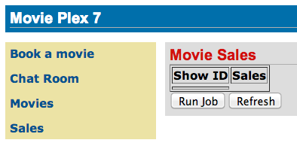

Figure 36: Movie Sales Page Output

**8.15** Click on “Sales” to see the output as shown in Figure 36.

The empty table indicates that there is no sales data in the database.

**8.16** Click on “Run Job” button to initiate data processing of CSV file. Look for Wait for a couple of seconds for the processing to finish and then click on “Refresh” button to see the updated output as shown in Figure 37.

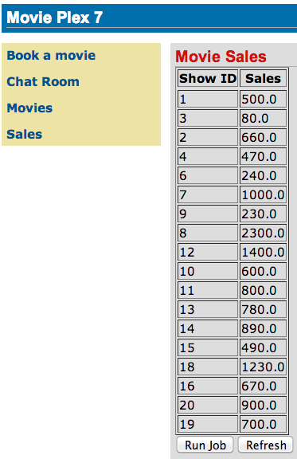

Figure 37: Movie Sales Details Page Output

Now the table is populated with the sales data.

Note that record 5 is missing from the table, as this records did not have correct numeric entries for the sales total. The Job XML for the application explicitly mentioned to skip such errors.

# 9.0 Movie Points (Java Message Service 2)

**Purpose**: Customers accrue points for watching a movie.

Java Message Service 2.0 allows sending and receiving messages between distributed systems. JMS 2 introduced several improvements over the previous version.

This section will provide a page to simulate submission of movie points accrued by a customer. These points are submitted to a JMS queue that is then read synchronously by another bean. JMS queue for further processing, possibly storing in the database using JPA.

**9.1** Right-click on Source Packages, select “New”, “Java Package…”, specify the value as “org.glassfish.movieplex7.points”, and click on “Finish”.

**9.2** Right-click on newly created package, select “New”, “Java Class…”, specify the name as “SendPointsBean”. Change the class definition and add:

implements Serializable

Add the following class-level annotations:

@Named

@SessionScoped

This makes the bean to be EL-injectable and automatically activated and passivated with the session.

**9.3** Typically a message to a JMS Queue is sent after the customer has bought the tickets. Another bean will then retrieve this message and update the points for that customer. This allows the two systems, one generating the data about tickets purchased and the other about crediting the account with the points, completely decoupled.

This lab will mimic the sending and consuming of a message by an explicit call to the bean from a JSF page.

Add the following field to the class:

@NotNull

@Pattern(regexp = "^\\d{2},\\d{2}", message = "Message format must be 2 digits, comma, 2 digits, e.g. 12,12")

private String message;

This field contains the message sent to the queue. This field’s value is bound to an inputText in a JSF page (created later). It also has a Bean Validation constraint that enables validation of data on form submit. It requires the data to consists of 2 numerical digits, followed by a comma, and then 2 more numerical digits. If the message does not meet the validation criteria then the error message to be displayed is specified using message attribute.

This could be thought as conveying the customer identifier and the points accrued by that customer.

Generate getter/setters for this field. Right-click in the editor pane, select “Insert Code” (Ctrl + I shortcut on Mac), select “Getter and Setter…”, select the field, and click on “Generate”.

**9.4** Add the following code to the class:

@Inject

JMSContext context;

@Resource(mappedName = "java:global/jms/pointsQueue")

Queue pointsQueue;

public void sendMessage() {

System.out.println("Sending message: " + message);

context.createProducer().send(pointsQueue, message);

}

The Java EE Platform requires a pre-configured JMS connection factory under the JNDI name java:comp/DefaultJMSConnectionFactory. If no connection factory is specified then the pre-configured connection factory is used. In a Java EE environment, where CDI is enabled by default anyway, a container-managed JMSContext can be injected as:  
  
@Inject  
JMSContext context;

This code uses the default factory to inject an instance of container-managed JMSContext.

JMSContext is a new interface introduced in JMS 2. This combines in a single object the functionality of two separate objects from the JMS 1.1 API: a Connection and a Session.

When an application needs to send messages it use the createProducer method to create a JMSProducer that provides methods to configure and send messages. Messages may be sent either synchronously or asynchronously.

When an application needs to receive messages it uses one of several createConsumer or createDurableConsumer methods to create a JMSConsumer. A JMSConsumer provides methods to receive messages either synchronously or asynchronously.

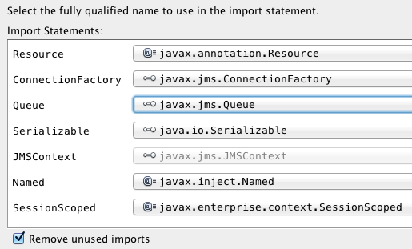

All messages are then sent to a Queue instance (created later) identified by java:global/jms/pointsQueue JNDI name. The actual message is obtained from the value entered in the JSF page and bound to the message field.

Resolve the imports.

Make sure Queue class is imported from javax.jms.Queue instead of the default java.util.Queue as shown in Figure 38.

Figure 38: Resolve Imports for Queue

Click on “OK”.

**9.5** Right-click on “org.glassfish.movieplex7.points” package, select “New”, “Java Class…”, specify the name as “ReceivePointsBean”. Change the class definition and add:

implements Serializable

Add the following class-level annotations:

@JMSDestinationDefinition(name = "java:global/jms/pointsQueue",

interfaceName = "javax.jms.Queue”)

@Named

@SessionScoped

This allows the bean to refered from an EL expression. It also activates and passivates the bean with the session.

JMSDestinationDefinition is a new annotations introduced in JMS 2. It is used by the application to provision the required resources and allow an application to be deployed into a Java EE environment with minimal administrative configuration. This code will create Queue with the JNDI name java:global/jms/pointsQueue.

**9.6** Add the following code to the class:

@Inject

JMSContext context;

@Resource(mappedName="java:global/jms/pointsQueue")

Queue pointsQueue;

public String receiveMessage() {

String message = context.createConsumer(pointsQueue).receiveBody(String.class);

System.out.println("Received message: " + message);

return message;

}

This code is very similar to SendPointsBean. createConsumer method creates JMSConsumer which is then used to synchronously receive a message.

**9.7** Add the following method to the class:

public int getQueueSize() {

int count = 0;

try {

QueueBrowser browser = context.createBrowser(pointsQueue);

Enumeration elems = browser.getEnumeration();

while (elems.hasMoreElements()) {

elems.nextElement();

count++;

}

} catch (JMSException ex) {

ex.printStackTrace();

}

return count;

}

This code creates a QueueBrowser to look at the messages on a queue without removing them. It calculates and returns the total number of messages in the queue.

Resolve the imports.

**9.8** Right-click on “Web Pages”, select “New”, “Folder…”, specify the name as “points”, and click on “Finish”. Create “points.xhtml” in that folder following the steps explained in 4.2.

Copy the following code inside <ui:define> with name=”content”:

<h1>Points</h1>

<h:form>

Queue size:   
 <h:outputText value="#{receivePointsBean.queueSize}"/><p/>

<h:inputText value="#{sendPointsBean.message}"/>

<h:commandButton  
 value="Send Message"  
 action="points"   
 actionListener="#{sendPointsBean.sendMessage()}"/>

</h:form>

<h:form>

<h:commandButton  
 value="Receive Message"  
 action="points"   
 actionListener="#{receivePointsBean.receiveMessage()}"/>

</h:form>

Click on the yellow bulb to resolve namespace prefix/URI mapping for h: prefix.

This page displays the number of messages in the current queue. It provides a text box for entering the message that can be sent to the queue. The first command button invokes sendMessage method from SendPointsBean and refreshes the page. Updated queue count, incremented by 1 in this case, is displayed. The second command button invokes receiveMessage method from ReceivePointsBean and refreshes the page. The queue count is updated again, decremented by 1 in this case.

If the message does not meet the validation criteria then the error message is displayed on the screen.

**9.9** Add the following code in “template.xhtml” along with other <outputLink>s:  
  
<p/><h:outputLink value=" ${facesContext.externalContext.requestContextPath}/faces/points/points.xhtml">Points</h:outputLink>

**9.10** Run the project. The update page looks like as shown:  
  
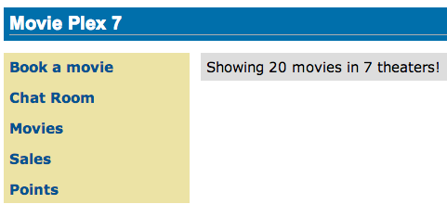

Figure 39: Points Link

Click on “Points” to see the output as:  
  
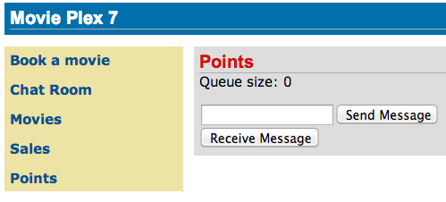

Figure 40: Points Page Default Output

The output shows that the queue has 0 messages. Enter a message “1212” in the text box and click on “Send Message” to see the output as shown in Figure 41.  
  
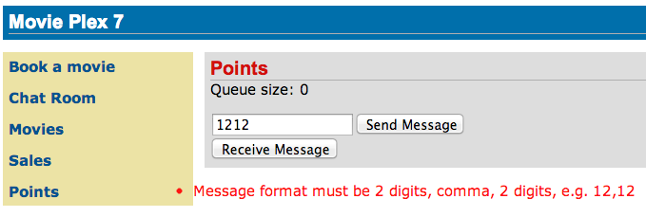

Figure 41: Bean Validation Error Message

This message is not meeting the validation criteria and so the error message is displayed.

Enter a message as “12,12” in the text box and click on “Send Message” button to see the output as:  
  
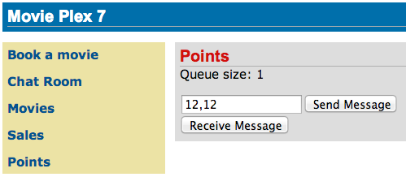

Figure 42: Points Page Output: 1 Message in Queue

The updated count now shows that there is 1 message in the queue.

Click on “Receive Message” button to see output as:  
  
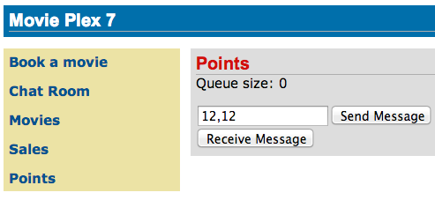

Figure 43: Points Page Output: 0 Message in Queue

The updated count now shows that the message has been consumed and the queue has 0 messages.

Click on “Send Message” 4 times to see the output as:

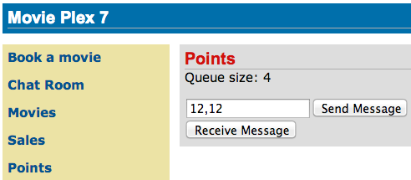

Figure 44: Points Page Output: 4 Messages in Queue

The updated count now shows that the queue has 4 messages.

Click on “Receive Message” 2 times to see the output as:  
  
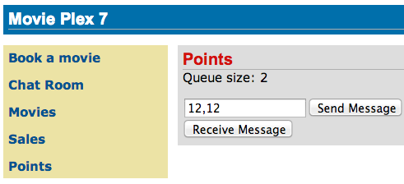

Figure 45: Points Page Output: 2 Messages in Queue

The count is once again updated to reflect the 2 consumed and 2 remaining messages in the queue.

# 10.0 Conclusion

This hands-on lab built a trivial 3-tier web application using Java EE 7 and demonstrated the following features of the platform:

* Java EE 7 Platform (JSR 342)
  + Maven coordinates
  + Default DataSource
  + Default JMSConnectionFactory
* Java Persistence API 2.1 (JSR 338)
  + Schema generation properties
* Java API for RESTful Web Services 2.0 (JSR 339)
  + Client API
  + Custom Entity Providers
* Java Message Service 2.0 (JSR 343)
  + Default ConnectionFactory
  + Injecting JMSContext
  + Synchronous message send and receive
* JavaServer Faces 2.2 (JSR 344)
  + Faces Flow
* Contexts and Dependency Injection 1.1 (JSR 346)
  + Injection of beans
* Bean Validation 1.1 (JSR 349)
  + Integration with JavaServer Faces
* Batch Applications for the Java Platform 1.0 (JSR 352)
  + Chunk-style processing
  + Exception handling
* Java API for JSON Processing 1.0 (JSR 353)
  + Streaming API for generating JSON
  + Streaming API for consuming JSON
* Java API for WebSocket 1.0 (JSR 356)
  + Annotated server endpoint
  + JavaScript client
* Java Transaction API 1.2 (JSR 907)
  + @Transactional

Hopefully this has raised your interest enough in trying out Java EE 7applications using GlassFish 4.

Send us feedback at users@glassfish.java.net.

# 11.0 Troubleshooting

**11.1** How can I start/stop/restart GlassFish from within the IDE ?  
  
In the “Services” tab, right-click on “GlassFish Server 4”. All the commands to start, stop, and restart are available from the pop-up menu. The server log can be viewed by clicking on “View Server Log” and web-based administration console can be seen by clicking on “View Admin Console”.

**11.2** I accidentally closed the GlassFish output log window. How do I bring it back ?

In “Services” tab of NetBeans, expand “Servers”, choose the GlassFish node, and select “View Domain Server Log”.

# 12.0 Acknowledgements

The following GlassFish community members graciously reviewed this hands-on lab:

* Antonio Goncalves (@agoncal)
* Markus Eisele (@myfear)
* Craig Sharpe (@dapugs)
* Marcus Vinicius Margarites (@mvfm)
* David Delabasse (@delabasse)
* John Clingan (@jclingan)

Thank you very much for providing the valuable feedback!

# 13.0 Completed Solutions

The completed solution can be downloaded from [glassfish.org/hol/movieplex7-solution.zip](http://glassfish.org/hol/movieplex7-solution.zip).

# 14.0 TODO

1. Update the namespace from java.sun.com -> xmlns.jcp.org. Waiting for runtime and tooling to sync up.
2. Default Enabling of CDI.
3. Fix hyperlinking in the generated PDF.
4. Add the following use cases:
   1. Concurrency Utilities for Java EE
   2. WebSocket Java Client
   3. JAX-RS Logging Filter
5. Replace @Stateless with @Transactional. Is it possible?
6. Disable errors in persistence.xml
7. How to override .m2/repository in NetBeans?

# Revision History

1. Incorporating typos, missing dialog boxes, and code optimizations received during DevoxxUK.
2. Updating instructions after some of the bugs have been fixed.
3. Using the final GlassFish 4 build (b89).
4. Remove beans.xml dependency and pointed to the final release bits.

# Appendix

## Appendix A: Configure GlassFish 4 in NetBeans IDE

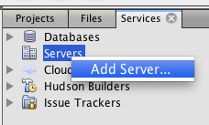A.1 In NetBeans, click on the “Services” tab.  
  
A.2 Right-click on Servers, choose “Add Server...” in the pop-up menu.

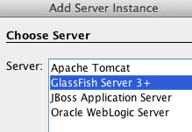A.3 Select “GlassFish Server 3+” in the Add Server Instance wizard, set the name to “GlassFish 4.0” and click “Next >”.

A.4 Click on “Browse …” and browse to where you unzipped the GlassFish build and point to the “glassfish4” directory that got created when you unzipped the above archive. Click on “Finish”.