PROJECT DOCUMENTATION
User and Entity Behaviour Analytics (UEBA) for Internal Threat Identification
A Cloud-Hosted, Real-Time Insider Threat Detection Platform using Unsupervised Machine Learning and Generative AI Explainability
Final Year Project — B.E. Computer Science and Engineering (Cyber Security)
Sri Krishna College of Engineering and Technology, Coimbatore (Anna University)
Batch Members
Sanjay Ruban — 727723EUCY050
Dharshan Balu T — 727723EUCY018
Denzil Abraham R — 727723EUCY015
Amarnath Sekar — 727723EUCY007
Supervisor: Ms. Anitha G
Document version 1.0 | Prepared following the Zeroth Review

1. Abstract
Insider threats — malicious, negligent, or compromised users acting within an organisation's own network — are notoriously difficult for traditional Security Information and Event Management (SIEM) systems to catch, because the activity often looks like ordinary, authorised traffic. Rule-based detection ("alert if a user downloads more than 500 files") either misses slow, low-volume exfiltration or drowns analysts in false positives. This project builds a User and Entity Behaviour Analytics (UEBA) platform that learns what "normal" looks like for each user from unlabelled activity logs, flags statistically significant deviations using an unsupervised Isolation Forest model, and — going beyond a bare anomaly score — layers in peer-group baselining, lightweight rule-based corroboration, an analyst feedback loop, and a generative-AI narrator that turns a raw risk score into a plain-English explanation a Security Operations Centre (SOC) analyst can act on immediately.
The system is built as a real-time pipeline: a log simulator emulates enterprise user activity, a FastAPI service ingests events into Redis Streams, a scoring worker computes a blended risk score per event, results are persisted in a TimescaleDB-backed PostgreSQL database, and a React dashboard renders live alerts over WebSockets. The document below is a build-ready specification: architecture, data model, module boundaries, API contracts, ML methodology, an enhanced (but still final-year-scoped) feature set, a testing plan, and a phase-wise implementation schedule — everything needed to take this from a review presentation to a working, demonstrable system.

2. Introduction

2.1 Background
Digital transformation has made the human user the weakest link in enterprise cybersecurity. Perimeter defences (firewalls, antivirus, IDS/IPS) are built to keep outsiders out — they have very little to say about a legitimate, authenticated user who is misbehaving, whether through malice, negligence, or a compromised credential. Detecting this class of threat requires watching behaviour over time, not just matching signatures.

2.2 Problem Statement
Traditional SIEM systems fail to detect novel insider threats, compromised accounts, and subtle data exfiltration because they rely on static, rule-based thresholds and signature matching. This produces two failure modes at once: zero-day blindness against "low-and-slow" attacks that never cross a hard-coded threshold, and alert fatigue from thousands of false positives a day, which causes analysts to genuinely miss the real alerts buried in the noise.

2.3 Why This Matters
Malicious insider activity is specifically designed to resemble legitimate traffic, so the organisations most exposed are the ones that most need continuous, adaptive, and explainable monitoring. The financial and regulatory cost of a missed insider incident (data leakage, compliance penalties, loss of trust) is significant, and it scales with how long the behaviour goes undetected — which is precisely what rule-based systems are bad at shortening.

2.4 Sustainable Development Goals Alignment
- SDG 9 — Industry, Innovation and Infrastructure: builds resilient digital infrastructure using AI-driven security tooling to protect enterprise data.
- SDG 16 — Peace, Justice and Strong Institutions: reduces cybercrime and data theft, helping institutions safeguard sensitive information from insider threats.
- SDG 8 — Decent Work and Economic Growth: protects enterprise continuity and economic productivity from the financial impact of breaches.

3. Literature Review
The reviewed body of work converges on one theme: supervised User and Entity Behaviour Analytics (UEBA) models struggle because labelled insider-threat data is scarce — real incidents are rare, sensitive, and rarely tagged at the event level. Unsupervised anomaly detection is therefore the dominant direction, but the surveyed literature also surfaces three recurring gaps this project is designed to address directly:
- Scalability: many published approaches are validated on offline, batch datasets rather than real-time, high-throughput streams — this project uses Redis Streams and a FastAPI ingestion layer specifically to test the pipeline against streaming load.
- Class imbalance: anomalous events are naturally a tiny fraction of total traffic, which biases naive thresholding — addressed here through per-peer-group baselining rather than one global threshold.
- Interpretability: anomaly scores alone are a "black box" to a SOC analyst; several surveyed papers flag this as the main adoption barrier — addressed here through the GenAI explanation layer and MITRE ATT&CK technique tagging.

3.1 Key References
Reference | Source
[1] Multazam & Widiarto (2023) | Frontiers in Computer Science
[2] Ahmad (2025) | TULTECH Journals
[3] Coscia et al. (2024) | Frontiers in Big Data
[4] Bin Sarhan & Altwaijry (2023) | Journal of King Saud University
[5] Pulyala (2023) | Cybersecurity Insights
[6] Landmesser & Vommi (2023) | Journal of Information Security
[7] Mochurad et al. (2023) | Cybernetics & IT
[8] Fysarakis et al. (2023) | Computer Networks
[9] Datta et al. (2021) | Data Science Journal
[10] Al-Mhiqani et al. (2020) | IEEE Access

Further reading used to shape the operational design: the NIST Risk Management Framework's continuous monitoring guidelines, and the MITRE ATT&CK framework's insider-threat tactic catalogue (used in Section 8.4 to tag alerts).

4. Objectives

4.1 Primary Objective
Design and build a cloud-hosted, real-time UEBA platform that uses unsupervised machine learning to detect and surface anomalous user behaviour, with enough context (peer comparison, plain-English reasoning, MITRE mapping) that a SOC analyst can triage an alert in seconds rather than minutes.

4.2 Secondary Objectives
- Ingestion pipeline: a high-throughput FastAPI + Redis Streams pipeline that accepts simulated enterprise log events with sub-second buffering.
- Detection model: an unsupervised Scikit-learn Isolation Forest, extended with peer-group baselining and rule-based corroboration, to profile per-user and per-role behaviour.
- Explainability: an LLM integration that converts a numeric risk score and its top contributing features into a short, plain-English threat narrative with a suggested next action.
- Analyst workflow: a triage lifecycle (New → Acknowledged → Investigating → Resolved/False Positive) with an audit trail and a feedback mechanism that feeds back into detection thresholds.

4.3 Measurable Outcomes
- Latency: a React dashboard that renders new risk-score alerts via WebSockets within roughly one second of ingestion.
- Precision: a demonstrably low false-positive rate on the simulated dataset, evaluated before vs. after peer-group baselining and analyst feedback are enabled (Section 11).
- Coverage: detection across at least four insider-threat behaviour categories — off-hours access, abnormal data volume, privilege/role anomalies, and unusual access patterns (first-time resource access, impossible-travel logins).

5. Scope and Feasibility
This is a genuinely buildable final-year scope for a four-member team across two project phases — every feature below is either a well-documented open-source library call or a small, bounded engineering task. Nothing here requires production enterprise data, a live SOC, or novel research; the contribution is in the integration (hybrid scoring + peer baselining + GenAI explainability + analyst feedback loop) rather than in inventing a new detection algorithm.

5.1 In Scope
- A synthetic log simulator generating realistic user activity for ~50–200 simulated users across 3–5 departments/roles.
- Real-time ingestion, scoring, storage, and dashboard visualisation of that simulated traffic.
- Unsupervised anomaly detection (Isolation Forest) with peer-group baselines and simple rule-based heuristics blended into one risk score.
- An LLM-generated explanation per alert, alert triage workflow, RBAC (Admin/Analyst), notifications, and exportable incident reports.
- Dockerised local deployment plus an optional low-cost cloud deployment (Railway + Vercel) for the demo.

5.2 Out of Scope (explicitly, to protect feasibility)
- Integration with real enterprise SIEM/EDR products or live production log feeds.
- Online/continuous model retraining in real time — retraining is a scheduled batch job (e.g., nightly), not a streaming learner.
- Graph-based lateral-movement detection, UEBA for non-human entities (service accounts, IoT), and multi-tenant SaaS support — listed instead as future scope (Section 14).
- Formal red-team validation against a real attacker; evaluation is against injected synthetic anomalies in the simulator.

6. System Architecture
The system is organised as a streaming pipeline with a clear separation between ingestion, detection, storage, and presentation, so each layer can be built and tested independently by a different team member.
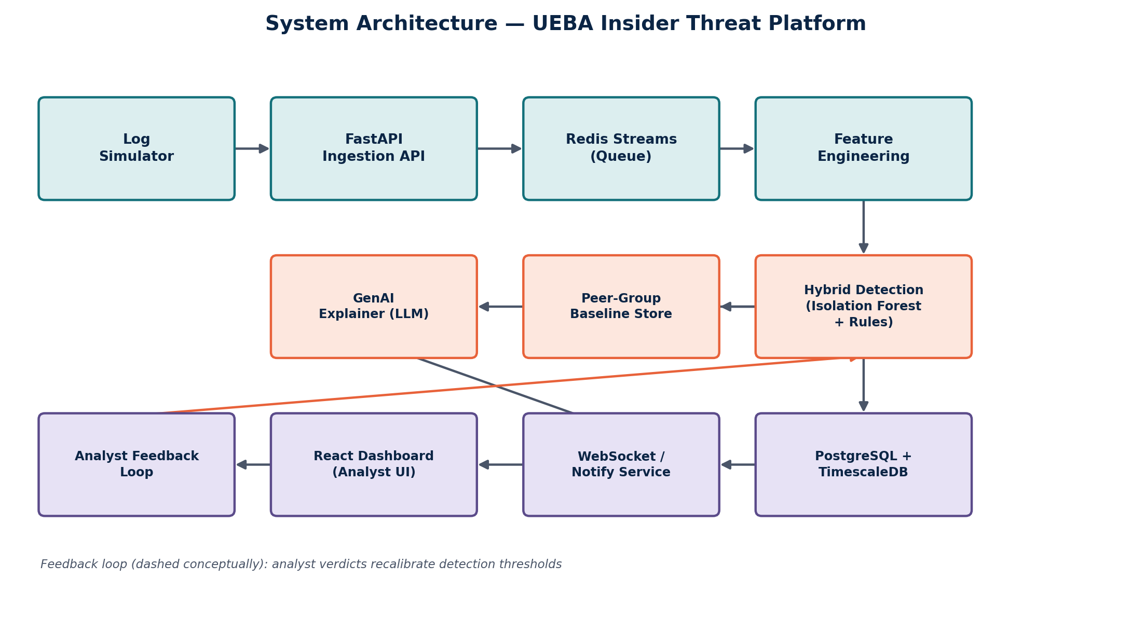
Figure 1 — End-to-end system architecture, including the peer-group baseline store and the analyst feedback loop.

6.1 Component Walkthrough
- Log Simulator: a Python script that generates synthetic user activity (logins, file access, downloads, resource requests) for a population of simulated users, with configurable "normal" patterns per role and injectable anomalies for testing.
- FastAPI Ingestion API: a REST endpoint that validates and accepts incoming events, then pushes them onto a Redis Stream — decoupling the ingestion rate from the (slower) scoring rate.
- Redis Streams: an append-only log acting as a buffer/queue between ingestion and scoring, so a burst of events doesn't overwhelm the ML worker.
- Feature Engineering worker: consumes events from the stream and computes the per-event feature vector (Section 9.1).
- Hybrid Detection Engine: scores each feature vector with the Isolation Forest model plus rule-based heuristics, using the relevant peer-group baseline, and produces a single blended risk score (Section 9).
- GenAI Explainer: for events that cross the alert threshold, calls an LLM API with the top contributing features to generate a short plain-English narrative and a suggested next action.
- PostgreSQL + TimescaleDB: stores raw events (as a TimescaleDB hypertable, optimised for time-series queries), computed baselines, alerts, feedback, and audit history.
- WebSocket / Notification Service: pushes new alerts to connected dashboard clients in real time, and separately forwards high-severity alerts to email/Slack.
- React Dashboard: the analyst-facing UI — live alert feed, risk leaderboard, per-user history, and an admin panel for thresholds and RBAC.
- Analyst Feedback Loop: when an analyst marks an alert True Positive / False Positive, that verdict is stored and used in the scheduled retraining job to adjust the Isolation Forest's contamination parameter and rule weights.

7. Technology Stack
Layer | Technology | Purpose
Frontend | React + Tailwind CSS + Recharts | Analyst dashboard, live charts, leaderboard
Backend API | Python, FastAPI | REST endpoints, WebSocket server, auth
Message Queue | Redis Streams | Decoupled, high-throughput event buffering
ML / Detection | Scikit-learn (Isolation Forest, StandardScaler, KMeans) | Anomaly scoring and peer-group clustering
GenAI | LLM API (Claude or OpenAI) | Plain-English alert narratives
Database | PostgreSQL + TimescaleDB extension | Time-series event storage and querying
Auth | JWT-based RBAC | Analyst vs. Admin roles
Notifications | SMTP email / Slack Incoming Webhook | Critical-alert delivery outside the dashboard
Deployment | Docker Compose (local), Railway (backend), Vercel (frontend) | One-command local demo; low-cost cloud demo
Testing | Pytest, React Testing Library, Locust (load test) | Unit, integration, and throughput testing

8. Enhanced Features Beyond the Original Proposal
The Zeroth Review scope (ingestion pipeline, Isolation Forest scoring, LLM narrative, real-time dashboard) is preserved in full below and remains the backbone of the system. The additions in this section are deliberately scoped to be achievable by the same four-person team in the same timeframe — each is a bounded feature built on the existing pipeline, not a new subsystem.

8.1 Hybrid Detection Engine
Rather than relying on the Isolation Forest score alone, a small set of interpretable rule-based heuristics (e.g., off-hours login combined with a large download, or first-time access to a sensitive resource) is computed alongside it. The final risk score is a weighted blend of the two. This gives the system a sanity check against the ML model's blind spots and makes some alerts explainable without even needing the LLM step.

8.2 Peer-Group Baselining
Users are clustered into peer groups by role/department (a simple KMeans pass on job-role features, or just using existing department labels for phase I). The Isolation Forest is trained per peer group rather than globally, so a system administrator's legitimately unusual access pattern is compared against other administrators, not against the whole company — directly reducing the false-positive rate that a single global baseline would produce.

8.3 Analyst Feedback Loop (Active-Learning-Lite)
Every alert can be marked True Positive or False Positive by the analyst from the dashboard. This feedback is stored and used in a scheduled (e.g., nightly) batch job that recalibrates the contamination parameter of the Isolation Forest and the weighting between ML and rule-based scores — a lightweight, low-risk form of the "human-in-the-loop" pattern that keeps the system's alert quality improving without building a full online-learning pipeline.

8.4 MITRE ATT&CK Technique Tagging
Each anomaly category maps to a relevant MITRE ATT&CK technique (for example, unusual credential use maps to T1078 Valid Accounts, and bulk data movement maps to T1030 Data Exfiltration). Showing this tag on the alert card gives analysts an immediately recognisable, industry-standard frame of reference instead of a bare anomaly label.

8.5 Role-Based Access Control (RBAC)
Two roles: Analyst (can view and triage alerts, cannot change detection thresholds) and Admin (can additionally manage users, tune per-department sensitivity, and view audit logs). This is a small, well-understood addition (JWT claims + route guards) that meaningfully improves the system's realism as a security tool.

8.6 Alert Lifecycle / Triage Workflow
Alerts move through explicit states — New → Acknowledged → Investigating → Resolved / False Positive — with every transition recorded in an audit log (who, when, from which state). This turns a stream of scores into something that actually resembles a SOC workflow.

8.7 Notification Integration
High-severity alerts (above a configurable risk threshold) are additionally pushed to email or a Slack webhook, so a critical alert isn't missed if nobody happens to be watching the dashboard at that moment.

8.8 Exportable Incident Reports
A one-click export (PDF or CSV) of an alert's full context — event details, risk score breakdown, GenAI narrative, MITRE tag, and triage history — for handover or compliance record-keeping.

8.9 Configurable Detection Thresholds
An admin-only settings page to tune the alert threshold and rule weights per department, without needing a redeploy — makes the system demonstrably configurable rather than hard-coded.

8.10 One-Command Dockerised Setup
A single docker-compose.yml that starts Redis, PostgreSQL/TimescaleDB, the backend, and the frontend together — makes the project trivially runnable for a reviewer or evaluator on a laptop.

9. Machine Learning Methodology
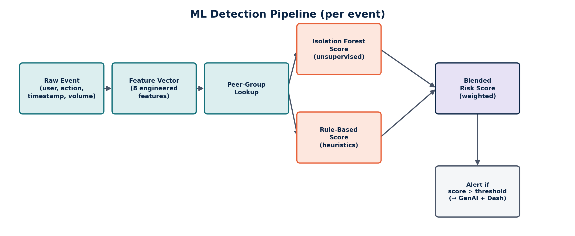
Figure 2 — Per-event scoring pipeline, from raw event to blended risk score.

9.1 Feature Engineering
Each raw event is converted into a numeric feature vector before scoring. Suggested starting feature set:
- login_hour — hour of day of the action, to capture off-hours activity
- failed_login_attempts — rolling count in the current session/day
- files_accessed / files_downloaded — rolling count in a time window
- data_volume_transferred_mb — rolling sum in a time window
- distinct_ips_used — count of distinct source IPs in a recent window (impossible-travel proxy)
- off_hours_access_flag — boolean derived from login_hour vs. the user's typical hours
- first_time_resource_access — boolean, whether this resource has been accessed by this user before
- peer_group_deviation_score — how far this event's features sit from the user's peer-group centroid

9.2 Detection Model
A Scikit-learn Isolation Forest is trained per peer group on the engineered features, using StandardScaler for normalisation. Isolation Forest is chosen because it needs no labelled data, handles high-dimensional numeric features well, and scores anomalies by how few random splits it takes to isolate a point — points that are quickly isolated are more anomalous.
A retraining job runs on a schedule (e.g., nightly, or after N new labelled feedback events accumulate) and folds in analyst feedback by adjusting the contamination parameter (the model's expected proportion of anomalies) and, separately, the weighting between the ML score and the rule-based score.

9.3 Blended Risk Score
risk_score = w1 × normalised_isolation_forest_score + w2 × rule_based_score, with w1 and w2 initialised at (0.7, 0.3) and adjusted over time by the feedback loop. An alert is raised when risk_score exceeds the department's configured threshold.

9.4 Evaluation Approach
Because there is no real labelled insider-threat dataset, evaluation uses the log simulator's ability to inject known synthetic anomalies (a "ground truth" set) alongside normal traffic, then measures precision/recall/false-positive rate of the detector against that injected ground truth — before and after peer-group baselining and feedback recalibration are switched on, to demonstrate the measurable improvement each enhancement contributes.

10. Database Schema
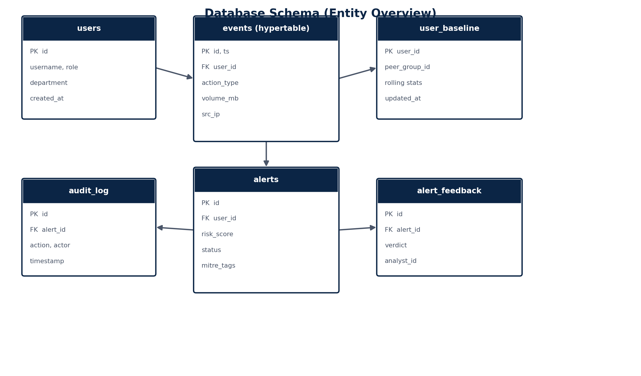
Figure 3 — Core entities and relationships.
Table | Key Columns | Purpose
users | id, username, role, department, created_at | Simulated organisation directory
events (hypertable) | id, ts, user_id, action_type, volume_mb, src_ip, resource_id | Raw ingested activity, partitioned by time via TimescaleDB
user_baseline | user_id, peer_group_id, rolling_stats (JSON), updated_at | Rolling per-user and per-peer-group statistics used for scoring
alerts | id, user_id, event_id, risk_score, status, mitre_tags, created_at | One row per raised alert and its current triage state
alert_feedback | id, alert_id, analyst_id, verdict, created_at | Analyst True/False Positive verdicts, feeds the retraining job
audit_log | id, alert_id, actor, action, timestamp | Full history of every status change on every alert
events is the only high-volume table and is the one converted into a TimescaleDB hypertable (partitioned automatically by time), which is what makes time-range queries — "this user's last 30 days of activity" — fast even as simulated log volume grows.

11. API Design
Method | Endpoint | Description
POST | /api/v1/events/ingest | Log simulator pushes a new raw event onto the pipeline
GET | /api/v1/alerts | List alerts, filterable by status, department, risk range
GET | /api/v1/alerts/{id} | Full alert detail: event context, score breakdown, GenAI narrative
PATCH | /api/v1/alerts/{id}/status | Analyst transitions an alert through the triage lifecycle
POST | /api/v1/alerts/{id}/feedback | Analyst records a True/False Positive verdict
GET | /api/v1/users/{id}/risk-history | Time-series of a user's risk score, for the trend chart
GET | /api/v1/reports/{alert_id}/export | Generates a PDF/CSV incident report for an alert
GET | /api/v1/admin/thresholds | Admin-only: view per-department detection thresholds
PUT | /api/v1/admin/thresholds | Admin-only: update per-department detection thresholds
WS | /ws/alerts | Live push of newly raised alerts to connected dashboard clients
All non-simulator endpoints require a JWT bearer token; Admin-only routes additionally check the role claim in middleware before the handler runs.

12. Frontend Module Breakdown
- Login / Auth: JWT-based sign-in, role-aware redirect (Analyst vs. Admin landing page).
- Live Alert Feed: WebSocket-driven list of incoming alerts with risk score, MITRE tag, and quick-triage buttons.
- Risk Leaderboard: top-N riskiest users, updated in real time, click-through to a user's history.
- Alert Detail View: full event context, score breakdown (ML vs. rule contribution), GenAI narrative, triage state changes, export button.
- User Risk History: a time-series chart of a single user's risk score, useful for spotting slow-building patterns.
- Admin Settings: threshold tuning per department, user/role management, audit log viewer.

13. Suggested Team Roles and Implementation Roadmap

13.1 Suggested Division of Labour
Member | Focus Area | Owns
Member A | Backend & Ingestion | FastAPI ingestion API, Redis Streams integration, feature engineering worker
Member B | ML & Detection | Isolation Forest training, peer-group clustering, blended scoring, retraining job
Member C | Frontend & Dashboard | React dashboard, WebSocket client, charts, RBAC-aware routing
Member D | GenAI, Infra & QA | LLM explainer integration, notifications, Docker Compose setup, testing

13.2 Phase-Wise Timeline (indicative, 16-week span across Phase I / II)
Timeframe | Milestone
Weeks 1–2 | Requirements freeze, log simulator, database schema, Docker Compose skeleton
Weeks 3–4 | Ingestion API + Redis Streams working end-to-end with dummy scoring
Weeks 5–7 | Isolation Forest + peer-group baselining, blended risk score, alert persistence
Weeks 8–9 | React dashboard: live feed, leaderboard, alert detail view over WebSockets
Weeks 10–11 | GenAI explainer, MITRE tagging, RBAC, triage lifecycle, notifications
Weeks 12–13 | Analyst feedback loop + retraining job, exportable reports, threshold admin UI
Weeks 14–15 | Load testing, evaluation against injected anomalies, bug fixing, documentation
Week 16 | Final polish, demo rehearsal, viva/report submission

14. Testing Strategy
- Unit tests (Pytest): feature engineering functions, blended risk-score calculation, rule-based heuristics — each tested against known input/output pairs.
- Integration tests: end-to-end event flow from ingestion API through Redis Streams to a persisted, scored alert.
- Load testing (Locust): simulate a burst of concurrent log events to confirm the queue absorbs load without dropping events, and measure end-to-end alert latency.
- Model evaluation: precision/recall/false-positive rate against the simulator's injected ground-truth anomalies, run before and after each enhancement (peer baselining, feedback loop) to quantify improvement.
- Frontend tests (React Testing Library): alert list rendering, WebSocket update handling, RBAC-gated route access.
- Manual UX pass: a walkthrough with a non-team "analyst" (e.g., a classmate) triaging five injected alerts, to sanity-check that the GenAI narrative and MITRE tag actually speed up triage.

15. Budget and Resources
Item | Provider | Estimated Cost
Backend hosting | Railway | ~₹415/month
Frontend hosting | Vercel | Free tier
Database | TimescaleDB Cloud | ~₹1,245/month
LLM API | Claude or OpenAI API | ~₹1,245/month
Dev tools | VS Code, Docker Desktop | Free
Total estimated cost: approximately ₹2,950/month during active development, self-funded as an academic prototype with no external grant dependency. For local demos and most of development, the Docker Compose setup (Section 8.10) removes any cloud cost entirely — cloud hosting is only needed for the final demo/deployment window.
Resources needed: personal laptops, the cloud services above for the deployment window, and LLM API access (a free-tier or low-usage-tier key is sufficient given the project's simulated, non-production traffic volume).

16. Risks and Mitigations
Risk | Mitigation
Simulated data doesn't resemble real enterprise logs closely enough | Base the simulator's behaviour profiles on patterns described in the reviewed literature and public UEBA datasets' feature distributions
Isolation Forest tuning takes longer than planned | Start with scikit-learn defaults and a single global model in Phase I; add peer-group baselining once the base pipeline is proven
LLM API cost or rate limits during demos | Cache/replay a small set of pre-generated narratives for the live demo; call the API live only for a handful of fresh alerts
Redis Streams / WebSocket integration complexity | Build and test each with a minimal hard-coded producer/consumer before wiring in the real pipeline
Team members blocked on each other's modules | Freeze the API contract (Section 11) and database schema (Section 10) in Weeks 1–2 so all four members can build in parallel against a shared interface

17. Future Scope (Beyond This Capstone)
- Online/continuous learning instead of scheduled batch retraining, once a larger and more continuous feedback dataset exists.
- Graph-based lateral-movement detection (modelling access as a graph to catch multi-hop privilege escalation, not just single-event anomalies).
- UEBA for non-human entities — service accounts, API keys, IoT/OT devices — which behave very differently from human users and need separate baselines.
- Single Sign-On (SSO/SAML) integration and multi-tenant support, to move from an academic prototype toward a deployable product.
- Integration with a real SIEM (e.g., ingesting a live Splunk/QRadar export) as a stretch validation exercise.

18. References
- [1] Multazam, A. & Widiarto, W. (2023). Frontiers in Computer Science.
- [2] Ahmad, S. (2025). TULTECH Journals.
- [3] Coscia, A. et al. (2024). Frontiers in Big Data.
- [4] Bin Sarhan, B. & Altwaijry, N. (2023). Journal of King Saud University.
- [5] Pulyala, S. R. (2023). Cybersecurity Insights.
- [6] Landmesser, J. & Vommi, S. (2023). Journal of Information Security.
- [7] Mochurad, L. et al. (2023). Cybernetics and Information Technologies.
- [8] Fysarakis, K. et al. (2023). Computer Networks.
- [9] Datta, P. et al. (2021). Data Science Journal.
- [10] Al-Mhiqani, M. N. et al. (2020). IEEE Access.

Further reading: NIST Risk Management Framework (RMF) — continuous monitoring guidelines; MITRE ATT&CK Framework — insider threat tactics and techniques.

