Seller database:

Seller First

Seller last

Seller address

Seller listed (asking price)

Seller contract information: phone numbers, address (which may be different from the property address), email address

Photo file

Table for properties

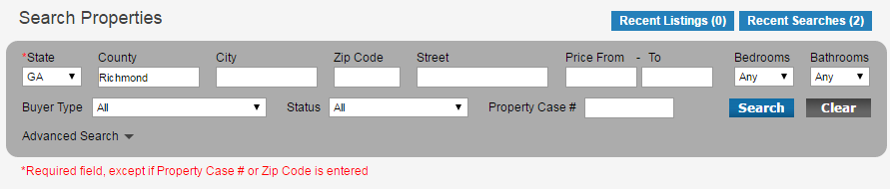

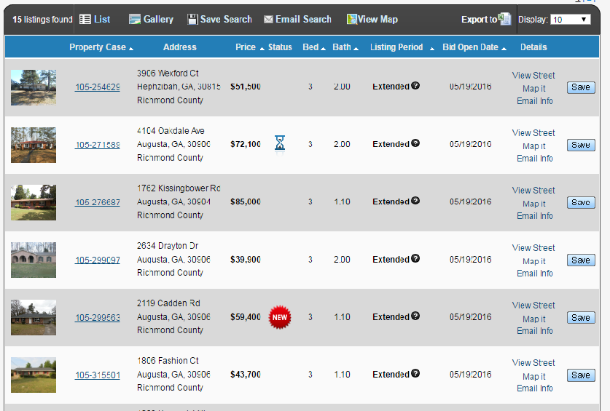

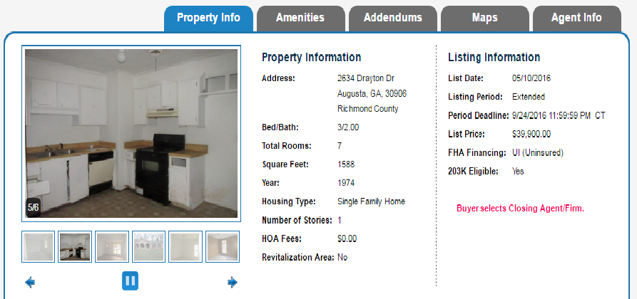



Bids submitted cannot go below 80%

­­­­­­­­­­­­­­­­­­­­­­­­­

Pg 2

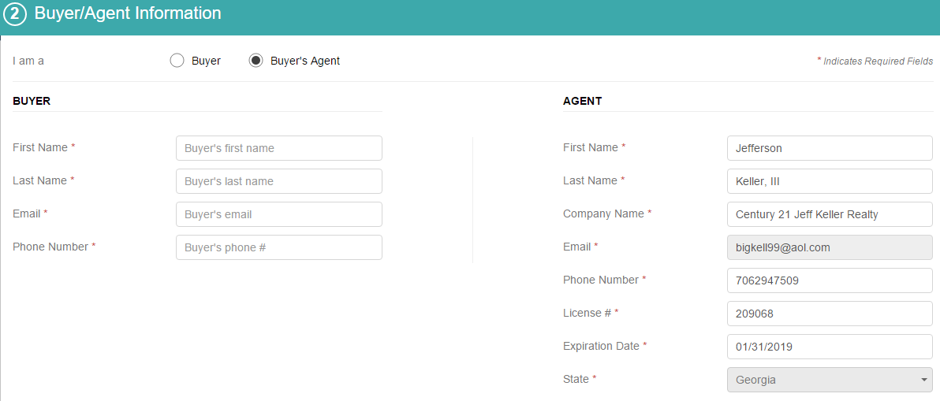

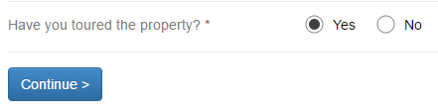

_____________________________________________________________________________next page



If paying cash please upload, a proof of payment such as a bank statement here 

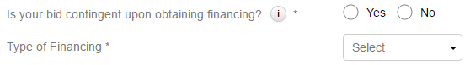

*********This drop down box should include three options, “FHA” “VA” or “Conventional”

The seller contributions cannot exceed 3% of the bid for conventional loan offers.

The seller contributions cannot exceed 6% of the bid for FHA/VA loan offers.

Banking TABLE

Mortage/ Loan Institution

Mortgage loan officer name

MLO email, address, NMLS# License number

This bid requires an earnest money amount of **1% of the list price or $500 whichever is more**, please upload a copy of the earnest money check:



________________________________________________________________________next page

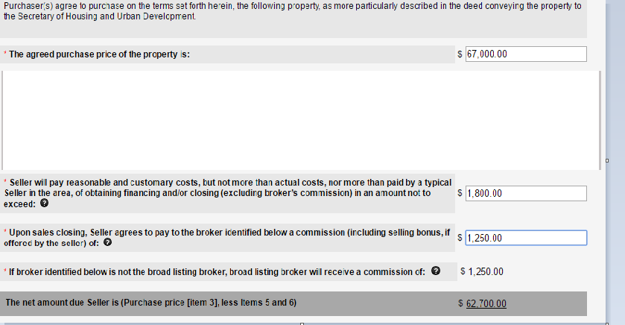

Seller------do you accept offer?



If yes, notify parties, designate property as offer pending online.

If no, seller makes counter offer:

Sellers can either make counter offer or accept.

Buyers can either make counter offer or accept.

Each offer should include an increment.

