Project Proposal

: Shopping Web for Mobile Parts

|  |  |
| --- | --- |
| 6564, | Bo-Han Chen |
| 8774, | Byungmu Jin |

# Table of Contents

### Introduction 2

### Background 2

### About Us 2

### Scope 2

### Market Analysis 3

### Market Trends 3

### Competitors 4

### Target Audience 5

### Web Design 5

### Architecture 5

### Key Features 6

### Minor Features 8

### Limitations 8

### Wireframes 10

### Mockups 18

### User Flow 18

### Project Plan 19

### Milestones 19

### Risk and Mitigation 20

### References 21

### 

## Introduction

### Background

CJ Corporation is carrying out a new 2021 web development project. As part of that, this project aims to develop a kind of Ecommerce Web, and is under the theme of mobile device and parts services. This proposal contains the detailed process and analysis based on market trends, target audience and competitors.

### About Us

CJ Corporation is a contemporary website design and development company, as a leading company in the global IT application market, with a focus on user-centered design while supporting our clients to achieve the desired goals. This project is largely divided into two parts; Front-End and Back-End, which are composed of two developers ‒ Front-End developer (Byungmu Jin) and Back-End developer (Bo-Han Chen).

## Scope

The scope is defined according to the Client’s requirements. The primary scope of this project is to develop the up-to-date Ecommerce web and enhance functionality, competitiveness, and convenience. The mandatory function requirements are listed as follows:

* Product browsing or list view
* Product view or detail view
* Product search
* Shopping cart
* User registration and login
* Order processing

The main and minor features, and limitations are explained in Web Design (Ch.4), reflecting market analysis (Ch.3).

## 

## Market Analysis

As part of the market targeting strategy, the flow of the supply chain of the modern online market was investigated and summarised in Fig.3.1 as a diagram.

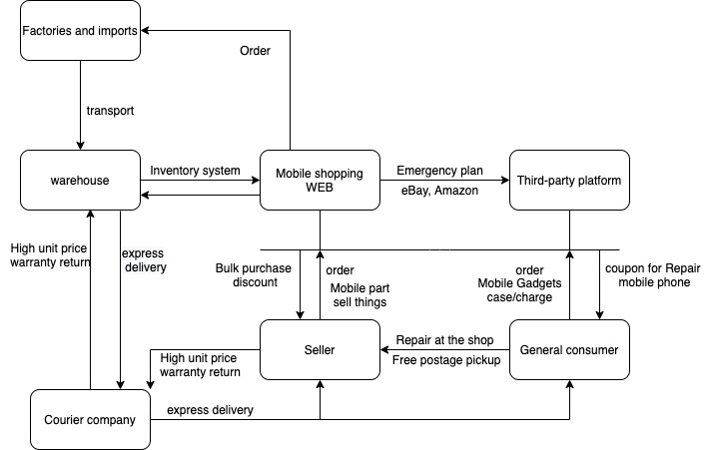

*Figure 3.1.* Supply chain diagram in online market

### Market Trends

Online shopping with the popularity of the Internet and mobile phones, people's acceptance and use of online shopping has increased every year, and the impact of the COVID-19 epidemic has further promoted people's online shopping and consumption.

According to the survey results from the mid-2010s to 2021, the number of online buyers is steadily increasing every year, and in proportion to this, the size of the Ecommerce market is also increasing as shown in Fig 3.2 and 3.3.

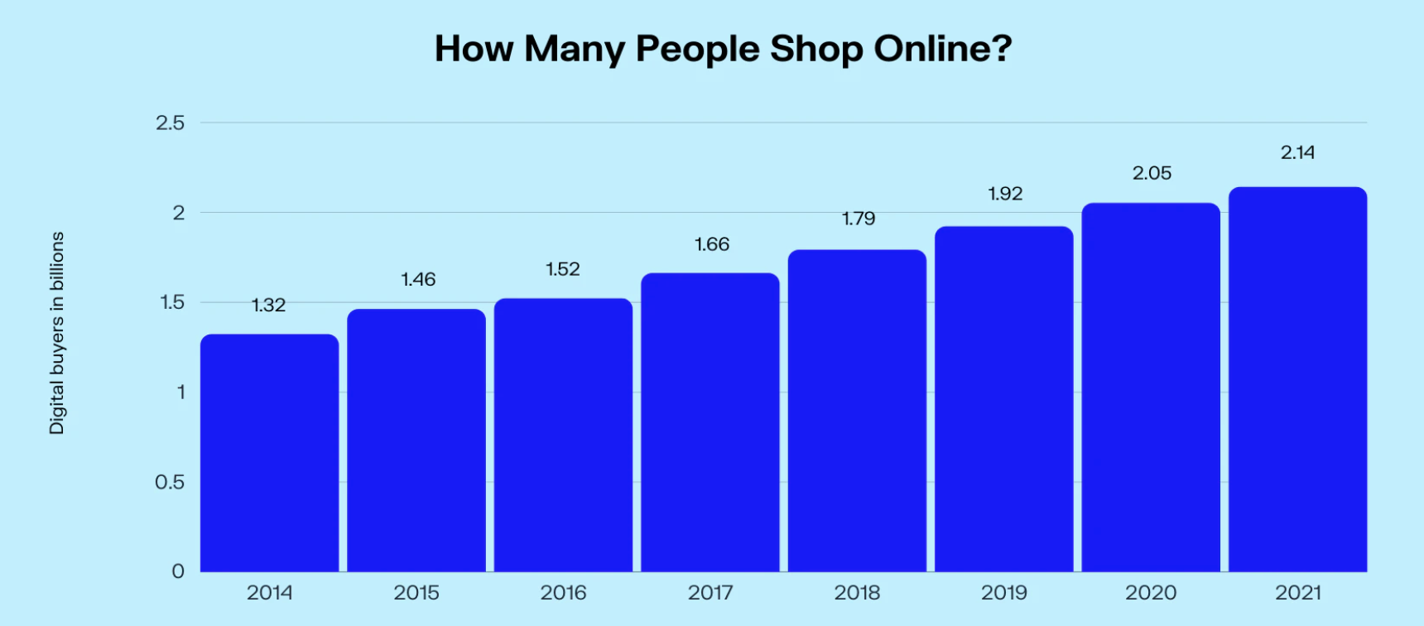

*Figure 3.2.* The growth of online shoppers worldwide from 2014 to 2021

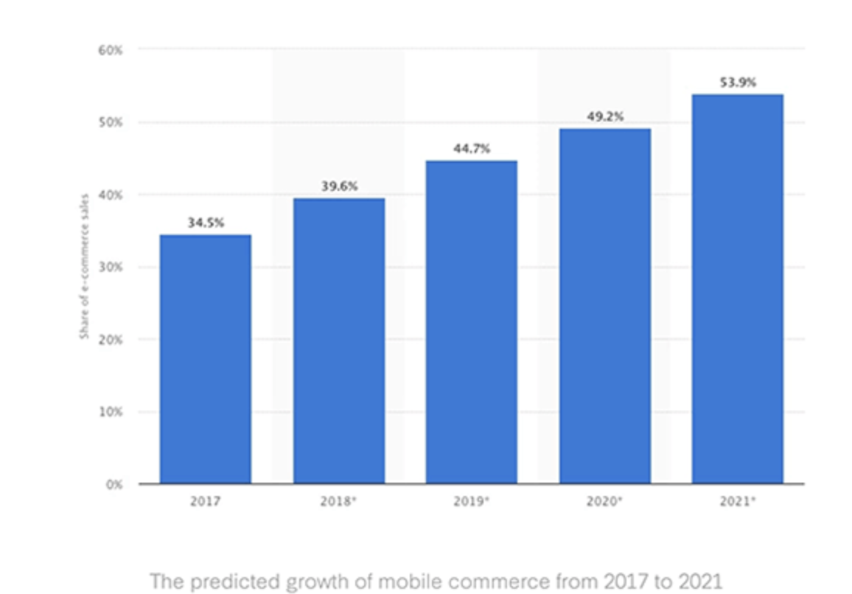

*Figure 3.3.* The predicted growth of Ecommerce from 2017 to 2021

### Competitors

The biggest competitors come from the original platforms eBay and Amazon, but they are pure buying sites. The quality is also difficult to guarantee, and the return and exchange is also troublesome. We mainly operate Ecommerce web pages and also cooperate with stores, which also means that can become our service location. If there is a certain number of stores to cooperate, the advantages will be obvious, and customers' doubts about quality and returns will be greatly reduced.

### Target Audience

We mainly sell mobile phone-related products. In addition to pure sales, we also provide repair point services. Mobile phone cases and protective stickers are all consumables. Some people like bare phones and often break the screen, then if there are nearby repair points and discounts. Most people take into account choosing the former product first, but compared to buying an expensive mobile phone, it can make customers turn around if they can obtain relatively preferential prices through overseas-imported products or cooperation with specific factories or brands, concentrated in the warehouse as the main workplace, mainly using the website as the platform for sales.

Based on the above, our target audience is divided into two major groups. The first target is general consumers ‒ products will be adjusted for a higher unit price and a smaller purchase quantity. In addition to providing products, we will also provide mobile computer services in nearby locations. Through our webpage booking service, we will provide coupon discounts. The second target is for the sales industry, the store sales demand is large, and the lower purchase price can be achieved through the contract. It can also cooperate with the store to allow consumers to pick up the goods in the store so that consumers can save online shopping postage, and also affect the store to increase passenger flow.

## Web Design

### Architecture

The structure of the web pages is as follows:

* Main page
* Category page
* Sign-up page
* Product page
* Shopping Cart / Checkout / Wishlist page
* Shipping page
* Back-end page*

‘*’ mark means limitations less important or rather difficult. These features are covered in Ch.4.1.3 below.

The sitemap of the web is described in Figure 4.1, which can be linked to the reader, and more details on features and limitations are described in Ch.4.1.1 - 4.1.3.

[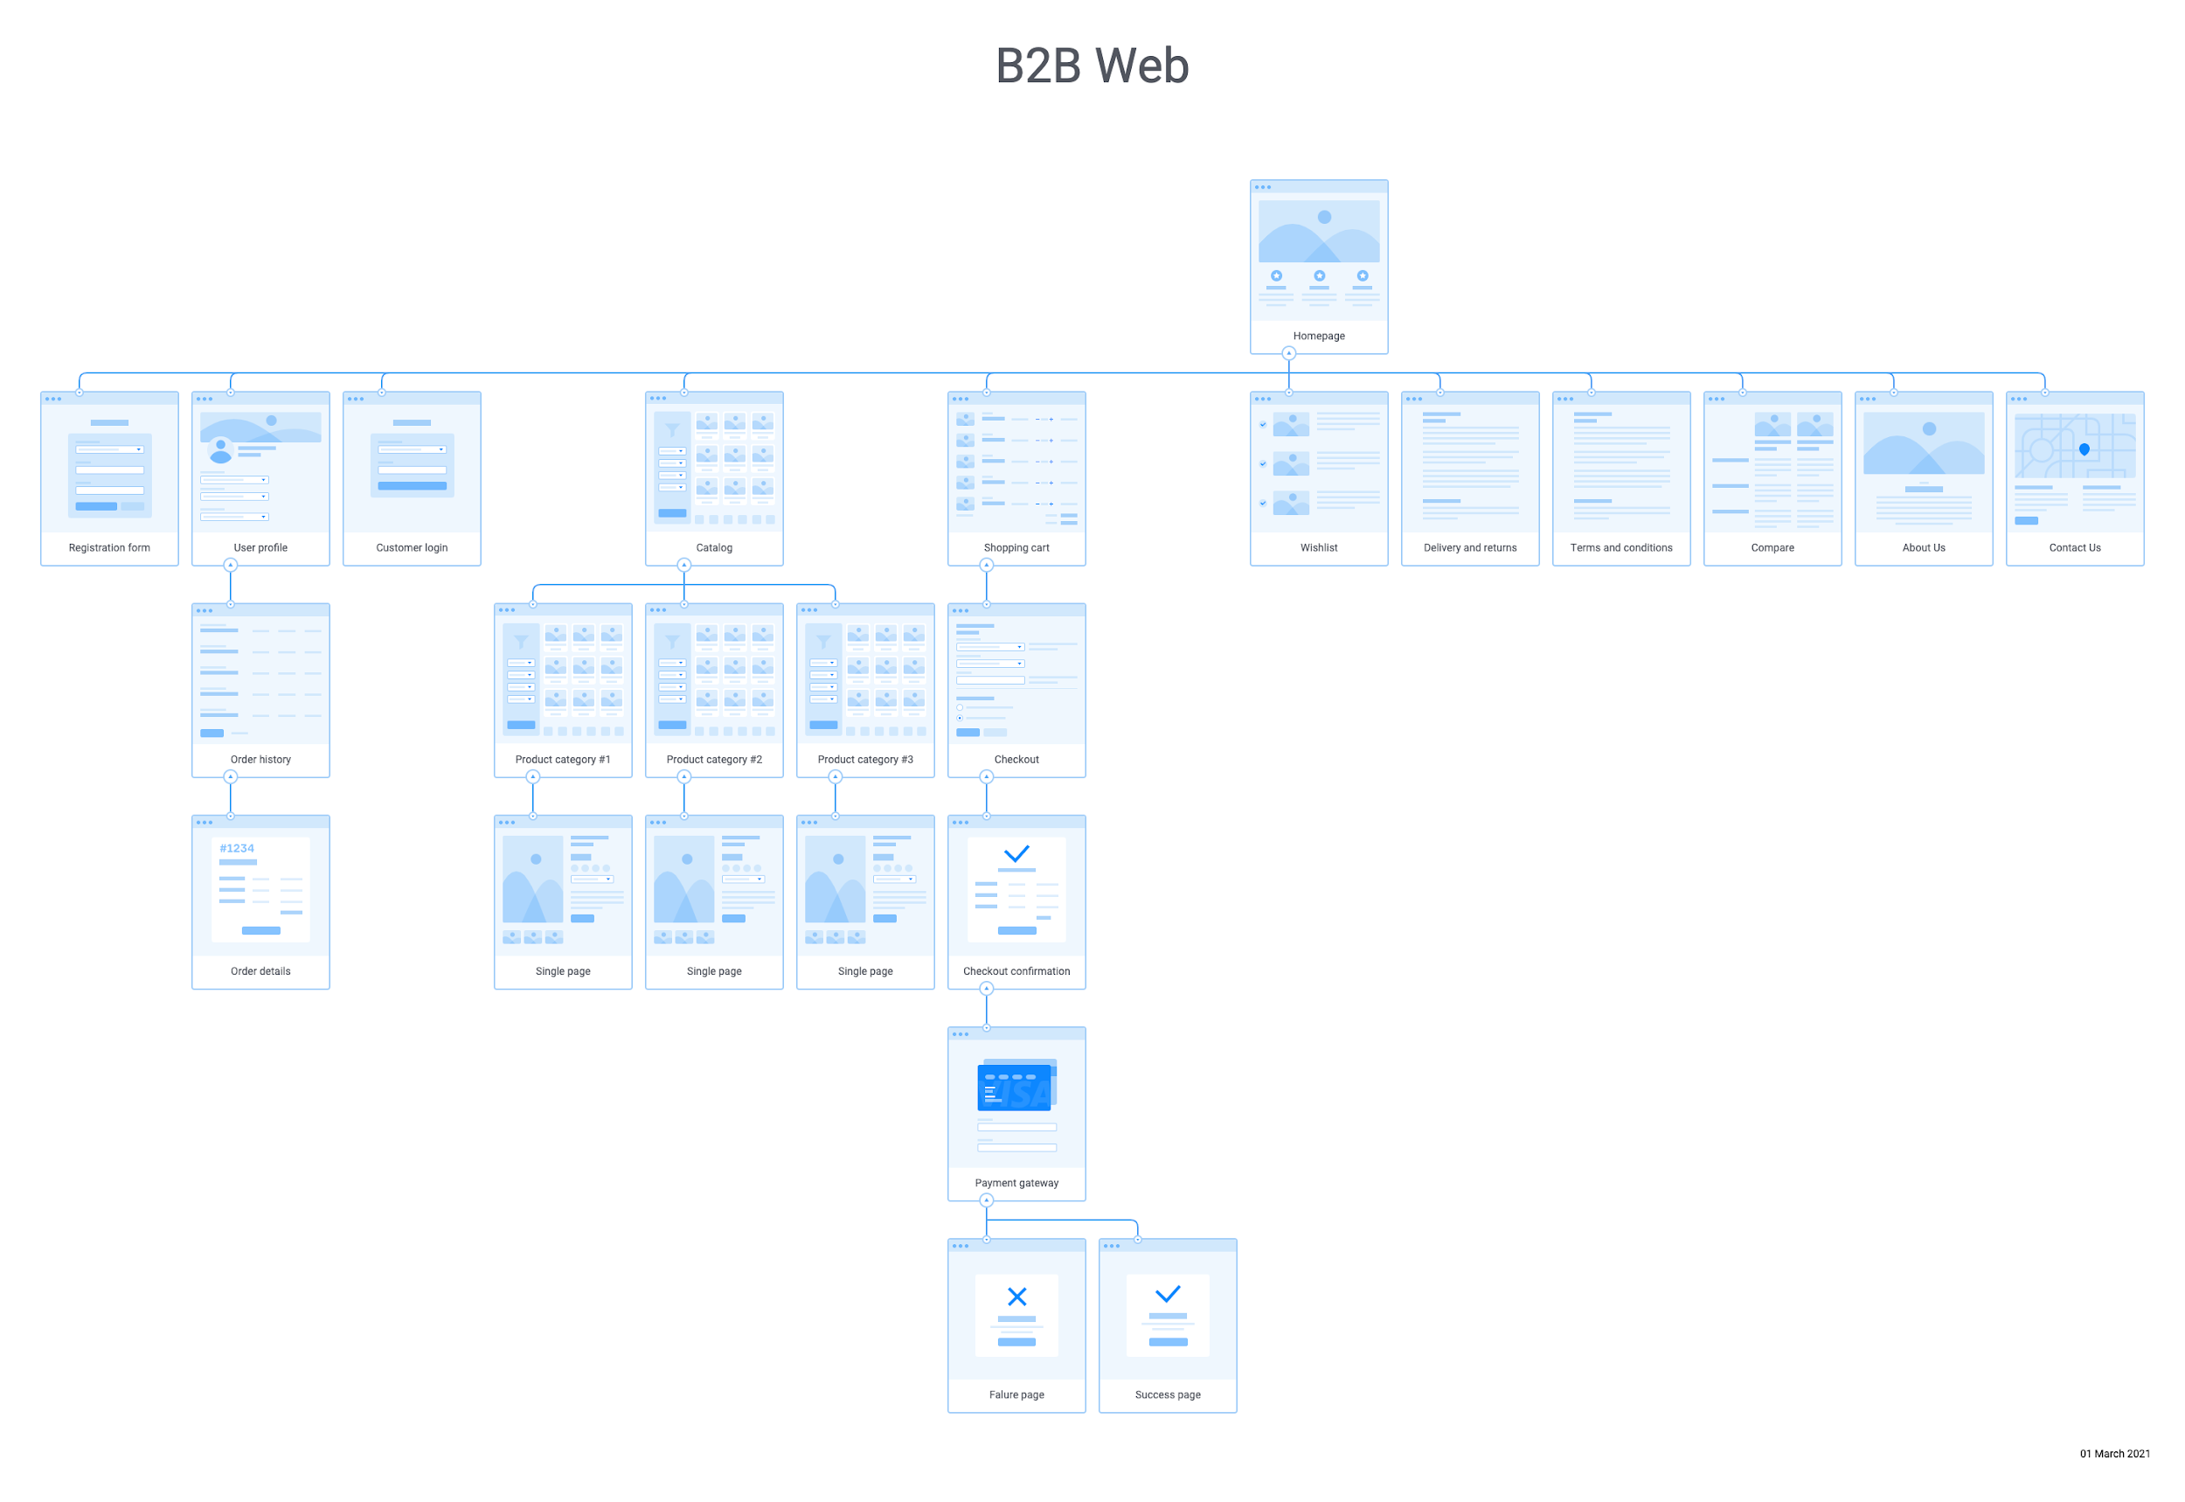](https://drive.google.com/file/d/1DtgjGSykaaXvMWOpWCZ30LP2_d31aTlr/view?usp=sharing)

*Figure 4.1.* [Sitemap](https://app.flowmapp.com/share/1c777f7f85bce4cebd765bbd9d4aac5f/sitemap/)

### Key Features

The functions essential for basic operation of Ecommerce web according to pages are shown in Table 4.1.

Table 4.1(a)

*Main page - Key Features*

|  |  |  |
| --- | --- | --- |
| No. | Feature | Description |
| 1 | Top-level domain | A top-level domain with a secured connection, HTTPS, and country code, AU |
| 2 | Logo | Business logo placed at a prominent position of the header |
| 3 | Navigation | Horizontal navigation bar to link to sub pages |
| 4 | Feature banner (Main banner) | Main features or description |
| 5 | Wishlist | A list of products interesting in which customers can easily find them next time |
| 6 | Customer login | Customers register and login |
| 7 | Shopping cart | A list of products in progress to check out |
| 8 | Search bar | Search for a single-line text |
| 9 | Customer care* | FAQ, returns, exchanges, and other information on the policy at the footer |
| 10 | Payment system icons | Icons at the bottom of the page to let customers know which payment systems can be available |
| 11 | Terms and Conditions, Privacy Policy, Sitemap | The standard documents and sitemap placed at the bottom of the page |

‘*’ mark means less important or rather difficult functions. These features are covered in Ch.4.1.3 below.

Table 4.1(b)

*Category pages - Key Features*

|  |  |  |
| --- | --- | --- |
| No. | Feature | Description |
| 1 | Breadcrumb navigation | Sub navigation under main navigation bar to let users browse through product categories |
| 2 | Consistent products layout | Consistent form including image, description, price, functional buttons |
| 3 | Filtering/Sorting | Filtering for customers to filter products based on different attributes and sorting for viewing products on ascending or descending order of price and arrival |
| 4 | Page indicator | Show the number of page and short description |

Table 4.1(c)

*Product pages - Key Features*

|  |  |  |
| --- | --- | --- |
| No. | Feature | Description |
| 1 | Product profile | Including name, quantity, price with potential sales or discounts, and variables such as colour or size |
| 2 | Product image with zoom-in function | Display high-quality images with zoom-in function at several angles |
| 3 | Add to Cart/Wishlist/Compare buttons | Enables products to link to Shopping cart, wishlist, and compare page |
| 4 | Social share buttons | Share favourite products with friends |
| 5 | Product description/review tap | Describe product specification and reviews in each tap |
| 6 | Related products view | Include a list of related products at the bottom of the page |

Table 4.1(d)

*Checkout/Shopping Cart/Whishlist pages - Key Features*

|  |  |  |
| --- | --- | --- |
| No. | Feature | Description |
| 1 | Billing & Shipping | Billing & Shipping Address, methods |
| 2 | Promo code | Text field to enter promo codes |
| 3 | Payment methods | List payment methods |
| 4 | Cart details | All details regarding what the customer has in the cart |
| 5 | Edit functions | Provide options to edit and remove items |
| 6 | Invoice details | All details including price, discount, shipping cost, tax, and the total |
| 7 | Product comparison view | Display reviews, rating, prices, description |

### Minor Features

The minor features are not mandatory, but are additional features of the web as an important part of business strategy. This is shown in Table 4.2.

Table 4.2

*Main page - Minor Features*

|  |  |  |
| --- | --- | --- |
| No. | Feature | Description |
| 1 | Language options* | Language options to let users switch between different languages/regions |
| 2 | Live Chat* | Web visitors can communicate with customer support in real-time |
| 3 | Unique Value Proposition (UVP) | Show specials with headline or image |
| 4 | Loyalty program banner | Mention things like a level or reward points for long time customers |
| 5 | Featured and best selling products view | Show featured products or automate the process to show a list of best selling products |
| 6 | Personalised products view | Show potential customers items based on their search or purchasing history |

‘*’ mark means less important or rather difficult functions. These features are covered in Ch.4.1.3 below.

### Limitations

There are several limitations depending on technical and environmental factors. These features are shown in Table 4.3.

Table 4.3(a)

*Environmental limitations on web pages*

|  |  |  |
| --- | --- | --- |
| No. | Limitation | Factor |
| 1 | Language options | Languages available may be limited depending on the business’s operational capabilities and needs |
| 2 | Live Chat | Depending on a capacity of business and the number of customers, customer service response may be uncertain |
| 3 | Shipping to other countries or isolated regions | Difficult to classify the delivery area available according to shipping companies or regions, especially other countries or isolated regions |
| 4 | Customer care | The Customer care service can vary depending on the warranty about return, exchange, and refund according to the date, condition, and price, and so on |
| 5 | Window shopping only | Customers can’t pick up, touch, and try on products, which leads to some troubles due to the uncertainty of product quality, material, size, colour, and so on |

Table 4.3(b)

*Technical limitations on web pages*

|  |  |  |
| --- | --- | --- |
| No. | Limitation | Factor |
| 1 | Back-end interface | The Back-end interface is a technical issue out of this project boundary |
| 2 | Collaboration with the third party partner | Standard database format and guidance on web operation with the third party involved |
| 3 | Responsive web design | The project is based on the PC web interface. The basic responsive interface is applied using bootstrap, but it does not guarantee that all devices will be satisfied |

### Wireframes

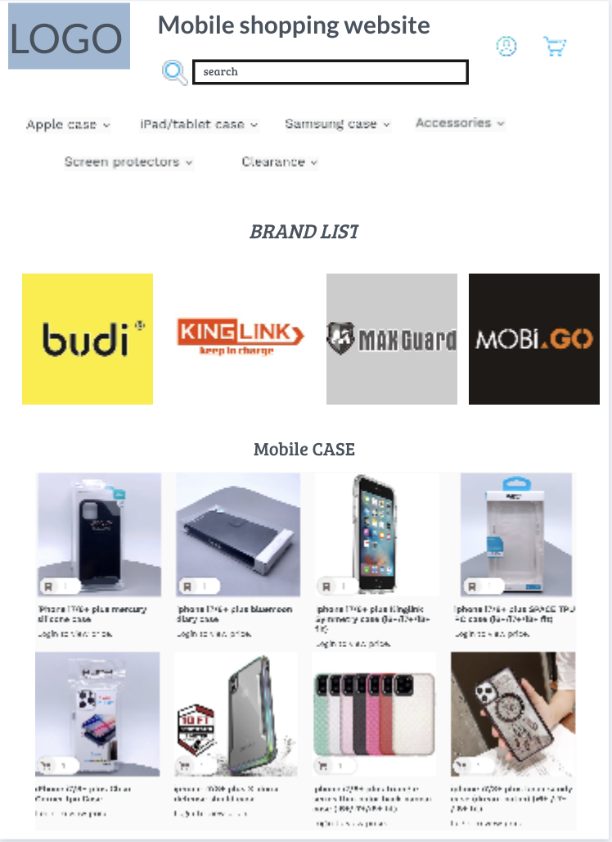

*Figure 4.2.* Wireframe - Main page with category

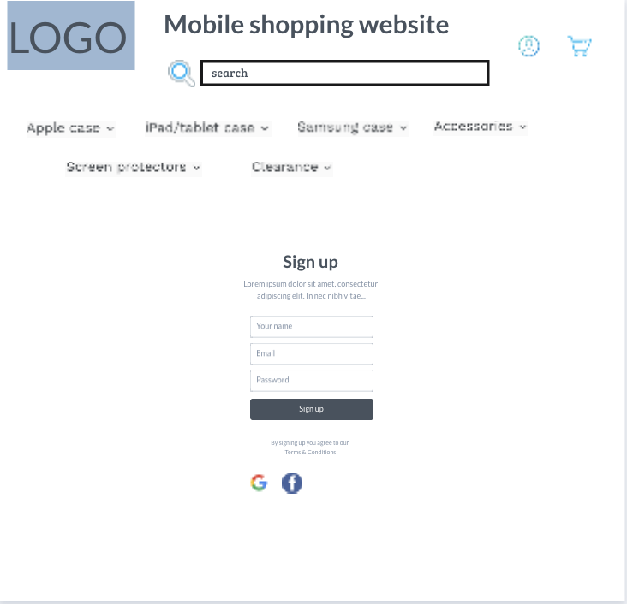

*Figure 4.3(a).* Wireframe - Sign-up page

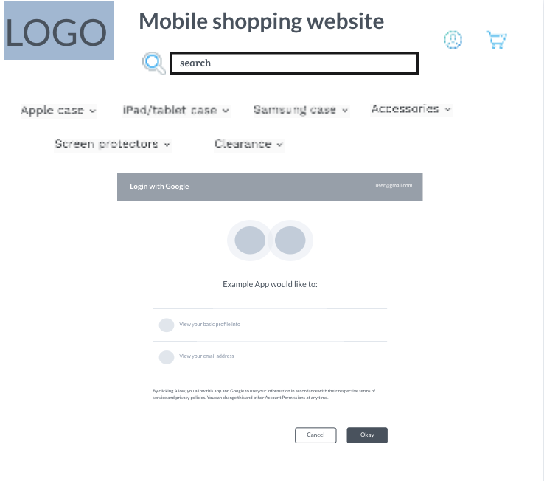

*Figure 4.3(b).* Wireframe - Sign-up page

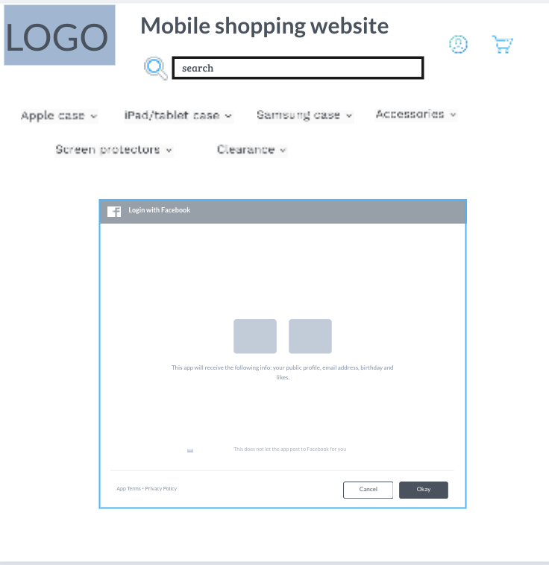

*Figure 4.3(c).* Wireframe - Sign-up page

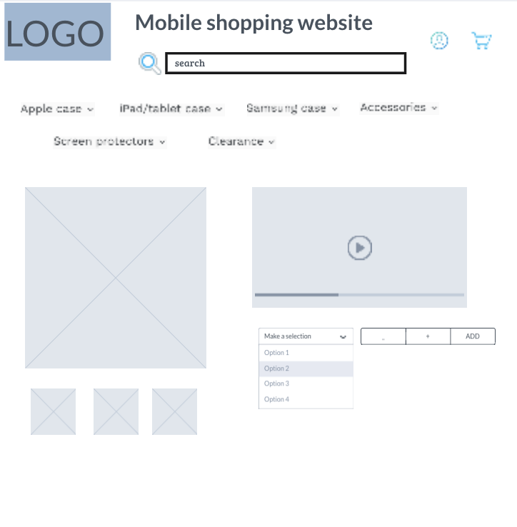

*Figure 4.4.* Wireframe - Product page

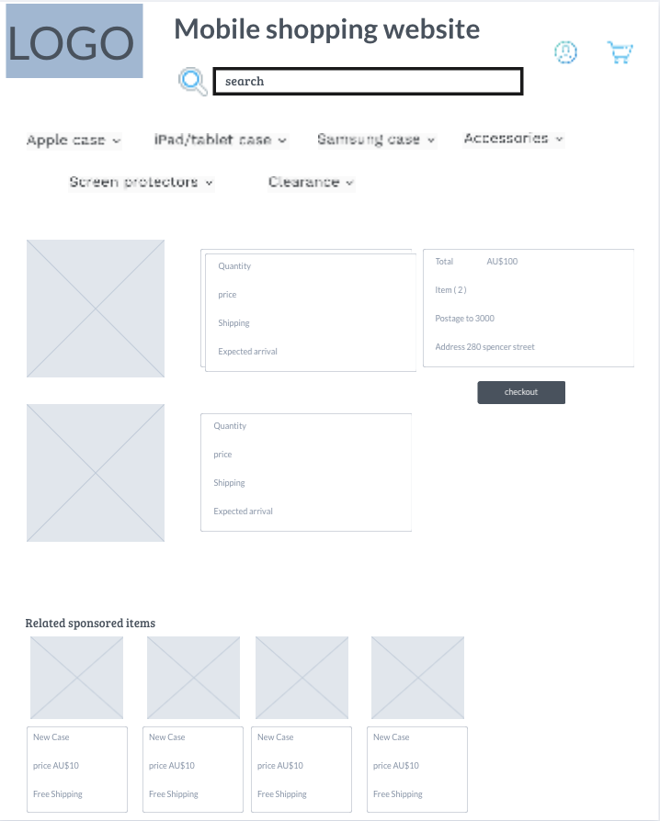

*Figure 4.5(a).* Wireframe - Checkout / Shopping cart / Wishlist page

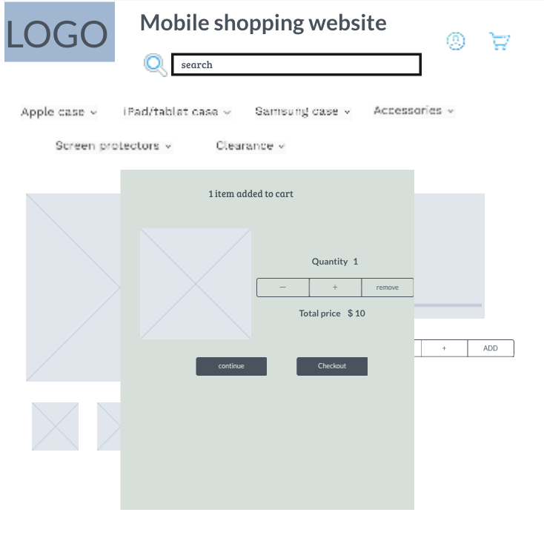

*Figure 4.5(b).* Wireframe - Checkout / Shopping cart / Wishlist page

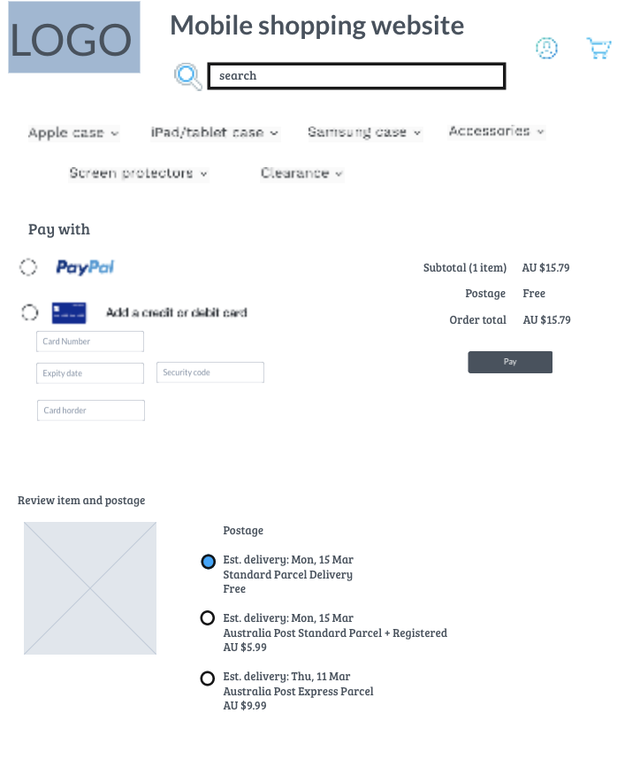

*Figure 4.5(c).* Wireframe - Checkout / Shopping cart / Wishlist page

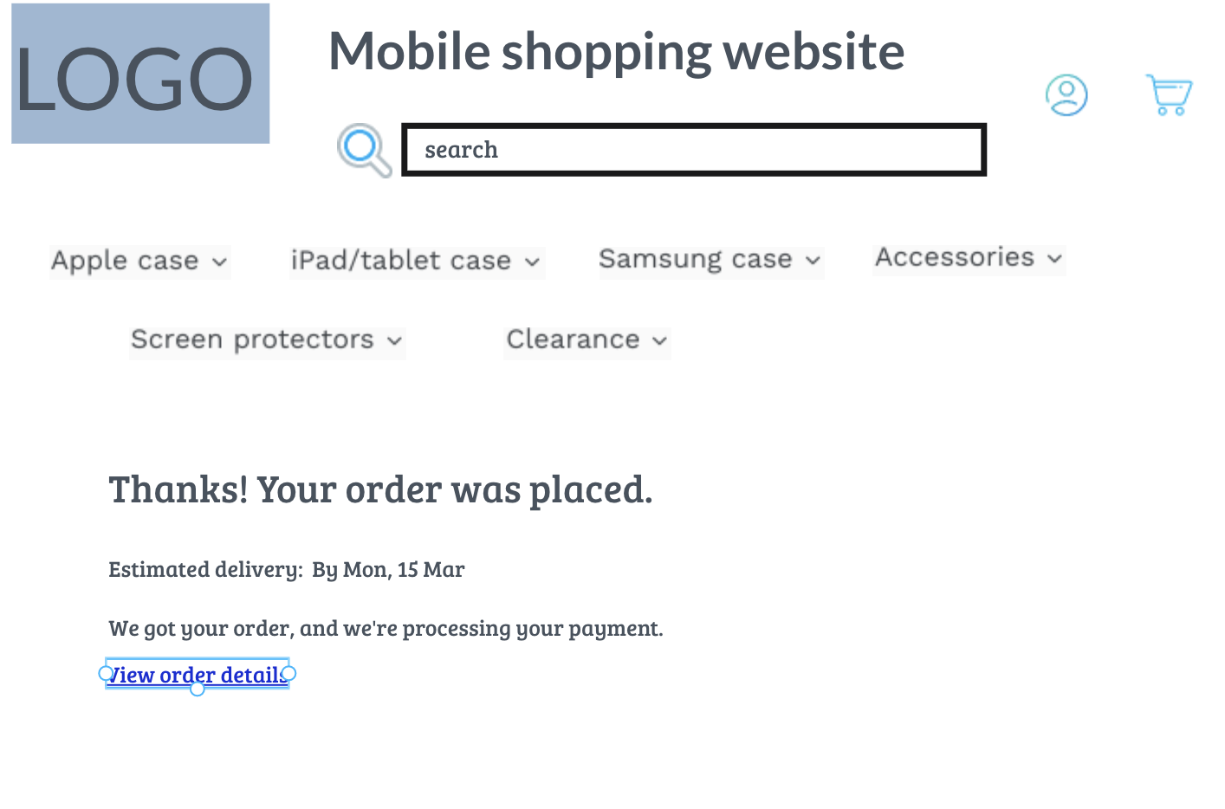

*Figure 4.6.* Wireframe - Shipping page

### Mockups

The mock-up of the main features shown in the wireframe was first produced, and the simulation is available through [this hyperlink](https://marvelapp.com/prototype/144g9db4)* or the address below.

*Mockup link - <https://marvelapp.com/prototype/144g9db4>

### User Flow

The user flow can begin with the entry point like the sign-up or login, and ends with the final action or outcome like purchasing a product or closing.

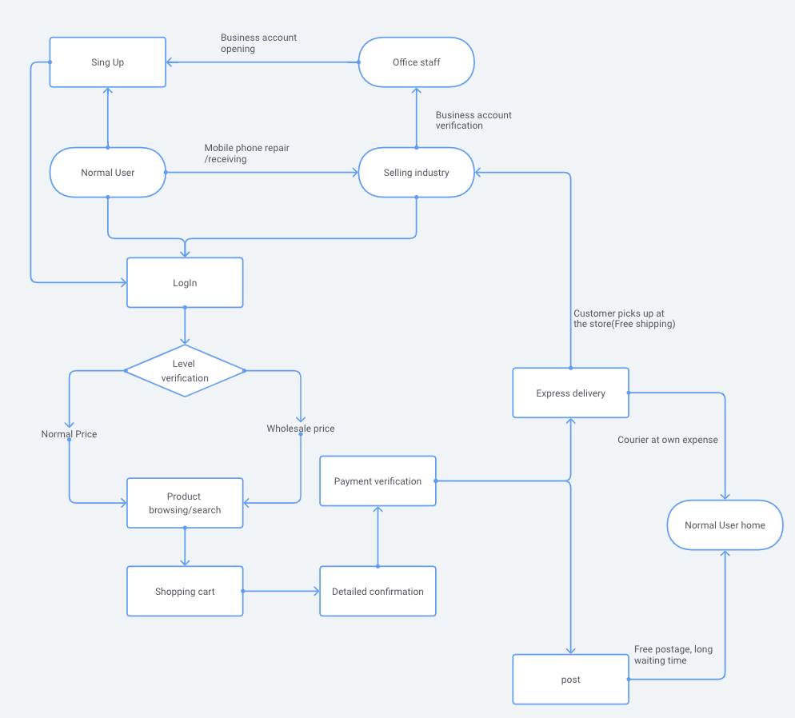

*Figure 4.7.* Flowchart for User Flow

## Project Plan

The project is undertaken from the proposal documentation on 01/March/2021 for 12 weeks with the final presentation.

### Milestones

Table 5.1

*Milestones with work breakdown structure*

|  |  |  |  |  |  |  |  |  |  |
| --- | --- | --- | --- | --- | --- | --- | --- | --- | --- |
| Stage | Key person | W1 | W2 | W3 | W4 | W5 | W6 | W7 | W8 |
| Proposal Documentation | All | x |  |  |  |  |  |  |  |
| Web design | All | x |  |  |  |  |  |  |  |
| Web coding | Front-End |  | x | x | x | x |  |  |  |
| Database design & coding | Back-End |  | x | x | x | x |  |  |  |
| Testing | All |  |  |  |  | x | x | x |  |
| Fix and Update | All |  |  |  |  |  |  | x | x |
| Presentation | All |  |  |  |  |  |  |  | x |

### Risk and Mitigation

Risks to the project completion are taken into account and rated according to their likelihood ‒ scale of 1 to 5, with 1 for unlikely to happen and 5 for likely to happen ‒ and proposed a way to mitigate shown in Table 5.2

Table 5.2

*Risks and mitigation to the project completion*

|  |  |  |  |
| --- | --- | --- | --- |
| No. | Risk | Scale | Mitigation |
| 1 | Project data loss | 1 | Daily backup and version control using GitHub |
| 2 | Limited time management | 2 | Proceed with tasks on schedule, check the status weekly, and work in collaboration for the delayed |
| 2 | Project data overlapping | 3 | Manage the project using GitHub to avoid overlapping between tasks |
| 3 | Database form | 3 | Follow the standards as much as possible, but make sure to record the specifics in the final report or guidance |
| 4 | Compatibility problem | 3 | For special functions, check the compatibility among browsers and their version by referring to the library |
| 5 | Unexpected technical errors or updates | 4 | Errors or key features must be undertaken first and then minor features can be considered if possible |
| 6 | Limited technical skills;  Bootstrap, PHP, MySQL, Jquery | 5 | Learning skills for the next stage in advance |

## 

## References

* Features for Ecommerce Website. (2019, March 15). Retrieved from <https://www.webalive.com.au/ecommerce-website-features/>
* UX tools for web design. Retrieved from [https://flowmapp.com](https://app.flowmapp.com/share/1c777f7f85bce4cebd765bbd9d4aac5f/sitemap/)
* Digital buyers statistics. (2021). Retrieved form https://www.oberlo.com/statistics/how-many-people-shop-online
* The growth of online shopping statistics. (2021). Retrieved from <https://optinmonster.com/online-shopping-statistics/#ecommerce-statistics>
* APA Style Guide Formatting II. (2017). Retrieved from<https://youtu.be/PeIW2Qn8Gsw>