Case Study:

Web Development

Proposal

(Online Shopping Website)

Date: 22/06/2020

**Contents**

1. **Scenario**
2. **Concept Design  
   (incl. Responsive Design)**
   1. Site Structure Diagram
   2. Wireframes
   3. Mock-ups
3. **Technology in brief**
4. **Implementation Plan**
5. **Scenario**

Client, Yen Clothing, supplies a variety of fashion items and accessories. It is run in very traditional ways, which is trying to grow and compete in the rapidly changing modern technological age.

To increase its marketing options, Yen Clothing’s management wants to promote and display its products online. Yen’s Clothing’s website must be with functions as listed below:

* Modern and well-designed website
* Responsive website for customers using different devices such as PC, laptop, and mobile as well
* ?

*Online ordering system is not included in this project, but in the future, the client wants to add it on to the current project.*

1. **Concept Design**

* **Site Structure Diagram**
* **Wireframes**
  + **Index page**

1. **Branding**

* Client’s name : Yen Clothing
* Logo :
* Slogan :

1. **Colors**

Common pages

* + Header and Footer :
  + Background :

Index page

1. **Typography**

Main font :

Size  
- h2 : Menus (Home, Scores, News, Contact)  
- h3 : Submenus (Other Match, Games)  
- p : others except above

1. **Site Structure Diagram**

* Home : Main page
* Scores : Schedules and records of games
* News : Game information, news and slogan
* Contact : Contact information and application for participation

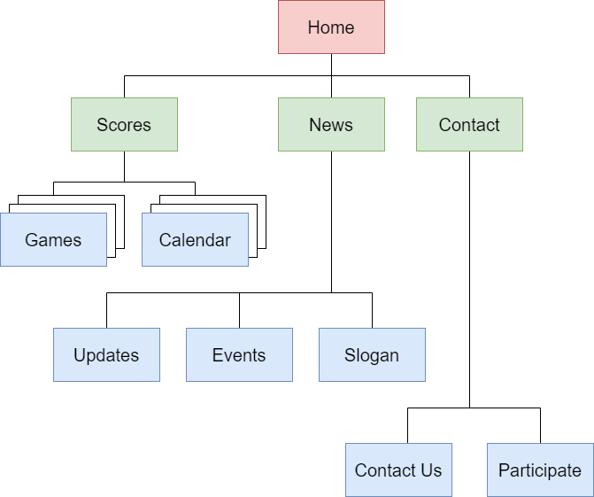

1. **Wireframes**

* Primary page (Home)  
  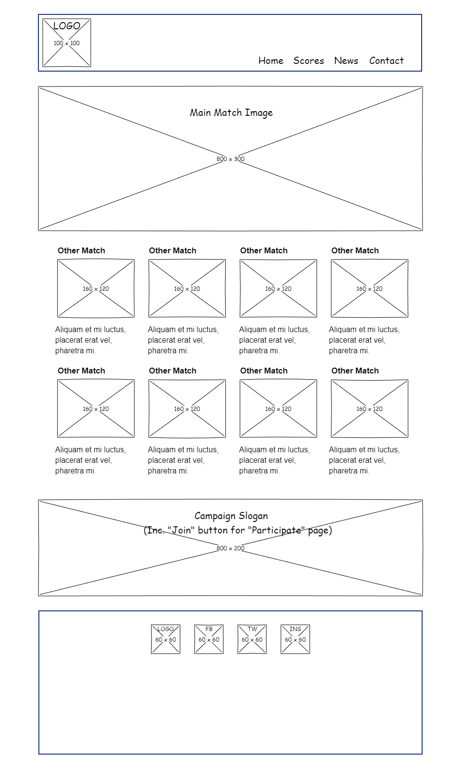
* Secondary page (Scores)  
  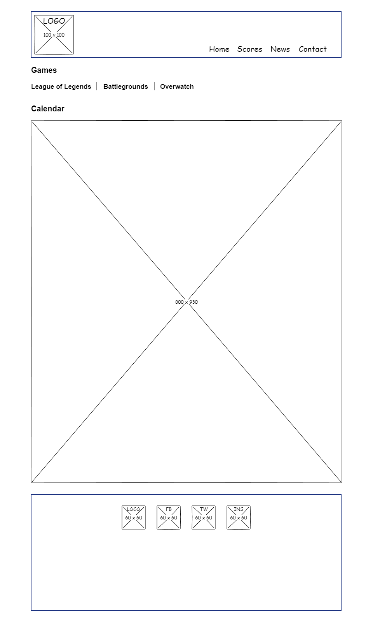

1. **Mockups**

- Primary page (Home)  
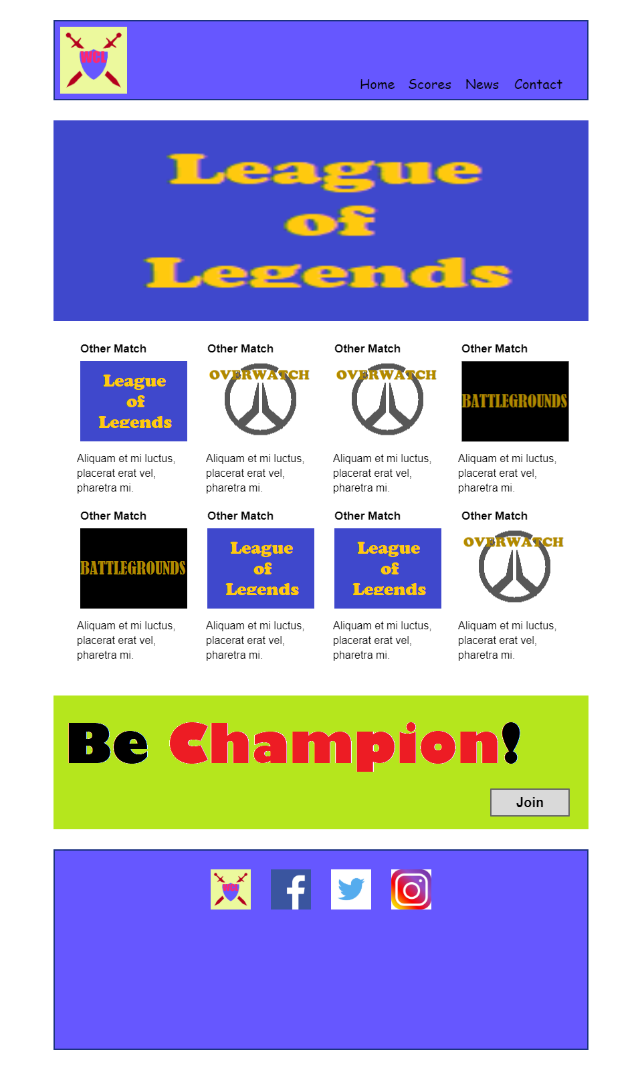

- Secondary page (Scores)  
