JO EQUIP refinements – 260710
Jake, the following refinements are based on what I see on my small SE iPhone screen. I assume internationally people probably have older smaller screens, so if we can make this look good there that would be ideal.

https://staging-equip.jesusonline.com/
[ ] Slightly reduce the font size of Ministry Resources Hub because it wraps on my phone.

[ ] The hamburger menu does not look very inviting because it is so dark. It would also be nice to have lines between the items similar to the .org menu to give it a little bit more visual appeal.
[ ] Add a Welcome option to the top of menu
[ ] Add a Contact option to the bottom of menu
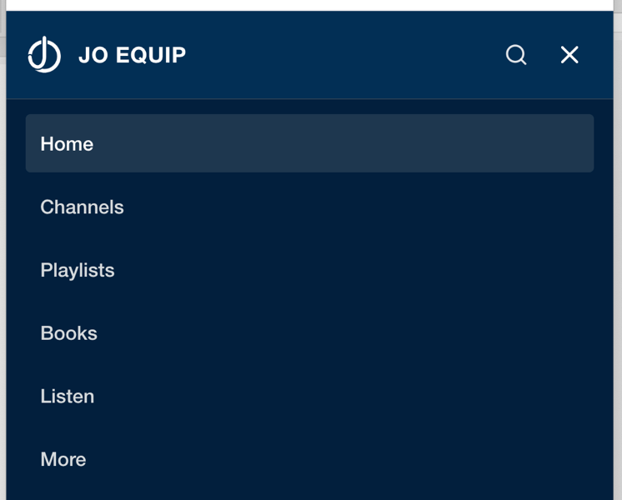

https://staging-equip.jesusonline.com/reviews
[ ] Make four separate Reviews pages and add the following link on all review pages below the review options, and above the specific title. Link it to a specific review, comment form requesting, first name, country, and their review. (We want them to always have to scroll past the share your review link in every category so they are reminded to send us a review.)

Share your review to encourage others.
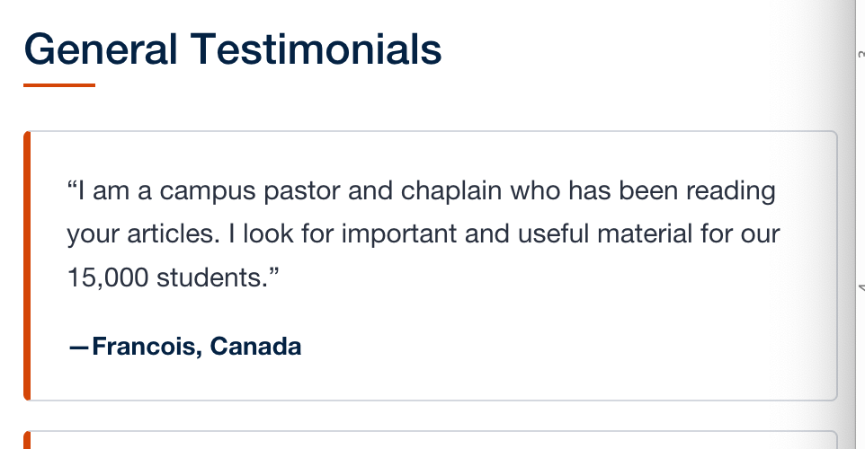

[ ] Use this text on the Review page above the form fields.
Share Your Review
Share your story to encourage others. How has JO EQUIP helped you? We'd love to hear from you.
[FORM FIELDS]
<<Send Review>>

https://staging-equip.jesusonline.com/channels
[ ] Change the heading from Channels for Your Ministry Needs to Ministry Channels
[ ] Change Resource Channels to Ministry Channels
[ ] The changes I sent were not made on these Channel pages. See below:


Ministry Channels
These free resources are grouped to help you serve with greater effectiveness and spiritual vitality in fulfilling Christ's Great Commission.
JO EQUIP

Evidence Resources


Persuade doubters with clear, compelling facts about the true identity of Christ, the existence of God, and the reliability of the Bible.
Explore 3 Evidence Topics >

Growth Resources


Disciple believers to become all that God created them to be, so they may do all that he has created them todo.
Explore 21 Growth Topics >

Church Resources


Develop fruitful, prayer field, spirit lead ministries that multiply disciples, and build churches, all in obedience to Christ and his Inspired word.
Explore 9 Topics >
Explore 9 Church Topics >

