Additional Resources

Share Your Thoughts
Leave a Review or Send Us a Note — If you found this helpful, please consider leaving a short review. Your feedback helps us improve future resources and encourages others. We love hearing how God is using these materials in your life. Share Your Story → equip.jesusonline.com/reviews/share

The JO Discipleship App

The JO App helps believers grow closer to Jesus through Bible studies, daily devotionals, prayer tools, and discipleship series. Most users explore the content on their own. Those who want personal guidance are supported by our Discipleship Pastor and trained volunteers.
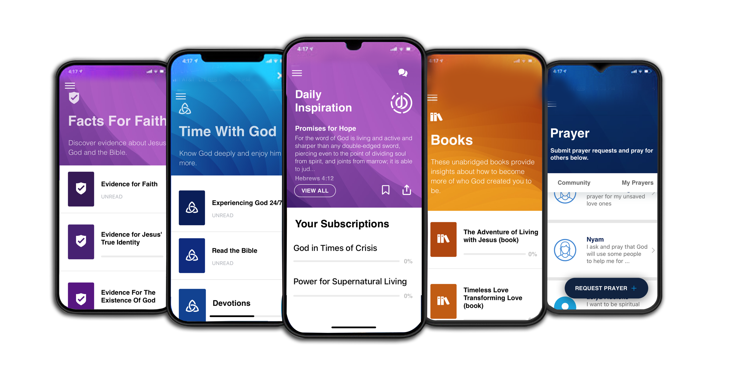

The JO EQUIP Resources for Discipleship
JO EQUIP is a free digital library of practical, biblically grounded tools that equip pastors and disciple-makers with Evidence, Growth, and Church resources—uniting apologetics, identity-centered discipleship, and tools for healthy churches in one trusted hub.


