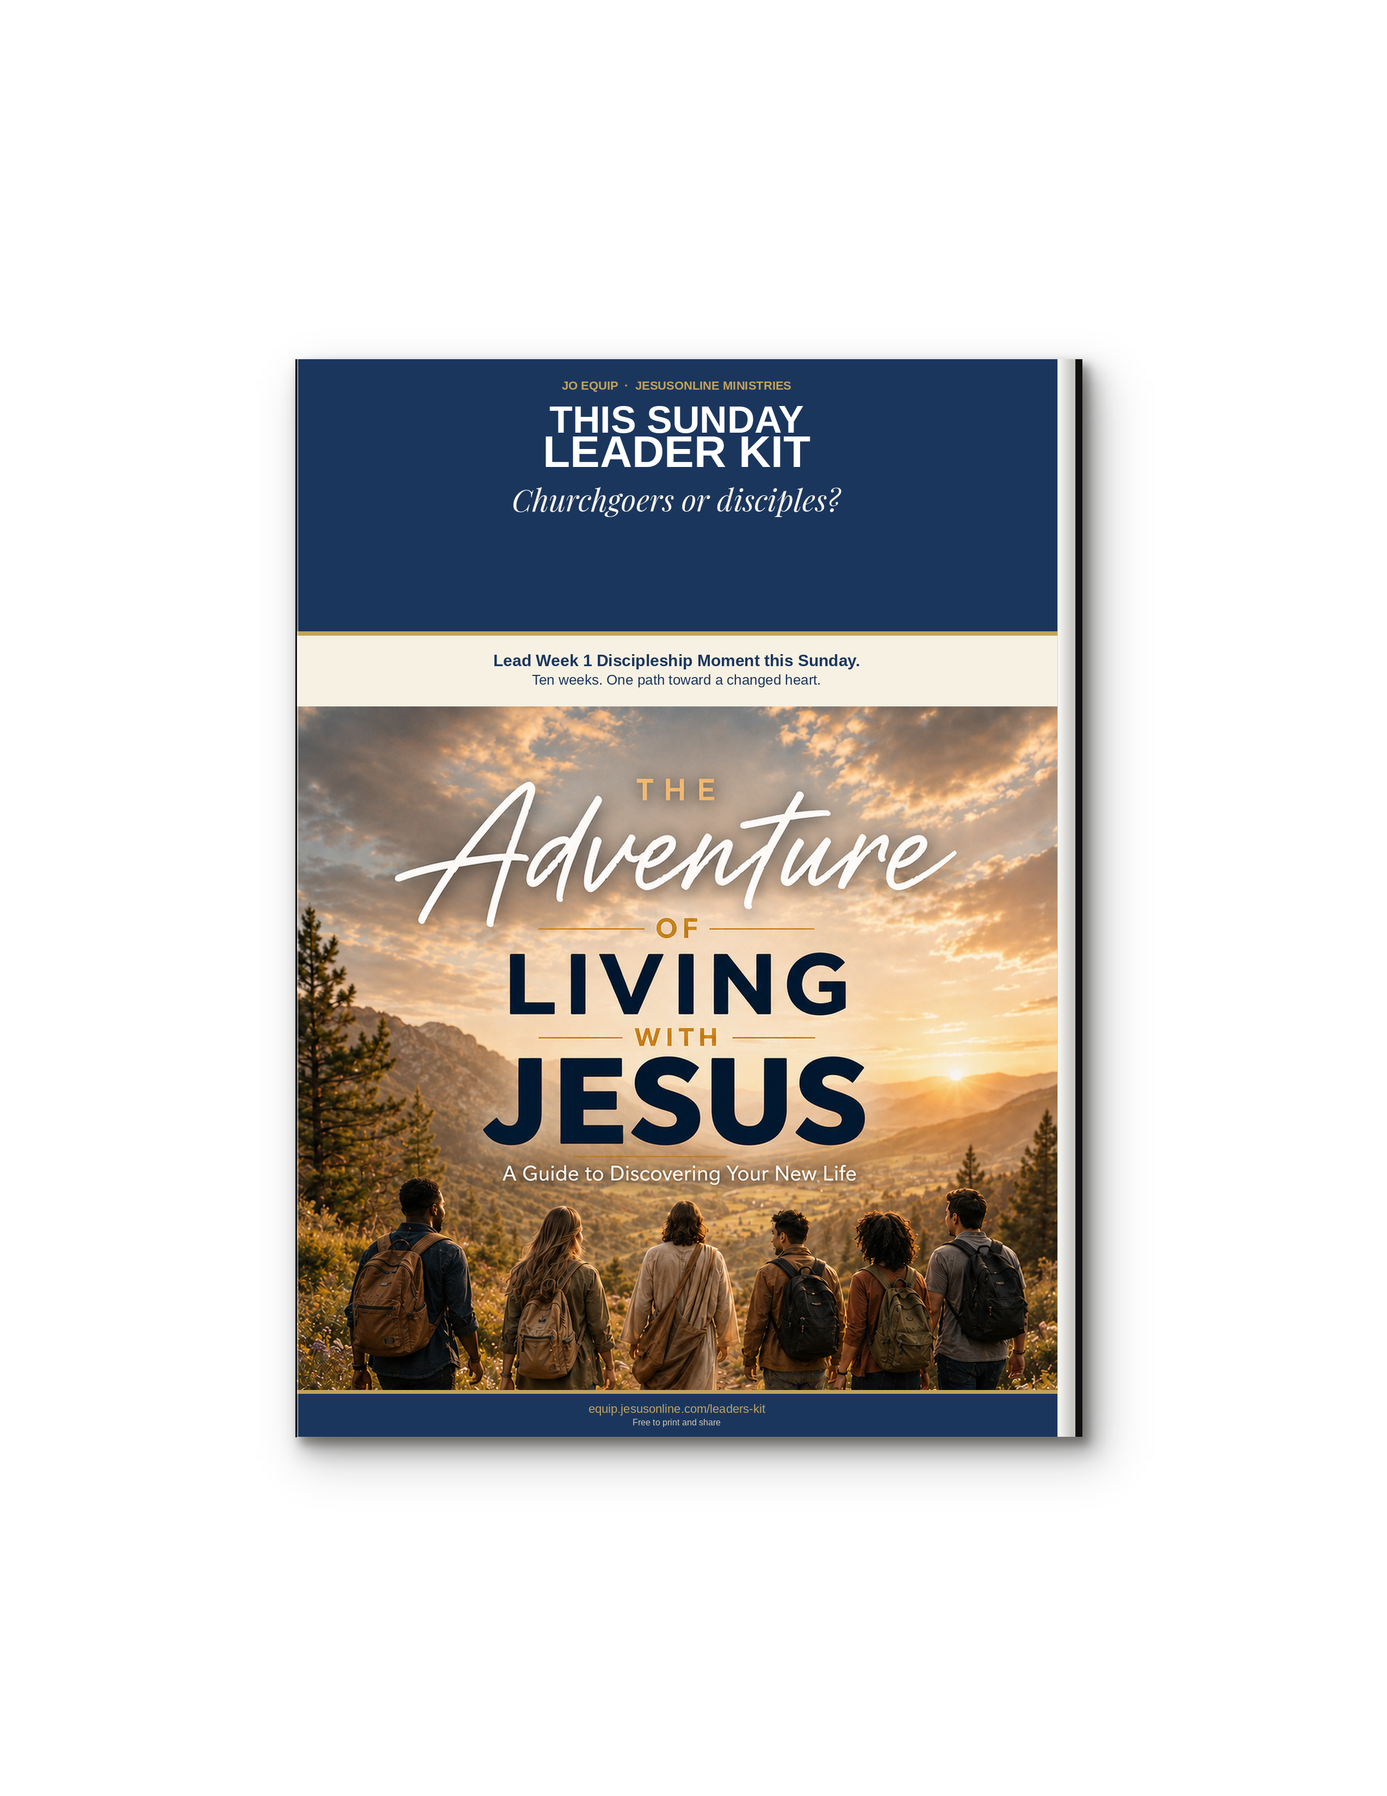
Why This Kit Exists

Pastors—especially in small churches—tell us they have attenders who are not yet disciples, and they lack a manual they can preach, print, or hand to a group leader this week.
Many discipleship programs emphasize biblical knowledge, behavioral change, and spiritual disciplines. JO EQUIP acknowledges these essentials but starts with heart transformation through identity-centered discipleship.
Heart Transformation Through Identity-centered Discipleship
Identity-centered heart transformation starts in the inner person, not with trying harder on the outside. The biblical heart is the control center of beliefs, loves, trust, and choices. From it flow words, desires, and actions. God renews that heart as three realities are embraced together: who you now are in Christ, who God actually is, and how the Holy Spirit functions in daily life.
How you view each of those identities is not extra theology. It is what either frees a new life or keeps an old pattern running.
Why a First Sunday Matters
A pastor in Togo put the need in his own words. He realized he had been gathering churchgoers, not disciples. He needed to be discipled himself. The Adventure of Living with Jesus changed how he lived and how he taught. People were touched when he began to teach from that place.
“I pastored a church full of churchgoers, not disciples. … The Adventure of Living with Jesus discipleship booklet has transformed my life and my understanding about what it is to live for Christ. People are touched and amazed when I am teaching it to them.”
— Pastor Assah, Togo

This kit is ten weeks. Week 1 is this Sunday. It does not replace the JO EQUIP library or the Adventure Guide. It gives you one message to lead, one assignment to send people out with, and a clear next step. After the gathering, the Guide and the JO App carry the journey.

MAIN KEY TAKE-AWAY
A changed life follows a changed heart—and a changed heart begins with who you already are in Christ.

Identity-centered heart transformation

These questions are not a program to complete. They are a continual diagnostic for the heart. Use them on yourself before you use them with anyone else. Full teaching lives on equip.jesusonline.com.

1 IDENTITY FOCUS
How you view your redeemed identity shapes how you live.
When you received Christ, you were not improved; you were made new. “If anyone is in Christ, the new creation has come: The old has gone, the new is here!” (2 Cor. 5:17). God already sees you in Christ. Growth is learning to live as the person He has already made you. A weak view of that identity turns the Christian life into striving. A clear view turns it into alignment.
equip.jesusonline.com/categories/growth/identity-in-christ

2 GOD FOCUS
How you view God’s divine identity shapes how you live.
A distorted view of His character produces a thin life; a true and balanced view does the opposite. You become like what you behold: “beholding the glory of the Lord, [we] are being transformed into the same image” (2 Cor. 3:18). Seeing only part of who God is warps the heart. Seeing Him as He is—holy and loving, just and merciful—forms worship, humility, and trust.
equip.jesusonline.com/categories/growth/attributes-of-god

3 SPIRIT FOCUS
How you view the Holy Spirit’s functional identity shapes how you live.
If the Christian life is “me plus some help from God,” the reflex is self-effort—try harder, white-knuckle holiness. That is Galatians 3:3: beginning by the Spirit, then finishing by the flesh. This is not passivity, but active trust. You still choose, confess, obey, and put off the old self as a new person depending on the Spirit who already lives in you.
equip.jesusonline.com/categories/growth/ministry-holy-spirit

Heart transformation is not “change your behavior so you can feel like a new person.” It is “embrace who you already are, know the God who said so, and depend on the Spirit who lives in you — then behavior follows a changed heart.”
That is identity-centered heart transformation: the inner person renewed so that a new kind of living becomes possible — not by becoming someone else, but by living as the person God has already made you in Christ.

MAIN KEY TAKE-AWAY
That is identity-centered heart transformation: not becoming someone else, but living as the person God has already made you in Christ.

How to Use This Kit

Slip a Discipleship Moment into almost any gathering. Read it almost as written, or put it in your own words. These moments do not replace the Adventure Guide. They are a spoken doorway into it.
Church service | Small group | One-to-one | After they trust Christ
FIVE STEPS FOR THIS WEEK
1 | Prepare your own heart  Read Why This Kit Exists and the three Focus pages until they are in your own mouth. Use them on yourself first.
2 | Do not skip the doubter  If someone is not sure Jesus is who He said, give them a door before Week 1—not a debate.
3 | Lead this week’s moment  Sermon, cell, chapel, or one conversation. Stay near five minutes. A video is extra time only.
4 | Send them out with one assignment  Give this week’s single practice before you dismiss. Ask them to come ready to share what happened.
5 | Keep walking the Guide  Use The Adventure of Living with Jesus alongside the ten weeks. After Week 10, choose one Go Further series.
A SIMPLE 5-MINUTE FLOW
45 sec  Verse | 2 min  Summary | 30 sec  Take-away | 60–90 sec  Close | Then  Assignment

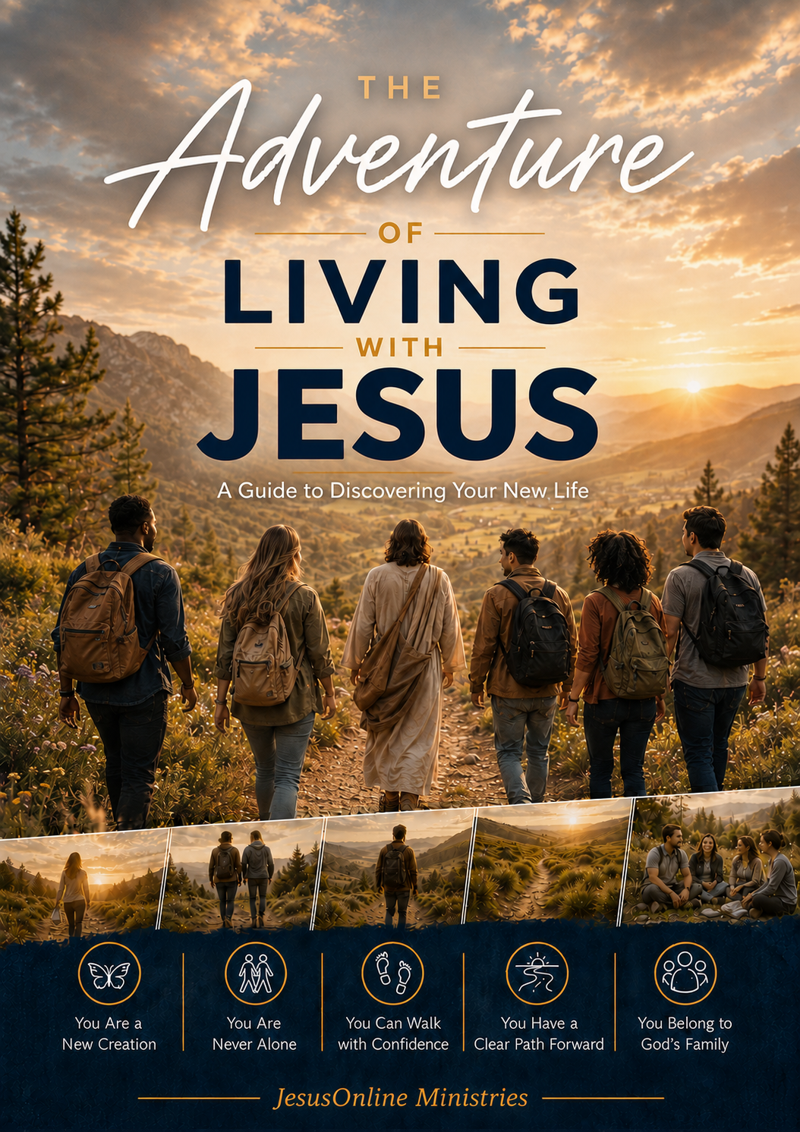 | GET THE FULL GUIDE  The Adventure of Living with Jesus  Free PDF for devices, print, or group study.  equip.jesusonline.com/books/adventure-of-living-with-jesus.pdf  Or take notes in the JO App · app.jesusonline.com

Do Not Skip the Doubter

JO EQUIP unites apologetics with identity-centered discipleship. Sunday is not an evidence lecture. If someone is not sure Jesus is who He said—or not sure God is there at all—give them a door, not a debate. Use this page before Week 1. The ten Moments assume a person has begun with Jesus. This page serves the one who has not.
Two books to leave in a hand
  FREE BOOK  Who Is the Real Jesus?  Open |   FREE BOOK  Has Science Discovered God?  Open
Two playlists if they can watch
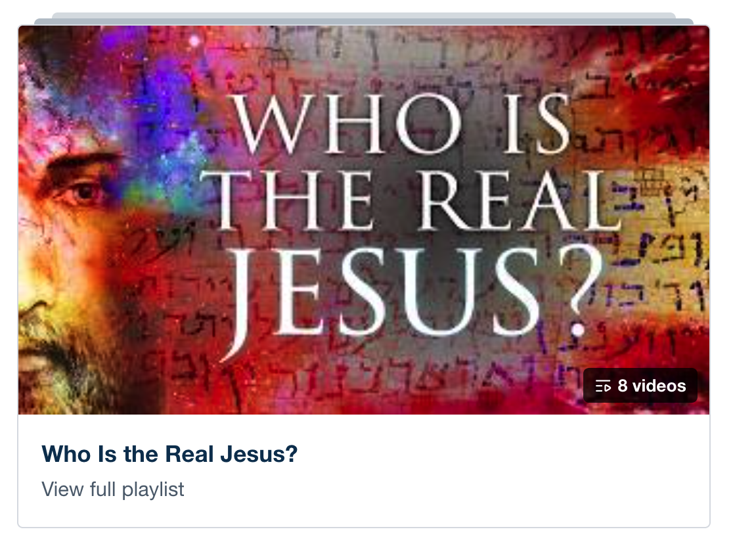  8 VIDEOS  Who Is the Real Jesus?  Open |   1 VIDEO  Science and The Origin of Life  Open

Ask two questions after they read or watch: Did this make sense? Would you like to respond to Jesus? If yes, begin Week 1. If not, stay near. Leave the book. Pray. Do not pressure.

MAIN KEY TAKE-AWAY
Give the doubter a door. Do not skip them, and do not turn Sunday into a debate.

Video Moments

These three videos are optional extras. Use them only if you have a screen and a working connection. They add time beyond the spoken five-minute moment. They never replace it.

  God’s Vision  Weeks 1–2. Helps people see their life from God’s point of view—not only their own story.  Watch | 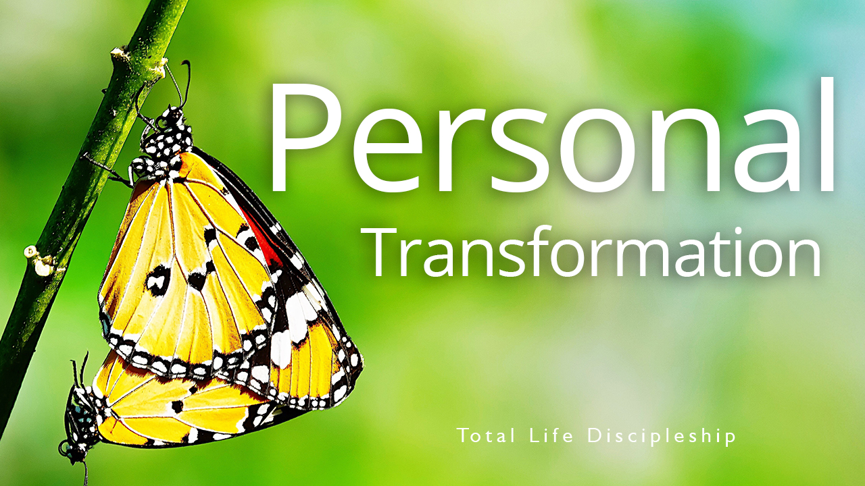  Personal Transformation  Weeks 3–5. Fits identity, the Spirit, and walking by faith—the inner change already begun in Christ.  Watch |   Eternal Impact  Weeks 8–10. Fits belonging, purpose, and finishing the race—fruit that lasts beyond this week.  Watch

Playlist: Total Life Discipleship — Core Principles
These videos are extra time added to the regular five-minute moment. Use one of them in as many as three of the ten weeks if it serves the room. They do not replace the moment. If you have no screen or no connection, lead the moment as written.

MAIN KEY TAKE-AWAY
A video may open a heart. It must not replace the Word, the take-away, or the walk that follows.

WEEK 1 OF 10
Introduction — Begin the Adventure

THEME VERSE
He who began a good work in you will carry it on to completion until the day of Christ Jesus.
— Philippians 1:6, NIV
2-MINUTE LESSON SUMMARY
Something real has already begun. When you invited Jesus Christ into your life, you did not sign up for a religion to manage. You entered a relationship that will never end. The One who created you now lives within you, and He has promised to take you as you are and make your life Christ-centered and purposeful.
Robert Boyd Munger pictured that moment as Jesus walking into the home of his heart. He turned on the light, built a fire on the hearth, started music where there had been silence, and filled the emptiness with His own fellowship. Then He began to walk through every room—thoughts, desires, relationships, work, free time, even the private places we would rather keep locked. In every room He offered light, order, and life.
That is the adventure ahead of you. It is more like a marathon than a sprint. There will be days of clarity and days of confusion, ordinary Tuesdays and unexpected victories. What does not change is the presence of Christ and the patient work of His Spirit. He has already given you everything you need for the journey. This booklet is not a finish line. It is a map for walking with Jesus in everyday life.
The eight lessons that follow are the path God has already marked: assurance, identity, the Holy Spirit, faith, Scripture, prayer, God’s family, and purpose. Move slowly enough for the truth to settle. Look up the verses. Speak honestly with God. He is already with you. The next step is simply to walk with Him.

MAIN KEY TAKE-AWAY
Jesus has already come in. The adventure is learning to let Him lead every room of your life.

THIS WEEK’S ASSIGNMENT
Do this one thing. Come ready to share what happened.
Walk through the rooms of your life this week—thoughts, desires, relationships, work, free time, private places. Name three rooms you will invite Jesus to settle into, and pray over one of them each day.

Suggested close (60–90 seconds): Read Philippians 1:6 aloud. Ask: “Which room of my life am I still holding back from Jesus?” Pray the invitation: “Lord, settle into every part of me.”

WEEK 2 OF 10
1. Citizen of Heaven

THEME VERSE
I write these things to you who believe in the name of the Son of God so that you may know that you have eternal life.
— 1 John 5:13, NIV
2-MINUTE LESSON SUMMARY
After you receive Christ, a quiet question often remains: “If I died today, am I certain I would be with Him?” The Bible does not leave that question hanging. God wants you to know—not hope, not guess—that you belong to Him now and always.
Eternal life is a gift, not a wage. Jesus paid the full price for every sin at the cross. Romans 5:8, Ephesians 2:8-9, Titus 3:5-6, and 1 Peter 3:18 all say the same thing: God did the saving. You cannot add your good works to the blood of Jesus. You can only receive what He has already purchased. In the original language, “believe” means to trust in, cling to, and rely upon—the way a climber trusts the rope that holds him.
Feelings will rise and fall. Faith rests on facts God has spoken. First John 5:11-13 says that if you have the Son, you have life. Romans 8:38-39 says nothing can separate you from His love. Hebrews 13:5 says He will never leave you. Hebrews 8:12 says He remembers your sins no more. Your standing with God does not rest on your performance today. It rests on Christ’s finished work.
Ashley discovered this when her old friendships collapsed and she felt worthless. Someone told her Jesus wanted to be her best friend. She invited Him in, and He stayed. That is the same promise given to you. Keep walking with Him. He will not give up on you—even on the days you feel like giving up on yourself.

MAIN KEY TAKE-AWAY
If you have Jesus, you can know you have eternal life—because He finished the work and He will never leave you.

THIS WEEK’S ASSIGNMENT
Do this one thing. Come ready to share what happened.
Complete this sentence in writing: “If I died today, I know I have eternal life because…” Base your answer only on what God has done in Christ, not on how you feel. Read it each morning this week.

Suggested close (60–90 seconds): Read 1 John 5:11-13. Ask: “Am I trusting Christ’s work, or still trying to earn my place?” Thank God out loud that the gift is already yours.

WEEK 3 OF 10
2. Your New Identity in Christ

THEME VERSE
Therefore, if anyone is in Christ, the new creation has come: The old has gone, the new is here!
— 2 Corinthians 5:17, NIV
2-MINUTE LESSON SUMMARY
The moment you trusted Christ, your identity changed—whether your feelings caught up or not. You are no longer defined by your past, your performance, or other people’s opinions. You are a child of God, with a new nature and a secure place in His family.
C. S. Lewis warned that mere morality is not the point of our existence. We were made for an inheritance. Living for Christ is not the duty of a slave. It is the privilege of a son or daughter. Scripture says your sins are completely forgiven, you are God’s child forever, Christ has come into your life, the Spirit is your guarantee, and you have been given a new nature.
You may not always feel new or act new. In God’s eyes you already are. He sees you as the one His Son purchased with His own blood—His royal child. Peter calls believers living stones in a spiritual temple, a chosen people, a kingdom of priests, God’s very own possession, citizens of His holy nation. Background, ability, appearance, and status no longer write the first line of your story. Belonging to Christ does.
God’s plan is not to leave you as you were. Romans 8:29 says He is conforming you to the image of His Son. Philippians 2:13 says it is God who works in you to will and to act. The change is His work. Your part is to receive who you already are in Christ and walk it out one surrendered day at a time.

MAIN KEY TAKE-AWAY
You are not becoming a new creation by trying harder. In Christ, you already are one—now live from that identity.

THIS WEEK’S ASSIGNMENT
Do this one thing. Come ready to share what happened.
Name one old label you still wear (failure, unwanted, addict, not enough, outsider). Write the biblical name that replaces it. When the old label surfaces this week, speak the new one instead.

Suggested close (60–90 seconds): Read 2 Corinthians 5:17 and 1 Peter 2:9. Ask: “What old label am I still wearing that God has already replaced?” Thank Him for one new name He has given you.

WEEK 4 OF 10
3. The Holy Spirit — Your Constant Companion

THEME VERSE
You will receive power when the Holy Spirit comes on you; and you will be my witnesses.
— Acts 1:8, NIV
2-MINUTE LESSON SUMMARY
The first disciples loved Jesus and were eager to follow Him. Enthusiasm was not enough. Jesus told them to wait for the Father’s promise: power when the Holy Spirit came upon them. Without the Spirit, living for Christ is impossible. With Him, you can do what God asks through the strength He supplies.
When you received Christ, the Spirit entered your life and He will remain with you forever. You are never alone. He is a real Person—the Spirit of Jesus, fully God. He lives in you as Encourager and Comforter. He strengthens your inner being so that Christ may settle into every room of your heart.
A battle still remains. The flesh pulls one way; the Spirit another. Family, success, even good things can take the throne if they become the center. Galatians 5 contrasts a self-directed life with a Spirit-directed life. To be filled with the Spirit is not a mysterious extra experience. It is yielding control the way a player yields to a trusted coach. Ephesians 5:18 commands it: be filled—keep being directed—by the Spirit.
When fellowship breaks because of sin, salvation is not lost. The way back is simple: yield again, confess specifically, and trust the Spirit to take control. Bill Bright called it spiritual breathing—exhale sin through confession, inhale His leadership by faith. Do that as often as you need to. He is always ready to restore and empower you.

MAIN KEY TAKE-AWAY
The Christian life is not you trying harder for Jesus. It is Jesus living His life in you by His Spirit as you yield control.

THIS WEEK’S ASSIGNMENT
Do this one thing. Come ready to share what happened.
Each morning yield control: “Holy Spirit, take control of my life right now.” When you sin or take the throne back, practice spiritual breathing—confess specifically, then trust Him to lead again. Note one moment He helped you.

Suggested close (60–90 seconds): Read Galatians 5:16 and Ephesians 5:18. Pray the surrender prayer from the booklet, then practice one “spiritual breath” right now.

WEEK 5 OF 10
4. Walking by Faith, Not by Feelings

THEME VERSE
And without faith it is impossible to please God, because anyone who comes to him must believe that he exists and that he rewards those who earnestly seek him.
— Hebrews 11:6, NIV
2-MINUTE LESSON SUMMARY
God’s power to live for Christ is available only through faith. Faith is steadfast trust that results in action—not trying to copy Jesus in your own strength, but trusting Him enough to do what He says, the way He wants it done. Genuine faith produces obedience even when the path includes ups and downs.
Your faith will be tested. Scripture names three persistent enemies: the world, the flesh, and the devil. God has not left you unarmed. Ephesians 6:10-18 calls you to stand in the Lord’s strength and put on His armor. Victory is not the absence of struggle. It is trusting God when circumstances and emotions argue otherwise.
Joni Eareckson Tada learned this after a dive left her paralyzed. The promises of God felt untrue. Through a friend’s encouragement and the Word, she chose faith over feeling. Looking back, she saw that God used even that loss. Hebrews 11 is full of people who trusted God through adversity. By contrast, Israel saw miracles and still refused to enter the land because of giants. An entire generation wandered instead of resting in God’s promise.
What “giants” make trust hard for you—relationships, money, plans, habits, past failure, fear, the need to control? Romans 12:2 says transformation begins when God changes the way you think. Victorious faith is taking God at His Word and moving forward, even when you cannot yet see the reason.

MAIN KEY TAKE-AWAY
Faith is not a feeling you wait for. It is taking God at His Word and moving forward when feelings lag behind.

THIS WEEK’S ASSIGNMENT
Do this one thing. Come ready to share what happened.
Name the main “giant” that makes trust hard right now. Write one verse beside it. Then take one small obedient step in that area this week, even if your feelings lag behind.

Suggested close (60–90 seconds): Read Hebrews 11:6. Name one “giant” aloud. Ask God to change how you think about it, then take one small obedient step this week.

WEEK 6 OF 10
5. God’s Word — Your Road Map

THEME VERSE
Let the word of Christ dwell in you richly.
— Colossians 3:16, NIV
2-MINUTE LESSON SUMMARY
If Jesus handed you a personal letter of love and direction, you would read it carefully and return to it often. That is what the Bible is—God’s own word to you. A new baby needs milk to grow. You need Scripture to grow in your new life.
Instinct is a poor guide in unfamiliar country. A map will not show every roadside detail, but it will keep you from heading the wrong way. The Bible answers the questions that matter most: who God is, why you are here, how to grow, how to decide, how to love, how to suffer, how to die. Hebrews 4:12 says it is living and active, able to judge the thoughts and desires of the heart.
Your mind is already being filled by something. The voices around you are mostly the world’s perspective. If God’s perspective is going to shape your life, His Word must become a daily habit—a consistent time, a quiet place, a listening heart. There are five ways to take it in: hearing, reading, studying, memorizing, and meditating. Start where you are. Mark or John, then Acts, is a wise beginning.
David Berkowitz’s life was rewritten in a prison cell by a Bible he was given. Transformation happens as God’s viewpoint slowly replaces the world’s. The time you give to Scripture is one of the clearest indicators of your walk with Christ. Let His Word become the road under your feet.

MAIN KEY TAKE-AWAY
God’s Word is not extra information. It is the map, the food, and the voice that forms you into Christ’s likeness.

THIS WEEK’S ASSIGNMENT
Do this one thing. Come ready to share what happened.
Choose a consistent time and quiet place. Read one chapter a day this week in Mark or John. After each reading, write one sentence: “The Holy Spirit showed me…”

Suggested close (60–90 seconds): Read Psalm 1:1-3. Decide one specific time and place this week to open the Bible. Start with a short passage in Mark or John.

WEEK 7 OF 10
6. Prayer — Your Ongoing Conversation with God

THEME VERSE
Let us then approach God’s throne of grace with confidence, so that we may receive mercy and find grace to help us in our time of need.
— Hebrews 4:16, NIV
2-MINUTE LESSON SUMMARY
Imagine a voice interrupting lunch: “This is your Heavenly Father. I have been wanting to talk with you.” That is the heart of prayer. God is not waiting for a polished speech. He runs toward those who come home, as the father did in Luke 15. Through Jesus you have direct access to Him.
Prayer is relationship, not a rule to master. Every healthy relationship needs honest conversation. Your Father wants you to seek Him for guidance, peace, and companionship—not only when you need something—because He delights in you. The Spirit helps you pray. Faith makes prayer effective. The Word teaches you who He is.
Knowing His character changes how you come: He is sovereign, eternal, all-knowing, present, all-powerful, unchanging, holy, just, loving, and completely trustworthy. Come with confidence because you belong to Him. Come with humility because pride resists dependence. Abide in Christ and let His words remain in you. Ask according to His will. Wait with patience. Some answers come quickly; others take years.
Grow the practice in ordinary ways: begin the day with a simple offering of the hours ahead; carry a promise such as Proverbs 3:5-6; restore fellowship quickly through confession; thank Him and adore Him from the psalms; keep bringing requests that are biblical and within His will. Prayer is not a duty to finish. It is a conversation to enjoy.

MAIN KEY TAKE-AWAY
Prayer is not performing for God. It is a child talking with a Father who already wants to hear you.

THIS WEEK’S ASSIGNMENT
Do this one thing. Come ready to share what happened.
Begin each morning this week with an honest sentence: “Father, I love You. I want to walk with You today. Lead me in what lies ahead.” No performance—just presence.

Suggested close (60–90 seconds): Read Hebrews 4:16 and John 15:7. Take one honest minute of conversation with God—no performance, just presence. Name one request and one thanks.

WEEK 8 OF 10
7. Belonging to God’s Family

THEME VERSE
And let us consider how we may spur one another on toward love and good deeds, not giving up meeting together… but encouraging one another.
— Hebrews 10:24-25, NIV
2-MINUTE LESSON SUMMARY
When you trusted Christ, you received more than a new identity. You were placed in a new family. You belong to the body of Christ across every generation and every place—and Jesus intends that belonging to become local and personal. “Where two or three gather in my name, there am I with them.”
The book of Acts shows the first believers meeting in homes, sharing life, and supporting one another with deep commitment. Their love and steady witness were so compelling that the gospel spread through the Roman world. God still works through ordinary people who take their life together seriously.
Isolation is one of the most common reasons believers grow weak. Paul teaches in 1 Corinthians 12 that every member is necessary. Christ is the Head. No part is unimportant. The parts that seem weaker are indispensable. A single coal grows cold when pulled from the fire; together, coals keep one another burning. Gifts differ, but the same Spirit gives them all for the common good—and for the Great Commission.
If you are not yet connected, you are missing God’s best. Ask Him to lead you to faithful believers. Look for a church that teaches the Bible and values both community and mission. Join a small group where you can know and be known. Offer your gifts. Walk with someone more mature, and stay open to encouraging someone else. Fellowship is not an optional extra. It is how the family lives.

MAIN KEY TAKE-AWAY
You were saved into a family. You cannot become all God designed you to be while remaining a disconnected coal.

THIS WEEK’S ASSIGNMENT
Do this one thing. Come ready to share what happened.
Take one concrete step into God’s family this week: attend a Bible-teaching gathering, visit a small group, or ask a mature believer to talk. Do not only intend it—go.

Suggested close (60–90 seconds): Read Hebrews 10:24-25 and 1 Corinthians 12:27. Ask: “What is my next concrete step toward a local body this week?” Then take it.

WEEK 9 OF 10
8. Living a Life of Purpose

THEME VERSE
We are therefore Christ’s ambassadors, as though God were making his appeal through us.
— 2 Corinthians 5:20, NIV
2-MINUTE LESSON SUMMARY
Assurance, identity, the Spirit, faith, the Word, prayer, and God’s family are not destinations. They are the means by which you become all God created you to be so you can do all He created you to do.
Purpose begins with holiness. God is holy, and the Spirit is forming that same set-apart life in you—from the inside out. It continues with supernatural love. Corrie ten Boom learned to love even a former prison guard, not by human effort but by yielding to the Spirit so His love could flow through her new nature. Galatians 2:20 is the pattern: “I no longer live, but Christ lives in me.”
Jesus spoke of life as an investment. In Luke 19, servants were entrusted with resources. Two put them to work and were commended. One protected what he had and produced nothing. Life on earth is brief. The opportunities to bear fruit that remains are now. One day every believer will stand before Christ—not for condemnation, but for evaluation and reward. We invest our lives as a grateful response to love already secured.
You are an ambassador of the King in a foreign land. Your witness is your walk and your talk. People around you carry hidden burdens. You may be the first person through whom they encounter Jesus. Ask God to enlarge your territory. Keep your eyes on Jesus and run the race He has marked. He is able to do infinitely more than you ask or think.

MAIN KEY TAKE-AWAY
You were not saved only to be safe. You were saved to represent Jesus and invest this brief life for fruit that lasts.

THIS WEEK’S ASSIGNMENT
Do this one thing. Come ready to share what happened.
Name one person in your daily life who needs hope. Pray for them each day this week, and look for one opening to show or speak the hope you have found in Jesus.

Suggested close (60–90 seconds): Read 2 Corinthians 5:20. Name one person in your daily life who needs hope. Ask God for one opening this week to walk and speak as His ambassador.

WEEK 10 OF 10
Conclusion — Continuing with Jesus

THEME VERSE
Let us run with endurance the race that God has set before us. We do this by keeping our eyes on Jesus, on whom our faith depends from start to finish.
— Hebrews 12:1-2, NLT
2-MINUTE LESSON SUMMARY
You have now walked through eight foundational truths: you are a citizen of heaven; you have a new identity; the Spirit is your companion; you walk by faith; God’s Word is your map; prayer is conversation with your Father; you belong to His family; and your life has eternal purpose. These truths are not meant to be studied once and set on a shelf. They are meant to be lived—slowly, steadily, sincerely—in ordinary days.
Your walk with Jesus is a life cycle. You were born again as a spiritual infant. The Father’s desire is that you grow into maturity and take your place in His work. Keep getting to know who God is. Keep learning who you are in Christ. Practice reliance on the Spirit in small moments. Stay rooted in Scripture and honest prayer. Remain connected with other believers. Share what you are discovering.
Weights will try to slow you. Distractions will pull your eyes off Jesus. Strip them off and run. Those who hope in the Lord renew their strength. They walk and do not faint. The One who called you is trustworthy and remains with you every step. His plans are for hope and a future. His power at work within you can accomplish more than you imagine.
The adventure has just begun. You have an indispensable part to play in God’s story. Keep walking with Him—and watch what unfolds next.

MAIN KEY TAKE-AWAY
The Christian life is not a booklet you finish. It is a race you keep running with your eyes on Jesus.

THIS WEEK’S ASSIGNMENT
Do this one thing. Come ready to share what happened.
Name one specific next step for this week—a Word habit, a conversation with God, a connection with believers, or a person to encourage—and complete it before the week ends. Tell one person what you did.

Suggested close (60–90 seconds): Pray the closing prayer from the booklet. Then write one truth you will practice and one specific next step for this week.

Go Further

The Adventure of Living with Jesus is the beginning of this journey. It showed you the path. The series below help with deeper heart transformation as you continue for a longer stretch.
Each one takes a single part of your new life and gives it room—your heart, your identity, the greatness of God, the Spirit’s presence, and the habits of growing up in Christ.
You do not have to use them in order. Begin with the series that meets the need of your current discipleship situation. Each series can be downloaded free from the Leaders Kit:
equip.jesusonline.com/leaders-kit
A Heart After God · 8 lessons
Seven Reflections on the Inner Life
Learn to want what God wants—in the hidden places no one else sees.

Your New Identity in Christ · 10 lessons
Embracing Who God Says You Are
Settle the question of who you are now, so the old names lose their hold.

Beholding the Majesty of God · 6 lessons
Explore His Divine Attributes
Lift your eyes from your own story long enough to see the God who holds it.

Walking in the Spirit · 15 lessons
A Practical Guide to the Holy Spirit’s Presence, Power, and Fruit
Discover how the Spirit who lives in you shapes ordinary decisions, not only high moments.

Building Blocks for Maturity · 11 lessons
Practiced Steps of Growing Up in Christ
Grow up in Christ one practiced step at a time—not by trying harder, but by walking with Him.

MAIN KEY TAKE-AWAY
He is already with you. Choose one series and take the next step.

Free on JO EQUIP · Also in the JO App · app.jesusonline.com

