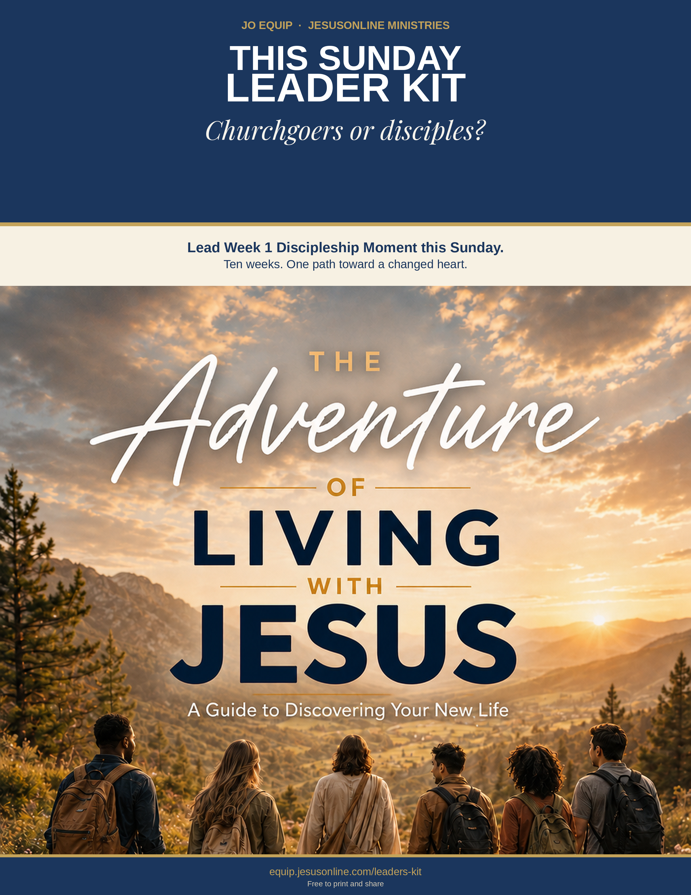
Why This Kit Exists

“I pastored a church full of churchgoers, not disciples.”
Pastor Assah of Togo names what many churches live with: people who attend, and few who are being formed as disciples of Jesus.
Discipleship programs often emphasize biblical knowledge, behavioral change, and spiritual disciplines. JO EQUIP honors those essentials and starts one step earlier: heart transformation through identity-centered discipleship.
Heart Transformation Through Identity-Centered Discipleship
Identity-centered heart transformation starts in the inner person, not with trying harder on the outside. The biblical heart is the control center of beliefs, loves, trust, and choices. From it flow words, desires, and actions. God renews that heart as three realities are embraced together: who you now are in Christ, who God actually is, and how the Holy Spirit functions in daily life. How you view each of those identities either frees a new life or leaves the old life in charge.
Discipleship Moments
This kit helps foster a culture of life transformation by moving people from passive listeners to active doers. Each Moment introduces one key truth concisely, so it can slip into a service, a small group, or a conversation. It is a spoken doorway into the full training—not a replacement for it.
Discipleship Moments are standardized and systematic because effective discipleship must be reproducible.
“And what you have heard from me in the presence of many witnesses entrust to faithful people who will be able to teach others also” (2 Timothy 2:2).
Standardized training enables more people to teach what they have learned more readily. A systematic progression in discipleship provides a clear pathway for people to grow from spiritual birth toward maturity in Christ (Colossians 1:28).
You Can Start Immediately
This kit has ten five-minute moments. Each has: one message, one assignment, and one next step. Start this Sunday.
“I pastored a church full of churchgoers, not disciples. … The Adventure of Living with Jesus discipleship booklet has transformed my life and my understanding about what it is to live for Christ. People are touched and amazed when I am teaching it to them.”
— Pastor Assah, Togo

Ten weeks. After each Discipleship Moment, invite people to read that week’s The Adventure of Living with Jesus chapter—in the book or on the JO App. The Moment opens the door. The chapter is where they walk through.

MAIN KEY TAKE-AWAY
A changed life follows a changed heart—and a changed heart begins with who you already are in Christ.

Identity-Centered Heart Transformation

These three focuses are not a program to complete. They are a continual diagnostic for the heart: who you now are in Christ, who God actually is, and how the Holy Spirit works in daily life. Use them on yourself first. Then use them with others. Full teaching is available on equip.jesusonline.com.

1 IDENTITY FOCUS
How you view your redeemed identity shapes how you live.
When you received Christ, you were not improved; you were made new. “If anyone is in Christ, the new creation has come: The old has gone, the new is here!” (2 Cor. 5:17, NIV). God already sees you in Christ. Growth is learning to live as the person He has already made you. A weak view of that identity turns the Christian life into striving. A clear view turns it into alignment.
equip.jesusonline.com/categories/growth/identity-in-christ

2 GOD FOCUS
How you view God’s divine identity shapes how you live.
A distorted view of His character produces a life different from what God envisioned for you; a true and balanced view does the opposite. You become like what you behold: “beholding the glory of the Lord, [we] are being transformed into the same image” (2 Cor. 3:18, ESV). Seeing only part of who God is warps the heart. Seeing Him as He is—holy and loving, just and merciful—forms worship, humility, and trust.
equip.jesusonline.com/categories/growth/attributes-of-god

3 SPIRIT FOCUS
How you view the Holy Spirit’s functional identity shapes how you live.
If the Christian life is “me plus some help from God,” the reflex will be self-effort—try harder, white-knuckle holiness. That is Galatians 3:3: After beginning by the Spirit, are you now finishing by the flesh? Full dependence on the Spirit is not passivity, but active trust. You still choose, confess, obey, and put off the old self as a new person empowered by on the Spirit who already lives in you.
equip.jesusonline.com/categories/growth/ministry-holy-spirit

Identity-centered heart transformation is not “change your behavior so you can feel like a new person.” It is “embrace who you already are, know the God who said so, and depend on the Spirit who lives in you — then behavior follows a changed heart.”
Identity precedes behavior. Transformation flows from what God has already done in Christ. A new kind of living becomes possible not by becoming someone else, but by living as the person God has already made you to be in Christ.

MAIN KEY TAKE-AWAY
That is identity-centered heart transformation: not becoming someone else, but living as the person God has already made you in Christ.

How to Use This Kit

Discipleship Moments are short training modules designed to help equip believers to become disciples. Use them as part of your Sunday service, small groups, chapel services, house church, or in one-on-one discipleship conversations. They do not replace the underlying training series. Each Moment is a “spoken” doorway into the more complete training.
Discipleship Moments from The Adventure of Living with Jesus focuses on essential truths of the Christian walk.
Follow the five steps. You can read it as written or put it in your own words. Remember that the power to transform lives does not come from how well you deliver the material. Transformation comes from the Holy Spirit as people put God’s truth into practice.
Church service | Small group | One-to-one | After they trust Christ
FIVE STEPS FOR THIS WEEK
1 | Prepare your own heart  Read Why This Kit Exists and the three Focus blocks until you can explain them naturally. Use them on yourself first.
2 | Do not skip the doubter  If someone is not sure Jesus is who He said He is, show them resources in “Do Not Skip the Doubter.”
3 | Lead this week’s moment  Keep the Moment to about 5 minutes. A video is additional and optional.
4 | Send them out with one assignment  Give this week’s single practice before you dismiss. Ask them to come ready to share what happened.
5 | Keep walking the Guide  Use The Adventure of Living with Jesus alongside the Moment. The deeper work happens when people also read the chapter.
A SIMPLE 5-MINUTE FLOW
45 sec  Verse | 2 min  Summary | 30 sec  Take-away | 60–90 sec  Close | Then  Assignment

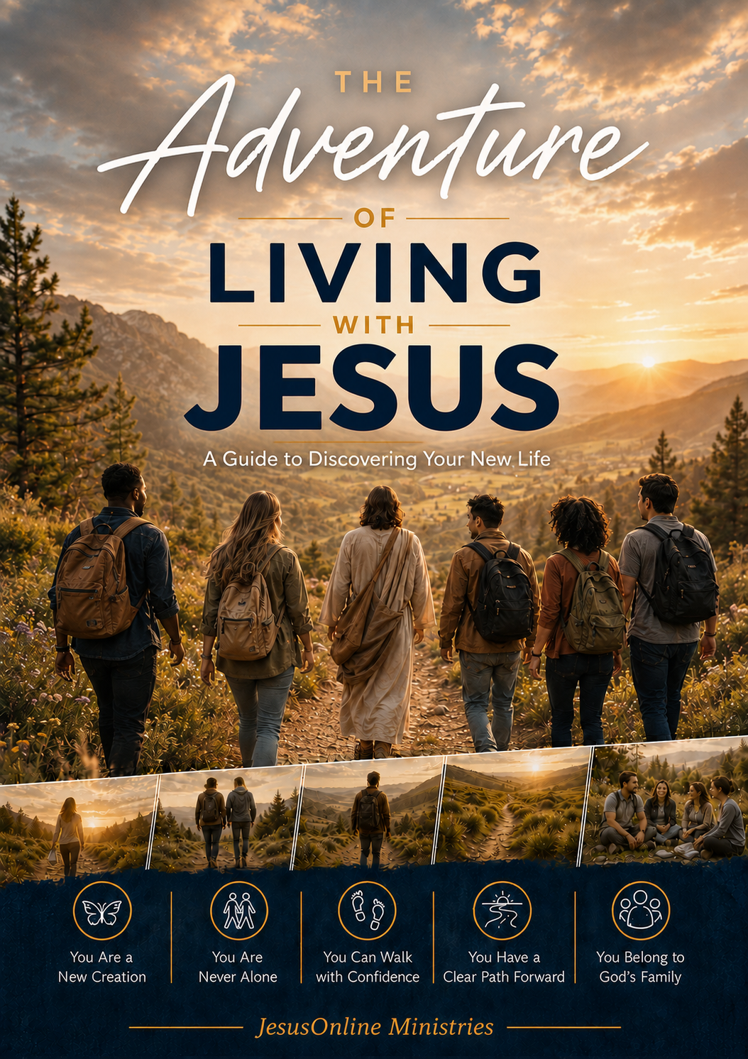 | GET THE FULL GUIDE  The Adventure of Living with Jesus  Free PDF for devices, print, or group study.  equip.jesusonline.com/books/adventure-of-living-with-jesus.pdf  Or take notes in the JO App · app.jesusonline.com

Do Not Skip the Doubter

JO EQUIP unites apologetics with identity-centered discipleship. Discipleship Moments assume a person has begun with Jesus. If someone is not sure Jesus is who He said—or not sure God is there at all—give them a different door. Use this page.
TWO BOOKS TO LEAVE IN A HAND
  FREE BOOK  Who Is the Real Jesus?  Open |   FREE BOOK  Has Science Discovered God?  Open
TWO PLAYLISTS IF THEY CAN WATCH
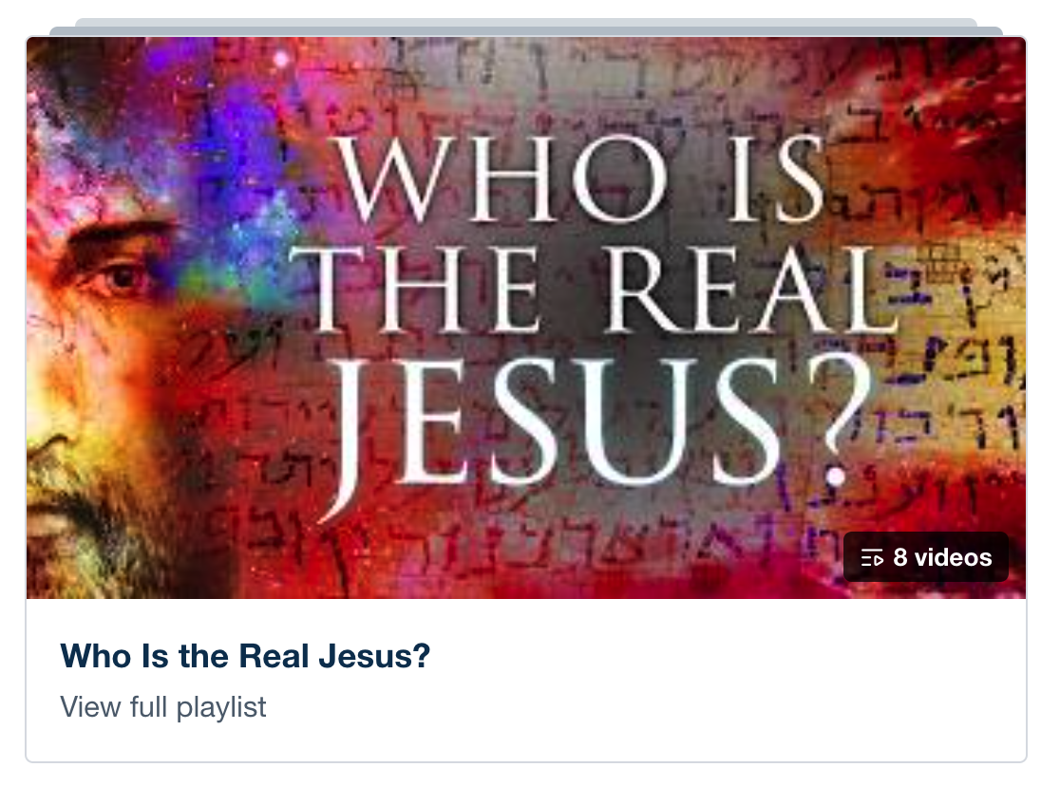  8 VIDEOS  Who Is the Real Jesus?  Open |   1 VIDEO  Science and The Origin of Life  Open

Ask two questions after they read or watch: Did this make sense? Would you like to respond to Jesus? If yes, begin Week 1. If not, stay near. Leave the book. Pray. Do not pressure.

MAIN KEY TAKE-AWAY
Give the doubter a different door. Do not ignore them.

Video Moments

These videos are optional and require extra time beyond the regular five-minute moment. They do not replace the moment. These videos do not directly correspond to the nine lessons of The Adventure of Living with Jesus.
Playlist: Total Life Discipleship: Core Principles
  God’s Vision  Weeks 1–2. Helps people see their life from God’s point of view—not only their own story.  Watch | 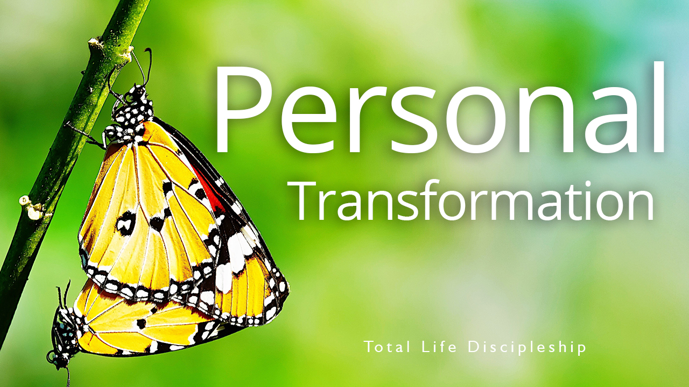  Personal Transformation  Weeks 3–5. Fits identity, the Spirit, and walking by faith—the inner change already begun in Christ.  Watch |   Eternal Impact  Weeks 8–10. Fits belonging, purpose, and finishing the race—fruit that lasts beyond this week.  Watch

MAIN KEY TAKE-AWAY
A video may open a heart. It must not replace the message, the take-away, or the walk that follows.

WEEK 1 OF 10
Introduction — Begin the Adventure

THEME VERSE
He who began a good work in you will carry it on to completion until the day of Christ Jesus.
— Philippians 1:6, NIV
2-MINUTE LESSON SUMMARY
Something real has already begun. When you invited Jesus in, you did not sign up for a religion to manage. You stepped into a relationship that will not run out. The One who made you now lives in you. He has promised to take you as you are and make your life His.
Robert Boyd Munger pictured it this way. Jesus walked into the home of his heart. He turned on the light. He built a fire. He put music where there had been silence. Then He started walking through the rooms—thoughts, desires, relationships, the locked doors you hoped He would not notice. He wants to remake your entire house, from the foundation up, one room at a time.
That is the adventure in front of you. It is more of a marathon than a sprint. Some days will be clear. Some days will be fog. Ordinary Tuesdays. Unexpected victories. What does not change is this: Christ is with you, and His Spirit is patient. He has already given you what you need for the next step.
The weeks ahead walk a path God has already marked: assurance, identity, the Spirit, faith, Scripture, prayer, His family, and purpose. Do not rush it. Look up the verses. Tell God the truth. He is already with you. The next step is simply to walk with Him.

MAIN KEY TAKE-AWAY
Jesus has already come in. The adventure is learning to let Him transform every room of your life.

THIS WEEK’S ASSIGNMENT
Do this one thing. Come ready to share what happened.
Walk through the rooms of your life this week—thoughts, desires, relationships, work, free time, private places. Name three rooms you will invite Jesus to settle into, and pray over one of them each day.

Suggested close (60–90 seconds): Read Philippians 1:6 aloud. Ask: “Which room of my life am I still holding back from Jesus?” Pray the invitation: “Lord, settle into every part of me.”

WEEK 2 OF 10
1. Citizen of Heaven

THEME VERSE
I write these things to you who believe in the name of the Son of God so that you may know that you have eternal life.
— 1 John 5:13, NIV
2-MINUTE LESSON SUMMARY
After you receive Christ, a quiet question often stays in the room: If I died today, would I be with Him? God does not want you guessing. He wants you to know that you belong to Him—now, and always.
Eternal life is a gift. It is not a wage. Jesus paid the full price at the cross. Romans, Ephesians, Titus, Peter—they all say the same thing. God did the saving. You cannot add your good works to the blood of Jesus. You can only receive what He has already bought.
Feelings will rise and fall. Faith rests on what God has said. If you have the Son, you have life because eternal life is being in fellowship with God through Jesus. Nothing can separate you from His love. He will not leave you. He remembers your sins no more. Your standing with Him does not ride on a good week.
Here is an experience of a woman named Ashley. She learned this when her old friendships fell apart and she felt worthless. Someone told her Jesus wanted to be her friend. She invited Him in. He stayed. That is the same promise given to you. Keep walking. He will not give up on you—even on the days you feel like giving up on yourself.

MAIN KEY TAKE-AWAY
If you have Jesus, you can know you have eternal life—because He finished the work and He will never leave you.

THIS WEEK’S ASSIGNMENT
Do this one thing. Come ready to share what happened.
Complete this sentence in writing: “If I died today, I know I have eternal life because…” Base your answer only on what God has done in Christ, not on how you feel. Read it each morning this week.

Suggested close (60–90 seconds): Read 1 John 5:11-13. Ask: “Am I trusting Christ’s work, or still trying to earn my place?” Thank God out loud that the gift is already yours.

WEEK 3 OF 10
2. Your New Identity in Christ

THEME VERSE
Therefore, if anyone is in Christ, the new creation has come: The old has gone, the new is here!
— 2 Corinthians 5:17, NIV
2-MINUTE LESSON SUMMARY
The moment you trusted Christ, your identity changed. Your feelings may still be catching up. You are no longer defined by your past, your performance, or other people’s verdicts. God defines you. You are a child of God. You have a new nature. You have a place in His family. You are who God says you are.
C. S. Lewis said mere morality is not why you exist. You were made for an inheritance. Living for Christ is not the duty of a slave. It is the privilege of a son or daughter. Your sins are forgiven. You are His child forever. Christ lives in you. The Spirit is the guarantee. You have been given a new nature.
You may not always feel new. You may not always act new. In God’s eyes you already are. He sees the precious one His Son purchased. Peter calls you a living stone, a chosen people, a priest, God’s own possession. Background, ability, appearance, status—they no longer write the first line of who you are. Belonging to Christ does.
God’s plan is not to leave you as you were. He is conforming you to the image of His Son. He works in you to will and to act. The change is His work. Your part is to receive who you already are and walk it out, one surrendered day at a time.

MAIN KEY TAKE-AWAY
You are not becoming a new creation by trying harder. In Christ, you already are one—now live from that identity.

THIS WEEK’S ASSIGNMENT
Do this one thing. Come ready to share what happened.
Name one old label you still wear (failure, unwanted, addict, not enough, outsider). Write the biblical name that replaces it. When the old label surfaces this week, speak the new one instead.

Suggested close (60–90 seconds): Read 2 Corinthians 5:17 and 1 Peter 2:9. Ask: “What old label am I still wearing that God has already replaced?” Thank Him for one new name He has given you.

WEEK 4 OF 10
3. The Holy Spirit — Your Constant Companion

THEME VERSE
You will receive power when the Holy Spirit comes on you; and you will be my witnesses.
— Acts 1:8, NIV
2-MINUTE LESSON SUMMARY
The first disciples loved Jesus. They were eager. Eagerness was not enough. Jesus told them to wait for the Father’s promise—power when the Holy Spirit came upon them. Without the Spirit, living for Christ is impossible. With Him, you can do what God asks with the strength He supplies.
When you received Christ, the Spirit entered your life. He will not leave. You are never alone. He is not an it. He is a Person—the Spirit of Jesus, fully God. He lives in you as Encourager and Comforter. He strengthens the inner life so Christ can settle into every room.
A battle remains. The flesh pulls one way. The Spirit another. Family, success, even good things can take the throne if they become the center of your life. Galatians 5 explains that conflict. Being filled with the Spirit is not a mysterious extra. It is yielding, the way a player yields to a trusted coach. Keep being directed by Him.
When sin breaks your fellowship with God, your salvation is not lost. The way back is simple. Yield again. Confess specifically. Trust the Spirit to take the lead. Bill Bright called it spiritual breathing: exhale sin, inhale His leadership by faith. Do it as often as you need to. He is ready.

MAIN KEY TAKE-AWAY
The Christian life is not you trying harder for Jesus. It is Jesus living His life in you by His Spirit as you yield control.

THIS WEEK’S ASSIGNMENT
Do this one thing. Come ready to share what happened.
Each morning yield control: “Holy Spirit, take control of my life right now.” When you sin or take the throne back, practice spiritual breathing—confess specifically, then trust Him to lead again. Note one moment He helped you.

Suggested close (60–90 seconds): Read Galatians 5:16 and Ephesians 5:18. Pray the surrender prayer from the booklet, then practice one “spiritual breath” right now.

WEEK 5 OF 10
4. Walking by Faith, Not by Feelings

THEME VERSE
And without faith it is impossible to please God, because anyone who comes to him must believe that he exists and that he rewards those who earnestly seek him.
— Hebrews 11:6, NIV
2-MINUTE LESSON SUMMARY
God’s power to live for Christ comes through faith. Faith is both believing and trusting in Him enough to do what He says, the way He wants it done. Real faith moves. It obeys even when the way forward is long, uncertain, difficult, or costly.
Your faith will be tested. The world, the flesh, and the devil do not retire when you trust Christ. God has not left you unarmed. Stand in His strength. Put on His armor. Victory is not the absence of struggle. It is trusting God when circumstances and emotions argue otherwise.
Joni Eareckson Tada learned this after a dive left her paralyzed. The promises felt untrue. Through a friend and the Word, she chose faith over feeling. Looking back, she saw that God used even that loss. Hebrews 11 is full of people who trusted God through adversity. But the Bible also gives the opposite example. Israel saw God’s miracles and still failed to trust Him and to enter the Promised Land because of giants. An entire generation wandered instead of resting in what God had said.
What giants make trust hard for you—relationships, money, plans, habits, old failure, fear, the need to control? Transformation begins when God changes the way you think. His perspective will strengthen your faith. Victorious faith is taking God at His Word and moving forward, even when you cannot yet see why.

MAIN KEY TAKE-AWAY
Faith is not a feeling you wait for. It is taking God at His Word and moving forward when feelings lag behind.

THIS WEEK’S ASSIGNMENT
Do this one thing. Come ready to share what happened.
Name the main “giant” that makes trust hard right now. Write one verse beside it. Then take one small obedient step in that area this week, even if your feelings lag behind.

Suggested close (60–90 seconds): Read Hebrews 11:6. Name one “giant” aloud. Ask God to change how you think about it, then take one small obedient step this week.

WEEK 6 OF 10
5. God’s Word — Your Road Map

THEME VERSE
Let the word of Christ dwell in you richly.
— Colossians 3:16, NIV
2-MINUTE LESSON SUMMARY
If Jesus handed you a letter of love and direction with your name on it, you would read it. You would come back to it. That is what the Bible is. God’s own word to you. A new baby needs milk. You need Scripture to grow.

MAIN KEY TAKE-AWAY
God’s Word is the map that guides you, the food that nourishes you, and the voice that forms you into Christ’s likeness.

THIS WEEK’S ASSIGNMENT
Do this one thing. Come ready to share what happened.
Choose a consistent time and quiet place. Read one chapter a day this week in Mark or John. After each reading, write one sentence: “The Holy Spirit showed me…”

Suggested close (60–90 seconds): Read Psalm 1:1-3. Decide one specific time and place this week to open the Bible. Start with a short passage in Mark or John.

WEEK 7 OF 10
6. Prayer — Your Ongoing Conversation with God

THEME VERSE
Let us then approach God’s throne of grace with confidence, so that we may receive mercy and find grace to help us in our time of need.
— Hebrews 4:16, NIV
2-MINUTE LESSON SUMMARY
Prayer is a conversation with your Father. He already knows what you need. He still wants to hear you. He wants you to seek Him for guidance, for peace, for companionship, anytime, and not only when you need something. He delights in you. He desires fellowship with you. The Spirit helps you pray. Faith makes prayer alive. The Word teaches you the dynamics of prayer.
Knowing His character changes how you come. He is sovereign, holy, just, loving, and completely trustworthy. Come with confidence because you belong to Him. Come with humility because He is the holy King. Stay in Christ. Let His words stay in you. Ask according to His will. Wait and be persistent. Some answers come quickly. Some take years.
Grow it in ordinary ways. Offer Him the day when you wake. Carry a promise like Proverbs 3:5-6. When fellowship breaks, confess quickly. Thank Him. Use the psalms to adore Him. Keep bringing requests that fit His heart.
Prayer is a fellowship with God to enjoy. You do not have to sound impressive. You have to come. He is waiting.

MAIN KEY TAKE-AWAY
Prayer is not performing for God. It is a child talking with the Father who already wants to hear you.

THIS WEEK’S ASSIGNMENT
Do this one thing. Come ready to share what happened.
Begin each morning this week with an honest sentence: “Father, I love You. I want to walk with You today. Lead me in what lies ahead.” No performance—just presence.

Suggested close (60–90 seconds): Read Hebrews 4:16 and John 15:7. Take one honest minute of conversation with God—no performance, just presence. Name one request and one thanks.

WEEK 8 OF 10
7. Belonging to God’s Family

THEME VERSE
And let us consider how we may spur one another on toward love and good deeds, not giving up meeting together… but encouraging one another.
— Hebrews 10:24-25, NIV
2-MINUTE LESSON SUMMARY
When you trusted Christ, you received more than a new name. You were placed in a family. You belong to the body of Christ across every generation and every place. Jesus also intends that belonging to be local. Where two or three gather in His name, He is there.
Acts shows the first believers in homes, sharing life and caring for one another. Their love and steady witness were so compelling that the gospel moved throughout the Roman world. God still works through ordinary people who embrace a shared life in community.
Isolation is one of the most common reasons believers grow weak. Paul says every member is necessary. Christ is the Head. No part is extra or optional. A single coal grows cold when you pull it from the fire. Together, coals keep one another burning. We are each unique. Gifts differ. The same Spirit gives them for the common good so that people who don’t know Jesus can see Him in our community.
If you are not yet actively involved in the life of this community, you are missing something God meant for you. Ask Him to lead you and show you how you are to be active. Change your perspective on what the church is for you. Reach out to someone in the church. Stay open and ready to encourage or walk with someone around you.

MAIN KEY TAKE-AWAY
You were saved into a family. You cannot become all God designed you to be while remaining an isolated coal.

THIS WEEK’S ASSIGNMENT
Do this one thing. Come ready to share what happened.
Take one concrete step into God’s family this week: attend a Bible-teaching gathering, visit a small group, or ask a mature believer to talk. Do not only intend it—go.

Suggested close (60–90 seconds): Read Hebrews 10:24-25 and 1 Corinthians 12:27. Ask: “What is my next concrete step toward a local body this week?” Then take it.

WEEK 9 OF 10
8. Living a Life of Purpose

THEME VERSE
We are therefore Christ’s ambassadors, as though God were making his appeal through us.
— 2 Corinthians 5:20, NIV
2-MINUTE LESSON SUMMARY
Assurance, identity, the Spirit, faith, the Word, prayer, and God’s family are not finish lines. They are how you become who God created you to be—so you can do what He created you to do.
Purpose begins with personal holiness. God is holy, and the Spirit is forming that set-apart life in you from the inside out. God’s purpose is not only our transformation. Changing others is another. We love them with His supernatural love.
Jesus spoke of life as an investment. In Luke 19, servants were entrusted with resources. Two put them to work. One risked nothing and produced nothing. Life on earth is brief. The chances to bear lasting fruit are now. One day every believer will stand before Christ and give an account of what was placed in their hands.
You are an ambassador of the King in a land that is not your final home. Your witness is your walk and your words. People around you carry hidden burdens. You may be the first person through whom they meet Jesus. Ask God to enlarge your territory for a more effective impact. Keep your eyes on Him. Run the race He marked. He is able to keep you.

MAIN KEY TAKE-AWAY
You were not saved to be safe. You were saved to represent Jesus and invest this brief life for fruit that lasts.

THIS WEEK’S ASSIGNMENT
Do this one thing. Come ready to share what happened.
Name one person in your daily life who needs hope. Pray for them each day this week, and look for one opening to show or speak the hope you have found in Jesus.

Suggested close (60–90 seconds): Read 2 Corinthians 5:20. Name one person in your daily life who needs hope. Ask God for one opening this week to walk and speak as His ambassador.

WEEK 10 OF 10
Conclusion — Continuing with Jesus

THEME VERSE
Let us run with endurance the race that God has set before us. We do this by keeping our eyes on Jesus, on whom our faith depends from start to finish.
— Hebrews 12:1-2, NLT
2-MINUTE LESSON SUMMARY
You have walked eight foundational truths. You are a citizen of heaven. You have a new identity. The Spirit is your companion. You walk by faith. God’s Word is your map. Prayer is conversation with your Father. You belong to His family. Your life has eternal purpose. These are not ideas to admire. They are a life to live.
Your walk with Jesus is a life cycle. You were born again as a spiritual infant. The Father’s desire is that you grow up and take your place. Keep getting to know who God is. Keep learning who you are in Christ. Rely on the Spirit in small moments. Stay in the Word. Stay in prayer. Stay with His people.
Weights will try to slow you. Distractions will pull your eyes off Jesus. Lay them down and stay in the race. Those who hope in the Lord renew their strength. They walk and do not faint. The One who called you is trustworthy. He remains with you. His plans are hope and a future. Your King with His rewards awaits you.
The adventure has just begun. You have a part to play that no one else can play the same way. Keep walking with Him, and watch what unfolds next.

MAIN KEY TAKE-AWAY
The Christian life is a race you keep running with your eyes on Jesus. He eagerly awaits at the finish line with His rewards.

THIS WEEK’S ASSIGNMENT
Do this one thing. Come ready to share what happened.
Name one specific next step for this week—a Word habit, a conversation with God, a connection with believers, or a person to encourage—and complete it before the week ends. Tell one person what you did.

Suggested close (60–90 seconds): Pray the closing prayer from the booklet. Then write one truth you will practice and one specific next step for this week.

Go Further

The Adventure of Living with Jesus is the beginning of this journey. It guided your initial steps. The series below help with deeper heart transformation as you continue for a longer stretch. These series explore different dimensions of your new life in Christ—your heart, your identity, the greatness of God, the Spirit’s presence, and the habits of growing mature in Christ.
You do not have to use them in order. Begin with the series that meets the need of your current discipleship situation. Each series can be downloaded free from the Leaders Kit: equip.jesusonline.com/leader-kits
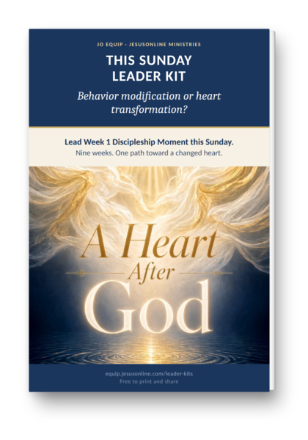 | A Heart After God · 9 lessons  Seven Reflections on the Inner Life  Learn to want what God wants—in the hidden places no one else sees.

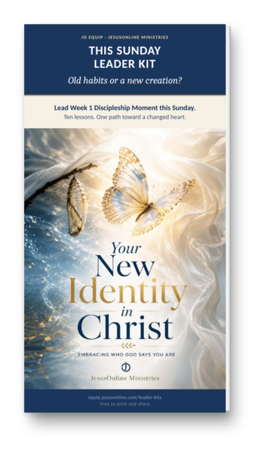 | Your New Identity in Christ · 10 lessons  Embracing Who God Says You Are  Settle the question of who you are now, so the old names lose their hold.

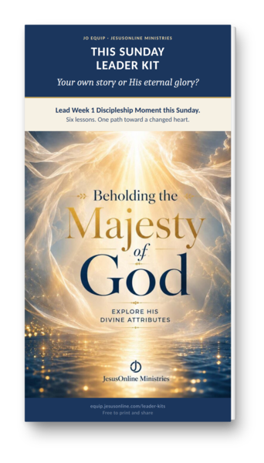 | Beholding the Majesty of God · 6 lessons  Explore His Divine Attributes  Lift your eyes from your own story long enough to see the God who holds it.

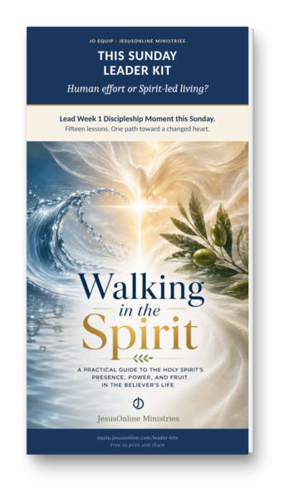 | Walking in the Spirit · 15 lessons  A Practical Guide to the Holy Spirit’s Presence, Power, and Fruit  Discover how the Spirit who lives in you shapes ordinary decisions, not only high moments.

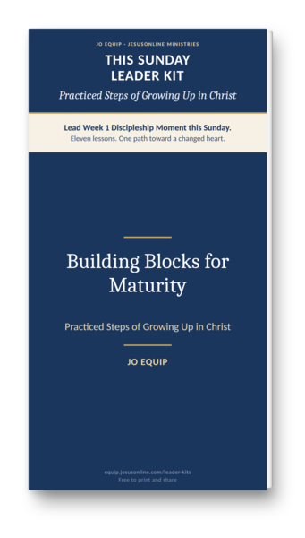 | Building Blocks for Maturity · 11 lessons  Practiced Steps of Growing Up in Christ  Grow up in Christ one practiced step at a time—not by trying harder, but by walking with Him.

We Would Be Grateful to Hear from You
If you have led a Moment from this kit—or walked someone through the chapter that follows—please tell us. A few sentences about where you serve and what God is forming in those you lead will encourage the next leader and help us serve you better.
equip.jesusonline.com/reviews/share

MAIN KEY TAKE-AWAY
He is already with you. Choose one series and take the next step.

Additional Resources
SHARE YOUR THOUGHTS
Leave a Review or Send Us a Note — If you found this helpful, please consider leaving a short review. Your feedback helps us improve future resources and encourages others. We love hearing how God is using these materials in your life. Share Your Story → equip.jesusonline.com/reviews/share

THE JO APP FOR PERSONAL GROWTH
The JO App helps believers grow closer to Jesus through Bible studies, daily devotionals, prayer tools, and discipleship series. Most users explore the content on their own. Those who want personal guidance are supported by our Discipleship Pastor and trained volunteers. Visit app.jesusonline.com.
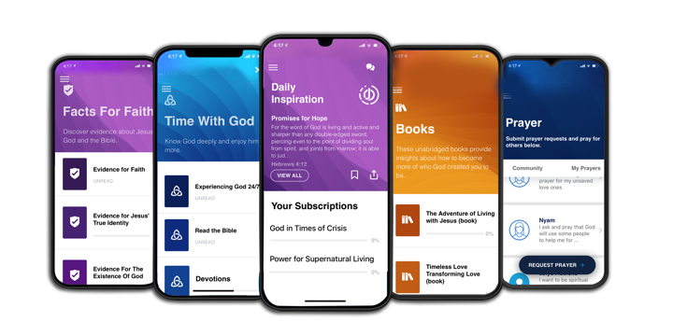

THE JO EQUIP RESOURCES FOR DISCIPLERS
JO EQUIP is a free digital library of practical, biblically grounded tools that equip pastors and disciple-makers with Evidence, Growth, and Church resources—uniting apologetics, identity-centered discipleship, and tools for healthy churches in one trusted hub. Visit equip.jesusonline.com.



