Target URLs: https://equip.jesusonline.com/categories/church/understanding-evangelism/what-is-evangelism

<H1> What Is Evangelism?

Table of Contents
- Definitions
- Types of Evangelism
- Why Is Evangelism Important?
- How to Choose the Right Evangelism Resources?
- Evangelism Resources for Pastors, Home Church Leaders, Missionaries, & Chaplains
- How Can JO EQUIP Evangelism Resources Guide Your Evangelism Journey?
- FAQs

<H2> Definitions
- Evangelism is an act of believers who participate with the Holy Spirit in telling people about God’s love for them and inviting them into a personal relationship with the Lord Jesus Christ.
Evangelism comes from a Greek word, euangelion which means good news or good message. A distant runner in wartime would bring messages from a distant battle to a city to let the residents know what was happening. The ones that brought good news from the battle were called evangelists – “those who bring good news”.
- The Gospel is ultimately about Jesus. The word “Gospel” means “good news”. Jesus went from town to town preaching the good news.
- “God so loved the world that He gave his one and only Son, that whoever believes in him shall not perish but have eternal life” (John 3:16). God’s motivation is Love.
- “While we were still sinners, Christ died for us” (Romans 5:8, NKJV). Jesus died for sinners.
- I Corinthians 151-6 in summary says that Christ died for our sins; came back from the dead
- The Greek word for “witness” is martus from which the English word, martyr, comes. Often, those in the early Church were martyred for this faith as a result of their witness for Christ.
Someone said: Evangelism is “One beggar telling another beggar where to find food.”
A good witness is one who shares the truth about what they have seen. John says: “That which was from the beginning, which we have heard, which we have seen with our eyes, which we have looked at and our hands have touched – this we proclaim concerning the Word of life” (I John 1:1).

<H2> Types of Evangelism
- Personal or relational evangelism: Sharing the Gospel through personal conversations, such as speaking to a friend or neighbour about Jesus.
- Lifestyle evangelism: Demonstrating Christian faith through daily actions, such as being open about your faith and showing honesty, kindness, patience, and helpfulness to others.
- Servant evangelism: Helping people in your community and sharing the Gospel when appropriate, such as offering support to someone and talking about Jesus.
- Mass or event evangelism: Sharing the Gospel by attending a Gospel meeting or participating in a planned outreach event.
- Digital or online evangelism: Using the internet to share the Gospel, such as posting Bible verses, Christian videos, or Gospel messages online.
- Church-based or small-group evangelism: Sharing the Gospel through church groups and activities, such as participating in Bible studies, home groups, or church outreach programs.

<H2> Why Is Evangelism Important?
Evangelism is important because it fulfills the core Christian command to share the message of Jesus Christ & invite others into a restored relationship with God. Here are the key reasons for evangelism:-

<H3> Obedience to Jesus
Christians see sharing the faith as a direct command from Jesus, known as the Great Commission in Matthew 28:19–20.

<H3> Act of Love
Believers are motivated by love & compassion to share what they consider the best news possible, desiring others to experience salvation.

<H3> Spiritual Growth
Engaging in conversations about faith deepens a believer's own understanding of scripture. It builds resilience against tough questions, & strengthens personal reliance on God.

<H3> Community Focus
The priority is to keep churches looking outward to help others rather than inward on minor internal disagreements.

<H2> How to Choose the Right Evangelism Resources?

<H3> Match Resources to Your Approach
Choose resources that match your approach: conversation guides and testimonies for relational evangelism, Bible-based answers for apologetic evangelism, Gospel guides and Scripture for direct evangelism, and community outreach materials for service-oriented evangelism.

<H3> Consider Your Ministry Needs
Select discipleship resources based on your role and audience. Beginners may need simple Gospel guides, while pastors, missionaries, and small-group leaders may benefit from Bible studies, training materials, and outreach guides.

<H3> Check the Biblical Foundation
Go for resources that explain the Gospel accurately, use Scripture in context, and keep Jesus at the centre. They should also encourage love, honesty, and respect when sharing faith.

<H3> Look for Practical Guidance
Pick materials that help you explain the Gospel, share your testimony, answer common questions, and start meaningful conversations about Jesus.
JO EQUIP offers free, Bible-based resources to help Christians understand evangelism and share their faith. Explore its articles, books, videos, and other available materials to prepare for Gospel conversations, strengthen your biblical understanding, and support outreach and discipleship.

<H2> Evangelism Resources for Pastors, Home Church Leaders, Missionaries, & Chaplains
Pastors, Home church leaders, missionaries, & chaplains can use key organizational frameworks, curricula, and evangelism tools to equip their communities for outreach and discipleship.

<H3> Evangelism Resources for Pastors
Pastors looking to build an evangelistic culture & equip their congregations can have access to several foundational books, Bible study tools, and organizational kits.

<H3> Evangelism Resources for Home Church Leaders
Home church leaders can use several key toolkits, structured programs, and church resources, to build & train an evangelistic culture within their congregations:

<H3> Evangelism Resource for Missionaries
Essential evangelism tools, training frameworks, and digital resources help missionaries share the gospel and build local churches across diverse cultures.

<H3> Evangelism Resource for Chaplains
Chaplains operate in pluralistic, secular, or high-crisis environments, such as hospitals, military bases, prisons, & corporate settings, where balancing authentic witness with professional ethics is essential.

<H2> Digital Evangelism: Sharing the Gospel Online
Digital evangelism is the practice of using the internet, mobile devices, social media, and digital platforms to share the gospel, connect with seekers, and build online Christian communities.

<H2> How Can JO EQUIP Evangelism Resources Guide Your Evangelism Journey?
JO EQUIP offers free, Bible-based resources to help Christians understand the Gospel and confidently share their faith. If you’re just starting your evangelism journey or helping someone else on their journey, these resources can help you take the next step.
Check for resources that help you:
- Know the meaning of evangelism & the purpose of evangelism.
- Discover how to share the Gospel effectively.
- Prepare and share your personal testimony.
- Find biblical answers to common questions about faith.
- Learn practical ways to start conversations about Jesus.
- Grow in your understanding of evangelism and discipleship.
Explore Understanding Evangelism: Evangelism Is A Process to learn more about the process of sharing the Gospel and helping others grow in their faith.

<H2> FAQs

<H3> Where can ministry leaders find free evangelism resources?
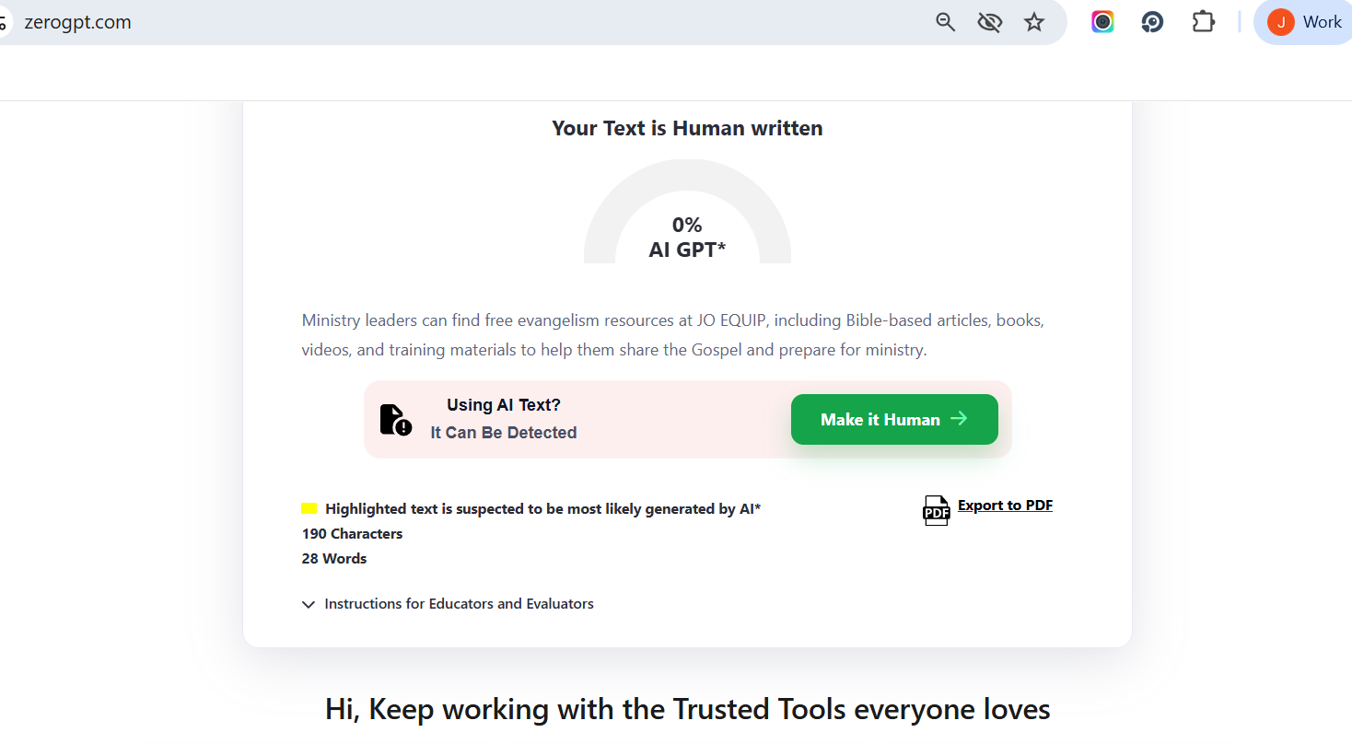
Ministry leaders can find free evangelism resources at JO EQUIP, including Bible-based articles, books, videos, and training materials to help them share the Gospel and prepare for ministry.

<H3> What Does the Bible Say About Evangelism?
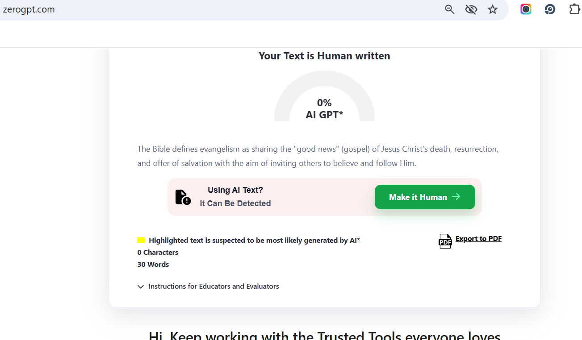
The Bible defines evangelism as sharing the "good news" (gospel) of Jesus Christ’s death, resurrection, and offer of salvation with the aim of inviting others to believe and follow Him.

<H3> What Are the Best Evangelism Tools for Beginners?
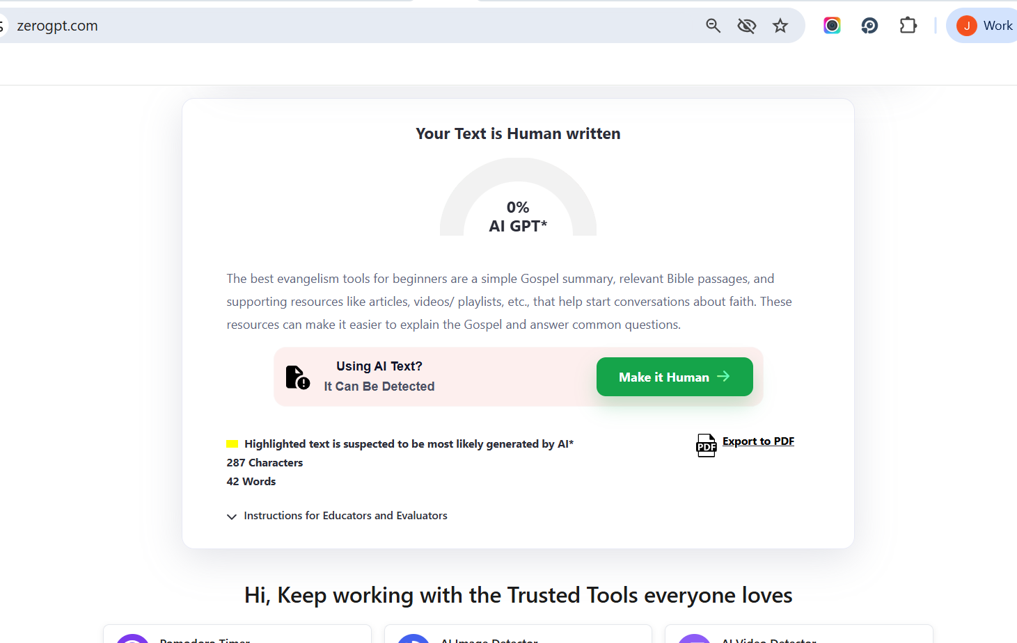
The best evangelism tools for beginners are a simple Gospel summary, relevant Bible passages, and supporting resources like articles, videos/ playlists, etc., that help start conversations about faith. These resources can make it easier to explain the Gospel and answer common questions.

<H3> What Online Evangelism Tools Can I Use?
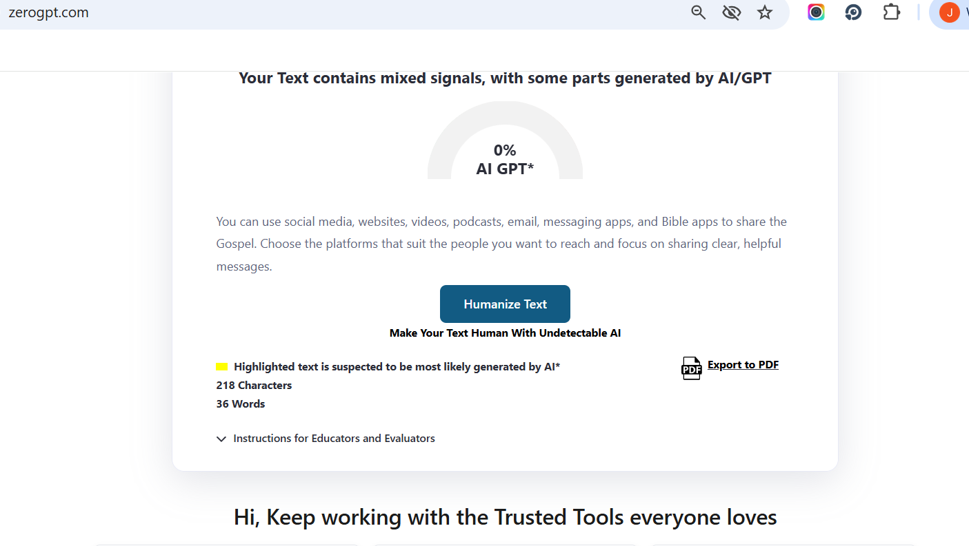
You can use social media, websites, videos, podcasts, email, messaging apps, and Bible apps to share the Gospel. Choose the platforms that suit the people you want to reach and focus on sharing clear, helpful messages.

<H3> How Can Pastors Equip Their Congregation to Share the Gospel?
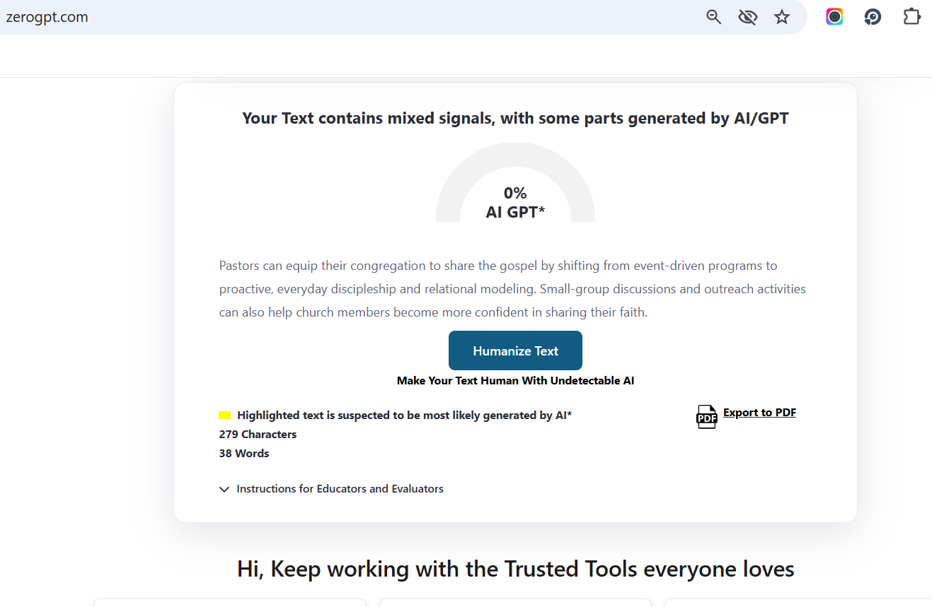
Pastors can equip their congregation to share the gospel by shifting from event-driven programs to proactive, everyday discipleship and relational modeling. Small-group discussions and outreach activities can also help church members become more confident in sharing their faith.

<H3> What Is the Best Evangelism Training for Small Groups?
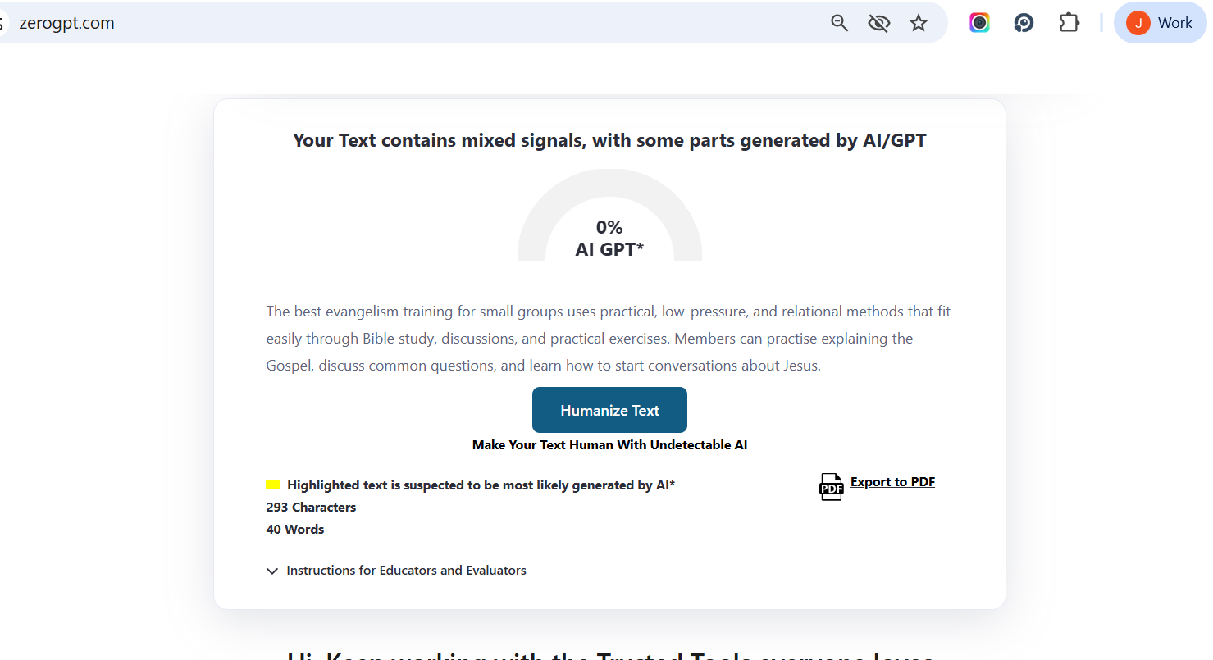
The best evangelism training for small groups uses practical, low-pressure, and relational methods that fit easily through Bible study, discussions, and practical exercises. Members can practise explaining the Gospel, discuss common questions, and learn how to start conversations about Jesus.

<H3> How Do Missionaries Share the Gospel Across Cultures?
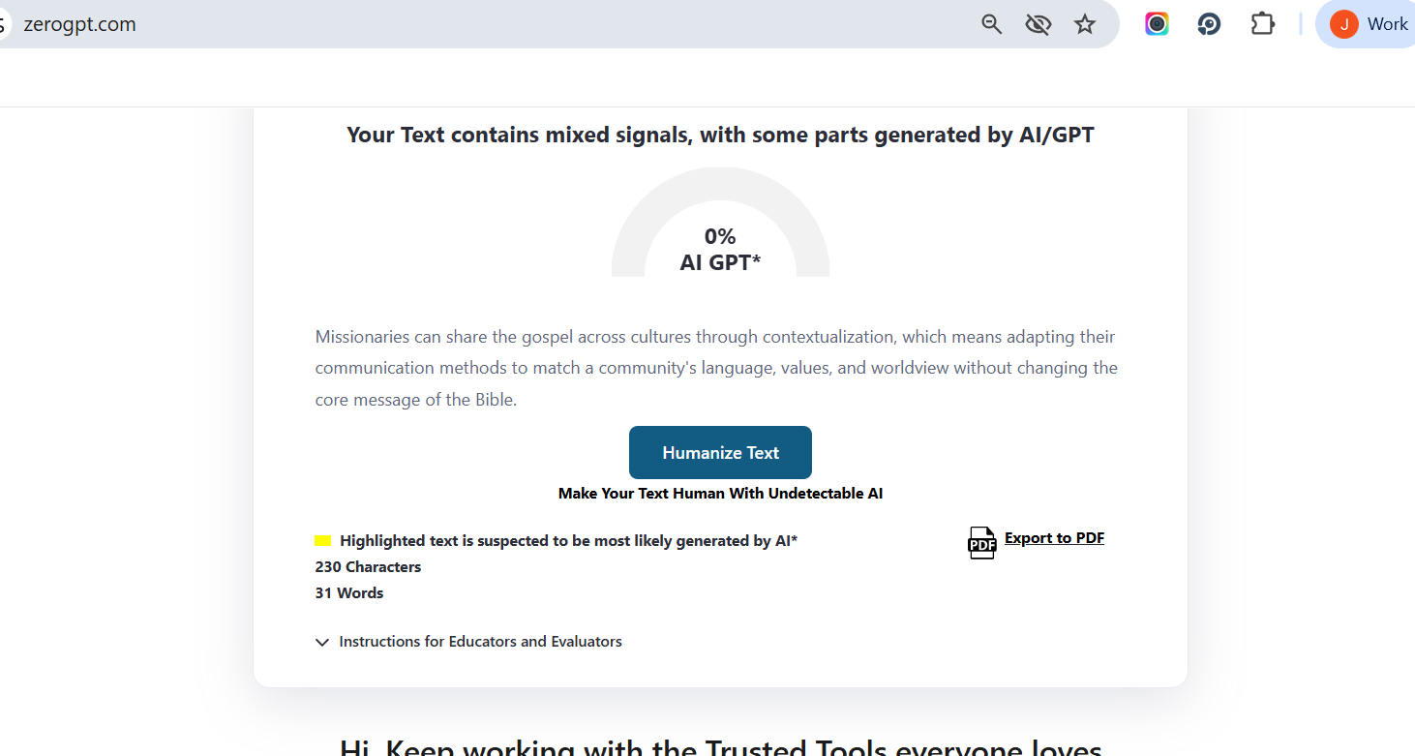
Missionaries can share the gospel across cultures through contextualization, which means adapting their communication methods to match a community's language, values, and worldview without changing the core message of the Bible.

