URL: equip.jesusonline.com/leader-kits

Jake, the correct book covers need to be inserted into the mockup.



This Sunday Leader Kits
This Sunday Leader Kits are ready-to-lead tools: one five-minute Moment, one assignment, and a next step into identity-centered heart transformation. They are a spoken doorway into training already written, so churchgoers can begin to walk as disciples this Sunday.

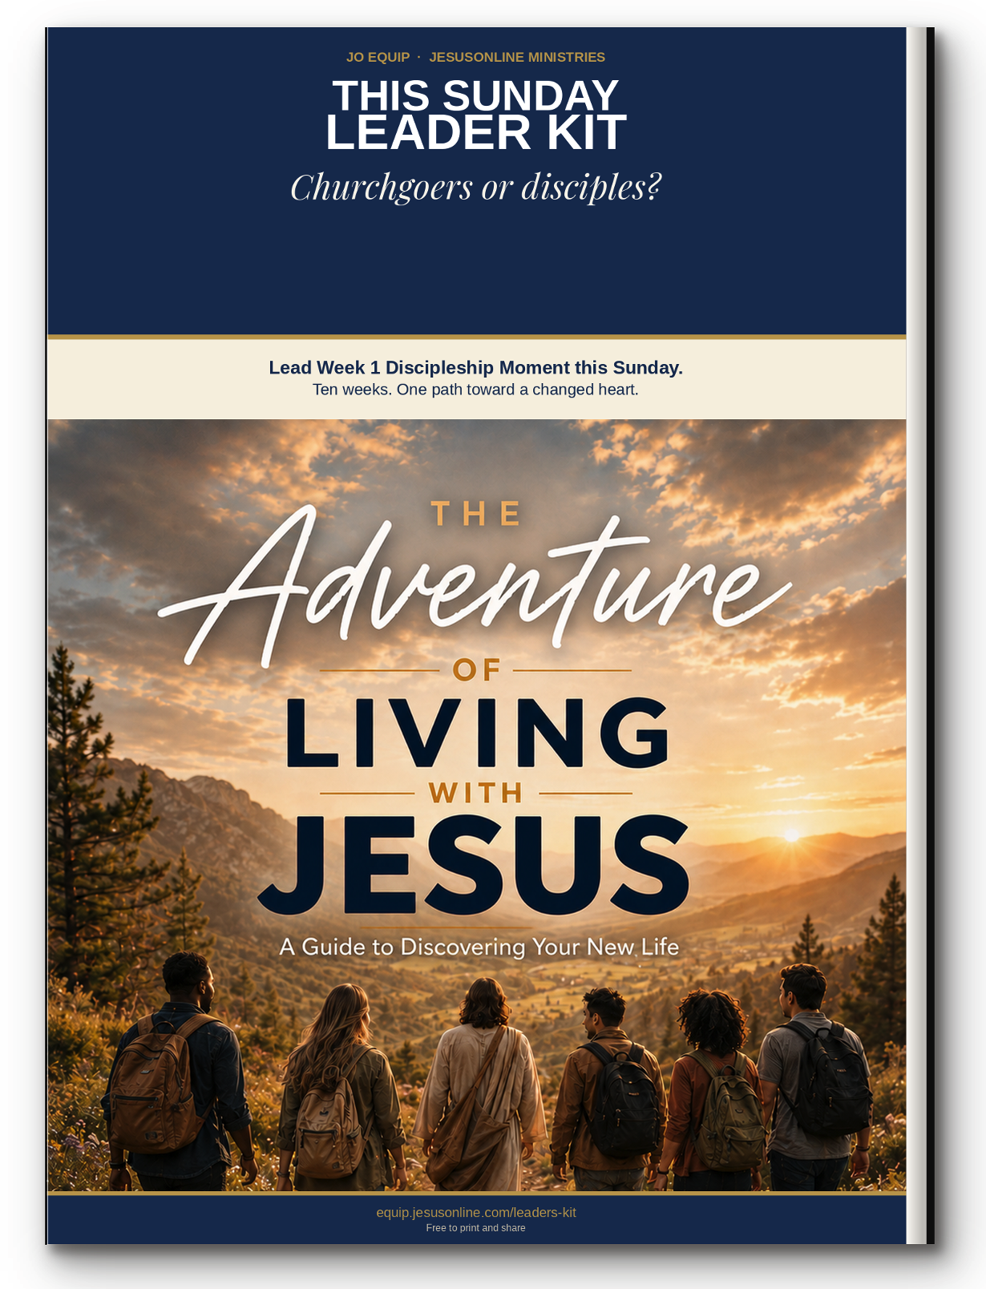

The Adventure of Living with Jesus
A Guide to Discovering Your New Life
Eight essential truths that help believers walk with Jesus each day with confidence and clarity.

10 Discipleship Moments
[ DOWNLOAD FREE KIT] BUTTON


A Heart After God
Seven Reflections on the Inner Life
Learn to want what God wants, in the hidden places no one else sees.

9 Discipleship Moments
[ DOWNLOAD FREE KIT] BUTTON



Your New Identity in Christ
Embracing Who God Says You Are
Settle the question of who you are now, so the old names lose their hold.

10 Discipleship Moments
Available October 1, 2026


Beholding the Majesty of God
Explore His Divine Attributes
Lift your eyes from your own story long enough to see the God who holds it.

6 Discipleship Moments
Available October 1, 2026


Walking in the Spirit
A Guide to the Holy Spirit's Presence and Power
Discover how the Spirit who lives in you shapes ordinary decisions, not only high moments

15 Discipleship Moments
Available October 1, 2026

