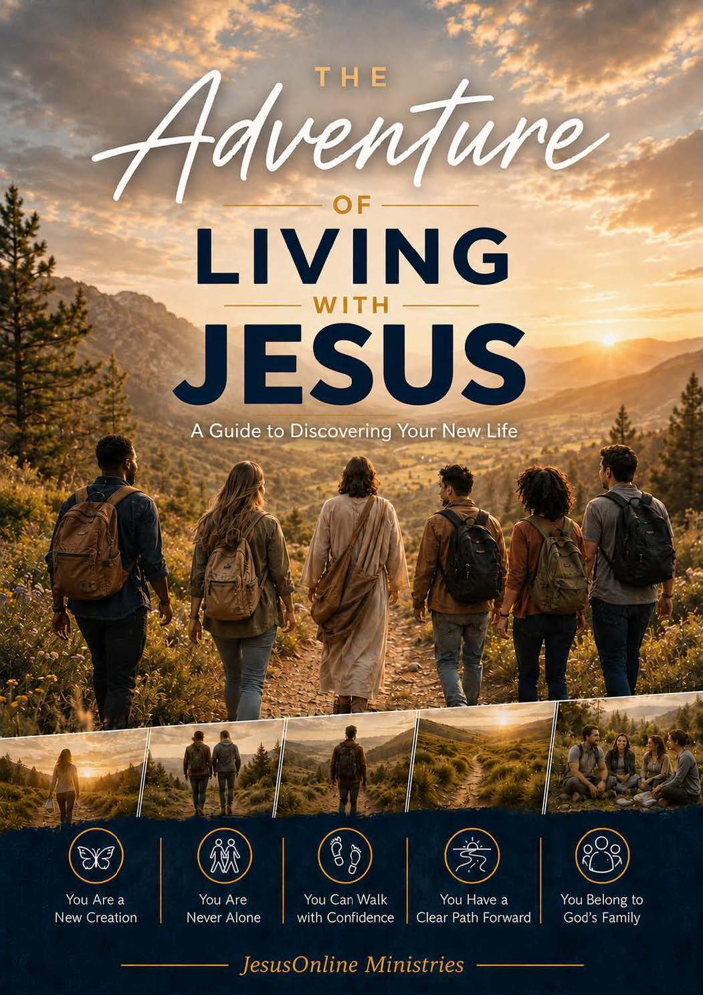

The Adventure of Living with Jesus
A Guide to Discovering Your New Life

© 2026 by JesusOnline Ministries. All rights reserved.

Unless otherwise indicated, Scripture quotations are from The Holy Bible, New International Version®, NIV®. Copyright © 1973, 1978, 1984, 2011 by Biblica, Inc.® Used by permission. All rights reserved worldwide.
Scripture quotations marked NLT are taken from the Holy Bible, New Living Translation, copyright © 1996, 2004, 2015 by Tyndale House Foundation. Used by permission of Tyndale House Publishers. All rights reserved.
Scripture quotations marked NASB are from the New American Standard Bible®. Copyright © The Lockman Foundation. Used by permission.

Permission to reproduce this material
The publisher grants permission to reproduce this material without written approval, provided it is used without charge and only for non-profit ministry purposes.
If you are walking someone through these pages—or using them in a church, home gathering, or quiet place of your own—we would be grateful to know. A short note about where this booklet is being used, and how it is serving new believers, helps us keep forming resources that last. Write to us at equip.jesusonline.com/reviews/share.

Contents
Begin the Adventure
1. Citizen of Heaven
2. Your New Identity in Christ
3. The Holy Spirit — Your Constant Companion
4. Walking by Faith, Not by Feelings
5. God’s Word — Your Road Map
6. Prayer — Your Ongoing Conversation with God
7. Belonging to God’s Family
8. Living a Life of Purpose
Continuing with Jesus
Additional Resources

Begin the Adventure
Something real has begun in your life.
When you asked Jesus Christ to come in, you stepped into a personal relationship with God that will never end. The One who created you now lives within you, and Jesus promises to take you as you are and make your life extraordinary, Christ-centered, and purposeful. It is the beginning of a new way of living—with Jesus Himself as your leader.

My Heart, Christ’s Home
Many years ago, Robert Boyd Munger described what it felt like when he first invited Jesus into his life. He pictured his heart as a home, and Jesus as the welcomed guest who began to settle in:
“One evening I invited Jesus Christ into my heart. What an entrance He made! It was not a spectacular, emotional thing, but very real. Something happened at the very center of my life. He came into the darkness of my heart and turned on the light. He built a fire on the hearth and banished the chill. He started music where there had been stillness, and He filled the emptiness with His own loving, wonderful fellowship.”
Munger then imagined Jesus walking through each “room”—his thoughts, his desires, his relationships, his work, his free time, even the private places he felt ashamed to open to anyone. In every room, Jesus offered to bring light, order, and life.
Munger’s story illustrates how Jesus will transform your life from the inside out as you surrender every area to Him and let Him be in charge. This booklet shows you how to begin that adventure: to become all God created you to be, so that you can do all He created you to do.

Walking the Path Ahead
The Christian life is more like a marathon than a sprint. There will be days of clarity and days of confusion, moments of triumph and moments of defeat, ordinary days and unexpected events. What remains constant is the presence of Christ and the patient work of His Spirit within you. He has already given you everything you need to take this journey.

What You Will Discover
This booklet is a guide for your new life in Christ. In the lessons ahead, you will explore:
• Citizen of Heaven — the assurance of your eternal belonging and secure future with God
• Your New Identity in Christ — who you truly are now that you belong to Him
• The Holy Spirit — Your Constant Companion — the power and presence of God living in you
• Walking by Faith, Not by Feelings — how to trust God when circumstances press hard
• God’s Word — Your Road Map — the Bible as a reliable path for your steps
• Prayer — Your Ongoing Conversation with God — learning to talk with your heavenly Father
• Belonging to God’s Family — the strength and joy of life with other believers
• Living a Life of Purpose — how God sees your new life from His eternal purpose
Each lesson includes Bible verses, thoughtful questions, and space to respond. The goal is not merely to finish these pages but to begin living the everyday adventure of walking with Jesus.
He is already with you. Your journey awaits.
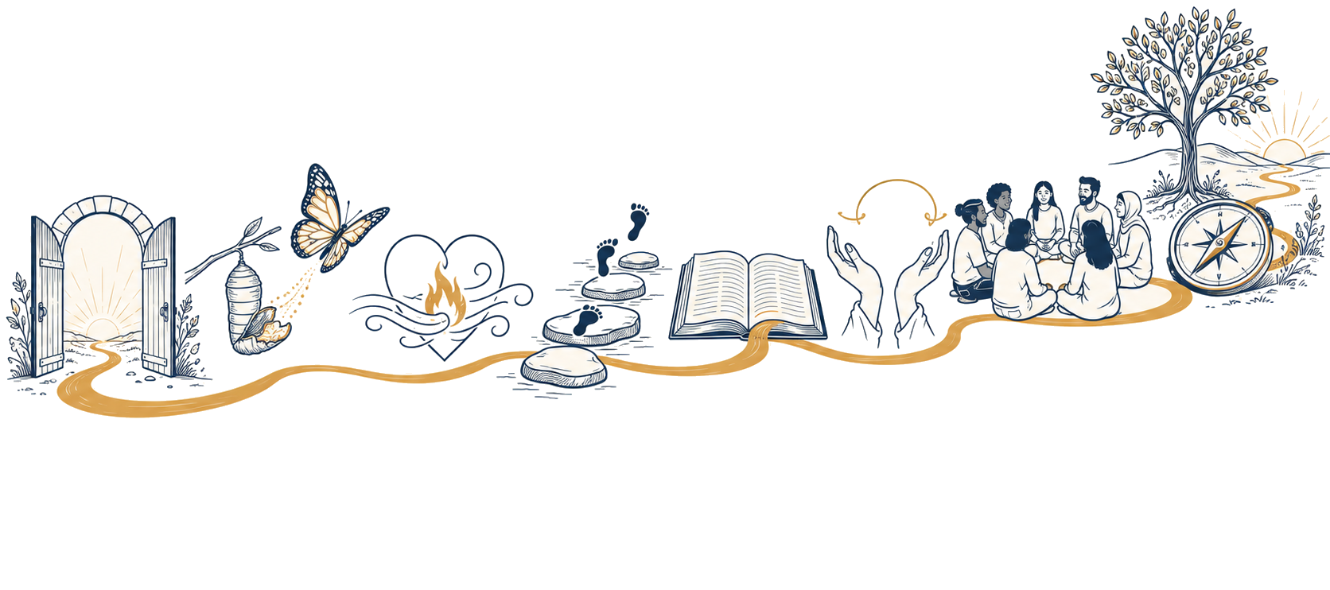
The path ahead: a new beginning, a new heart, the Word, prayer, God’s family, and a sure direction.

How to Walk This Path
Use one chapter at a sitting when you can. A chapter may take thirty to forty-five minutes if you look up the verses and write honest answers. You may walk it alone or with a mentor. If you are walking it with someone else, read the lesson first, then talk through the questions.
You will need a Bible. You can use the NET Bible at follow.jesusonline.com/bible/. Type the reference printed in this Guide, and the passage will open on the page. Free Bibles in many languages are also available at bible.com.
How to find a Bible verse
A reference such as John 3:16 means the book of John, chapter 3, verse 16. If two numbers appear with a dash (John 15:1–5), that means the book of John, chapter 15, from verse 1 to verse 5.
To read any verse online, go to follow.jesusonline.com/bible/ and type the reference.

Q: What do you hope Jesus will form in you as you begin this Guide?
______________________________________________
______________________________________________

Keep walking. If you want more on what you just read, pause here first.
CONTINUE THE ADVENTURE  Next: 1. Citizen of Heaven  Turn the page to continue. | GO DEEPER · optional  The Need for a New Heart  God does not offer repair to the old heart. He offers a new one. Your new life begins when He does.  Return here when you are ready for the next chapter.  equip.jesusonline.com

1. Citizen of Heaven
Are you certain you would go to heaven if you died today?
The Bible tells us we can know for sure. Even after inviting Jesus into your life, you may still wonder. This lesson is written to give you clear, biblical confidence that you belong to Christ—now and always.

God’s Free Gift
Jesus Christ paid the full price for all your sins on the cross. Through His death and resurrection, you have been given direct access to God. God’s perfect justice has been completely satisfied by the blood of Jesus. He has purchased you, and He will not take back what He has purchased (Hebrews 7:25; 9:12).
Because this gift is so complete, a natural question often arises: “What about the good things I have done? Don’t they somehow contribute?” The Bible gives you a clear answer. Read the following verses and write what each one reveals about who is responsible for your salvation.
Romans 5:8
______________________________________________
______________________________________________

Ephesians 2:8–9
______________________________________________
______________________________________________

Titus 3:5–6
______________________________________________
______________________________________________

1 Peter 3:18
______________________________________________
______________________________________________

Now this is eternal life: that they know you, the only true God, and Jesus Christ, whom you have sent. (John 17:3)
Eternal life is not about going to a better place. Jesus defines it as knowing God—a relationship marked by love and trust. Going to heaven means being in God’s presence under His rule, glorifying and enjoying Him forever.
This eternal life is a gift from God. You cannot earn it.

If You Are Not Yet Sure You Have Received Him
This Guide is written for those who have already asked Jesus to be Savior and Lord. If you are still deciding, the way into God’s family is the same gift described above. The one requirement is to believe in Jesus, that is, to trust in Him enough to rely upon Him and follow Him.
Q: According to 1 John 5:11–13 and John 3:16–18, what is the one requirement for eternal life?
______________________________________________
______________________________________________

In the original language of the New Testament in the Bible, “believe” is active trust—much like the faith a climber has in the rope that holds him. Becoming a Christian means placing that kind of trust in Jesus: relying fully on His death for your sins and His resurrection for your life.
If you are ready to trust Jesus, tell Him so, right now, in your own words: that you have sinned, that you believe He died and rose for you, and that you trust and receive Him as Savior and Lord. If you have just done that, the rest of this Guide is now your path.

Where Are You Going After You Die?
Christianity is a relationship with Christ based on faith (trust) alone! Your faith is based on the facts (truth) found in the Bible…not feelings. Feelings change, but God’s promises will remain unchanged. Chapter 4 will show you more about walking by faith when feelings argue otherwise. Here, rest on what He has said.
Q: Read 1 John 5:11–13. If you have Jesus Christ in your life, what are you sure of?
______________________________________________
______________________________________________

Q: Once you have put your faith in Christ, is there anything that can separate you from God’s love? What does Romans 8:38–39 tell you?
______________________________________________
______________________________________________

Q: Will Christ ever leave you? What does Hebrews 13:5 say?
______________________________________________
______________________________________________

Q: For how long will God forgive your sins? Read Hebrews 8:12.
______________________________________________
______________________________________________

As God’s child, He will always love you—even when you fail Him. He will never give up on you—even when you give up on Him. Keep walking with Him.

Your Faithful Friend
The Bible tells you that Jesus is the friend who remains closer than any other. He is loyal, present, and unchanging.

Ashley’s Story
“I always put my friends above God. In fact, my life revolved around my friends so much that I began to get involved in reckless behavior just to seem ‘cool’ to others. Pretty soon I got involved in drugs, sex and alcohol. My life got out of control, and I felt worthless, with no purpose other than to get ‘high.’ Then I even lost my friends, who called me ‘trash.’ One day someone told me that Jesus Christ not only created me, but wanted to be my best friend. I couldn’t believe it at first. Later, I decided to invite Him into my life. Since then, God has given me a new purpose in life and helped me break my addictions. I now have many new friends, but the greatest of all is Jesus Christ. He accepts me for who I am, and tells me that He will never leave or forsake me.”

Ashley discovered what believers in every nation have discovered: Jesus is a faithful friend. No other friend loves you so much or will stay with you so closely (Proverbs 18:24). Jesus is totally loyal and faithful (Proverbs 20:6).
Growth Is God’s Plan for You
God does not leave you to figure out the Christian life on your own. From the beginning He has a clear path for your growth: walk in the Holy Spirit; trust God with your life; know and trust His Word; talk with Him in prayer; connect with other believers; live a life of purpose.
These are not requirements to earn His love. They are the natural ways a new life in Christ begins to take shape. He is already committed to the work He has begun.
Q: When doubt about heaven rises this week, which promise will you return to?
______________________________________________
______________________________________________

Keep walking. If you want more on what you just read, pause here first.
CONTINUE THE ADVENTURE  Next: 2. Your New Identity in Christ  Turn the page to continue. | GO DEEPER · optional  The Gift of Eternal Life  Eternal life is not earned, and it is not a guess you wait to settle after death. Because of Jesus, you can know where you will spend eternity.  Return here when you are ready for the next chapter.  equip.jesusonline.com

2. Your New Identity in Christ
The moment you trusted Christ, your identity changed forever. You are no longer defined by your past, your performance, or others’ opinions. You are now a child of God, with a new nature and a secure place in His family. You are who God says you are.
C. S. Lewis pointed out: “Mere morality is not the end of life. You were made for something quite different from that… The idea of reaching ‘a good life’ without Christ is based on a double error. Firstly, we cannot do it; and secondly… we have missed the very point of our existence.”
The point of our existence centers on the inheritance we have in Christ as His children. Living for Christ is not our duty as slaves, but our privilege as sons and daughters.

Your Inheritance in Christ
As a Christian, you have been given a remarkable inheritance. Read the following verses and thank God for what is now true of you:
• Your sins are completely forgiven (Colossians 2:13–14)
• You become a child of God—forever (John 1:12)
• Christ lives in you (Galatians 2:20; Colossians 1:27)
• The Holy Spirit is your guarantee (2 Corinthians 1:22)
• Christ gives you His new nature (2 Corinthians 5:17)

A New You
Therefore, if anyone is in Christ, the new creation has come: The old has gone, the new is here! (2 Corinthians 5:17)
You are now a completely new creation—like a butterfly that was once a caterpillar. You may not always feel new or act new, but in God’s eyes you are fully new. The Father sees you as the one His Son purchased with His own blood. You are His royal child (Hebrews 2:9–11).
You also, like living stones, are being built into a spiritual house… You are a chosen people, a royal priesthood, a holy nation, God’s special possession. (1 Peter 2:5, 9)
It does not matter what your background, abilities, appearance, or status may be. You now belong to Christ’s body with believers from every time and place. You are a full citizen of heaven (Ephesians 2:19).
Your thoughts: What does it mean to you that you are who God says you are?
______________________________________________
______________________________________________

More like Christ
God’s plan is to conform you into Christ’s image (Romans 8:29). Jesus’ Spirit living in you has begun this change, and He will continue His work throughout your life (Philippians 1:6).
Q: Whose work is it according to Philippians 2:13?
______________________________________________
______________________________________________

Q: What qualities have you noticed in Jesus that you want Him to form in you?
______________________________________________
______________________________________________

Q: What is one way you will remember your new identity this week?
______________________________________________
______________________________________________

Keep walking. If you want more on what you just read, pause here first.
CONTINUE THE ADVENTURE  Next: 3. The Holy Spirit — Your Constant Companion  Turn the page to continue. | GO DEEPER · optional  Embracing Your New Identity in Christ  You are not an improved version of your former self. God declares that you are a new creation in Christ.  Return here when you are ready for the next chapter.  equip.jesusonline.com

3. The Holy Spirit — Your Constant Companion

Ready in Heart, but Not Yet Empowered
The disciples were deeply moved after the resurrection and eager to follow Jesus wherever He led. Yet even after three years of walking with Him, they still lacked the power to live the life He had called them to live. Enthusiasm alone would not be enough.
Jesus knew they needed more. He told them, “You will receive power when the Holy Spirit comes on you” (Acts 1:8). Before leaving, He instructed them to wait for the promise of the Father: “I am going to send you what my Father has promised” (Luke 24:49).
The Holy Spirit is given many names in the Bible. Among the roles He plays in your life, He is your Encourager and Comforter as you walk with Christ (John 16:7–15). Without Him, living for Christ is impossible. With Him, you can do all things through the strength He supplies (Philippians 4:13).

The Indwelling Holy Spirit
When you invited Jesus Christ to be your Savior and Lord, He entered your life through the Holy Spirit, and He will remain with you forever. You are never alone.
Ephesians 3:16–17 says that God strengthens you with power through His Spirit in your inner being, so that Christ may dwell in your hearts through faith. As Robert Munger pictured it, Jesus desires to settle into every room of your life. Christ lives in you by His Spirit.

Who Is the Holy Spirit?
Though invisible, the Holy Spirit is a real Person, the Spirit of Jesus (John 14:16–21). Read the following verses and note what they reveal about Him.
Q: Acts 5:3–4
______________________________________________
______________________________________________

Q: John 14:16–17
______________________________________________
______________________________________________

Q: 1 Corinthians 6:19
______________________________________________
______________________________________________

The Bible makes clear that the Holy Spirit is fully God—one with the Father and the Son. As you yield areas of your life to Him, He brings purpose and meaning. The process is gradual and will include setbacks, yet “he who began a good work in you will carry it on to completion until the day of Christ Jesus” (Philippians 1:6).

The Battle Within
Every day you face influences from within and from the world that pull you away from God and go against His will—temptations, anger, addictions, jealousy, and other destructive patterns (Galatians 5:19–21). Even good things such as family, success, and security can come between God and you when they become the center of your life. True satisfaction comes only when you give Jesus His rightful place: the throne of your life (Matthew 6:33).
In Romans 7, Paul writes about his desire to live for Christ and his repeated failures. This battle of the flesh versus the Spirit can only be won as we surrender our wills to the Holy Spirit. Romans 8 shows the victory that follows.
As long as we live in this body, the conflict between self-centered desires and Christ’s way will remain. The question is which voice we will follow.
Q: What does Galatians 5:16–18 say about this inner conflict?
______________________________________________
______________________________________________

Q: According to Galatians 5:16–23, contrast the self-directed life and the Spirit-directed life.
______________________________________________
______________________________________________

The Filling of the Holy Spirit
To walk by the Spirit and win the battles, you need to be filled with the Spirit. It means to be directed and controlled by Him. A player willingly places himself under a coach’s direction to play well. In the same way, we freely choose to place ourselves under the Spirit’s leadership.
Q: What does Ephesians 5:18 instruct us to do?
______________________________________________
______________________________________________

God’s purpose is to conform you to the image of Christ (Romans 8:29). This lifelong process is the work of the Holy Spirit as you give Him control moment by moment. There is freedom in giving control to Him. You will no longer be imprisoned by self-centered cravings.
The diagrams below show two ways a Christian can live. The difference is not whether a person has received Christ, but who is allowed to direct daily life.
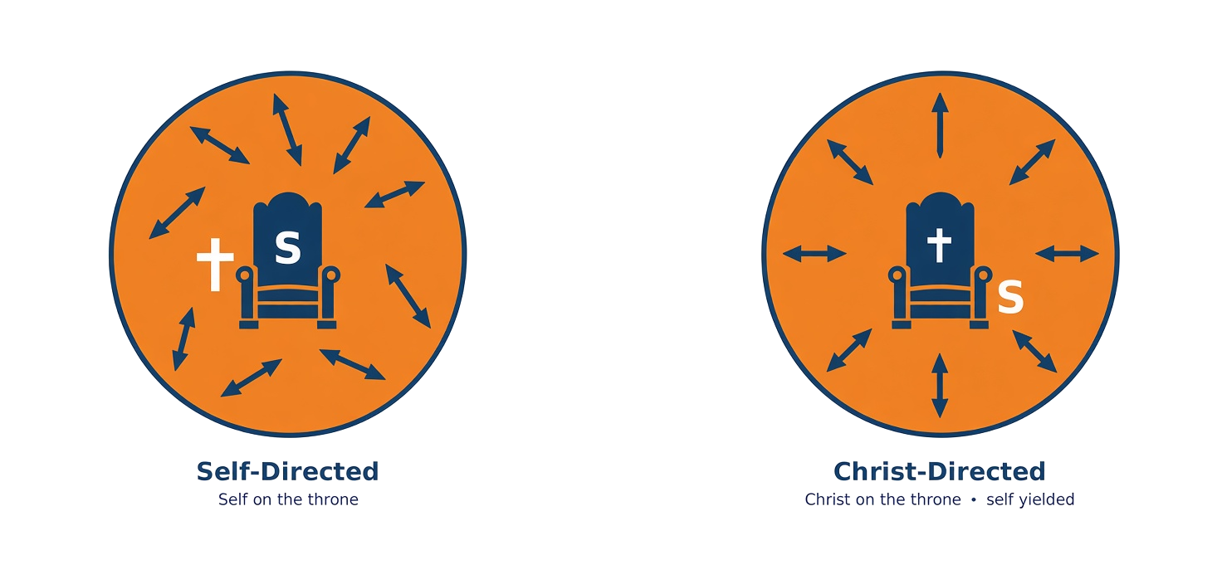
When self sits on the throne, life is out of control. When Christ sits on the throne, life is focused upward and ordered.
The motivation for yielding control is not duty or pressure. It is the love of Christ. Because He is our Heavenly Father who unconditionally loves us, we love Him (1 John 4:19) and express our love for Him by yielding and placing ourselves voluntarily under His good and perfect authority.
For Christ’s love compels us… he died for all, that those who live should no longer live for themselves but for him. (2 Corinthians 5:14–15)

Todd’s Story
“For three years I wanted nothing more than to join the most popular group at my high school—the Mavericks. Even after becoming a Christian, I still thought it might be harmless, even though it was a drinking club. I finally decided I needed to go all out for Christ. That same week I was invited to join the Mavericks. I immediately knew that the stakes were high, and that Satan was trying to derail my decision. Instead of giving in, I turned my life fully over to God. He gave me freedom I had not known before and a purpose that reached beyond myself.”

A Simple Step of Surrender
Giving control of your life to the Holy Spirit is a decision of faith, just as receiving Christ was. You place yourself in the hands of a trustworthy God.
You might pray: “Lord Jesus, I want my life to be directed by You rather than by self. I confess the ways I have lived independently of You. Holy Spirit, I ask You to take control of my life right now.”
Q: What does this kind of commitment mean to you?
______________________________________________
______________________________________________

Restoring Fellowship
At times believers sin and break fellowship with the Holy Spirit (1 John 1:8). This does not mean your salvation is lost. Jesus paid for all your sins on the cross, once for all. Broken fellowship means you are not abiding in Christ. You are back on the throne of your life, ignoring Him. If it is not mended, you will not experience the abundant life Jesus promised and will begin to miss His purpose and plan for your life.
You can return at any moment: yield yourself again to God; confess your specific sins; trust that the Spirit is in control.
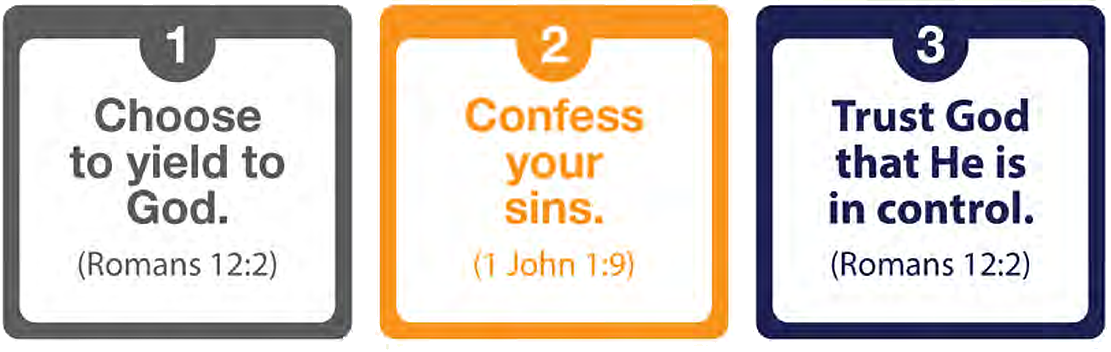

Spiritual Breathing
Walking in the Spirit is a moment-by-moment dependence on Him. Bill Bright called this spiritual breathing. Exhale—confess the sin that grieves Him. Inhale—ask the Spirit by faith to fill and direct you again. He is always ready to restore and empower you.
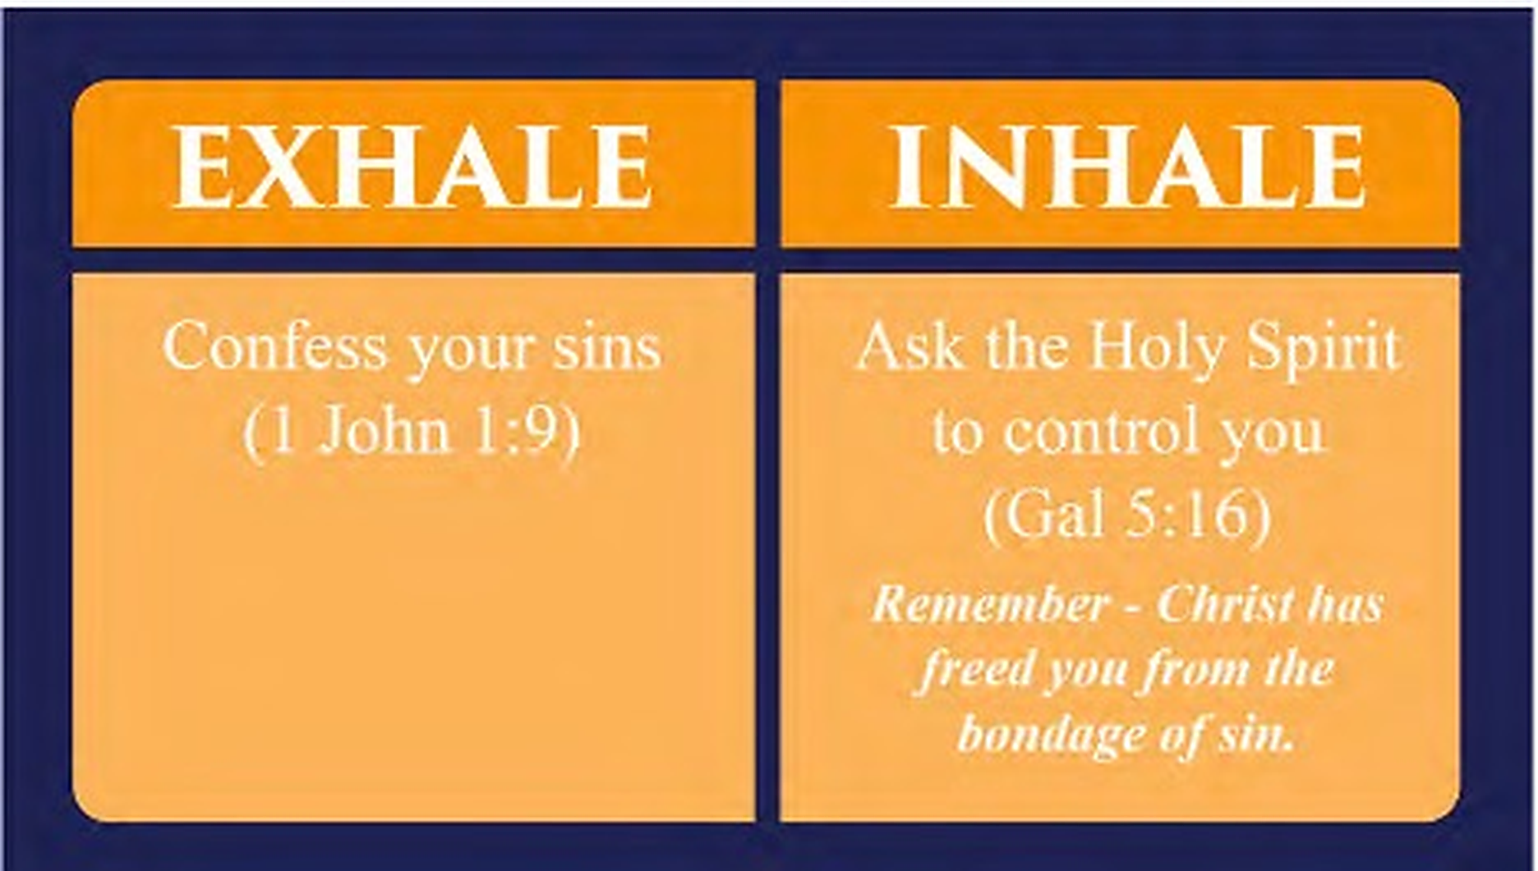

Bearing Fruit
The Holy Spirit will empower you not only to defeat the flesh but also to bear fruit. Jesus compared your life to a branch that is totally dependent on the grapevine. The gardener cares for the branches, expecting to harvest grapes. They draw nutrients from the vine to produce fruit.
I am the vine; you are the branches. If you remain in me and I in you, you will bear much fruit; apart from me you can do nothing. (John 15:5)
One kind of fruit your life in Christ produces is the fruit of the Spirit: love, joy, peace, patience, kindness, goodness, faithfulness, gentleness, and self-control. You do not manufacture it. You abide, and it grows naturally. This fruit shapes your life so that God can use it to reach others for Christ. (Read John chapter 15)

The fruit of the Spirit — Galatians 5:22–23

Your Daily Power
Mark where you have been depending on yourself, and where you will depend on God.
Daily issue | My power | God’s power
Relationships | ☐ | ☐
Health / fears | ☐ | ☐
Trials / temptations | ☐ | ☐
Emotions | ☐ | ☐
School / work | ☐ | ☐
Goals / dreams | ☐ | ☐

When you get up in the morning, call on the Holy Spirit to lead you throughout your day. Plan your day with Him. Ask Him for guidance and empowerment to follow Him. God gives you these promises:
For the Spirit God gave us does not make us timid, but gives us power, love and self-discipline. (2 Timothy 1:7)
Trust in the LORD with all your heart and lean not on your own understanding; in all your ways submit to him, and he will make your paths straight. (Proverbs 3:5–6)
Memorize these verses and remind yourself daily of the truth about Spirit-directed living.

Q: Who are you depending on in each area of the above chart—and what is one place you will depend on the Spirit today?
______________________________________________
______________________________________________

Keep walking. If you want more on what you just read, pause here first.
CONTINUE THE ADVENTURE  Next: 4. Walking by Faith, Not by Feelings  Turn the page to continue. | GO DEEPER · optional  Living an Empowered Life  He already lives in you. Filling is how His power is released through you.  Return here when you are ready for the next chapter.  equip.jesusonline.com

4. Walking by Faith, Not by Feelings
God’s power to live for Christ and walk in the Holy Spirit is available to us only through faith.
Q: What does Hebrews 11:6 say about faith?
______________________________________________
______________________________________________

Faith is a steadfast trust in God that results in action. Living for Christ is not trying to do what Jesus did in our own strength, but letting Him live His life through us by faith—trusting Jesus enough to do whatever He tells us to do, exactly as He wants it done.
As we live by faith, Jesus’ life will shine through us. Genuine faith in Him produces obedience to God’s Word, the Bible, even though there will be ups and downs (James 2:17). Your faith will be tested. Testing is how faith is strengthened, as muscles are built by use. The Christian life is a battlefield with three persistent enemies: the world, the flesh, and the devil. God has given us powerful means to stand firm and overcome them.
Q: Read Ephesians 6:10–18. What are the keys to standing in this battle?
______________________________________________
______________________________________________

Overcoming Doubt

Joni’s Story
Joni Eareckson was an active, athletic teenager until the day she dove into shallow water and broke her neck. In a moment the future she had imagined was gone. She would never walk or use her hands again. Although she had trusted Christ as a teenager, the months that followed shook her deeply. “In those first few months,” she later wrote, “the promises of God seemed anything but true… How could I be expected to believe when everything inside and outside of me screamed just the opposite?” Through the steady encouragement of a friend and the truth of God’s Word, Joni began to choose faith over her feelings. Looking back, she has said that her paralysis was not a cruel joke but was used by God’s love. Today she leads an international ministry that shares the hope of Christ with people affected by disability. Her life reminds us that victorious faith is not the absence of struggle. It is trusting God even when we cannot yet see the reason.

Victorious Faith
Hebrews 11 introduces men and women who trusted God despite adversity, opposition, and even suffering. Faith in Christ pleases God and results in a supernatural life of victory over any circumstance.

Q: Read Hebrews 11:1–8. What stands out to you about those who walked by faith?
______________________________________________
______________________________________________

A life without faith is disastrous for God’s people. God saved Israel from slavery with spectacular miracles—ten plagues in Egypt, the parting of the Red Sea, and daily provision in the wilderness. Yet they soon doubted His promise of a good land. When twelve spies returned, they said the land was fruitful but occupied by giants. Only Joshua and Caleb were willing to move forward. The rest turned back in fear. Because of their lack of faith, that generation wandered forty years and did not enter the rest God had prepared (Numbers 13 and 14).
Q: What “giants” in your life currently make trust difficult?
______________________________________________
______________________________________________

Q: Read Hebrews 3:7–4:11. How do we enter God’s rest, and what does the passage warn us against?
______________________________________________
______________________________________________

God still promises rest to those who trust Him. Victorious faith is taking God at His Word and moving forward, even when circumstances or emotions suggest otherwise.

Examining Your Trust
What in your life keeps you from trusting God fully—relationships, finances, plans, habits, past failures, thought life, fear, or the desire for control? Mark whether each area is helping or hurting your faith in Christ, then take what God shows you back to Him.
Area | Helping | Hurting
Friends | ☐ | ☐
Recreations | ☐ | ☐
Habits | ☐ | ☐
Time in God’s Word | ☐ | ☐
Thoughts | ☐ | ☐
Do not conform to the pattern of this world, but be transformed by the renewing of your mind. Then you will be able to test and approve what God’s will is—his good, pleasing and perfect will. (Romans 12:2)
Ask God to show you His perspective on the areas of your life that are hindering your faith. Your faith will be strengthened when you first change your way of thinking about them and see them as God sees them.

Q: What is one area you will take back to God this week and trust Him with?
______________________________________________
______________________________________________

Keep walking. If you want more on what you just read, pause here first.
CONTINUE THE ADVENTURE  Next: 5. God’s Word — Your Road Map  Turn the page to continue. | GO DEEPER · optional  Faith: Knowing God Who Is Trustworthy  The power of faith is not in its strength. It is in the object of your faith—God who is true, able, and faithful.  Return here when you are ready for the next chapter.  equip.jesusonline.com

5. God’s Word — Your Road Map
If you received a personal letter from Jesus telling you how much He loves you and offering clear direction for your daily life, would you read it carefully? Would you return to it often?
That is what the Bible is—God’s own word to you. Just as a new baby needs milk to grow, you need God’s Word to grow in your new life.

Before You Begin
If you do not have a printed Bible, open the NET Bible at follow.jesusonline.com/bible/ and type the verse listed in the lesson. The King James Version (KJV) is common, but the English language is old. A modern translation like NET Bible is easier to understand. Free online Bibles in many languages are available at bible.com.

God’s Road Map for Your Life
If you were traveling to a place you had never been, would you rely only on instinct, or would you use a reliable map? The map will not show every detail along the road, but it will keep you from heading the wrong way. The Bible is the road map for your journey with God. It guides you with the truth you need for life.

Forming a New Habit
Most of what we do each day is out of habit. To make God’s Word part of your life, you need to make it one of your daily habits. Choose a consistent time and a quiet place. Read a section of the Bible and ask God to show you what He wants you to understand and apply. Be patient and persistent. It takes time to develop a new habit. The more you let His Word dwell in you richly (Colossians 3:16), the more you will experience His presence and power.

God’s Viewpoint
The Bible gives God’s answers to the most important questions of life: who God is; your purpose; how to grow in Christ; moral decisions; relationships; peace in hardship; suffering and death.
For the word of God is alive and active. Sharper than any double-edged sword, it penetrates even to dividing soul and spirit… it judges the thoughts and attitudes of the heart. (Hebrews 4:12)

What Fills Your Mind
Every day your mind is flooded with voices—most of them reflecting the world’s perspective. What you allow to fill your “vat” will influence your decisions, attitudes, and direction. If God’s perspective is to shape your life, you must give regular time and serious effort to keep filling the vat with His Word.
In today’s world driven by social media, filling your “vat” with God’s truth is ever more critical for you to live a Christ-directed, Spirit-empowered life.

Two taps fill one mind. What you open most will flow out in your life.
Matthew Henry said, “If you want to get close to God, you must study His Word.”
Q: How does Colossians 3:16 speak to you personally?
______________________________________________
______________________________________________

Five Ways to Take in God’s Word
1. Hearing. You can hear the Bible through a local church service, faithful Bible teachers, small groups, trusted online resources, and audio Bibles. If public gathering is not possible where you live, you can still hear God’s Word by reading aloud and listening in private.
Q: In what ways are you currently hearing God’s Word? How could you increase that?
______________________________________________
______________________________________________

Q: What does Acts 17:11 encourage us to do when we hear teaching?
______________________________________________
______________________________________________

When you hear God’s Word taught, listen for what the Holy Spirit is trying to teach you personally. Taking good notes and writing down your thoughts will help you remember and apply His teaching.
2. Reading. Read slowly. Keep a pen to underline or note what stands out. Some Christians consider the Bible sacred and do not write in it. Other devout Christians write in it because it’s a private meeting space between God and them. God gives you freedom to choose.
If you are new to the Bible, start with (the Gospel of) Mark or (the Gospel of) John. Then read the book of Acts that records the actions of the early Christians. (The Gospel of) Luke and Acts were both written by Luke the Physician and together give you key events in the first century from the birth of Jesus to the explosive growth of the church.
Q: Which book of the Bible are you currently reading? What is the Holy Spirit showing you?
______________________________________________
______________________________________________

3. Studying. Study a short passage, a theme, or a key verse. You can also study a book in the Bible (such as Genesis, Ruth, Mark, Galatians) or a theme (such as love, forgiveness, faith). The goal of studying the Bible is not information alone but insight into who God is and what He wants you to do in your life.
A simple way to start studying is to read a short passage (segment or section) of the Bible slowly. Read it a couple of times. Then ask: What does this show me about God? About myself? About how I am to live? Write down your thoughts.
Q: Read 2 Corinthians 5:14–21. What does this passage show you about God, yourself, and how to live?
______________________________________________
______________________________________________

4. Memorizing. Hiding God’s Word in your heart gives you truth to carry into every situation. Begin with a few key verses. Write them on small cards, review them regularly, and speak them aloud. Over time, they become part of your inner vocabulary.
I have hidden your word in my heart that I might not sin against you. (Psalm 119:11)
5. Meditating. Turn God’s Word over in your mind throughout the day. When stress or temptation arises, the Holy Spirit will bring a relevant verse to your mind. Let it steady you.
Q: What does Philippians 4:6–7 offer in moments of anxiety?
______________________________________________
______________________________________________

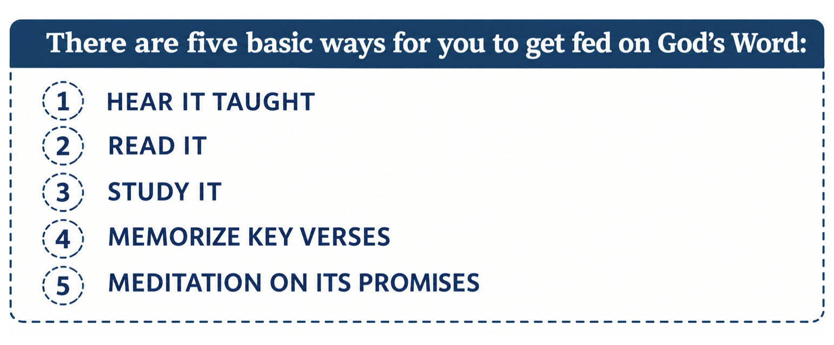

The Power of God’s Word to Transform
In the late 1970s, David Berkowitz—known as the “Son of Sam”—was imprisoned after a series of murders in New York. While in prison, he was given a Bible. As he read, the Word of God began to confront and change him. In time, he turned to Christ in genuine repentance. Today he serves as a chaplain’s assistant, a living example of how Scripture can break old patterns and create a new life.
Transformation happens as the world’s perspective is gradually replaced by God’s. The amount of time you commit to the Bible is probably the single best indicator of your walk with Christ, and the best predictor of your future growth in Christ.
Let the message of Christ dwell among you richly. (Colossians 3:16)
Q: Read Psalm 1:1–3. What picture does it give of a life rooted in God’s Word?
______________________________________________
______________________________________________

Q: What is one time and place you will take in the Bible today and tomorrow?
______________________________________________
______________________________________________

Keep walking. If you want more on what you just read, pause here first.
CONTINUE THE ADVENTURE  Next: 6. Prayer — Your Ongoing Conversation with God  Turn the page to continue. | GO DEEPER · optional  Renewing the Mind for Transformation  What enters the mind influences the person. Thoughts form beliefs. Beliefs mold values, and they shape the way of life.  Return here when you are ready for the next chapter.  equip.jesusonline.com

6. Prayer — Your Ongoing Conversation with God
Imagine you are having lunch with a friend when your phone rings. An unfamiliar voice speaks your name and says, “This is your Heavenly Father. I have been wanting to talk with you.” How would you respond—surprised, hesitant, grateful, or unsure?
God desires that kind of open conversation with you. He wants you to know Him well enough that you feel free to come to Him at any time, even when you have sinned. The father who runs toward his returning son in Luke 15:11–32 reveals God’s heart toward you.
Prayer is one of the great privileges of belonging to Christ. Through Jesus, you have direct access to your Heavenly Father. He invites you to bring Him whatever is on your heart, and He promises to listen. Three truths support a growing life of prayer:
• The Holy Spirit helps you pray
• Faith makes prayer effective
• God’s Word teaches you who He is and how to pray

Relationship, Not Rules
Every healthy relationship depends on honest communication. Your Father wants you to seek His guidance, peace, and companionship at all times, and not only when you need something, because He delights in you (Galatians 4:6). Jesus said, “Ask and you will receive, and your joy will be complete” (John 16:24).
Prayer deepens and strengthens your relationship with God. He not only delights in you but also gives you to make your joy complete. Prayer is all about interacting with and knowing God.

Knowing Your Father
The more clearly you see who God is, the more you will want to talk with Him. His glorious being is far beyond full human understanding, yet the Bible gives a glimpse of His character: sovereign, eternal, all-knowing, present everywhere, all-powerful, unchanging, holy, just, loving, and completely trustworthy.
As you consider each of these, see how it affects your view of God and your relationship with Him.

Praying with Confidence and Humility
Let us then approach God’s throne of grace with confidence, so that we may receive mercy and find grace to help us in our time of need. (Hebrews 4:16)
You are always welcome in His presence because you are His beloved child. At the same time, His sovereignty and holiness demand that you approach Him with humility. Pride resists dependence. Humility opens the way for His help (1 Peter 5:5–6). Your confidence in prayer rests on the following truths:
You belong to Him. God hears the prayers of His children. He also hears those who turn to Christ for the first time.
You remain (abide) in Him. Jesus said, “If you remain in me and my words remain in you, ask whatever you wish, and it will be done for you” (John 15:7). A life close to Christ becomes a life of prayer according to God’s will.
Q: What does John 15:7 teach about the connection between abiding and prayer?
______________________________________________
______________________________________________

Q: What warning and encouragement do you find in Psalm 66:18–20?
______________________________________________
______________________________________________

You desire His will. Jesus modeled this in Gethsemane, submitting His own will to the Father’s purpose (Mark 14:32-40). “If we ask anything according to his will, he hears us” (1 John 5:14). You can be confident, if you are abiding in Him, that He will answer any prayer that is according to His perfect will.
You wait with patience. Some answers come quickly; others take years. Patience is a sign of a Spirit-controlled life (Galatians 5:22). Many believers can testify to God’s faithfulness after long seasons of persistent prayer.

Growing in the Practice of Prayer
Beginning the day: A simple way to strengthen your relationship with Christ is to turn to Him at the start of each day. Before the demands of the morning take over, you might say: “Father, I love You. I want to walk with You today. Lead me in what lies ahead.”
Claiming His promises: Carry a verse with you and turn to it throughout the day. Proverbs 3:5–6 is a steady place to begin.
Restoring fellowship: When you become aware of sin, name it, and choose to let Him control your life. He will then restore you to fellowship with Him. “If we confess our sins, he is faithful and just and will forgive us our sins and purify us from all unrighteousness” (1 John 1:9). The Spirit helps us in our weakness (Romans 8:26–27).
Thanksgiving and adoration. God has already done for you more than you can measure. Many psalms sing praise and express gratitude to God. Praying through them is a great way to worship Him. Begin with Psalms 95, 107, and 145.
Bringing requests. Your Father wants you to ask. He delights in your requests since it is an act of faith and obedience. Never quit asking Him for things that are biblical and within His will. He promises to answer those prayers … in His time!
Q: How has your experience of prayer changed since you began following Christ?
______________________________________________
______________________________________________

Q: What is one step you can take this week to grow in honest conversation with God?
______________________________________________
______________________________________________

As you continue in God’s Word and yield to the Spirit, conversation with your Father in prayer will become more natural. Prayer is not a duty to master; it is a relationship to enjoy. Prayer is not a duty to master. It is a relationship to enjoy.

Keep walking. If you want more on what you just read, pause here first.
CONTINUE THE ADVENTURE  Next: 7. Belonging to God’s Family  Turn the page to continue. | GO DEEPER · optional  The Lord’s Prayer Guide  Jesus taught us to pray by leading us, step by step, from the Father’s name to our deepest needs.  Return here when you are ready for the next chapter.  equip.jesusonline.com

7. Belonging to God’s Family
When you trusted Christ, you were not only given a new identity. You were placed into a new community. God is our Heavenly Father; this community, the church, is His family. The Bible also calls the church the body of Christ. Jesus is the head. We are members of His body.

Christ’s Local Body
All who follow Jesus across every generation and every place make up the Church. The Bible also uses the word church for a local gathering of believers. Jesus promises, “For where two or three gather in my name, there am I with them” (Matthew 18:20).

The Example of the Early Church
The book of Acts shows how the first believers lived this family life. They met, shared their lives, and supported one another with deep commitment. The New Testament letters were written to these early communities, and the same Spirit who guided them continues to guide the church today.
Their love for one another and steady witness were so compelling that the message of Christ spread through the Roman world. God worked through ordinary people who took their life together seriously.
Q: Read Acts 2:42–47, 4:32-35 and 11:27-30. What stands out about the way the early believers related to one another?
______________________________________________
______________________________________________

Q: How important are other believers to you at this stage of your journey?
______________________________________________
______________________________________________

Q: What are you currently doing to build relationships with other followers of Jesus?
______________________________________________
______________________________________________

Why Connection Matters
One of the most common reasons believers grow weak is isolation. Paul taught that every Christian is a necessary part of the body. Just as every part of the human body has a role—some visible, some hidden—so every believer has a place and a purpose.
When believers who are growing in Christ share life together, their faith is strengthened, their burdens are shared, their love for God and others deepens, and they learn from each other. A single coal grows cold when separated from the fire. Together, coals keep one another burning.
Read 1 Corinthians 12:14–27.
Q: Who is described as the head?
______________________________________________
______________________________________________

Q: Who are the members? Are any unimportant?
______________________________________________
______________________________________________

Q: What does Paul say about the parts that may seem weaker (v. 22)?
______________________________________________
______________________________________________

If you cannot gather in public
In some places, a public church is unsafe or unavailable. You are not outside the family. Ask God for even one or two faithful believers. Meet as you are able—quietly, online when that is wise, or by letter and through prayer. The same Spirit who formed the first church will sustain you. “Belong and Become” says more about this (see “Go Deeper” at the end of this chapter).

Baptism and the Lord’s Table
Jesus gave us two practices that mark our life together. Baptism is the public sign that you have died with Christ and been raised to new life (Romans 6:3–4). The Lord’s Table (Lord’s Supper, Communion) is the regular remembering of His body and blood until He comes (1 Corinthians 11:23–26). Ask a mature believer how these are practiced among the people who walk with you.

Unique Gifts for the Common Good
God has designed you with purpose. He has given every believer gifts needed for the common good of the body of Christ (1 Corinthians 12:7).
Q: Who is the source of the gifts (v. 11)?
______________________________________________
______________________________________________

Q: What attitude are we warned against (v. 25)?
______________________________________________
______________________________________________

Q: How are we to treat one another when one member suffers or is honored (v. 26)?
______________________________________________
______________________________________________

Some gifts, such as teaching, may appear more important than others because they are more visible. However, God’s Word is clear that each gift is vital to His Kingdom. The body of Christ is gifted to accomplish Jesus’ Great Commission to “go into all the world and tell the Good News to everyone” (Matthew 28:19-20).

Taking Steps to Belong
If you are able to connect with other believers who love and follow Jesus, that is God’s ordinary path for your growth. He has designed us to be part of His body to build His Kingdom. To connect and belong:
• Ask God to lead you to faithful believers
• Look for a gathering that teaches the Bible and values both community and mission
• Join a small group where you can know others and be known
• Offer the gifts you have for the good of others
• Seek a mature believer who can walk with you
• Remain open to encouraging someone else
But if we walk in the light, as he is in the light, we have fellowship with one another. (1 John 1:7)
Q: Read Hebrews 10:24–25. How can you apply these verses in your setting this week?
______________________________________________
______________________________________________

Keep walking. If you want more on what you just read, pause here first.
CONTINUE THE ADVENTURE  Next: 8. Living a Life of Purpose  Turn the page to continue. | GO DEEPER · optional  Belong and Become  The church is God’s family, and you are her member. It is where you learn, mature, love, and serve together.  Return here when you are ready for the next chapter.  equip.jesusonline.com

8. Living a Life of Purpose
A new identity, walking with the Holy Spirit, faith, the Bible, prayer, and belonging to God’s family are not ends in themselves. They are the means by which we become all God created us to be, so that we can do all He created us to do.

Personal Holiness
Being holy is one of the primary purposes of becoming all that God created us to be. Holiness is one of God’s defining attributes. He is morally pure, righteous, and set apart from all. The Holy Spirit has set us apart for God and works within us to form the holiness of Christ to be holy.
Nancy DeMoss writes: “True holiness starts on the inside–with our thoughts, attitudes, values, and motives–those innermost parts of our hearts that only God can see. It also affects our outward and visible behavior: ‘Be holy in all your conduct.’”
Q: What does Peter say in 1 Peter 1:15–16?
______________________________________________
______________________________________________

Q: What does Paul say in 1 Corinthians 6:18–20?
______________________________________________
______________________________________________

Love for Others
Doing all God created us to do includes loving others. The Spirit gives us His supernatural love that is forgiving rather than resentful, patient rather than irritable, compassionate rather than cold. Corrie ten Boom experienced God’s supernatural love when she chose, by faith, to love the prison guard who had demeaned and abused her. This kind of love is not the work of human effort. As we surrender to the Spirit in obedience and become His willing vessels, His love flows through our new nature in Christ.
Q: What does Paul ask in Galatians 3:3, and what solution does he offer in Galatians 2:20?
______________________________________________
______________________________________________

Q: Read Galatians 5:22-23. In what areas have you already noticed the Spirit making you more like Christ? The fruit of the Spirit is the mark of a Christ-like person. What still needs to be yielded?
______________________________________________
______________________________________________

Ambassadors for Christ
Paul writes, “We are therefore Christ’s ambassadors” (2 Corinthians 5:20). An ambassador represents a king in a foreign state. Jesus, your King, has commissioned you to represent His Kingdom in this world, where you are. You are Christ’s witness and God’s choice to reach others for Him with the love of Christ. Your witness takes two forms: your walk and your talk.

The people already around you are part of your calling—family, work, neighbors, and the family of faith.
Many people around you quietly carry burdens, disappointments, or hurts. Some are searching for meaning and purpose. You may be the person through whom they first encounter Jesus.
Q: Who in your daily life could you share this hope with?
______________________________________________
______________________________________________

Investing Your Life
Jesus often spoke of life as investment. Our days, relationships, and resources are meant to count for His kingdom. In Luke 19, He told of a prince who entrusted money to servants. Two multiplied the resources and were commended. The third protected what he was given but produced nothing. God has given you new life and expects you to grow and bear fruit that remains (John 15:16). Life on earth is brief. The opportunities are now.
Q: How are you currently investing your life?
______________________________________________
______________________________________________

Expanding Your “Territory”
In 1 Chronicles 4, Jabez asked God to bless him and enlarge his territory (1 Chronicles 4:9–10). That prayer was not a request for status. It was a request to make his life count. In the 19th century, an American evangelist, D. L. Moody, expressed a similar desire when he said: “The world has yet to see what one man who is totally sold out to Jesus Christ can accomplish. By God’s grace, I want to be that man!”
Q: What area of influence or usefulness are you asking God to grow—beginning where you already are?
______________________________________________
______________________________________________

Accountability and Reward
Every believer will one day stand before Christ and give an account of a life lived with Him (2 Corinthians 5:10). This is not condemnation for those who belong to Him. It is evaluation and reward.
Q: What does Paul say in 1 Corinthians 3:11–15 about the way our lives will be tested?
______________________________________________
______________________________________________

Jesus expects you to invest your life for the greatest possible impact for His Kingdom. Like the prince who rewarded the servants who multiplied their investments, Jesus eagerly looks forward to rewarding you.
Remember, however, our motivation is not earning God’s love. That is already secure in Christ. We invest our lives as a grateful response to His unconditional love and immeasurable grace.

Continuing the Journey
The Christian life is a marathon, sustained by a steady dependence on Christ. God’s Word tells you how to finish strong:
Let us throw off everything that hinders… and let us run with perseverance the race marked out for us, fixing our eyes on Jesus, the pioneer and perfecter of faith. (Hebrews 12:1–2)
Q: What currently tends to distract or hinder you in walking with Jesus?
______________________________________________
______________________________________________

Q: What is the most important truth you want to carry forward from this study?
______________________________________________
______________________________________________

When Christ remains at the center of your life, life begins to take on a different quality, marked by growing peace and joy, a desire to please Him, and a love that extends even to difficult people. God “is able to do immeasurably more than all we ask or imagine, according to his power that is at work within us” (Ephesians 3:20).
You do not walk this path alone. The One who called you is trustworthy and remains with you every step of the way. His promises are sure:
Those who hope in the LORD will renew their strength. They will soar on wings like eagles; they will run and not grow weary, they will walk and not be faint. (Isaiah 40:31)
At the end of the race, God waits, eager to crown you and lavish you with rewards for your faithfulness and fruitfulness. So, God’s Word encourages us to run in such a way as to get the prize (1 Corinthians 9:24).
God’s promise in Jeremiah 29:11 was spoken to His people in exile—far from home, with no quick rescue in sight. In that setting, the Lord said He knew the plans He had for them were for welfare and a future. This is a promise that God’s intent toward His people is good, even in a hard place. That is enough to walk forward.

Keep walking. If you want more on what you just read, pause here first.
CONTINUE THE ADVENTURE  Next: Continuing with Jesus  Turn the page to continue. | GO DEEPER · optional  God’s Plan for You  Your life is not an accident. God formed you for His good purposes and reveals His plan one obedient step at a time.  Return here when you are ready for the next chapter.  equip.jesusonline.com

Continuing with Jesus
You have now explored eight foundational truths for living with Jesus.
• Citizen of Heaven — the assurance of your eternal belonging and secure future with God
• Your New Identity in Christ — who you truly are now that you belong to Him
• The Holy Spirit — Your Constant Companion — the power and presence of God living in you
• Walking by Faith, Not by Feelings — how to trust God when circumstances press hard
• God’s Word — Your Road Map — the Bible as a reliable path for your steps
• Prayer — Your Ongoing Conversation with God — learning to talk with your heavenly Father
• Belonging to God’s Family — the strength and joy of life with other believers
• Living a Life of Purpose — how God sees your new life from His eternal purpose
These truths are not meant to be studied once and set aside. They are meant to be lived and experienced slowly, steadily, and sincerely as you walk with Jesus in the ordinary days ahead.

Keep Taking the Next Step
Your walk with Jesus is a life of growth. You are born as a spiritual baby. You are to grow and mature to be a spiritual adult so that you can participate in your Heavenly Father’s business more fruitfully.
In the days ahead, continue to:
• Keep getting to know who God is
• Learn more about who you are in Christ
• Practice reliance on the Holy Spirit in daily moments
• Stay rooted in Scripture and honest conversation with God
• Remain connected with other believers as you are able
• Share with others what you are discovering
Q: What is the most important truth you want to practice from this study?
______________________________________________
______________________________________________

Q: What is one specific next step you will take this week?
______________________________________________
______________________________________________

A Closing Prayer
“Lord Jesus, thank You for the new life You have given me. Thank You for Your Holy Spirit, Your Word, and Your people. Help me to walk with You by faith each day. Continue to change me from the inside out, and lead me in the purposes You have for my life. Amen.”
The adventure of living with Jesus has just begun. You have stepped into God’s epic story. You have an indispensable part to play. Keep walking with Him and see what will unfold next.

Keep walking. If you want more on the inner life this booklet has opened, pause here first.

GO FURTHER
A Heart After God
The heart is the control center of your inner life. From it flow the springs of life (Proverbs 4:23). This is the next path after the Adventure.
equip.jesusonline.com/books

Additional Resources

We Would Be Grateful to Hear from You
If this Guide has helped you—or if you are using it to walk with someone else—please tell us. A few sentences about where you are reading it and what God is forming through it will encourage the next reader and help us serve you better. Share your note at equip.jesusonline.com/reviews/share.

The JO App for Personal Growth
The JO App equips believers to deepen their relationship with Jesus through Bible studies, daily devotionals, prayer tools, and discipleship series. Those who request personal guidance are supported by a Discipleship Pastor and trained volunteers. Visit app.jesusonline.com.
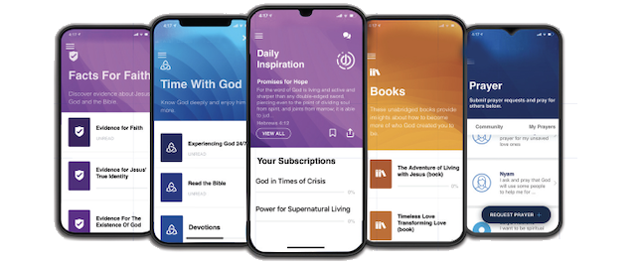

JO EQUIP Resources for Disciplers
JO EQUIP is a free digital library of practical, biblically grounded tools that equip pastors and disciple-makers. Visit equip.jesusonline.com.


