
Free Ministry Resources
Churchgoers or Disciples?
This Sunday: One Discipleship Moment
Five minutes. One assignment. Free.

THE ADVENTURE OF LIVING WITH JESUS
A free Leader Kit for pastors and home church leaders who have attenders—but no manual they can preach, print, or hand to a group leader this week. Ten Discipleship Moments. One assignment. Heart transformation that starts with who they already are in Christ.
✓ Week 1 is this Sunday—service, small group, chapel, or one conversation
✓ A 5-minute flow: verse, summary, take-away, close, then one assignment
✓ Identity-centered discipleship—plus a door for the doubter before Week 1

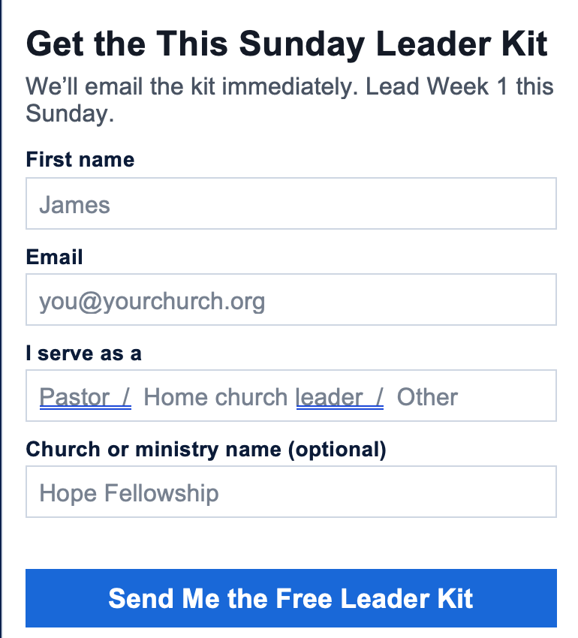
No cost. No curriculum to buy. You can unsubscribe anytime. We will never sell your information.


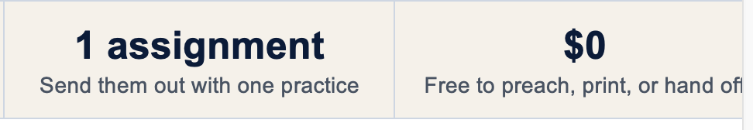
WHY THIS KIT EXISTS
Pastors tell us they have attenders who are not yet disciples.
Especially in small churches, they lack a manual they can preach, print, or hand to a group leader this week. Many programs start with knowledge, behavior, and disciplines. JO EQUIP honors those essentials—but starts with heart transformation through identity-centered discipleship.
This kit is ten weeks. Week 1 is this Sunday. It does not replace the full free Adventure Guide. It gives you one message to lead, one assignment to send people out with, and a clear next step. After the gathering, the Guide and the JO App carry the journey.
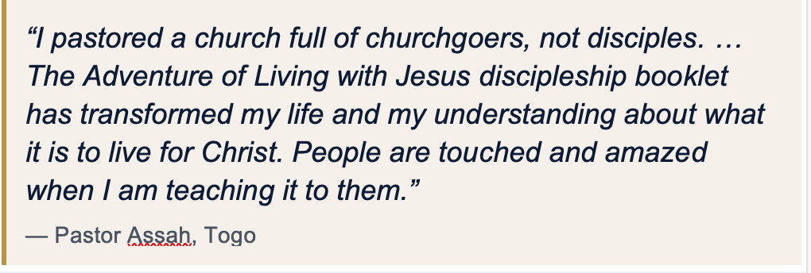
A changed life follows a changed heart.
Identity-centered heart transformation starts in the inner person, not with trying harder on the outside.

Identity-Centered Discipleship
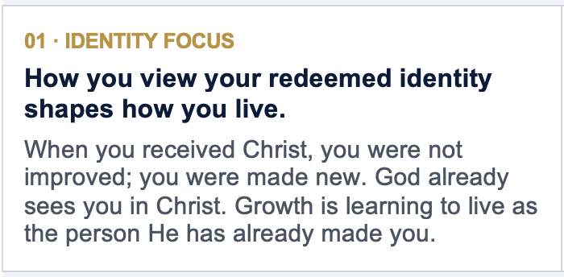
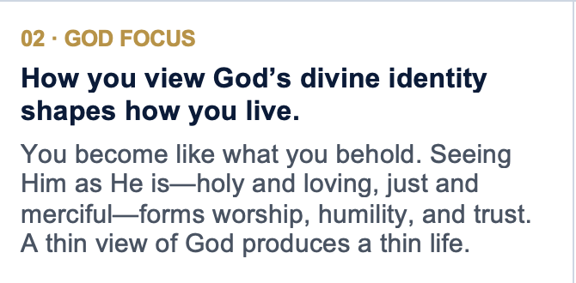
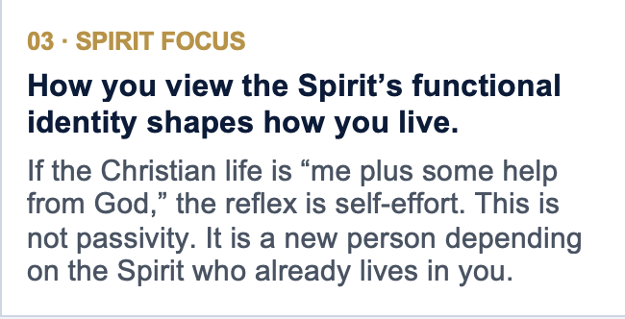
Heart transformation is not “change your behavior so you can feel like a new person.” It is “embrace who you already are, know the God who said so, and depend on the Spirit who lives in you—then behavior follows a changed heart.”

A simple 5-minute flow.
Slip a Discipleship Moment into almost any gathering. Read it almost as written, or put it in your own words. These moments do not replace the Adventure Guide. They are a spoken doorway into it.

Verse | 45 SEC
One Scripture the whole room can hear and hold.
Summary | 2 MIN
Pastoral teaching you can read almost word for word
Take-away | 30 SEC
One sentence they can remember on an ordinary Tuesday.
Close | 60–90 SEC
A verse, a question, and a simple prayer of response.
Assignment | THEN
One practice. Come ready to share what happened.
Ten weeks. One adventure.
The path God has already marked: assurance, identity, the Spirit, faith, Scripture, prayer, His family, and purpose.
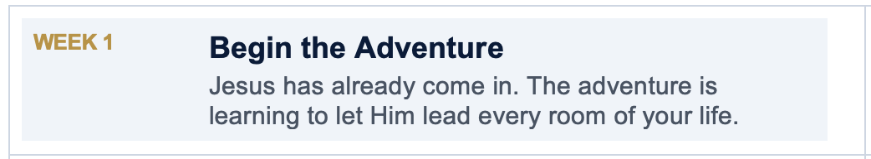
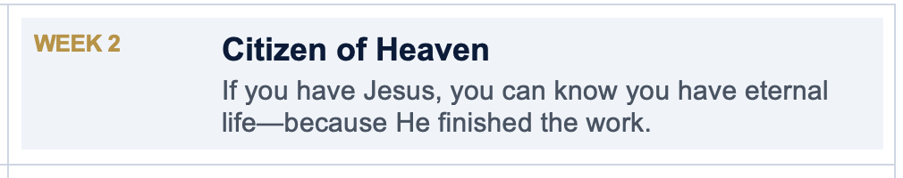

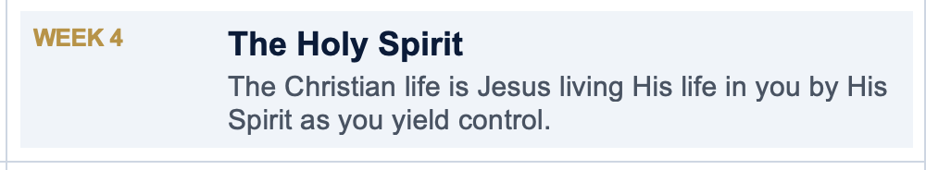
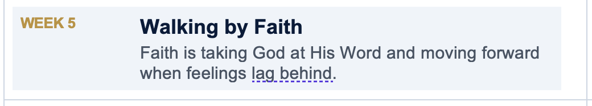
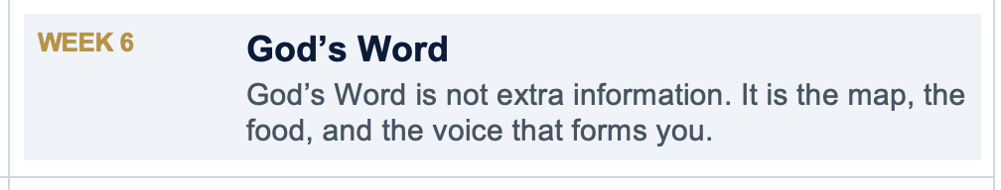

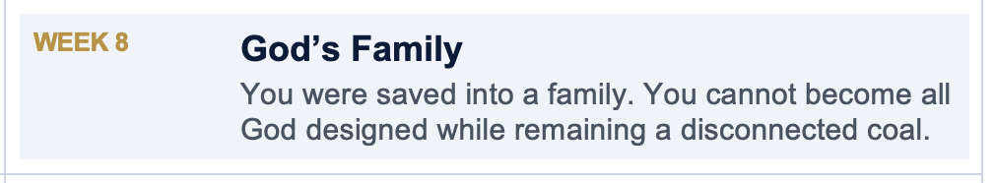

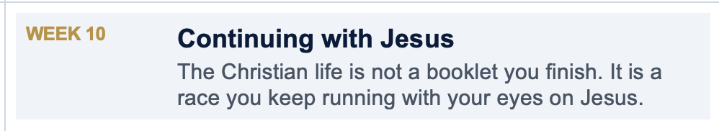
Slip a Moment into the gathering you already have.
Stay near five minutes. A video is extra time only.
Church service
Preach it, read it, or place it after the message. One Moment. One assignment. Then dismiss.
Small group
Read the summary, sit with the question, pray the close. No extra curriculum stack required.
One-to-one
A pastor, mentor, or mature believer can walk a single person through one Moment a week.
After they trust Christ
A 10-week on-ramp—assurance first, purpose last, Jesus at the center.

WHAT YOU RECEIVE
One message to lead. One assignment to send them out with.
This kit does not replace the Adventure Guide or the JO EQUIP library. It gives you a spoken doorway you can use this Sunday—then the Guide and the JO App carry the journey.
✓ Why this kit exists, and the three heart-focuses (identity, God, Spirit)
✓ How to use it: church service, small group, one-to-one, after they trust Christ
✓ Five steps for this week and the 5-minute flow
✓ Do Not Skip the Doubter—a door before Week 1, not a debate
✓ 10 Discipleship Moments with verse, summary, take-away, assignment, and close
✓ Optional Video Moments plus a Go Further map into free JO EQUIP series
✓ Full Guide PDF: equip.jesusonline.com/books/adventure-of-living-with-jesus.pdf
Download the free kit

