
Free Ministry Resources
Churchgoers or Disciples?
This Sunday: One Discipleship Moment
A free Leader Kit for pastors and home church leaders with Ten Discipleship Moments — all ready to teach. Encourage heart transformation.
✓ Week 1 This Sunday—whether in service, small group, or chapel
✓ Each Moment A 5-minute flow: verse, summary, take-away, close, one assignment
✓ Focus Identity-centered discipleship, along with evidence for those who may doubt.
✓ Cost $0 — free to preach, print, and hand out

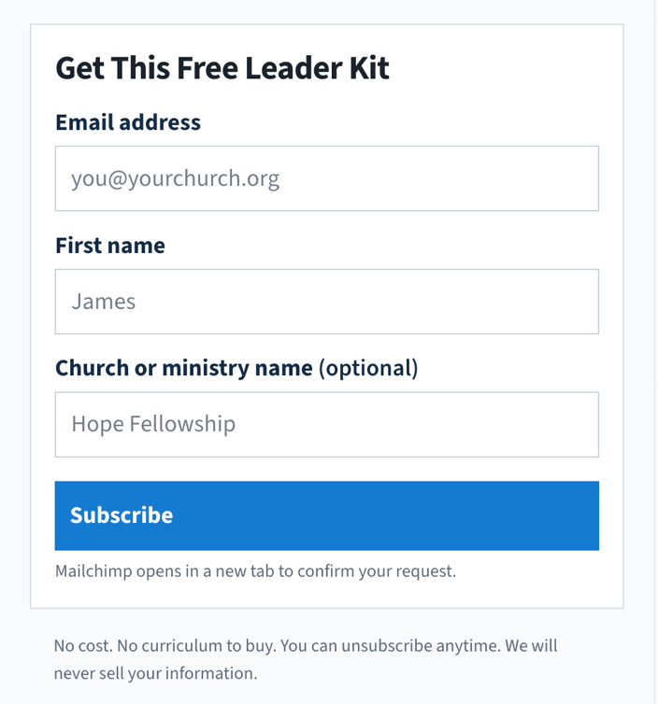

WHY THIS KIT EXISTS
Pastors tell us they have attendees who are not yet disciples.
“I pastored a church full of churchgoers, not disciples. ... The Adventure of Living with Jesus discipleship booklet has transformed my life and my understanding about what it is to live for Christ. People are touched and amazed when I am teaching it to them.”
— Pastor Assah, Togo

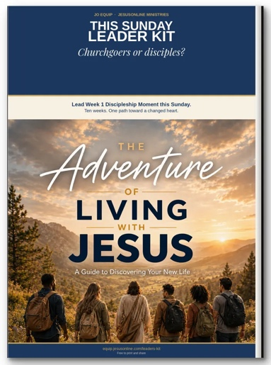

The Adventure of Living with Jesus

A Simple 5-minute flow
Slip a Discipleship Moment into almost any gathering. Read it as written, or put it in your own words.

Verse | 45 sec
The main Scripture passage

Summary | 2 min
Teaching you can read almost word for word

Take-away | 30 sec
One sentence they can remember

Close | 60-90 sec
A verse, a question, and simple prayer of response.

Assignment | Then
Something to apply

Ten weeks. One adventure.
The path God has already marked: assurance, identity, the Spirit, faith, Scripture, prayer, His family, and purpose.

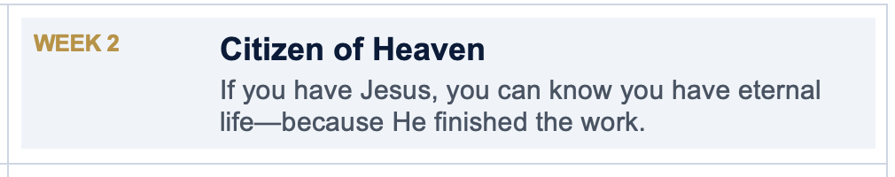



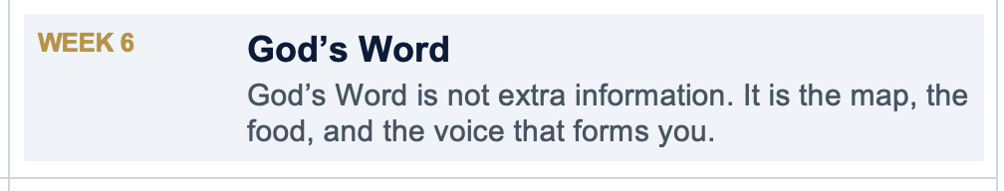

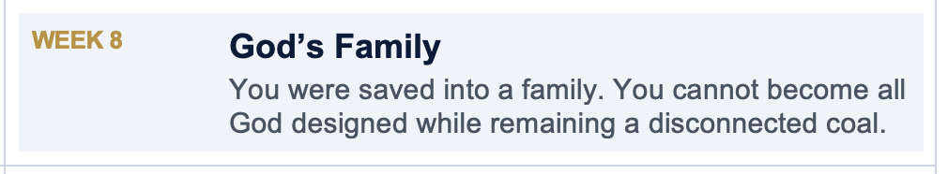

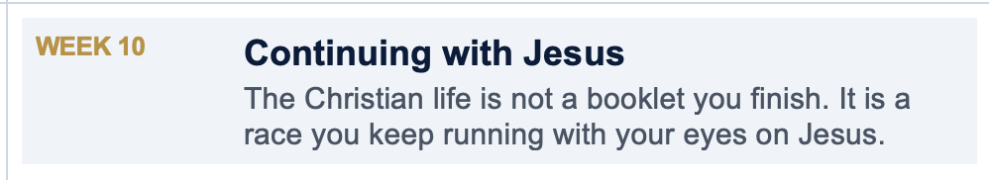

A changed life follows a changed heart.
Identity-centered heart transformation starts in the inner person, not with trying harder on the outside.

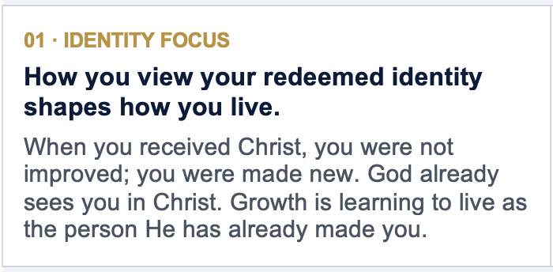
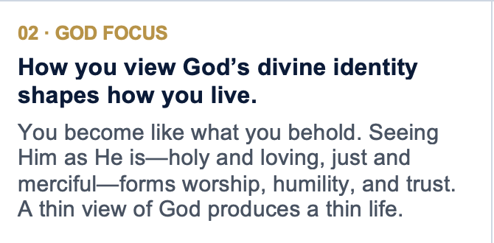
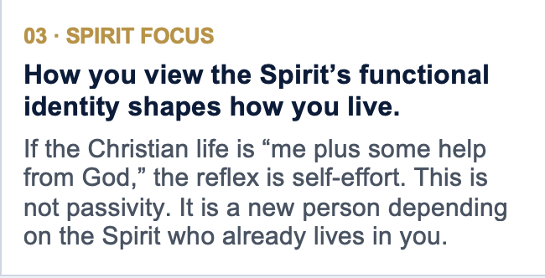
Heart transformation is not “change your behavior so you can feel like a new person.” It is “embrace who you already are, know the God who said so, and depend on the Spirit who lives in you—then behavior follows a changed heart.”

WHAT YOU RECEIVE
This Sunday Leader Kit includes:
✓ Why this kit exists, and the three heart-focuses (identity, God, Spirit)
✓ How to use it: church service, small group, one-to-one, after they trust Christ
✓ Five steps for this week and the 5-minute flow
✓ Do Not Skip the Doubter—evidence for faith
✓ 10 Discipleship Moments with verse, summary, take-away, assignment, and close
✓ Optional Video Moments plus a Go Further map into free JO EQUIP series
✓ The Adventure of Living with Jesus book PDF
Download the free kit

