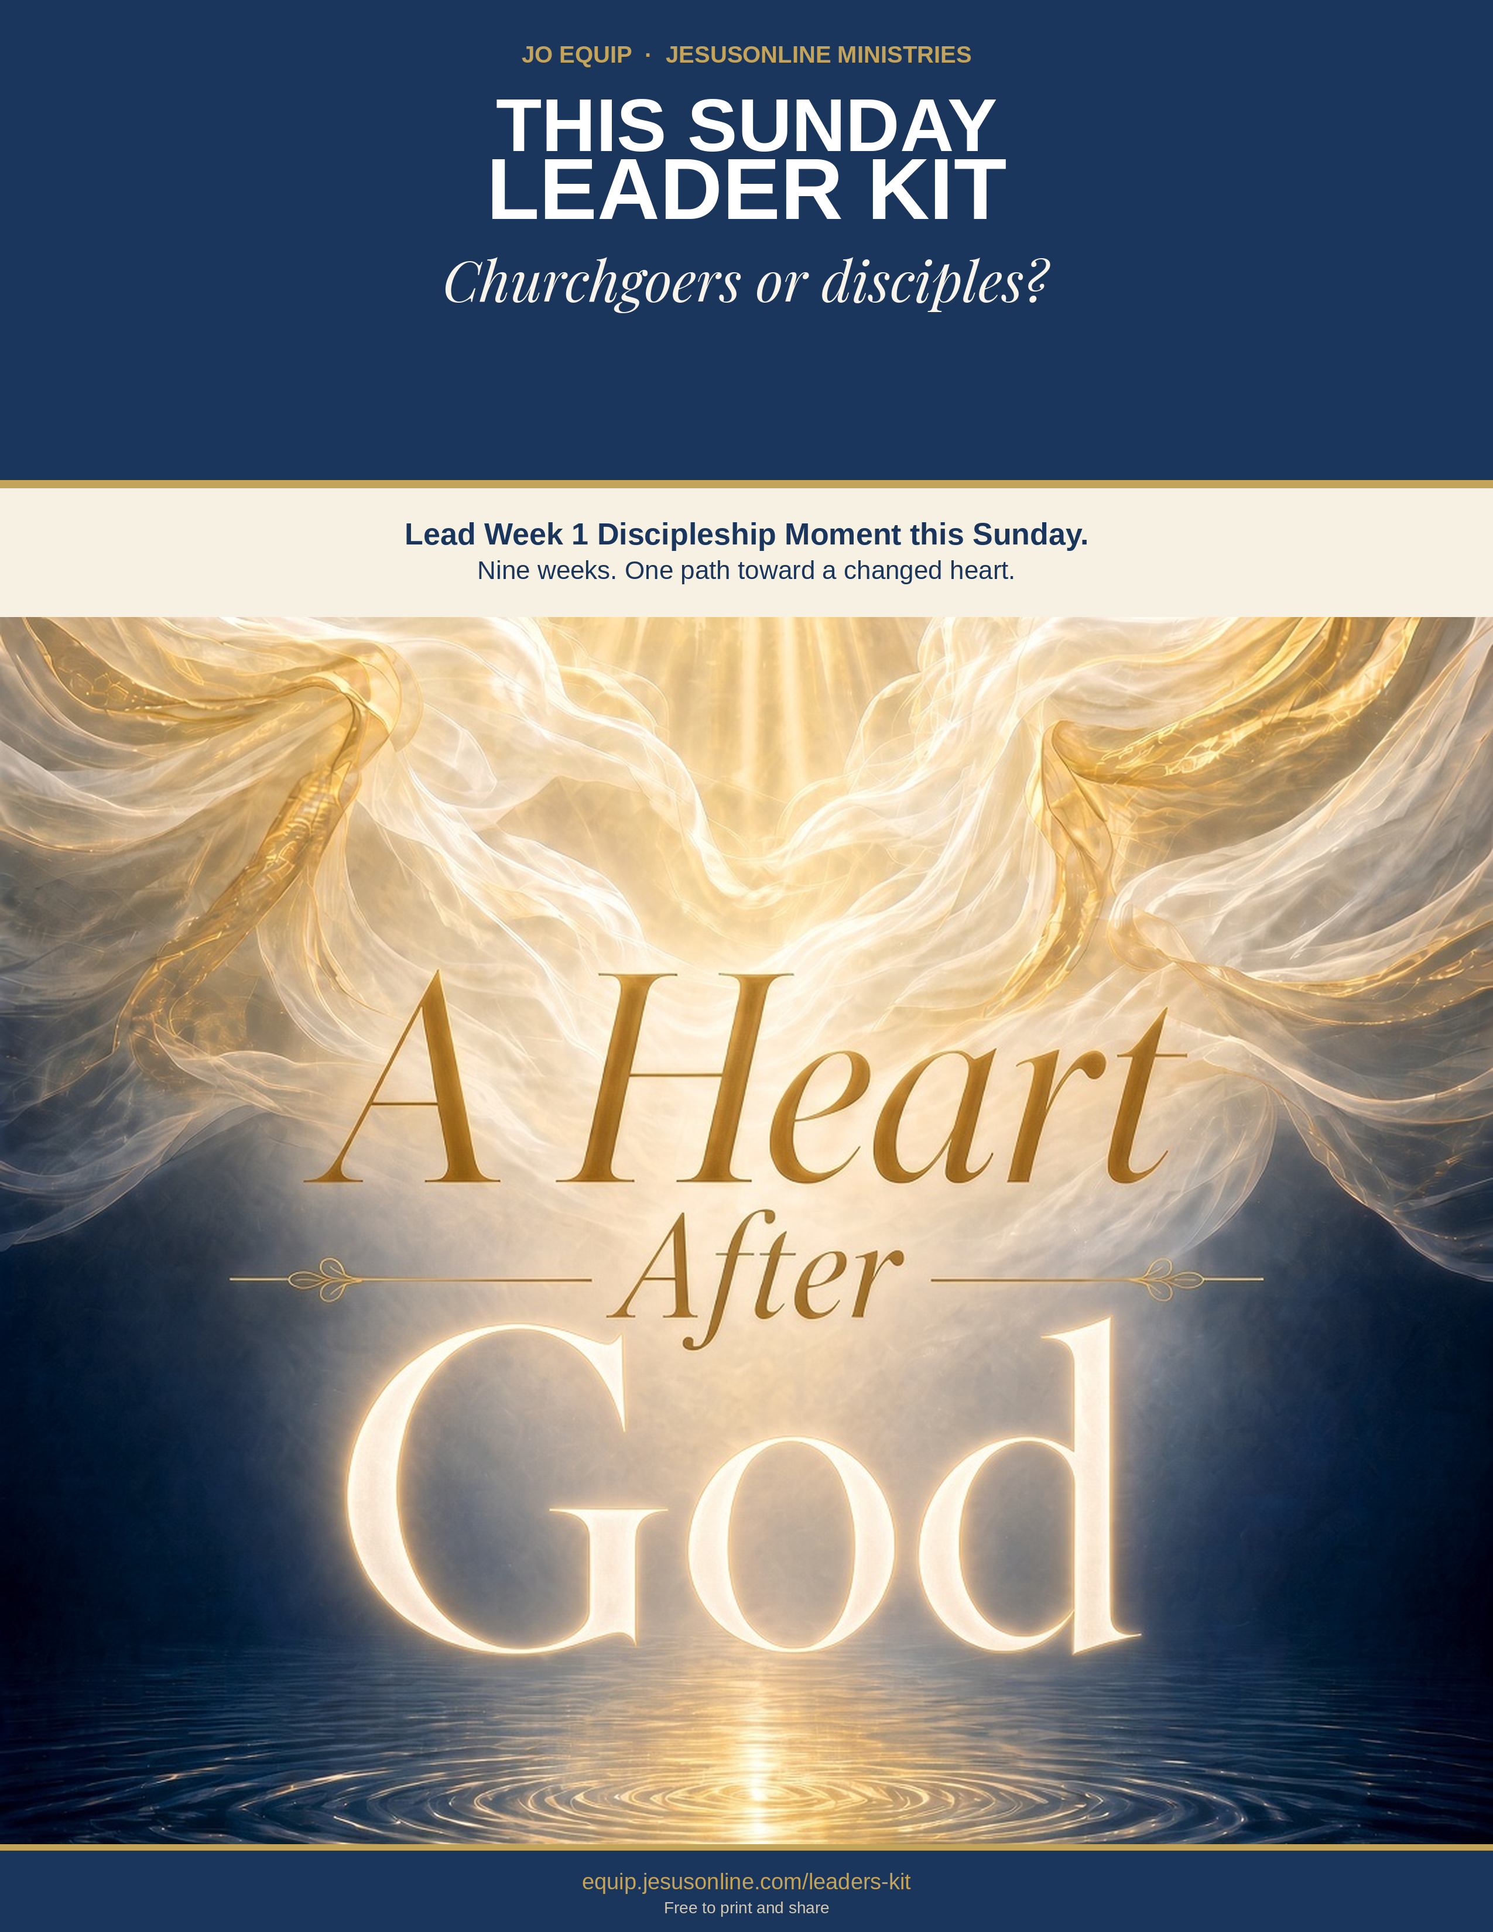

Why This Kit Exists

“I pastored a church full of churchgoers, not disciples.”
Pastor Assah of Togo names what many churches live with: people who attend, and few who are being formed as disciples of Jesus.
Discipleship programs often emphasize biblical knowledge, behavioral change, and spiritual disciplines. JO EQUIP honors those essentials and starts one step earlier: heart transformation through identity-centered discipleship.
Heart Transformation Through Identity-Centered Discipleship
Identity-centered heart transformation starts in the inner person, not with trying harder on the outside. The biblical heart is the control center of beliefs, loves, trust, and choices. From it flow words, desires, and actions. God renews that heart as three realities are embraced together: who you now are in Christ, who God actually is, and how the Holy Spirit functions in daily life. How you view each of those identities either frees a new life or leaves the old life in charge.
Discipleship Moments
This kit helps foster a culture of life transformation by moving people from passive listeners to active doers. Each Moment introduces one key truth concisely, so it can slip into a service, a small group, or a conversation. It is a spoken doorway into the full training—not a replacement for it.
Discipleship Moments are standardized and systematic because effective discipleship must be reproducible.
“And what you have heard from me in the presence of many witnesses entrust to faithful people who will be able to teach others also” (2 Timothy 2:2).
Standardized training enables more people to teach what they have learned more readily. A systematic progression in discipleship provides a clear pathway for people to grow from spiritual birth toward maturity in Christ (Colossians 1:28).
You Can Start Immediately
This kit has nine five-minute moments. Each has: one message, one assignment, and one next step. Start this Sunday.
“I pastored a church full of churchgoers, not disciples. … The Adventure of Living with Jesus discipleship booklet has transformed my life and my understanding about what it is to live for Christ. People are touched and amazed when I am teaching it to them.”
— Pastor Assah, Togo

Nine weeks. After each Discipleship Moment, invite people to read that week’s A Heart After God chapter—in the book or on the JO App. The Moment opens the door. The chapter is where they walk through.

MAIN KEY TAKE-AWAY
A changed life follows a changed heart—and a changed heart begins with who you already are in Christ.

Identity-Centered Heart Transformation

These three focuses are not a program to complete. They are a continual diagnostic for the heart: who you now are in Christ, who God actually is, and how the Holy Spirit works in daily life. Use them on yourself first. Then use them with others. Full teaching is available on equip.jesusonline.com.

1 IDENTITY FOCUS
How you view your redeemed identity shapes how you live.
When you received Christ, you were not improved; you were made new. “If anyone is in Christ, the new creation has come: The old has gone, the new is here!” (2 Cor. 5:17, NIV). God already sees you in Christ. Growth is learning to live as the person He has already made you. A weak view of that identity turns the Christian life into striving. A clear view turns it into alignment.
equip.jesusonline.com/categories/growth/identity-in-christ

2 GOD FOCUS
How you view God’s divine identity shapes how you live.
A distorted view of His character produces a life different from what God envisioned for you; a true and balanced view does the opposite. You become like what you behold: “beholding the glory of the Lord, [we] are being transformed into the same image” (2 Cor. 3:18, ESV). Seeing only part of who God is warps the heart. Seeing Him as He is—holy and loving, just and merciful—forms worship, humility, and trust.
equip.jesusonline.com/categories/growth/attributes-of-god

3 SPIRIT FOCUS
How you view the Holy Spirit’s functional identity shapes how you live.
If the Christian life is “me plus some help from God,” the reflex will be self-effort—try harder, white-knuckle holiness. That is Galatians 3:3: After beginning by the Spirit, are you now finishing by the flesh? Full dependence on the Spirit is not passivity, but active trust. You still choose, confess, obey, and put off the old self as a new person empowered by on the Spirit who already lives in you.
equip.jesusonline.com/categories/growth/ministry-holy-spirit

Identity-centered heart transformation is not “change your behavior so you can feel like a new person.” It is “embrace who you already are, know the God who said so, and depend on the Spirit who lives in you — then behavior follows a changed heart.”
Identity precedes behavior. Transformation flows from what God has already done in Christ. A new kind of living becomes possible not by becoming someone else, but by living as the person God has already made you to be in Christ.

MAIN KEY TAKE-AWAY
That is identity-centered heart transformation: not becoming someone else, but living as the person God has already made you in Christ.

How to Use This Kit

Discipleship Moments are short training modules designed to help equip believers to become disciples. Use them as part of your Sunday service, small groups, chapel services, house church, or in one-on-one discipleship conversations. They do not replace the underlying training series. Each Moment is a “spoken” doorway into the more complete training.
Discipleship Moments from A Heart After God focuses on essential truths of the Christian walk.
Follow the five steps. You can read it as written or put it in your own words. Remember that the power to transform lives does not come from how well you deliver the material. Transformation comes from the Holy Spirit as people put God’s truth into practice.
Church service | Small group | One-to-one | After they trust Christ
FIVE STEPS FOR THIS WEEK
1 | Prepare your own heart  Read Why This Kit Exists and the three Focus blocks until you can explain them naturally. Use them on yourself first.
2 | Do not skip the doubter  If someone is not sure Jesus is who He said He is, show them resources in “Do Not Skip the Doubter.”
3 | Lead this week’s moment  Keep the Moment to about 5 minutes. A video is additional and optional.
4 | Send them out with one assignment  Give this week’s single practice before you dismiss. Ask them to come ready to share what happened.
5 | Keep walking the Guide  Use A Heart After God alongside the Moment. The deeper work happens when people also read the chapter.
A SIMPLE 5-MINUTE FLOW
45 sec  Verse | 2 min  Summary | 30 sec  Take-away | 60–90 sec  Close | Then  Assignment

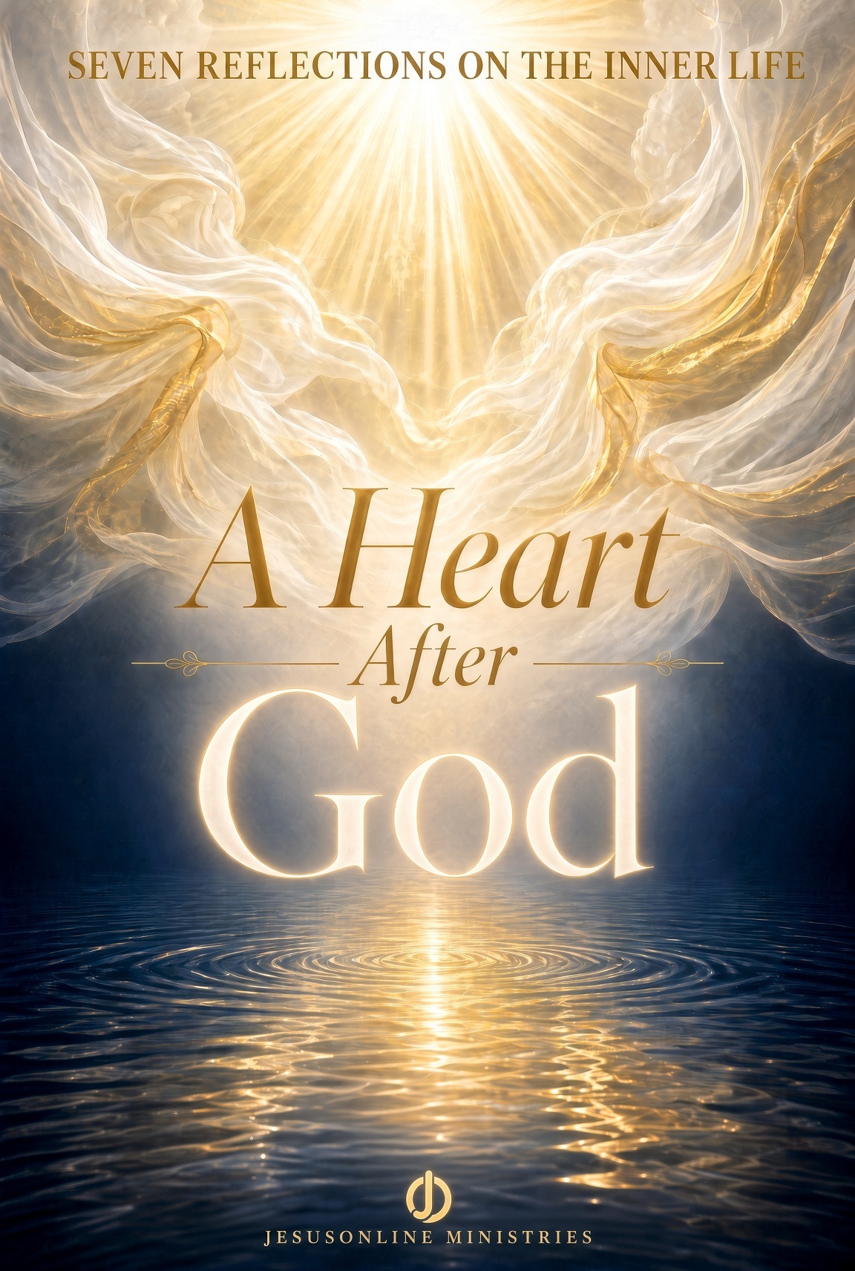 | GET THE FULL BOOK  A Heart After God  Free PDF for devices, print, or group study. Share it with your group.  Download the book: equip.jesusonline.com/books/a-heart-after-god.pdf

Do Not Skip the Doubter

JO EQUIP unites apologetics with identity-centered discipleship. Discipleship Moments assume a person has begun with Jesus. If someone is not sure Jesus is who He said—or not sure God is there at all—give them a different door. Use this page.
TWO BOOKS TO LEAVE IN A HAND
  FREE BOOK  Who Is the Real Jesus?  Open |   FREE BOOK  Has Science Discovered God?  Open
TWO PLAYLISTS IF THEY CAN WATCH
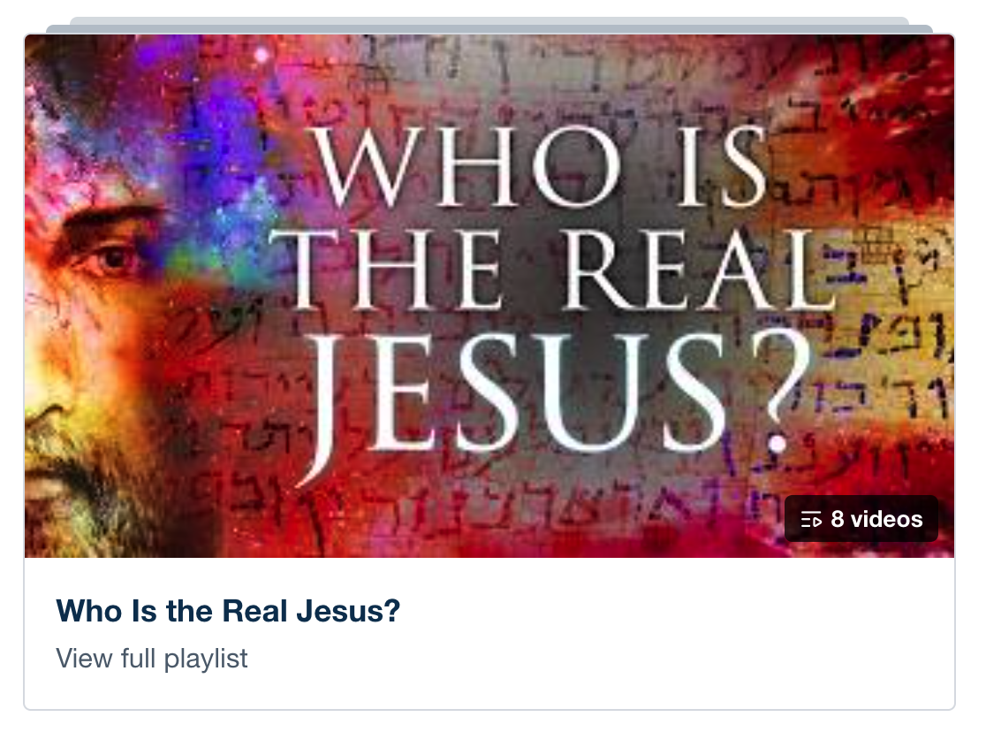  8 VIDEOS  Who Is the Real Jesus?  Open | 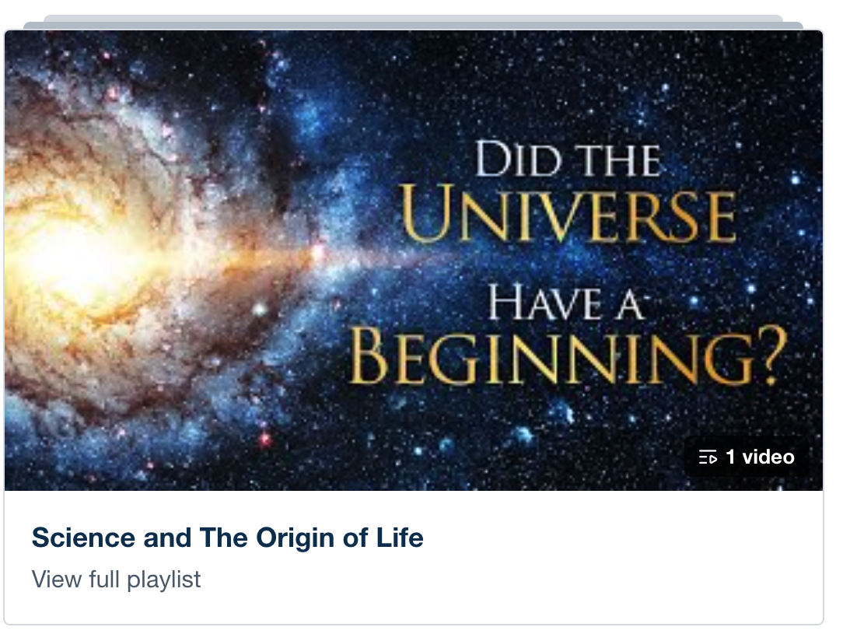  1 VIDEO  Science and The Origin of Life  Open

Ask two questions after they read or watch: Did this make sense? Would you like to respond to Jesus? If yes, begin Week 1. If not, stay near. Leave the book. Pray. Do not pressure.

MAIN KEY TAKE-AWAY
Give the doubter a different door. Do not ignore them.

Video Moments

These videos are optional and require extra time beyond the regular five-minute moment. They do not replace the moment. These videos do not directly correspond to the nine lessons of A Heart After God.
Playlist: 7 Habits for a Deeper Relationship with God
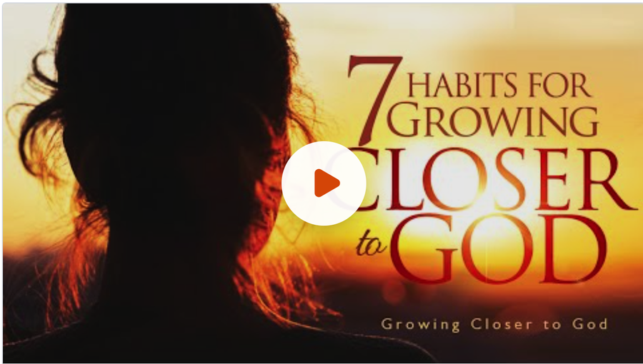  7 Habits for Growing Closer to God  Week 2. Ordinary practices that tend the fire. | 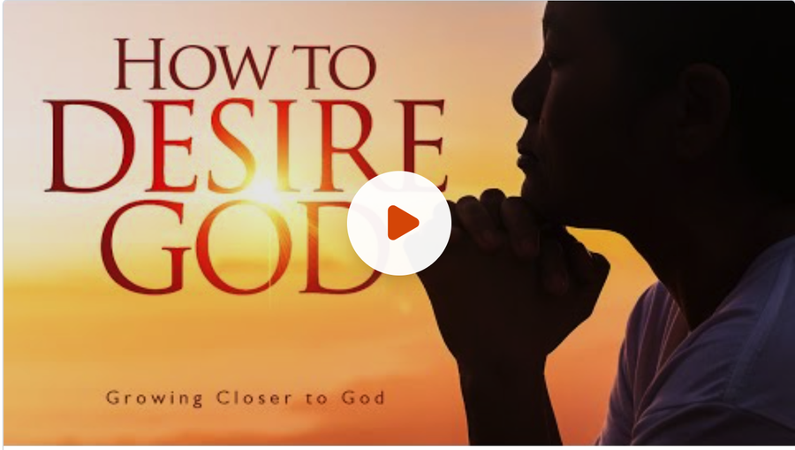  How to Desire God  Week 3. When the inner life feels dull or restless. |   How to Pursue God  Week 4. Seeking Him with an undivided heart. | 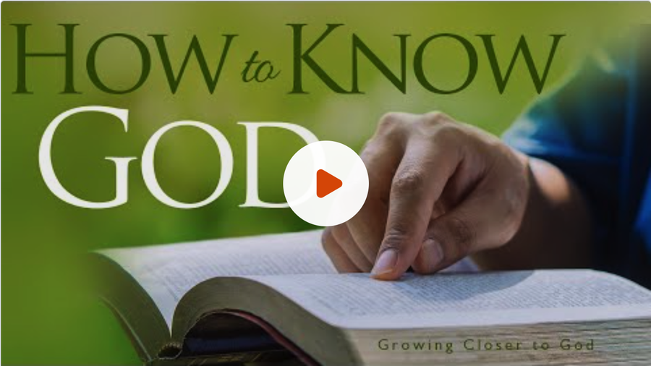  How to Know God  Week 5. Seeing Him as He is, not as we imagine.

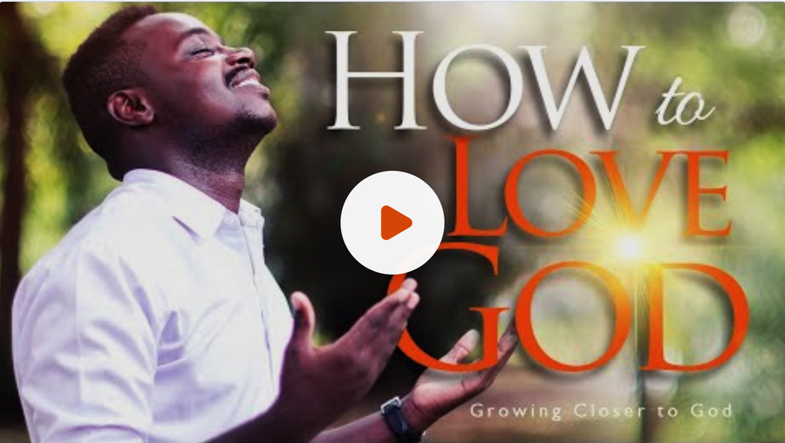  How to Love God  Week 6. Wholeheartedness formed by walking with Him. | 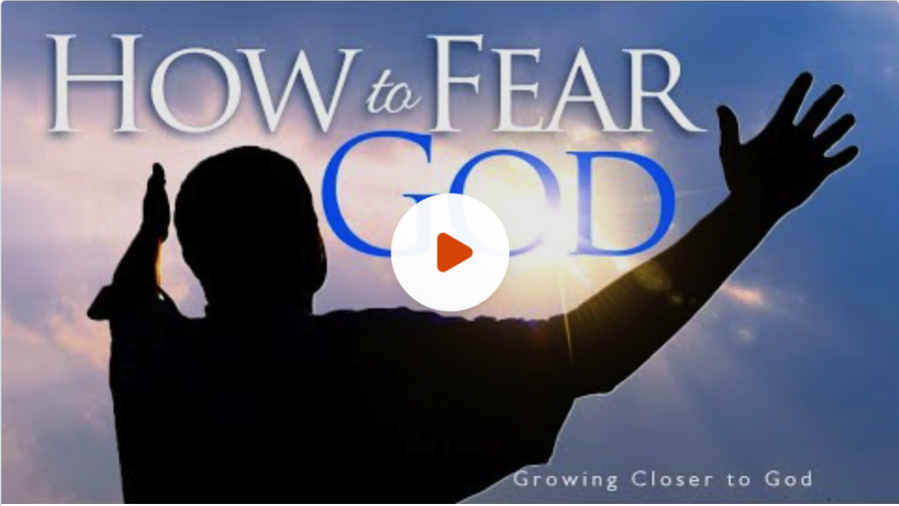  How to Fear God  Week 7. The God who sees the heart—holy and near. | 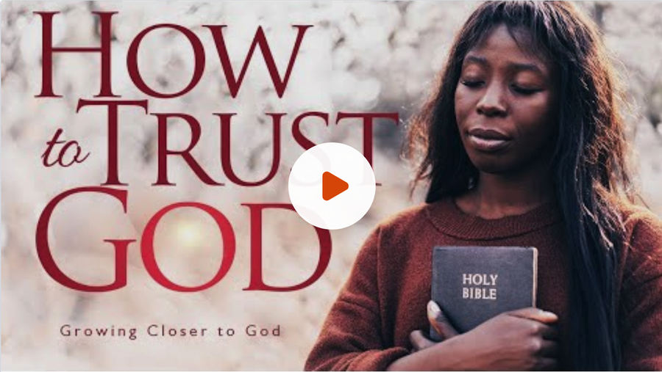  How to Trust God  Week 8. Dependence instead of self-effort. | 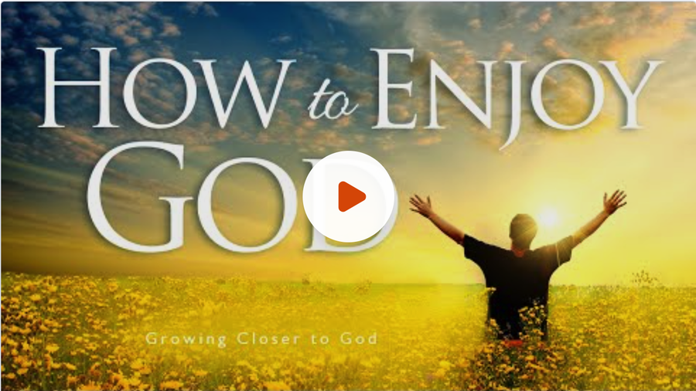  How to Enjoy God  Week 9. Fellowship at the table; remaining with joy.

MAIN KEY TAKE-AWAY
A video may open a heart. It must not replace the message, the take-away, or the walk that follows.

WEEK 1 OF 9
Introduction — The Journey Starts with the Heart

THEME VERSE
You have made us for Yourself, O Lord, and our heart is restless until it rests in You.
— Augustine, echoing the longing of Scripture
2-MINUTE LESSON SUMMARY
Something in you already knows this. A word comes out sharper than you meant. A motive surfaces you would rather hide. The life people see and the life you carry inside do not always match. Scripture is not silent about that inner world. It calls it the heart.
Oswald Chambers said if you want to understand the Bible word “heart,” just say “me.” Not your feelings only. You. The inner person—thought, will, desire, conscience, worship. What is true there does not stay there. It shows up in words, choices, and relationships.
These nine weeks will not ask you to polish the outside first. They begin with the heart as it is. Then they take you to the God who already sees it and still draws near in Jesus. They name what is happening inside you. They tell you the old heart cannot be repaired by trying harder. God gives a new one.
This is an invitation to bring the inner life under the care of the God who gives a new heart and then forms it to look like His Son. A heart after God is not produced in one intense hour. It is formed as you live from what He has already given—honestly, day by day.

MAIN KEY TAKE-AWAY
The heart is restless and wants to be whole. That is where the journey begins.

THIS WEEK’S ASSIGNMENT
Do this one thing. Come ready to share what happened.
Each morning this week, quietly ask: “Lord Jesus, what is the true condition of my heart today?” Write one honest sentence. Do not fix it yet. Tell the truth to Him.

Suggested close (60–90 seconds): Read Proverbs 4:23. Ask: “Lord, what is the true condition of my heart today?” Sit in silence for twenty seconds, then pray, “I bring my inner life under Your care.”

WEEK 2 OF 9
1. The Heart Reflects the Person

THEME VERSE
As in water the face is reflected as a face, so a person’s heart reflects the person.
— Proverbs 27:19
2-MINUTE LESSON SUMMARY
Think of a still pool. On a calm morning, it reflects your true face. Throw a stone in, and the face breaks. Ripples take over. You can still see something there. You cannot trust it.
Your heart works the same way. When it is quiet before God, it reflects truth, trust, and love. When it is stirred—racing thoughts, restless wants, feelings no one has tended—the picture blurs. And those ripples do not stay hidden. They leak into your words and your relationships.
When the Bible says “heart,” it does not mean the organ in your chest. It means you on the inside: the mind that interprets, the will that chooses, the emotions that rise, the conscience that knows God. The outside life is only telling on the inside life. Jesus started there. “Guard your heart with all vigilance, for from it are the sources of life.”
That is why this matters. Sooner or later your inner self will surface. And that is why there is hope. The God who searches the heart asks you to place it in His care.

MAIN KEY TAKE-AWAY
Your heart is already telling the truth. Learn to hear it before your life has to.

THIS WEEK’S ASSIGNMENT
Do this one thing. Come ready to share what happened.
Each evening, ask, “Lord Jesus, review my day with me. Show me how my words, attitudes, and actions revealed my heart.” Write down your observation.

Suggested close (60–90 seconds): Read Proverbs 27:19 and 4:23. Ask: “What is my life revealing about my heart?” Pray, “Lord, still the water. Teach me to hear what my heart is saying.”

WEEK 3 OF 9
2. God Looks at the Heart

THEME VERSE
People look at the outward appearance, but the Lord looks at the heart.
— 1 Samuel 16:7
2-MINUTE LESSON SUMMARY
People judge the curb appeal. God looks at the foundation. You have seen the house: fresh paint, neat yard, everything looking fine from the curb. Then someone checks underneath and finds the foundation cracked.
Samuel almost made that mistake. God sent him to anoint a king, and Samuel saw Eliab—tall, strong, impressive. The Lord stopped him. People look at the outward appearance. The Lord looks at the heart. He weighs motives. He sees thoughts you never say out loud.
A lot of us work hard to look the part. Right words. Right habits. Right impression at church. And still a quiet fear sits underneath: If they knew what I still think, would I still belong? Here is the freeing news. God already knows. And Jesus has not stepped back.
You cannot perform your way out of His sight. You also do not have to hide there. The God who sees the foundation does not turn away when He finds weakness. He calls you into the light, and He stays.

MAIN KEY TAKE-AWAY
God is not watching the performance. He sees the heart—and He has not turned away.

THIS WEEK’S ASSIGNMENT
Do this one thing. Come ready to share what happened.
Begin each day with: “Lord, You see my heart completely. I choose to be honest with You today.” When you feel the urge to impress someone or hide a motive, pause and bring that thought to God in one honest sentence.

Suggested close (60–90 seconds): Read 1 Samuel 16:7. Say aloud: “Lord, You see my heart completely. I choose to be honest with You today.” Thank Him that His knowledge is matched by His love.

WEEK 4 OF 9
3. Understanding the Inner Life of the Heart

THEME VERSE
Guard your heart with all vigilance, for from it are the sources of life.
— Proverbs 4:23
2-MINUTE LESSON SUMMARY
Picture the instruments on a ship. Many dials, all speaking at once. Ignore one of them long enough, and the whole vessel is in trouble. Guarding your heart is learning to read those inner readings with the Spirit—not letting one strong feeling or thought run the whole life.
You do not have to master everything inside you before you can walk with Jesus. Start with three. Thoughts: what you tell yourself about God, about you, about this day. Desires: what you want, what you reach for, or what you secretly live for. Conscience: that inner warning light. When it is healthy, it stings when you drift and settles when you walk in truth.
There is more in there—values, emotions, attitude, the new identity Christ gave you, and the flesh that still pulls away from God. They talk to each other. A thought feeds a desire. A desire pushes a choice. You do not have to watch all of it at once.
Ask the Spirit, “Which one needs attention today?” Name that one thing. What you can name, you can bring to God. What you will not name often ends up driving you.

MAIN KEY TAKE-AWAY
What you can name inside you, you can bring to God instead of being driven by it.

THIS WEEK’S ASSIGNMENT
Do this one thing. Come ready to share what happened.
Identify which feels strongest today—a thought, a desire, or the voice of conscience—and bring that one thing to Jesus. If you wish, take one thought captive and replace it with a sentence from Scripture.

Suggested close (60–90 seconds): Read Proverbs 4:23. Name one instrument aloud—a thought, a desire, or the voice of conscience. Hand that one thing to Jesus in a single sentence.

WEEK 5 OF 9
4. The Need for a New Heart

THEME VERSE
I will give you a new heart, and I will put a new spirit within you.
— Ezekiel 36:26
2-MINUTE LESSON SUMMARY
You can change your diet. You can exercise. You can take every good precaution. If the heart itself is failing, those things may slow the decline. They cannot give you a new one. At some point, only a transplant gives life.
That is the honest news about the natural human heart. It is not merely weak. Scripture says it is deceitful. Jesus said what defiles a person comes from inside. Better habits can tidy the surface. They cannot fix the source. God does not offer to patch the old heart. He offers a new one.
Jesus told Nicodemus, “Unless a person is born from above, he cannot see the kingdom of God.” What you need is not more effort from the old life. You need a new beginning by the Spirit. That happens when you receive Jesus Christ and His finished work. If you have never done that, you can turn to Him now.
When He gives that new heart, you are a new creation. The flesh is still there. It still argues. But you are no longer alone with it, and it no longer has the last word. The transplant is a gift. Living from it is a daily yes.

MAIN KEY TAKE-AWAY
God does not ask the old heart to try harder. He gives a new one.

THIS WEEK’S ASSIGNMENT
Do this one thing. Come ready to share what happened.
Thank God specifically for the new heart He has given you—or ask Him for it if you have never received Christ. Read 2 Corinthians 5:17 slowly and say, “I am a new creation in Christ.”

Suggested close (60–90 seconds): Read Ezekiel 36:26 and 2 Corinthians 5:17. If you belong to Christ, thank Him for the new heart. If you have never received Him, this is the hour to ask.

WEEK 6 OF 9
5. Adoption and Fellowship — The Journey Begins

THEME VERSE
The Spirit himself bears witness to our spirit that we are God’s children.
— Romans 8:16-17
2-MINUTE LESSON SUMMARY
Adoption puts you in the family. Fellowship is sitting down at the table. Those are not the same thing. Sin does not tear up the adoption papers. It can send you away from the table in shame. You do not need to be adopted again. You need to come back.
If you belong to Christ, you are legally a child of God. Nothing in creation can separate you from His love. That is settled. And with that place comes a new name: forgiven, His, complete in Christ. You did not earn those names. They are given to you.
A new sister in Christ kept praying, “God, please take me back.” Her friend said, “He never sent you out of the family. He is asking you to come back to the table.” Adoption establishes the unbreakable relationship. Fellowship keeps that relationship current and strong.
If the table feels far today, the way home is not complicated. Agree with God. Turn. Resist what pulled you away. Rest in the forgiveness already paid for. The chair is still yours.

MAIN KEY TAKE-AWAY
You belong. Fellowship can be restored the same day.

THIS WEEK’S ASSIGNMENT
Do this one thing. Come ready to share what happened.
Declare each morning: “I am an adopted child of God, fully accepted in Christ.” Confess any known sin as soon as conscience is stirred. If false guilt returns, speak Romans 8:1.

Suggested close (60–90 seconds): Read Romans 8:16-17 and 8:1. Declare: “I am an adopted child of God, fully accepted in Christ.” If condemnation returns, speak Romans 8:1 aloud.

WEEK 7 OF 9
6. Relationship, Wholeheartedness, and Passion

THEME VERSE
You will find me available to you if you seek me with all your heart and soul.
— Jeremiah 29:13
2-MINUTE LESSON SUMMARY
A roaring fire is not one giant log thrown on and left. It is tended. A deep friendship is not one great conversation. It is showing up—learning the other person, spending time, telling the truth, noticing who they are, choosing to trust them again.
Walking with God grows the same way. Five practices nurture it. Knowledge: you learn His character in Scripture. Togetherness: you live aware that He is with you. Communication: you talk to Him, and you listen. Observation: you notice His hand in ordinary days. Commitment: you entrust yourself to Him—again and again.
None of these looks dramatic. Do it steadily, the heart becomes increasingly marked by an undivided desire, a settled attitude of love, and values that are fully aligned with God. This is wholeheartedness. Passion is what overflows when you have been with Him day in and day out.
Jesus said that the greatest commandment is to love God wholeheartedly. David is a good example in the Bible. A heart after God is formed as Identity becomes secure, conscience stays clear, thoughts are renewed, desire is set on God, and the flesh is daily resisted—by one ordinary practice at a time.

MAIN KEY TAKE-AWAY
A heart after God is not a mood you wait for. It is formed by walking with Him.

THIS WEEK’S ASSIGNMENT
Do this one thing. Come ready to share what happened.
Choose one of the five ingredients—knowledge, togetherness, communication, observation, or commitment—and give it five to ten unhurried minutes each day this week.

Suggested close (60–90 seconds): Read Jeremiah 29:13 and Matthew 22:37. Name one of the five practices you will give ten unhurried minutes. Pray, “Lord, I will show up. Form love in me.”

WEEK 8 OF 9
7. The Holy Spirit and the Transformation of the Heart

THEME VERSE
What is born of the flesh is flesh, and what is born of the Spirit is spirit.
— John 3:6
2-MINUTE LESSON SUMMARY
You can set the sails. You still need the wind to sail. Prayer, Scripture, honest attention to your heart—those matter. They are how you set the sail. They don’t generate the wind. The power that actually changes the heart belongs to the Holy Spirit. He is the wind.
The new heart Ezekiel promised is the Spirit’s gift. When you were born from above, He made you alive, joined you to Christ, sealed you as God’s own, and moved in. That heart is not something you now maintain by yourself. It lives by the One who gave it.
He renews your mind. He reorders what you love. He steadies what you feel. He clarifies conscience. He keeps telling you who you are. He gives power to say no to the flesh. He does not remove the conflict. He gives you a different source in the middle of it.
So the Christian life is not, “I work hard, and the Spirit helps a little.” It is: “The Spirit is already at work in me, and I yield and cooperate.” He can be grieved. He can be welcomed. The God who began this in you will Himself finish it.

MAIN KEY TAKE-AWAY
The Spirit who gave you a new heart is the One who keeps forming it.

THIS WEEK’S ASSIGNMENT
Do this one thing. Come ready to share what happened.
Begin each day by yielding: “Holy Spirit, I depend on You today to form the heart of Christ in me.” When a fleshly desire or attitude rises, pause and ask the Spirit for power to respond differently.

Suggested close (60–90 seconds): Read John 3:6 and John 15:4. Pray: “Holy Spirit, I depend on You today to form the heart of Christ in me.” Then be still for ten seconds.

WEEK 9 OF 9
A Heart That Remains

THEME VERSE
Remain in me, and I will remain in you. Just as the branch cannot bear fruit by itself, unless it remains in the vine, so neither can you unless you remain in me.
— John 15:4
2-MINUTE LESSON SUMMARY
A branch does not bear fruit by straining. It bears fruit by remaining. These nine weeks have been one journey. Your heart tells the truth about you. God looks at that heart. The inner life can be named. The old heart cannot be repaired. You have been adopted. You can come back to the table. You walk with Him with five practices. The Spirit does what you cannot.
None of that was meant to leave you with a finished feeling. A heart after God is not a certificate. It is a way of staying. Jesus said it plainly: remain in Me. The still pool stays clear only while it is quiet in His presence. The new heart lives only while it stays joined to the One who gave it.
Guard the heart. Remain in Christ. If you have left the table, confess again, return, and sit down again. Set the sail again. Good days and bad days, both belong to the journey, helping you walk more wholeheartedly. David was called a man after God’s heart not because he never wandered. He always came back.
So do not ask, “Have I arrived?” Ask, “Will I remain?” You are not asked to complete yourself. You are asked to stay with the One who completes what He has started. When the heart grows restless again—and it will—bring it back. It has wandered away. He has not moved.

MAIN KEY TAKE-AWAY
You do not finish this journey. You remain in the One who does.

THIS WEEK’S ASSIGNMENT
Do this one thing. Come ready to share what happened.
Pray once each morning: “Lord Jesus, I choose to remain in You today.” Then live the first hour as if that prayer were true. When the heart feels restless, treat it as an invitation to come back—not as failure.

Suggested close (60–90 seconds): Read John 15:4-5 and Philippians 1:6. Pray once, slowly: “Lord Jesus, I choose to remain in You today.” Then live the next hour as if that prayer were true.

Go Further

A Heart After God opened the inner life. The series below give that life room to keep growing. Each one stays with a single part of walking with Jesus—who you now are, who God is, and how the Spirit shapes ordinary days.
You do not have to use them in order. Begin with the series that meets the need in front of you. Each can be downloaded free from the Leaders Kit:
equip.jesusonline.com/leader-kits
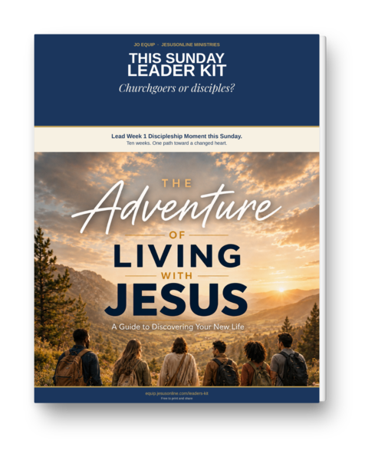 | The Adventure of Living with Jesus · 10 weeks  A first path for a new life  Walk the foundations: assurance, identity, the Spirit, faith, the Word, prayer, family, and purpose.

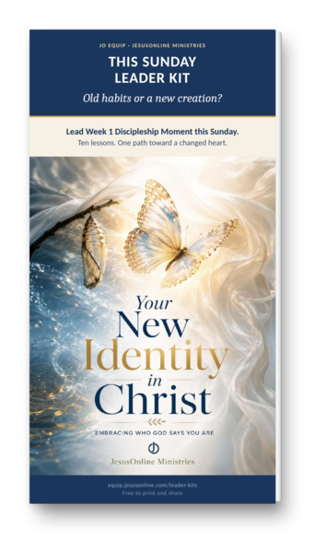 | Your New Identity in Christ · 10 lessons  Embracing Who God Says You Are  Settle the question of who you are now, so the old names lose their hold.

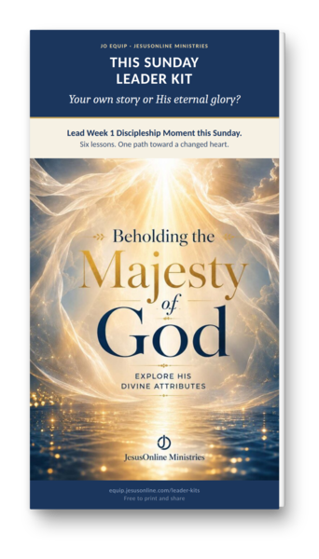 | Beholding the Majesty of God · 6 lessons  Explore His Divine Attributes  Lift your eyes from your own story long enough to see the God who holds it.

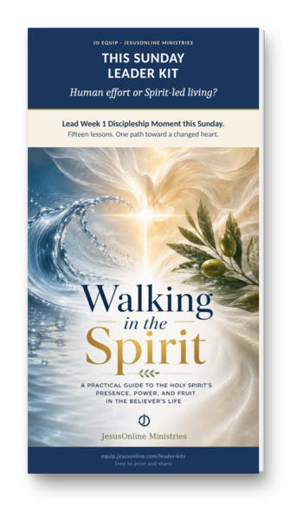 | Walking in the Spirit · 15 lessons  A Practical Guide to the Holy Spirit’s Presence, Power, and Fruit  Discover how the Spirit who lives in you shapes ordinary decisions, not only high moments.

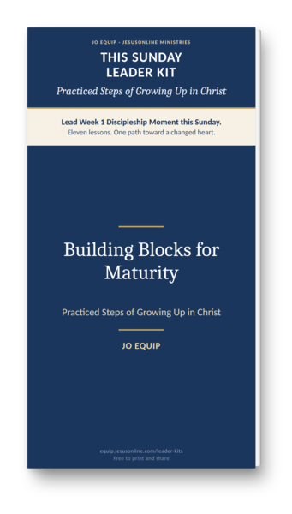 | Building Blocks for Maturity · 11 lessons  Practiced Steps of Growing Up in Christ  Grow up in Christ one practiced step at a time—not by trying harder, but by walking with Him.

MAIN KEY TAKE-AWAY
He is already with you. Choose one series and take the next step.

Additional Resources
SHARE YOUR THOUGHTS
Leave a Review or Send Us a Note — If you found this helpful, please consider leaving a short review. Your feedback helps us improve future resources and encourages others. We love hearing how God is using these materials in your life. Share Your Story → equip.jesusonline.com/reviews/share

THE JO APP FOR PERSONAL GROWTH
The JO App helps believers grow closer to Jesus through Bible studies, daily devotionals, prayer tools, and discipleship series. Most users explore the content on their own. Those who want personal guidance are supported by our Discipleship Pastor and trained volunteers. Visit app.jesusonline.com.
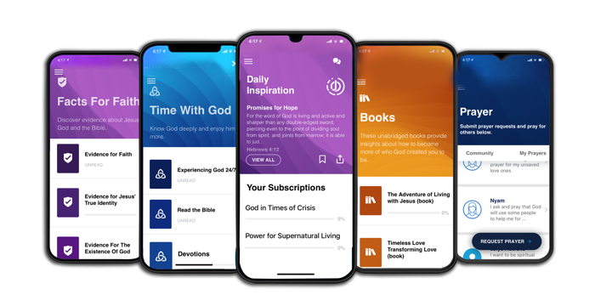

THE JO EQUIP RESOURCES FOR DISCIPLERS
JO EQUIP is a free digital library of practical, biblically grounded tools that equip pastors and disciple-makers with Evidence, Growth, and Church resources—uniting apologetics, identity-centered discipleship, and tools for healthy churches in one trusted hub. Visit equip.jesusonline.com.



