Target URL: https://equip.jesusonline.com/categories/church/bible-study-tools/essential-bible-study-tools

Bible Study Tools

Bible Study Tools
Categories > Church > Bible Study Tools
Great sermons and Bible teaching begin with careful study of God's Word. The free tools below put translations, commentaries, original-language helps, and study resources within reach of every pastor, teacher, and serious Bible student.
Table of Content - Desktop Version
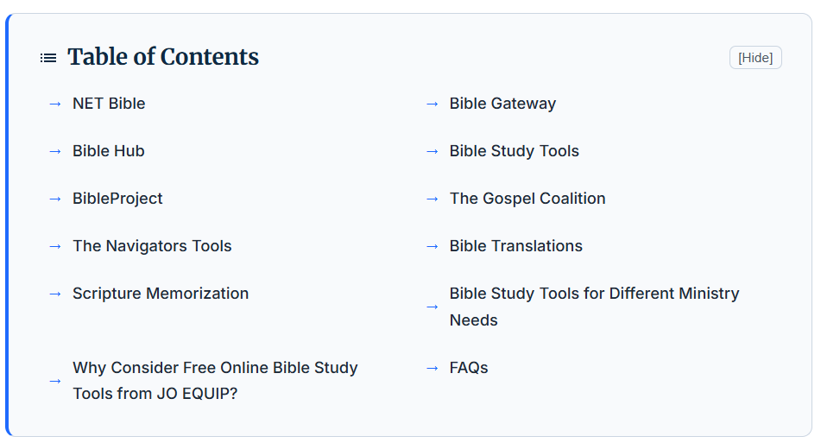

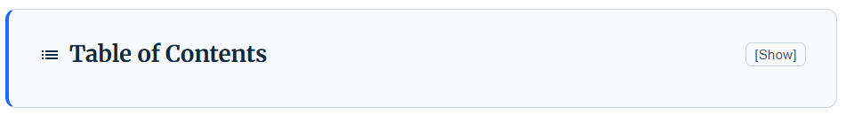

Table of Content - Mobile Version
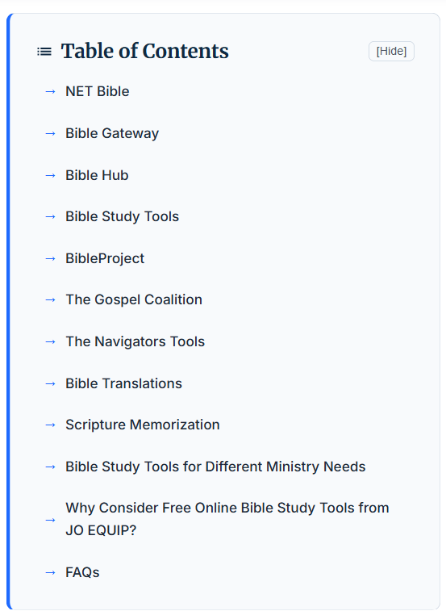


NET Bible
The NET (New English Translation) Bible is available in the JO App (app.jesusonline.com). Read the NET Bible on the JO App.
NET Bible also offers a free online Bible at netbible.org. This site provides 60,932 notes by more than 25 scholars — experts in the original biblical languages — who translated the NET Bible directly from the best currently available Hebrew, Aramaic, and Greek texts. The website is a great reference source for serious Bible students.

Bible Gateway
Bible Gateway (biblegateway.com) is a searchable online Bible tool hosting more than 200 versions of the Bible in over 70 languages that you can freely read, research, and reference anywhere. Including a library of audio Bibles, mobile apps, devotionals, email newsletters, and other free resources, Bible Gateway equips you not only to read the Bible, but to understand it.
- Lookup Passage
- Keyword Search
- Topical Index

Bible Hub
Bible Hub (biblehub.com) is an online parallel Bible with search and study tools including parallel texts, cross references, Treasury of Scripture, and commentaries. This site provides quick access to topical studies, interlinears, sermons, Strong's and many more resources, and is a great way to link any verse on your site to an instant menu of 25 versions. This website allows you to:
- Search: Enter any combination of book, abbreviation, chapter, verse, or keyword.
- Read: Click any version name to read the full chapter for that text.
- Study: Click any study tab to view sermons, topics, commentaries, interlinear, Strong's, or Greek and Hebrew for your passage.

BibleStudyTools.com
Bible Study Tools (biblestudytools.com) is the largest free online Bible website for verse search and in-depth studies. It aims to offer the freshest and most compelling biblically-based content to Christians who take their relationship with Christ seriously, giving Christians of any age and at any stage the opportunity to read, study, understand, and apply the Bible to their lives. With free devotionals, study guides, helpful articles, and rich personalization functions, visitors can make the most of their Bible study time and unlock its meaning:

- Devotionals
- Topical Verses
- Bible Commentaries
- Bible Concordances
- Bible Dictionaries
- Encyclopedias
- Church History
- Christian Classics
- Pastor Resources
- Sunday School Lessons

BibleProject
Explore the BibleProject animated videos about the books of the Bible and various Bible themes like Holiness, Holy Spirit, The Messiah, The Covenants, and many more.
From page one to the final word, the Bible is a unified story that leads to Jesus. In addition to videos and podcasts, their Bible resources help people experience the Bible in a way that is approachable, engaging, and transformative.
To learn more about their ministry and find Bible study resources, visit bibleproject.com.

The Gospel Coalition
The Gospel Coalition is a global fellowship of evangelical churches in the Reformed tradition deeply committed to renewing our faith in the gospel of Christ and to reforming our ministry practices to conform fully to the Scriptures.
Their website (thegospelcoalition.org) offers daily Bible reading and devotionals, articles, blogs, commentary, essays, and other resources. They also offer different country editions in several different languages.
Try their Bible commentary in the U.S. Edition.

The Navigators Bible Study Tools
The Navigators is a ministry that shares the gospel of Jesus and helps people grow in their relationship with Him through Life-to-Life® discipleship, creating spiritual generations of believers.
Browse through their most popular Bible study tools, including free PDF downloads, book excerpts, and even full eBooks. As you explore these Bible study resources, discover new and fresh ways to read and apply Scripture.
Visit The Navigators for more resources.

English Bible Translations
The original manuscripts of the Bible — known as the autographs — were written by their respective authors but have not survived. Nevertheless, the biblical text has been faithfully preserved and transmitted through thousands of ancient manuscripts and fragments discovered around the world.
The Scriptures were originally composed in Hebrew (most of the Old Testament), Aramaic (small portions of the Old Testament), and Greek (the entire New Testament). Biblical scholars carefully study and compare these and other Latin manuscripts to produce accurate translations of the Bible into modern languages.
Today, there are many English versions of the Bible. “A Guide to Finding the Right Bible Translation” by Olive Tree Bible Software will help you understand different English translations.

Scripture Memorization
The Navigators show you how to memorize Scripture with a proven method. Read the article, “How to Memorize Scripture.”
The Topical Memory System (TMS) is a simple, easy-to-use system for memorizing key Bible verses that point to essential gospel truths.
—---------------------------------------------------------------------------------
New Content Section Addition

<H2> Bible Study Tools for Different Ministry Needs

Bible Study Tools for Pastors
Pastors can use the Bible study tools to prepare sermons, explore Scripture in greater depth, and develop biblically grounded teaching.

Bible Study Tools for Home Church Leaders
Home church leaders can use JO Equip Bible study tools to study, prepare Bible discussions, and encourage meaningful discipleship.

Bible Study Tools for Chaplains
Chaplains can use our Bible study tools to better understand and communicate Scripture when providing spiritual care and encouragement.

Bible Study Tools for Missionaries
Missionaries can use the Bible study tools to deepen their understanding and prepare for teaching and discipleship across different ministry contexts.
—------------------------------------------------------------------------------
New Content Section Addition

<H2> Why Consider Free Online Bible Study Tools from JO EQUIP?
JO EQUIP, the ministry resource hub from JesusOnline, offers the best online Bible study tools for pastors, home church leaders, chaplains, missionaries and others at different stages of studying Scripture.
Here are the benefits of choosing the JO EQUIP online Bible study tools and resources:-
- Deeper Understanding: Our free online Bible study tools help you gain a deeper understanding of God’s Word and explore connections between different passages.
- Historical and Cultural Clarity: Resources like study Bibles and atlases reveal the original context, idioms, and backgrounds of ancient audiences.
- Structure and Consistency: Workbooks and guided digital tools provide daily direction and keep you grounded in a steady routine.
- Practical Application: Our Bible study tools and resources bridge the gap between academic interpretation and personal transformation in your everyday life.

FAQs Section- Suggestion - Reference: https://equip.jesusonline.com/pastors
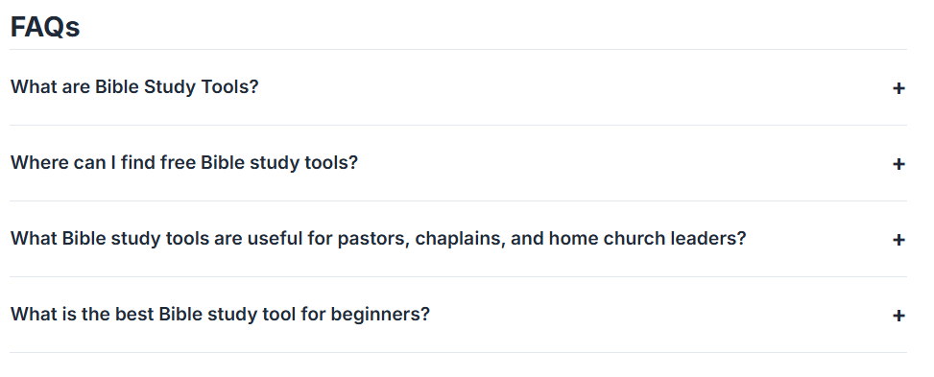
New Content Section Addition

<H2> FAQs
<H4> What are Bible Study Tools?
Bible study tools are resources, books, and digital platforms that help readers understand, study, interpret, and apply Scripture. They include Bible translations, commentaries, dictionaries, concordances, study guides, and other resources that provide helpful context and insights into Scripture. JO EQUIP from JesusOnline Ministries brings many of these resources together to help pastors, leaders, and Bible students explore Scripture, know God more deeply, and grow in His Word.

<H4> Where can I find free Bible study tools?
You can find free Bible study tools on websites like the JO EQUIP from JesusOnline Ministries, which offers free animated overviews, podcasts, and guides.

<H4> What Bible study tools are useful for pastors, chaplains, and home church leaders?
Essential Bible study tools that are useful for pastors, chaplains, and home church leaders include comprehensive platforms, background commentaries, and original-language references that streamline sermon and lesson preparation.

<H4> What is the best Bible study tool for beginners?
For beginners, a simple online Bible with an easy-to-understand translation is a good place to start. JO EQUIP from JesusOnline Ministries also offers free Bible study resources to help you read, understand, and apply Scripture. As you grow in your study, you can explore commentaries, Bible dictionaries, and other study tools.

