URL: https://follow.jesusonline.com/xp/believer



Good to See You Here
Watch this video: How God sees you now >>>
Link to: https://www.youtube.com/watch?v=psw_5rn9WFY&list=PLyI_AdjR33H3yAO7F9M4tJoq9EwU7Afmc&index=2

Thank you for watching. Since you already walk with Jesus, we’re glad these truths could encourage you today.
If you would like to keep growing or simply be refreshed in the basics of walking with Him, this short guide is a clear and steady place to continue.
[Button: Begin This Short Guide]

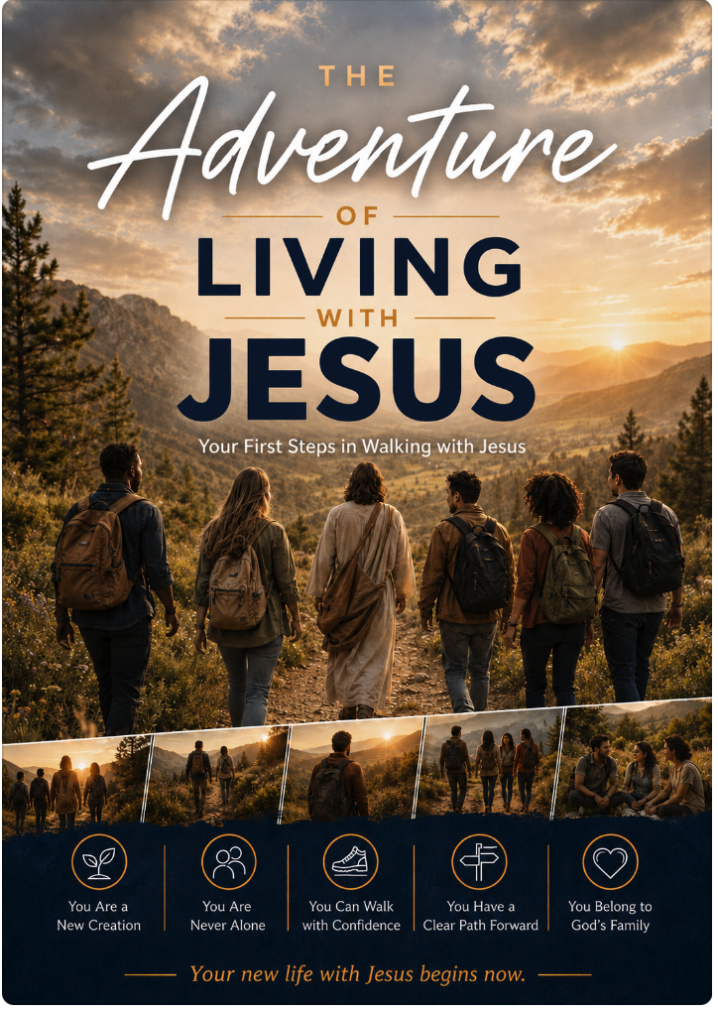

Many believers find it helpful to return to these foundational truths from time to time—or to share them with someone who is just beginning.
[Button: Download the Guide]
Want to come back easily later? [Send this page to yourself] or save it in your browser.

Ways You Might Use These Resources
- Refresh the foundations of your own walk with Jesus
- Find clear language for conversations with others
- Help someone who is new in their faith
- Revisit a specific area (identity, prayer, Scripture, purpose)
- More options?
We’re Here If You Need Anything
If you have a question or would like help finding the right resource, feel free to reach out.
[Button: Send a Message]

