URL: https://follow.jesusonline.com/xp/received



Something Real Has Begun

Watch this video: How God sees you now >>>
Link to: https://www.youtube.com/watch?v=psw_5rn9WFY&list=PLyI_AdjR33H3yAO7F9M4tJoq9EwU7Afmc&index=2
You just took a step of faith. What happened is real. These simple next steps will help you understand it more clearly and begin walking forward with confidence.
[Button: Begin This Short Guide]

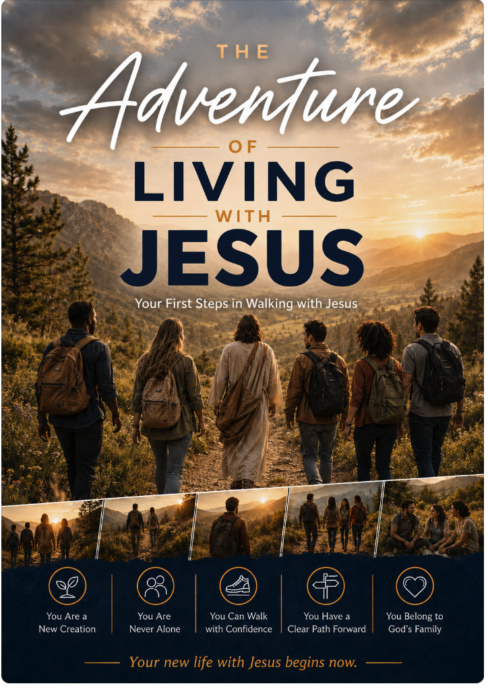

In the video you heard that Jesus offers a new life. This guide helps you see what that new life looks like in ordinary days—clearly, gently, and at your own pace.
[Button: Download the Guide]
Want to come back easily later? [Send this page to yourself] or save it in your browser.

You’re Not the Only One Wondering…
- How do I know this is real?
- I’m afraid…
- How should I handle my current relationships?
- What do I do now?
- I have questions about church
- I want to know Jesus more
- More questions?

We’re Here If You Need Anything
If a question or concern is on your heart, you’re welcome to share it.
[Button: Send a Message]

