URL: https://follow.jesusonline.com/xp/rededicated



Welcome Back
Watch this video: How God sees you now >>>
Link to: https://www.youtube.com/watch?v=psw_5rn9WFY&list=PLyI_AdjR33H3yAO7F9M4tJoq9EwU7Afmc&index=2

You just took a meaningful step. Turning toward Jesus again matters. What you did is real, and He receives you with open arms.
These simple next steps will help you renew your walk with Him and move forward with clarity and confidence.
[Button: Begin This Short Guide]

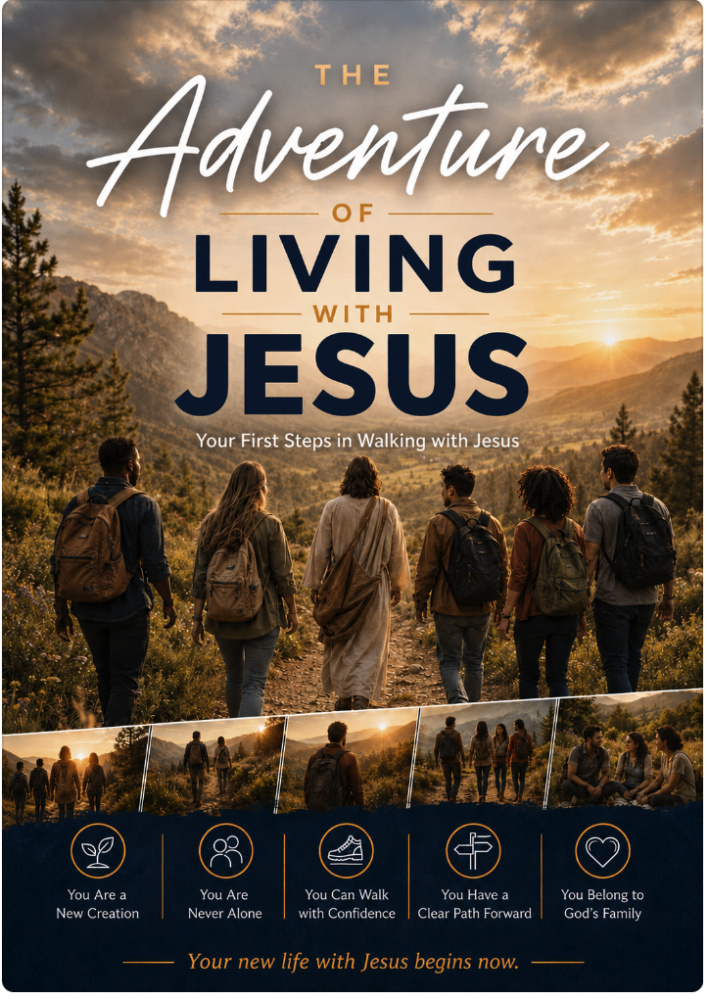

In the video you were reminded of the life Jesus offers. This guide will help you return to the daily reality of walking with Him—steadily and sincerely.
[Button: Download the Guide]
Want to come back easily later? [Send this page to yourself] or save it in your browser.

You’re Not the Only One Feeling This Way…
- How do I start walking closely with Him again?
- I feel ashamed or distant…
- How should I handle the relationships and patterns I left behind?
- What practical steps can I take right now?
- I have questions about getting connected again
- I want to know Jesus more deeply
- More questions?
We’re Here If You Need Anything
If something is weighing on you or you simply want help taking the next step, you’re welcome to share it.
[Button: Send a Message]

