URL: https://jesusonline.org/xp/no-already-received



Good to See You Here

Thank you for watching. Since you already walk with Jesus, we’re glad these truths could encourage you today.
If you would like to keep growing or simply be refreshed in the basics of walking with Him, this short guide is a clear and steady place to continue.

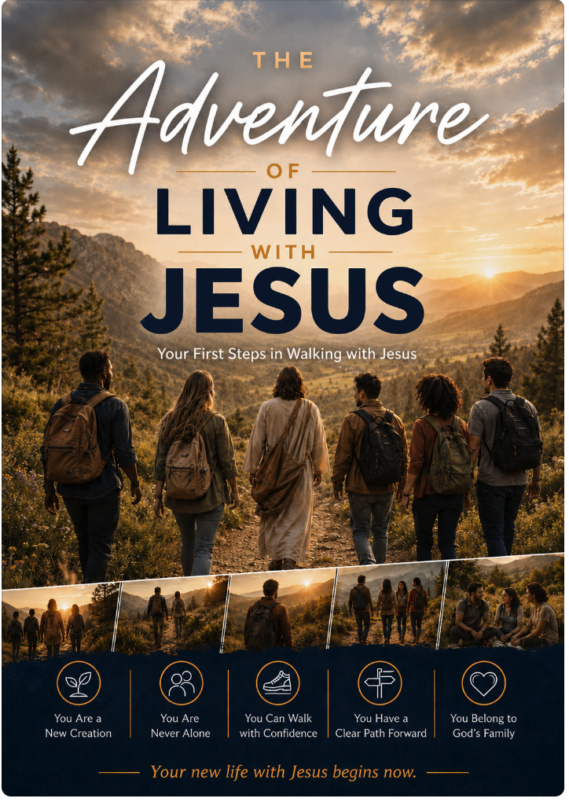

[Button: Begin This Short Guide]
8 short readings · written in order · start anywhere
Prefer to keep a copy on your phone? Download the Guide (PDF)
Want this page later? Send it to yourself · or bookmark it.
How God sees you now
In three minutes, hear the same good news you just stepped into: you belong to Christ, and God already sees you as His.
Watch 3 minutes — How God sees you now
Link to: https://www.youtube.com/watch?v=psw_5rn9WFY&list=PLyI_AdjR33H3yAO7F9M4tJoq9EwU7Afmc&index=2
Ways You Might Use These Resources
- Refresh the foundations of your own walk with Jesus
- Find clear language for conversations with others
- Help someone who is new in their faith
- Revisit a specific area (identity, prayer, Scripture, purpose)
- More options?
We’re Here If You Need Anything
If a question or concern is on your heart, you are welcome to share it. A real person will read what you send.
BUTTONS → Email us Message on WhatsApp

