URL: https://jesusonline.org/xp/yes-i-rededicated



Welcome Back

You just took a meaningful step. Turning toward Jesus again matters. What you did is real, and He receives you with open arms.
These simple next steps will help you renew your walk with Him and move forward with clarity and confidence.
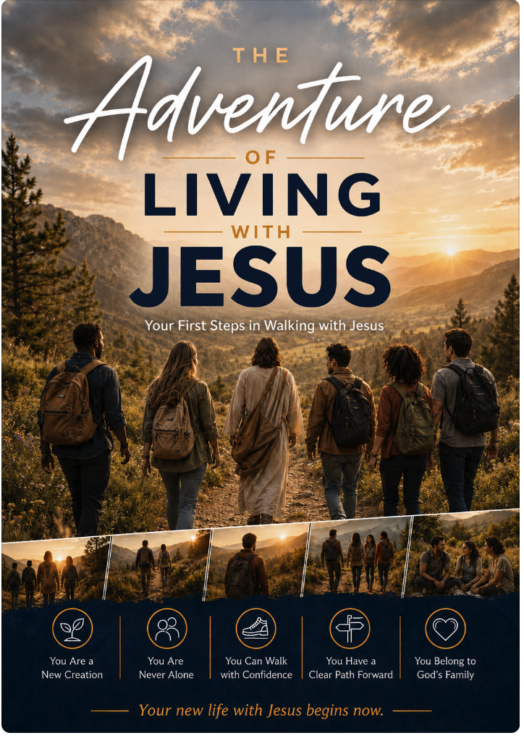

[Button: Begin This Short Guide]
8 short readings · written in order · start anywhere
Prefer to keep a copy on your phone? Download the Guide (PDF)
Want this page later? Send it to yourself Or bookmark it.
How God sees you now
In three minutes, hear the same good news you just stepped into: you belong to Christ, and God already sees you as His.
Watch 3 minutes — How God sees you now
Link to: https://www.youtube.com/watch?v=psw_5rn9WFY&list=PLyI_AdjR33H3yAO7F9M4tJoq9EwU7Afmc&index=2

You’re Not the Only One Feeling This Way…
- How do I start walking closely with Him again?
- I feel ashamed or distant…
- How should I handle the relationships and patterns I left behind?
- What practical steps can I take right now?
- I have questions about getting connected again
- I want to know Jesus more deeply
- More questions?
We’re Here If You Need Anything
If a question or concern is on your heart, you are welcome to share it. A real person will read what you send.
You do not have to figure out church, fear, or next steps by yourself.
BUTTONS → Email us Message on WhatsApp

