Chapter 2 Work Manual for Each Department (General Assembly, Tribes)

15. The Department of Domestic Missions
Table of Contents

1. Staff Composition

2. Duties
A. Operation of Mission Churches
B. Management, Supervision, and Support of Various Gatherings
C. Establishment of Gentile Presbyteries and Denominations
D. Evangelizing Pastors and Evangelists
E. Gathering Information on Christianity and the Religious Community
F. Protection of Saints
G. Promotion of Shincheonji
H. Operation of Mission Organizations
I. Public Debates with Gentile Denominations

3. Definitions of Terms

4. Report Forms and Writing Guidelines
1) Month-End Report
2) Mission Church Status Report
3) Mission Church Registration and Dropout Status
4) Mission Church Weekly Report
5) Mission Church Weekly Offering Statement
6) Mission Church Month-End Financial Accounting Report
7) Mission Church Establishment and Operation Plan
8) Gathering Plan Report
9) Gathering Result Report
10) Mission Church Log
11) Mission Church Performance Target Report
12) Mission Church Closure Plan Report
13) Mission Church History

5. Reporting Other Matters

6. Special Instructions from the Chairman Regarding the Department of Domestic Missions

1. Staff Composition
A. General Director, Domestic Missions Dept. of each tribe and branch church
B. Missionaries and Head Instructors of mission churches

2. Duties
A. Operation of Mission Churches (Public and Non-public)
1) Purpose of Establishing Mission Churches
A) Enables natural connection to the Gospel Room and easy guidance to the Mission Center
B) Used as a venue for gatherings that make contact with prospects and connect them to the Gospel Room
C) Easy management after guidance to the Mission Center: low chance of being "stung" (influenced by opposition), so a high pass-over rate
D) Serves as a refuge for saints who are persecuted: makes it possible to evangelize family members and relatives
E) Easy long-term management of prospects, management of those eligible for re-registration, and easy re-evangelization (checking their faith)
F) Makes it possible to evangelize those who are hard to evangelize, such as people with no time, people with weak faith, people with no religion, and people with many doubts
G) Easy to accommodate believers who have left their churches and are wandering in search of the word
H) Serves as a forward base for infiltrating and breaking up the CCK and Gentile denominations
I) Used as a place to re-evangelize those who dropped out of the Gospel Room or the Mission Center
J) Used as a foundation for establishing mission organizations
K) Through the operation of public Shincheonji mission churches, those who came to know Shincheonji and were contacted through public street booths, open houses, etc. are gathered and the church is used as a place of evangelism
2) Administrative Procedure for the Mission Church Establishment and Operation Plan
A) Draft a report on the mission church establishment and operation plan to the church and the tribe
B) Submit the real estate contract plan through electronic approval up to the tribe, designating the Department of Construction of the General Assembly as recipient
C) Submit the "Mission Church Establishment and Operation Plan, evangelism plan, new worker report (Head Instructor of the mission church), and minutes of the key leaders' meeting" through electronic approval up to the tribe, designating the Department of Domestic Missions of the General Assembly as recipient
D) Obtain the Chairman's approval for (2) and (3) → implement
3) Appointment of the Head Instructor of the Mission Church and Formation of the Operating Staff
A) Head Instructor of the mission church: a person able to preach on world news, news of the Christian community, and the word of Shincheonji is recommended by the Head Instructor of the church and appointed with the approval of the Tribe Leader and the General Assembly; a "Worker Replacement Report" is written and reported to the Department of General Affairs (the appointment is issued after the General Assembly's approval is completed)
B) Operating staff: selected from among those able to teach in the Gospel Room
C) The roles of the mission church's operating staff are classified and decided by the Head Instructor of the mission church in consultation with the operating staff
4) Composition and Roles of the Mission Church Operating Staff
A) Role of the Head Instructor of the mission church
(1) In charge of the Sunday service and the Wednesday service
(2) Step-up education for evangelism targets who find it hard to make time on weekdays
(3) Discuss management plans for evangelism targets with the operating staff and networkers at least once a week
(4) Gospel Room for evangelism targets from outside the mission church
(5) Gathering information on the trends of the Christian community: collect various Christian newspapers
(6) Building ties with Gentile denominations and joining various organizations
(7) Planning and conducting various seminars and revival meetings
(8) Sermons at the mission church are preached with "the word of Shincheonji"
B) Role of the education pastor and the visiting evangelist
(1) Step-up education for evangelism targets who find it hard to make time on weekdays
(2) Visiting and counseling evangelism targets
(3) Discuss management plans for evangelism targets with the operating staff and networkers at least once a week
(4) Gospel Room training and leadership training for the operating staff
(5) Gospel Room for evangelism targets from outside the mission church
(6) Identify members who are the only believers in their families and evangelism targets in cooperation with each department of Shincheonji
C) Role of operating assistants (officers of each department)
(1) Leading cell group services
(2) Planning various mission church events with the Head Instructor
(3) Conducting the Gospel Room for evangelism targets and guiding them to the Mission Center
(4) Researching the various church-settlement programs of Gentile churches
(5) Gospel Room and counseling training
(6) Others
D) Ways to utilize networkers
(1) Cell group leader
(2) Evangelism activities and management of evangelism targets
(3) Others
E) Making contact and evangelizing through the mission church
(1) Gatherings and seminars
(2) Culture center classes: laughter therapy, guitar class, crafts, home fashion, concerts, etc.
(3) Gentile church events: total mobilization Sunday, feast events, testimony meetings with invited celebrities, praise meetings, prayer meetings for the nation, bazaars, etc.
(4) Acquaintances: requires the cooperation of departments; linked with the harvest field
(5) Volunteer activities: ear acupuncture lectures, scalp acupuncture lectures, food services, etc.
(6) Hobby club activities
(7) Evangelism through prayer meetings
F) Nurturing system of the mission church
(1) Reviewing (ruminating on) the sermon
(2) Cell group lessons and step-by-step education
(3) Attending seminars and gatherings, and attending follow-up education after gatherings
(4) Testimonies of faith
(5) Opening a Bible college
(A) Gospel Room materials
(B) Introductory Level materials
(C) Discipleship training: memorizing verses, speech
(D) Running differentiated programs: Jesus' Disciples Class, Good Soldiers Class
G) Financial operation and inspection of the mission church
(1) Financial operation
(A) Method of financial operation
- The mission church operates independently on its own finances (giving a tithe of its total offerings to the main church every week), or its finances are operated under the supervision of the main church
- If it is difficult for the mission church to be financially independent, it operates with financial support from the main church
(B) Regarding payment of travel and transportation expenses
- Head Instructor of the mission church (confirmed by the Chairman, Shincheonji Year 32.11.19)
400,000 won per month: based on the appointed position, the same regardless of appointed title or years of service; in difficult circumstances, separate support is given as a subsidy item at the decision of the Head Instructor of the church
- Evangelists: 300,000 won per month for those who have received a written appointment; 200,000 won per month for candidates (belonging to educators) (according to Official Letter 3212-565)
(2) Verbal approval for expenditures of 300,000 won or more: apart from regular expenses such as monthly rent and utility bills, when an expenditure of 300,000 won or more is needed, the Head Instructor of the mission church must obtain prior approval from the General Director of the Department of Domestic Missions either verbally or through documents (by writing a fund request form with the budget and
supporting documents attached) before spending
(3) Opening a bank account for the mission church
(A) Open and use only one account for the purpose of operating the mission church's finances
(B) Open and use an account in the name of Shincheonji or in the mission church's external name; accounts in an individual's name are not used
(C) Opening an account under an external name: bring the unique identification number certificate and the seal of the mission church's external name to open the account
(4) Monthly financial reporting and inspection
(A) Work proceeds in the following order: updating the bankbook → preparing the financial ledger and the file of supporting documents → preparing the Month-End Financial Accounting Report
(B) Each month, the Month-End Financial Accounting Report, the financial ledger, and the file of supporting documents are reported to the Department of Domestic Missions; after inspection, the Department of Domestic Missions obtains approval via the Department of Finance → Managing Director of Church (Managing Director of Tribe) → Head Instructor of Church (Tribe Leader)
(C) Approval line for the financial ledger
- Tribe headquarters church: accountant → Head Instructor of the mission church → General Director → Managing Director of Tribe → Tribe Leader
- Branch church: accountant → Head Instructor of the mission church → General Director → Managing Director of Church → Head Instructor of Church
(5) Regarding the issuance of donation receipts
(A) Mission churches may not issue donation receipts to our saints; they may be issued only to new family members (Gentiles). Since the main church also does not issue donation receipts to our saints, as a rule the mission church does not either. This is also prohibited to protect the mission church (out of concern for exposure).
(B) Follow the guidelines, but contact the General Assembly if there are any special matters
H) Handling inquiries about mission churches and requests for guidance and transfers
(1) Inquiries: for security reasons concerning mission church work, information is given only after receiving the inquiring saint's church/department/name/ID number
(2) Guidance: the Department of Domestic Missions checks the "Faith Management Card" or "Evangelism Request Form" and connects the person to a mission church
(3) Transfers: the mission church sending the transferee sends the transferee's "Faith Management Card" to the receiving mission church through the Department of Domestic Missions
(4) Others: whenever the Head Instructor of the mission church, the person in charge of evangelism connections, or the address changes, report the "Mission Church Contact List" to the General Assembly by e-mail (refer to postings/notices)
I) Files to be kept and stored
(1) Weekly reports: according to the form
(2) Gathering Plan Reports and Gathering Result Reports: according to the form
(3) Financial ledger and file of supporting documents: the same as those used by the main church
(4) Weekly Offering Statements: according to the form
(5) Month-End Financial Accounting Reports: according to the form
J) Preventing and dealing with the exposure of mission churches
(1) In the case of non-public operation: establish a system of associate pastors who hold pastoral certificates
(A) What associate pastors must prepare in advance
- A diploma from the seminary they graduated from, and accurate answers about the general assembly and presbytery of the denomination they previously belonged to and the pastor who ordained them
(B) Clear answers explaining the position of the associate pastor
- "I was expelled from my denomination because I learned the word at Shincheonji. I believe that what matters in a pastor's calling is not which denomination's teaching one has, but leading the congregation in accordance with the Bible."
- "When I learned the word of Shincheonji, everything made sense and was biblical. That is why I minister with the word of the Shincheonji denomination. I believe it is the work of the Holy Spirit. I think there are many pastors besides me who minister with Shincheonji's explanation of the parables. I have heard that there are more than several hundred pastors running their churches like this, knowingly or unknowingly."
- "Because I minister with the word of the Shincheonji denomination, the congregation members do not leave for Shincheonji, and as I give systematic education to members who thirst for the word, the church quickly grows. This is the reality now."
- Answer regarding inviting Shincheonji instructors: "I want to know the word of Shincheonji more clearly, and since I cannot yet deliver it fluently, I invite them and minister together. If a shepherd loves his flock, he will try to deliver good words to them by any means. This is one of those means."
- Answer regarding the current denominational affiliation: if affiliated with a Gentile denomination (including Gentile general assemblies and international general assemblies), "The denomination I currently belong to is an innovative denomination with a strong reformist tendency that does not take issue with such things. However, if the denomination makes an issue of this and wants me to leave, I will leave."
- If not affiliated with any denomination: "I left my denomination and am operating as an independent church."
- Please share good ways of responding according to the situation
(2) In the case of public operation as Shincheonji
(A) Answer regarding the title of pastor: "Even in the early church, according to Eph 4:11, people were given the title of pastor and put to work without having attended a seminary. We operate by following the example of the early church."
(B) Use of church names: in cases where the church was operated non-publicly without the denomination name,
it is fine to keep using the external name,
e.g., Korea Jesus OO Church, Korea Jesus OO Zion Church
K) For substitute services for the mission church's operating staff, networkers, and those weak in faith, refer to the worship service guidelines
1) Management, supervision, and support of various gatherings
A) Holding Shincheonji's Bible Seminars (refer to the Shincheonji Bible Seminar guidelines)
(1) Prepare the event organization chart and the role assignment table
(2) Financial budget
(3) Scale, method, and period of publicity, etc.
(4) Estimate the expected number of attendees and check the actual attendance, and select follow-up management plans (in cooperation with the Department of Evangelism)
(5) Report on the gathering plan and results
B) Public and non-public gatherings to make contact with prospects and connect them to the Gospel Room
(1) Nature of the gathering: fellowship, making contact, Gospel Room, follow-up education, guidance to the Mission Center
(2) Background of the affiliated organization or affiliated denomination
(3) Others: refer to the contents of the Gathering Plan Report
2) Establishment of Gentile churches, presbyteries, and denominations
A) Form a denomination to protect mission churches
(1) Documents required to establish a Gentile church: submit the following documents to the clerk of the presbytery
(A) Petition for church establishment
(B) Monthly status report of the pioneer church and 12 or more baptized members
(C) One educator card
(D) One abstract of the educator's family register and one copy of the resident registration
(E) One letter of recommendation for the educator
(F) Certificate of graduation from the educator's seminary
(G) The educator's confession of faith
(H) Certificate of the church's official seal
(I) Petition to join as a church
(2) Procedure for joining a Gentile presbytery
(A) Submit the above documents to the clerk of the regional superintendent of the presbytery's churches
(B) The regional superintendent submits them to the clerk of the presbytery after review by the officers' meeting
(C) The clerk of the presbytery has them reviewed by the moderator of the presbytery, the officers, and the political affairs committee, and if approved, an establishment service is held under the auspices of the presbytery
(D) The moderator of the presbytery proclaims the establishment of the church
(E) The clerk of the presbytery keeps all the documents at the presbytery
(3) Procedure for joining the CCK
(A) Size of the denomination: a denomination with 200 or more churches and 50,000 or more members
(B) Organization chart of the denomination
(C) Real estate status
(D) CCK membership fee for organizations: 20 million won; annual fee: 10,000 won per church
(E) Denominational seminaries: operate two or more seminaries
(F) Inspection
(4) Documents for registering the church as a corporation
(A) Certificate of church representative (general assembly)
(B) Permit for establishment of a corporation (general assembly)
(C) Certificate of member denomination (general assembly)
(D) Certificate of official seal; bring the church's official seal
(E) Certificate of affiliation (general assembly)
(F) Church bylaws (church)
(G) Lease contract
(H) Register the church with the city hall or district office
: bring ID, bank account number, the church representative's seal, and one tax office form
B) Building ties with emerging denominations: forming alliances with denominations classified as cults by the Christian community
C) Attacking the CCK by building ties with anti-CCK denominations
D) Infiltrating the CCK by building ties with Gentile denominations: Yejangyeon, Hanjangyeon, etc.
E) Producing pastoral certificates: issued to Head Instructors of mission churches
F) Cooperation with the Department of International Missions: preparing the documents needed to send missionaries overseas
G) Publishing a denominational newsletter
3) Evangelizing pastors and evangelists
A) Sending letters to pastors nationwide
B) Opening an online café for pastors who have come to Shincheonji:
http://cafe.naver.com/cmw24
C) Identifying and attending meetings of Gentile pastors
4) Gathering information on Christianity and the religious community
A) Gather information on the trends and missions of each denomination in Korea and the current status of each denomination (newspapers, broadcasts, movements), and report to the Managing Director (Shincheonji Year 32.2.24)
B) Study the doctrines of each denomination and attack them: refute unbiblical content
C) Establish a research institute for religious issues
D) Research on the religious community: size, doctrines, regional distribution, and organizational structure of each denomination
5) Protection of saints
A) Protest visits to coercive conversion educators, anti-Shincheonji media organizations, and betrayers
B) Counseling persecutors and sending them letters
C) Sending petitions and letters to social human rights organizations
6) Promotion of Shincheonji
A) Serving as the official spokesperson of Shincheonji
(1) Speaking on behalf of Shincheonji on aspects that are lawful under the social system yet misunderstood, and on the reasons for persecution
B) Holding public debates and forums
C) Presentations comparing Shincheonji and established churches
D) Producing and promoting mission videos
7) Operation of mission organizations
A) Used as a background when saints evangelize
B) Evangelizing pastors and prominent figures in society
C) Exchanges with Gentile organizations within Christianity and with organizations of other religions
D) Organizations currently in operation: Religious Reformation Research Institute, International General Assembly, Seonga General Assembly
8) Public debates with Gentile denominations (Chairman, Shincheonji Year 29.11.7)
A) Proposed topics for public debate
(1) Have you added to or taken away from Revelation, or not?
(2) Have you been harvested?
(3) There must be the one who overcomes for there to be the kingdom of heaven; have you overcome? Must one not overcome for there to be the one who overcomes?
(4) Even if you say only a word or two, you must say things that strike the ear, and make sure that no legal
problems arise
B) Reporting method
(1) Deadline: report to the General Assembly through electronic approval by drafting before and after the public debate
(2) Contents: schedule, venue, debaters (Shincheonji side and opposing side), contents of the public debate,
report on results

3. Definitions of Terms
A. Saints: members of Shincheonji, including the operating staff, those weak in faith, and those who are persecuted
1) Operating staff: those holding appointed positions and those active in the mission church
2) Weak in faith, persecuted: those weak in faith and those who are persecuted who worship at the mission church
3) New family members: Gentiles aged 19 or older and those eligible for re-registration who are registered,
new saints + internal Gospel Room + internal Mission Center
(Seniors) saints aged 70 and older
(Men/Women) men/women aged 36–69 (those under 36 who have children also belong here)
(Young Adults) men and women aged 20–35
4) Visitors: Gentiles aged 19 or older and those eligible for re-registration who attend services fewer than 4 times a month
5) New saints: Gentiles aged 19 or older and those eligible for re-registration who attend services 4 or more times a month
6) Gospel Room: Gentiles aged 19 or older and those eligible for re-registration who have taken Gospel Room classes at least twice a week for a total of 4 or more sessions (6 or more for those with no religion)
※ Up to taking the Introductory Level course in an irregular class, the person is at the Gospel Room stage; once registered at the Intermediate Level, the person is processed as registered at the Center
A) Internal Gospel Room: Gospel Room registrants who are attending services at the mission church
B) External Gospel Room: Gospel Room registrants who are not attending services at the mission church (applies only when the Gospel Room is held at the mission church; teachers include the operating staff and departments)
※ Note: Gospel Rooms conducted outside by the operating staff do not count (the students have no relationship with the mission church); this applies only when the mission church is used as a place for evangelism
7) Mission Center: Mission Center registrants (however, high school students and those preparing for the high school equivalency exam may register from November 1 of the year they turn 19, and university students may register regardless of age); refer to the guidelines of the Department of Theology
A) Internal Mission Center: Mission Center registrants who are attending services at the mission church
B) External Mission Center: Mission Center registrants who are not attending services at the mission church
C) Next stage: based on the end of the course (those held back are processed to the next stage after the end of the course of the class they were held back to)
8) Registration: number of new registrations of new saints, Gospel Room, and Mission Center
9) Dropout: those who drop out during each course
A) New saints: those absent for 2 months or more
B) Gospel Room: those unable to attend classes for 3 or more consecutive weeks after registration; if there is a valid reason (hospitalization, overseas trip, etc.), dropout may be deferred for an additional 2 weeks
C) Mission Center: those who give up the class themselves, those with 8 unexcused absences over 2 consecutive weeks, those who cannot be held back,
and those judged unable to attend classes according to the Mission Center regulations
10) Mission church transfers: processed 2 weeks after the transfer, upon agreement among the relevant tribe, church, and mission church
11) Terms used in gathering-related reports
A) Evangelism targets: Gentile attendees
B) Contact management: those available for fellowship and contact; Contact: those expected to be connected to the Gospel Room within 1 week
C) Gospel Room: those who have taken 2 or more sessions; Follow-up education: those who have taken 2 or more group Gospel Room sessions
D) Dropout: those who do not fall under contact management, contact, Gospel Room, or follow-up education

4. Report Forms and Writing Guidelines
1) Month-End Report (tribe, church, mission church)

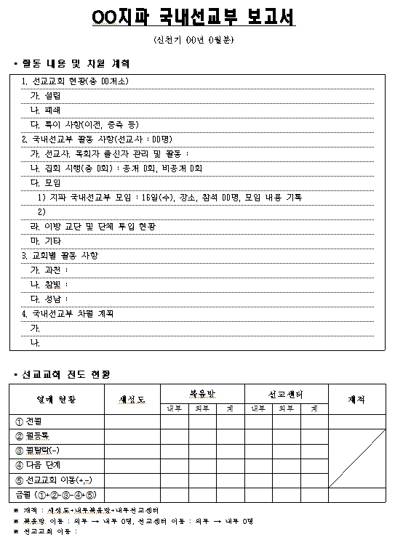

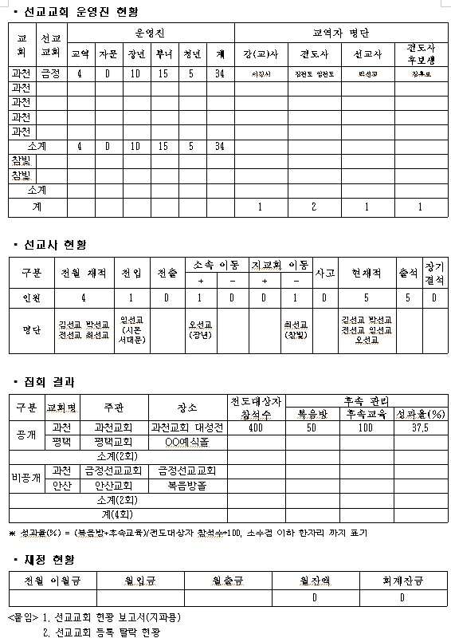

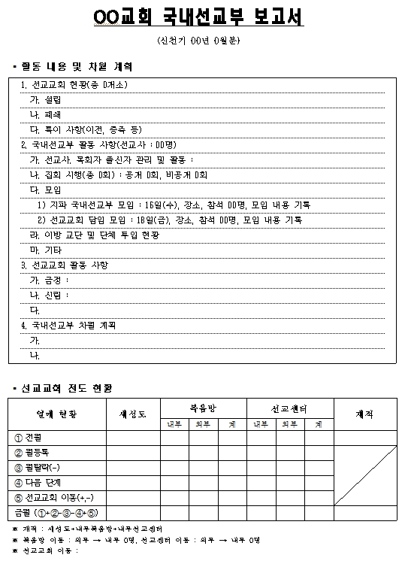

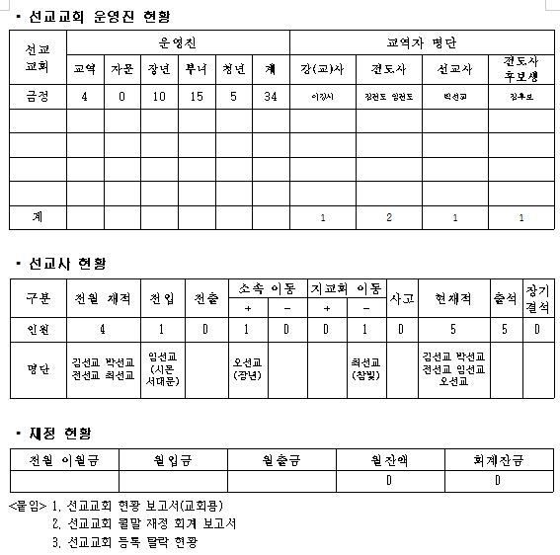

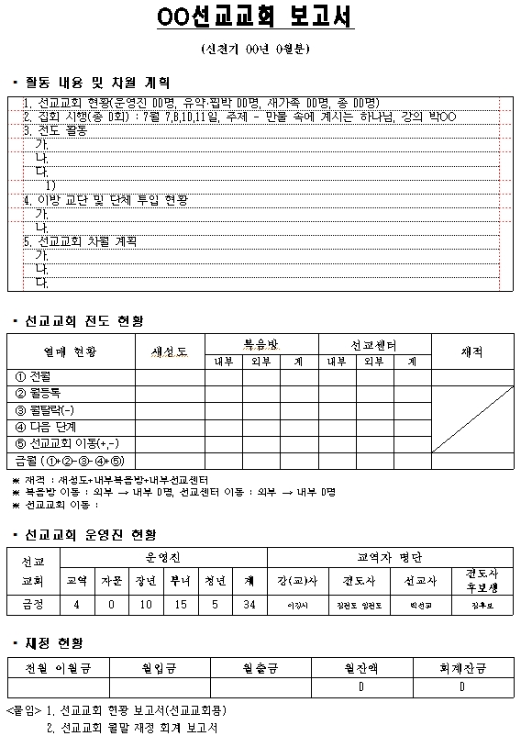

[Writing Guidelines]
A) Activities and plans for the next month
(1) For tribes and churches: write the activities of the Department of Domestic Missions and the plans for the next month (date and time, number of attendees, results, etc.)
(2) For mission churches: write the activities of the mission church and the plans for the next month (date and time, number of attendees, results, etc.)
B) Evangelism status of the mission church
(1) Fruit status
(A) New saints
(B) Gospel Room, Mission Center
- Indicate internal ↔ external transfers (at the bottom of the evangelism status table):
e.g., ※ Gospel Room transfers: external → internal 4 people; Mission Center transfers: external → internal 4 people
(C) Registered: new saints + internal Gospel Room + internal Mission Center

Fruit Status | New Saints | Gospel Room |  |  | Mission Center |  |  | Registered
Fruit Status | New Saints | Internal | External | Total | Internal | External | Total | Registered
➀ Previous month | 20 | 5 | 5 | 10 | 10 | 0 | 10 | 35
➁ Registered this month | 5 | 7 | 1 | 8 | 6 | 2 | 8
➂ Dropped out this month | 1 | 0 | 0 | 0 | 0 | 0 | 0
➃ Next stage | 7 | 6 | 2 | 8 | 3 | 0 | 3
➄ Mission church transfer (+,-) | +4, -1 | 0 | 0 | 0 | 0 | 0 | 0
This month (➀+➁-➂-➃+➄) | 21 | 6 | 4 | 10 | 13 | 2 | 15 | 40

(2) This month: previous month + registered this month – dropped out this month – next stage + mission church transfer (+,-)
(3) Mission church transfer (+,-)
(A) Example: +4 = 4 people received by transfer, -1 = 1 person sent by transfer
(B) For the tribe month-end report: transfers within the same tribe cancel each other out (+,-), so they are 0
(C) For the church month-end report: transfers within the same church cancel each other out (+,-), so they are 0
(D) Bottom of the table: ※ Mission church transfers: new saints +4 (John Gwacheon Geumjeong), new saints –1 (John Gwacheon Sadang)
C) Status of the mission church operating staff: based on the department they belong to in the main church
D) Status of missionaries: based on the presentation of the missionary's written appointment
(1) Transfers in and out: those transferring between tribes
(2) Change of affiliation: change of department affiliation for those who received a missionary's written appointment or were dismissed
(3) Branch church transfers: those transferring between branch churches within the tribe
(4) Incidents: incident handling
(5) Attendance: current number of attendees
(6) Long-term absence: those absent 8 or more consecutive times (Wednesday and Sunday services)
E) Gathering results: record the results of the gatherings reported this month
F) Financial status (department finances): finances of the Department of Domestic Missions
G) File naming: John-DomesticMissionsMonthEndReport32-2-28
Gwacheon-DomesticMissionsMonthEndReport32-2-28
GwacheonOOMissionChurch-MonthEndReport32-2-28

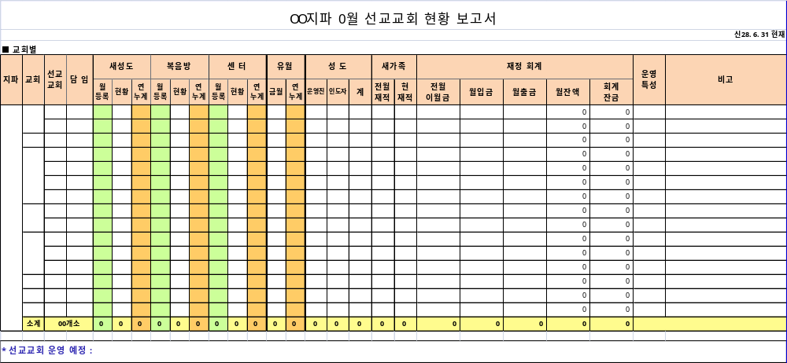
2) Mission Church Status Report (tribe, church, mission church)
- Mission churches, churches, and tribes attach the Mission Church Status Report to the month-end report.

[Writing Guidelines]
A) Average monthly service attendance rate (%): write the average attendance rate of "new family members" at Sunday and Wednesday services this month to one decimal place, e.g., 83.8%
B) Achievement of performance targets (based on the Performance Target Report): write this month's performance target, achievement, and achievement rate to one decimal place, e.g., 86.7%
C) Financial accounting (based on the Month-End Financial Accounting Report): accounting balance = amount carried over from the previous month + monthly balance
D) Type of operation: record as public, non-public, or closed
E) File naming: John-MissionChurchStatusReport31-7-31
Gwacheon-MissionChurchStatusReport31-7-31
GwacheonOOMissionChurch-StatusReport31-7-31
3) Mission Church Registration and Dropout Status (tribe, church, mission church)
- Registration status (Sheet 1)

- Dropout status (Sheet 2)

- Mission churches, churches, and tribes attach the Mission Church Status Report to the month-end report.

[Writing Guidelines]
A) Criteria for writing
(1) Registration: current number of Gospel Room and Mission Center registrants
(2) Dropout: number of Gospel Room and Mission Center dropouts this month
B) File naming: GwacheonOOMissionChurch-RegistrationDropoutStatus32-2-28
C) For detailed writing guidelines, refer to the [Writing Guidelines] at the bottom of the form

4) Mission Church Weekly Report
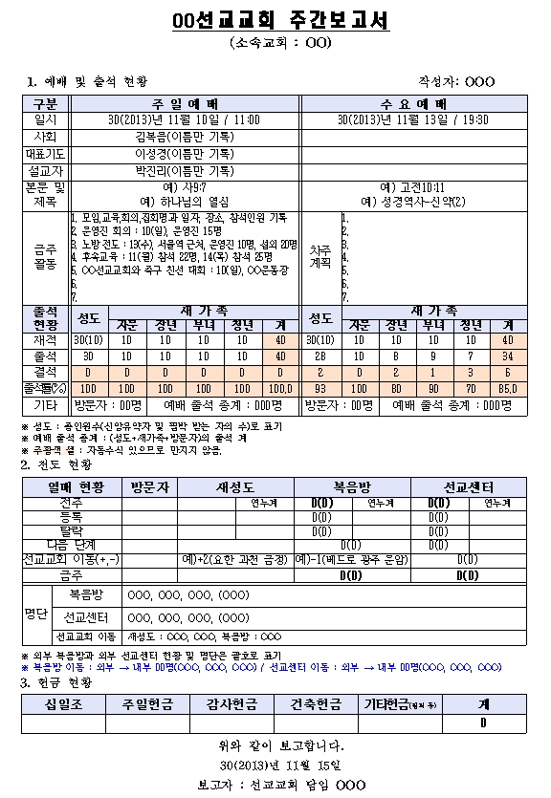

- Each mission church reports to its main church, by Thursday of the following week, a weekly report containing its services and activities from Saturday to Friday of the following week. The church reports to the tribe.

[Writing Guidelines]
A) Status of services and attendance
B) Evangelism status
(1) Annual cumulative total: cumulative total from January 1, Shincheonji Year 00
(2) Criteria for evangelism status (refer to the Definitions of Terms on p. 9)
(A) Visitors
(B) New saints
(C) Gospel Room: record the total number (external Gospel Room)
- Registration in the internal Gospel Room is possible only after registering as a new saint and then stepping up
- If an external Gospel Room registrant worships at the mission church, record only a reduction in the number of the external Gospel Room and indicate it as in the ※ example at the bottom of the evangelism status
e.g., if there are 3 people in the internal Gospel Room and 1 in the external Gospel Room, record 4(1) in the report, a total of 4 (1 external)
e.g., if the Gospel Room status is 4(1), record the Gospel Room list as: Kim OO, Lee OO, Park OO, (Lim OO)
(D) Mission Center
- If an external Mission Center registrant worships at the mission church, record only a reduction in the number of the external Mission Center
and indicate it as in the ※ example at the bottom of the evangelism status
(3) This week's status = previous week + registered – dropped out – next stage + mission church transfer (+,-)
Total new family members = new saints + internal Gospel Room + internal Mission Center in this week's status
(4) Mission Center next stage: based on the end of the Mission Center course (including those held back)
(5) Transfers to mission churches: recorded 2 weeks after the transfer upon prior administrative agreement between the mission churches (tribes); record the operator sign + (received) or - (sent) with the number, the tribe, church, and mission church before the transfer in parentheses as shown, and the list of transferees
e.g., +2 (John Gwacheon Geumjeong)
(6) Others
(A) One person can be recorded as stepping up only one stage per week
(B) When a "Gospel Room or Mission Center registrant" drops out and goes down a stage, process them as a dropout and then as a registration at that stage
(C) When "a person eligible for re-registration" comes to worship at the mission church: register them from the visitor stage
(D) When "a Mission Center registrant" comes to worship at the mission church: they do not fall under any administrative report and only attend the service
(E) When "a Gospel Room registrant with no religion" comes to worship at the mission church: register them from the visitor stage
(F) When held back during the Mission Center course: keep them at the Mission Center stage
(G) When, during the Mission Center course, they attend the Center service or the newcomer service before the end of the course: recognized as attendance at the mission church

5) Mission Church Weekly Offering Statement

- The mission church writes the offering details of the saints (operating staff + networkers) and new family members (Gentiles)
on the given form and reports them to its main church by Sunday evening every week.

[Writing Guidelines]
A) Name: write in the order of saints, then new family members; for married couples, write both names on one line
B) ID number (resident registration number): for saints, write the ID number to protect personal information; for married couples, write only one ID number; for new family members, write "new family member"
C) Offering accounts
1) Tithes: for a married couple's tithe, record both names in one cell and record the ID number of the first person, e.g., Lee Sin-rang, Park Sin-bu
2) Thanksgiving offerings: includes gathering offerings and donations
3) Building offerings: saints' building offerings for the General Assembly and the main church are not included
D) Fund requests: request the mission church's operating expenses from the total offerings, excluding the tithe reserve (when calculating the tithe reserve, exclude the mission church building offerings and the mission church support offerings)

6) Mission Church Month-End Financial Accounting Report
- The mission church writes its monthly deposits and withdrawals on the given form and reports them to its main church with each month-end report. The church reports to the tribe.

[Writing Guidelines]
A) Accounting status: accounting balance = amount carried over from the previous month + monthly balance (monthly deposits - monthly withdrawals)
B) Deposit status
(1) Period and deposits (type of offering): may be adjusted to the circumstances of the tribe and church
(2) Others: bank interest, proceeds from tape sales, bazaar proceeds, etc.
(3) Saints' building offerings for the main church are given in full to the main church
C) Withdrawal status: calculate the "total" by adding the tithe reserve and each subtotal
D) File naming: GwacheonOOMissionChurch-MonthEndFinancialAccountingReport31-7-31

7) Mission Church Establishment and Operation Plan
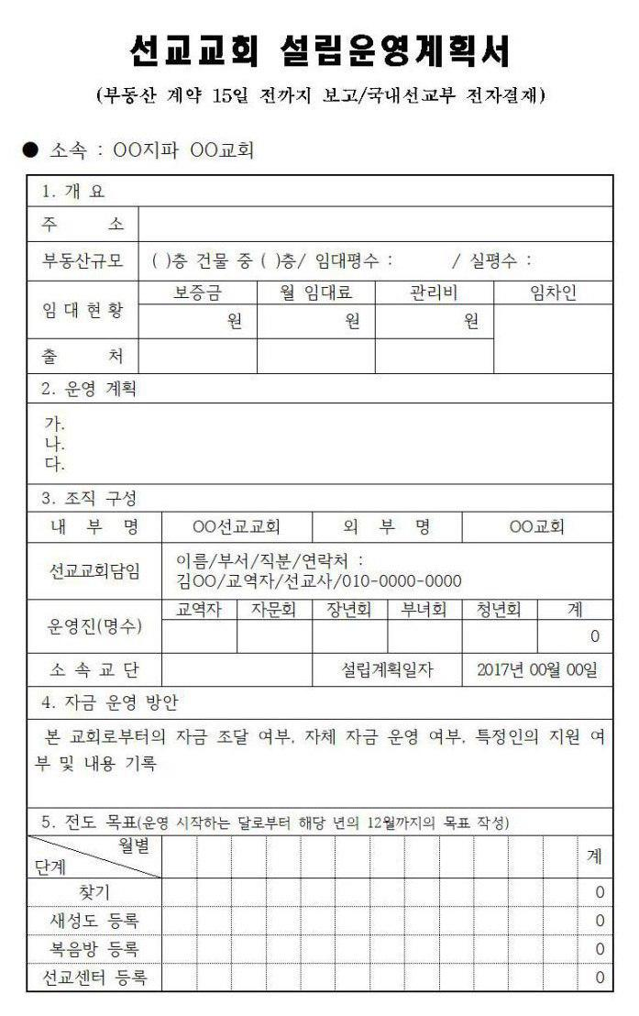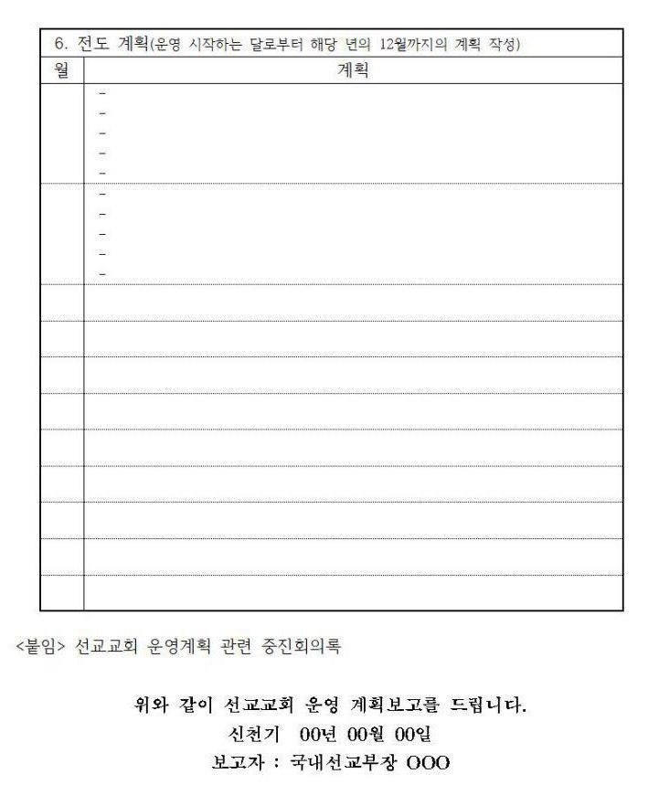

- When drafting the establishment and operation of a mission church, attach the Establishment and Operation Plan and the minutes of the key leaders' meeting; the church reports to the tribe, and the tribe reports to the General Assembly.

[Writing Guidelines]
A) Overview: record the details of the real estate contract
B) Operation plan: briefly record the overall operation plan of the mission church
C) Organizational structure: distinguish between the internal name and the external name, and record the planned date of establishment
(1) Creating the internal name: area name (city, district, neighborhood) + purpose (public mission church, mission church)
Public, e.g., Mapo Public Mission Church; "Public" is indicated only for public Shincheonji churches
Non-public, e.g., Gunpo Mission Church
(2) Planned date of establishment: the date of the mission church's first service (refer to Official Letter 3404-239 on the criteria for the real estate establishment date)
D) Fund operation plan: record the procurement of funds from the main church, self-funded operation, and whether support is given and its details
E) Evangelism goals: record the monthly registration goals for each stage
F) Status of evangelism plans: report the specific plans to achieve the goals in chart form, establishing detailed plans by month or by first half and second half of the year

8) Gathering Plan Report
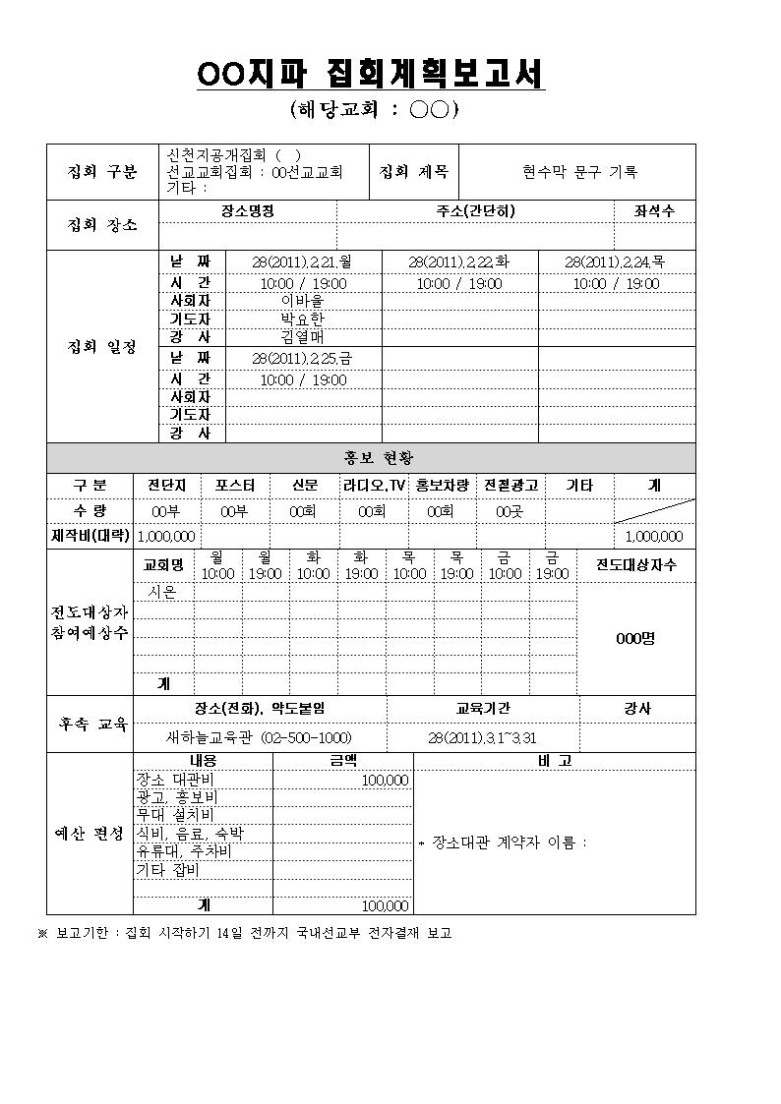
[Writing Guidelines]
A) Criteria for gatherings: all public and non-public gatherings lasting from 2 days to within 2 weeks that are held to lead people to the word or to follow-up education (regular gatherings repeated every week or month, and gatherings for opening a Mission Center class rather than for connecting to the Gospel Room, are not reported)
B) Reporting method: report to the Department of Domestic Missions through electronic approval at least 10 days before the start of the gathering
C) File naming: e.g., John-GeumjeongMissionChurchGatheringPlanReport29-5-18
Tribe name Gathering host Report date
Peter-GwangjuChurchNonpublicGatheringPlanReport29-9-12
Record whether public or non-public
D) Indicate the type of gathering according to its purpose and delete the parts that do not apply
E) Publicity status: if the desired item is not in the categories, the item may be changed to the desired publicity medium
F) For mission church gatherings, record the mission church's internal name as the church name in the expected number of evangelism target participants
G) Expected number of evangelism target participants: it is fine to record only "by day of the week" or the "total"
H) Number of evangelism targets: record the number of those who attended at least once; that is, a person who attended several times during the gathering period is counted as one person, so this may differ from the attendance of each lecture
I) Total production cost in the publicity status: the same as the advertising and publicity expenses in the budget
※ Reporting changes (date and time, venue, lecturer, etc.) and cancellations after the gathering plan has been reported: revise the changed parts in the Gathering Plan Report and resubmit it; when resubmitting, write (Revised) or (Canceled) at the end of the electronic approval title, and write the revisions or the reason for cancellation in the text.

9) Gathering Result Report
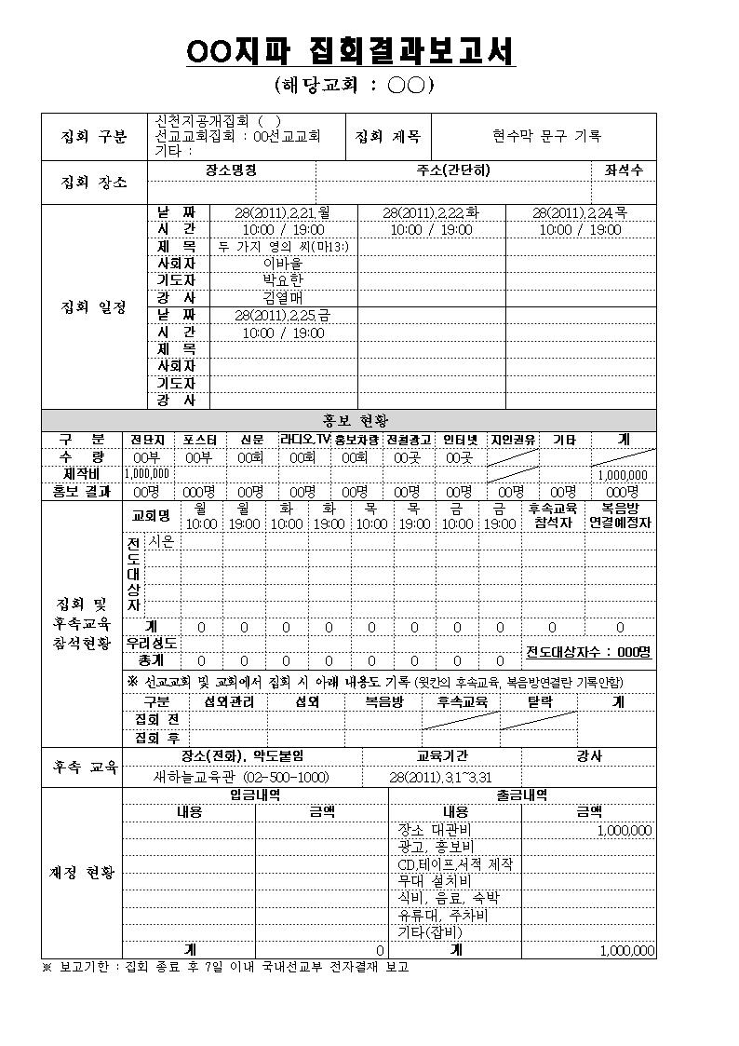
[Writing Guidelines]
A) Adjust the columns flexibly to fit the gathering schedule, and report to the Department of Domestic Missions through electronic approval within 10 days after the gathering ends
B) File naming: e.g., John-GeumjeongMissionChurchGatheringResultReport29-5-18
Tribe name Gathering host Report date
Matthias-DaejeonChurchPublicGatheringResultReport29-9-12
Record whether public or non-public (not recorded for mission church gatherings since they are non-public)
C) For Shincheonji's Bible Seminars, fill in the "Publicity Results" column of the publicity status by referring to the follow-up results form; for mission church gatherings, it does not need to be filled in
D) Status of attendance at gatherings and follow-up education
(1) Evangelism targets: record the number of attendees by church and by time slot; for mission church gatherings, it is fine to record by day only
(2) Those expected to be connected to the Gospel Room: record the number of those to be connected to the Gospel Room within 1 week
(3) Number of evangelism targets: record the number of those who attended at least once; that is, a person who attended several times during the gathering period is counted as one person, so this may differ from the sum of the attendance of each lecture; it is the same as the pre-gathering total and the post-gathering total
(4) Before and after the gathering: analyze and record the number of evangelism targets in each category before and after the gathering, and give feedback on the results of the gathering
(A) Pre-gathering total: contact management + contact + Gospel Room
(B) Post-gathering total: contact management + contact + Gospel Room + follow-up education + dropout
E) Total production cost in the publicity status: the same as the advertising and publicity expenses in the withdrawal details

10) Mission Church Log
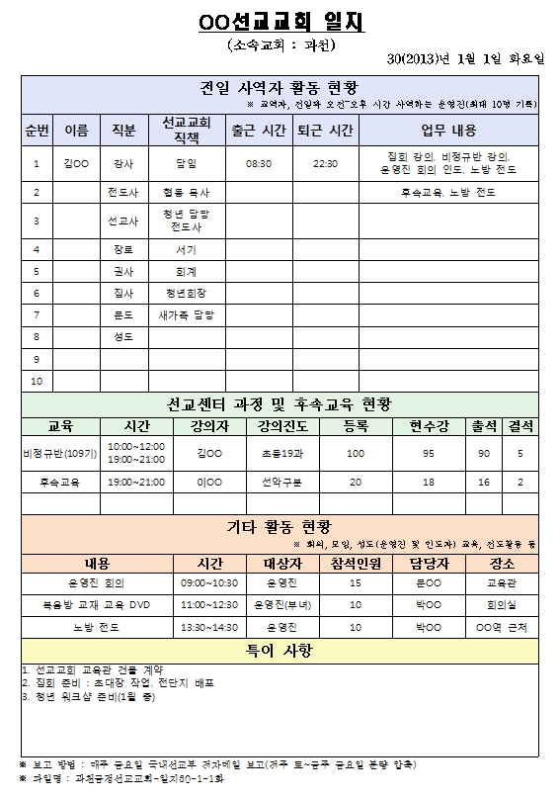

- The mission church creates one file covering Saturday of the previous week to Friday of this week (or compresses the files) and reports it by e-mail to the Department of Domestic Missions of the church, and the Department of Domestic Missions submits it through electronic approval up to the Managing Director of Church (it is not reported to the tribe headquarters).

11) Mission Church Performance Target Report (for tribes and churches, for mission churches)

[Writing Guidelines]
A) How to write: write based on the "evangelism status" data in the mission church's weekly report
B) Reporting method: the mission church attaches it to the weekly report and reports it weekly to the Department of Domestic Missions
C) Criteria
(1) Current registration of saints (operating staff, weak in faith, persecuted) and new family members: write based on the status in each weekly report
(2) Previous month's registration of new family members: write based on the registration in the previous month's month-end report
(3) Performance target, achievement: registrations of (new saints + external Gospel Room)
New saint registration target ≤ performance target ≤ (new saints + external Gospel Room) registration target
(4) Cumulative monthly registrations: cumulative total of monthly registrations (new saints + external Gospel Room); total achievement = sum of the cumulative monthly
registrations
(5) Cumulative monthly dropouts: cumulative total of monthly dropouts (new saints + Gospel Room + Mission Center)
(6) Cumulative monthly pass-overs: monthly cumulative total of those moving on to the next stage from the Mission Center

12) Mission Church Closure Plan Report
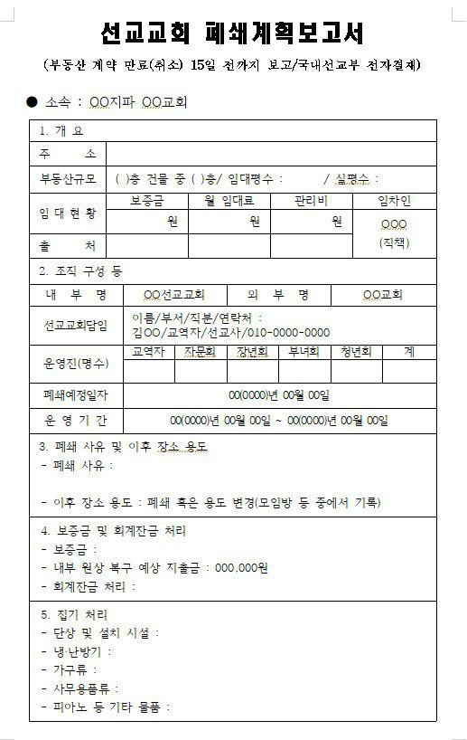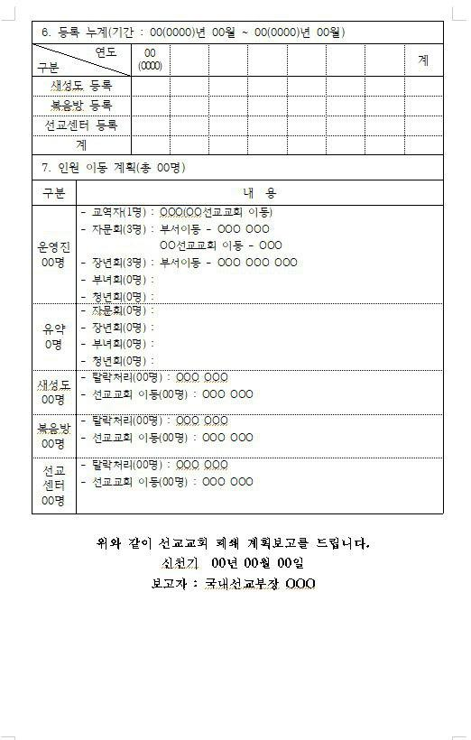
[Writing Guidelines]
A) How to write: from the time the closure is decided, carry out the work according to the items above and write the report
B) Reporting method: after first reporting verbally to the General Director at the General Assembly, report through electronic approval at least 15 days before the expiration (cancellation) of the real estate contract (additionally designate the Department of Construction as a recipient)
C) Handling of the deposit and the accounting balance: complete all deposits and withdrawals in the month of closure and settle the accounting balance to 0
D) Fill in "7. Personnel Transfer Plan"
(1) Those currently attending services among the new saints, Gospel Room, and Mission Center should be transferred to a nearby mission church as soon as possible (transfer can be processed administratively after 2 weeks of attendance)
(2) As of the date of the last service, the current numbers of new saints, Gospel Room, and Mission Center are administratively processed as dropouts

13) Mission Church History
A) Real estate history: whenever there is a change in real estate–related status such as the establishment, relocation, contract renewal, or change of investors of the mission church,
record everything without leaving any blanks
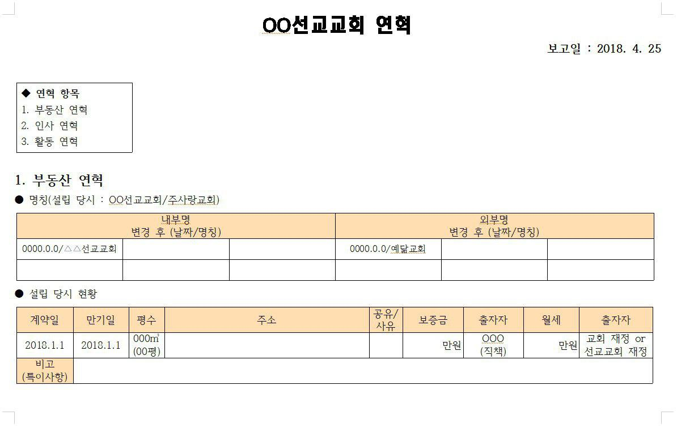
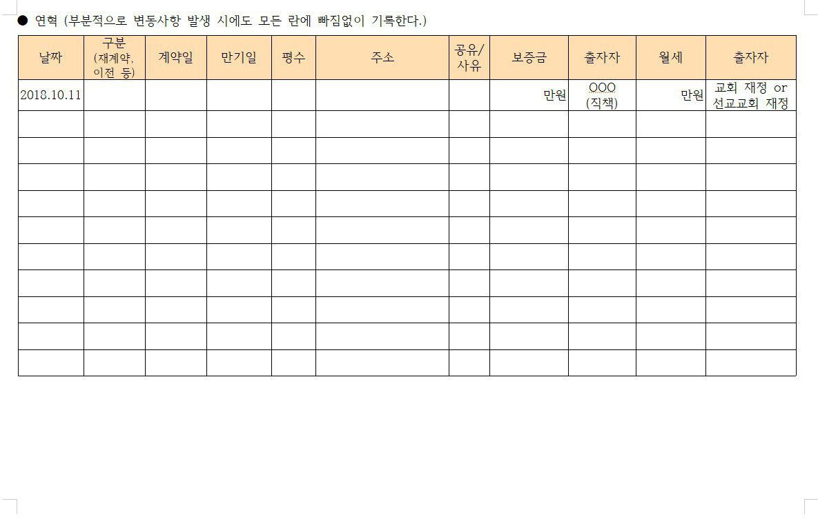
B) Personnel history: record everything without leaving any blanks whenever there is a change in workers (Head Instructor, educators with appointed titles, administrative secretary, accountant, and the president of each group)
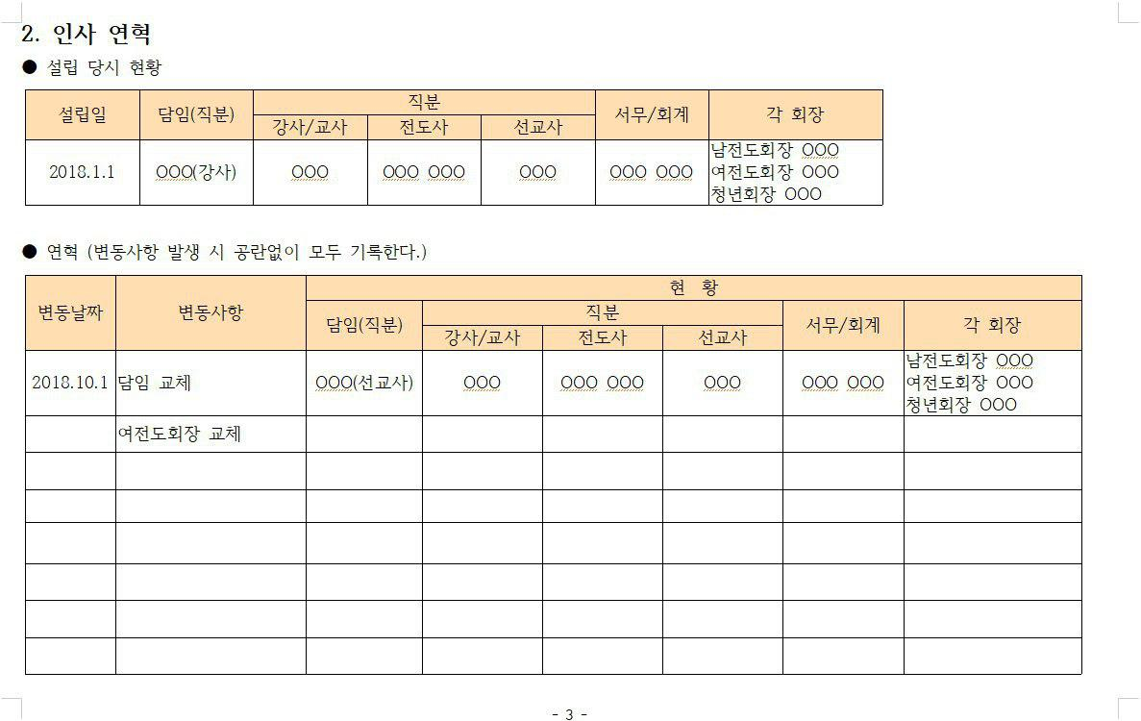

C) Activity history: after conducting gatherings, events, visits, irregular class openings, etc., record everything
without leaving any blanks
5. Reporting Other Matters
1) Reporting plans for relocating or expanding a mission church
A) Real estate–related reports: the Department of Construction reports to the higher Department of Construction through electronic approval
B) Plan-related reports: the Department of Domestic Missions reports to the higher Department of Domestic Missions through electronic approval; a prior verbal report to the General Director at the General Assembly is requested
(1) Reporting deadline: 2 weeks before the real estate approval
(2) Report form: none; report using the "General Report" in electronic approval
(3) How to submit through electronic approval
(A) Writing guidelines
e.g., in OO, choose and write the item to be reported, either relocation or expansion

(Title) Tribe headquarters: John-᨜᨜MissionChurch OO Plan Report
Branch church: Chambit-᨜᨜MissionChurch OO Plan Report
(Contents) 1. Planned place of OO
A. Address: 0th floor, ▲▲ Building, 00 △△-dong, ■■-si, Gyeonggi-do
B. Actual floor area/monthly rent/maintenance fee/deposit: 100 pyeong/3 million won/300,000 won/70 million won
2. Planned date of OO: Shincheonji Year 33.0.00
3. Reason for OO: write according to the 5W1H principle

(B) Planned date of relocation or expansion: the date of the move; planned date of closure: the date of the last service
(C) Designating the approval line: the same as the approval line for the weekly report, additionally designating the Department of Construction as a recipient C) After approval is completed, revise the "Mission Church Contact List" and report it to the General Assembly
2) Reporting changes to the internal and external names of a mission church
A) Real estate–related reports: the Department of Construction reports to the higher Department of Construction through electronic approval
B) Plan-related reports: the Department of Domestic Missions reports to the higher Department of Domestic Missions through electronic approval
(1) Reporting deadline: 1 week before using the changed name
(2) Report form: none; report using the "General Report" in electronic approval
(3) How to submit through electronic approval
(A) Writing guidelines
e.g., in OO, choose and write the item to be reported, either the internal name or the external name

(Title) Tribe headquarters: John-᨜᨜MissionChurch Change of OO Name
Branch church: Chambit-᨜᨜MissionChurch Change of OO Name
(Contents) 1. Before the change: internal name - ᨜᨜ Mission Church, external name - △△△ Church
2. After the change: internal name - ■■ Mission Church, external name - ▲▲▲ Church
3. Reason for the change: write according to the 5W1H principle

(B) Designating the approval line: the same as the approval line for the weekly report, additionally designating the Department of Construction as a recipient
C) After approval is completed, revise the "Mission Church Contact List" and report it to the General Assembly
3) Reporting the replacement of the Head Instructor of a mission church
A) Reporting method: write the "Worker Replacement Request Form" (record the recommended appointed position as: Head Instructor of OO Mission Church
) and deliver it to the Department of Administration; electronic approval by the Department of General Affairs
B) The Department of Domestic Missions of the General Assembly receives a printout of the "Worker Replacement Report" from the Department of General Affairs of the General Assembly
and checks it
C) After approval is completed, revise the "Mission Church Contact List" and report it to the General Assembly

6. Special Instructions from the Chairman Regarding the Department of Domestic Missions

- Take charge of the world of pastors.
- The Department of Domestic Missions has much to do.
- Cooperate with the Department of International Missions (Department of Diplomatic Policy).
- Do on your own what missionaries ought to do.
- Do not sit and wait for heaven; seek it out and make creative efforts.
- Find and do work that is worthwhile.
- Write letters to pastors in Korea, pastors of churches overseas, and Bible research institutes in Korea and abroad.
- Write and send letters with good content, letters of reasoning, and letters of doctrine to the pastors in Gwacheon as well.
- Write letters to persecutors and betrayers.
- Establish mission churches for capable people. You must do work that brings results.
- Make known the errors of Calvinist Presbyterianism.
- Since the worldly churches have faults, it seems that it would be effective if the Department of Domestic Missions were active.
- Host interdenominational Bible seminars: go out to gatherings after praying and gaining wisdom with the resolve, "We blow the trumpet on behalf of God, staking it on the name of the God of Shincheonji!" Gatherings must not be held blindly.
- The Department of Domestic Missions must have a big heart.
- You must change the faith of many denominations, including the CCK.
- When pastors come, give them special care and educate them in the word so that they can run Centers and churches as well. Through special care, they must be made into useful vessels.
- Shincheonji must be steadily promoted through Shincheonji's Bible Seminars.
- Promote to pastors and seminary students in the regions where Shincheonji's Bible Seminars will be held so that they attend.
- You must nurture pastors and raise workers who will lead mission churches.
- The Head Instructor (instructor) of a mission church must be good at all three: the language of the established churches, the language of the world, and the word (Shincheonji Year 29.9.19).
- The Department of Missions has the mission of domestic and overseas missions and of mission churches. Churches in Korea and overseas belong to each tribe. A mission church is a place that works through liaison activities with churches of society (Gentile churches). Its mission is to communicate and speak on behalf of Shincheonji between Shincheonji and Gentile churches. It is the mission of education and evangelism in mission churches (Shincheonji Year 30.12.11).
- The mission church is the place that connects worldly churches and Shincheonji (Shincheonji Year 30.12.16).
- Those who were formerly pastors should also interact with each denomination on a global scale. It must be developed systematically through the internet (online cafés, homepages) (Shincheonji Year 31.2.19).
- Since the pastors of our country do not come to Shincheonji but slander it, the method of evangelism must be different. You must think wisely and devise it (Shincheonji Year 31.2.19).
- The way to the pastors of the world must be opened through dialogue. Those who were formerly pastors are somewhat lacking in ability, but because they were in Babylon, they must go in there and talk (Shincheonji Year 31.2.19).
- Report the trends and missions of each denomination in Korea, the current status of each denomination (newspapers, broadcasts, movements, etc.), and the status of mission churches to the Managing Director of Tribe, and the tribe reports to the General Assembly (Shincheonji Year 32.2.24).
- You must interact with Gentile pastors so that a path to dialogue can be opened (Shincheonji Year 32.11.23).
- Those in the Department of Domestic Missions who were formerly pastors must go to new religious orders, make friends with their pastors and religious leaders, and open a path for interaction. I hope you will be active every day (Shincheonji Year 32.12.2).
- Mission churches must grow. When the winds are released, the multitude in white will be gathered, and the mission churches must hold them.
- Make the Head Instructors and evangelists of mission churches capable people. Do not have excessive numbers of mission church operators. The families of the mission church must evangelize first. Education must be at the level of the listener and must make sense. Education on the need to know the promised word of God, the Absolute Being. History, instruction, prophecy, fulfillment; God, the devil, heaven, hell, the four kinds of pastors. Betrayal, destruction, salvation; love and grace; spiritual and physical food. Food at the proper time, promise, the purpose of the covenant. The hardest place to educate is the mission church. It must be checked at all times. This is the Chairman's request. (Shincheonji Year 35.10.26)

