CS 148 Database Deign for the Web

Jacob Warshaw

Assignment 10 - Final

BuzzKiller – Take Back the Roads

Version <1.1>

Table Of Contents

Time Log 3

Software Requirements Specifications 4

Introduction 4

Purpose 4

Scope 4-5

Definitions, acronyms, and abbreviations 5

Overview 6

Overall Description 6

Data Dictionary 7

Entity Relationship Diagram 8

Schema 9-10

Story Board 11

Specific requirements 12-13

|  |  |  |  |
| --- | --- | --- | --- |
| Time Log | | | |
| Estimated time to complete assignment => | | | 40 Hours |
| Date | Time Spent  (in hours) | Description | Author |
| 11/7/14 | 2 | Create project specification documents | Jacob Warshaw |
| 11/8/14 | 4 | Version 1.1 of the specification documents, Create ERD and Schema | Jacob Warshaw |
| 11/8/14 | 4 | Creating database backend/ beginning the home page | Jacob Warshaw |
| 11/9/14 | 5 | Rough Draft of the home page, Report page, Search Page | Jacob Warshaw |
| 11/12/14 | 1 | Understanding how to submit to multiple tables from one form | Jacob Warshaw |
| 11/24/14 | 11 | Create the draft of the statistics pages, the safety pages, finish the report page and troubleshoot all of the issue with it not correctly submitting | Jacob Warshaw |
| 11/25/14 | 11 | Finishing the search and statistics pages including troubleshooting all issues associated with them, style the website, make sure all of the pages pass w3c validation | Jacob Warshaw |
| 11/26/14 | 4 | Create index page, begin working on admin pages | Jacob Warshaw |
|  |  |  |  |
|  |  |  |  |
|  |  |  |  |
|  |  |  |  |
|  |  |  |  |
|  |  |  |  |
|  |  |  |  |
|  |  |  |  |
|  |  | <=Total Time Spent |  |

Software Requirements Specifications

## Introduction

### Purpose

The purpose of this document is to describe the requirement specification for the web site “BuzzKiller”.

The intended audience for this document is the prospective developers of this site. The goal is that this document will allow someone to make the site without needing to ask any questions.

The web site is being created as a way for cyclist to report incidents of being “Buzzed” while riding. This information will be used to be able to determine what are safer roads, times, etc. to ride.

### Scope

The scope of this project is to create a 6 page website that is connected to a database backend. The website will allow users to add an incident of being “buzzed” including the fields

* Reporter Email
* Reporter First Name
* Reporter Last Name
* Reporter Zip Code
* Buzzer Car Make
* Buzzer Car Color
* Buzzer License Plate Number
* Buzzer License Plate State
* Incident Zip Code
* Incident Street Address
* Incident Date
* Incident Time
* Incident Description (short)
* Incident If There Were Injuries
* Incident Severity Of The Injuries

The website will have the ability to search whether a specific “buzzer” has been reported before. This form will have the fields of:

* License Plate Number
* License Plate State

There will be a form that allows searching about the number of incident in a certain geographic location using the fields:

* Incident Zip Code
* Incident Street
* Incident Time
* Incident If There Were Injuries
* Incident Severity of Injuries

There will be a form that allows searching about the number of incidents pertaining to a certain car type using the fields:

* Perpetrator Car Make
* Perpetrator Car Color
* Perpetrator License Plate State
* Incident If There Were Injuries
* Incident Severity of Injuries

Finally, there will be a home page and bicycle safety page that have images and text as needed but will have no relation to the database. All other specific website requirement will be outlined in the specific requirements section.

There will be a database backend created in MySQL in order to support this website. There will be 4 main tables:

* Reporter
* Incident
* Perpetrator
* City

As well as any supporting tables needed. A more specific outline of the database is provided in the ERD section.

There will be admin pages allowing an admin to log in and edit the database as needed.

### Description, acronyms, and abbreviations

HTML – Hypertext markup language

CSS – Cascading Style Sheets

W3 Validation – refers to both Html and CSS validation tool provided by the W3c.org. the html validator is located at:

<http://validator.w3.org/>

With the CSS validator located at:

<http://jigsaw.w3.org/css-validator/>

## 

## Overview

The website will be based upon a web-form where cyclist who are “Buzzed” can report the incident. There will also be the ability to search for incidents occurring based on different criteria such as time, road name, zip code, car make, car color, injuries, etc.

## Overall Description

The goal of this site is two fold. First it is to give cyclist a place to record these incidents of being buzzed and to search for which roads are safer to ride. As well as when it is safer to ride. Cyclist have the ability to report when they are buzzed so that other cyclist can use this information to determine which roads are safer to ride. As well as be bale to determine what time what roads are safe to ride. Maybe one road is very dangerous between 7 and 10 in the morning but between 11 and 3 it is the safest road in the town. This website attempts to take this qualitative feeling and put quantitative data behind it. Therefore the first goal is to promote both safer bicycle riding and to prevent road rage from angered motorists.

The second goal is to gain insight on when and where these incidents of buzzing take place. With this quantitative information it will be more possible to lobby municipalities for changes such as bike lanes or larger shoulders. We will also be able to see if these additions to the roadways do decrease the number of buzzings or if there are other solutions that must be found in order to deal with the issues of having safe roads for cyclist and motorists alike.

## 

## Data Dictionary

|  |  |  |  |  |
| --- | --- | --- | --- | --- |
| **Field** | **Data Type** | | | **Other** |
| **tblReporter** | | | | |
| pmkRepEmail | varchar(100) | | | Primary Key |
| fldRepFName | varchar(30) | | |  |
| fldRepLName | varchar(30) | | |  |
| fnkRepZip | varchar(5) | | |  |
| **tblPerpetrator** | | | | |
| fldPerpCarMake | varchar(30) | | | Primary Key |
| fldPerpCarColor | varchar(20) | | |  |
| pmkPerpPlate | varchar(15) | | |  |
| pmkPerpPlateState | varchar(15) | | |  |
| **tblIncident** | | | | |
| pmkIncId | int(11) | | | Primary Key |
| fnkRepEmail | varchar(100) | | |  |
| fnkZip | varchar(5) | | |  |
| fldIncStreet | varchar(40) | | |  |
| fldIncDate | date | | |  |
| fldIncidentTime | time | | |  |
| fldIncDescription | varchar(150) | | |  |
| fldInjuries | varchar(4) | | |  |
| fldInjurySeverity | varchar(30) | | |  |
| fnkPerpPlate | varchar(15) | | |  |
| fnkPerpPlateState | varchar(15) | | |  |
| **tblCity** | | | | |
| pmkZip | varchar(5) | | |  |
| fldCityName | varchar(30) | | |  |
| fldState | varchar(30) | | |  |
| fldPopulation | varchar(100) | | |  |
| fldPoliceReportURL | varchar(150) | | |  |
| **tblColor** | | | | |
| pmkColor | varchar(10) | | | Primary Key |
| **tblMake** | | | | |
| pmkMake | varchar(55) | | | Primary Key |
| **tblSeverity** | | | | |
| pmkSeverityId | int(11) | | | Primary Key |
| fldSeverity | int(3) | | |  |
| **tblState** | | | | |
| pmkStateName | | varchar(255) | PRIMARY KEY | |
| fldabbreviation | | varchar(255) |  | |
| fldcountry | | varchar(255) |  | |
| fldtype | | varchar(255) |  | |
| fldstatus | | varchar(255) |  | |
| **tblTime** | | | | |
| pmkTime | | time | Primary Key | |

## Entity Relationship Design

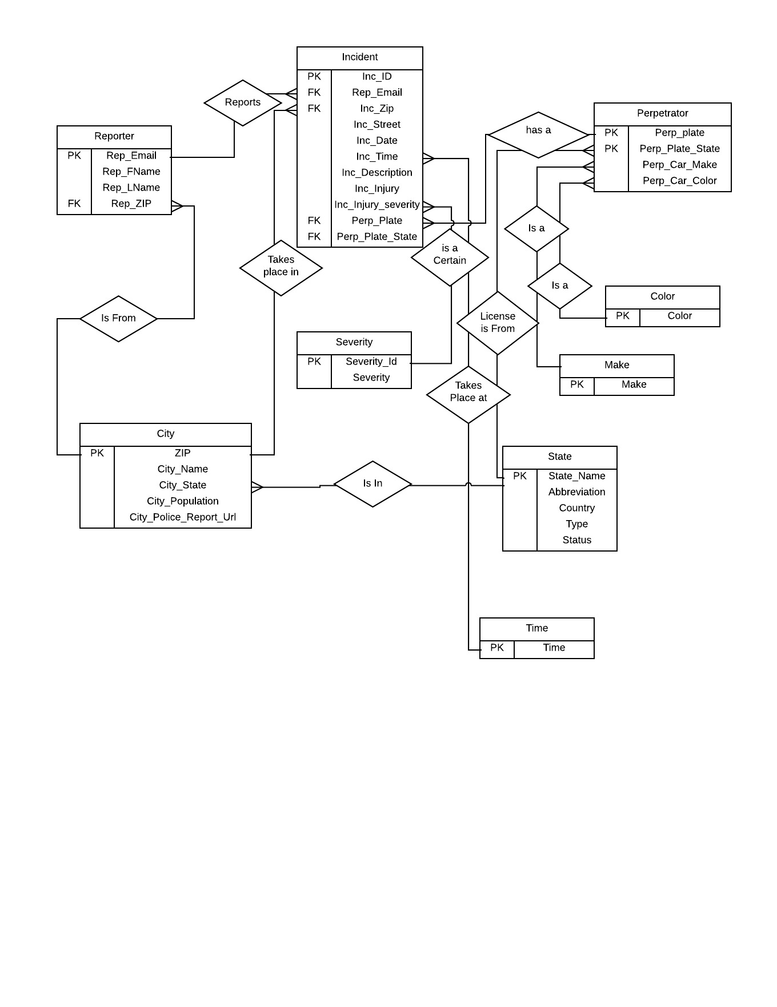

## Schema

**Table tblReporter:**

CREATE TABLE IF NOT EXIST tblReporter (

pmkRepEmail varchar(100) NOT NULL,

fldRepFName varchar(30) NOT NULL,

fldRepLName varchar(30) NOT NULL,

fnkRepZip varchar(5) NOT NULL,

PRIMARY KEY (pmkRepEmail))

**Table tblPerpetrator:**

CREATE TABLE IF NOT EXIST tblPerpetrator (

fldPerpCarMake varchar(30) DEFAULT NULL,

fldPerpCarColor varchar(20) DEFAULT NULL,

pmkPerpPlate varchar(15) NOT NULL DEFAULT '',

pmkPerpPlateState varchar(15) NOT NULL DEFAULT '',

PRIMARY KEY (pmkPerpPlate, pmkPerpPlateState))

**Table tblIncident:**

CREATE TABLE IF NOT EXIST tblIncident (

pmkIncId int(11) NOT NULL AUTO_INCREMENT,

fnkRepEmail varchar(100) NOT NULL,

fnkZip varchar(5) NOT NULL,

fldIncStreet varchar(40) NOT NULL,

fldIncDate date NOT NULL,

fldIncidentTime time NOT NULL,

fldIncDescription varchar(150) NOT NULL,

fldInjuries varchar(4) NOT NULL,

fldInjurySeverity varchar(30) DEFAULT NULL,

fnkPerpPlate varchar(15) NOT NULL,

fnkPerpPlateState varchar(15) NOT NULL,

PRIMARY KEY (pmkIncId))

**Table tblCity:**

CREATE TABLE IF NOT EXIST tblCity (

pmkZip varchar(5) NOT NULL,

fldCityName varchar(30) NOT NULL,

fldState varchar(30) NOT NULL,

fldPopulation varchar(100) DEFAULT NULL,

fldPoliceReportURL varchar(150) DEFAULT NULL,

PRIMARY KEY (pmkZip))

**Table tblColor:**

CREATE TABLE IF NOT EXIST tblColor (

pmkColor varchar(10) NOT NULL,

PRIMARY KEY (pmkColor))

**Table tblMake:**

CREATE TABLE IF NOT EXIST tblMake (

pmkMake varchar(55) NOT NULL DEFAULT '',

PRIMARY KEY (pmkMake))

**Table tblSeverity:**

CREATE TABLE tblSeverity (

pmkSeverityId int(11) NOT NULL AUTO_INCREMENT,

fldSeverity int(3) NOT NULL,

PRIMARY KEY (pmkSeverityId))

**Table tblState:**

CREATE TABLE tblState (

pmkStateName varchar(255) NOT NULL DEFAULT '',

fldabbreviation varchar(255) DEFAULT NULL,

fldcountry varchar(255) DEFAULT NULL,

fldtype varchar(255) DEFAULT NULL,

fldstatus varchar(255) DEFAULT NULL,

PRIMARY KEY (pmkStateName))

**Table tblTime:**

CREATE TABLE IF NOT EXIST tblTime (

pmkTime time NOT NULL)

### Story Board

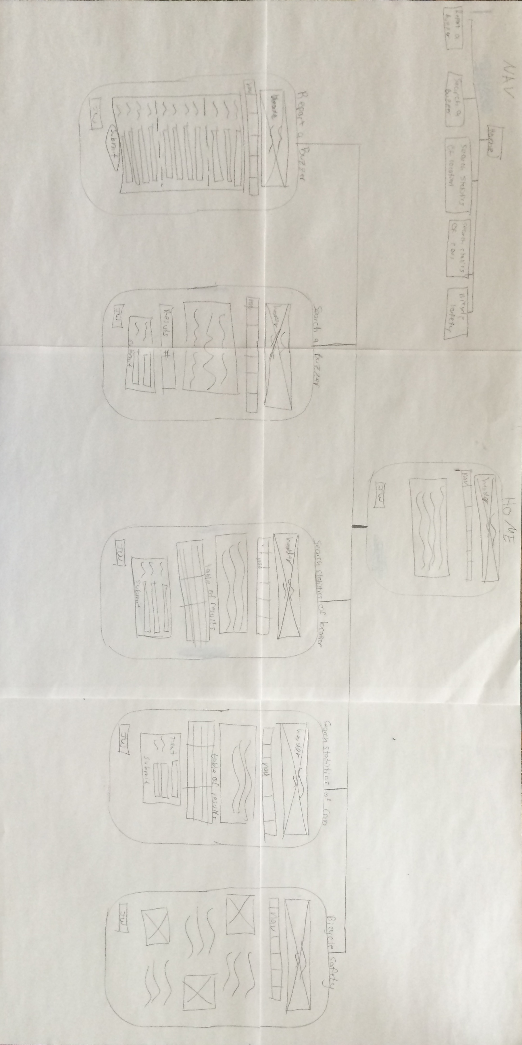

## Specific Requirements

1. *Html Validation* – All pages will pass W3C Html validation for html 5.
2. *CSS Validation* – All pages will pass W3C 3.0 CSS validation.
3. *Meta Information* – All pages will contain a proper title tag, Meta tags (author, character set and description.
4. *Head Section* – put the doctype and head section information in a file named top.php so you can include it all the pages.
5. *Header* – All pages will contain a header with the logo about your site. File name should be header.php
6. *Navigation* – All pages will contain navigation to all other pages on the site using an ordered list. File name should be nav.php
7. *Browser compatibility* - This site will be checked on Firefox, Safari, Chrome and Internet Explorer.
8. *Footer* – All pages will contain a footer containing my name and the date the page was last updated.
9. *Title for main page – BuzzKiller – Take Back the Roads*
10. *Meta Description – BuzzKiller – Creating safer roads for cyclists and cars*
11. *Logo – https://jwarshaw.w3.uvm.edu/cs148/assignment10/header_img_3.jpg*
12. *CSS* – all pages will have a linked style sheet.
13. *Main accent color –* Blue - #00498E
14. *Background color –* white - #fff
15. *Navigation –* will have hover – change to #fff background when on link
16. *Navigation –* will have hover – change text color to #00498E when on hover
17. *Font-*family- arial
18. *Font-size –* 17px
19. *Text-indent –* 38 px
20. *Header image –* will be on all pages with the same H1 and H2 throughout
21. *Report a buzzer page –* will use fields described in scope
22. *Report a buzzer page –* will have 3 sections of the form split into about buzzer, about reporter, and about incident
23. *Text boxes vs drop down –* As many drop down selects will be used instead of text fields throughout
24. *Search for a buzzer page –* Will only display a count of times record shows, it will not display the records
25. *Search statistic of location -* Will display a table of results as well as a count
26. *Table of results –* Will have a hover attribute to show where a person is on the form
27. *Table of results –* Will be alternating between white and light blue lines
28. *Table of results –* When a line is hovered the color will change to a darker blue
29. *Bicycle Safety page –* pictures will alternate which side they are pushed to
30. *Bicycle safety page –* text will have gaps between section the size of 2 blank spaces
31. *Title on safety page –* Will be blue and large like the header text
32. *Header h1 text–* Font-family Nevis
33. *Bicycle safety page* – The images will be no larger then 400px