**Project 7: Synchronous Communication**

*Author: Malvin Emin*

*Group Members: Sangje Sherpa, Erl Abayao, Peter Luong*

ELEC – 3371-01

Due Date – 12/05/2020

**Table of Contents**

* Title Page (pg. 1)
* Table of Contents (pg. 2)
* Abstract (pg. 3)
* Introduction (pg. 4)
* Objective 1 Attempt (pg. 5)
* Objective 2 Attempt (pg. 6)
* Objective 3 Attempt (pg. 7)
* Objective 4 Attempt (pg. 8)
* Bonus Objective 1 Attempt (pg. 9)
* Bonus Objective 2 Attempt (pg. 10)
* Objective 1 Results (pg. 11)
* Objective 2 Results (pg. 12)
* Objective 3 Results (pg. 13)
* Objective 4 Results (pg. 14)
* Conclusion (pg. 15)
* Appendix (pg. 16)

**Abstract:**

For this project, our goal was to model and prototype a real-world home security system using multiple micro-controllers linked through SPI (Serial Peripheral Interface), where the master device receives data from the serial terminal and depending on the input will it toggle the port LEDs on the other slave devices connected that would also receive inputs that get sent to the master device and report its status to the serial terminal. A flow diagram was also constructed with the content of 4 mandatory objectives for this project. Objective 1 was to draw a schematic layout of how the connections between the master and slave devices would look through SPI. Objective 2 was to use the USART terminal to send a signal to the master of whether to arm a zone, cancel arming, or when a breach occurs. Objective 3 was to designate each micro-controller to a zone, with master being Z1, and using PA4 to indicate zone armed or not, and objective 4 was for PB6 to trigger a breach with a countdown on PORTE where an SPI message goes to master indicating a breach where the master then sends to terminal the breach occurs and at which zone.

Overall, our group was able to effectively get each objective done, without doing any of the bonus objectives, with lite struggling in the beginning getting started with connecting the boards together.

**Introduction:**

As outlined in the abstract, 4 main objectives were to be completed for the real-world home security system. The diagram below illustrates how the floorplan is divided into three zones, Z1, Z2, and Z3. The first objective was making sure we picked our master device for the whole project and label which pin / ports would be used in the schematic on how to connect each board, like using SPI pins would include the use of MOSI, MISO, CLK, & CS (SS) where LEDs would be labeled with a bus to each port.

The second objective introduced the use of USART terminal to send a command ‘S’ or ‘s’ to the master telling it to go into Arming mode, where with that information, the master would write back and ask which of the 3 zones to set. This process continues until all zones are set or unless a new command introduced is put in affect, ‘C’ or ‘c’ that gets sent to cancel arming. Until all three zones are set, the command ‘A’ or ‘a’ is sent where the LEDs on PORTE is used as a count down from 10 for when it reaches 0 a message would be sent to the USART terminal saying all three zones are armed with the use of PA0 to cancel the countdown (interrupt) and cancel arming, all during the countdown.

The third objective is where we connect each board together, with one labeled as the master that takes Z1, Z2, & Z3. Where PA4 is being used to indicate whether the zone is armed or not and the master device NEEDING to send an SPI command to each of the zones to iterate whether to set or clear PA4.

The fourth objective lists that when a zone is armed, PB6 is then used to trigger that a breach occurs. Then a countdown begins on PORTE on whichever zone was breached from 15. Once the countdown reaches 0, an SPI message then travels to the master device describing that a breach happened. Where the master will then have to send to the terminal that the breach occurred at Zone: #.

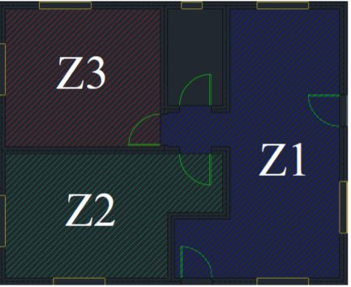

**Objective 1 Attempt:**

The task of this objective is to create a schematic overviewing the operation of connectivity between each of the groups’ boards, with one being the master and the other 3 being the ‘slaves.’

The diagram below is drawn in parallel SPI where the master device connects the three slave devices through SCK (master clock), MOSI (Master Out Slave In), MISO (Master In Slave Out), and SS (Slave Select) where SS is very important since it’s used to select which slave to be communicated with when a breach occurs in our security system so that the master can send out the proper message to the terminal of when Zone: # is breached.



**Objective 2 Attempt:**

The point of this objective was to have each case implemented with the command ‘S’ or ‘s’ sent to master through the terminal to tell it to go into arming mode and which zone it would arm between the 3. And then the command ‘C’ or ‘c’ being to cancel arming. And lastly, the command ‘A’ or ‘a’ being used when either all zones are set or just one zone being set, that the LEDs on PORTE countdown from 10 to when 0 is reached, USART terminal receives the message and displays all zones being set and armed except for PA0 being implemented that could cancel the countdown and arming during the countdown process.

Below is our groups’ flowchart describing the logic I mentioned above for each case of either ‘S’, ‘C’, or ‘A’ and the prompts followed from each case.

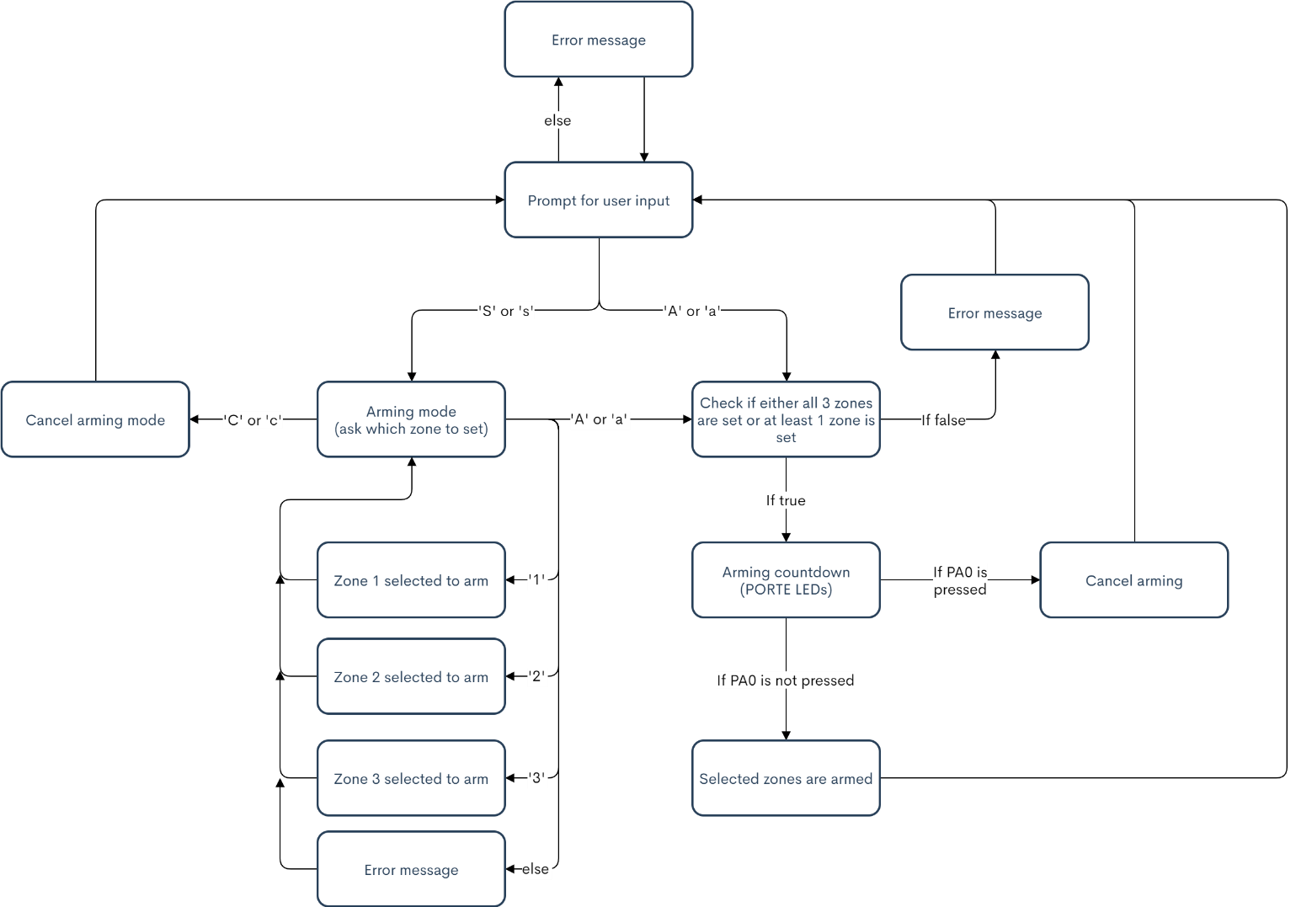

**Objective 3 Attempt:**

Objective three is about connecting each board together where we have the one master device as Z1, Z2 & Z3 where PA4 is used to indicate whether the zone is armed or not and with that information, the master sends out an SPI command to each zone instructing it to set or clear PA4.

Our groups’ flowchart below details which input inputted would correspond to the PA’s to tell a zone that it has been set.

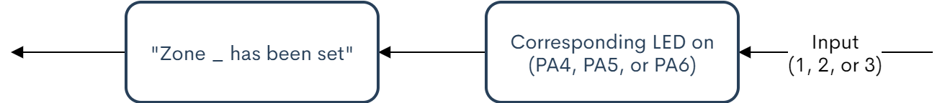

**Objective 4 Attempt:**

The final objective is about triggering a breach when a zone is armed through PB6 that would start a countdown on PORTE from 15 that when 0 is reached, the SPI message goes to master iterating the breach occurred where the master then sends to terminal the breach happened and the zone it is associated to the breach.

Flowchart below shows how the logic would go about:

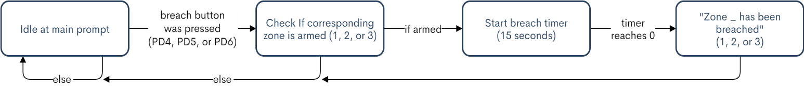

**Bonus Objective 1 Attempt:**

The group was unable to do this objective due to time inconvenience on all ends and so, no results are listed for this objective.

**Bonus Objective 2:**

The group was unable to do this objective due to time inconvenience on all ends and so, no results are listed for this objective.

**Objective 1 Results:**

For this objective, our group seemed to have done a good job analyzing the schematics given to us and the ones we tried drawing to properly understand the logic behind connecting each board together using SPI. Looking at the diagram for this objective, we had the right logic and thinking for the objective. By connecting the LEDs at the SS of individual slaves, so that when one of them is enabled through the master, it would glow showing the selected slave(s). And by using SPI we would have higher data, faster rate with the support of multiple slave devices and a lower power requirement as compared to I2C.

**Objective 2 Results:**

With objective 2, our group wrote out code (Appendix) for each command that is used in the USART terminal displaying whether a zone is set, cancelled, or when all zones are set and armed except for PA0 to cancel countdown and arming. Overall, our code worked, and every case was coded in for this objective, with the flowchart above explaining the logic behind everything we required to code.

**Objective 3 Results:**

For this objective, we were to connect each board together where one is designated as master, as Z1, Z2 & Z3 and by using PA4 to indicate if the zone was armed or not. Our group could not figure this objective out too well as connecting the boards physically left us quite confused. After trying numerous times and asking others for help on connectivity, we decided to not pursue this objective as much as the others. I believe our main problem was only figuring out how to get each board connected to one another and designating the one board we all decided on as the ‘master’ board. Our logic behind the flowchart made sense but getting the connections between all boards was not in our knowledge frame and so we could not get it done.

**Objective 4 Results:**

Objective 4 was to use PB6 to trigger a breach with a countdown on PORTE of the breached device from 15-0, where when 0 was reached, the master sent to terminal that the breach happened and lists which zone was at fault. Our group managed to complete this objective and so with the help of our flowchart, listed above, and coding we were able to make the prototype security system functional for breaches that occurred across either Z1, Z2 or Z3. We incorporated PB6 well into the code with reference to PORTE for the countdown and sending over the signal from master to terminal of a breach occurrence.

**Conclusion:**

Overall, the project was to create a prototype home security system for the real world and by doing this project, we all learned how to go about connecting multiple micro-controllers using SPI and its labels and pins that correspond to the master. We learned how the master device would receive data from the serial terminal to send out data to each slave when to toggle a ports LEDs or when to arm, cancel, or set a zone depending on the command the USART terminal sends over. Where each slave device that receives the input from the master regarding zone breaches would then get sent to the serial terminal of the status of each zone. Our approach to this project consisted of using one total master device board for all zones and it worked out well on our end, with the code and program running just as intended.

For future consideration, we would have included better implementation of each bonus objective and how to have gone about connecting multiple boards together as intended. Also, would have been good to have gone about using an alarm that is incorporated in the micro-controller that when a breach occurred, the ‘alarm’ (sound cue) would go off indicating a breach better with the zone that it happened in, and the implementation of a keypad code that would toggle the alarm back off after a breach along with the alarm. Regardless, using what we learned about SPI communication, we were able to create a real-world alarm-system where SPI communication is used.

**Appendix**

* Source code

