Tracking Data

Jake O’Connor

MS544

Assignment 2 – Tracking Your Own Data

Introduction

This document will analyze the content of my schedule for the ten contiguous days from July 2nd through July 11th in the year 2021 and aims to glean some form of meaningful information about it through descriptive analytics. These ten days are likely the least useful of the entire year to analyze, as my schedule throughout this window was absolute chaos and involved driving more than four thousand miles and visiting over a dozen relatives across five households. Regardless, I will analyze the data from this schedule in an attempt to gain some insight or to back up existing knowledge.

# Data Gathered

This dataset contains eleven different values tracked throughout the ten days of the schedule. Ten of these values are time durations of various activities, each tracked per day and approximated to the nearest half-hour. In addition to the daily activities, both the number of assignments due each day and my personal stress level have been tracked in order to contribute to later analysis. All tracked values were recorded at the end or beginning of each day, in order to maximize accuracy and minimize estimation.

## Sleeping

This measure tracks hours of sleep, whether restful or not. This measure does not include time spent falling asleep or waking up, nor does it include time spent in bed while doing another activity such as reading or working on school assignments.

## Driving

This measure tracks hours spent on general travel. This measure includes driving a vehicle, idling in traffic, queuing at a fuel station, and refilling the gas tank. Additionally, this measure also includes travel-related time such as time spent outside of the car at rest stops, purchasing snacks/drinks, and allowing the dog to relieve himself.

## Family (Outings & Visiting)

These measures track hours spent together with one or more family members who are not part of my household. The outings measure tracks time spent with family participating in activities which take place outside of a personal residence, or that are otherwise public activities, such as dining out or visiting a museum. The visiting measure tracks time spent with family within a personal residence, such as participating in a cookout or simply conversing.

## School (Reading & Assignments)

These measures track hours spent working on one or more school objectives. The reading measure tracks time spent reading course material, either via a textbook or Canvas link. The assignments measure tracks time spent actively researching and writing discussion posts and papers.

## Errands

This measure tracks hours spent completing discrete objectives not otherwise contained within another measure, such as shopping for travel supplies or in the case of one day getting a new key fob made.

## Work

This measure tracks hours spent either working or participating in work-related activities. For the scope of this dataset the only work activity which broke the half-hour threshold was a single Dungeons and Dragons game played remotely with coworkers.

## Assignments Due

This measure tracks the number of individual assignments due on each day via Canvas, regardless of type. This includes both long-form research papers, discussion posts and replies, as well as small standup-style posts.

## Stress Level

This measure tracks my personal stress level throughout each day. The stress level is rated on a 1-5 scale with a 1 equating to ambient/nominal stress levels and 5 equating to near panic attack levels. This value was tracked in order to provide some meaningful value for analysis, as simply analyzing such a chaotic schedule did not seem like it would be fruitful.

# Dataset

## Daily Activities

Below is a chart detailing the ten daily activity measurements within the dataset. A stacked bar chart best represents these data points as they are all hours spent within a single 24-hour period. The number of individual measurements does make the stacked bar chart especially easy to read in detail, but the rough relative size of the bars can be used as a loose gauge.

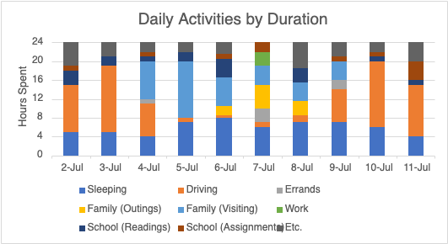

## Stress Level

Below is a chart detailing the personal stress level measurement within the dataset. A line chart was chosen to represent this data visually, as even though discrete values were recorded each day the underlying meaning of the data exists as more of a continuous value.

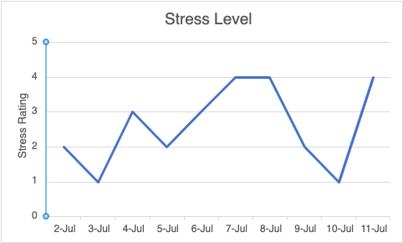

## Assignments Due

Below is a chart detailing the assignments due measurement within the dataset. A bar chart was chosen to represent this data visually, as this measure is of discrete, non-continuous values.

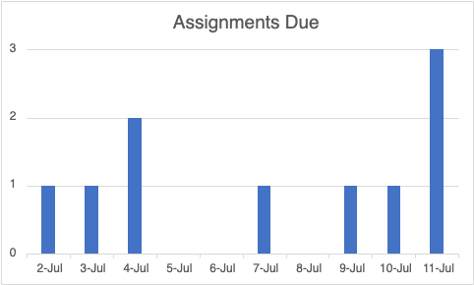

# Descriptive Analysis

## Sleep Time

Below is a chart of the sleep time measurement from the dataset along with the mean value and standard deviation within the data range. As shown, the average sleep time throughout the ten-day period is just under six hours (5.9), with a deviation of just above one hour (1.37). This is neither an ideal average nor ideal deviation amount from a purely biological perspective, but the data values do inversely correlate with the number of hours spent driving (shown in the next section).

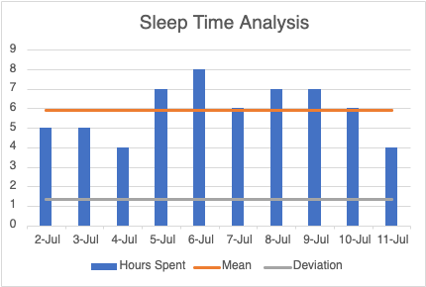

## Drive Time

Below is a chart of the driving time measurement from the dataset along with the mean value and standard deviation within the data range. As shown, the average driving time throughout the ten-day period is just under seven hours (6.7), with a standard deviation of over five hours (5.44). This is an exceptional amount of time spent driving when compared to my normal day-to-day (especially during COVID-19 lockdown), and the extreme deviation shows how heavy the driving days were compared to the in-town days.

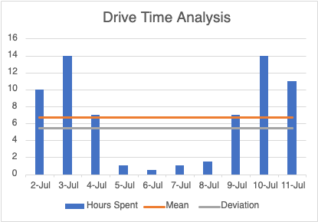

## Family Time

Below is a chart of both the two categories of family time measurements from the dataset, along with the mean values and standard deviations for each. As shown, the average time spent visiting with family during this ten-day period was four hours (4) with a deviation of more than 4 hours (4.11), and the average time spent on outings with family was one hour (1) with a deviation of nearly 2 hours (1.76). The comparison of these averages and deviations point toward the disparity between the days spent traveling and the days spent visiting with family.

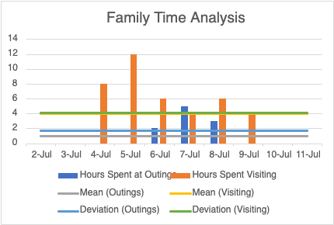

## School Time

Below is a chart of both the two categories of school time measurements from the dataset, along with the mean values and standard deviations for each. As shown, the average time spent reading for school during this ten-day period was nearly two hours (1.7) with a deviation of just over one hour (1.34), and the average time spent working on school assignments was just over one hour (1.1) with a deviation of just over one hour (1.2). Though not many hours overall, the proximity between the average and deviation values for both measurements points to a concerted effort to keep up on schoolwork even through the chaotic travel schedule.

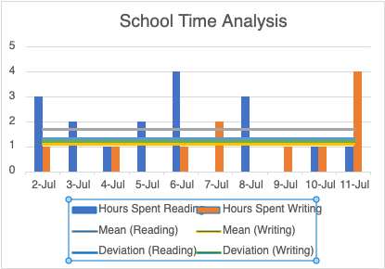

## Stress Level

Below is a chart of my personal stress level overlayed upon a stacked bar chart of both the hours spent on family outings and number of school assignment due dates. Time spent on outings and number of due dates both positively correlate to an increase in stress levels throughout the ten-day period. None of the other measured values have any significant correlation with stress level. This correlation is not unexpected, as severe social anxiety plays a large role in stress levels pertaining to outings and a greatly reduced amount of free time during this period made the completion of assignments on time a challenge.

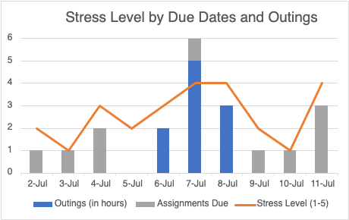

# Conclusion

I’m not sure I can draw any meaningful conclusions from this dataset due to its chaotic nature. This ten-day period was probably the most tumultuous of the entire year, and the measurements recorded within this dataset don’t track for any other time. Were this data gathered during any normal week, it would be meaningful to extract information about time spent working on schoolwork versus work-work versus leisure in an effort to find patterns in days and times which are more productive than others. But given the nature of the period, most of this dataset was controlled by the requirement of traveling a certain distance in a fixed time and the whims of various relatives, leaving only the scraps of time for elective tasks such as school assignments and readings. The one meaningful conclusion that can be drawn from the dataset as it stands is that anxiety- and deadline-induced stress is a real thing, and that the stress values do not immediately bottom-out due to the lack of a stressor, but instead slowly fall over time in the absence of stressors.