Build vs Buy

Accounting Software

Jake O’Connor

MS544

Assignment 4 – Build vs Buy

# Introduction

This report will explore the possibility of upgrading the company’s current accounting software to one which has capabilities more in line with the goals of the company. Chief among those capabilities is the functionality to assign tags to expense reports, or parts of expense reports, which can be used to better track customer acquisition costs. The company would like to compare the options of either licensing a third-party accounting software as well as creating a customized in-house accounting software.

# Assumptions

The incredible broadness of this request requires a significant number of assumptions to be made, which will be outlined here in as much detail as possible to clarify the context of the results below.

## Company Size

For the sake of this report, we will be assuming that the company has 200 employees which need access to the accounting software. The majority of available accounting software in the market have monthly fees on a per-user basis, which makes this piece of data integral to the build vs buy analysis. We will also be assuming that one of the company’s goals is to grow over time, not remain at a fixed 200 employees forever.

## Normal Business Needs

For the sake of this report, we will be assuming that in addition to the specifically requested feature of expense report tagging that the company wishes to have a piece of accounting software with all the basic accounting functionality. This includes tracking sales, revenue, customer information, employee/salesperson information, and other integral features. All commercially available accounting software contain these features, and usually many more, but a series of minimum viable specifications is required in order to properly estimate the costs of a custom piece of software.

## Timeline

For the sake of this report, we will be assuming that the company intends to use the new accounting software for the foreseeable future. We will chart the projected cost of each option of accounting software over the course of approximately ten years in order to truly see the costs to the company’s bottom line. Additionally, any introductory offers or short-term discounts will be excluded from direct cost comparisons, as those will only change the cost in the very early stages.

# Strategy

The custom-built software and third-party software-as-a-service applications differ greatly in their implementation, but they will be compared evenly along the same lines both with a qualitative and quantitative approach. Since they do differ so greatly in implementation though, values that can be compared with one another must be calculated or estimated.

## Custom-Built Software

For the custom-built accounting software, we’ll be using a variation of the COCOMO software effort estimation as outlined by William Roetzheim of Cost Xpert Group, Inc. In order to attempt to calculate a reasonable estimation for the number of engineer-months that a project will take based on its complexity. This process breaks down a piece of software into five key fields, called Function Points, that make up the software’s functionality. As there was no specific outline for which features the company needs aside from more detailed expense reporting, we will be assuming that the software will only need the basics of accounting software such as sales, revenue, and expense tracking. With these assumptions in place, and the COCOMO method, we come up with the following chart of estimated function points for the piece of software.

|  |  |  |  |
| --- | --- | --- | --- |
| **Function Point Estimation** | **Count** | **FP Factor** | **Function Points** |
| Inputs | 10.00 | 4.00 | 40.00 |
| Interface Files | 6.00 | 7.00 | 42.00 |
| Outputs | 6.00 | 5.00 | 30.00 |
| Queries | 6.00 | 4.00 | 24.00 |
| Logical Tables | 4.00 | 10.00 | 40.00 |
|  |  | Total | 176.00 |

From this value, 176 Function Points, we can then calculate derived values based on Roetzheim’s method. We take the number of Function Points estimated and multiply it with pre-established lines-of-language cost for each potential programming language, giving us a KSLOC value (thousand source lines of code). Next, we can take the KSLOC value and plug it into a formula which considers the software’s categorical complexity in the form of both a Linear Productivity Factor and an Exponential Size Penalty Factor, as such:

{Linear Productivity Factor} x {KSLOC} ^ {Exponential Size Penalty Factor}

The above formula results in an estimated number of engineer-months per language required to complete the software development of our custom application. These are best-case estimates that assume no drastic changes to the original design.

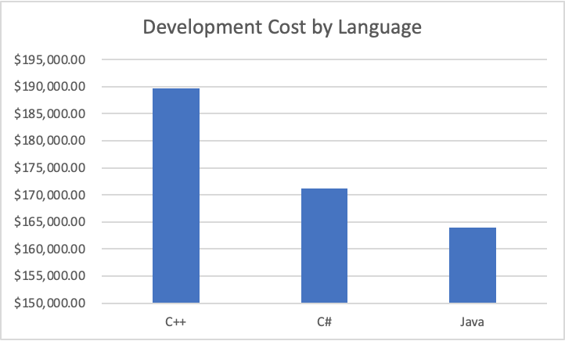

As can be seen above, the cost of software development for the company’s custom accounting software will likely be in the lower six digits regardless of language of implementation. For the remainder of this document, we will be assuming that the company’s intended implementation language is C# due to its versatility, ease of use, and readily available developers in the market (and as a reasonable middle ground between the two other estimates). This puts the total initial development cost for a custom piece of accounting software at $171,000.

In addition to the upfront cost of developing the software platform itself, a piece of custom developed accounting software will also need service, maintenance, and support throughout its lifecycle. For the sake of this comparison, we will make an optimistic assumption that only 5% of the engineering work that went into the software will be required to maintain it and update it as necessary to keep it functional for the business. This puts the custom software’s monthly maintenance cost at roughly $8,500, or 1.12 mid-level engineers.

## Software as a Service

There are a vast number of pieces of accounting software available in the market, a great deal of which offer customizable expense reporting functionality in order to track detailed expenses and generated reports based on those values. The majority of these pieces of accounting software operate on a software-as-a-service model, which is to say they have no upfront cost and instead charge per month and/or per user in order to make a profit and fund continued development and improvement of the product. For this report, we have chosen three comparable software-as-a-service accounting tools which offer a large suite of functionality for companies of different sizes.

## Odoo

Odoo is a customizable cloud accounting platform which offers a full suite of accounting tools, such as sales and invoice tracking, expense reporting, product inventory, and much more. Oodo’s pricing model is on a per-user, per-month basis with each optional module of functionality contributing to the overall monthly price (*Odoo Pricing: Odoo*). For comparison’s sake, we have costed Oodo’s platform with all the basic accounting modules, as well as the sales, customer, and expense tracking modules. This results in Oodo costing $128/user/month.

## Reckon

Reckon is a simplified, web based, cloud accounting platform designed for small businesses. Reckon’s two main drawbacks are that it does not have many of the advanced accounting features of the other platforms, such as inventory tracking and customer acquisition, and that it has a hard limit of 200 user accounts per business. On the other hand, Reckon has a very simple pricing model with a reasonable monthly fee for the company (*Reckon One*). This results in Reckon costing only $67/month, but with the limitation of only allowing 200 user accounts.

## Xero

Xero is a high-performance accounting platform which offers an extensive suite of accounting tools out of the box. Xero’s pricing model is based on a fixed monthly fee for the business plus an additional fee per user account (*Xero Premium Pricing Plan Details*). This results in Xero costing $67/month plus $7/user/month.

|  |  |  |  |
| --- | --- | --- | --- |
|  | **Odoo** | **Reckon** | **Xero** |
| Monthly Flat Cost | $- | $67.00 | $67.00 |
| Monthly User Cost | $128.00 | $- | $7.00 |
| Company Size Costs (Monthly) |  |  |  |
| 50 | $6,400.00 | $67.00 | $417.00 |
| 100 | $12,800.00 | $67.00 | $767.00 |
| 250 | $32,000.00 | LIMIT 200 | $1,817.00 |
| 500 | $64,000.00 | LIMIT 200 | $3,567.00 |
| Company Size Costs (Yearly) |  |  |  |
| 50 | $76,800.00 | $804.00 | $5,004.00 |
| 100 | $153,600.00 | $804.00 | $9,204.00 |
| 250 | $384,000.00 | LIMIT 200 | $21,804.00 |
| 500 | $768,000.00 | LIMIT 200 | $42,804.00 |

# Results

The four options, a custom piece of software, Oodo, Reckon, and Xero, will be compared both qualitatively and quantitatively to come to a recommendation for how the company should proceed.

## Qualitative

The comparative qualitative analysis of the four options has been done using seven different values, each rated 1-5 and each with a different multiplier applied based on the value’s relative importance to the company. The seven values are as follows: upfront cost, the total lump sum amount required to get the software working; monthly cost, the fixed monthly fee to use the software; user cost, the per-user cost for using the software; flexibility, the extensibility of the features included in the software suited and how suited they are for the company; support, how well the software’s product support pages and documentation operate and their breadth of content; breadth of features, how many different accounting features are included in the software suite; and cost for growth, the change in product cost as the company grows and needs more users and more features.

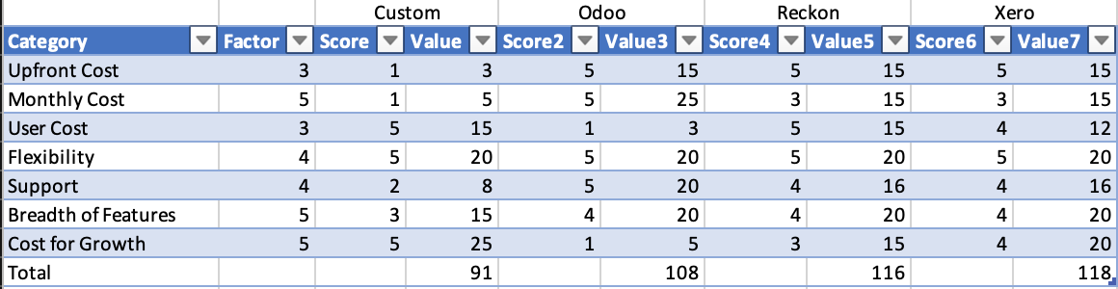

As can be seen above, the three cloud accounting platforms are roughly equivalent in their weighted qualitive rating. Reckon and Xero are neck and neck due to their near-identical service offerings and similar price points, but Xero edges out the competition due to the ability to grow past 200 user accounts if the company needs more.

## Quantitative

The comparative quantitative analysis of the four options has been done by charting the upfront costs, per-month costs, and per-user costs of each of the four solutions. For a fair comparison between all four accounting platforms a fixed 200 employee account value is set for the chart to allow Reckon to compete with the other platforms that offer a higher ceiling of user accounts. Each product’s costs are estimated throughout the course of nearly ten years in order to create a far-sighted prediction of the company’s future costs.

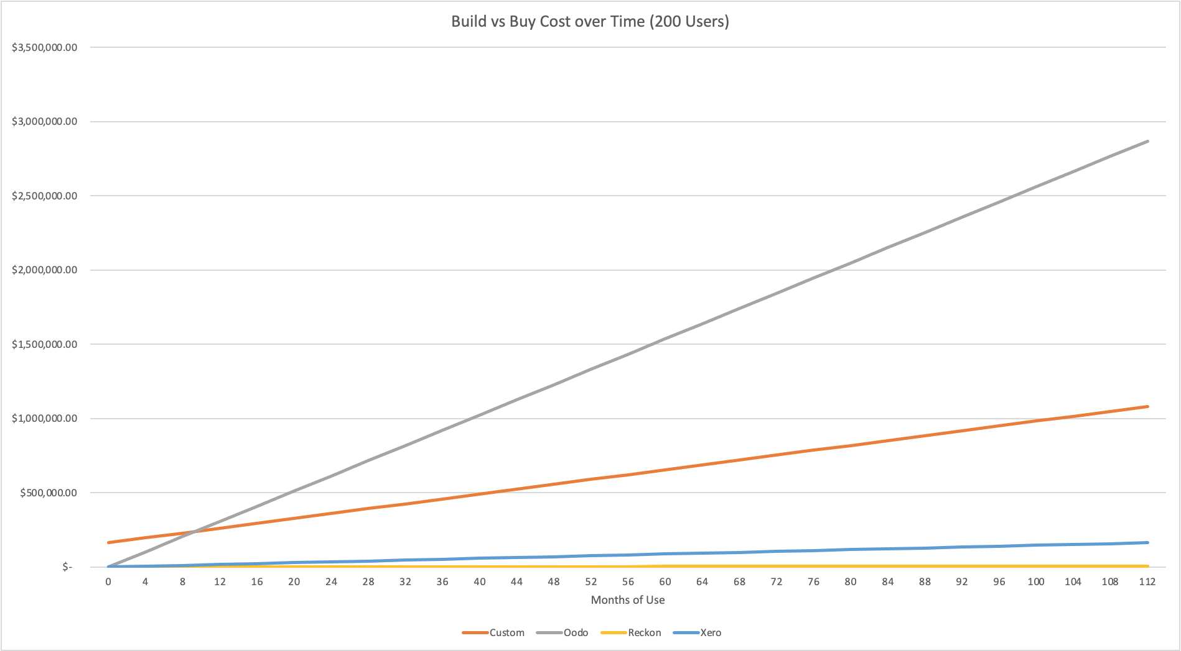

As can be seen in the graph above, Oodo almost immediately becomes a cost-prohibitive solution due to its incredibly high per-user, per-month fee of $128. Within eight months, the fees for Oodo would already cost the company more than creating an entirely new piece of accounting software. In second comes the custom-built accounting software, based on its ideal-case upfront cost and significant upkeep cost. At a near tie for cheapest solution, Reckon and Xero both barely step off of the bottom of the chart due to their low monthly and per-user fees.

# Conclusion

Four functionally similar products have been compared to replace the company’s current accounting software, including a potential bespoke software solution tailored specifically to the company’s needs. These solutions have been compared along as equal of lines as possible by costing them for equivalent feature sets (where possible) and have been compared qualitatively based on their customer support, breadth of additional options, and overall suitability for the company’s future growth. Based on all these evaluations, there is a clear best choice of the four.

## Xero

Xero, hands down, is the direction the company should go if it wishes to replace its current accounting software system with one which has an expansive breadth of features, a low price tag, and an excellent network of support and documentation. Costing only $88,000 for five years of use for a 200-user company, the company would save over $500,000 compared to creating bespoke software and nearly $1.5 million compared to licensing Odoo. While Reckon technically has a much smaller cost due to its lack of a per-user fee, we recommend Xero because it does not come with the same user-count and request-count limitations that its cheaper competitor does.

# References

*Intermediate Software Engineer Salary*. Salary.com. (n.d.). <https://www.salary.com/research/salary/alternate/intermediate-software-engineer-salary>.

Keshta, I. M. (2017). Software Cost Estimation Approaches: A Survey. *Journal of Software Engineering and Applications*, *10*(10), 824–842. <https://doi.org/10.4236/jsea.2017.1010046>

Lederer, A. L., & Prasad, J. (1995). Causes of inaccurate software development cost estimates. *Journal of Systems and Software*, *31*(2), 125–134. <https://doi.org/10.1016/0164-1212(94)00092-2>

*Odoo Pricing: Odoo*. Odoo S.A. (n.d.). <https://www.odoo.com/pricing>.

*Reckon One*. Reckon. (2021, July 22). <https://www.reckon.com/au/accounting-software/#pricing>.

Roetzheim, W. H. (2000). Estimating software costs. *SOFTWARE DEVELOPMENT-SAN FRANCISCO*, *8*(10), 66–68. <http://carlosproal.com/itpm/files/cocomo/SDArticle1.pdf>

*Xero Premium Pricing Plan Details*. Xero. (n.d.). <https://www.xero.com/au/pricing-plans/premium/>.