What is the Problem?

Tractor and Mower Sales

Jake O’Connor

MS544

Assignment 5: What's the Problem?

# Introduction

The company has identified a presumed trend in the sale of tractors and mowers throughout the course of five years: that tractor sales have doubled, and mower sales have stagnated. This report will analyze the company’s dataset of this five-year period to first establish if this trend is factual, and then to identify potential causes for this trend and recommend solutions.

# Dataset

The Performance Lawn Equipment dataset contains a plethora of data over the months spanning from January 2010 through December 2014. This includes both company and industry sales data for both the tractor and mower segments in question, as well as dealer and customer satisfaction survey results, complaint records, and production costs. This dataset shows significant patterns in both the industry’s and the company’s performance in both product segments in question for this report.

# Analysis

## The Tractor Industry is on an Incline

The tractor sector as a whole has been on a relatively steep incline throughout the four years within the dataset, as can be seen in the chart below. Accounting for seasonal fluctuations in demand, the global sales of tractors has increased over fifty percent. This overall global increase comes from corresponding increases in the North American, South American, and China regions, while the European and Pacific regions stagnated over the dataset’s range.

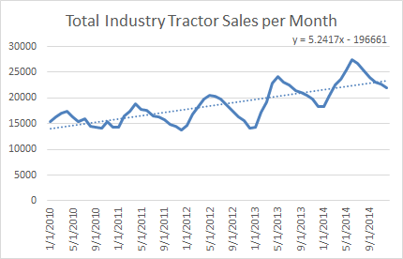

As for the company’s part in the global tractor market, the doubling of tractor sales can be strongly correlated with the increase in the company’s market share. In the same period that the tractor industry grew over fifty percent, the company’s market share increased over three-fold. A great deal of this increase in global market share can be attributed to the company’s high increase in the North American market, which is the largest consumer of tractor equipment within the dataset by a healthy margin.

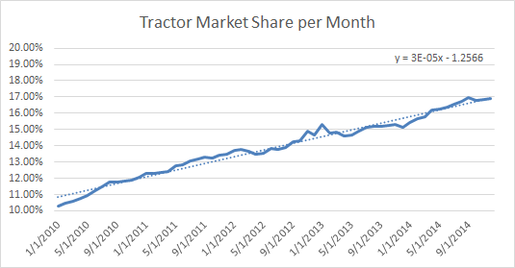

## The Mower Industry is on a Decline

Where the tractor industry increased over the dataset’s timespan, the global mower industry as a whole shrank an equivalent amount. This decrease in industry mower sales can be positively correlated with declines in regional sales in all regions but the Pacific, in which regional sales doubled.

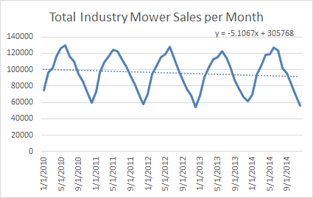

Over the period within the dataset, the company’s sales of mowers also decreased to an equivalent degree to the industry as a whole. Even though the company’s market share of the mower sector has been trending slightly upwards, the overall shrinkage in the mower sector has resulted in a significant drop of sales.

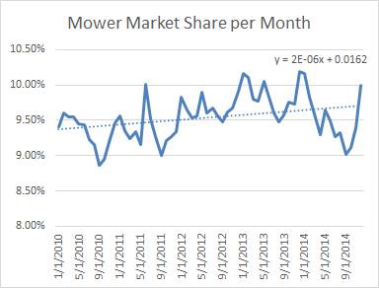

## Dealer and Customer Satisfaction are Stable or Improving

Over the years covered by the dataset, responses to the company’s dealer satisfaction survey have been on an upward trend. While larger markets such as North America, South America, and Europe have maintained relative consistency in their clustering around the satisfaction rating of 4, smaller markets such as the Pacific and China which started much lower have increased to be similarly clustered over the years within the dataset. As this data points to increasingly satisfied dealers, we can infer that the cause for decreased mower sales is not related to the company’s regional dealers but instead some other factor.

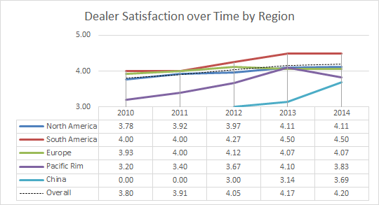

Much like the dealer satisfaction surveys, end-user/customer satisfaction survey results have also been positive over the course of the dataset’s four-year window. Customer satisfaction survey results have stayed strongly clustered around the satisfaction rating of 4 in every region within the dataset. Even the emerging China market has responded favorably to user satisfaction surveys and quickly joined the clustered data. As there have been little to no changes in user satisfaction over time, and what little change there has been is positive, we can infer that any changes in tractor and mower sales are not strongly correlated to changes in user satisfaction.

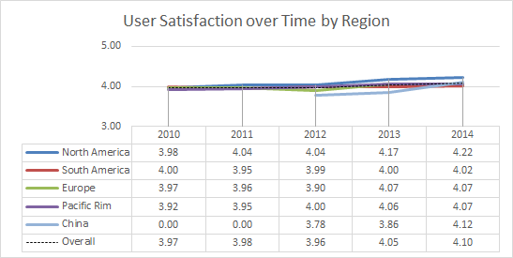

## Customer Complaints are Slightly Rising

Over the course of the dataset the number of customer complaints to the company per month has been on a steady rise, after accounting for seasonal changes in sales. As the number of mower sales has remained relatively stable and the number of tractor sales has doubled over the same period, a straight increase in overall customer complaints per month is not wholly unexpected.

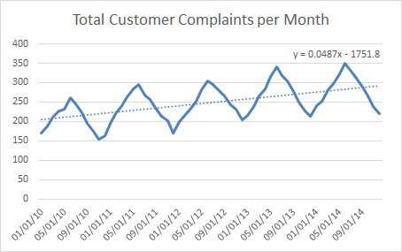

When we calculate the metric of customer complaints as a portion of monthly sales, we can see that there is still a positive increase in customer complaints, but it is much smaller than when viewed in the raw. Throughout the dataset’s timespan of five years there is only an increase in customer complaints of less than one-half of one percent. As the number of customer complaints has barely changed when compared to the number of sales, and the customer satisfaction survey results have remained consistent, we can infer that the disparity between mower and tractor sales is not correlated with a rise in customer complaints.

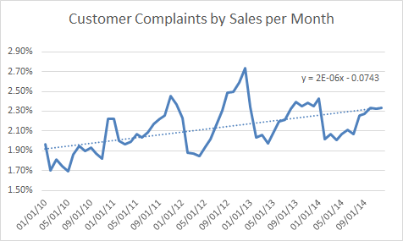

# Answers

As the goal of this report is to identify a cause for the disparate changes in tractor and mower sales for the company, and these changes appear unrelated to one another, we will discuss both independently to identify their potential explanations.

## Tractor Sales Doubling is a Result of Increased North American Market Share

The twofold increase in tractor sales throughout the dataset’s timespan can be directly attributed to two factors: the growth of the global tractor market as a whole, and the increase in the company’s market share of tractor sales in the North American market. As can be seen in the chart below, the growth of the company’s tractor sales strongly correlates to the growth in global tractor sales throughout the corresponding period of time.

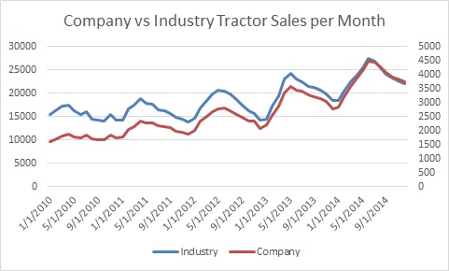

An additional piece of the puzzle in why the company’s tractor sales have doubled over the dataset’s five-year period is shown in the chart below. Throughout the data period, the company’s market share of the North American tractor market has grown from just seven percent to just shy of twenty percent. As the North American market is by far the largest single market within the dataset, this increase in market share can be directly linked to the steady rise in tractor sales which exceeds the rate of growth for the industry.

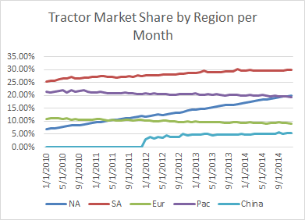

## Mower Sales Stagnating is a Result of Industry Trend

Now that we’ve established how the tractor segment of the company has grown, we will identify why the mower segment has not. Unlike the tractor segment, the overall global mower industry has seen steadily declining sales over the five years within the dataset. While not a stark or sudden decrease in sales, each year has seen a consistently lower demand than the previous year. The chart below shows how the company’s and industry’s rate of mower sales very strongly correlate and have been declining slowly over time.

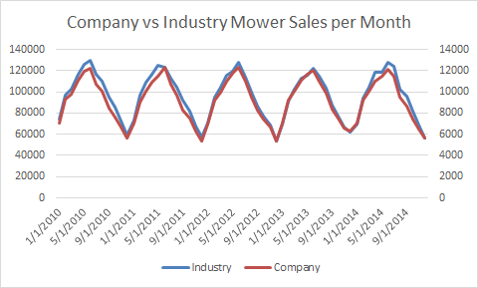

Much the same as the tractor sector, sales in the mower sector are dominated by the North American market with roughly three-quarters of the total sales. Unlike with the tractor sector, the company’s market share of North American mower sales has not increased by any significant amount over the five years covered by the dataset. While the company’s market share of the South American mower market has remained high and grown, that market accounts for less than one tenth of the total global sales.

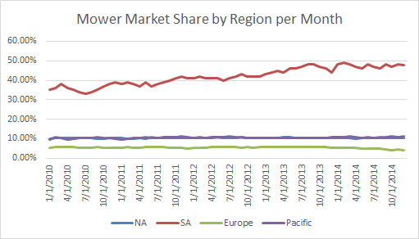

# Conclusion

This report has shown that over the course of the dataset’s timespan of five years customers and dealers have remained satisfied with the company’s products, that tractor sales have exceeded market expectations, and that mowers sales have remained closely correlated with the movements of the global market.

If the company wishes to increase sales of mowers in much the same way that sales of tractors were increased, they should focus on increasing the market share of mower sales in the North American market. This is the largest market for mower sales by an incredibly large margin, and the company’s market share in that market has remained stagnant over the dataset’s five years. For the mower sector to increase considerably like the tractor sector has, the company’s North American mower market share will need to increase at least twofold to account for the slow decline in the global mower market.

# References

Ishola, T. A., & Adeoti, J. S. (2004). A Study of Farm Tractors Reliability in Kwara State of Nigeria. <https://uilspace.unilorin.edu.ng/bitstream/handle/20.500.12484/1384/Proceedng_1.pdf?sequence=1>

*John Deere*. Agriculture and Farming Equipment | John Deere US. (n.d.). <https://www.deere.com/en/agriculture/>.

Kipriyanov, F. A., Medvedeva, N. A., & Medvedeva, S. V. (2019, August). Ensuring the operational reliability of the tractor fleet. In IOP Conference Series: Earth and Environmental Science (Vol. 315, No. 6, p. 062015). IOP Publishing. <https://iopscience.iop.org/article/10.1088/1755-1315/315/6/062015/pdf>

Powell, O. S. (1929). Forecasting Farm Tractor Sales in North Dakota. Journal of the American Statistical Association, 24(165A), 234-240. <https://fraser.stlouisfed.org/files/docs/historical/frbminn/presidents/powell/powell_19290301.pdf>

Siregar, I., Ridho, A., Gustia, D., Triono, A., & Shafira, Y. (2018, September). Product design of a lawn mower tool for agriculture. In IOP Conference Series: Materials Science and Engineering (Vol. 420, No. 1, p. 012140). IOP Publishing. <https://iopscience.iop.org/article/10.1088/1757-899X/420/1/012140/pdf>

Tyutrin, S. (2019, May). Improving reliability of parts of mounted mower according to monitoring results by fatigue gauges from tin foil. In Proceedings of 18th International Scientific Conference “Engineering for rural development”. Jelgava, Latvia (pp. 22-27). <http://tf.llu.lv/conference/proceedings2019/Papers/N019.pdf>