AI In Industry

Jake O’Connor

MS548

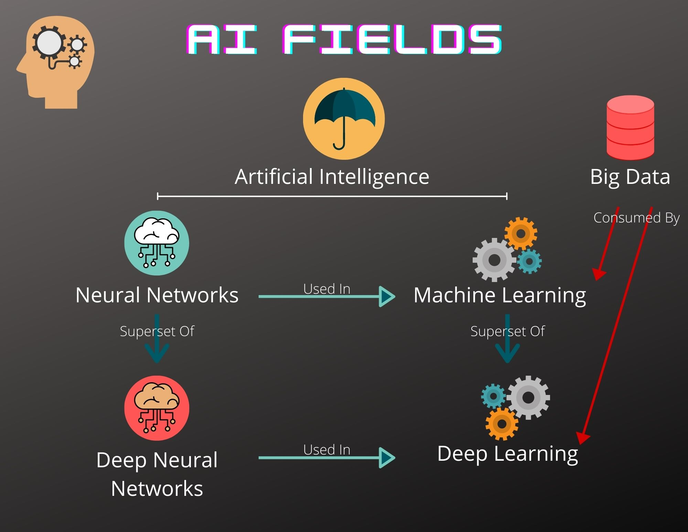

# Artificial Intelligence

Artificial Intelligence is a blanket term which covers all aspects of computerized technology that simulates human-like reasoning. There are dozens of fields within the umbrella of artificial intelligence, including speech, image, and text recognition, event and value prediction, and natural language parsing. Nearly every industry in the world uses some form of artificial intelligence on a daily basis, either to inform their business decisions, influence their marketing targets, or price their products competitively.

# Big Data

Big Data, while not technically a field within artificial intelligence, is an integral factor in carrying out AI operations. Big Data is the collection of vast (big) amounts of data, whether from the environment or from customers or from social media. Big Data is characterized by what are called the 3 high V’s (sometimes 5 V’s), which are high volume, high velocity, and high variety. Big Data is big because it collects massive amounts of information at increasingly high rates and with increasingly varied content. This massive trove of information is key to performing artificial intelligence algorithms that extract data and detect meaningful patterns.

Within the gaming industry contains as much or more Big Data as any other industry and in can be used in much the same way. Customer service records, purchasing records, reviews, and playtime values can all be used to better predict which cohorts of players will most likely be influenced by marketing strategies and how likely they are to purchase upcoming releases, expansions, and subscriptions. In addition, an area of the gaming industry that could better use Big Data is the collection and use of raw gameplay data. Historically, games have tracked massive amounts of analytics data based on hard-coded events and situations, but Big Data could be used to gather, store, and later act on the raw gameplay data of how players interact with games. This could be used by Deep Learning algorithms to predict the difficulty of certain types of games, levels, and enemies, and to compare those values against other information to help make more meaningful decisions in both game design and distribution.

# Machine Learning

Machine Learning is a category of artificial intelligence defined by its reliance on learning algorithms that get better as time goes on. Machine learning can be used for many types of pattern recognition, including in virtual assistants, product recommendations, and targeted advertising. The main steps of constructing a Machine Learning model are the identification of training data, the selection of a suitable algorithm, and the training of said algorithm with the identified data. Training data generally falls into two categories: labeled, data that has already been tagged and categorized by humans or other algorithms; and unlabeled, raw data. The quality and quantity of training data, as well as the intended outcome, determine which machine learning algorithms are suitable for use. Once an algorithm has been selected, it is then iteratively trained using as much data as possible, until the resulting output of the model is up to the standards of the developer. Finally, the trained model can be used on new data as applicable, with each new set of data improving the model itself.

Rudimentary types of Machine Learning algorithms, such as decision trees, have been used in games for decades in order to craft more believable virtual worlds and character behaviors. Future games and developers would be wise to make use of more broad types of Machine Learning in order to better develop virtual worlds.

# Neural Networks

Neural Networks simulate the behavior of the human brain through mathematical algorithms. Each neuron in a network is activated (turned on) when its input values exceed a certain threshold, and a network can have any number of neurons within it and in many layers. The simplest neural networks can just have a single neuron which takes a number of input values and calculates a Boolean result, while more complex networks have hundreds of neurons which each receive input from and provide output for hundreds more. Neural Networks are an integral part of Deep Learning, as they form the basis of the decision-making processes. Networks with many layers of neurons are generally referred to as Deep Neural Networks and are necessary for the processing of unlabeled data.

# Deep Learning

Deep Learning is a subset of Machine Learning that uses Neural Networks (especially Deep Neural Networks) to operate primarily on unlabeled data. Other types of Machine Learning are capable of building models off of training via labeled data, but the expense of manually tagging enough input data is often too high. Deep Learning solves this problem by taking in massive amounts of unlabeled training data and using Deep Neural Networks to both extract relevant data and make decisions upon it. This process is called Unsupervised Learning (meaning there is no necessary human oversight). Deep Learning models are used in order to identify potential cancer cells within medical scans, recognize certain types of objects within images or videos, and to predict or identify signs of illegal activity within financial transactions.

Deep Learning could be used in the games industry to create much more immersive worlds that cater to their players. Deep Neural Networks can be constructed in order to form more believable character AI systems that make monsters and NPCs act on and react to their world similarly to how real players would. In order to fully train these Deep Learning models, game developers would need to begin tracking much more granular analytic data about how their games are played.

# References

Chen, J. (2020, December 23). Neural network definition. Retrieved March 27, 2021, from <https://www.investopedia.com/terms/n/neuralnetwork.asp>

Frankenfield, J. (2021, March 24). How artificial intelligence works. Retrieved March 27, 2021, from <https://www.investopedia.com/terms/a/artificial-intelligence-ai.asp>

Hargrave, M. (2020, December 14). How deep learning can help prevent financial fraud. Retrieved March 27, 2021, from <https://www.investopedia.com/terms/d/deep-learning.asp>

IBM Cloud Education. (n.d.). What are neural networks? Retrieved March 27, 2021, from <https://www.ibm.com/cloud/learn/neural-networks>

IBM Cloud Education. (n.d.). What is artificial intelligence (ai)? Retrieved March 27, 2021, from <https://www.ibm.com/cloud/learn/what-is-artificial-intelligence>

IBM Cloud Education. (n.d.). What is deep learning? Retrieved March 27, 2021, from <https://www.ibm.com/cloud/learn/deep-learning>

IBM Cloud Education. (n.d.). What is machine learning? Retrieved March 27, 2021, from <https://www.ibm.com/cloud/learn/machine-learning>

Meserole, C. (2019, October 25). What is machine learning? Retrieved March 27, 2021, from <https://www.brookings.edu/research/what-is-machine-learning/>

Segal, T. (2021, January 04). Big data. Retrieved March 27, 2021, from <https://www.investopedia.com/terms/b/big-data.asp>

What is big data? (n.d.). Retrieved March 27, 2021, from <https://www.oracle.com/big-data/what-is-big-data/>