Thirty Day Hero

Project Proposal

# Description

*Thirty Day Hero* (TDH) is a browser-based, rogue-like JRPG with roots in games like *One Way Heroics*, *Knights of Pen and Paper*, and *Kingdom of Loathing.* The goal of *TDH* is to defeat an oncoming cataclysm in the form of a randomized final boss after spending the preceding thirty (30) in-game days adventuring, training, and equipping your heroes with the best equipment possible. The game contains a plethora of unique enemy types, character classes, weapons, and special abilities.

Gameplay of *TDH* is divided between JRPG combat encounters and menu-based interactions with NPCs and locations. Each unique encounter with either a group of monsters, an NPC, or location will consume one third (1/3) of an in-game day, with each day divided into a Day, Evening, and Night segment. This results in a single ‘run’ of *TDH* being composed of, at most, 91 (30 days * 3 segments + 1 boss) unique encounters. Day progress, day-segment, and day-of-week all affect which event types and specific events are available, as well as determine if certain events are more or less effective (e.g. Resting is more effective during Night; Shops are only available during Day).

The JRPG combat of *TDH* is composed of a variable number of ally and enemy characters, based on the encounter, and uses a speed-based initiative system as an added layer of combat complexity. Each character in *TDH* has six (6) primary stats that scale with character level based on each class’s proficiencies: Strength, Dexterity, Constitution, Intelligence, Magic, and Charisma. These primary stats are used to derive multiple secondary stats, like Health, Stamina, and Speed, as well as to determine combat effectiveness and pass non-combat encounter checks. *TDH*’s combat takes place in turns, with each turn prompting the highest-initiative character to choose one of their available actions and subsequent targets and then resolving the results, until only one party of characters remains.

# Functionality

## Web Access

*TDH* is a single-page web app based on ASP.NET and running on Azure. This means that players will be able to access *TDH* from any device with an internet connection and a web browser. Player, character, and party details being stored in the cloud means that a player can pause their run or switch devices at any point without losing their progress.

## JRPG Combat

*TDH*’s JRPG combat is based on classics of the genre and features mechanics like unique character classes, a plethora of abilities and equipment, and speed-based initiative system. This combination of mechanics leads to a deep combat system which grows in depth as the player’s characters level up and gain new equipment and abilities.

## Rogue-Like Gameplay

*TDH* is a rogue-like, meaning that death is permanent and once all the characters in the player’s party are dead then the run is over. Each run starts with a party of 3-4 player characters with randomized classes, stats, and starting equipment. Combat is fair but difficult, and healing is rare and costly. To offset the difficulty of gameplay and lessen the impact of a single character’s loss, combat EXP is divided among only living party members.

## Day-Night Cycle

*TDH* features a pseudo day-night cycle, with each in-game day being divided into three equal segments: Day, Evening, Night. These time segments are a major factor in the gameplay of *TDH* as certain locations and events are unavailable during certain times of day, and certain events are mutated based on the time of day. Certain strong monsters are more likely to be encountered during the Night segment but have correspondingly high rewards. Certain shops and helpful locations in town can only be accessed during Day or Evening time segments.

## Run History / Hall of Heroes

*TDH* stores the party and progress information of all previous runs for the player, allowing them to look back on previous runs. The Hall of Heroes is accessible as soon as a player completes a single run and keeps a record of notable events throughout the run.

## Extensible Framework

*TDH* is build upon an extensible JRPG framework which makes the addition of wholly new character classes, monsters, equipment, and abilities extremely easy. This framework means that content expansions and balance tweaks can be done quickly and efficiently to provide players with as much quality content as possible.

# Cloud Computing Technologies

## Microsoft Azure Web Services

*TDH* is hosted on Microsoft’s Azure Web Services in order to provide seamless integration with the ASP.NET Core and C# it is built upon. Azure Web Services allows *TDH*’s back-end to scale as necessary in order to match the required capacity of active players, ensuring that each player’s experience is as optimal as possible.

## Google Firebase

*TDH* uses Google’s Firebase platform for authentication, databases, file storage, configuration, and monetization. Firebase offers a convenient suite of features that enable *TDH* to maintain consistency across multiple devices, deploy content updates in real-time, and be effectively managed from a single end-point.

# Market Research

## ‘One Way Heroics’ franchise

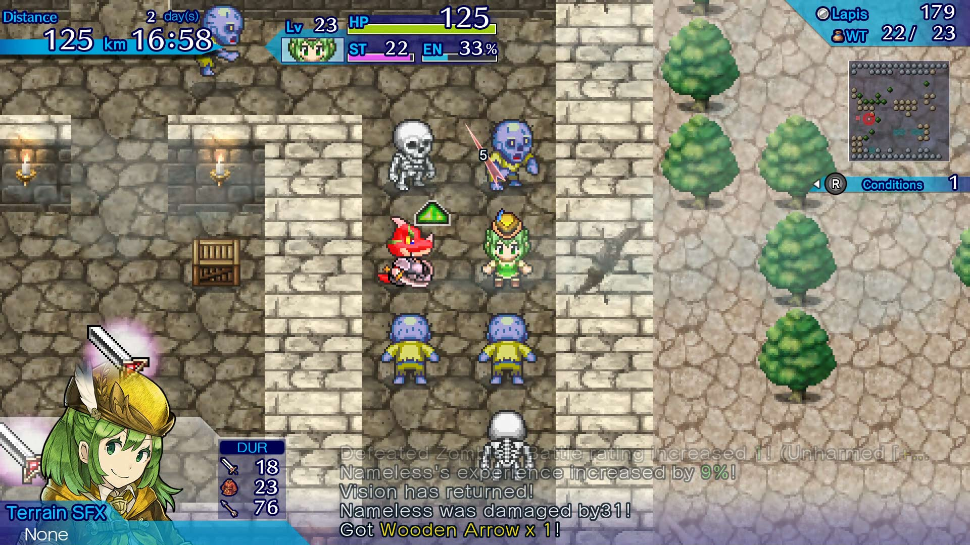

*One Way Heroics* and its sequels are rogue-lite games in which the player controls a single RPG character on a quest to battle some great foe in a certain amount of time. This time usually takes the form of a certain lateral distance from the player’s starting position before the boss monster spawns, with a wall of light constantly pushing the player character forward. These games feature multiple playable classes, weapons, and abilities, and generally have overworld combat which is less tactical than a JRPG. A player’s results are tabulated at the end of a run and they are rewarded with new characters, boosts, and other features that are shared across all future runs.

*One Way Heroics* and *Thirty Day Hero* are spiritual siblings. Both pit players against a series of challenges in order to strengthen them for an inevitable final fight against a tough boss, both feature rogue-style gameplay with each decision having a lasting or fatal impact on the run, and both have runs that only last a maximum of a few hours to complete. The combat of *TDH* is more complex and in-depth than *One Way Heroics* and death is a more permanent loss in *TDH* due to its more stringent application of the rogue-like formula. The two games differ greatly when it comes to execution, but at their core they offer a similar experience.

## ‘Knights of Pen & Paper’ franchise

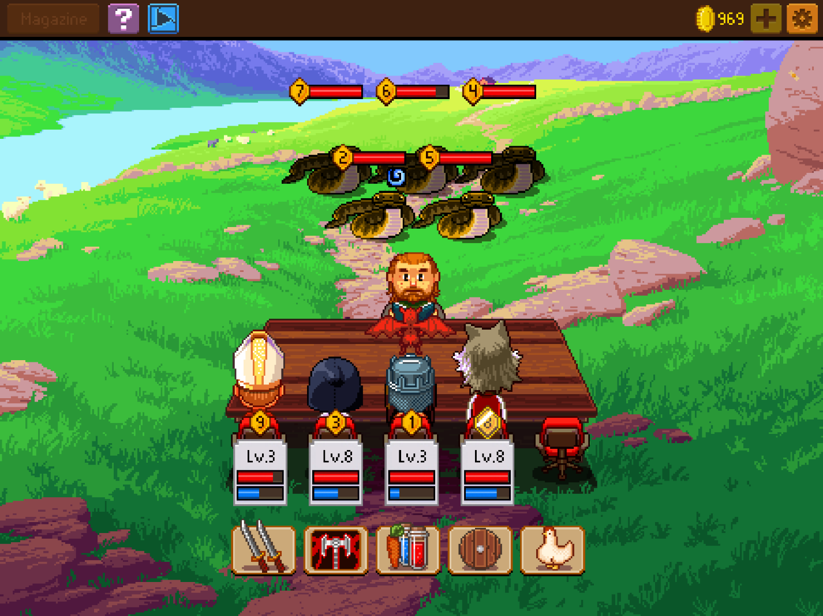

The *Knights of Pen & Paper* franchise is a series of mobile games simulating the adventures of a group of characters playing Dungeons & Dragons-style tabletop RPG. The player controls everything from the number of characters in the group and their corresponding in-game character class to the dungeon master’s decision on how difficult a challenge to provide the group. The game features in-depth turn-based combat using a plethora of class-specific abilities and skills, as well as plenty of special items and equipment to turn the tide of battle. Outside of combat players freely adventure around the world map picking up quests, delving into dungeons, and perusing shops in the game’s towns.

*Knights of Pen & Paper* and *Thirty Day Hero* are most similar in their use of RPG combat systems. *Knights of Pen & Paper* uses a standard D&D-style initiative system which is fixed at the start of combat, which differs from *TDH*’s speed-based flexible initiative. Both feature an abundance of character classes with unique abilities and skills but differ in that *TDH* does not allow the player to select their starting party’s makeup. They also differ in that *Knights of Pen & Paper* does not feature any rogue-like mechanics like permadeath, nor does it have a fixed timeline like *TDH*’s thirty day limit.

## ‘Kingdom of Loathing’

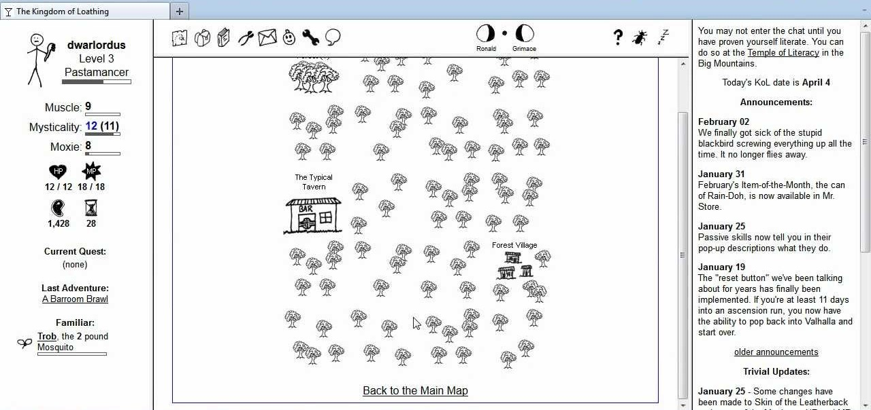

*Kingdom of Loathing* is a multiplayer browser-based RPG adventure game filled with countless jokes and near-limitless replayability due to its age and breadth of content. The game features the standard RPG fare of turn-based combat, experience and levels, quests, and unique character classes. In addition to the single-player features there are a plethora of multiplayer features including clans, trading, and multiplayer dungeons.

*Kingdom of Loathing* and *Thirty Day Hero* differ greatly in both style and gameplay but offer a similarly approachable game in that they can be easily accessed by any web browser and played at the user’s leisure. *Kingdom of Loathing*’sstyleis full of pop culture references and surreal humor, unlike *TDH*’s more by-the-books fantasy setting. *Kingdom of Loathing*’s combat system is also more simplified than that of *TDH* since it makes up a smaller relative portion of the gameplay and it does not feature the same rogue-like gameplay. While both *Kingdom of Loathing* and *TDH* are browser-based RPGs, their similarities mostly end there.

# Screen Mockups

## Combat

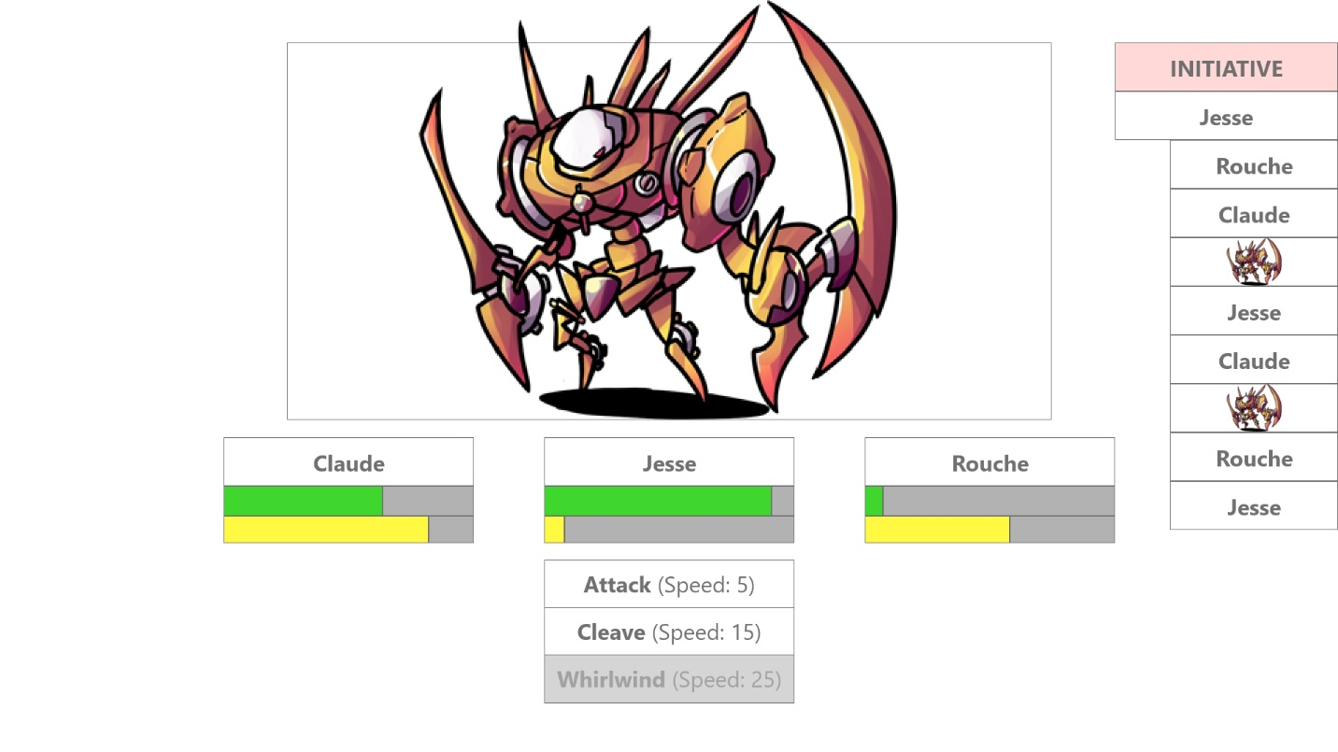

## Town

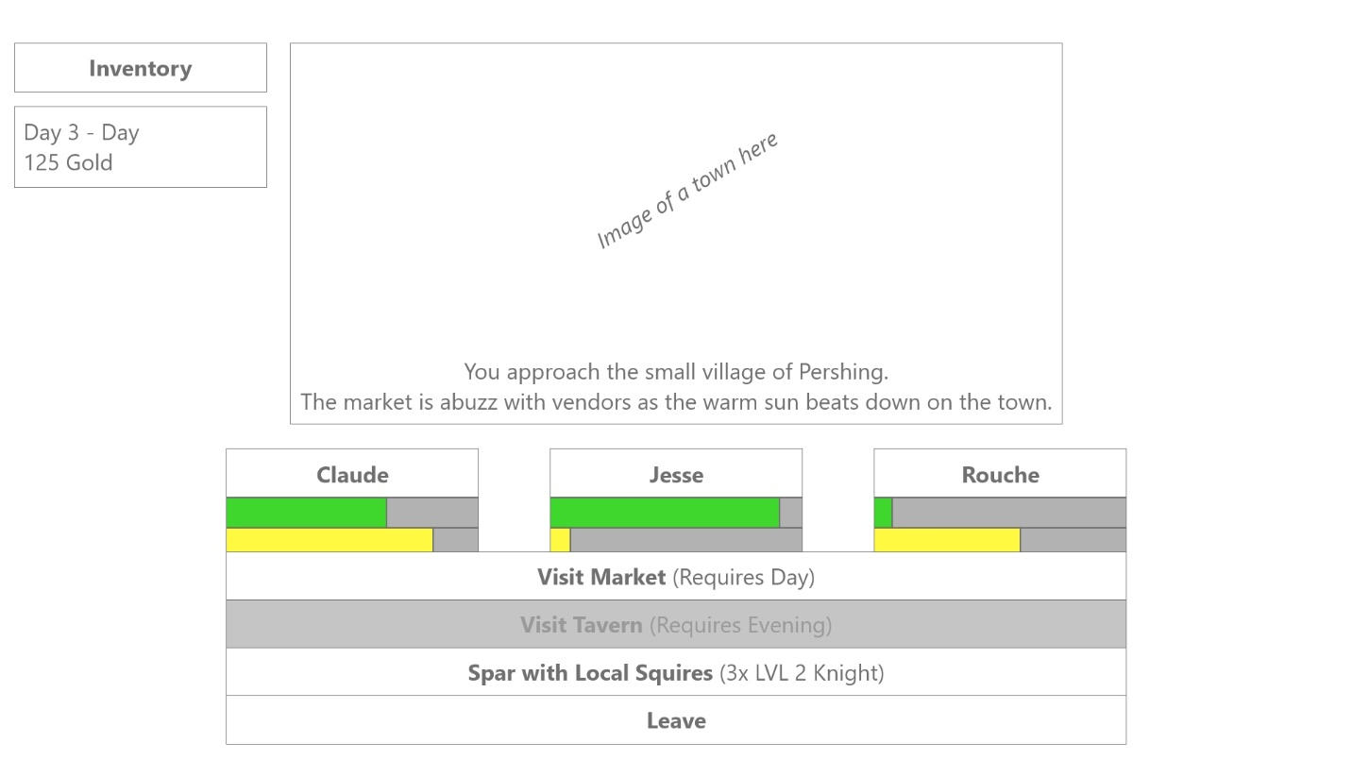

## Event