Technology Inventory of the

Kent School District

Jake O’Connor

Case Study 2: Technology Inventory

# Introduction

The Kent School District in Washington state serves nearly 30,000 students from diverse backgrounds through 28 elementary schools, 6 middle schools, and 4 high schools. The school district is located in Kent, Washington, roughly 20 miles south of Seattle proper, and serves over 19,000 families across more than 8 cities and unincorporated areas. The district recently achieved a 1:1 student to laptop ratio and has class sizes averaging 18 students per teacher. (*About Us / Fast Facts* 2021)

Like many school districts across the United States, the Kent School District is slow to adopt technologies regardless of how new or old they are. Budget constraints, parent, teacher, and union pushback, and the lack of a centralized technology director in the school district all play a role in the slow adoption of technology by the Kent School District. The move to entirely remote learning has greatly stressed the district’s technological capabilities, the lack of a central technology guidance leaving individual schools and teachers to make decisions on which tools they use to communicate with students, issue assignments, and submit grades.

# Technology Inventory

## Follet Destiny Library Manager

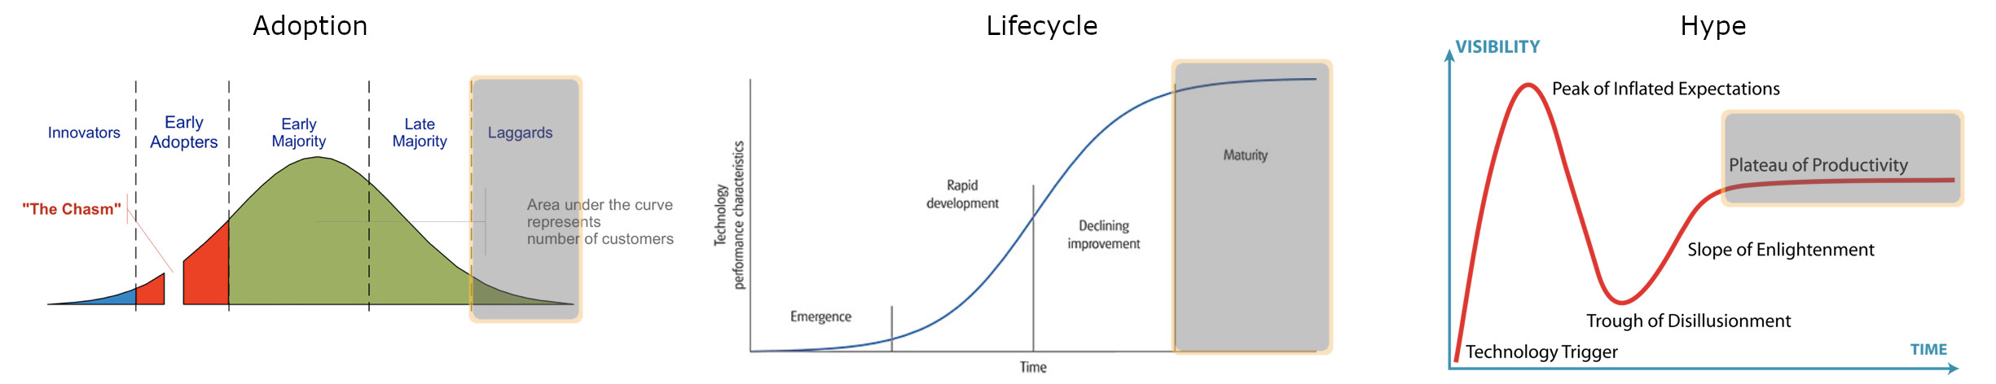

Follet’s Destiny Library Manager is an integrated library system (ILS) which has been widely used by school districts across the United States for years (Breeding, 2013). The Kent School District adopted Destiny Library Manager as its choice of ILS two years ago at the insistence of its librarians and library staff. Follet’s ILS has been around for over a decade and is the industry leader by a large margin.

### Contribution

The Destiny Library Manager enables students, parents, teachers, and librarians to access a breadth of functionality that older systems struggled to. The Follet ILS is hosted in the cloud and can be accessed from any web browser by using appropriate login credentials, which lightens the load on an already overwhelmed district IT staff. It features integrations with dozens of software solutions used by the Kent School District, such as the school management system Skyward and the payment management system InTouch. The Destiny ILS manages holds, automated notifications, robust reporting, and many other tasks that the previous solution failed to deliver the district.

### Current State

Follet’s Destiny Library Manager currently serves a vital role in ensuring that students and teachers have access to books from libraries in the Kent School District and ensuring that those books are well documented. Few alternative solutions for an integrated library system exist that offer comparable services to Destiny Library Manager, making it not only a good but necessary fit for the Kent School District’s current needs. Additionally, the Destiny Library Manager’s overwhelming market share, and Follet’s many other education endeavors, offers some guarantee of stability and reliability for the coming years.

### Future Prospective

The Destiny Library Manager is expected to capture even more market share as more school districts around the United States and abroad update their existing integrated library systems to more modern solutions. The two- and four-year prospective for Follet’s ILS are the same, it will continue to be a vital technology used by the Kent School District and neighboring districts. The age of the Destiny Library Manager and its active, continued development guarantee that its features and operations maintain relevancy as time passes. If anything, Follet’s Destiny Library Manager will become more effective as time passes due to the addition of new features and integrations as well as the Kent School District’s inevitable future adoption of other modern education technologies that can better integrate with the Follet ILS.

## Promethean ActivPanel

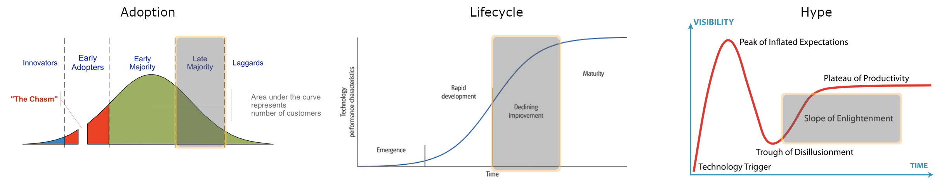

Promethean ActivPanels are a brand of Android-based interactive displays slowly being deployed to classrooms across the Kent School District, starting with high schools and then moving on to lower grade classrooms. These smart displays function as both monitors which the teacher can use to project images, videos, and video calls, as well as smart whiteboards which allow teachers and students to interact with the content on screen through marker-like accessories. While interactive smart displays have been around for years, and deployed in many classrooms, their features and adoption are still somewhat behind in the education industry, most likely due to the inherent delay in public school curriculum and technology.

### Contribution

Currently, Promethean ActivPanels have a rather small contribution to the classrooms and curriculums of the Kent School District. As a recently deployed technology, and with all schools in the district adhering to a fully online schedule for the 2020-2021 academic year, the Promethean boards that have been deployed have gone mostly unused aside from optional training and testing. Additionally, as a newer technology in the education industry, smart boards have yet to become a staple part of the adopted curriculum, making their use more of a novelty, at least in the Kent School District.

### Current State

With their slow rollout, lack of integration into the curriculum, and ongoing remote learning during the pandemic, it is hard to argue that Promethean ActivPanels are currently an appropriate and effective technology for the Kent School District. Most of these blockers to the effectiveness of Promethean ActivPanels are due to factors outside of the technology itself, making an unbiased determination difficult at the current time.

### Future Prospective

The future effectiveness and applicability of Promethean ActivPanels to the Kent School District is expected to increase in the coming years. The future of classrooms in the United States is one that incorporates many aspects of technology, including smart displays. In the next 24 months as students and teachers return to in-person learning, they will begin being exposed to the Promethean ActivPanels on a regular basis and the effectiveness of the technology will increase. It is unexpected for the Promethean ActivPanels to become a truly effective technology in the classroom within the next 24 months though.

On the other hand, in the next 48 months, Promethean ActivPanels can be expected to become a highly effective and applicable technology for the Kent School District. As more classrooms are equipped with smart boards and more teachers are exposed to the benefits of smart board technologies, lesson plans will slowly begin to adapt. Once Promethean ActivPanels reach critical mass across the Kent School District’s K-12 schools it is likely that more district-wide training will be available and more of the widely adopted curriculum will include lessons relying on the smart boards.

## Canvas

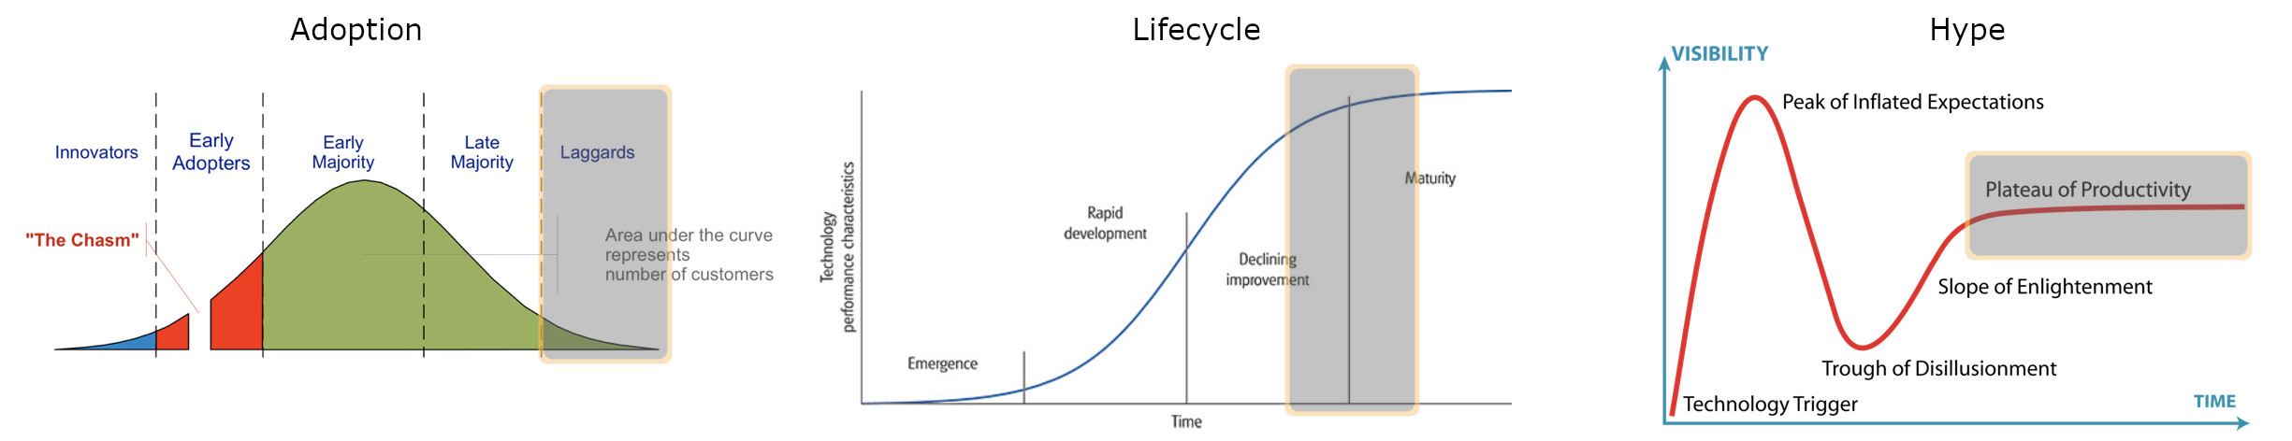

Instructure Canvas is one of the most full-featured learning management solutions (LMS) available on the market and has been adopted by a substantial percentage of schools and colleges around the country. The Kent School District makes use of Canvas, but it is not officially adopted as the standard LMS for all schools or classrooms, instead leaving specific implementation details up to individual school administrators and teachers.

### Contribution

The Instructure Canvas LMS features a full suite of learning and class management tools, including assignments, grades, tests, and chat rooms. In addition to all the features built into the LMS itself, Canvas integrates smoothly with dozens of other popular educational technologies. Canvas is currently only used by some of the schools and classrooms in the Kent School District, mostly in the high schools, with lower grade schools and classrooms relying on other, similar LMS technologies like Seesaw and ELMO. This distribution of varying LMS technology means that for different schools and teachers may or may not currently see any benefit from using Canvas.

### Current State

Canvas itself is an LMS that is highly effective, which is one of the reasons it has been so widely adopted for use in schools across the country. The current state of the Kent School District’s adoption of Instructure Canvas leaves the technology very ineffective when considering the district as a whole. On the individual school and classroom level, for those that make use of the Canvas LMS as it is intended, the technology is both applicable and effective. Canvas has been in the market for years, and its features and offerings only increase as increasingly disparate customer bases make use of the platform.

### Future Prospective

The future applicability of Instructure Canvas to the Kent School District is in question. As more classes go back to in-person instruction, it is likely that they will return to using technologies and solutions that they previously relied upon instead of maintaining an LMS most appropriate for distance learning. Over the next 24 months it is expected that the applicability of Instructure Canvas to the Kent School District will drop due to the decreased necessity of using an LMS solution for in-person learning, and the current district wide adoption of alternative tools for grading and record-keeping.

The applicability of Instructure Canvas over the next 48 months is unclear. While the technology will continue to provide many of the services that classrooms across the district rely upon, the lack of a district-wide adoption mandate and the current use of many disparate alternative technologies will likely continue to hinder the efficacy of Canvas as an LMS for the Kent School District.

# Preliminary Recommendations

## Follet Destiny Library Manager

The Destiny Library Manager integrated library system was recently deployed to school libraries across the Kent School District, and thus far it has served the librarians, library paraeducators, and catalogers in the district well. Follet is not expected to suddenly discontinue service for its ILS, and the features and integrations with other services and local library technologies are likely to expand in the coming years. It is for these reasons that we recommend that Follet Destiny Library Manager is maintained as the current integrated library system for the Kent School District, and additionally that the use of Destiny’s built-in features is expanded to include integrations with more products and services, such as those that provide eBooks and audio books to students.

## Promethean ActivPanel

Promethean ActivPanel smart interactive displays are slowly being deployed to classrooms across the Kent School District, starting with high schools and eventually being installed in elementary schools. The current effectiveness of these smart displays is negligible, as teachers and curriculums have not been trained and updated to make use of this new technology. Public schools and classrooms across the country are expected to become more technologically enabled and devices such as smart boards are expected to become a common sight in the American classroom. As such, we recommend that the Promethean ActivPanel smart displays continue to be deployed to all classrooms in the district, and that adequate training is provided to teachers, staff, and IT representatives in order to effectively use and maintain these devices.

## Instructure Canvas

The Instructure Canvas learning management system has been adopted by the Kent School District’s high schools, and partially adopted by some lower grades, but the effectiveness is limited by the confusion and mishandling of deployment throughout the district as a whole. Canvas has been actively used and developed for the last decade, primarily focusing on higher education, which makes the interface and support naturally geared towards a more adult audience. The Kent School District, in addition to using Canvas as an LMS also uses Seesaw, ELMO, and Microsoft Teams, which means that both students and teachers must have some proficiency with all these platforms as they rotate between classes and grades. Thusly, it is recommended that the Kent School District discontinues the use of Seesaw, ELMO, and Microsoft Teams as LMS solutions and instead focuses on a single LMS technology like Instructure Canvas, as its wide adoption, plentiful integrations, and continued development guarantee that it will effectively serve students, parents, and teachers for the coming years.

# References

About Us / Fast Facts. (2021, January 06). Retrieved January 31, 2021, from <https://www.kent.k12.wa.us/domain/4199>

ActivPanel Nickel - Interactive Display for Education. (2021, January 26). Retrieved January 31, 2021, from <https://www.prometheanworld.com/products/interactive-displays/activpanel-elements-series/activpanel-nickel/>

Breeding, M. (2013, September). Tech Trends and Challenges for K–12 School Libraries. Retrieved January 31, 2021, from <https://www.infotoday.com/cilmag/sep13/Breeding--Tech-Trends-and-Challenges%20-for-K-12-School-Libraries.shtml>

Library Management System. (n.d.). Retrieved January 31, 2021, from <https://www.follettlearning.com/technology/products/library-management-system#features>

LMS - K12. (n.d.). Retrieved January 31, 2021, from <https://www.instructure.com/product/canvas/k-12/lms>