Emerging Technology Assessment

For the Kent School District

Jake O’Connor

Case Study 3: Emerging Technology Assessment

# Introduction

The Kent School District, located in King County Washington, is one of the largest school districts in Washington state and serves over 25,000 students across 42 schools (*Kent School District...* 2021). The district serves a diverse population of students and families from a wide variety of racial and economic backgrounds. As an educational institution, the Kent School District and the schools within it are limited in the technologies they can adapt due to a wide variety of factors, from budget and regulatory limitations to the oversight of the school board and voters in the county.

# Emerging Technologies

There are a variety of emerging technologies coming online in the near future that might have a beneficial effect on the Kent School District and the schools within it. Some of these technologies will aid the families served by the district and allow them to better access school resources, some will have a direct effect on the classroom experience, and some will provide logistical and safety improvements for the district’s students. Regardless of the technology, it is likely that due to the behind-the-curve nature of the educational industry there will be significant lag time between the wide adoption of these emerging technologies and their application and adoption by the Kent School District.

## 5G Telecoms

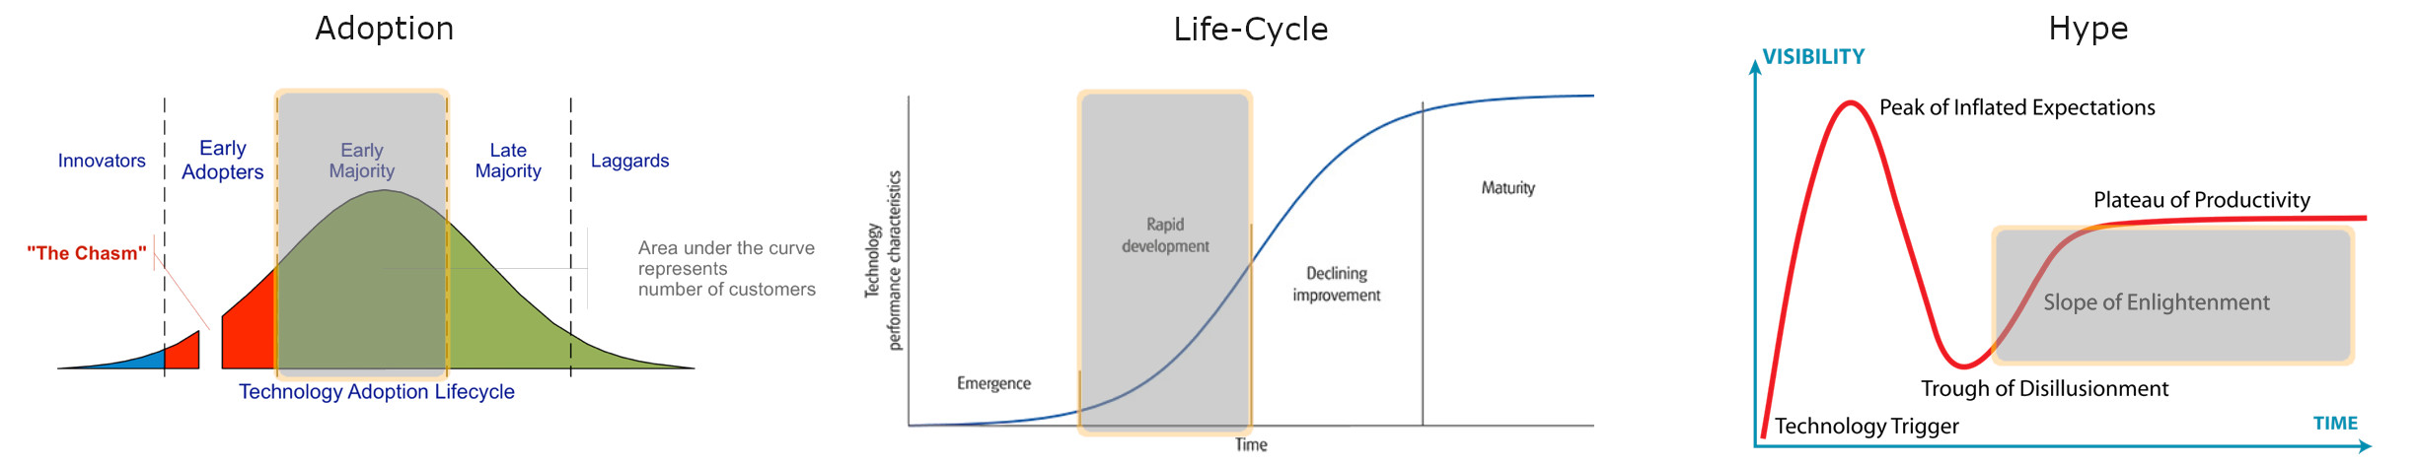

5G telecoms are the convergence of existing network technologies with new radio bands and cellular radio technologies to enable much higher speeds and the ability to sustain more concurrent connections.

### Market Viability

The widespread adoption of 5G is already underway. Most major cellular carriers offer some version of 5G network connectivity across the whole of the United States, and the density of 5G-capable cellular towers is increasing rapidly. As more and more consumer devices and networks adopt 5G connectivity, the number of applications for the technology will grow as well. High fidelity video streaming, seamless video calling, an increase in IoT connections, and virtual experiences streamed from remote computers are all expected to become more common in the coming years (Taulli, 2020). In addition, as 5G broadcast towers become more common and more of 5G’s network bands are fully served, 5G connectivity may offer a competitive alternative to broadband internet services.

### Value Network

The value network of the 5G telecommunications technology is vast and interconnected, which is one of the contributing factors to its rapid spread. Cellular radio chips and the devices that use them are manufactured and distributed by a wide range of companies across the globe, laying a strong foundation for adoption. Multiple regulatory and management bodies are involved in the operation and adoption of 5G, such as the FCC and 3GPP, which continues to help ensure that all 5G compatible devices are clearly labeled and adhere to the network standards to enable fast and stable connections. The customers of 5G are another major component of its value network, primarily brought into the network by the adoption of 5G by major cell carriers.

### Proposal

The Kent School District should aim to adopt 5G as soon as possible for the benefit of both the district itself and the students it serves. With all schools in the district now having adopted a 1:1 student-to-laptop ratio, as well as deploying smart displays in many classrooms across the district, the local wireless networks of many schools are reaching their capacity. The adoption of 5G, either built into new technologies or used via cellular peripherals distributed with laptops, could provide every student and teacher a fast, stable connection and reduce the district’s IT budget by removing the need to maintain such a large local network. Additionally, as a sizeable percentage of families in the Kent School District are lower income and lack stable home internet connections, the distribution of 5G devices to students could enable them to study at home and complete assignments that would otherwise be impossible.

## Augmented/Virtual Reality

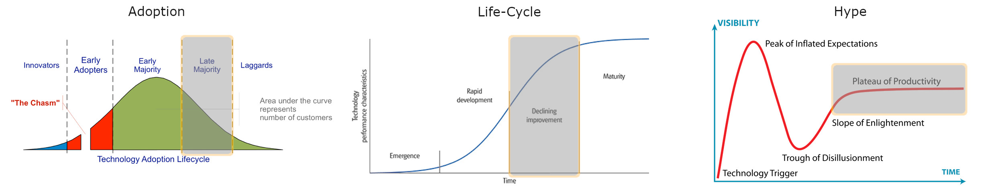

Augmented and Virtual Reality is the fusion of existing technologies like high-definition screens, motion tracking, and interactive software in order to provide users with a unique experience unlike anything standard software can. For the Kent School District’s purposes, the use of AR/VR technology is speciation from its primary domain of entertainment and gaming.

### Market Viability

Virtual Reality is already a market viable technology in the domain of entertainment and gaming, providing unique virtual experiences across a wide variety of platforms and genres from virtual chatrooms to games designed specifically for VR. Augmented Reality has been slower to catch on and be adopted widely, mostly due to the comparative lack of devices and software applications supporting AR available. Augmented Reality has so far mostly had success in the industrial domain, allowing companies to provide virtually guided hands-on training to new employees and virtual guidance in machine repair (Davenport, 2021). As the price of virtual and augmented reality devices continue to fall, and the software offered for them becomes more functional, these devices will become more and more viable in the domains they currently inhabit as well as new domains.

### Value Network

The majority of the value network of Augmented and Virtual Reality is shared with similar technologies like cell phones and game consoles, making the network of manufacturers and distributors well suited to develop and deploy the technology. The high-definition screens and chipsets required to manufacture AR/VR headsets are widely available due to their similarity to those used in cell phones and similar devices. Software for AR/VR experiences is no longer only developed by niche companies, making the availability and cost of 3rd party development cheaper than ever before. The customers of Augmented and Virtual Reality technologies are a major driving factor in their development and adoption and a key part of their value network, as evidenced by the current primary domain of AR/VR being entertainment and gaming.

### Proposal

The current state of Augmented and Virtual Reality technology is not at a point where the Kent School District needs to immediately act, as the availability of relevant software solutions and the cost of hardware are not yet a fit for the needs of the district. But the Kent School District should keep these technologies, specifically Augmented Reality, in mind for the coming years as the technology develops. Current deployments of Augmented Reality in the industrial sector prove out the viability of AR devices as a method of hands-on learning that could be effectively adapted for use in the classroom. Augmented and Virtual Reality could someday provide more engaging lessons in the classroom and afford teachers the opportunity to give lessons otherwise impossible from books alone.

## Artificial Intelligence

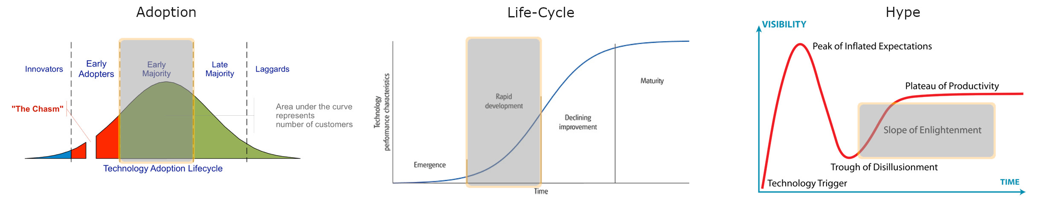

Artificial Intelligence is a broad technology but is mostly the convergence of many disparate technologies, such a machine learning, with existing problem-solving software.

### Market Viability

Artificial Intelligence, in one form or another, is already a market viable technology. Hundreds of companies around the world use AI software, mostly based on machine learning, daily to solve complex problems and identify patterns more quickly than a human can. Automated and partially automated vehicles use limited artificial intelligence to determine the best course of action at any given moment, based on advanced algorithms and training data. Voice assistance like Siri, Cortana, and Google Assistant, as well as customer service chatbots, use artificial intelligence to parse the requests given to them and take appropriate actions on behalf of the user. AI has been viable in every industry it has been introduced to so far, and as the technology continues to develop and advanced into more intelligent forms of artificial intelligence this trend is expected to continue.

### Value Network

The value network of artificial intelligence as a technology is heavily dependent customer input and on operations. Customer input is what drives and will continue to drive the advancements in artificial intelligence, especially while the technology is in the current stage of training-based machine learning, as only the intelligent users of the artificial intelligence can gauge the technology’s facsimile of intelligence. The second most important part of artificial intelligence’s value network is the operational capacity for AI algorithms to be stored and run on adequate hardware and servers in order to enable effective machine learning.

### Proposal

Artificial Intelligence is not yet at a point which is highly beneficial to the Kent School District, but as AI algorithms and machine learning increase to the point of a facsimile of emotional intelligence that evaluation will change. Most likely in the next 3-5 years, Artificial Intelligence like that used in voice assistants will be able to accurately gauge the emotional state of the user and read non-verbal cues in order to better serve the user. This emotionally intelligent AI will most likely originate in customer service and retail industries, but will trickle down into the education sector through automated services that help students with homework and to resolve problems. While this technology is fairly far off, it is in the best interest of the Kent School District to keep these sorts of technologies in mind as they come online.

## Blockchain

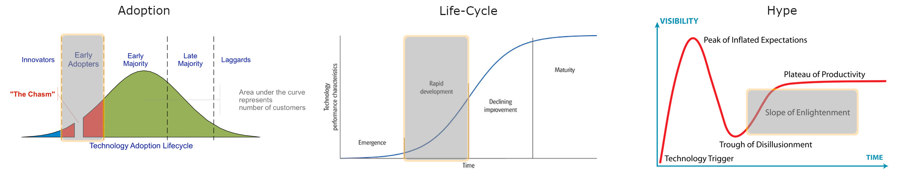

Blockchain is a type of distributed ledger system, which is a fusion of peer-to-peer networking and cryptography among others, that allows for highly secure and transparent record keeping.

### Market Viability

Blockchain is currently viable as the basis for cryptocurrencies such as Bitcoin and Ethereum but is gaining more and more viability in other areas where secure transactions are required. Voting, banking, and digital signatures are three areas where blockchain technology is being used to guarantee the authenticity and security of transactions and records (*The next big thing...* 2021). Blockchain technology is also being considered for tax recording and auditing, as it would allow the auditing process to be much faster and more thorough. This technology has already spread outside of the high-profile industry of digital currency and can be expected to gain very notable expansion into other industries in the next few years.

### Value Network

The most important part of blockchain’s value network is the customer feedback; if customers and users of products backed up by the inherent security of blockchain transactions don’t believe in or trust the security of blockchain technology, then they will not support products that use the technology. Another important element of the value network of blockchain is the community which maintains the blockchain. As a transparent, distributed ledger, blockchain technologies cannot exist without a large enough base of maintainers authenticating and recording transactions.

### Proposal

Only one blockchain backed technology is currently a viable solution for the Kent School District. The authentication of student identity, transcripts, and test results via blockchain would allow schools in the Kent School District to transmit guaranteed records of student standing between the school and parents, and more importantly obviate the need for sealed, paper transcripts to be mailed to colleges. Another more far off blockchain technology that may someday be employed by the Kent School District is the ability to track the supply chain of foods served in the cafeteria. This is a blockchain technology very early in development but would allow schools to guarantee their food was safe and that nothing came into unexpected contact with allergens.

## Driverless Vehicles

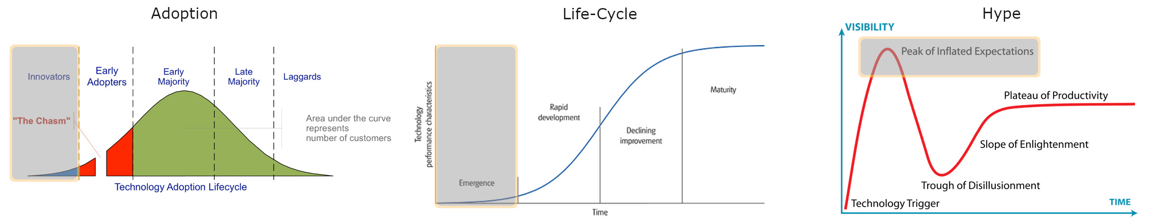

Driverless Vehicles, or Autonomous Vehicles, are the convergence of automobiles, artificial intelligence, and advanced sensor technology, and allow vehicles to operate without direct input from a driver.

### Market Viability

There are currently no viable truly Driverless Vehicle technologies on the market, although there are many fully- or mostly autonomous vehicle technologies deployed in small geographic areas under strict supervision. The problem keeping Driverless Vehicle technology from market viability is multi-faceted. One difficulty is that federal and local government regulations are slow to adapt to new technologies, and as such the wide adoption of autonomous vehicles will be artificially slowed by regulation. Another is that while current autonomous vehicle tests can deftly maneuver through reasonable traffic in reasonable conditions, human drivers and mother nature are not always reasonable. It will likely take a number of years before fully autonomous vehicles become commercially available, but at the current rate of growth is very possible that driverless buses and semis may see use within the next few years.

### Value Network

The value network of Driverless Vehicle technology relies heavily on the value network of vehicle manufacturers, as nearly all autonomous vehicle tests are built upon existing vehicles. Another element of the value network of Driverless Vehicles are the disparate manufacturers of the sensors (lidar, radar, camera, etc.) and computers required to enable a vehicle with autonomous functionality. Possibly most importantly of any element of the value network, the customers and their feedback govern the direction of the advancement of Driverless Vehicles.

### Proposal

While a large portion of the Kent School District’s students live within walking distance of their respective schools, there are dozens of buses and bus drivers employed by the district to ferry students to and from school. As the technology for Driverless Vehicles comes online within the next decade, it would be reasonable to sunset the existing legacy bus technology in exchange for safe, autonomous buses. This would allow school staff to prioritize the safety of the students on and around the bus instead of focusing on the act of driving. Barring the adoption of autonomous buses, the Kent School District could also invest in adjacent technology for the district’s fleet of buses, such as sensors and cameras to improve the safety of existing buses.

# References

Davenport, T. (2021, February 05). Augmented reality: The new knowledge management. Retrieved February 07, 2021, from <http://www.forbes.com/sites/tomdavenport/2021/02/05/augmented-reality-the-new-knowledge-management/>

Eliot, L. (2021, January 26). Self-Driving cars Spurring nearby human drivers into speeding and Abysmal reckless driving. Retrieved February 07, 2021, from <http://www.forbes.com/sites/lanceeliot/2021/01/28/self-driving-cars-spurring-nearby-human-drivers-into-speeding-and-abysmal-reckless-driving/>

Honeywell BrandVoice: How 5G will change the world - and why it's even more important now. (2020, September 18). Retrieved February 07, 2021, from <http://www.forbes.com/sites/honeywell/2020/09/18/how-5g-will-change-the-world---and-why-its-even-more-important-now>

Joshi, N. (2019, June 26). 7 types of artificial intelligence. Retrieved February 07, 2021, from <http://www.forbes.com/sites/cognitiveworld/2019/06/19/7-types-of-artificial-intelligence/>

Kent School District Interactive Fast Facts. (2021, February 04). Retrieved February 07, 2021, from <https://public.tableau.com/profile/kent.school.district#!/vizhome/KSDFastFacts/KSDFastFactsHome>

Kite-Powell, J. (2020, December 28). How augmented reality will affect these Four industries in 2021. Retrieved February 07, 2021, from <http://www.forbes.com/sites/jenniferhicks/2021/12/28/how-augmented-reality-will-affect-these-four-industries-in-2021/>

Marr, B. (2020, October 13). The 4 top artificial Intelligence trends for 2021. Retrieved February 07, 2021, from <http://www.forbes.com/sites/bernardmarr/2020/09/21/the-4-top-artificial-intelligence-trends-for-2021/>

The next big thing: The top five emerging blockchain technologies. (2021, February 04). Retrieved February 07, 2021, from <http://digitalskills.engin.umich.edu/fintech/top-five-emerging-blockchain-technologies/>

Ohnsman, A. (2021, January 30). Self-Driving tech heads to transit with New FLYER'S autonomous electric bus. Retrieved February 07, 2021, from <http://www.forbes.com/sites/alanohnsman/2021/01/29/self-driving-tech-goes-to-transit-with-new-flyers-autonomous-electric-bus/>

Smith, S. (2021, February 03). Crypto taxes make headlines, but blockchain might be the key to real time reporting. Retrieved February 07, 2021, from <http://www.forbes.com/sites/seansteinsmith/2021/02/03/crypto-taxes-make-headlines-but-blockchain-might-be-the-key-to-real-time-reporting/>

Taulli, T. (2020, December 26). 5G: What can we expect for next year? Retrieved February 07, 2021, from <http://www.forbes.com/sites/tomtaulli/2020/12/26/5g-what-can-we-expect-for-next-year>