UAT MS555 Assignment 2

Tough Mudder

Problem Statement
Our friend has convinced us that we should compete in an upcoming Tough Mudder event. The Tough Mudder Classic is an untimed race through 8-10 miles of mud and 25 unique obstacles, this may be fun but we also might die.

Gold Card

Cost
(Undefined, though a rough budget of $500 should be able to account for any travel, lodging, and the required ticket needed to compete in nearby Tough Mudder.)

Schedule
90 days

Scope
- Compete in a Tough Mudder
- Complete a Tough Mudder

The Problem
We’ve been convinced to take part in a Tough Mudder and need to prepare within 90 days.

The Customers
Ourself and our friend who convinced us to do this.

WBS
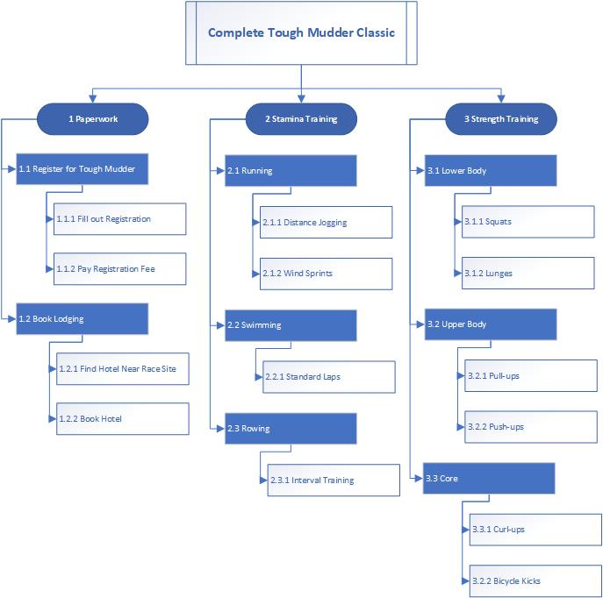

Risk Matrix

Risk Matrix Definitions

Inclement Weather
While Tough Mudders are very rarely canceled due to inclement weather, it has been known to happen. We can’t do much to reduce the likelihood of of a cancellation since that’s up to the weather and the Tough Mudder staff, but we can have a plan in place in the rare case that that does happen. Alternate races could be later Tough Mudders in nearby locations, or comparable events. Either way, wasting our planning and training is the worst option.

Shin Splints
Shin splints are a common occurrence among both distance runners and sprinters, and can cause a decent amount of pain both during and after a race. A case of shin splints is unlikely to end our run in the Tough Mudder, but it definitely won’t make it any easier, so we can attempt to mitigate the potential for shin splints by strengthening our calves and hips during training and stretching adequately prior to training and on race day.

Ankle Sprain (During Race)
If we sprain an ankle during the Tough Mudder it’s a near-positive that we won’t be able to finish in a reasonable amount of time, if at all. To mitigate the risk of a sprained ankle during the race we need to strengthen our calves, ankles, and feet during training as well as appropriately stretching and warming up before our wave on race day. A quality pair of shoes that offer adequate ankle support will also help prevent ankle sprains.

Ankle Sprain (During Training)
If we sprain an ankle during our training, it has the potential to take a huge chunk of time out of our stamina training schedule. Quality shoes, proper stretching, and avoiding rough terrain will help us avoid a sprained ankle. Diversifying our stamina training regimen to include more than just running will also help to mitigate the effects of a potential sprained ankle.

Morale Loss
Running and training for Tough Mudder is hard and our only skin in the game is that our friend thought it would be a good idea that we sign up. If we lose morale at any time during the training process or race it’s possible that we either give up entirely or suffer a delay in our training schedule. In order to combat this, we’re going to sign our friend(s) up as well. Having a support structure in others who are going through a similar last-minute training process will give us a level of external accountability and help us to strive for something.

Global Pandemic
While generally this isn’t very likely to happen it has similar effects to the Inclement Weather risk, with Tough Mudder being canceled or delayed. We can mitigate this risk by preparing for alternative races.

Dislocated Shoulder
With the level of physical exertion during a Tough Mudder and some of the obstacles requiring climbing, especially with the aid of others, it’s possible that during the run we may experience a dislocated shoulder. A dislocated shoulder will definitely end our run completely unless it happens during the very last obstacles of the course, in which case it’s only be very likely to end our run. In order to mitigate the risk of a dislocated shoulder we can prioritize strengthening our shoulders, back, and upper arms during training.

Dehydration
Dehydration is extremely common in athletes of all kinds and its effects are often not felt until well after it happens, especially while physically exerting oneself. The weakness, fatigue, and lightheadedness brought on by dehydration will very likely negatively affect our training schedule and performance on race day. During training we can mitigate this risk by properly hydrating ourselves before and during training, especially by replenishing the electrolytes lost through sweat. On race day, we should thoroughly hydrate before our wave and also make use of the 4-5 mid-course drink stations provided by Tough Mudder. Even if we don’t feel thirsty we should be aware that our body definitely will be.

