|  |
| --- |
| Food Violations Report |
| Jake Attard s51386472810ICT Software TechnologiesOctober 6, 2019 |

# Abstract

This report is based on food inspection and health violation data provided in excel sheets which has been analysed and put into a sqlite database. Python was used to analyse the data through graphs being made using matplotlib which is an extension to numpy. Matplotlib is a plotting library which is able to generate graphs using the Python programming language. This report provides methods for each of the four tasks making the data presented straightforward which meets the tasks requirement. All of the results in this report are analysed in depth with clear conclusions for the tasks completed.

# Introduction

The purpose of this report is to analyse food inspections and health violations by using the data provided in the two excel documents inspections and violations. This information is then put into a sqlite database which is used to create Python programs which analyse and highlight key data as specified.

Task 1 required to create a new Python program called createddb_food.py. The main purpose of this file was to create a sqlite database called ‘database.db’ which imports all the information from the insepctions.xlsx and violations.xlsx. All the column names from the excel files were used as the column name for the database. Within the database there was two tables created called inspections and violations.

Task 2 required to create a new Python program called sql_food.py. This Python program lists all the distinctive businesses which have at least one violation. The businesses name is then listed alphabetically in the console with the count of the violations for each individual business. This data is then saved into the ‘database.db’ in a new table called previous_violations. The table includes the columns of the business name, address, zip code and city.

Task 3 required to create a new Python program called excel_food.py. This program file creates a new excel file called ViolationTypes.xlsx with the sheet name Violations Types. The purpose of the excel file is to display the total number of violations broken down into three columns showing the code, description and count. The total count of all violations is at the bottom of the data count (line 118).

Task 4 required to create a new Python program called numpy_food.py. This program file creates two graphs; the first graph includes the postcode with the highest total of violations per month, postcode with the lowest total of violations and the average number of violations per month for all of California. The second graph includes the average number of violations per month for all of McDonalds compared with Burger Kings.

## Database Structure

Three database tables were created which included inspections, violations and previous_violations. Here below is the sql query commands for creating the three databases.

CREATE TABLE inspections (

activity_date date, employee_id varchar(12), facility_address varchar(120), facility_city varchar(60), facility_id varchar(12), facility_name varchar(12), facility_state varchar(2), facility_zip varchar(10), grade text, owner_id varchar(12), owner_name varchar(100), pe_description text, program_element_pe integer(4), program_name varchar(100), program_status text, record_id varchar(12), score integer(3), serial_number varchar(15), service_code integer(5)

);

CREATE TABLE violations {

points integer(2), serial_number varchar(15), violation_code varchar(5), violation_description text, violation_status text

};

CREATE TABLE previous_violations {

name varchar(100), address varchar(120), zipCode varchar(10), city varchar(60)

};

A UML diagram demonstrating the structure of each table in the database has been provided.

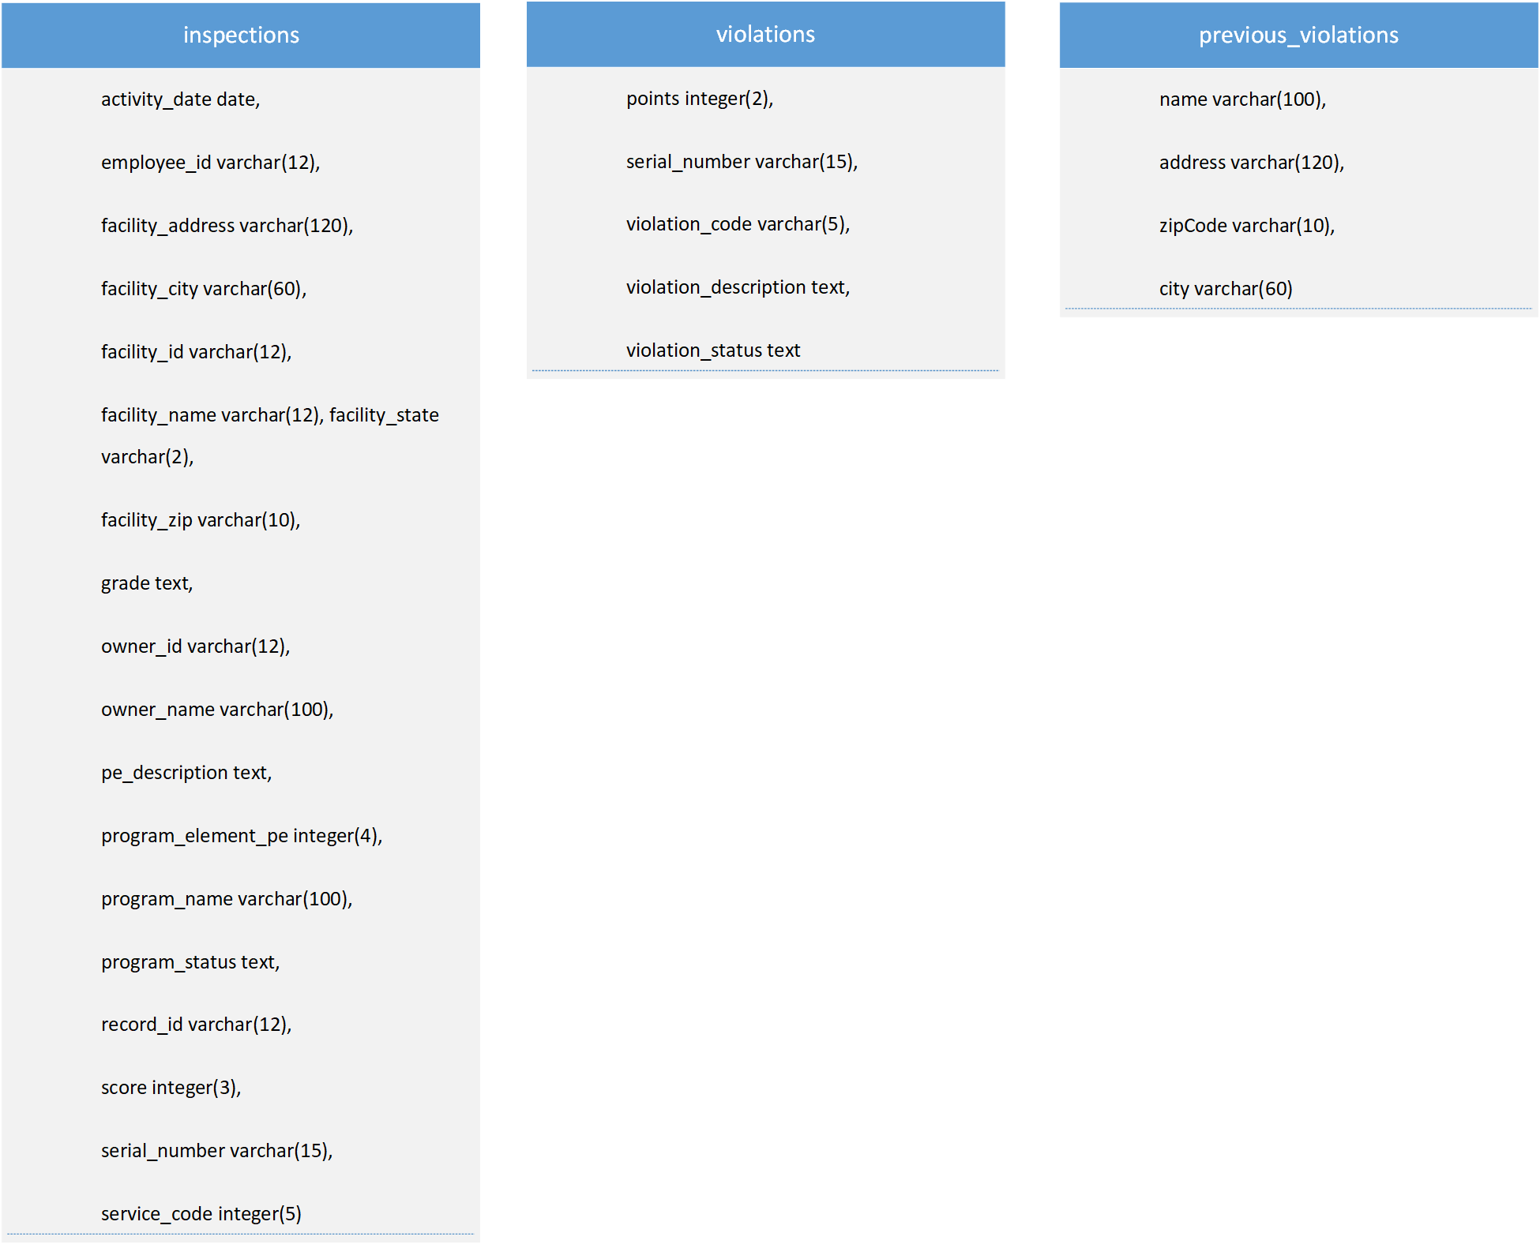

## Database Images

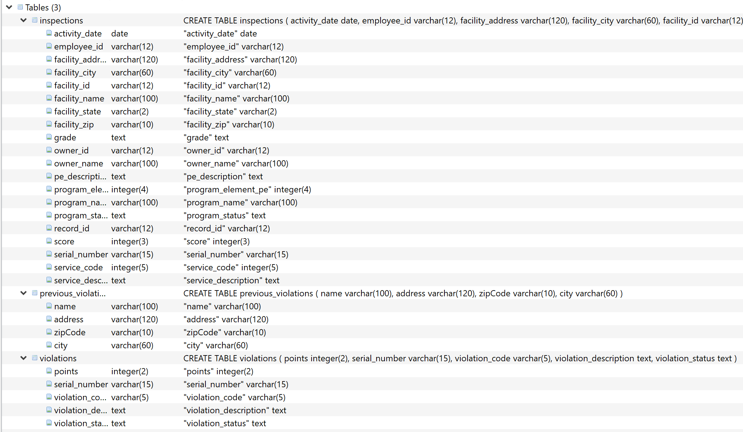

## Inspections Table

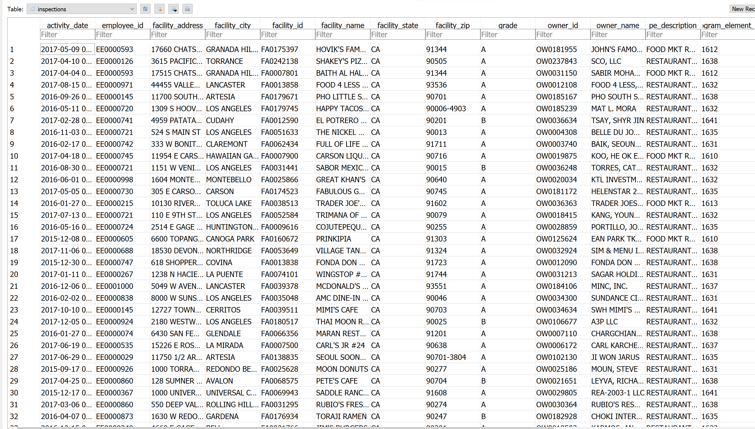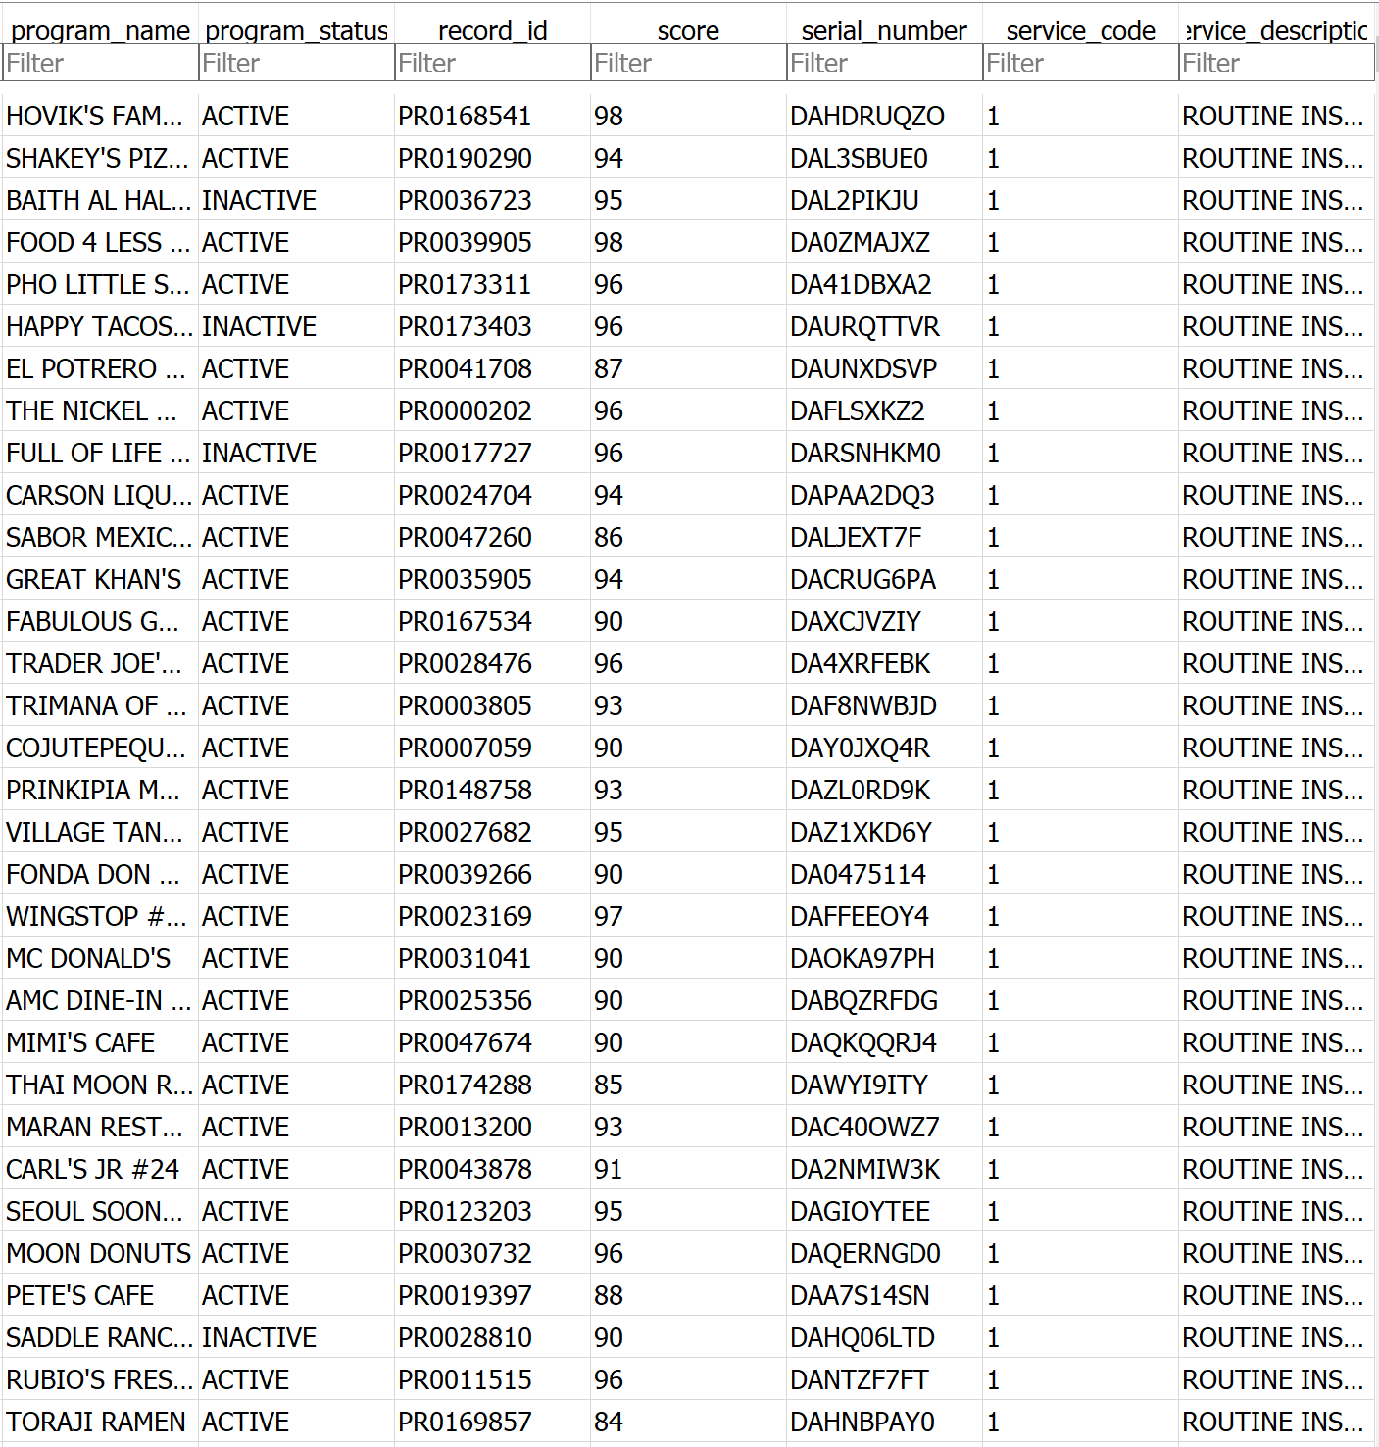

## Violations Table

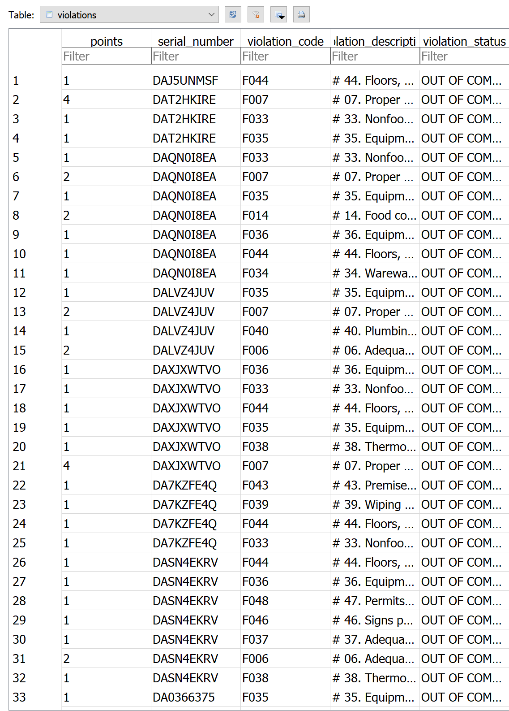

## Previous_Violations Table

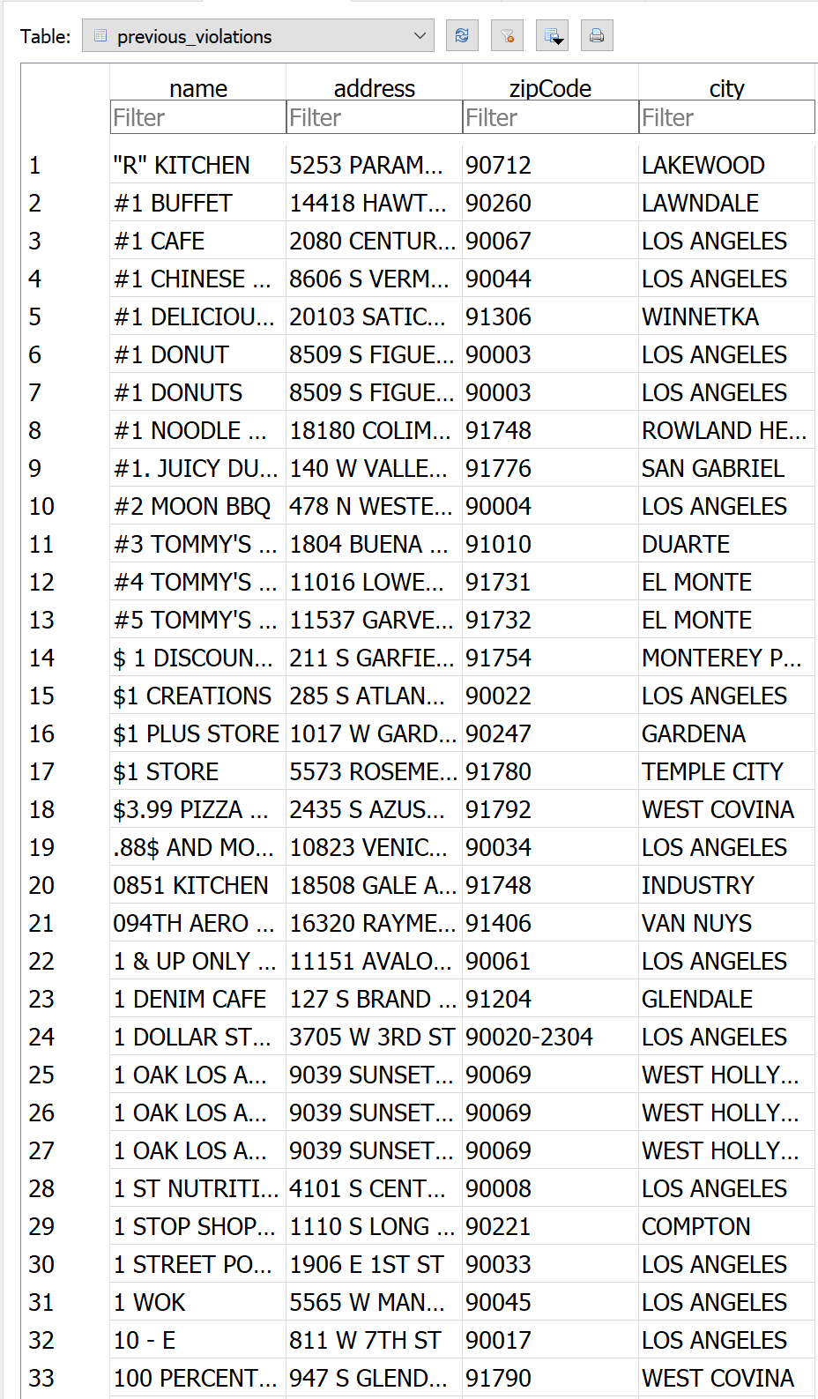

# **Querying the database**

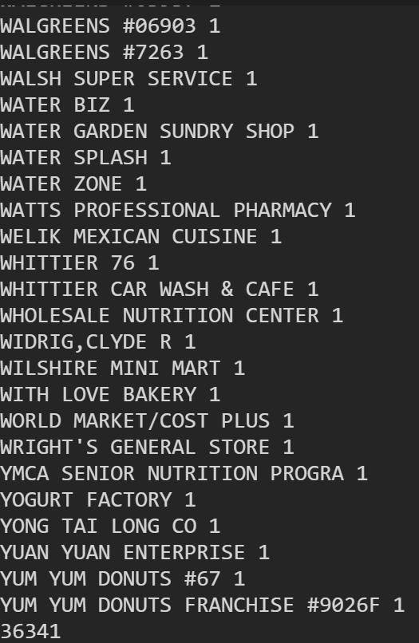

# **Violation counts**

The excel workbook ViolationTypes shows the number of each type of violations based on the violation code. This data was taken from the database ‘database.db’ by querying the above requirement. The data was then displayed in excel to help with the readability when conducting an analysis of the information.

The total count of the number of violations was a staggering 906,014. Two code violations had a high amount of violations compared to the other codes. This included code F033 with 100,083 violations and F044 with 102,012 violations. Code violation F033 is a nonfood-contact surfaces, clean and in good repair while F044 is floors, walls and ceilings properly built, maintained in good repair and clean. From analysing the data it can be seen that no code violations have zero violations however fifteen codes have only one violation.

|  |  |  |
| --- | --- | --- |
| **Code** | **Description** | **Count** |
| CL21 | Public Health Permit/License valid | 1 |
| F001 | # 01a. Demonstration of knowledge | 6883 |
| F002 | # 02. Communicable disease; reporting, restrictions & exclusions | 40 |
| F003 | # 03. No discharge from eyes, nose, and mouth | 37 |
| F004 | # 04. Proper eating, drinking, or tobacco use | 3365 |
| F005 | # 05. Hands clean and properly washed; gloves used properly | 5152 |
| F006 | # 06. Adequate handwashing facilities supplied & accessible | 33954 |
| F007 | # 07. Proper hot and cold holding temperatures | 41110 |
| F008 | # 08. Time as a public health control; procedures & records | 4707 |
| F009 | # 09. Proper cooling methods | 7994 |
| F010 | # 10. Proper cooking time & temperatures | 54 |
| F011 | # 11. Proper reheating procedures for hot holding | 855 |
| F012 | # 12. Returned and reservice food | 31 |
| F013 | # 13. Food in good condition, safe and unadulterated | 5012 |
| F014 | # 14. Food contact surfaces: clean and sanitized | 34447 |
| F015 | # 15. Food obtained from approved source | 623 |
| F016 | # 16. Compliance with shelf stock tags, condition, displayed | 1088 |
| F017 | # 17. Compliance with Gulf Oyster Regulations | 48 |
| F018 | # 18. Compliance with variance, specialized process, & HACCP Plan | 214 |
| F019 | # 19. Consumer advisory provided for raw or undercooked foods | 256 |
| F020 | # 20. Licensed health care facilities/public & private schools; prohibited foods not offered | 2 |
| F021 | # 21b. Water available | 6791 |
| F022 | # 22. Sewage and wastewater properly disposed | 1639 |
| F023 | # 23. No rodents, insects, birds, or animals | 29730 |
| F024 | # 24. Person in charge present and performs duties | 983 |
| F025 | # 25. Personal cleanliness and hair restraints | 11878 |
| F026 | # 26. Approved thawing methods used, frozen food maintained frozen | 7799 |
| F027 | # 27. Food separated and protected | 17867 |
| F028 | # 28. Fruits and vegetables washed as required | 207 |
| F029 | # 29. Toxic substances properly identified, stored, used | 17986 |
| F030 | # 30. Food properly stored; food storage containers identified | 39855 |
| F031 | # 31. Consumer self service facilities properly constructed and maintained | 669 |
| F032 | # 32. Food properly labeled & honestly presented | 6735 |
| F033 | # 33. Nonfood-contact surfaces clean and in good repair | 100083 |
| F034 | # 34. Warewashing facilities: Adequate, maintained, properly use, test strips available | 19210 |
| F035 | # 35. Equipment/Utensils - approved; installed; clean; good repair, capacity | 80020 |
| F036 | # 36. Equipment, utensils and linens: storage and use | 49744 |
| F037 | # 37. Adequate ventilation and lighting; designated areas, use | 48046 |
| F038 | # 38. Thermometers provided and accurate | 11061 |
| F039 | # 39. Wiping cloths: properly used and stored | 35849 |
| F040 | # 40. Plumbing: Plumbing in good repair, proper backflow devices | 50870 |
| F041 | # 41. Garbage and refuse properly disposed; facilities maintained | 4742 |
| F042 | # 42. Toilet facilities: properly constructed, supplied, cleaned | 16153 |
| F043 | # 43. Premises; personal/cleaning items; vermin-proofing | 42949 |
| F044 | # 44. Floors, walls and ceilings: properly built, maintained in good repair and clean | 102012 |
| F045 | # 45. Sleeping quarters | 437 |
| F046 | # 46. Signs posted; last inspection report available | 15736 |
| F047 | # 48. Plan Review required for new or remodel construction | 607 |
| F048 | # 47. Permits Available | 5515 |
| F049 | # 50. Impoundment of unsanitary equipment or food | 5928 |
| F050 | # 51. Permit Suspension | 2955 |
| F051 | # 49. Samples Collected | 40 |
| F052 | # 01b. Food safety certification | 18359 |
| F053 | # 21a. Hot Water Available | 4218 |
| F054 | # 52. Multiple Major Critical Violations / Increased Risk to Public Health | 1214 |
| F055 | # 01a. Demonstration of knowledge | 1515 |
| F056 | # 10. Proper cooking time & temperatures | 12 |
| F057 | # 18. Compliance with variance, specialized process, & HACCP Plan | 43 |
| F058 | # 19. Consumer advisory provided for raw or undercooked foods | 185 |
| MF07 | # 07. Adequate handwashing facilities supplied & accessible | 1 |
| MF42 | # 42. Garbage and refuse properly disposed; facilities maintained | 1 |
| SF15 | No Health Code Violations Observed At The Time Of Inspection | 1 |
| SS33 | Garbage / rubbish receptacles not maintained clean and sanitary | 1 |
| W001 | Proper hot and cold holding temperatures | 9 |
| W002 | Food in good condition, safe and unadultered | 1 |
| W003 | Food storage separated and protected | 6 |
| W004 | Food storage space | 3 |
| W005 | Food elevated | 11 |
| W006 | Food packaging protected | 2 |
| W008 | Rodent | 6 |
| W009 | Cockroaches | 42 |
| W011 | Storage of materials 18 inches above the floor. | 2 |
| W012 | Fly Breeding Material | 3 |
| W014 | Fly Breeding | 5 |
| W016 | Building rodent proof | 3 |
| W017 | Hot and cold water available | 18 |
| W018 | Waste water or sewage properly disposed or not discharged on the ground. | 3 |
| W019 | Plumbing approved and maintained in good repair. | 15 |
| W020 | Wall(s) maintained clean | 9 |
| W021 | Wall(s) maintained in good repair | 6 |
| W022 | Wall(s) constructed of approved material | 1 |
| W023 | Floor maintained clean | 23 |
| W024 | Floor maintained in good repair | 6 |
| W025 | Ceiling maintained clean | 2 |
| W026 | Ceiling maintained in good repair | 3 |
| W027 | Ceiling constructed of smooth, durable, and non-absorbent material | 6 |
| W028 | Toilet in good repair | 4 |
| W029 | Toilet maintained clean / sanitary | 6 |
| W030 | Hand sink in good repair | 1 |
| W031 | Hand sink maintained clean / sanitary | 4 |
| W032 | Toilet room floor / walls / ceiling in good repair | 3 |
| W033 | Toilet room floor / walls / ceiling clean | 2 |
| W034 | Toilet room with toilet paper / soap / towels / trash receptacle | 4 |
| W035 | Toilet room well ventilated | 2 |
| W036 | Toilet room well lighted | 2 |
| W037 | Toilet available | 1 |
| W038 | Hand sink available | 2 |
| W039 | Proper storage or use of hazardous materials | 1 |
| W040 | Compliance with shellfish tag requirements | 2 |
| W041 | Premises maintained clean and sanitary | 6 |
| W042 | Garbage / Rubbish receptacles approved type | 8 |
| W043 | Garbage / Rubbish receptacles maintained in good repair | 3 |
| W044 | Garbage / Rubbish receptacles maintained clean and sanitary | 4 |
| W045 | No unapproved sleeping accomodations | 1 |
| W046 | Live animals | 2 |
| W047 | Thermometer: available, maintained in good repair | 8 |
| W048 | Permits Available | 122 |
| W049 | Food from an approved source | 5 |
| W050 | Food properly labeled | 15 |
| W051 | Walls, Floors, Ceilings: approved, maintained clean and in good repair | 32 |
| W052 | Equipment, Shelving, Cabinets: approved, maintained clean and in good repair | 31 |
| W053 | Permit Suspension | 35 |
| WP13 | # 13. Disease Transmission - Carrier / Lesion / Rash | 1 |
| WP15 | # 15. Tobacco / Eating / Drinking / Habits / Behaviors | 1 |
| WP16 | # 16. Hair Restraints / Outer Garments / Nails / Rings | 1 |
| WP18 | # 18. Personal Hygiene | 1 |
|  | Total Sum | 906014 |

# **Violations over time**

Based on Task 4 of your assignment, describe the results of your analysis (in addition to the graph – you may need to screenshot or otherwise export from your iPython console). Make any comments about the data you see fit.

# **Configuration Management and Version Control**

Throughout the Data Analysis and Visualisation project Github was used as the configuration management and version control. All my files were updated through Github whenever I made major or minor changes. These changes were labelled with a brief description so all updates were logged with what changed or was created. The main reasoning for this was to make sure if any unexpected issues arise within certain versions then it will be easy to look back at previous versions and investigate it.

# **Github Log**