**Validation Evidence Website Project**

Home Page Validation Evidence (index.html):

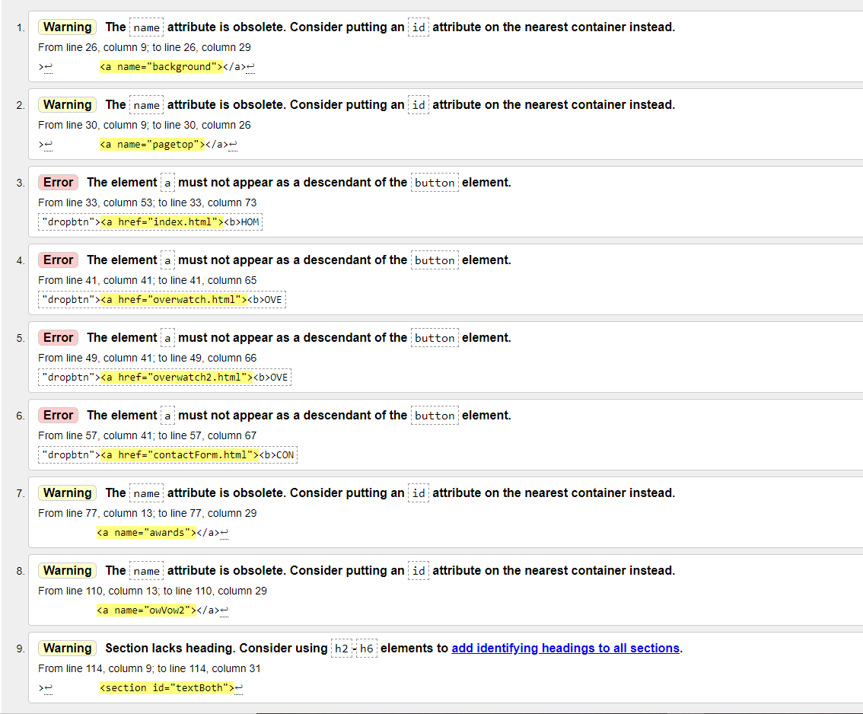

Overwatch Page Validation Evidence (overwatch.html):

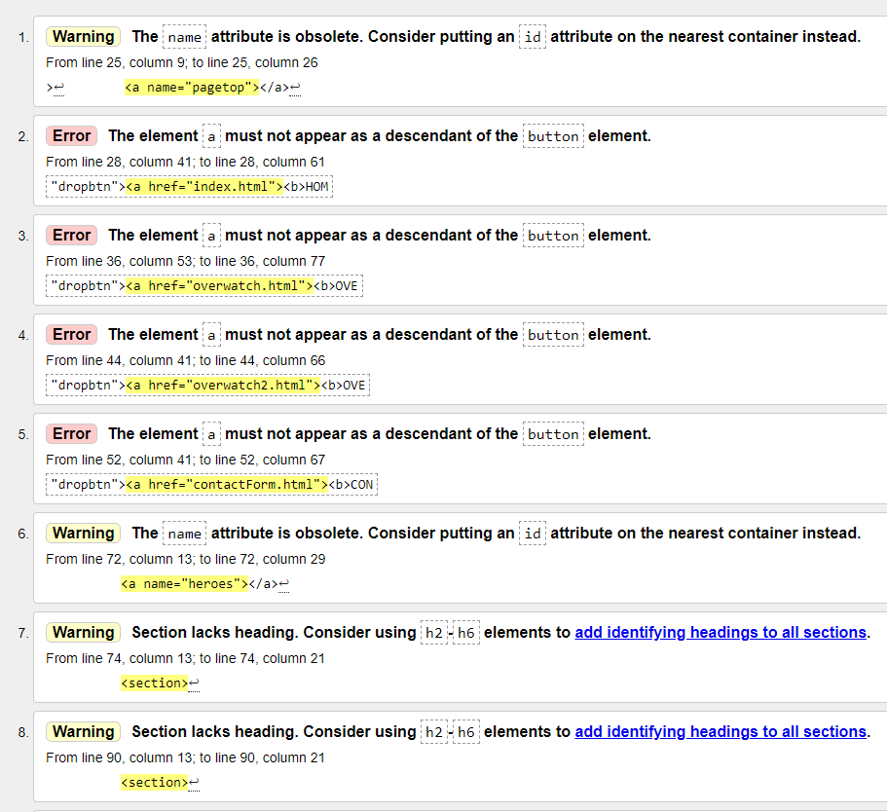

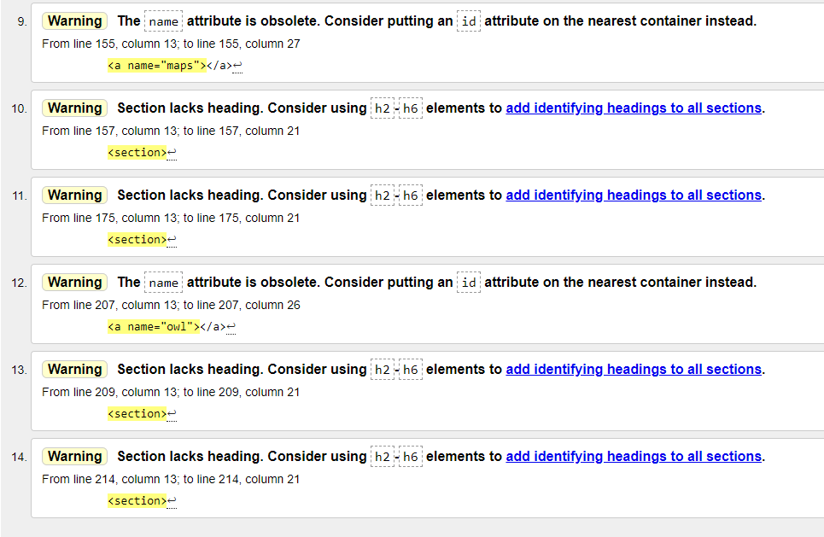

Overwatch 2 Page Validation Evidence (overwatch2.html):

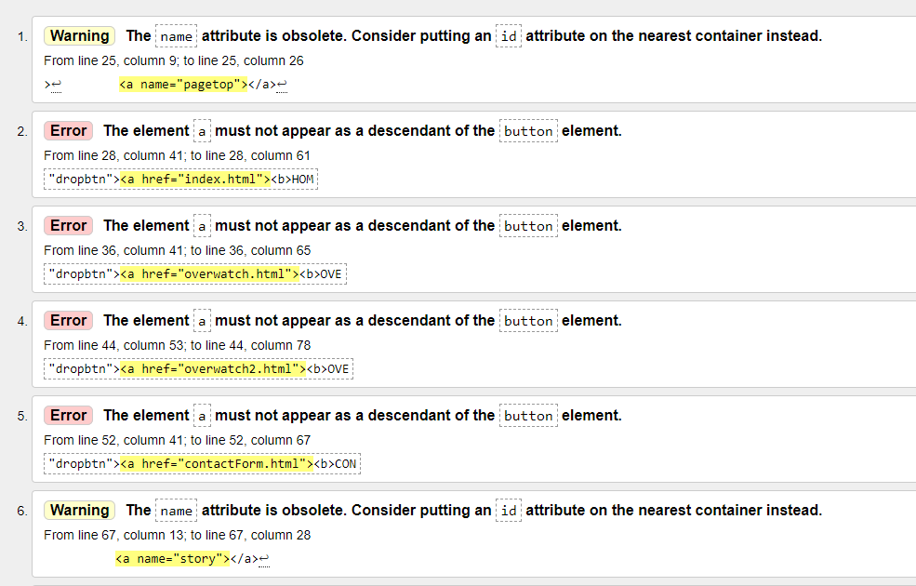

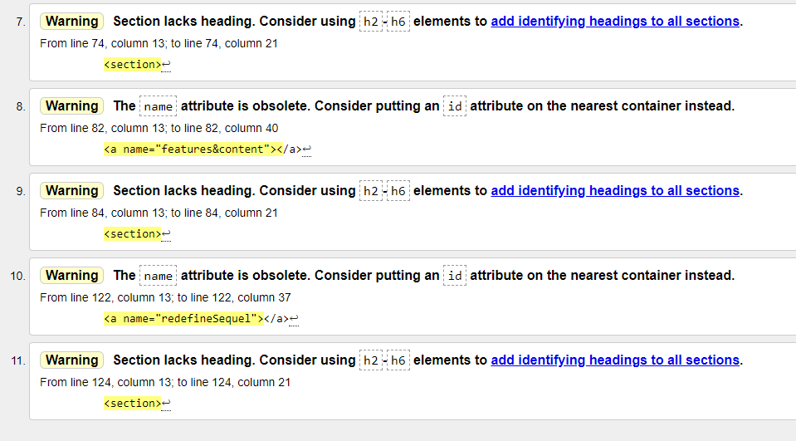

Contact Form Page Validation Evidence (contactForm.html):

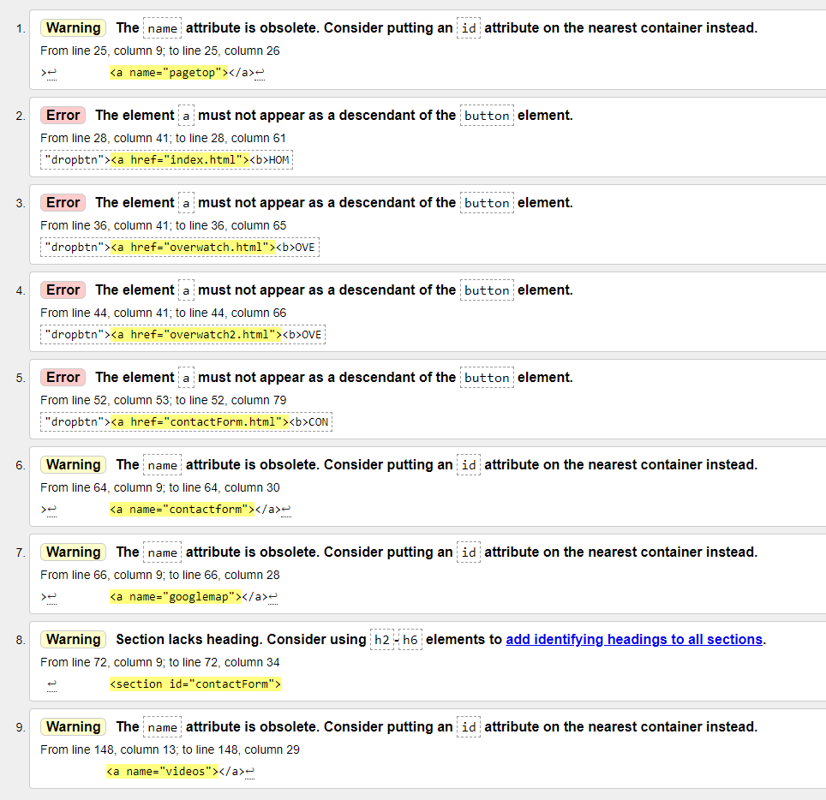

CSS Validation Evidence (style.css):

