Introduction

For my four page website project, I created a four page website on the award winning game franchise from Blizzard Entertainment, Overwatch. I made a Home Page, introducing Overwatch, talking about its achievements in terms of awards and differentiating between Overwatch and its upcoming sequel, Overwatch 2. Next, I made a page dedicated to Overwatch. Here I went into detail talking about the Heroes of Overwatch, the Maps of Overwatch and The Overwatch League. After that, I made a page dedicated to Overwatch 2. Here I went into detail talking about the Story of Overwatch 2, the New Features & Content of Overwatch 2 and how Blizzard Entertainment are going about Redefining a Sequel. The purpose of this website is to firstly promote Blizzard Entertainment’s game, Overwatch, and to secondly inform the audience of the differences between the original game, Overwatch and its upcoming sequel, Overwatch 2. The intended audience is to be people with an interest in video games and who are of an age of twelve years and over.

GitHub

GitHub Pages URL:

[**https://jakebeecham.github.io/WebDesignWebsite/**](https://jakebeecham.github.io/WebDesignWebsite/)

GitHub Repository URL:

[**https://github.com/JakeBeecham/WebDesignWebsite**](https://github.com/JakeBeecham/WebDesignWebsite)

Original Mockup Sketch of Website Home Page

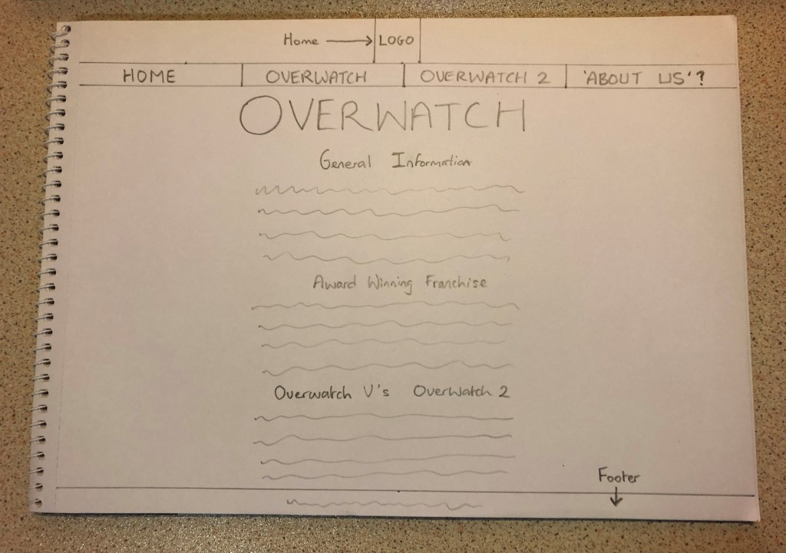

Website Described

Page 1 – Home Page

The purpose of my Home Page is to promote Overwatch and its upcoming sequel, Overwatch 2. It does this by giving a little background information about Overwatch as a game, informing the audience of Overwatch’s achievements in terms of awards and comparing the differences between Overwatch and Overwatch 2. This section clearly outlines the situation of the Overwatch franchise, as some of the Overwatch community is confused at this moment in time about the news of the upcoming sequel. I got all the information on this page from the [**Official Overwatch Website**](https://playoverwatch.com/en-gb/), the [**Official Overwatch 2 Website**](https://overwatch2.playoverwatch.com/en-gb/trailer) and the [**Overwatch IMDb Awards Page**](https://www.imdb.com/title/tt4332152/awards). All images used on this page were got using Advanced Google Image Search, with the usage rights of free to use or share.

Page 2 – Overwatch Page

The purpose of my Overwatch Page is to promote the game Overwatch. It does this by describing the features and content of the game, including the Heroes of Overwatch, the Maps of Overwatch and The Overwatch League. This is in order to help the audience differentiate between Overwatch and Overwatch 2. I got all the information on this page from the [**Official Overwatch Website**](https://playoverwatch.com/en-gb/) and the [**Official Overwatch League Website**](https://overwatchleague.com/en-us/). All images used on this page were got using Advanced Google Image Search, with the usage rights of free to use or share.

Page 3 – Overwatch 2 Page

The purpose of my Overwatch 2 Page is to promote the upcoming sequel of Overwatch, Overwatch 2. It does this by describing the Story of Overwatch 2, the New Features & Content of Overwatch 2 and how Blizzard Entertainment are trying to Redefine a Sequel. This is also in order to help the audience differentiate between Overwatch and Overwatch 2. I got all the information on this page from the [**Official Overwatch 2 Website**](https://overwatch2.playoverwatch.com/en-gb/trailer). All images used on this page were got using Advanced Google Image Search, with the usage rights of free to use or share.

Page 4 – Contact Form Page

The purpose of my Contact Form Page is to allow the audience to send feedback they may have about the website and questions they may have about Overwatch or Overwatch 2. This page also includes a Google Map of the headquarters of Blizzard Entertainment, as a little piece of extra information. Along with this, this page also includes two extra videos as advertisement, in order to try and get the audience to engage with Overwatch. The information on this page is from Google Maps and YouTube. All images used on this page were got using Advanced Google Image Search, with the usage rights of free to use or share.

HTML5 Validation Results

Page 1 – Home Page – index.html

Errors – I am leaving the 4 errors in because these are to do with my additional feature of dropdown lists, and I was following code I found.

Warnings –

“The ‘name’ attribute is obsolete”: I am leaving these 4 warnings in because they are to do with my internal navigation through my pages.

“Section lacks heading”: I am leaving this warning in because I have a heading outside the section that covers the section that it is warning has no heading.

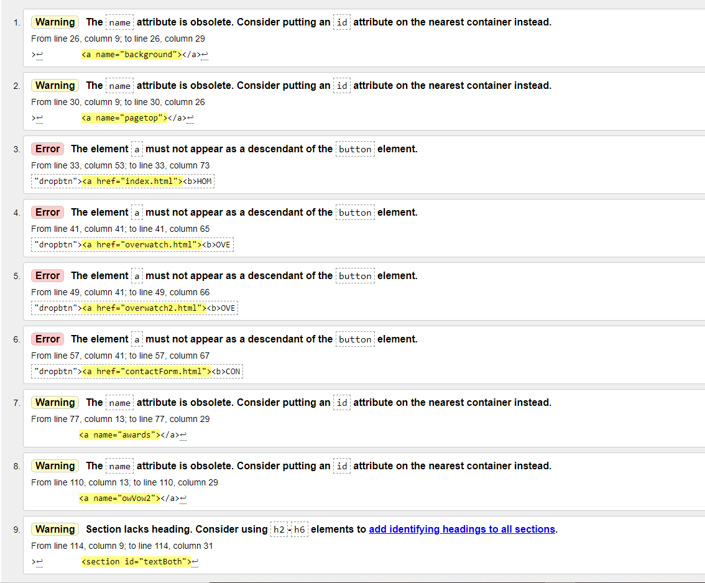

Page 2 – Overwatch Page – overwatch.html

Errors – I am leaving the 4 errors in because these are to do with my additional feature of dropdown lists, and I was following code I found.

Warnings –

“The ‘name’ attribute is obsolete”: I am leaving these 4 warnings in because they are to do with my internal navigation through my pages.

“Section lacks heading”: I am leaving these 6 warnings in because I have headings outside the sections that cover the sections that it is warning have no headings.

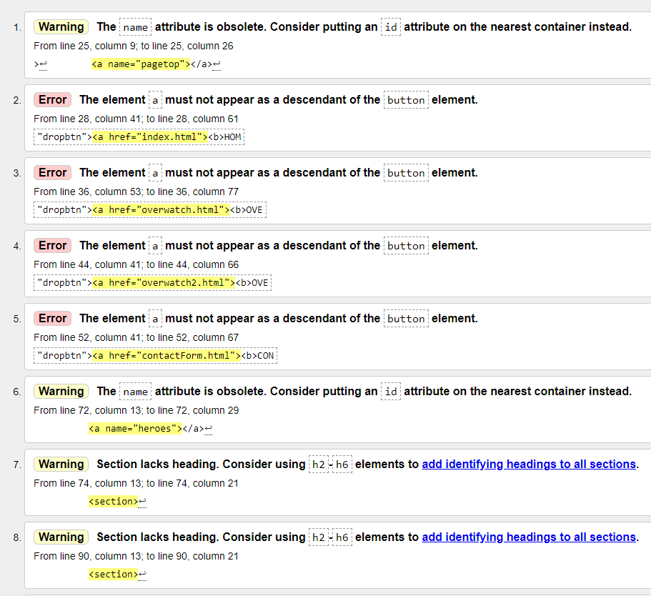

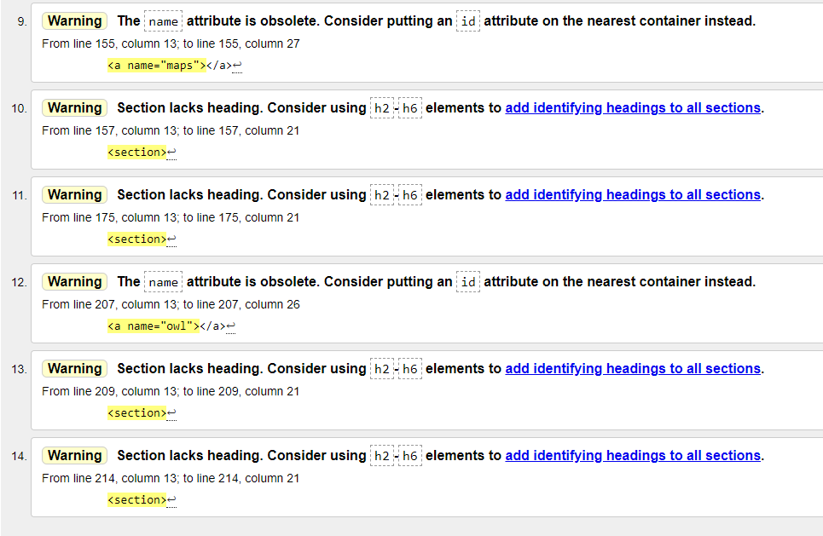

Page 3 – Overwatch 2 Page – overwatch2.html

Errors – I am leaving the 4 errors in because these are to do with my additional feature of dropdown lists, and I was following code I found.

Warnings –

“The ‘name’ attribute is obsolete”: I am leaving these 4 warnings in because they are to do with my internal navigation through my pages.

“Section lacks heading”: I am leaving these 3 warnings in because I have headings outside the sections that cover the sections that it is warning have no headings.

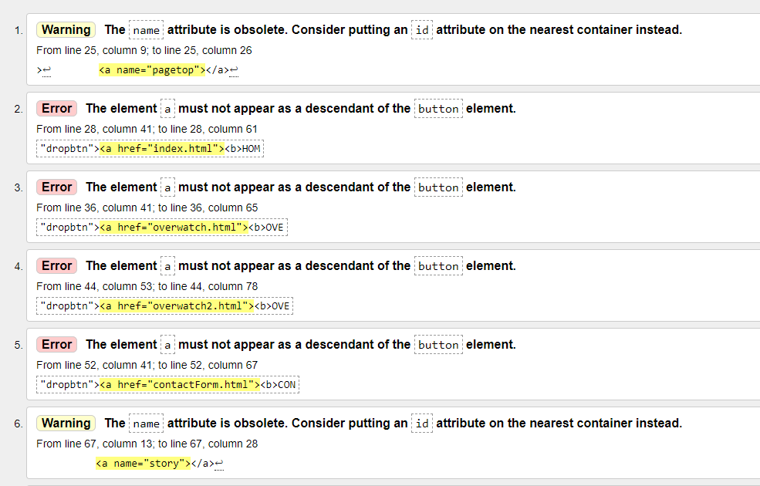

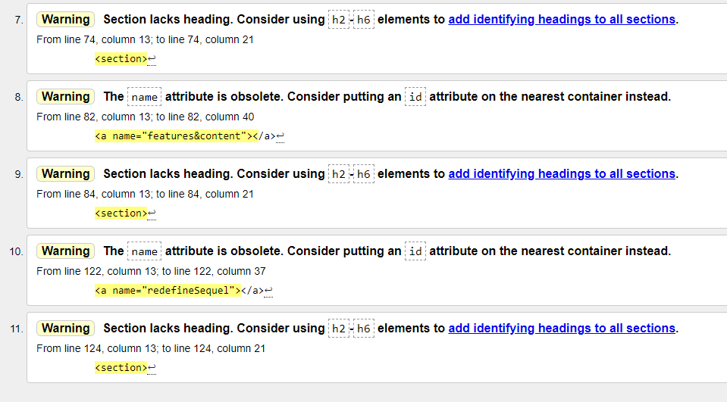

Page 4 – Contact Form Page – contactForm.html

Errors – I am leaving the 4 errors in because these are to do with my additional feature of dropdown lists, and I was following code I found.

Warnings –

“The ‘name’ attribute is obsolete”: I am leaving these 4 warnings in because they are to do with my internal navigation through my pages.

“Section lacks heading”: I am leaving this warning in because I have a heading outside the section that covers the section that it is warning has no heading.

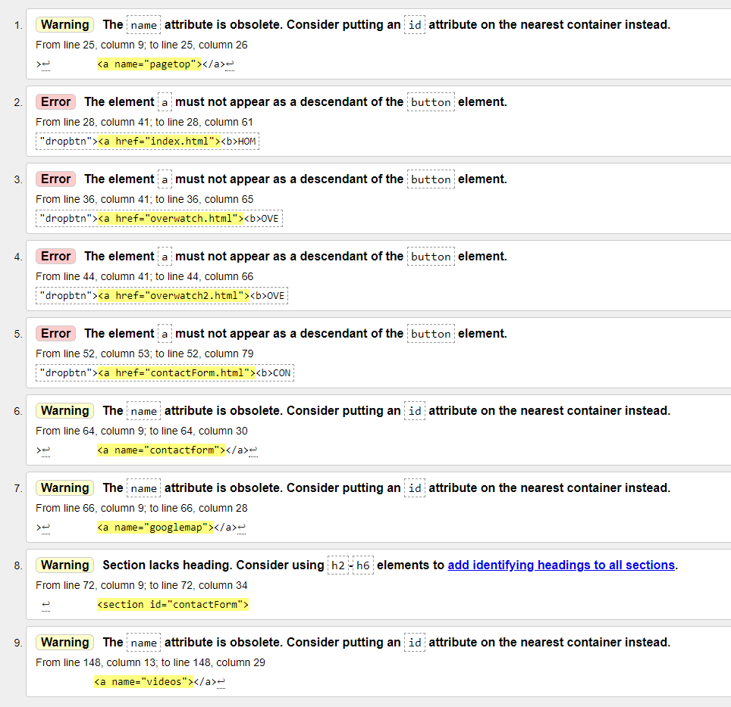

CSS Validation Results

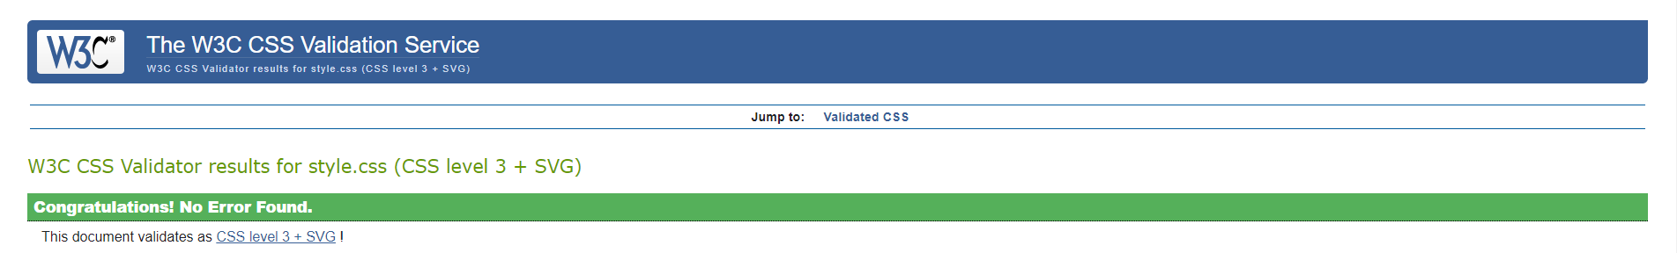

Project Checklist

**You are asked to complete an original website of your own work. The website should contain the features listed below.**

Create a website using HTML5 / CSS that will include the below Project Checklist elements. Features must be obviously outlined where they are located on the web page, in order to mark the project. The student will present the website and explain the code, declaration of own work submitted.

Features are outlined in comment form, in the code of the web pages, on the right-hand side.

|  |
| --- |
| * **\*\*\*\*Must include a Report including purpose and intended audience of the website and sources of images and information of each web page and HTML & CSS validation results. Upload completed project include URL in report.** |
| * **Minimum of 4 HTML Pages with navigation menu not dummy text, use text and hyper link from appropriate website** (outline college project on landing page, do not include any personal or college information in the content of the pages). |
| * **Upload progress and completed website to GitHub account** |
| * **HTML5 standards and recommended page layout structure** (header, main, aside, article, footer, etc.) |
| * **Include appropriate Meta data – description & appropriate keywords etc. to improve pages SEO** |
| * **Include font family for web page body** |
| * **Appropriate use of External Style Sheet – Recommended CSS** (standard for majority of your CSS) |
| * **Appropriate use of Internal & Inline Styling on HTML page** (one example of each)   **Internal Styling is used in:**  **Page 1 in:**  **Head Section, for main h1(The main heading of the page).**  **Inline Styling is used in:**  **Page 1 in:**  **Background Section, for an image.**  **Awards Section, for an image.**  **Page 4 in:**  **Video Section, for margin.**  **Video Section, for a h3 heading.** |
| * **Home page content aligned to each other and visually attractive** |
| * **Include navigation above fold and bottom of web pages - Indicate on navigation the current page** |
| * **Include both Class and ID as CSS Selectors**   **Class CSS Selectors are included in each page of the website.**  **ID CSS Selectors are included in each page of the website.** |
| * **Consistency of design on all pages, use of fonts, colour, etc.** |
| * **Appropriate use of Headings (h1, h2, h3, h4)** |
| * **Appropriate use of Colours (test for colour blind users)** |
| * **Include an article or section with 2 or 3 columns** (by using appropriate CSS)   **Section with 2 columns is included in:**  **Page 1 in:**  **Background Section, to structure the section.**  **Awards Section, to structure the section.**  **Overwatch V Overwatch 2 Section, to structure the section.**  **Page 3 in:**  **Visual Evolution Sub-Section, to structure the sub-section.**  **Section with 3 columns is included in:**  **Page 2 in:**  **Hero Roles Sub-Section, to structure the sub-section.**  **Page 3 in:**  **Ever-Evolving Multiplayer Sub-Section, to structure the sub-section.**  **Brand-New Story Content Sub-Section, to structure the sub-section.**  **Section with 4 columns is included in:**  **Page 2 in:**  **Map Types Sub-Section, to structure the sub-section.** |
| * **Include logo and display in header of page** |
| * **Clear, consistent and align content on all pages** (reference all sources) |
| * **Include images (with at least one image floated with text alongside)**   **Images are included in each page of the website.**  **Floated Image with Text alongside is included in:**  **Page 2 in:**  **Heroes of Overwatch Section.**  **Maps of Overwatch Section.**  **Overwatch League Section.**  **Floated Video with Text alongside is included in:**  **Page 3 in:**  **Story of Overwatch 2 Section.**  **New Features & Content Section.**  **Redefining a Sequel Section.** |
| * **Use of background image**   **A Background Image is used in each page of the website in the Header Section, visible in the External Style Sheet called style.css.** |
| * **Include table of data / information only for statistical data**   **A Table of Data / Information is included in:**  **Page 2 in:**  **Heroes of Overwatch Section, to list out all the**  **Heroes of Overwatch in their respective roles.**  **Maps of Overwatch Section, to list out all the**  **Maps of Overwatch in their respective map types.**  **Overwatch League Section, to list out all the**  **Teams of The Overwatch League in their respective conferences.** |
| * **Include lists ordered or unordered (different shaped bullet points)**   **Unordered Lists are included in the footer of each page of the website for footer navigation.**  **Unordered Lists (with a different shaped bullet point) were included in:**  **Page 1 in:**  **Awards Section, for each year list of awards.** |
| * **Include a link to a suitable video and google map –** use iframe code from YouTube or google maps from share, embed, copy iframe into your html page   **Link to a suitable video is included in:**  **Page 3 in:**  **Story of Overwatch 2 Section, to display the**  **Overwatch 2 Announcement Cinematic.**  **New Features & Content Section, to display the**  **Overwatch 2 Gameplay Trailer.**  **Redefining a Sequel Section, to display the**  **Overwatch What’s Next Panel from Blizzcon 2019.**  **Page 4 in:**  **Videos Section, to display the Overwatch Reveal Cinematic Trailer.**  **Videos Section, to display the Overwatch Reveal Gameplay Trailer.**  **Link to a suitable Google Map is included in:**  **Page 4 in:**  **Google Map Section, to display Overwatch's**  **Developer, Blizzard Entertainment's Headquarters in**  **Irvine, California.** |
| * **Include a contact me form and include red * beside required / mandatory input fields** |
| * **Verify data collected on contact form, using get and data attached to URL** (Use the method get to display values entered on form will be appended to URL and passed to server<form action=" [http://year1.ccpdev.me/FormTest.php](http://year1.ccpdev.me/FormTest.php?fdf=fdsaf&fdsfs=hfdsahfkjhfa)" method="get">) |
| * **Footer information including Copyright© 2020 and navigation** |
| * **Internal anchor Links on one of the webpages**   **Internal Anchor Links are included in the Logo at the top, in the navigation above the fold and in the footer navigation of each page of the website.**  **Internal Anchor Links are included in:**  **Page 1 in:**  **Overwatch V Overwatch 2 Section, in the Overwatch Logo Image.**  **Overwatch V Overwatch 2 Section, in the Overwatch 2 Logo Image.** |
| * **External Link to external website**   **External Links to External Websites (References) are included in the footer of each page of the website.**  **External Link to External Website is included in:**  **Page 2 in:**  **Title Logo above Page Title, to display the Official Overwatch Website.**  **Heroes of Overwatch Section, to display the Heroes**  **Page on the Official Overwatch Website.**  **Maps of Overwatch Section, to display the Maps**  **Page on the Official Overwatch Website.**  **Overwatch League Section, to display the**  **Official Overwatch League Website.**  **Page 3 in:**  **Title Logo above Page Title, to display the Official**  **Overwatch 2 Website.**  **Story of Overwatch 2 Section, to display the Story**  **Page on the Official Overwatch 2 Website.**  **New Features & Content Section, to display the Explore**  **Page on the Official Overwatch 2 Website.** |
| * **Any Additional Features included:**   **Dropdown Lists (an additional feature that was not covered) were included.**  **Dropdown Lists were included in the above the fold navigation of each page of the website, to allow navigating each page easier.** |
| * **Results included in report of HTML5 Validation (with majority of issues addressed)** |
| * **Results included in report of CSS Validation (with majority of issues addressed)** |
| * **Include Favicon on the Title tab** |
| * **Guideline on Website appearance, design and Content** [**https://webdesignledger.com/10-signs-of-a-user-focused-design/**](https://webdesignledger.com/10-signs-of-a-user-focused-design/) |
| * **Guidelines on Website overall appearance & design** [**https://webdesignledger.com/20-dos-and-donts-of-effective-web-design/**](https://webdesignledger.com/20-dos-and-donts-of-effective-web-design/) |

Website Project Assignment Declaration

I the undersigned declare that the project material, which I now submit, is my own work. This material or project has not previously been submitted for any other assignment. Any assistance received by way of borrowing from previous work, or, the work of others has been cited and acknowledged within the work. I make this declaration in the knowledge that a breach of the rules pertaining to project submission may carry serious consequences. We are aware that the project will not be accepted unless this form has been handed in along with the project.

Website: Overwatch Website

Signed: Jake Beecham

Date: 22 / 04 / 2020