**Validation Evidence Week 7**

Home Page Validation Evidence (Index.html) :

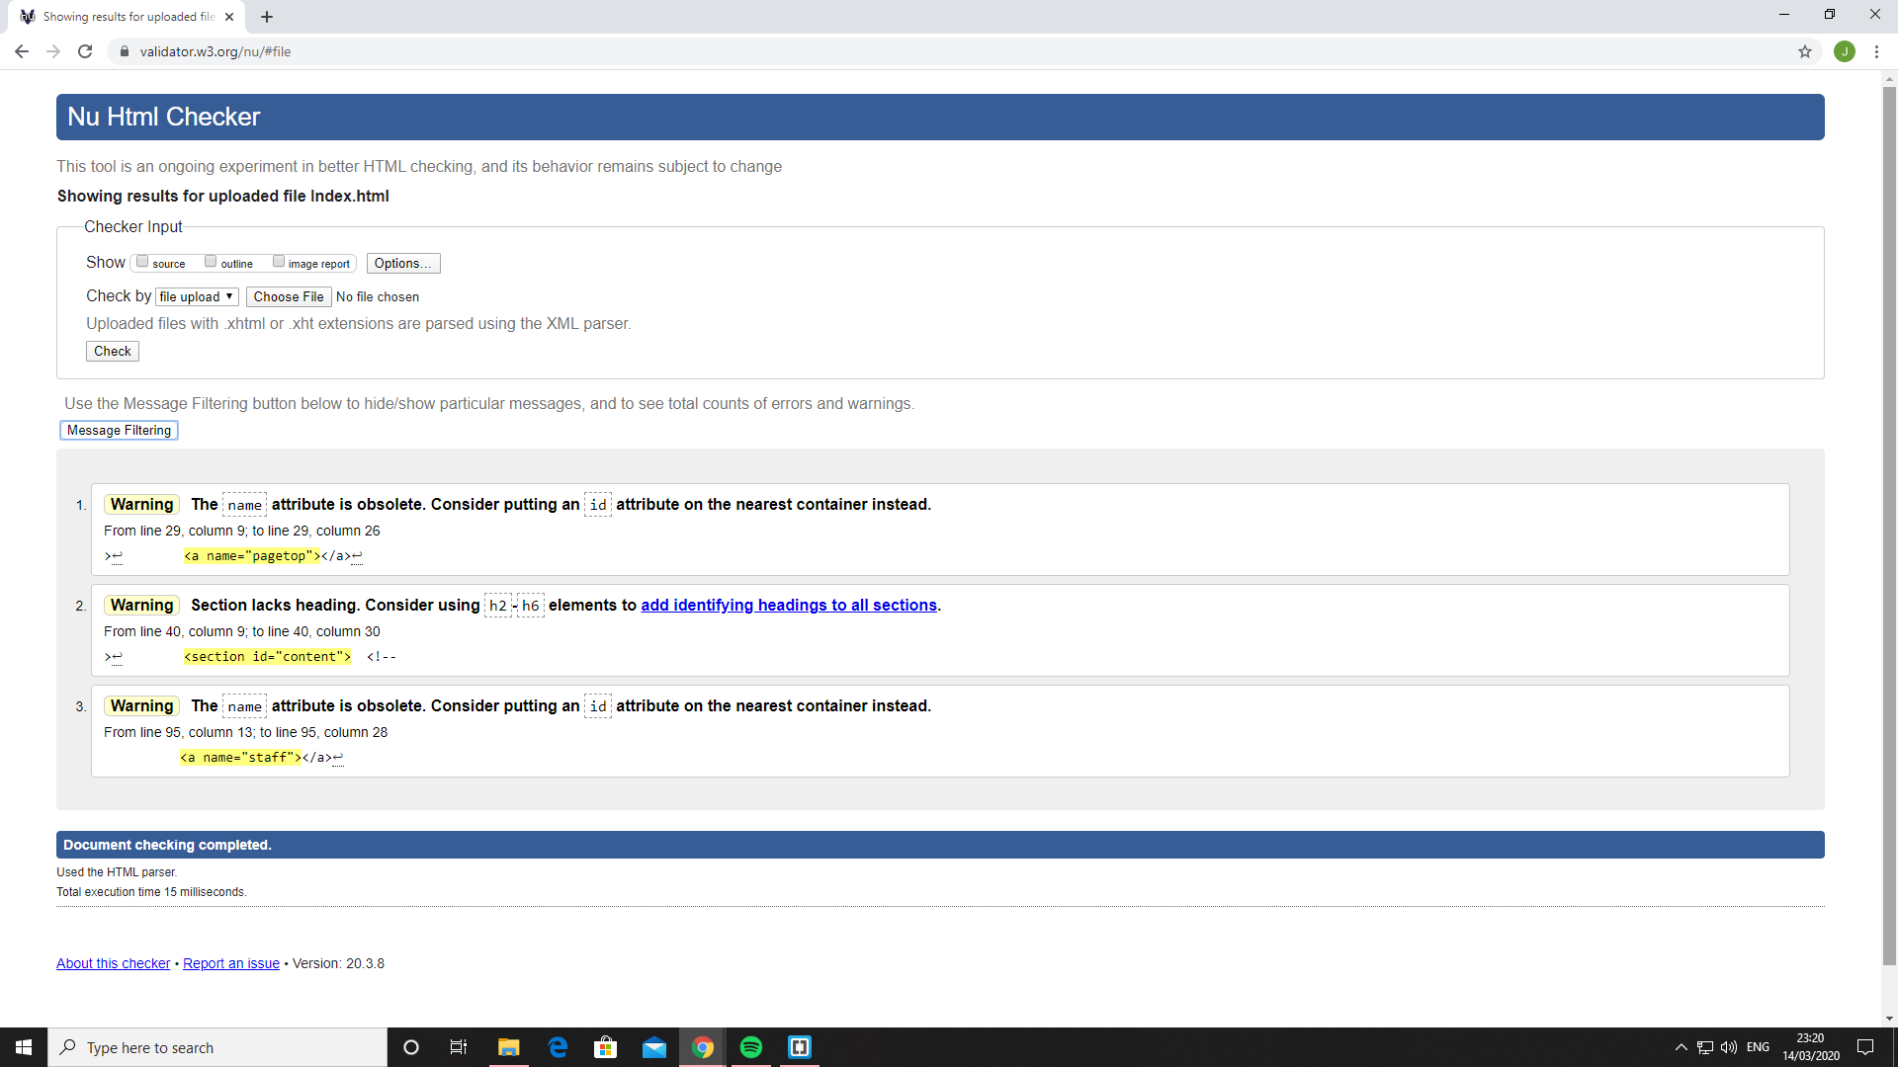

Menu Page Validation Evidence :

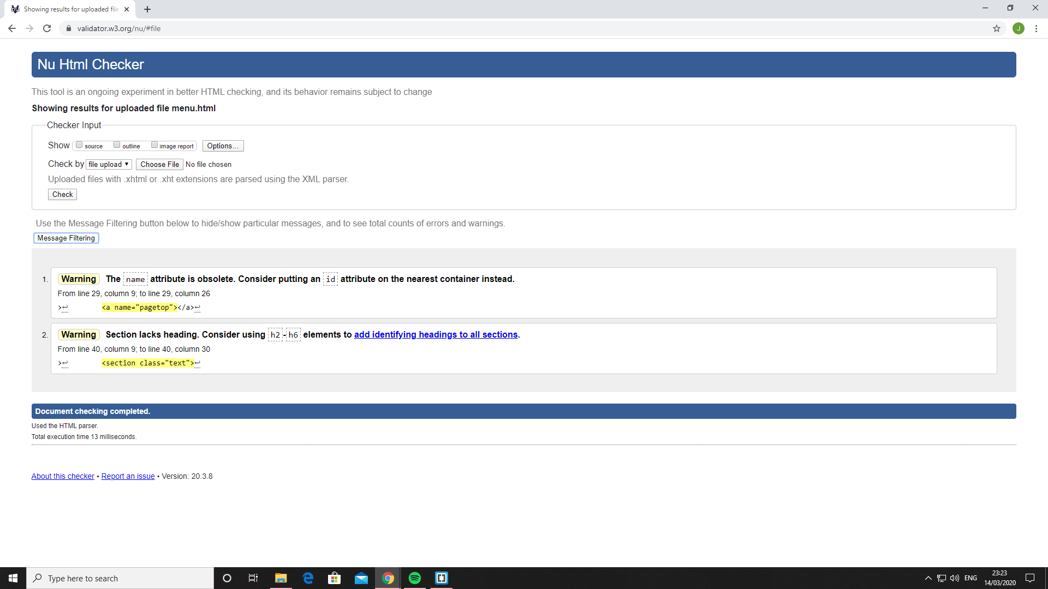

Sounds Page Validation Evidence :

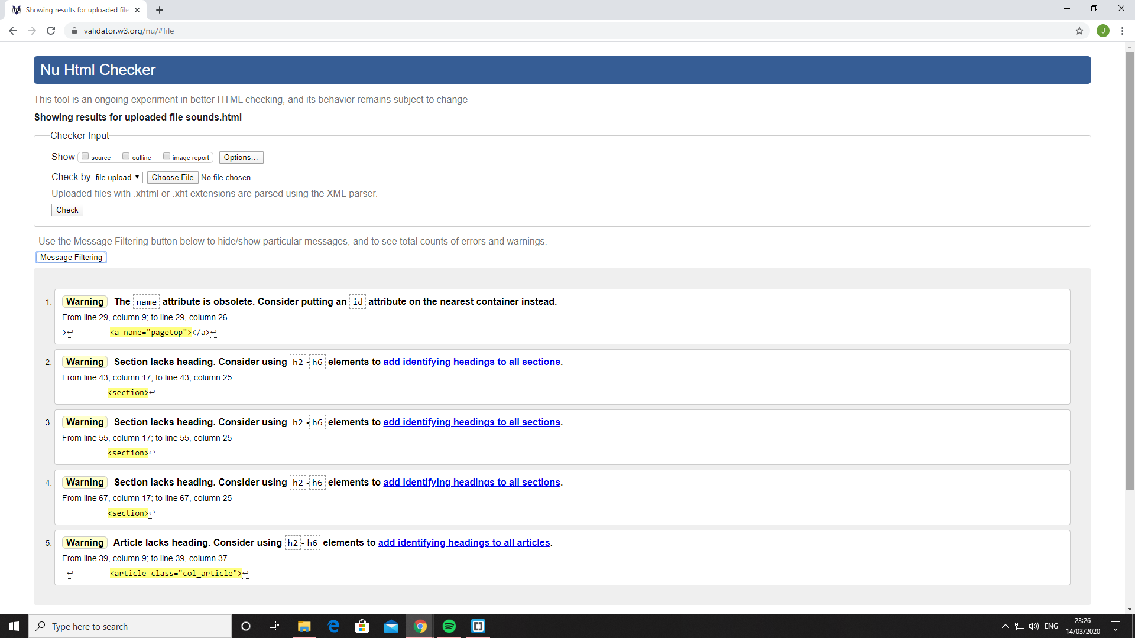

Video Page Validation Evidence :

