**Validation Evidence Week 8**

Home Page Validation Evidence (index.html) :

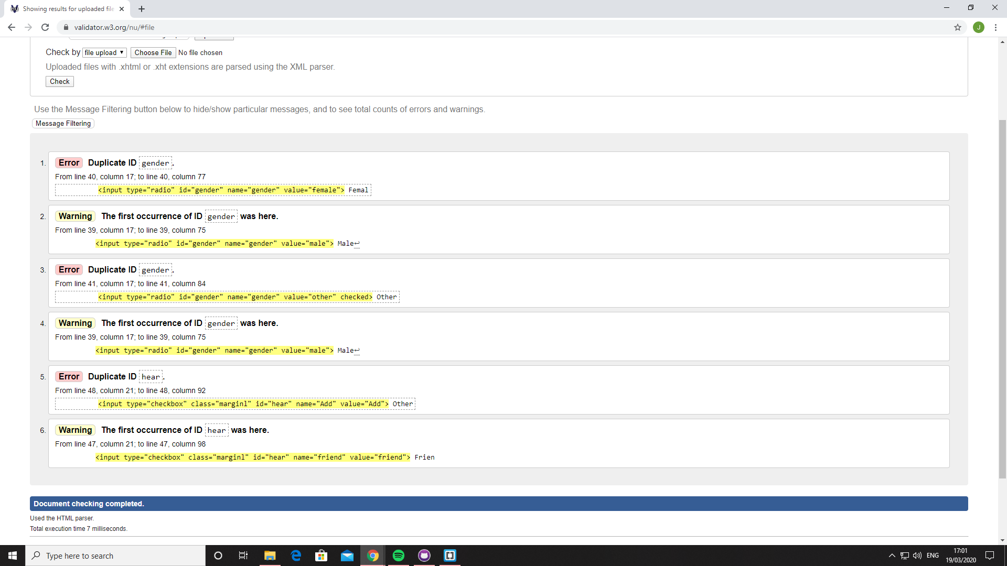

GitHub Pages Link :

<https://jakebeecham.github.io/WebDesignWeek8/>