Arduino, Viewing Distance, and Impacts on User Performance
CS 4326 Human Factors of Computer Systems
Jake Bram, Gerardo Cantu, Yasha Hockliff, Johnathon Sibbett
December 4, 2023
Texas State University, San Marcos, TX 78666, USA
ABSTRACT: Gamers, videographers, and many other professionals have a natural instinct to move toward their display while in a flow state or when attempting to increase efficiency. In a world where more workers are being asked to spend time in front of computer displays, we aim to investigate whether optimizing viewing distance can improve system usability as well as the relationship with fatigue and Computer Vision Syndrome.

Keywords: Arduino, Viewing Distance, Computer Vision Syndrome (CVS), System Usability, Python Library.

Introduction and motivations
When a user is operating a computing system, many aspects of the system spring to mind when we talk about system usability. Our focus for this semester was specifically how does ones viewing distance from a display impact their system usability. As all of us group members are both coders as well as gamers, we have all experienced the phenomenon of moving your head closer to the display to create a more immersive experience. This, for lack of a better term, seems to make the system more usable in an anecdotal form of evidence, but we wanted to research this topic specifically.
Our research is not one dependent on posture, that is something we aimed to keep as constant as possible. We also decided to use the same display. The reason for this was that viewing ratio, the ratio between viewing distance and display size, adds more depth to the problem. For the sake of identifying a trend, all tests were conducted on the same size display. This is particularly a challenging problem because of the various factors that make each users interaction with the system unique. It is also a challenging problem because of the effects of Computer Vision Syndrome, or CVS. CVS is symptoms of fatigue observed in the eyes, vision, and the brain in general from prolonged use and staring at a computer screen. Our hypothesis was that there is a distance that will maximize the usability with the least amount of CVS effects.
The goal of this project was to develop a system that responds to user viewing distance in order to take data, analyze, and create a product to help the user. This could be used in just about any job that heavily relies on a computer screen, but our first thoughts were to gamers, programmers, visual design professionals, and computer science statisticians.

Related works
Many experts have previously identified causes of CVS, and ways to avoid that [1]. What this means is that the cause of CVS is generally known, however there has been little research in the relationship between CVS and of how well the user is actually using the system. The many identified preventative measures for CVS include choosing a less straining viewing distance, filtering blue light from the display with glasses or another light filter, giving your eyes breaks, and working in an appropriately lighted setting.
There have also been studies researching usability and its relationship with viewing ratio [2]. We found these very interesting, as user performance seemed to improve visibly as the user was given larger screens, and then moving back to see the whole screen. In our study, most users will not be working on large projected displays, so the results of this are some that we aim to replicate or compare on a smaller screen. We hypothesize that study we are referring to is expanding the field of view for the user, which is the opposite of our study, which is to minimize that field of vision to roughly the size of the display for each test. One other shortcoming of this study for our ideas is the use of the Nintendo Wii system. It certainly is a computer system, and this is a great study for virtual reality remotes or motion activated systems, it won’t translate well to programming. In essence, this study is good in that it minimizes CVS with viewing distance and tries to get the most out of a user, and we would like to investigate specifically distances relationship on success, and those two variables relationship to user CVS symptoms.

Data collection
Our project involved two rounds of data collection. The first of these was our tests with the Human Benchmark website [3]. To best simulate using a computer system, we broke it down into simulating specific aspects of usability. The tasks selected were reaction time, target practice, and typing. Each of these tests were conducted on each of the group members, once at a range of 20 to 30 centimeters, and again at a range of 50 to 60 centimeters. The Arduino set up was used during both rounds of testing to keep users within their bounds and to track their distance from the display.
The second round of data collection was to simulate multiple aspects of a computer system at once, as the results of the previous tests seemed dependent on the task itself. To combine reaction time, correct input, input timing, and fatigue over time, chose the Google Chrome No Internet T-Rex arcade game [4]. There are sites that run this game online for users to compare scores or compete globally, but we used one of these just for consistency. This data collection was also conducted for all group members, but each played the game 10 times; 5 with Arduino to enforce viewing distance and 5 times without. The scores were manually recorded and analyzed with seaborn.

Methods description
4.1. Analysis and Python Libraries
Our methods for statistical analysis were to use python and multiple libraries or frameworks that will make the process simpler. The first of these was pandas, which is a framework for creating and modifying large frames of data. This framework was very useful because after our data was processed, which just took a bit of formatting, then we could read in the files and easily create a sort of database to work off. We also used seaborn, which is a library for statistical analysis. This library was used because it is particularly good for generating graphs from the data frame. These two libraries were also selected on the fact that they work well with sk-learn, a machine learning library that we had hoped to implement at some point. It is worth noting for python developers that the pandas, seaborn, and sk-learn work very well in accordance with each other.
4.2. Individual Contributions
Yasha took the lead on the Arduino set up in this project. He was the one who ordered the kit to his house, and the set up was assembled at his personal desktop. He was the programmer for the Arduino and was responsible for troubleshooting and tweaking the program for each test. Yasha was a hardware master of this project. The ideas for lights and the text display as user feedback was an idea from Yasha. This semester Yasha took the lead of the Arduino hardware while also pulling his weight in presentations.
Jake did the Python programming and took the data into a Jupyter Notebook for statistical analysis. This involved manipulating the data, reading it into the program, and generating graphs and charts for data visualization. Jake was also in charge of the proposal and final report development. This entailed the bulk of the final report being developed by Jake as well as general formatting for reports and slide presentations. The end goal of the group was to identify a Machine Learning problem, as Jake had recently taken Machine Learning at Texas State University and was eager to apply some of these principles, however the group decided we did not have a sufficient size dataset for machine learning in this project.
Jerry was involved in all parts of the development. Developed a large bulk of the presentation slides, made significant contribution to reports, and was present to record data. Jerry made many developmental suggestions; our selection of the T-Rex game was his idea. This semester Jerry was very helpful in that he was willing to change gears at any time and switch his attention to another part of our project, even if it was not a strength of his.
Johnathon was also involved in multiple phases of the project. He was responsible for the suggestion of the Human Benchmark site for round one of testing and was present for all data collection and group presentations.

Results and findings
5.1. Testing Round 1 Findings
The results of each of our tests were not all that we had hoped, but they all offered promising results. Our first test was over three tasks to simulate a computer system and our results varied significantly depending on the task. For reaction time, the shorter the viewing distance was seemed to improve the users score. What was particularly interesting was that we observed poor results on the aim task, but specifically when closer to the monitor. We hypothesize that in instances that require aim or some sort of precision, that being too close to the screen makes your eyes travel farther and in doing so work harder. Therefore, the user would also experience less CVS from less strain being put on the eyes. The overall results of aiming were that the more that the user could see with the least amount of effort seemed to improve score as well as likely reducing the CVS. When it came to typing, we found this very dependent on the users keyboarding skills at the time of the tests. With both viewing distances designed to not directly impede usability and allow the user to see and interpret the display output, there were little things for the viewing distance to actually interfere with. The results of this round of testing implies that the tasks that are affected by viewing distance are primarily using the eyes and their connection with the brain, and also that tasks relying on motor skills are dependent on those motor skills and the ability to see and read while remaining unaffected by viewing distance.

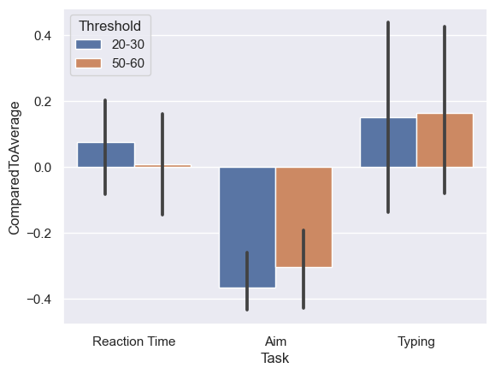
Figure 1: Scores from Testing Round 1 - Compared to Human Average.
Axes are Tasks vs Percent Difference from (given) Average Scores.

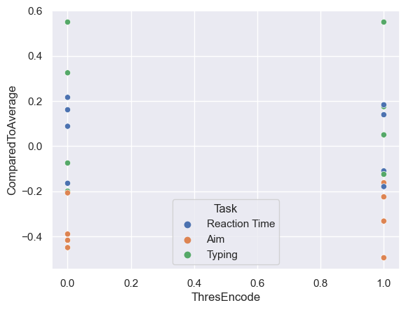
Figure 2: Scores from Testing Round 1 - Compared to Human Average.
Axes – Threshold Given for Task (0 = 20-30cm, 1 = 50-60cm) vs Percent Difference from (given) Average Scores.

5.2. Testing Round 2 Findings
As previously mentioned, we had identified that we had multiple parts of a system all with different results. To see if we could identify a trend in a full system we began testing with the T-Rex game. The results of this were much more conclusive. Over two kinds of runs within the game, one with our Arduino set up and once without, users got a significantly higher score when using the Arduino. Analyzing specific scores helped us notice that it was not a longer duration of time but the fact that the system speeds up and required more precise inputs. This game is set up to alter the success window of your input, and as the scrolling gets faster it may be easier to do a correct command you must react quicker and with the correct input. Another important facet of this game is that you lose when you fail for the first time, which is hitting an obstacle, and there are no second chances. This is really helpful for taking large amounts of data, as well as in future studies there is only one way to fail, and there is no ‘winning’; its endless, a great arcade game for mass data collecting since there is one outcome. When in an optimal viewing distance users were reacting to the stimulus of the system even when the window for success was shortening, meaning when users were forced into an acceptable viewing distance, they were able to react to stimulus at a much more successful rate. In other words, the users seemed to handle more difficult success windows better when at an acceptable viewing distance, and it took more from the system to force the user to an error.

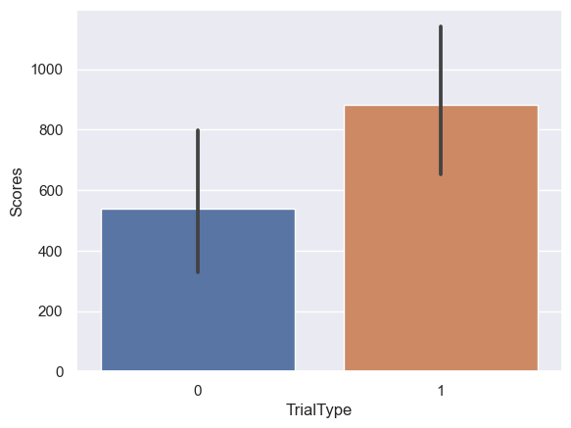
Figure 3: Scores from Testing Round 2 – T-Rex Game
Axes – Trial Type (0 = no assistance, 1 = Arduino assistance) vs Score (Bar = Average, Line = Standard Deviation)

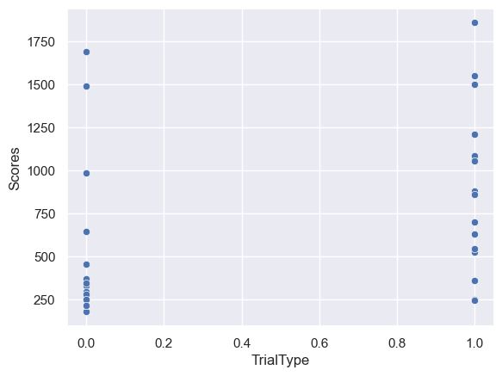
Figure 4: Scores from Testing Round 2 – T-Rex Game
Axes – Trial Type (0 = no assistance, 1 = Arduino assistance) vs Score

5.3. Conclusion and Future Works
In fairness we must critique ourselves and the first of our critiques for ourselves was there was not enough induction of CVS. In attempts to make tests repeatable, we failed to address that CVS usually manifests itself after a long period of time. We identified CVS in some users during the T-Rex game and hypothesize that this could have been the reason for their misinput and failing the run. Some interesting tests to follow these could be how soon CVS is identifiable from certain viewing distances, minimization tactics in regard to CVS when optimizing viewing distance, as well as testing for a relationship between success and CVS or human effort and CVS. The last is a result of a final question we had about the T-Rex test, where we hypothesize the harder the user tries then the more efficient that they will be, but at the same time the faster they will get fatigued.
We also would like a future test to have much more data. We did identify trends, but as suggested during the presentation we need many more features to fit a machine learning model like we had anticipated. Height, weight, gender, glasses prescriptions, and many other factors all affect system usability, more of which could have been documented. It is in this way that a machine learning problem could be identified. Machine learning algorithms with more data could answer some classification problems such as if the user needs a break or if they have CVS. Another machine learning problem could be if the user is maintaining an optimal viewing distance.
During this project we have concluded that viewing distance does have a direct impact on system usability. The results of our first test confirms this, with data supporting that viewing distance has the ability to increase or decrease system usability depending on the human task. Our second test also supports this claim, as optimizing viewing distance seemed to optimize the scores as well. More data is however needed to identify where and when viewing distance can be used for efficiency, and when CVS is impeding someone from efficient system usability.
Source Code - https://github.com/JakeBram/HumanFactors/tree/main
References
[1] Goldsborough, Reid. “Keeping Your Eyes Healthy in Front of the Computer Screen.” Tech Directions, vol. 66, no. 10, May 2007, p. 12. EBSCOhost, search.ebscohost.com/login.aspx?direct=true&db=bth&AN=25326177&site=eds-live&scope=site.
[2] Franzoni, Valentina & Gervasi, Osvaldo & Tasso, Sergio & Pallottelli, Simonetta. (2008). Web Usability on the Nintendo Wii Platform. Lecture Notes in Computer Science. 5073. 105-118. 10.1007/978-3-540-69848-7_10.
[3] Human Benchmark, 2007, humanbenchmark.com/.
[4] “Dinsaur T-Rex Game.” T-Rex Game - Google Dino Run, TRex-Runner.com, 2017, trex-runner.com/.

