2015_Q

Jake Cavaiani

9/22/2022

## French and Moose 2015 Discharge

The purpose of this script is to import raw PT data from each of our sites in 2015 (Moose, French), clean (out of water points, potential beaver dams, noisy data, remove a PT if data is bad etc.) and prepare to convert to continuous predicted discharge (Q)

Important NOTES: 1) Water level data is obtained from HOBO pressure transducers (PTs) that were installed in PVC pipes in streams, with the PT sitting on top of a rebar piece at bottom of pipe. Raw pressure from PTs were processed in HOBOware to correct for atmospheric pressure to get water depth. Atmospheric pressure was obtained from a PT installed at each site in a tree. HOWEVER, water depth is absolute PT depth, NOT actual water depth. To get actual water depth, we need a reference water depth from a time point in the water depth time series that is an accurate measure of the depth of the pt from the water surface. We do not have these (depth measurements from flow meter measurements were not done sufficiently close to PT locations to use).We have waterlevel surveys from Kate Broberg in 2020 and 2021 We must therefore rely on the rating curve to convert absolute water depth to continuous Q.

1. Date/time from HOBOware data is GMT-8, which is Alaska Daylight Time, which is the correct timezone for this project in summer (AK is in GMT-9 March-November when daylight savings is not observed). Data/time therefore needs to be formatted but not timezone-converted.

Step 1: import raw data hoboware files which is site, datetime, absolute pressure and water level Step 2: Clean errant points within the data that could be due to installation/decommission or gaps in data Step 3: Write final output of cleaned site, datetime, absolute pressure and water level Step 4: import Qsummary document to generate rating curves of Q and pressure Step 5: clean errant points in regression Step 6: apply rating curve to generate continuous predicted discharge at each site Step 7: Output final discharge as csv.

2015 data is read from DoD->2015 AK sensors->Discharge->discharge->pressure transducer-> “PT_Site_Compiled” 2015 data was taken att 5 minute intervals

### Observed Discharge at French and Moose

Slugs were the only method of discharge for 2015

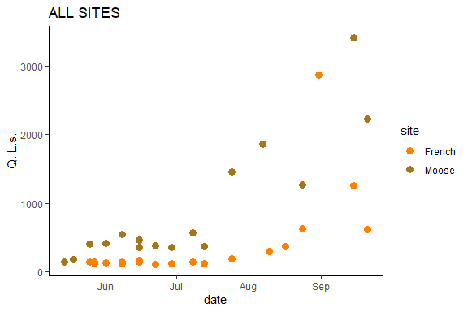 This is from the DOD Q Summary csv that is DoD Project->2015 AK sensors ->Discharge

eielson.atmo.2015.url <- "https://docs.google.com/spreadsheets/d/e/2PACX-1vSx5CyMTHZWjvTaYfNQcDZw7U59URY8v6PSJvH4bGwjtSkbD0picwdOJCyBqg3_BGcjwHztwT0b1sQT/pub?output=csv"  
  
eielson.atmo.2015 <- read.csv(url(eielson.atmo.2015.url), skip = 6)   
eielson.atmo.2015 <- eielson.atmo.2015[-1,]  
  
names(eielson.atmo.2015) <- c("Site", "DateTimeAK", "sea_level_pressure", "1_day")  
  
eielson.atmo.2015$DateTimeAK <- mdy_hm(eielson.atmo.2015$DateTimeAK)  
  
eielson.atmo.2015$DateTimeAK <- force_tz(eielson.atmo.2015$DateTimeAK, "America/Anchorage")  
  
eielson.atmo.2015$DateTimeAK <- lubridate::round_date(eielson.atmo.2015$DateTimeAK, "15 minutes")  
  
  
eielson.atmo.2015$AirPressure <- as.numeric(eielson.atmo.2015$sea_level_pressure)  
eielson.atmo.2015$sea_level_pressure <- as.numeric(eielson.atmo.2015$sea_level_pressure)  
  
eielson.atmo.2015$AirPressure <- eielson.atmo.2015$AirPressure*3.38639 # converting from inHG to kPa  
  
eielson.atmo.2015 <- subset(eielson.atmo.2015, DateTimeAK > "2015-05-01" & DateTimeAK < "2015-10-31")  
  
# correcting for elevation   
eielson.atmo.2015$mmHG <- eielson.atmo.2015$sea_level_pressure * 25.44 # converting to mmHG  
  
# conversion to elevation at each site   
# MOOS   
eielson.atmo.2015$mmHGcorrectedMOOS <- eielson.atmo.2015$mmHG - (2.5*574/100)   
  
eielson.atmo.2015$AirPressureCorrectedMOOS <- eielson.atmo.2015$mmHGcorrectedMOOS * 0.133322 # converting this to kPA to compare with MOOS PT  
  
# FRCH  
eielson.atmo.2015$mmHGcorrectedFRCH <- eielson.atmo.2015$mmHG - (2.5*601/100)   
  
eielson.atmo.2015$AirPressureCorrectedFRCH <- eielson.atmo.2015$mmHGcorrectedFRCH * 0.133322 # converting this to kPA   
  
  
  
ggplot(aes(x = DateTimeAK, y = AirPressureCorrectedMOOS), data = eielson.atmo.2015) +  
 geom_line(aes(x = DateTimeAK, y = AirPressureCorrectedMOOS), data = eielson.atmo.2015, color="#A6761D") +  
 geom_line(aes(x = DateTimeAK, y = AirPressureCorrectedFRCH), data = eielson.atmo.2015, color="#FF7F00") +  
 theme_classic() +  
 ggtitle("Eielson corrected to MOOS (Brown) & Eielson corrected to FRCH (Orange)")

## Warning: Removed 3 row(s) containing missing values (geom_path).  
## Removed 3 row(s) containing missing values (geom_path).

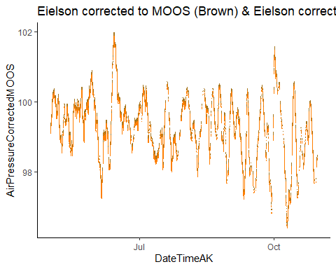

##### Checking Raw PT data

## Raw Moose

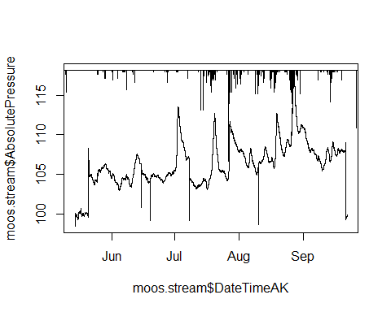

There is a big increase in middle to end of may that doesnt seem to be real from precip , and then a lot of vertical drops in middle of June, July, August (potentially cleanning points) and then at the end of september we get a big drop, this is when the site was taken out…(PT was taken out on the 21st)… let the cleaning commence!

## Moose 1.0

## [1] 4052 5270 5271 5272 5273 5274 5275 5276 5277

## [1] 2047

## [1] 2679 2680 2681

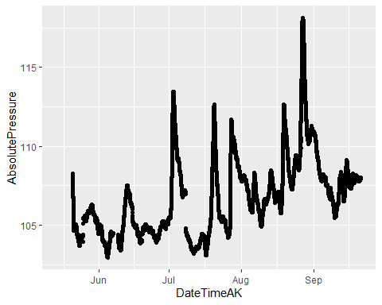 1) Clipped off the take out date (anything after 2015-09-20 18:30:00) 2) Set vertical drops in raw data to NA’s 3) NEED TO DO NA INTERPRET

I will clean up the jumps.

# Shift following pressure up after Jul 8 jump:  
moos.stream[15821,2] - moos.stream[15823,2]

## [1] 2.182

moos.stream <- moos.stream %>%  
 mutate(across(c(AbsolutePressure),   
 ~ifelse(DateTimeAK > "2015-07-08 02:30:00", AbsolutePressure + 2.182, .)))  
  
# Shift following pressure up after May 25 jump:  
moos.stream[3146,2] - moos.stream[3149,2]

## [1] -0.993

moos.stream <- moos.stream %>% filter(DateTimeAK < "2015-05-25 02:15:00" | DateTimeAK > "2015-05-25 02:30:00") %>%  
 mutate(across(c(AbsolutePressure),   
 ~ifelse(DateTimeAK > "2015-05-25 02:15:00", AbsolutePressure - 0.993, .)))  
  
# Shift following pressure up after Jun 19 jump:  
moos.stream[10403,2] - moos.stream[10413,2]

## [1] NA

moos.stream <- moos.stream %>%  
 mutate(across(c(AbsolutePressure),   
 ~ifelse(DateTimeAK > "2015-06-19 07:05:00", AbsolutePressure - 0.468, .)))  
  
# Shift following pressure up after Aug 26 jump:  
moos.stream[30086,2] - moos.stream[30093,2]

## [1] -1.388

moos.stream <- moos.stream %>% filter(DateTimeAK < "2015-08-26 15:15:00" | DateTimeAK > "2015-08-26 15:50:00") %>%  
 mutate(across(c(AbsolutePressure),   
 ~ifelse(DateTimeAK > "2015-08-26 15:15:00", AbsolutePressure + 1.781, .)))  
  
# Shift following pressure up after Sep 7 jump:  
moos.stream[33693,2] - moos.stream[33694,2]

## [1] 0.021

moos.stream <- moos.stream %>%   
 mutate(across(c(AbsolutePressure),   
 ~ifelse(DateTimeAK > "2015-09-08 04:30:00", AbsolutePressure - 0.714, .)))  
  
moos.stream %>% #filter(DateTimeAK > "2015-05-01" & DateTimeAK < "2015-5-30") %>%  
 ggplot(aes(x = DateTimeAK, y = AbsolutePressure)) +  
 geom_point()

## Warning: Removed 2439 rows containing missing values (geom_point).

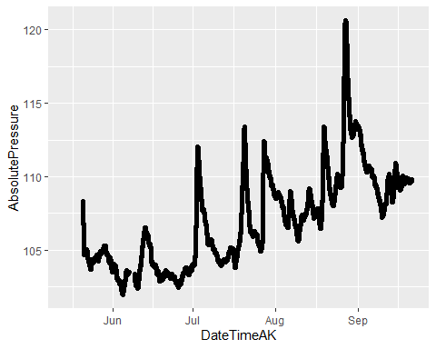 ### Impute missing observations in pressure for Moose 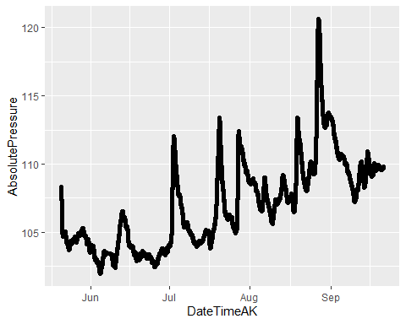

## Raw FRCH

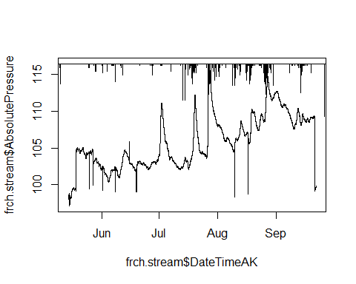

Similarily to Moose There is a big increase in middle to end of may that doesnt seem to be real from precip , and then a lot of vertical drops in middle of June, July, August (potentially cleanning points) and then at the end of september we get a big drop, this is when the site was taken out…(PT was taken out on the 21st)… let the cleaning commence!

### French 1.0

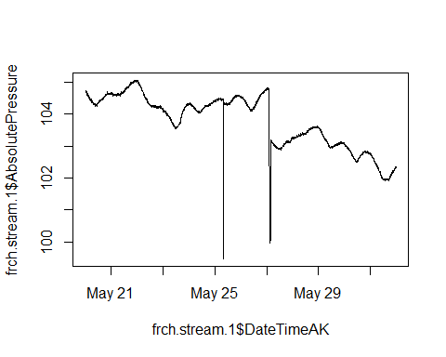

## [1] 1535 2047 2048 2049 2050 2051 2052 2053 2054 2055 2056 2057 2058 2059 2060  
## [16] 3305 3306 3307 3308 3309 3310 3311 3312 3313 3314 3315 3316 3317 3318 3319  
## [31] 3320 3321 3322 3323 3324 3325 3326 3327 3328 3329 3330 3331 3332 3333 3334  
## [46] 3335 3336 3337 3338 3339 3340 3341 3342 3343 3344 3345 3346 3347 3348 3349  
## [61] 3350 3351 3352 3353 3354 3355 3356 3357 3358 3359 3360 3361 3362 3363 3364  
## [76] 3365 3366 3367 3368 3369 3370 3371 3372 3373 3374 3375 3376 3377 3378 3379  
## [91] 3380 3381 3382 3383 3384

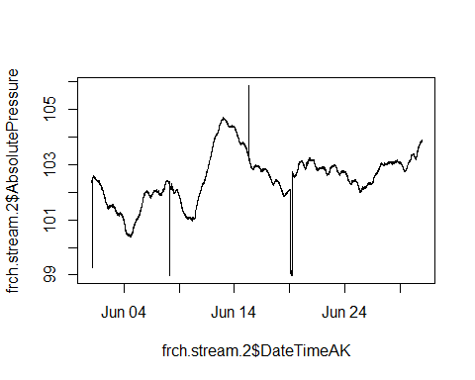

## [1] 49 2052 5213 5214 5215 5216 5217 5218 5219 5220 5221 5222 5223 5224 5225  
## [16] 5226 5227 5228 5229 5230 5231 5232 5233 5234 5235 5236 5237 5238 5239 5240  
## [31] 5241

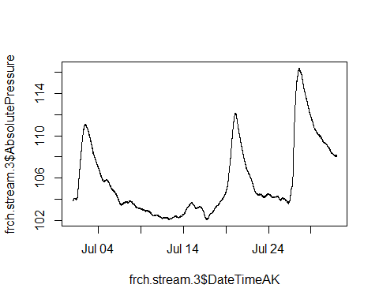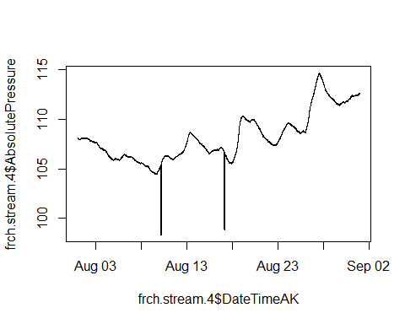

## [1] 2641 2642 2643 2644 2645 2646 2647 2648 2649 2650 2651 2652 2653 2654 2655  
## [16] 2656 4631 4632 4633 4654

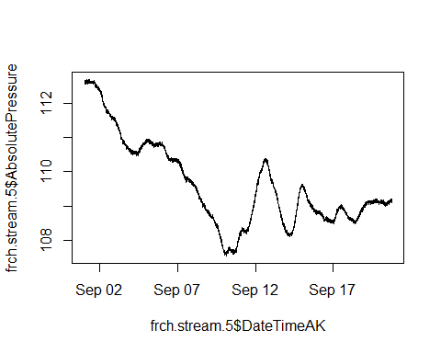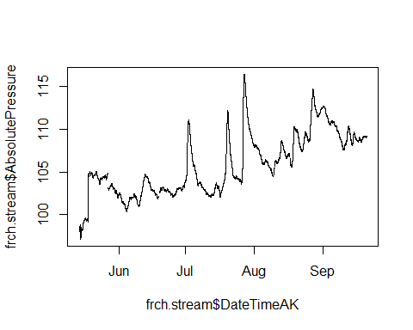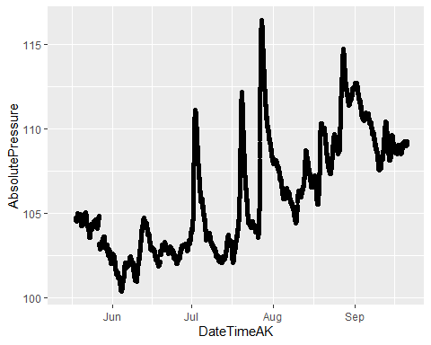 1) Clipped off the take out date (anything after 2015-09-20 18:30:00) 2) Set vertical drops in raw data to NA’s 3) NEED TO DO NA INTERPRET (na_kalman)

I will clean up the jumps.

# Shift following pressure up after Jul 27 jump:  
frch.stream[3726,2] - frch.stream[3741,2]

## [1] 1.64

frch.stream <- frch.stream %>% filter(DateTimeAK >= "2015-05-18 07:15:00") %>%  
 mutate(across(c(AbsolutePressure),   
 ~ifelse(DateTimeAK > "2015-05-27 02:30:00  
", AbsolutePressure + 1.64, .)))  
  
# Shift following pressure up after Jul 19 jump:  
frch.stream[9158,2] - frch.stream[9189,2]

## [1] -0.669

frch.stream <- frch.stream %>% filter(DateTimeAK != "2015-06-19 05:15:00") %>%  
 mutate(across(c(AbsolutePressure),   
 ~ifelse(DateTimeAK > "2015-06-19 02:45:00  
", AbsolutePressure - 0.669, .)))

### Impute missing observations in pressure for French

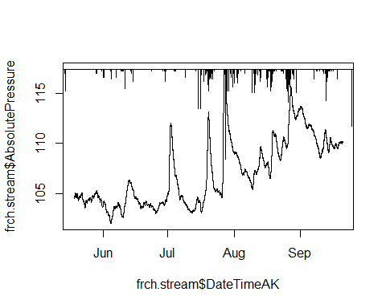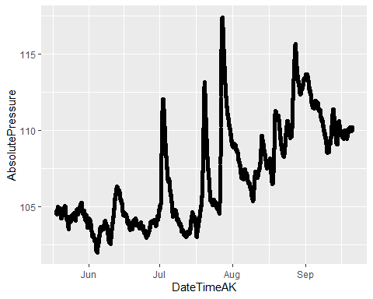

### Raw Rating Curve with Moose 1 Pressure Transducer

### Filter MOOS ###  
QSummary.MO <- QSummary %>% filter(site =="Moose")  
  
ggplot(QSummary.MO) +  
 geom_point(aes(x = DateTimeAK, y = Q..L.s., color = site), size=3) +  
 theme_classic() +  
 scale_color_manual(values=c("#A6761D")) +   
 ggtitle("MOOS")

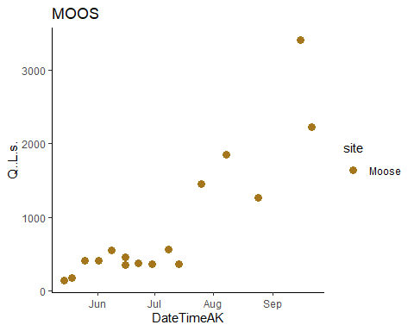

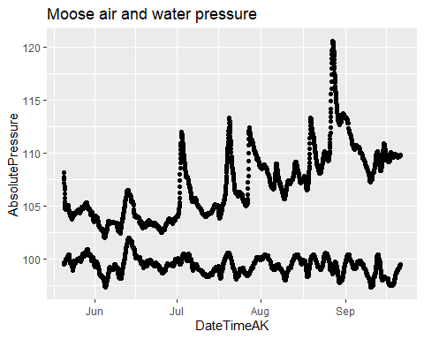

# Water pressure - atmospheric pressure  
MOOS.2015.one$difference <- MOOS.2015.one$AbsolutePressure - MOOS.2015.one$AirPressureCorrectedMOOS

# trying to merge by nearest date if we have an offset point   
MOOS.2015.one.dt <- setDT(MOOS.2015.one)   
MOOS.2015.one.dt <- subset(MOOS.2015.one.dt, DateTimeAK < "2015-09-20 18:00:00") # removing rows that had dates corresponding to end of record that messed up the rolling nearest function   
QSummary.MO.dt <- QSummary.MO   
  
Moose1comb.2015 <- MOOS.2015.one.dt[QSummary.MO.dt, on = "DateTimeAK", roll = 'nearest']  
  
MOOS1.lm.2015 <- lm(Moose1comb.2015$Q..L.s. ~ Moose1comb.2015$difference)

# plot rating curve   
moos.formula = y~x  
  
ggplot(aes(x = difference, y = Q..L.s.), data = Moose1comb.2015) +  
 geom_point(size = 3) +  
 geom_smooth(method = "lm", se=FALSE, formula = moos.formula) +  
 stat_poly_eq(formula = moos.formula,  
 aes(label = paste(..eq.label.., ..rr.label.., sep = "~~~")),  
 parse = TRUE) +  
 #xlim(216, 216.4) +  
 #ylim(0,1500) +  
 theme_light() +  
 ggtitle("Moose all measured Q")

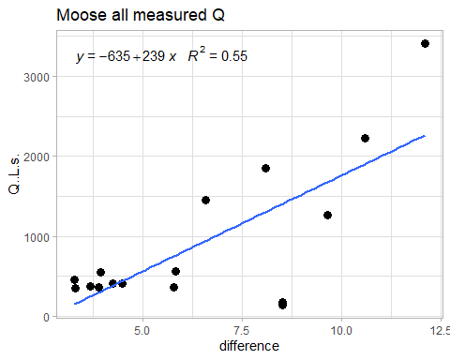

The two low points at the big difference are probably not the best

### Rating Curve with Moose 1 Pressure Transducer 2.0

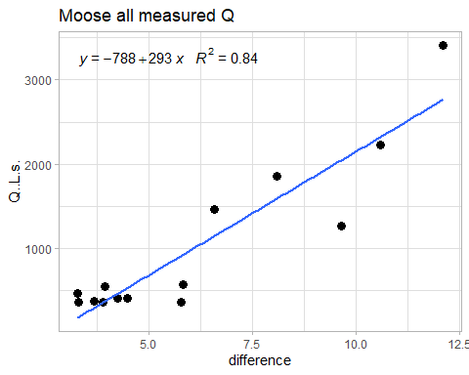

1. I removed low Q values with high pressure difference. This looks like it is quadratic.

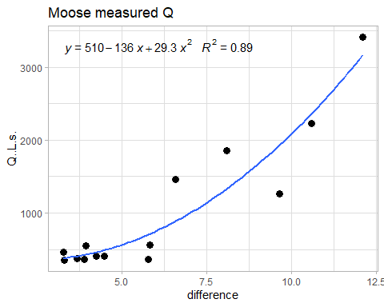

Plot predicted Q.

## Predict STRT Q  
MOOS1.lm.2015 <- lm(Moose1comb.2015.part.two$Q..L.s. ~ Moose1comb.2015.part.two$difference + I(Moose1comb.2015.part.two$difference^2))  
  
MOOS.2015.one.dt$pred.moos.Q <- coef(MOOS1.lm.2015)[2] * MOOS.2015.one.dt$difference + coef(MOOS1.lm.2015)[1] + coef(MOOS1.lm.2015)[3] * I(MOOS.2015.one.dt$difference^2)  
  
MOOS.2015.one.dt <- MOOS.2015.one.dt %>% filter(!pred.moos.Q %in% NA)  
  
# Fill in any missing predicted Q  
MOOS.2015.one.dt <- na_kalman(MOOS.2015.one.dt)  
  
MOOS.2015.one.dt %>% ggplot(aes(x = DateTimeAK, y = pred.moos.Q)) +  
 geom_line(color="#A6CEE3", size=1.25) +  
 geom_point(data = Moose1comb.2015.part.two, aes(x = DateTimeAK, y = Q..L.s.), size=3) +  
 theme_classic() +  
 ggtitle("MOOS 2015 predicted and measured Q") +  
 xlab("Date") +  
 ylab("Discharge (L/s)")

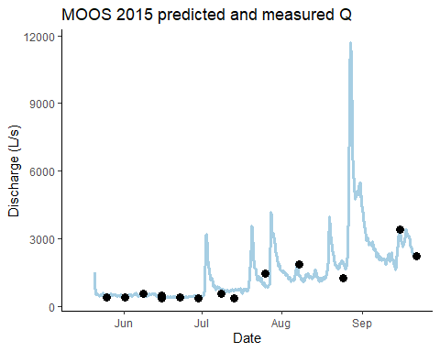

### Raw Rating Curve with French 1 Pressure Transducer

### Filter FRCH ###  
QSummary.FR <- QSummary %>% filter(site =="French")  
  
ggplot(QSummary.FR) +  
 geom_point(aes(x = DateTimeAK, y = Q..L.s., color = site), size=3) +  
 theme_classic() +  
 scale_color_manual(values=c("#FF7F00")) +   
 ggtitle("FRCH")

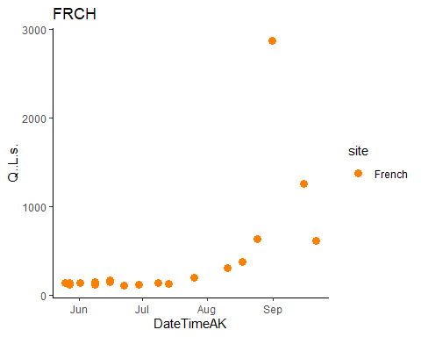

# trying to merge by nearest date if we have an offset point   
FRCH.2015.one.dt <- setDT(FRCH.2015.one)  
FRCH.2015.one.dt <- subset(FRCH.2015.one.dt, DateTimeAK < "2015-09-20 19:00:00") # removing rows that had dates corresponding to end of record that messed up the rolling nearest function   
QSummary.FR.dt <- QSummary.FR  
  
French1comb.2015 <- FRCH.2015.one.dt[QSummary.FR.dt, on = "DateTimeAK", roll = 'nearest']  
  
FRCH1.lm.2015 <- lm(French1comb.2015$Q..L.s. ~ French1comb.2015$difference)

# plot rating curve   
frch.formula = y~ x + I(x^2)  
  
French1comb.2015 %>% ggplot(aes(x = difference, y = Q..L.s.)) +  
 geom_point(size = 3) +  
 geom_smooth(method = "lm", se=FALSE, formula = frch.formula) +  
 stat_poly_eq(formula = frch.formula,  
 aes(label = paste(..eq.label.., ..rr.label.., sep = "~~~")),  
 parse = TRUE) +  
 theme_light() +  
 ggtitle("French all measured Q")

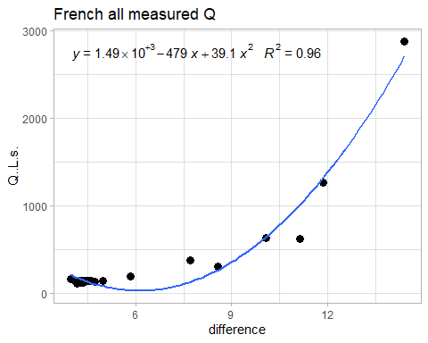

We need to alter the quadratic term to make it not dip down like that.

# plot rating curve   
frch.formula = y~ x + I(x^4/2)  
  
French1comb.2015 %>% ggplot(aes(x = difference, y = Q..L.s.)) +  
 geom_point(size = 3) +  
 geom_smooth(method = "lm", se=FALSE, formula = frch.formula) +  
 stat_poly_eq(formula = frch.formula,  
 aes(label = paste(..eq.label.., ..rr.label.., sep = "~~~")),  
 parse = TRUE) +  
 theme_light() +  
 ggtitle("French all measured Q")

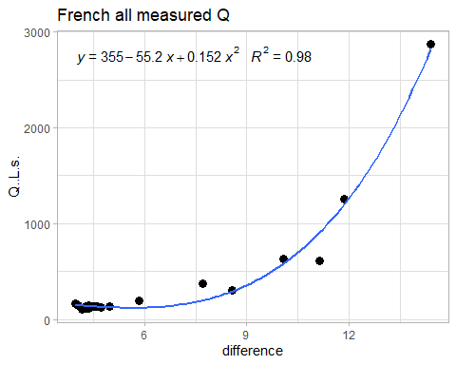

## Predict STRT Q  
FRCH.lm.2015 <- lm(French1comb.2015$Q..L.s. ~ French1comb.2015$difference + I(French1comb.2015$difference^4/2))  
summary(FRCH.lm.2015)

##   
## Call:  
## lm(formula = French1comb.2015$Q..L.s. ~ French1comb.2015$difference +   
## I(French1comb.2015$difference^4/2))  
##   
## Residuals:  
## Min 1Q Median 3Q Max   
## -292.737 -16.207 1.706 11.302 174.600   
##   
## Coefficients:  
## Estimate Std. Error t value Pr(>|t|)   
## (Intercept) 355.444295 77.741398 4.572 0.000236 ***  
## French1comb.2015$difference -55.210964 15.344481 -3.598 0.002056 **   
## I(French1comb.2015$difference^4/2) 0.152165 0.009288 16.383 2.92e-12 ***  
## ---  
## Signif. codes: 0 '***' 0.001 '**' 0.01 '*' 0.05 '.' 0.1 ' ' 1  
##   
## Residual standard error: 86.37 on 18 degrees of freedom  
## Multiple R-squared: 0.9832, Adjusted R-squared: 0.9814   
## F-statistic: 527.3 on 2 and 18 DF, p-value: < 2.2e-16

FRCH.2015.one.dt$pred.frch.Q <- coef(FRCH.lm.2015)[2] * FRCH.2015.one.dt$difference + coef(FRCH.lm.2015)[1] + coef(FRCH.lm.2015)[3] * I(FRCH.2015.one.dt$difference^4/2)  
  
FRCH.2015.one.dt <- FRCH.2015.one.dt %>% filter(!pred.frch.Q %in% NA)  
  
# Fill in any missing predicted Q  
FRCH.2015.one.dt <- na_kalman(FRCH.2015.one.dt)  
  
FRCH.2015.one.dt %>% ggplot(aes(x = DateTimeAK, y = pred.frch.Q)) +  
 geom_line(color="#A6CEE3", size=1.25) +  
 geom_point(data = French1comb.2015, aes(x = DateTimeAK, y = Q..L.s.), size=3) +  
 theme_classic() +  
 ggtitle("FRCH 2015 predicted and measured Q") +  
 xlab("Date") +  
 ylab("Discharge (L/s)")

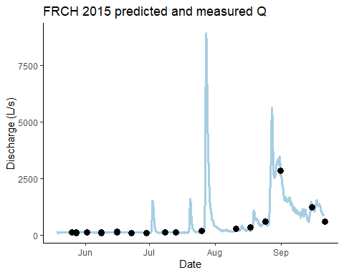

### Export 2015 predicted Q

pred_Q_2015 <- full_join(FRCH.2015.one.dt[,c(2,15)], MOOS.2015.one.dt[,c(2,15)])

## Warning in gzfile(file, mode): cannot open compressed file 'C:/Users/KARENJ~1/  
## AppData/Local/Temp/RtmpIPoIr6\file20984c9d3bbb', probable reason 'No such file  
## or directory'

## Joining, by = "DateTimeAK"

write.csv(pred_Q_2015, "Predicted_Q_2015.csv")  
  
pred_Q_2015 %>% ggplot() + geom_line(aes(DateTimeAK, pred.frch.Q), col = 1)+ geom_line(aes(DateTimeAK, pred.moos.Q), col = 2) + ylab("Predicted Q")

## Warning: Removed 49 row(s) containing missing values (geom_path).

