09_modelling_cont.

Jake Cavaiani

3/24/2022

# Read in data #   
antecedent_HI_FI_1_0 <- read_csv("~/Documents/Storms/Output_from_analysis/06_HI_fire_permafrost_script/antecedent_HI_FI_1.0.csv") # read in data

## Warning: Missing column names filled in: 'X1' [1]

##   
## ── Column specification ────────────────────────────────────────────────────────  
## cols(  
## .default = col_double(),  
## site.ID = col_character(),  
## storm.ID = col_character(),  
## response_var = col_character(),  
## burn = col_character(),  
## pf = col_character(),  
## date = col_date(format = "")  
## )  
## ℹ Use `spec()` for the full column specifications.

antecedent_HI_FI_1_0 <- antecedent_HI_FI_1_0[,-c(1:2,14:15,17,19)] # cleaning up columns that are unnecessary   
  
colNames <- c("Hyst_index", "HI_ymin", "HI_ymax", "site.ID", "storm.ID", "month", "day", "response_var", "Flush_index", "FI_ymin", "FI_ymax", "year", "beta", "StormPrecip", "StormTemp", "PrecipWeek", "PrecipMonth", "ThreeMonth", "TempWeek", "Duration", "Intensity", "doy", "burn", "pf", "date", "TimeSinceChena")  
  
names(antecedent_HI_FI_1_0)<- colNames # renaming columns   
  
# filling in holes that the automated script did not do correctly   
antecedent_HI_FI_1_0[c(306:310), 20] <- 68.75  
antecedent_HI_FI_1_0[c(306:310), 21] <- 0.01454545  
  
antecedent_HI_FI_1_0[c(313:315), 20] <- 68.75  
antecedent_HI_FI_1_0[c(313:315), 21] <- 0.01454545  
  
antecedent_HI_FI_1_0[c(327:330), 20] <- 61.25  
antecedent_HI_FI_1_0[c(327:330), 21] <- 0.07183673  
  
antecedent_HI_FI_1_0[c(628:631), 20] <- 21.25  
antecedent_HI_FI_1_0[c(628:631), 21] <- 0.09411765  
  
antecedent_HI_FI_1_0[c(650:652), 20] <- 30.25  
antecedent_HI_FI_1_0[c(650:652), 21] <- 0.2181818  
  
antecedent_HI_FI_1_0[c(656:657), 20] <- 23.5  
antecedent_HI_FI_1_0[c(656:657), 21] <- 0.03404255  
  
antecedent_HI_FI_1_0[c(810:813), 20] <- 30.5  
antecedent_HI_FI_1_0[c(810:813), 21] <- 0.1901639  
  
antecedent_HI_FI_1_0[c(848:850), 20] <- 58.5  
antecedent_HI_FI_1_0[c(848:850), 21] <- 0.1628205  
  
antecedent_HI_FI_1_0[c(885:888), 20] <- 31.5  
antecedent_HI_FI_1_0[c(885:888), 21] <- 0.1777778  
  
antecedent_HI_FI_1_0[c(86), 14] <- 6.604  
antecedent_HI_FI_1_0[c(86), 15] <- 13.560411  
antecedent_HI_FI_1_0[c(86), 16] <- 9.779  
antecedent_HI_FI_1_0[c(86), 17] <- 79.756  
antecedent_HI_FI_1_0[c(86), 18] <- 79.756  
antecedent_HI_FI_1_0[c(86), 19] <- 6.389494  
antecedent_HI_FI_1_0[c(86), 20] <- 32.46667  
antecedent_HI_FI_1_0[c(86), 21] <- 0.203408624  
antecedent_HI_FI_1_0[c(86), 22] <- 179.2299  
antecedent_HI_FI_1_0[c(86), 23] <- "burned"  
antecedent_HI_FI_1_0[c(86), 24] <- "medium"  
  
antecedent_HI_FI_1_0[c(86), 26] <- 38.22986  
  
antecedent_HI_FI_1_0[c(110), 14] <- 2.667  
antecedent_HI_FI_1_0[c(110), 15] <- 7.809827  
antecedent_HI_FI_1_0[c(110), 16] <- 8.255  
antecedent_HI_FI_1_0[c(110), 17] <- 109.474000  
antecedent_HI_FI_1_0[c(110), 18] <- 175.641000  
antecedent_HI_FI_1_0[c(110), 19] <- 9.680474  
antecedent_HI_FI_1_0[c(110), 20] <- 47.96667  
antecedent_HI_FI_1_0[c(110), 21] <- 0.055601112  
antecedent_HI_FI_1_0[c(110), 22] <- 235.4590  
antecedent_HI_FI_1_0[c(110), 23] <- "burned"  
antecedent_HI_FI_1_0[c(110), 24] <- "medium"  
#antecedent_HI_FI_1_0[c(110), 25] <- "2018-06-29"  
antecedent_HI_FI_1_0[c(110), 26] <- 94.45903  
  
antecedent_HI_FI_1_0[c(126:127), 14] <- 40.640  
antecedent_HI_FI_1_0[c(126:127), 15] <- 4.928689  
antecedent_HI_FI_1_0[c(126:127), 16] <- 21.082  
antecedent_HI_FI_1_0[c(126:127), 17] <- 26.543  
antecedent_HI_FI_1_0[c(126:127), 18] <- 26.543  
antecedent_HI_FI_1_0[c(126:127), 19] <- 5.977116  
antecedent_HI_FI_1_0[c(126:127), 20] <- 104.96667  
antecedent_HI_FI_1_0[c(126:127), 21] <- 0.387170530  
antecedent_HI_FI_1_0[c(126:127), 22] <- 262.9174  
antecedent_HI_FI_1_0[c(126:127), 23] <- "burned"  
antecedent_HI_FI_1_0[c(126:127), 24] <- "medium"  
#antecedent_HI_FI_1_0[c(126:127), 25] <- "2018-06-29"  
antecedent_HI_FI_1_0[c(126:127), 26] <- 121.91736  
  
antecedent_HI_FI_1_0[c(130), 14] <- 4.572  
antecedent_HI_FI_1_0[c(130), 15] <- 4.103419  
antecedent_HI_FI_1_0[c(130), 16] <- 48.133  
antecedent_HI_FI_1_0[c(130), 17] <- 67.183  
antecedent_HI_FI_1_0[c(130), 18] <- 67.183  
antecedent_HI_FI_1_0[c(130), 19] <- 5.676306  
antecedent_HI_FI_1_0[c(130), 20] <- 130.96667  
antecedent_HI_FI_1_0[c(130), 21] <- 0.034909646  
antecedent_HI_FI_1_0[c(130), 22] <- 267.3340  
antecedent_HI_FI_1_0[c(130), 23] <- "burned"  
antecedent_HI_FI_1_0[c(130), 24] <- "medium"  
#antecedent_HI_FI_1_0[c(130), 25] <- "2018-06-29"  
antecedent_HI_FI_1_0[c(130), 26] <- 126.33403  
  
antecedent_HI_FI_1_0[c(305), 23] <- "burned"  
antecedent_HI_FI_1_0[c(305), 24] <- "high"  
  
antecedent_HI_FI_1_0[c(313), 14] <- 37.600  
antecedent_HI_FI_1_0[c(313), 15] <- 12.7643333  
antecedent_HI_FI_1_0[c(313), 16] <- 54.800  
antecedent_HI_FI_1_0[c(313), 17] <- 106.600  
antecedent_HI_FI_1_0[c(313), 18] <- 229.000  
antecedent_HI_FI_1_0[c(313), 19] <- 12.263147  
antecedent_HI_FI_1_0[c(313), 20] <- 68.75  
antecedent_HI_FI_1_0[c(313), 21] <- 0.014545450  
antecedent_HI_FI_1_0[c(313), 22] <- 216.6042  
antecedent_HI_FI_1_0[c(313), 23] <- "burned"  
antecedent_HI_FI_1_0[c(313), 24] <- "high"  
#antecedent_HI_FI_1_0[c(313), 25] <- "2018-06-29"  
#antecedent_HI_FI_1_0[c(313), 26] <- 79.60417  
  
antecedent_HI_FI_1_0[c(339:342), 23] <- "burned"  
antecedent_HI_FI_1_0[c(339:342), 24] <- "high"  
  
antecedent_HI_FI_1_0 <- antecedent_HI_FI_1_0[-658,]  
  
antecedent_HI_FI_1_0[c(750), 23] <- "burned"  
antecedent_HI_FI_1_0[c(750), 24] <- "medium"  
  
which(antecedent_HI_FI_1_0$site.ID == "MOOS")

## [1] 38 39 40 41 42 43 44 45 46 47 48 49 50 51 52 53 54 55  
## [19] 56 57 58 59 60 61 62 63 64 65 66 67 68 69 70 71 72 73  
## [37] 74 75 76 77 78 79 80 81 216 217 218 219 220 221 222 223 224 225  
## [55] 226 227 228 229 230 231 232 233 234 235 236 237 238 239 240 241 242 243  
## [73] 244 245 246 247 248 249 250 251 252 253 254 255 256 257 258 259 260 261  
## [91] 262 263 264 503 504 505 506 507 508 509 510 511 512 513 514 515 516 517  
## [109] 518 519 520 521 522 523 524 525 526 527 528 529 530 531 532 817 818 819  
## [127] 820 821 822 823 824 825 826 827 828 829 830 831 832 833 834 835 836 837  
## [145] 838 839 840 841 842 843 844 845 846

# i have a discrepency with is MOOS is burned or not....2018/2019 are listed as burned and 2020/2021 are listed as unburned....MOOS is catergorized as BURNED  
  
antecedent_HI_FI_1_0[c(503:532, 817:846), 23] <- "burned"  
  
  
  
##subsetting by solute   
# NO3 #  
HI_FI_NO3 = subset(antecedent_HI_FI_1_0, response_var == "NO3")  
# fDOM #  
HI_FI_fDOM = subset(antecedent_HI_FI_1_0, response_var == "fDOM")  
# SPC #  
HI_FI_SPC = subset(antecedent_HI_FI_1_0, response_var == "SPC")  
# turb #  
HI_FI_turb = subset(antecedent_HI_FI_1_0, response_var == "turb")

Catchment effects

CV.all <- antecedent_HI_FI_1_0 %>% group_by(response_var,site.ID, year) %>%  
 summarize(meanHI = mean(Hyst_index),  
 meanFI = mean(Flush_index, na.rm = TRUE),  
 meanBETA = mean(beta, na.rm = TRUE),  
 sdHI = sd(Hyst_index),  
 sdFI = sd(Flush_index, na.rm = TRUE),  
 sdBETA = sd(beta, na.rm = TRUE),  
 CVhi = sdHI/meanHI,  
 CVfi = sdFI/meanFI,  
 CVbeta = sdBETA/meanBETA,  
 pf = paste(pf),  
 burn = paste(burn)) # calculating mean HI and CV for each year and each site

## `summarise()` has grouped output by 'response_var', 'site.ID', 'year'. You can  
## override using the `.groups` argument.

CV.all <- CV.all[!duplicated(CV.all$meanHI), ] # removing duplicated rows   
  
chem <- read_csv("~/Documents/Storms/Output_from_analysis/From_07_Modelling/Results_figures/Discharge_chem/all.chem.csv",   
 col_types = cols(fDOM.QSU = col_double(),   
 nitrateuM = col_double(), SpCond.uScm = col_double(),   
 Turbidity.FNU = col_double())) # reading in all chem data

## Warning: Missing column names filled in: 'X1' [1]

chem.mean <- chem %>% group_by(Site, year) %>%   
 summarize(meanfDOM = mean(fDOM.QSU, na.rm = TRUE)) # generating mean fDOM concentration by site and year

## `summarise()` has grouped output by 'Site'. You can override using the `.groups`  
## argument.

names(chem.mean) <- c("site.ID", "year", "meanfDOM") # changing the names so they can be merged  
  
CV.all.model <- left_join(CV.all, chem.mean, by = c("site.ID", "year")) # merging TNDOC and CV to run for the model   
  
NO3.CV <- subset(CV.all.model, CV.all$response_var == "NO3")  
NO3.CV <- NO3.CV[-c(4,19),] # removing CARI 2021 due to it being an outlier   
  
  
fcvno3 <- formula(CVhi ~ pf*meanfDOM + burn*meanfDOM + (1|year))  
  
Mcvno3 <- lmer(fcvno3, data = NO3.CV)

## boundary (singular) fit: see ?isSingular

summary(Mcvno3)

## Linear mixed model fit by REML ['lmerMod']  
## Formula: CVhi ~ pf * meanfDOM + burn * meanfDOM + (1 | year)  
## Data: NO3.CV  
##   
## REML criterion at convergence: 83.7  
##   
## Scaled residuals:   
## Min 1Q Median 3Q Max   
## -2.13941 -0.38734 -0.07283 0.47610 1.89623   
##   
## Random effects:  
## Groups Name Variance Std.Dev.  
## year (Intercept) 0.000 0.000   
## Residual 4.529 2.128   
## Number of obs: 18, groups: year, 4  
##   
## Fixed effects:  
## Estimate Std. Error t value  
## (Intercept) 9.88084 4.64543 2.127  
## pfmedium -7.41817 4.67001 -1.588  
## meanfDOM -0.12066 0.06857 -1.760  
## burnunburned -4.53488 5.24863 -0.864  
## pfmedium:meanfDOM 0.11697 0.06700 1.746  
## meanfDOM:burnunburned 0.08660 0.07111 1.218  
##   
## Correlation of Fixed Effects:  
## (Intr) pfmedm mnfDOM brnnbr pf:DOM  
## pfmedium -0.938   
## meanfDOM -0.965 0.899   
## burnunburnd -0.847 0.743 0.909   
## pfmdm:mnDOM 0.927 -0.953 -0.959 -0.859   
## mnfDOM:brnn 0.904 -0.823 -0.971 -0.970 0.924  
## optimizer (nloptwrap) convergence code: 0 (OK)  
## boundary (singular) fit: see ?isSingular

plot(Mcvno3)

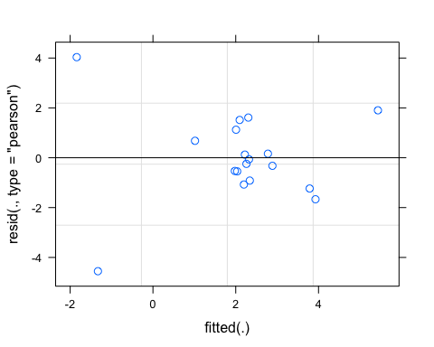

qqnorm(resid(Mcvno3))

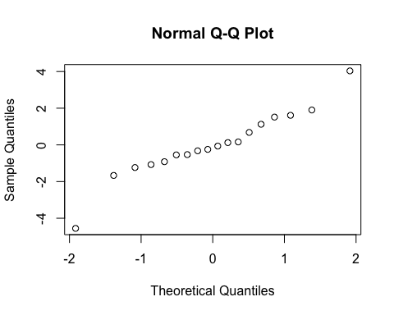

sjPlot::tab_model(Mcvno3)

## Warning: Argument 'df_method' is deprecated. Please use 'ci_method' instead.

CVhi

Predictors

Estimates

CI

p

(Intercept)

9.88

-0.47 – 20.23

0.059

pf [medium]

-7.42

-17.82 – 2.99

0.143

meanfDOM

-0.12

-0.27 – 0.03

0.109

burn [unburned]

-4.53

-16.23 – 7.16

0.408

pf [medium] * meanfDOM

0.12

-0.03 – 0.27

0.111

meanfDOM * burn[unburned]

0.09

-0.07 – 0.25

0.251

Random Effects

σ2

4.53

τ00 year

0.00

N year

4

Observations

18

Marginal R2 / Conditional R2

0.379 / NA

r.squaredGLMM(Mcvno3)

## Warning: 'r.squaredGLMM' now calculates a revised statistic. See the help page.

## R2m R2c  
## [1,] 0.3793882 0.3793882

m1 <- lm(CVhi ~ pf*meanfDOM + burn*meanfDOM, data = NO3.CV)  
dwplot(m1,  
 dot_args = list(color = "black"), # color for the dot  
 whisker_args = list(color = "red"), # color for the whisker  
 vline = geom_vline(xintercept = 0, colour = "grey50", linetype = 2)) +  
 xlab("Coefficient") +   
 ggtitle("") +  
 theme_classic()

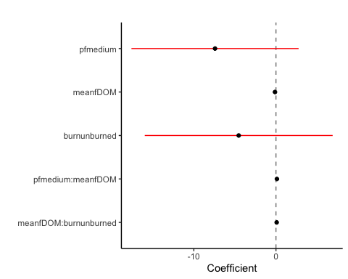

fDOM

fDOM.CV <- subset(CV.all.model, CV.all$response_var == "fDOM")  
  
fcvfdom <- formula(CVhi ~ pf*meanfDOM + burn*meanfDOM + (1|year))  
  
Mcvfdom <- lmer(fcvfdom, data = fDOM.CV)  
summary(Mcvfdom)

## Linear mixed model fit by REML ['lmerMod']  
## Formula: CVhi ~ pf * meanfDOM + burn * meanfDOM + (1 | year)  
## Data: fDOM.CV  
##   
## REML criterion at convergence: 104  
##   
## Scaled residuals:   
## Min 1Q Median 3Q Max   
## -1.39295 -0.51502 -0.04334 0.42248 1.91061   
##   
## Random effects:  
## Groups Name Variance Std.Dev.  
## year (Intercept) 1.732 1.316   
## Residual 5.949 2.439   
## Number of obs: 21, groups: year, 4  
##   
## Fixed effects:  
## Estimate Std. Error t value  
## (Intercept) -5.31762 5.47101 -0.972  
## pfmedium 4.49764 5.54283 0.811  
## meanfDOM 0.06184 0.08149 0.759  
## burnunburned 1.43906 6.21009 0.232  
## pfmedium:meanfDOM -0.06318 0.08122 -0.778  
## meanfDOM:burnunburned -0.04758 0.08476 -0.561  
##   
## Correlation of Fixed Effects:  
## (Intr) pfmedm mnfDOM brnnbr pf:DOM  
## pfmedium -0.936   
## meanfDOM -0.957 0.910   
## burnunburnd -0.855 0.776 0.923   
## pfmdm:mnDOM 0.920 -0.957 -0.963 -0.877   
## mnfDOM:brnn 0.905 -0.846 -0.977 -0.973 0.937

plot(Mcvfdom)

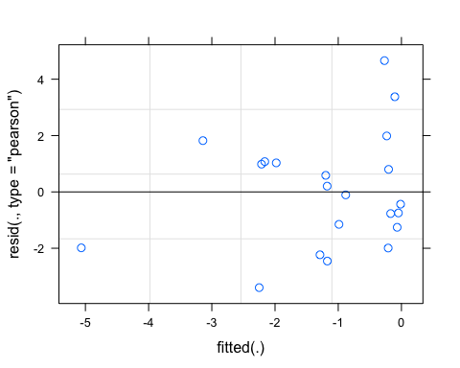

qqnorm(resid(Mcvfdom))

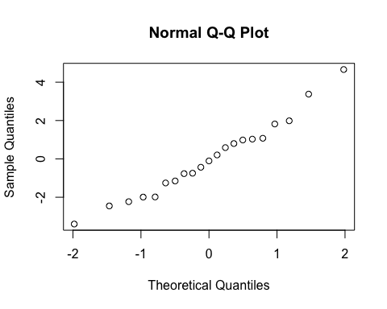

sjPlot::tab_model(Mcvfdom)

## Warning: Argument 'df_method' is deprecated. Please use 'ci_method' instead.

CVhi

Predictors

Estimates

CI

p

(Intercept)

-5.32

-17.14 – 6.50

0.349

pf [medium]

4.50

-7.48 – 16.47

0.432

meanfDOM

0.06

-0.11 – 0.24

0.461

burn [unburned]

1.44

-11.98 – 14.86

0.820

pf [medium] * meanfDOM

-0.06

-0.24 – 0.11

0.451

meanfDOM * burn[unburned]

-0.05

-0.23 – 0.14

0.584

Random Effects

σ2

5.95

τ00 year

1.73

ICC

0.23

N year

4

Observations

21

Marginal R2 / Conditional R2

0.084 / 0.291

r.squaredGLMM(Mcvfdom)

## R2m R2c  
## [1,] 0.08399726 0.290593

m1 <- lm(CVhi ~ pf*meanfDOM + burn*meanfDOM, data = fDOM.CV)  
dwplot(m1,  
 dot_args = list(color = "black"), # color for the dot  
 whisker_args = list(color = "red"), # color for the whisker  
 vline = geom_vline(xintercept = 0, colour = "grey50", linetype = 2)) +  
 xlab("Coefficient") +   
 ggtitle("") +  
 theme_classic()

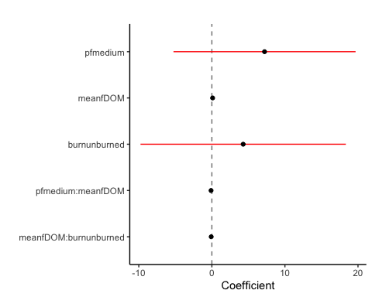

SPC

SPC.CV <- subset(CV.all.model, CV.all$response_var == "SPC")  
  
fcvspc <- formula(CVhi ~ pf*meanfDOM + burn*meanfDOM + (1|year))  
  
Mcvspc <- lmer(fcvspc, data = SPC.CV)

## boundary (singular) fit: see ?isSingular

summary(Mcvspc)

## Linear mixed model fit by REML ['lmerMod']  
## Formula: CVhi ~ pf * meanfDOM + burn * meanfDOM + (1 | year)  
## Data: SPC.CV  
##   
## REML criterion at convergence: 65.9  
##   
## Scaled residuals:   
## Min 1Q Median 3Q Max   
## -2.6847 -0.4931 0.1937 0.4507 1.4819   
##   
## Random effects:  
## Groups Name Variance Std.Dev.  
## year (Intercept) 0.0000 0.0000   
## Residual 0.5526 0.7434   
## Number of obs: 21, groups: year, 4  
##   
## Fixed effects:  
## Estimate Std. Error t value  
## (Intercept) 3.05840 1.61496 1.894  
## pfmedium -2.32476 1.62030 -1.435  
## meanfDOM -0.03239 0.02383 -1.359  
## burnunburned -1.16465 1.82694 -0.637  
## pfmedium:meanfDOM 0.02807 0.02332 1.203  
## meanfDOM:burnunburned 0.02889 0.02478 1.166  
##   
## Correlation of Fixed Effects:  
## (Intr) pfmedm mnfDOM brnnbr pf:DOM  
## pfmedium -0.942   
## meanfDOM -0.965 0.903   
## burnunburnd -0.854 0.759 0.917   
## pfmdm:mnDOM 0.929 -0.954 -0.961 -0.869   
## mnfDOM:brnn 0.908 -0.833 -0.976 -0.971 0.932  
## optimizer (nloptwrap) convergence code: 0 (OK)  
## boundary (singular) fit: see ?isSingular

plot(Mcvspc)

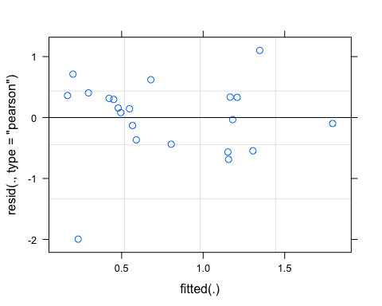

qqnorm(resid(Mcvspc))

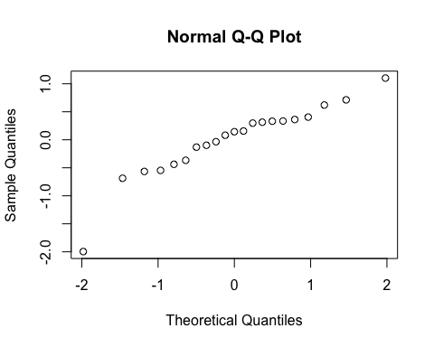

sjPlot::tab_model(Mcvspc)

## Warning: Argument 'df_method' is deprecated. Please use 'ci_method' instead.

CVhi

Predictors

Estimates

CI

p

(Intercept)

3.06

-0.43 – 6.55

0.081

pf [medium]

-2.32

-5.83 – 1.18

0.175

meanfDOM

-0.03

-0.08 – 0.02

0.197

burn [unburned]

-1.16

-5.11 – 2.78

0.535

pf [medium] * meanfDOM

0.03

-0.02 – 0.08

0.250

meanfDOM * burn[unburned]

0.03

-0.02 – 0.08

0.265

Random Effects

σ2

0.55

τ00 year

0.00

N year

4

Observations

21

Marginal R2 / Conditional R2

0.275 / NA

r.squaredGLMM(Mcvspc)

## R2m R2c  
## [1,] 0.2751071 0.2751071

m1 <- lm(CVhi ~ pf*meanfDOM + burn*meanfDOM, data = SPC.CV)  
dwplot(m1,  
 dot_args = list(color = "black"), # color for the dot  
 whisker_args = list(color = "red"), # color for the whisker  
 vline = geom_vline(xintercept = 0, colour = "grey50", linetype = 2)) +  
 xlab("Coefficient") +   
 ggtitle("") +  
 theme_classic()

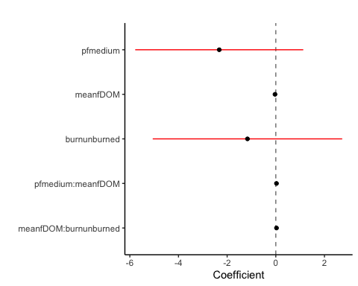

Turb

turb.CV <- subset(CV.all.model, CV.all$response_var == "turb")  
turb.CV <- turb.CV[-c(1,10),] # removing CARI 2018/MOOS 2019 due to it being an outlier   
  
fcvturb <- formula(CVhi ~ pf*meanfDOM + burn*meanfDOM + (1|year))  
  
Mcvturb <- lmer(fcvturb, data = turb.CV)  
summary(Mcvturb)

## Linear mixed model fit by REML ['lmerMod']  
## Formula: CVhi ~ pf * meanfDOM + burn * meanfDOM + (1 | year)  
## Data: turb.CV  
##   
## REML criterion at convergence: 99.5  
##   
## Scaled residuals:   
## Min 1Q Median 3Q Max   
## -1.5326 -0.6978 0.1704 0.5944 1.2575   
##   
## Random effects:  
## Groups Name Variance Std.Dev.  
## year (Intercept) 0.385 0.6205   
## Residual 10.408 3.2261   
## Number of obs: 19, groups: year, 4  
##   
## Fixed effects:  
## Estimate Std. Error t value  
## (Intercept) 2.52574 7.10564 0.355  
## pfmedium 1.36487 7.12819 0.191  
## meanfDOM -0.02378 0.10520 -0.226  
## burnunburned -8.20149 8.01963 -1.023  
## pfmedium:meanfDOM -0.02269 0.10268 -0.221  
## meanfDOM:burnunburned 0.07280 0.10920 0.667  
##   
## Correlation of Fixed Effects:  
## (Intr) pfmedm mnfDOM brnnbr pf:DOM  
## pfmedium -0.934   
## meanfDOM -0.964 0.897   
## burnunburnd -0.854 0.753 0.916   
## pfmdm:mnDOM 0.919 -0.954 -0.952 -0.864   
## mnfDOM:brnn 0.909 -0.829 -0.976 -0.970 0.925

plot(Mcvturb)

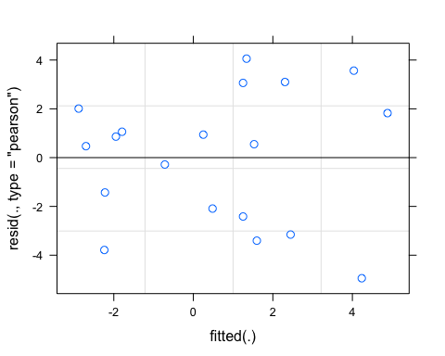

qqnorm(resid(Mcvturb))

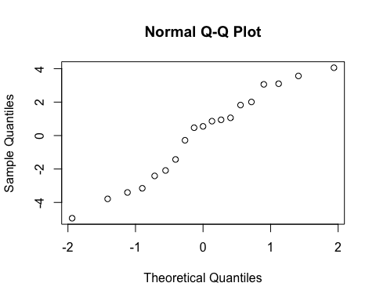

sjPlot::tab_model(Mcvturb)

## Warning: Argument 'df_method' is deprecated. Please use 'ci_method' instead.

CVhi

Predictors

Estimates

CI

p

(Intercept)

2.53

-13.11 – 18.17

0.729

pf [medium]

1.36

-14.32 – 17.05

0.852

meanfDOM

-0.02

-0.26 – 0.21

0.825

burn [unburned]

-8.20

-25.85 – 9.45

0.328

pf [medium] * meanfDOM

-0.02

-0.25 – 0.20

0.829

meanfDOM * burn[unburned]

0.07

-0.17 – 0.31

0.519

Random Effects

σ2

10.41

τ00 year

0.39

ICC

0.04

N year

4

Observations

19

Marginal R2 / Conditional R2

0.347 / 0.371

r.squaredGLMM(Mcvturb)

## R2m R2c  
## [1,] 0.3472307 0.3705182

m1 <- lm(CVhi ~ pf*meanfDOM + burn*meanfDOM, data = turb.CV)  
dwplot(m1,  
 dot_args = list(color = "black"), # color for the dot  
 whisker_args = list(color = "red"), # color for the whisker  
 vline = geom_vline(xintercept = 0, colour = "grey50", linetype = 2)) +  
 xlab("Coefficient") +   
 ggtitle("") +  
 theme_classic()

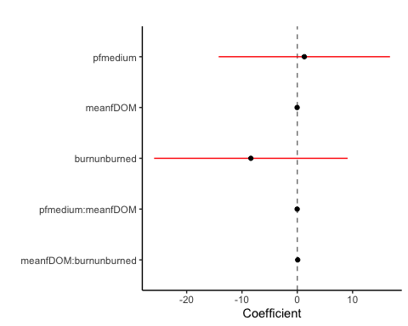

################################################################################################################################################ BETA

NO3

fcvno3 <- formula(CVbeta ~ pf*meanfDOM + burn*meanfDOM + (1|year))  
  
Mcvno3 <- lmer(fcvno3, data = NO3.CV)

## boundary (singular) fit: see ?isSingular

summary(Mcvno3)

## Linear mixed model fit by REML ['lmerMod']  
## Formula: CVbeta ~ pf * meanfDOM + burn * meanfDOM + (1 | year)  
## Data: NO3.CV  
##   
## REML criterion at convergence: 144.8  
##   
## Scaled residuals:   
## Min 1Q Median 3Q Max   
## -0.85337 -0.44603 -0.05101 0.06244 3.06740   
##   
## Random effects:  
## Groups Name Variance Std.Dev.  
## year (Intercept) 0.0 0.0   
## Residual 734.4 27.1   
## Number of obs: 18, groups: year, 4  
##   
## Fixed effects:  
## Estimate Std. Error t value  
## (Intercept) 7.8474 59.1586 0.133  
## pfmedium 22.2799 59.4716 0.375  
## meanfDOM -0.1016 0.8733 -0.116  
## burnunburned -25.1209 66.8402 -0.376  
## pfmedium:meanfDOM -0.1552 0.8533 -0.182  
## meanfDOM:burnunburned 0.1740 0.9055 0.192  
##   
## Correlation of Fixed Effects:  
## (Intr) pfmedm mnfDOM brnnbr pf:DOM  
## pfmedium -0.938   
## meanfDOM -0.965 0.899   
## burnunburnd -0.847 0.743 0.909   
## pfmdm:mnDOM 0.927 -0.953 -0.959 -0.859   
## mnfDOM:brnn 0.904 -0.823 -0.971 -0.970 0.924  
## optimizer (nloptwrap) convergence code: 0 (OK)  
## boundary (singular) fit: see ?isSingular

plot(Mcvno3)

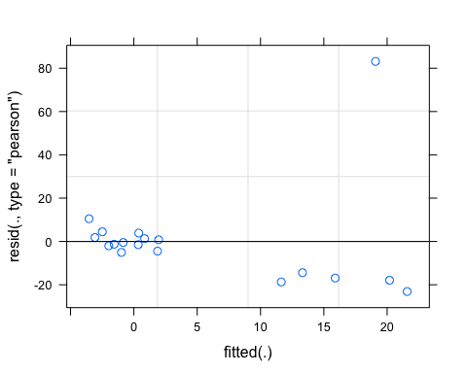

qqnorm(resid(Mcvno3))

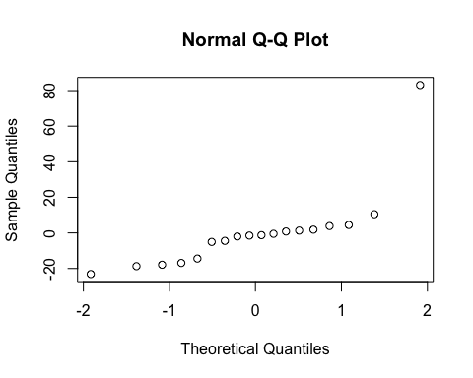

sjPlot::tab_model(Mcvno3)

## Warning: Argument 'df_method' is deprecated. Please use 'ci_method' instead.

CVbeta

Predictors

Estimates

CI

p

(Intercept)

7.85

-123.97 – 139.66

0.897

pf [medium]

22.28

-110.23 – 154.79

0.716

meanfDOM

-0.10

-2.05 – 1.84

0.910

burn [unburned]

-25.12

-174.05 – 123.81

0.715

pf [medium] * meanfDOM

-0.16

-2.06 – 1.75

0.859

meanfDOM * burn[unburned]

0.17

-1.84 – 2.19

0.851

Random Effects

σ2

734.44

τ00 year

0.00

N year

4

Observations

18

Marginal R2 / Conditional R2

0.099 / NA

r.squaredGLMM(Mcvno3)

## R2m R2c  
## [1,] 0.09891365 0.09891365

m1 <- lm(CVhi ~ pf*meanfDOM + burn*meanfDOM, data = NO3.CV)  
dwplot(m1,  
 dot_args = list(color = "black"), # color for the dot  
 whisker_args = list(color = "red"), # color for the whisker  
 vline = geom_vline(xintercept = 0, colour = "grey50", linetype = 2)) +  
 xlab("Coefficient") +   
 ggtitle("") +  
 theme_classic()



fDOM

fcvfdom <- formula(CVbeta ~ pf*meanfDOM + burn*meanfDOM + (1|year))  
  
Mcvfdom <- lmer(fcvfdom, data = fDOM.CV)

## boundary (singular) fit: see ?isSingular

summary(Mcvfdom)

## Linear mixed model fit by REML ['lmerMod']  
## Formula: CVbeta ~ pf * meanfDOM + burn * meanfDOM + (1 | year)  
## Data: fDOM.CV  
##   
## REML criterion at convergence: 150.7  
##   
## Scaled residuals:   
## Min 1Q Median 3Q Max   
## -2.1223 -0.4448 -0.1333 0.4597 2.1075   
##   
## Random effects:  
## Groups Name Variance Std.Dev.  
## year (Intercept) 0.0 0.00   
## Residual 157.5 12.55   
## Number of obs: 21, groups: year, 4  
##   
## Fixed effects:  
## Estimate Std. Error t value  
## (Intercept) -8.16203 27.26172 -0.299  
## pfmedium 25.65330 27.35187 0.938  
## meanfDOM -0.03811 0.40224 -0.095  
## burnunburned -20.16458 30.84016 -0.654  
## pfmedium:meanfDOM -0.14199 0.39374 -0.361  
## meanfDOM:burnunburned 0.18552 0.41838 0.443  
##   
## Correlation of Fixed Effects:  
## (Intr) pfmedm mnfDOM brnnbr pf:DOM  
## pfmedium -0.942   
## meanfDOM -0.965 0.903   
## burnunburnd -0.854 0.759 0.917   
## pfmdm:mnDOM 0.929 -0.954 -0.961 -0.869   
## mnfDOM:brnn 0.908 -0.833 -0.976 -0.971 0.932  
## optimizer (nloptwrap) convergence code: 0 (OK)  
## boundary (singular) fit: see ?isSingular

plot(Mcvfdom)

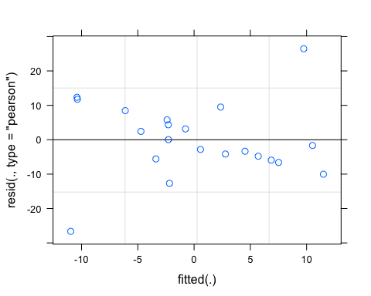

qqnorm(resid(Mcvfdom))

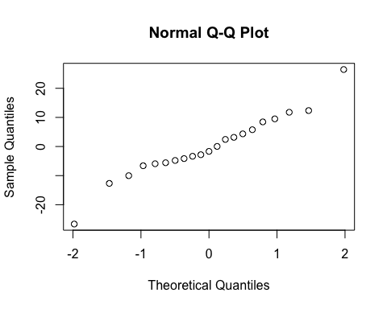

sjPlot::tab_model(Mcvfdom)

## Warning: Argument 'df_method' is deprecated. Please use 'ci_method' instead.

CVbeta

Predictors

Estimates

CI

p

(Intercept)

-8.16

-67.06 – 50.73

0.769

pf [medium]

25.65

-33.44 – 84.74

0.365

meanfDOM

-0.04

-0.91 – 0.83

0.926

burn [unburned]

-20.16

-86.79 – 46.46

0.525

pf [medium] * meanfDOM

-0.14

-0.99 – 0.71

0.724

meanfDOM * burn[unburned]

0.19

-0.72 – 1.09

0.665

Random Effects

σ2

157.48

τ00 year

0.00

N year

4

Observations

21

Marginal R2 / Conditional R2

0.229 / NA

r.squaredGLMM(Mcvfdom)

## R2m R2c  
## [1,] 0.2289006 0.2289006

m1 <- lm(CVbeta ~ pf*meanfDOM + burn*meanfDOM, data = fDOM.CV)  
dwplot(m1,  
 dot_args = list(color = "black"), # color for the dot  
 whisker_args = list(color = "red"), # color for the whisker  
 vline = geom_vline(xintercept = 0, colour = "grey50", linetype = 2)) +  
 xlab("Coefficient") +   
 ggtitle("") +  
 theme_classic()

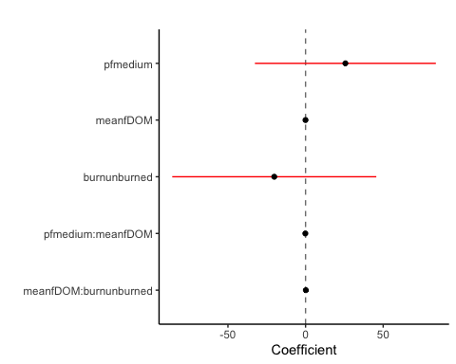

SPC

fcvspc <- formula(CVbeta ~ pf*meanfDOM + burn*meanfDOM + (1|year))  
  
Mcvspc <- lmer(fcvspc, data = SPC.CV)  
summary(Mcvspc)

## Linear mixed model fit by REML ['lmerMod']  
## Formula: CVbeta ~ pf * meanfDOM + burn * meanfDOM + (1 | year)  
## Data: SPC.CV  
##   
## REML criterion at convergence: 199.3  
##   
## Scaled residuals:   
## Min 1Q Median 3Q Max   
## -1.16329 -0.21198 0.01733 0.30414 2.55781   
##   
## Random effects:  
## Groups Name Variance Std.Dev.  
## year (Intercept) 933.5 30.55   
## Residual 3431.1 58.58   
## Number of obs: 21, groups: year, 4  
##   
## Fixed effects:  
## Estimate Std. Error t value  
## (Intercept) -28.103 131.216 -0.214  
## pfmedium 50.403 132.914 0.379  
## meanfDOM 1.979 1.954 1.013  
## burnunburned 202.824 148.953 1.362  
## pfmedium:meanfDOM -2.393 1.946 -1.230  
## meanfDOM:burnunburned -2.815 2.033 -1.385  
##   
## Correlation of Fixed Effects:  
## (Intr) pfmedm mnfDOM brnnbr pf:DOM  
## pfmedium -0.936   
## meanfDOM -0.958 0.910   
## burnunburnd -0.855 0.776 0.923   
## pfmdm:mnDOM 0.920 -0.957 -0.963 -0.877   
## mnfDOM:brnn 0.905 -0.846 -0.977 -0.973 0.936

plot(Mcvspc)

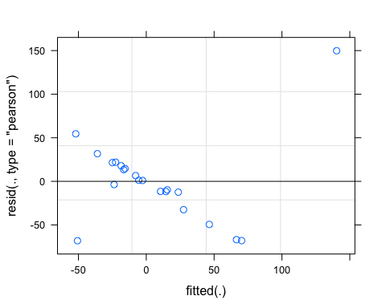

qqnorm(resid(Mcvspc))

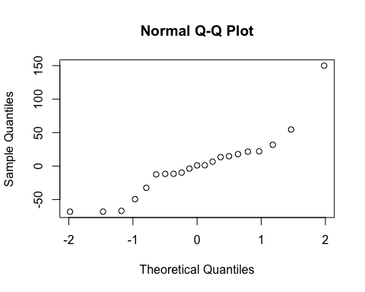

sjPlot::tab_model(Mcvspc)

## Warning: Argument 'df_method' is deprecated. Please use 'ci_method' instead.

CVbeta

Predictors

Estimates

CI

p

(Intercept)

-28.10

-311.58 – 255.37

0.834

pf [medium]

50.40

-236.74 – 337.55

0.711

meanfDOM

1.98

-2.24 – 6.20

0.330

burn [unburned]

202.82

-118.97 – 524.62

0.196

pf [medium] * meanfDOM

-2.39

-6.60 – 1.81

0.241

meanfDOM * burn[unburned]

-2.82

-7.21 – 1.58

0.189

Random Effects

σ2

3431.10

τ00 year

933.48

ICC

0.21

N year

4

Observations

21

Marginal R2 / Conditional R2

0.310 / 0.458

r.squaredGLMM(Mcvspc)

## R2m R2c  
## [1,] 0.3102663 0.4577842

m1 <- lm(CVbeta ~ pf*meanfDOM + burn*meanfDOM, data = SPC.CV)  
dwplot(m1,  
 dot_args = list(color = "black"), # color for the dot  
 whisker_args = list(color = "red"), # color for the whisker  
 vline = geom_vline(xintercept = 0, colour = "grey50", linetype = 2)) +  
 xlab("Coefficient") +   
 ggtitle("") +  
 theme_classic()

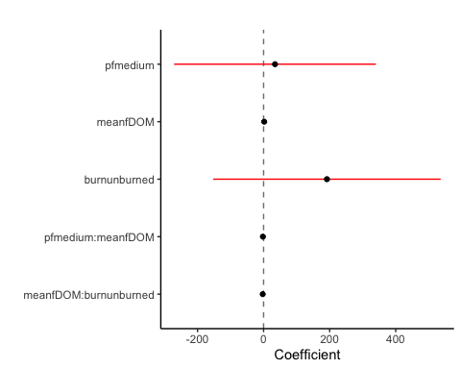

Turb

turb.CV <- turb.CV[-c(1,10),] # removing CARI 2018/MOOS 2019 due to it being an outlier   
  
fcvturb <- formula(CVbeta ~ pf*meanfDOM + burn*meanfDOM + (1|year))  
  
Mcvturb <- lmer(fcvturb, data = turb.CV)

## boundary (singular) fit: see ?isSingular

summary(Mcvturb)

## Linear mixed model fit by REML ['lmerMod']  
## Formula: CVbeta ~ pf * meanfDOM + burn * meanfDOM + (1 | year)  
## Data: turb.CV  
##   
## REML criterion at convergence: 129.1  
##   
## Scaled residuals:   
## Min 1Q Median 3Q Max   
## -2.56346 -0.09891 0.01799 0.21796 1.30918   
##   
## Random effects:  
## Groups Name Variance Std.Dev.   
## year (Intercept) 4.420e-14 2.102e-07  
## Residual 4.201e+02 2.050e+01  
## Number of obs: 17, groups: year, 4  
##   
## Fixed effects:  
## Estimate Std. Error t value  
## (Intercept) 13.1208 45.0185 0.291  
## pfmedium -6.7192 45.0506 -0.149  
## meanfDOM -0.6610 0.6654 -0.993  
## burnunburned -56.9424 50.8331 -1.120  
## pfmedium:meanfDOM 0.5773 0.6437 0.897  
## meanfDOM:burnunburned 0.8707 0.6901 1.262  
##   
## Correlation of Fixed Effects:  
## (Intr) pfmedm mnfDOM brnnbr pf:DOM  
## pfmedium -0.929   
## meanfDOM -0.965 0.889   
## burnunburnd -0.848 0.734 0.910   
## pfmdm:mnDOM 0.917 -0.950 -0.947 -0.855   
## mnfDOM:brnn 0.909 -0.817 -0.975 -0.968 0.919  
## optimizer (nloptwrap) convergence code: 0 (OK)  
## boundary (singular) fit: see ?isSingular

plot(Mcvturb)

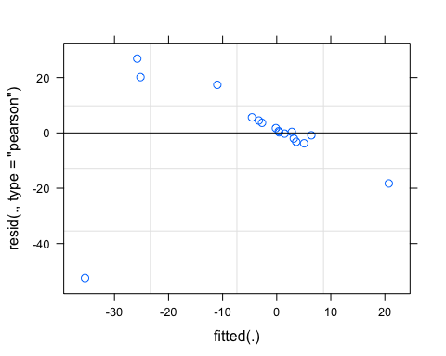

qqnorm(resid(Mcvturb))

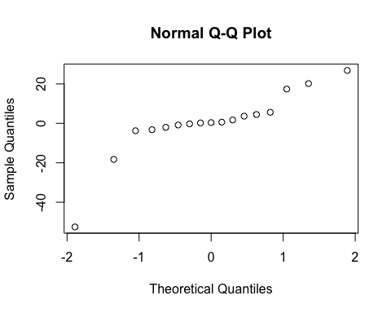

sjPlot::tab_model(Mcvturb)

## Warning: Argument 'df_method' is deprecated. Please use 'ci_method' instead.

CVbeta

Predictors

Estimates

CI

p

(Intercept)

13.12

-88.72 – 114.96

0.777

pf [medium]

-6.72

-108.63 – 95.19

0.885

meanfDOM

-0.66

-2.17 – 0.84

0.346

burn [unburned]

-56.94

-171.93 – 58.05

0.292

pf [medium] * meanfDOM

0.58

-0.88 – 2.03

0.393

meanfDOM * burn[unburned]

0.87

-0.69 – 2.43

0.239

Random Effects

σ2

420.06

τ00 year

0.00

N year

4

Observations

17

Marginal R2 / Conditional R2

0.309 / NA

r.squaredGLMM(Mcvturb)

## R2m R2c  
## [1,] 0.3089032 0.3089032

m1 <- lm(CVbeta ~ pf*meanfDOM + burn*meanfDOM, data = turb.CV)  
dwplot(m1,  
 dot_args = list(color = "black"), # color for the dot  
 whisker_args = list(color = "red"), # color for the whisker  
 vline = geom_vline(xintercept = 0, colour = "grey50", linetype = 2)) +  
 xlab("Coefficient") +   
 ggtitle("") +  
 theme_classic()

