10_gls_models

Jake Cavaiani

9/12/2022

#load libraries

library(here)

## here() starts at /Users/jakecavaiani/Documents/Storms_clean_repo

library(tidyverse)

## ── Attaching packages ─────────────────────────────────────── tidyverse 1.3.1 ──

## ✓ ggplot2 3.3.5 ✓ purrr 0.3.4  
## ✓ tibble 3.1.6 ✓ dplyr 1.0.7  
## ✓ tidyr 1.1.3 ✓ stringr 1.4.0  
## ✓ readr 1.4.0 ✓ forcats 0.5.1

## ── Conflicts ────────────────────────────────────────── tidyverse_conflicts() ──  
## x dplyr::filter() masks stats::filter()  
## x dplyr::lag() masks stats::lag()

library(nlme)

##   
## Attaching package: 'nlme'

## The following object is masked from 'package:dplyr':  
##   
## collapse

library(forecast)

## Registered S3 method overwritten by 'quantmod':  
## method from  
## as.zoo.data.frame zoo

##   
## Attaching package: 'forecast'

## The following object is masked from 'package:nlme':  
##   
## getResponse

library(stats)  
library(readr)  
library(ggplot2)  
library(plotly)

##   
## Attaching package: 'plotly'

## The following object is masked from 'package:ggplot2':  
##   
## last_plot

## The following object is masked from 'package:stats':  
##   
## filter

## The following object is masked from 'package:graphics':  
##   
## layout

library(GGally)

## Registered S3 method overwritten by 'GGally':  
## method from   
## +.gg ggplot2

library(ggpmisc)

## Loading required package: ggpp

##   
## Attaching package: 'ggpp'

## The following object is masked from 'package:ggplot2':  
##   
## annotate

library(ggpubr)

##   
## Attaching package: 'ggpubr'

## The following object is masked from 'package:forecast':  
##   
## gghistogram

library(ggExtra)  
library(lubridate)

##   
## Attaching package: 'lubridate'

## The following objects are masked from 'package:base':  
##   
## date, intersect, setdiff, union

library(nlme)  
library(MuMIn)  
library(multcomp)

## Loading required package: mvtnorm

## Loading required package: survival

## Loading required package: TH.data

## Loading required package: MASS

##   
## Attaching package: 'MASS'

## The following object is masked from 'package:plotly':  
##   
## select

## The following object is masked from 'package:dplyr':  
##   
## select

##   
## Attaching package: 'TH.data'

## The following object is masked from 'package:MASS':  
##   
## geyser

ggplot(mean_daily, aes(x = datetimeAK, y = dailyNO3, color = site.ID)) +  
 geom_line() +  
 facet_grid(site.ID ~ year) +  
 theme_classic()

## Warning: Removed 19 row(s) containing missing values (geom_path).

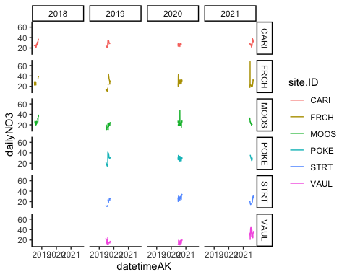 comparing each group to the base case (CARI) (and year of 2018) The intercept is the mean for CARI and the p-value each row for site is comparing that catchment mean across all years and site mean differs for caribou use a post hoc test to find if there is a significant interaction than we will run a post hoc test on the interaction

# corAR1 structure

no3.mod.ar1 <- gls(dailyNO3 ~ site.ID*year,   
 na.action = na.omit,   
 data = mean_daily,   
 correlation = corAR1(form = ~ julian|site.ID/year))  
  
summary(no3.mod.ar1) # Phi1 = 0.9844227

## Generalized least squares fit by REML  
## Model: dailyNO3 ~ site.ID * year   
## Data: mean_daily   
## AIC BIC logLik  
## 8256.072 8333.347 -4114.036  
##   
## Correlation Structure: ARMA(1,0)  
## Formula: ~julian | site.ID/year   
## Parameter estimate(s):  
## Phi1   
## 0.9431369   
##   
## Coefficients:  
## Value Std.Error t-value p-value  
## (Intercept) -671.039 2983.448 -0.2249206 0.8221  
## site.IDFRCH 2603.924 4276.654 0.6088695 0.5427  
## site.IDMOOS 1095.052 4222.695 0.2593255 0.7954  
## site.IDPOKE -4334.266 6045.457 -0.7169460 0.4735  
## site.IDSTRT -3452.959 5524.525 -0.6250238 0.5320  
## site.IDVAUL -16616.097 5513.149 -3.0139029 0.0026  
## year 0.346 1.477 0.2343344 0.8148  
## site.IDFRCH:year -1.290 2.118 -0.6091117 0.5425  
## site.IDMOOS:year -0.544 2.091 -0.2603287 0.7946  
## site.IDPOKE:year 2.146 2.993 0.7169833 0.4735  
## site.IDSTRT:year 1.707 2.735 0.6240652 0.5327  
## site.IDVAUL:year 8.222 2.729 3.0124774 0.0026  
##   
## Correlation:   
## (Intr) st.IDFRCH st.IDMOOS st.IDPOKE st.IDSTRT st.IDVAUL  
## site.IDFRCH -0.698   
## site.IDMOOS -0.707 0.493   
## site.IDPOKE -0.494 0.344 0.349   
## site.IDSTRT -0.540 0.377 0.382 0.267   
## site.IDVAUL -0.541 0.378 0.382 0.267 0.292   
## year -1.000 0.698 0.707 0.494 0.540 0.541   
## site.IDFRCH:year 0.698 -1.000 -0.493 -0.344 -0.377 -0.378   
## site.IDMOOS:year 0.707 -0.493 -1.000 -0.349 -0.382 -0.382   
## site.IDPOKE:year 0.494 -0.344 -0.349 -1.000 -0.267 -0.267   
## site.IDSTRT:year 0.540 -0.377 -0.382 -0.267 -1.000 -0.292   
## site.IDVAUL:year 0.541 -0.378 -0.382 -0.267 -0.292 -1.000   
## year s.IDFRCH: s.IDMOOS: s.IDPOKE: s.IDSTRT:  
## site.IDFRCH   
## site.IDMOOS   
## site.IDPOKE   
## site.IDSTRT   
## site.IDVAUL   
## year   
## site.IDFRCH:year -0.698   
## site.IDMOOS:year -0.707 0.493   
## site.IDPOKE:year -0.494 0.344 0.349   
## site.IDSTRT:year -0.540 0.377 0.382 0.267   
## site.IDVAUL:year -0.541 0.378 0.382 0.267 0.292   
##   
## Standardized residuals:  
## Min Q1 Med Q3 Max   
## -2.660892781 -0.522474128 0.003078765 0.582382438 6.413645160   
##   
## Residual standard error: 6.576789   
## Degrees of freedom: 1856 total; 1844 residual

The residuals do not look like they are normally distributed

# diagnostic plots

plot(resid(no3.mod.ar1, type = "normalized"))

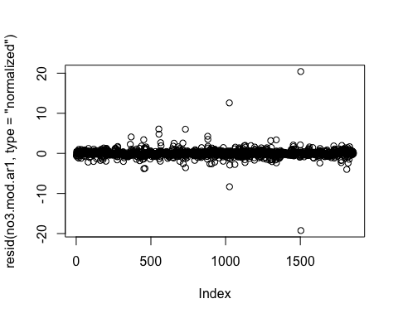

plot(no3.mod.ar1, resid(., type = "p") ~ fitted(.) | site.ID, abline = 0)

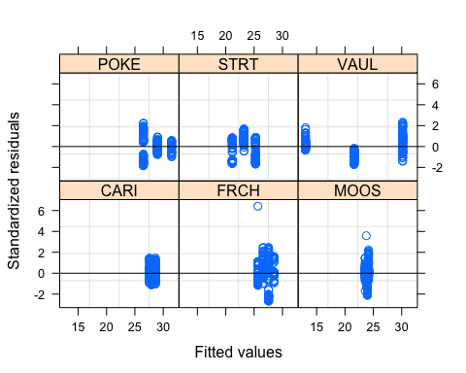

plot(no3.mod.ar1, dailyNO3 ~ fitted(.) | site.ID, abline = c(0,1))

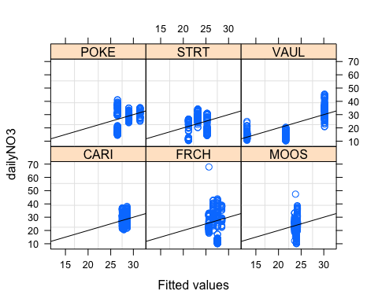

qqnorm(no3.mod.ar1, abline = c(0,1))

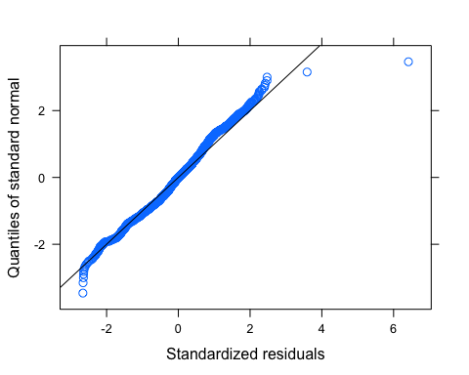 Let me log transform to see if its better

mean_daily$logdailyNO3 <- log((mean_daily$dailyNO3))  
mean_daily$site.ID <- as.factor(mean_daily$site.ID)  
  
no3.mod.ar1.log <- gls(logdailyNO3 ~ site.ID*year,   
 na.action = na.omit,   
 data = mean_daily,   
 correlation = corAR1(form = ~ julian|site.ID/year))  
  
summary(no3.mod.ar1.log) # Phi1 = 0.9844227

## Generalized least squares fit by REML  
## Model: logdailyNO3 ~ site.ID * year   
## Data: mean_daily   
## AIC BIC logLik  
## -3942.97 -3865.694 1985.485  
##   
## Correlation Structure: ARMA(1,0)  
## Formula: ~julian | site.ID/year   
## Parameter estimate(s):  
## Phi1   
## 0.9637605   
##   
## Coefficients:  
## Value Std.Error t-value p-value  
## (Intercept) -27.5837 158.7317 -0.1737754 0.8621  
## site.IDFRCH 89.6505 226.1652 0.3963938 0.6919  
## site.IDMOOS 25.8136 225.2087 0.1146209 0.9088  
## site.IDPOKE -198.5697 318.6100 -0.6232374 0.5332  
## site.IDSTRT -216.7445 294.9591 -0.7348290 0.4625  
## site.IDVAUL -682.6805 294.9244 -2.3147642 0.0207  
## year 0.0153 0.0786 0.1947423 0.8456  
## site.IDFRCH:year -0.0444 0.1120 -0.3967315 0.6916  
## site.IDMOOS:year -0.0129 0.1115 -0.1153671 0.9082  
## site.IDPOKE:year 0.0983 0.1577 0.6232219 0.5332  
## site.IDSTRT:year 0.1072 0.1460 0.7339744 0.4631  
## site.IDVAUL:year 0.3378 0.1460 2.3134213 0.0208  
##   
## Correlation:   
## (Intr) st.IDFRCH st.IDMOOS st.IDPOKE st.IDSTRT st.IDVAUL  
## site.IDFRCH -0.702   
## site.IDMOOS -0.705 0.495   
## site.IDPOKE -0.498 0.350 0.351   
## site.IDSTRT -0.538 0.378 0.379 0.268   
## site.IDVAUL -0.538 0.378 0.379 0.268 0.290   
## year -1.000 0.702 0.705 0.498 0.538 0.538   
## site.IDFRCH:year 0.702 -1.000 -0.495 -0.350 -0.378 -0.378   
## site.IDMOOS:year 0.705 -0.495 -1.000 -0.351 -0.379 -0.379   
## site.IDPOKE:year 0.498 -0.350 -0.351 -1.000 -0.268 -0.268   
## site.IDSTRT:year 0.538 -0.378 -0.379 -0.268 -1.000 -0.290   
## site.IDVAUL:year 0.538 -0.378 -0.379 -0.268 -0.290 -1.000   
## year s.IDFRCH: s.IDMOOS: s.IDPOKE: s.IDSTRT:  
## site.IDFRCH   
## site.IDMOOS   
## site.IDPOKE   
## site.IDSTRT   
## site.IDVAUL   
## year   
## site.IDFRCH:year -0.702   
## site.IDMOOS:year -0.705 0.495   
## site.IDPOKE:year -0.498 0.350 0.351   
## site.IDSTRT:year -0.538 0.378 0.379 0.268   
## site.IDVAUL:year -0.538 0.378 0.379 0.268 0.290   
##   
## Standardized residuals:  
## Min Q1 Med Q3 Max   
## -3.20276271 -0.42263950 0.07125793 0.56274468 3.36840137   
##   
## Residual standard error: 0.2995267   
## Degrees of freedom: 1856 total; 1844 residual

# diagnostic plots

plot(resid(no3.mod.ar1.log, type = "normalized"))

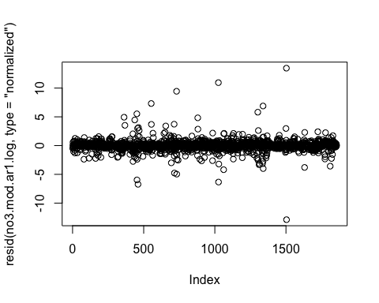

plot(no3.mod.ar1.log, resid(., type = "p") ~ fitted(.) | site.ID, abline = 0)

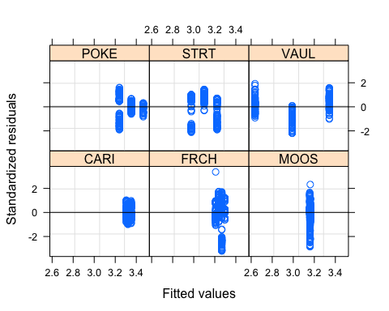

plot(no3.mod.ar1.log, logdailyNO3 ~ fitted(.) | site.ID, abline = c(0,1))

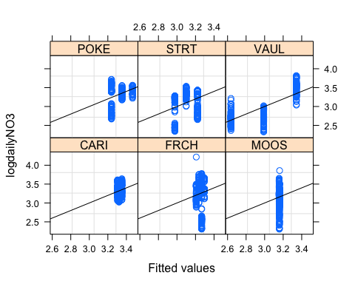

qqnorm(no3.mod.ar1.log, abline = c(0,1))

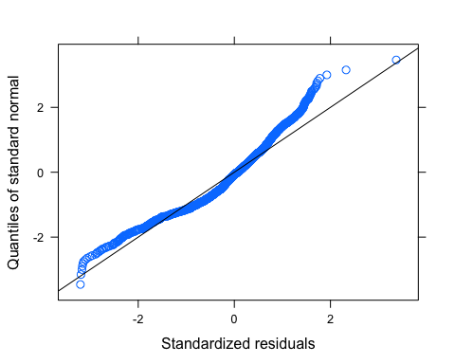

#ACF plots

Ear1<-residuals(no3.mod.ar1.log, type="normalized")  
I1<-!is.na(mean_daily$logdailyNO3)  
Efulla<-vector(length = length(mean_daily$logdailyNO3))  
Efulla<-NA  
Efulla[I1]<-Ear1  
acf(Efulla, na.action=na.pass)

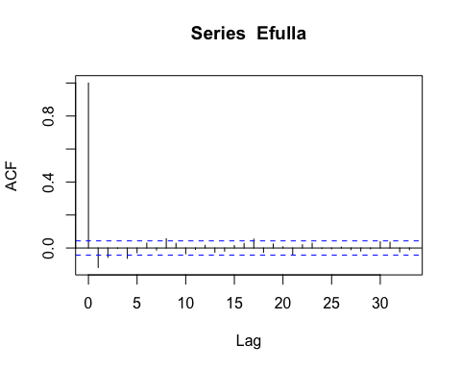

pacf(Efulla, na.action=na.pass)

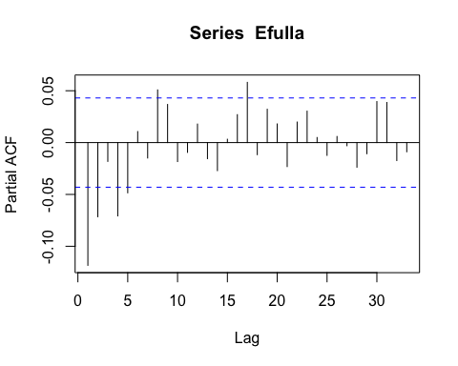

# corARMA structure

mean_daily$logdailyNO3 <- log((mean_daily$dailyNO3))  
mean_daily$site.ID <- as.factor(mean_daily$site.ID)  
  
no3.mod.arma.1 <- gls(logdailyNO3 ~ site.ID*year,   
 na.action = na.omit,   
 data = mean_daily,   
 correlation = corARMA(form = ~ julian|site.ID/year, p = 1, q = 1))  
  
no3.mod.arma.2 <- gls(logdailyNO3 ~ site.ID*year,   
 na.action = na.omit,   
 data = mean_daily,   
 correlation = corARMA(form = ~ julian|site.ID/year, p = 1, q = 2))  
  
no3.mod.arma.4 <- gls(logdailyNO3 ~ site.ID*year,   
 na.action = na.omit,   
 data = mean_daily,   
 correlation = corARMA(form = ~ julian|site.ID/year, p = 2, q = 2))  
  
AIC(no3.mod.arma.1, no3.mod.arma.2, no3.mod.arma.4)

## df AIC  
## no3.mod.arma.1 15 -3960.264  
## no3.mod.arma.2 16 -3966.106  
## no3.mod.arma.4 17 -3970.095

summary(no3.mod.arma.1) # Phi1 = 0.9844227

## Generalized least squares fit by REML  
## Model: logdailyNO3 ~ site.ID * year   
## Data: mean_daily   
## AIC BIC logLik  
## -3960.264 -3877.469 1995.132  
##   
## Correlation Structure: ARMA(1,1)  
## Formula: ~julian | site.ID/year   
## Parameter estimate(s):  
## Phi1 Theta1   
## 0.9729026 -0.1160452   
##   
## Coefficients:  
## Value Std.Error t-value p-value  
## (Intercept) -27.9046 176.6451 -0.1579699 0.8745  
## site.IDFRCH 97.2732 251.0395 0.3874815 0.6984  
## site.IDMOOS 22.6905 250.7575 0.0904880 0.9279  
## site.IDPOKE -200.9539 351.7721 -0.5712615 0.5679  
## site.IDSTRT -229.6991 328.7523 -0.6986997 0.4848  
## site.IDVAUL -665.8847 328.8652 -2.0247951 0.0430  
## year 0.0155 0.0875 0.1768233 0.8597  
## site.IDFRCH:year -0.0482 0.1243 -0.3877902 0.6982  
## site.IDMOOS:year -0.0113 0.1242 -0.0911105 0.9274  
## site.IDPOKE:year 0.0995 0.1742 0.5712502 0.5679  
## site.IDSTRT:year 0.1136 0.1628 0.6979444 0.4853  
## site.IDVAUL:year 0.3295 0.1628 2.0236021 0.0432  
##   
## Correlation:   
## (Intr) st.IDFRCH st.IDMOOS st.IDPOKE st.IDSTRT st.IDVAUL  
## site.IDFRCH -0.704   
## site.IDMOOS -0.704 0.496   
## site.IDPOKE -0.502 0.353 0.354   
## site.IDSTRT -0.537 0.378 0.379 0.270   
## site.IDVAUL -0.537 0.378 0.378 0.270 0.289   
## year -1.000 0.704 0.704 0.502 0.537 0.537   
## site.IDFRCH:year 0.704 -1.000 -0.496 -0.353 -0.378 -0.378   
## site.IDMOOS:year 0.704 -0.496 -1.000 -0.354 -0.379 -0.378   
## site.IDPOKE:year 0.502 -0.353 -0.354 -1.000 -0.270 -0.270   
## site.IDSTRT:year 0.537 -0.378 -0.379 -0.270 -1.000 -0.289   
## site.IDVAUL:year 0.537 -0.378 -0.378 -0.270 -0.289 -1.000   
## year s.IDFRCH: s.IDMOOS: s.IDPOKE: s.IDSTRT:  
## site.IDFRCH   
## site.IDMOOS   
## site.IDPOKE   
## site.IDSTRT   
## site.IDVAUL   
## year   
## site.IDFRCH:year -0.704   
## site.IDMOOS:year -0.704 0.496   
## site.IDPOKE:year -0.502 0.353 0.354   
## site.IDSTRT:year -0.537 0.378 0.379 0.270   
## site.IDVAUL:year -0.537 0.378 0.378 0.270 0.289   
##   
## Standardized residuals:  
## Min Q1 Med Q3 Max   
## -3.14698084 -0.43861141 0.05247945 0.52980141 3.31526334   
##   
## Residual standard error: 0.305694   
## Degrees of freedom: 1856 total; 1844 residual

The residuals do not look like they are normally distributed

# diagnostic plots

plot(resid(no3.mod.arma.1, type = "normalized"))

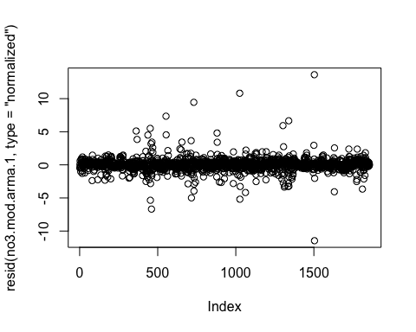

plot(no3.mod.arma.1, resid(., type = "p") ~ fitted(.) | site.ID, abline = 0)

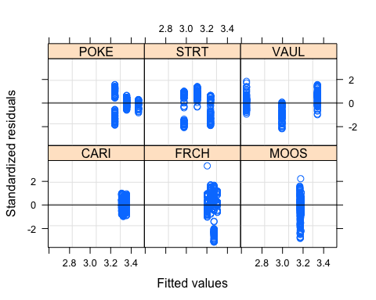

plot(no3.mod.arma.1, logdailyNO3 ~ fitted(.) | site.ID, abline = c(0,1))

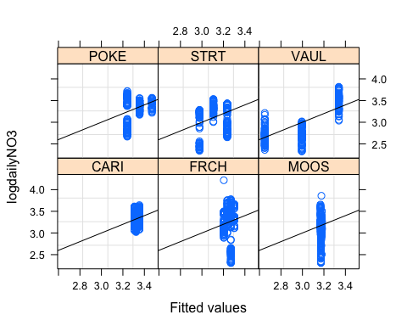

qqnorm(no3.mod.arma.1, abline = c(0,1))

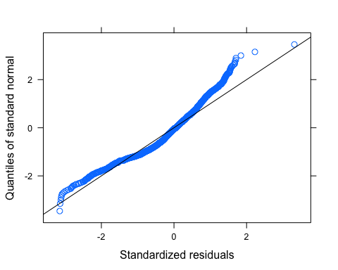

Ear1<-residuals(no3.mod.arma.1, type="normalized")  
I1<-!is.na(mean_daily$logdailyNO3)  
Efulla<-vector(length = length(mean_daily$logdailyNO3))  
Efulla<-NA  
Efulla[I1]<-Ear1  
acf(Efulla, na.action=na.pass)

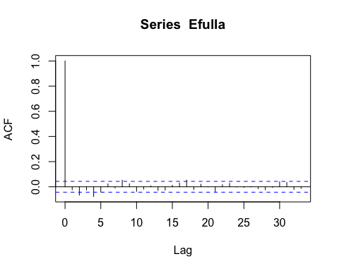

pacf(Efulla, na.action=na.pass)

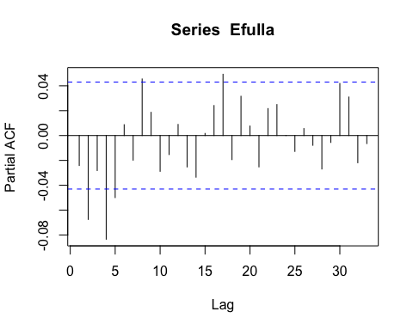

# generalized linear hypotheses

site.ID.comp <- glht(no3.mod.arma.2, linfct = mcp(site.ID = "Tukey"))

## Warning in mcp2matrix(model, linfct = linfct): covariate interactions found --  
## default contrast might be inappropriate

summary(site.ID.comp)

##   
## Simultaneous Tests for General Linear Hypotheses  
##   
## Multiple Comparisons of Means: Tukey Contrasts  
##   
##   
## Fit: gls(model = logdailyNO3 ~ site.ID * year, data = mean_daily,   
## correlation = corARMA(form = ~julian | site.ID/year, p = 1,   
## q = 2), na.action = na.omit)  
##   
## Linear Hypotheses:  
## Estimate Std. Error z value Pr(>|z|)  
## FRCH - CARI == 0 101.61 269.51 0.377 0.999  
## MOOS - CARI == 0 19.79 269.57 0.073 1.000  
## POKE - CARI == 0 -202.09 375.82 -0.538 0.994  
## STRT - CARI == 0 -240.00 353.69 -0.679 0.984  
## VAUL - CARI == 0 -654.20 353.86 -1.849 0.424  
## MOOS - FRCH == 0 -81.82 270.53 -0.302 1.000  
## POKE - FRCH == 0 -303.70 376.51 -0.807 0.965  
## STRT - FRCH == 0 -341.61 354.43 -0.964 0.926  
## VAUL - FRCH == 0 -755.81 354.60 -2.131 0.263  
## POKE - MOOS == 0 -221.87 376.55 -0.589 0.991  
## STRT - MOOS == 0 -259.79 354.47 -0.733 0.977  
## VAUL - MOOS == 0 -673.99 354.64 -1.900 0.392  
## STRT - POKE == 0 -37.91 440.71 -0.086 1.000  
## VAUL - POKE == 0 -452.12 440.84 -1.026 0.906  
## VAUL - STRT == 0 -414.20 422.14 -0.981 0.921  
## (Adjusted p values reported -- single-step method)

plot(print(confint(site.ID.comp)))

##   
## Simultaneous Confidence Intervals  
##   
## Multiple Comparisons of Means: Tukey Contrasts  
##   
##   
## Fit: gls(model = logdailyNO3 ~ site.ID * year, data = mean_daily,   
## correlation = corARMA(form = ~julian | site.ID/year, p = 1,   
## q = 2), na.action = na.omit)  
##   
## Quantile = 2.8338  
## 95% family-wise confidence level  
##   
##   
## Linear Hypotheses:  
## Estimate lwr upr   
## FRCH - CARI == 0 101.6105 -662.1377 865.3586  
## MOOS - CARI == 0 19.7866 -744.1183 783.6915  
## POKE - CARI == 0 -202.0877 -1267.0864 862.9109  
## STRT - CARI == 0 -240.0011 -1242.2849 762.2828  
## VAUL - CARI == 0 -654.2032 -1656.9764 348.5700  
## MOOS - FRCH == 0 -81.8239 -848.4619 684.8141  
## POKE - FRCH == 0 -303.6982 -1370.6589 763.2626  
## STRT - FRCH == 0 -341.6115 -1345.9800 662.7570  
## VAUL - FRCH == 0 -755.8136 -1760.6705 249.0432  
## POKE - MOOS == 0 -221.8743 -1288.9473 845.1986  
## STRT - MOOS == 0 -259.7877 -1264.2753 744.7000  
## VAUL - MOOS == 0 -673.9898 -1678.9657 330.9862  
## STRT - POKE == 0 -37.9133 -1286.7796 1210.9529  
## VAUL - POKE == 0 -452.1154 -1701.3745 797.1436  
## VAUL - STRT == 0 -414.2021 -1610.4458 782.0416

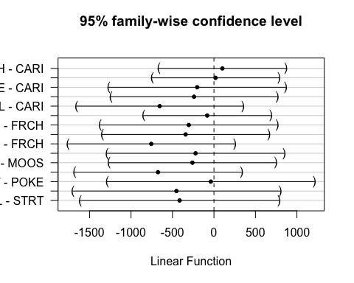

### fDOM

ggplot(mean_daily, aes(x = datetimeAK, y = dailyfDOM, color = site.ID)) +  
 geom_line() +  
 facet_grid(site.ID ~ year) +  
 theme_classic()

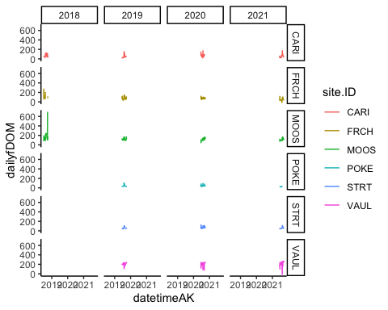

# corAR1 structure

fDOM.mod.ar1 <- gls(dailyfDOM ~ site.ID*year,   
 na.action = na.omit,   
 data = mean_daily,   
 correlation = corAR1(form = ~ julian|site.ID/year))  
  
summary(fDOM.mod.ar1)

## Generalized least squares fit by REML  
## Model: dailyfDOM ~ site.ID * year   
## Data: mean_daily   
## AIC BIC logLik  
## 17236.82 17314.86 -8604.412  
##   
## Correlation Structure: ARMA(1,0)  
## Formula: ~julian | site.ID/year   
## Parameter estimate(s):  
## Phi1   
## 0.790946   
##   
## Coefficients:  
## Value Std.Error t-value p-value  
## (Intercept) 1896.109 8480.571 0.2235827 0.8231  
## site.IDFRCH 30954.044 12447.863 2.4866954 0.0130  
## site.IDMOOS 19696.289 11741.067 1.6775554 0.0936  
## site.IDPOKE 7973.976 17424.844 0.4576211 0.6473  
## site.IDSTRT -1525.288 15385.075 -0.0991407 0.9210  
## site.IDVAUL -6721.586 15289.224 -0.4396290 0.6603  
## year -0.910 4.199 -0.2166478 0.8285  
## site.IDFRCH:year -15.320 6.163 -2.4856587 0.0130  
## site.IDMOOS:year -9.721 5.814 -1.6721000 0.0947  
## site.IDPOKE:year -3.958 8.627 -0.4587816 0.6464  
## site.IDSTRT:year 0.757 7.617 0.0993551 0.9209  
## site.IDVAUL:year 3.404 7.569 0.4497421 0.6529  
##   
## Correlation:   
## (Intr) st.IDFRCH st.IDMOOS st.IDPOKE st.IDSTRT st.IDVAUL  
## site.IDFRCH -0.681   
## site.IDMOOS -0.722 0.492   
## site.IDPOKE -0.487 0.332 0.352   
## site.IDSTRT -0.551 0.376 0.398 0.268   
## site.IDVAUL -0.555 0.378 0.401 0.270 0.306   
## year -1.000 0.681 0.722 0.487 0.551 0.555   
## site.IDFRCH:year 0.681 -1.000 -0.492 -0.332 -0.376 -0.378   
## site.IDMOOS:year 0.722 -0.492 -1.000 -0.352 -0.398 -0.401   
## site.IDPOKE:year 0.487 -0.332 -0.352 -1.000 -0.268 -0.270   
## site.IDSTRT:year 0.551 -0.376 -0.398 -0.268 -1.000 -0.306   
## site.IDVAUL:year 0.555 -0.378 -0.401 -0.270 -0.306 -1.000   
## year s.IDFRCH: s.IDMOOS: s.IDPOKE: s.IDSTRT:  
## site.IDFRCH   
## site.IDMOOS   
## site.IDPOKE   
## site.IDSTRT   
## site.IDVAUL   
## year   
## site.IDFRCH:year -0.681   
## site.IDMOOS:year -0.722 0.492   
## site.IDPOKE:year -0.487 0.332 0.352   
## site.IDSTRT:year -0.551 0.376 0.398 0.268   
## site.IDVAUL:year -0.555 0.378 0.401 0.270 0.306   
##   
## Standardized residuals:  
## Min Q1 Med Q3 Max   
## -7.09848339 -0.46541829 -0.09615328 0.47689502 17.34201487   
##   
## Residual standard error: 32.25249   
## Degrees of freedom: 1959 total; 1947 residual

The residuals do not look like they are normally distributed

# diagnostic plots

plot(resid(fDOM.mod.ar1, type = "normalized"))

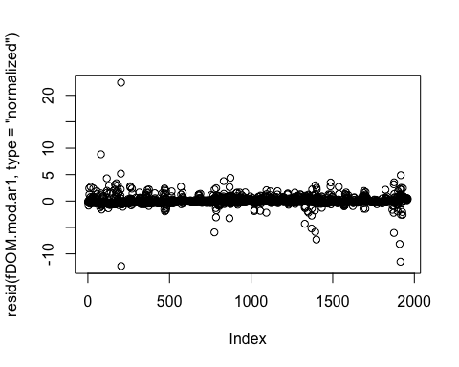

plot(fDOM.mod.ar1, resid(., type = "p") ~ fitted(.) | site.ID, abline = 0)

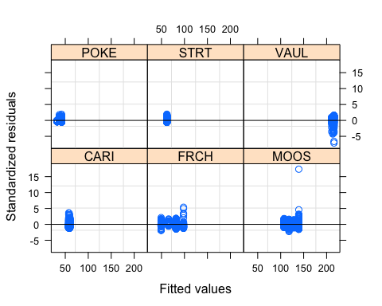

plot(fDOM.mod.ar1, dailyfDOM ~ fitted(.) | site.ID, abline = c(0,1))

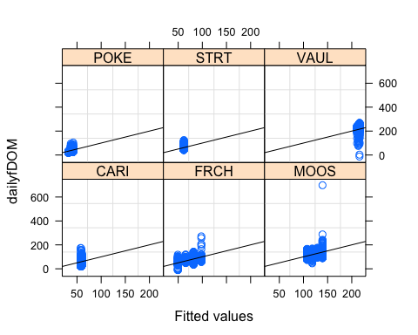

qqnorm(fDOM.mod.ar1, abline = c(0,1))

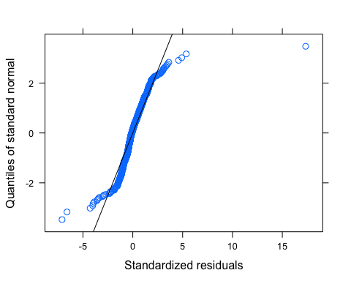

Let me log transform to see if its better

# log transformed

mean_daily$logdailyfDOM <- log(mean_daily$dailyfDOM)

## Warning in log(mean_daily$dailyfDOM): NaNs produced

mean_daily[c(1685,2031), 13] <- NA # removing clear outliers  
# First one is FRCH 8/5/21 where fDOM is 2   
# second one is VAUL 8/15/21 where fDOM is 3 and then ~140 the next day  
  
fDOM.mod.ar1.log <- gls(logdailyfDOM ~ site.ID*year,   
 na.action = na.omit,   
 data = mean_daily,   
 correlation = corAR1(form = ~ julian|site.ID/year))  
  
summary(fDOM.mod.ar1.log)

## Generalized least squares fit by REML  
## Model: logdailyfDOM ~ site.ID * year   
## Data: mean_daily   
## AIC BIC logLik  
## -1899.438 -1821.459 963.7192  
##   
## Correlation Structure: ARMA(1,0)  
## Formula: ~julian | site.ID/year   
## Parameter estimate(s):  
## Phi1   
## 0.9130439   
##   
## Coefficients:  
## Value Std.Error t-value p-value  
## (Intercept) 17.9641 136.42668 0.1316761 0.8953  
## site.IDFRCH 472.2901 197.63381 2.3897230 0.0170  
## site.IDMOOS 121.3608 190.87389 0.6358168 0.5250  
## site.IDPOKE 290.1267 277.77611 1.0444622 0.2964  
## site.IDSTRT 16.6732 250.11555 0.0666619 0.9469  
## site.IDVAUL -28.8036 249.77708 -0.1153173 0.9082  
## year -0.0069 0.06755 -0.1028005 0.9181  
## site.IDFRCH:year -0.2337 0.09786 -2.3884592 0.0170  
## site.IDMOOS:year -0.0597 0.09451 -0.6314799 0.5278  
## site.IDPOKE:year -0.1438 0.13753 -1.0457990 0.2958  
## site.IDSTRT:year -0.0082 0.12383 -0.0660881 0.9473  
## site.IDVAUL:year 0.0150 0.12366 0.1209926 0.9037  
##   
## Correlation:   
## (Intr) st.IDFRCH st.IDMOOS st.IDPOKE st.IDSTRT st.IDVAUL  
## site.IDFRCH -0.690   
## site.IDMOOS -0.715 0.493   
## site.IDPOKE -0.491 0.339 0.351   
## site.IDSTRT -0.545 0.377 0.390 0.268   
## site.IDVAUL -0.546 0.377 0.390 0.268 0.298   
## year -1.000 0.690 0.715 0.491 0.545 0.546   
## site.IDFRCH:year 0.690 -1.000 -0.493 -0.339 -0.377 -0.377   
## site.IDMOOS:year 0.715 -0.493 -1.000 -0.351 -0.390 -0.390   
## site.IDPOKE:year 0.491 -0.339 -0.351 -1.000 -0.268 -0.268   
## site.IDSTRT:year 0.546 -0.377 -0.390 -0.268 -1.000 -0.298   
## site.IDVAUL:year 0.546 -0.377 -0.390 -0.268 -0.298 -1.000   
## year s.IDFRCH: s.IDMOOS: s.IDPOKE: s.IDSTRT:  
## site.IDFRCH   
## site.IDMOOS   
## site.IDPOKE   
## site.IDSTRT   
## site.IDVAUL   
## year   
## site.IDFRCH:year -0.690   
## site.IDMOOS:year -0.715 0.493   
## site.IDPOKE:year -0.491 0.339 0.351   
## site.IDSTRT:year -0.546 0.377 0.390 0.268   
## site.IDVAUL:year -0.546 0.377 0.390 0.268 0.298   
##   
## Standardized residuals:  
## Min Q1 Med Q3 Max   
## -4.49352407 -0.52969337 0.03995587 0.57135796 4.75345923   
##   
## Residual standard error: 0.3535395   
## Degrees of freedom: 1951 total; 1939 residual

Residuals look a lot better

# diagnostic plots

plot(resid(fDOM.mod.ar1.log, type = "normalized"))

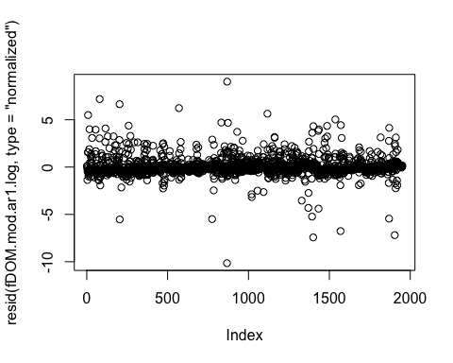

plot(fDOM.mod.ar1.log, resid(., type = "p") ~ fitted(.) | site.ID, abline = 0)

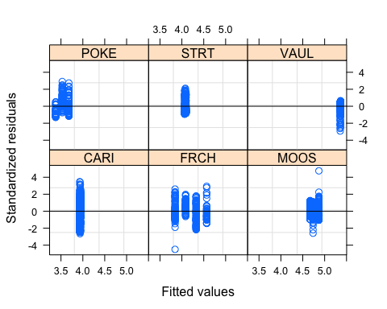

plot(fDOM.mod.ar1.log, logdailyfDOM ~ fitted(.) | site.ID, abline = c(0,1))

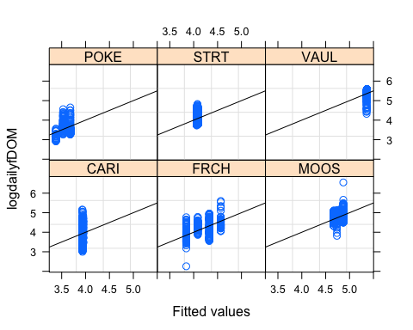

qqnorm(fDOM.mod.ar1.log, abline = c(0,1))

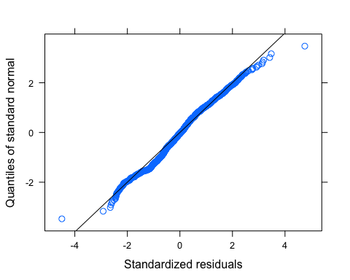 Looks much better

# ACF plot

Ear1<-residuals(fDOM.mod.ar1.log, type="normalized")  
I1<-!is.na(mean_daily$logdailyfDOM)  
Efulla<-vector(length = length(mean_daily$logdailyfDOM))  
Efulla<-NA  
Efulla[I1]<-Ear1  
acf(Efulla, na.action=na.pass)

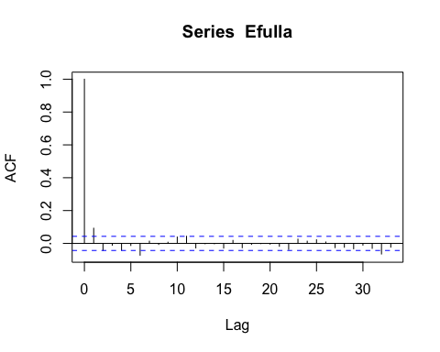

pacf(Efulla, na.action=na.pass)

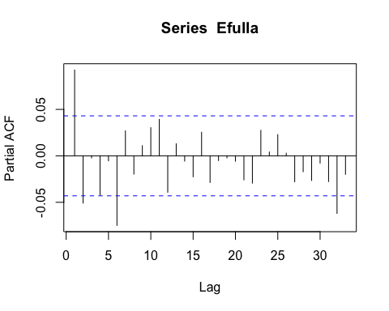 AR1 is not adequately handling the temporal autocorrelation

# generalized linear hypotheses

site.ID.comp <- glht(fDOM.mod.ar1, linfct = mcp(site.ID = "Tukey"))

## Warning in mcp2matrix(model, linfct = linfct): covariate interactions found --  
## default contrast might be inappropriate

summary(site.ID.comp)

##   
## Simultaneous Tests for General Linear Hypotheses  
##   
## Multiple Comparisons of Means: Tukey Contrasts  
##   
##   
## Fit: gls(model = dailyfDOM ~ site.ID * year, data = mean_daily, correlation = corAR1(form = ~julian |   
## site.ID/year), na.action = na.omit)  
##   
## Linear Hypotheses:  
## Estimate Std. Error z value Pr(>|z|)  
## FRCH - CARI == 0 30954 12448 2.487 0.123  
## MOOS - CARI == 0 19696 11741 1.678 0.537  
## POKE - CARI == 0 7974 17425 0.458 0.997  
## STRT - CARI == 0 -1525 15385 -0.099 1.000  
## VAUL - CARI == 0 -6722 15289 -0.440 0.998  
## MOOS - FRCH == 0 -11258 12205 -0.922 0.939  
## POKE - FRCH == 0 -22980 17741 -1.295 0.781  
## STRT - FRCH == 0 -32479 15742 -2.063 0.298  
## VAUL - FRCH == 0 -37676 15648 -2.408 0.148  
## POKE - MOOS == 0 -11722 17252 -0.679 0.984  
## STRT - MOOS == 0 -21222 15189 -1.397 0.721  
## VAUL - MOOS == 0 -26418 15092 -1.750 0.488  
## STRT - POKE == 0 -9499 19912 -0.477 0.997  
## VAUL - POKE == 0 -14696 19838 -0.741 0.976  
## VAUL - STRT == 0 -5196 18073 -0.288 1.000  
## (Adjusted p values reported -- single-step method)

plot(print(confint(site.ID.comp)))

##   
## Simultaneous Confidence Intervals  
##   
## Multiple Comparisons of Means: Tukey Contrasts  
##   
##   
## Fit: gls(model = dailyfDOM ~ site.ID * year, data = mean_daily, correlation = corAR1(form = ~julian |   
## site.ID/year), na.action = na.omit)  
##   
## Quantile = 2.8344  
## 95% family-wise confidence level  
##   
##   
## Linear Hypotheses:  
## Estimate lwr upr   
## FRCH - CARI == 0 30954.0437 -4327.8857 66235.9732  
## MOOS - CARI == 0 19696.2895 -13582.3131 52974.8921  
## POKE - CARI == 0 7973.9759 -41414.5905 57362.5424  
## STRT - CARI == 0 -1525.2875 -45132.3795 42081.8044  
## VAUL - CARI == 0 -6721.5861 -50057.0014 36613.8292  
## MOOS - FRCH == 0 -11257.7542 -45851.2903 23335.7818  
## POKE - FRCH == 0 -22980.0678 -73264.0397 27303.9042  
## STRT - FRCH == 0 -32479.3312 -77098.0023 12139.3398  
## VAUL - FRCH == 0 -37675.6298 -82028.8210 6677.5613  
## POKE - MOOS == 0 -11722.3135 -60621.4821 37176.8550  
## STRT - MOOS == 0 -21221.5770 -64273.5997 21830.4456  
## VAUL - MOOS == 0 -26417.8756 -69194.6965 16358.9453  
## STRT - POKE == 0 -9499.2635 -65937.2095 46938.6826  
## VAUL - POKE == 0 -14695.5621 -70923.8602 41532.7361  
## VAUL - STRT == 0 -5196.2986 -56420.9946 46028.3974

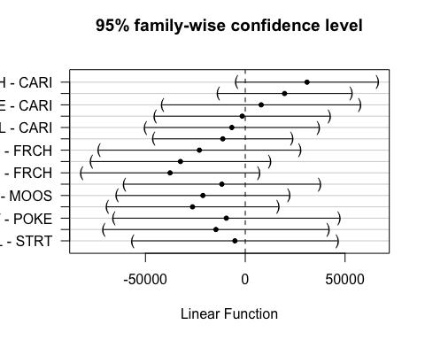 This shows that only FRCH and CARI are significantly different from each other? I would have expected more to be significantly different from each other just looking at our figures

# corARMA structure

fDOM.mod.arma.1 <- gls(logdailyfDOM ~ site.ID*year,   
 na.action = na.omit,   
 data = mean_daily,   
 correlation = corARMA(form = ~ julian|site.ID/year, p = 1, q = 1))  
  
fDOM.mod.arma.2 <- gls(logdailyfDOM ~ site.ID*year,   
 na.action = na.omit,   
 data = mean_daily,   
 correlation = corARMA(form = ~ julian|site.ID/year, p = 1, q = 2))  
  
fDOM.mod.arma.3 <- gls(logdailyfDOM ~ site.ID*year,   
 na.action = na.omit,   
 data = mean_daily,   
 correlation = corARMA(form = ~ julian|site.ID/year, p = 2, q = 1))  
  
fDOM.mod.arma.4 <- gls(logdailyfDOM ~ site.ID*year,   
 na.action = na.omit,   
 data = mean_daily,   
 correlation = corARMA(form = ~ julian|site.ID/year, p = 2, q = 2))  
  
AIC(fDOM.mod.arma.1, fDOM.mod.arma.2, fDOM.mod.arma.3, fDOM.mod.arma.4, fDOM.mod.ar1.log)

## df AIC  
## fDOM.mod.arma.1 15 -1913.638  
## fDOM.mod.arma.2 16 -1913.054  
## fDOM.mod.arma.3 16 -1917.798  
## fDOM.mod.arma.4 17 -1918.294  
## fDOM.mod.ar1.log 14 -1899.438

summary(fDOM.mod.arma.1)

## Generalized least squares fit by REML  
## Model: logdailyfDOM ~ site.ID * year   
## Data: mean_daily   
## AIC BIC logLik  
## -1913.638 -1830.089 971.8192  
##   
## Correlation Structure: ARMA(1,1)  
## Formula: ~julian | site.ID/year   
## Parameter estimate(s):  
## Phi1 Theta1   
## 0.8947351 0.1062623   
##   
## Coefficients:  
## Value Std.Error t-value p-value  
## (Intercept) 25.4536 126.75824 0.2008043 0.8409  
## site.IDFRCH 460.2764 184.21724 2.4985520 0.0126  
## site.IDMOOS 115.0660 176.89278 0.6504842 0.5155  
## site.IDPOKE 288.2742 258.41171 1.1155619 0.2647  
## site.IDSTRT 5.9623 231.63003 0.0257408 0.9795  
## site.IDVAUL -39.5403 231.18938 -0.1710301 0.8642  
## year -0.0107 0.06277 -0.1696904 0.8653  
## site.IDFRCH:year -0.2278 0.09122 -2.4972369 0.0126  
## site.IDMOOS:year -0.0566 0.08759 -0.6458221 0.5185  
## site.IDPOKE:year -0.1429 0.12794 -1.1169979 0.2641  
## site.IDSTRT:year -0.0029 0.11468 -0.0251269 0.9800  
## site.IDVAUL:year 0.0203 0.11446 0.1771436 0.8594  
##   
## Correlation:   
## (Intr) st.IDFRCH st.IDMOOS st.IDPOKE st.IDSTRT st.IDVAUL  
## site.IDFRCH -0.688   
## site.IDMOOS -0.717 0.493   
## site.IDPOKE -0.491 0.338 0.352   
## site.IDSTRT -0.547 0.377 0.392 0.268   
## site.IDVAUL -0.548 0.377 0.393 0.269 0.300   
## year -1.000 0.688 0.717 0.491 0.547 0.548   
## site.IDFRCH:year 0.688 -1.000 -0.493 -0.338 -0.377 -0.377   
## site.IDMOOS:year 0.717 -0.493 -1.000 -0.352 -0.392 -0.393   
## site.IDPOKE:year 0.491 -0.338 -0.352 -1.000 -0.268 -0.269   
## site.IDSTRT:year 0.547 -0.377 -0.392 -0.268 -1.000 -0.300   
## site.IDVAUL:year 0.548 -0.377 -0.393 -0.269 -0.300 -1.000   
## year s.IDFRCH: s.IDMOOS: s.IDPOKE: s.IDSTRT:  
## site.IDFRCH   
## site.IDMOOS   
## site.IDPOKE   
## site.IDSTRT   
## site.IDVAUL   
## year   
## site.IDFRCH:year -0.688   
## site.IDMOOS:year -0.717 0.493   
## site.IDPOKE:year -0.491 0.338 0.352   
## site.IDSTRT:year -0.547 0.377 0.392 0.269   
## site.IDVAUL:year -0.548 0.377 0.393 0.269 0.300   
##   
## Standardized residuals:  
## Min Q1 Med Q3 Max   
## -4.52056189 -0.53592222 0.03528246 0.56913374 4.76508179   
##   
## Residual standard error: 0.3520895   
## Degrees of freedom: 1951 total; 1939 residual

The residuals look good

# diagnostic plots

plot(resid(fDOM.mod.arma.1, type = "normalized"))

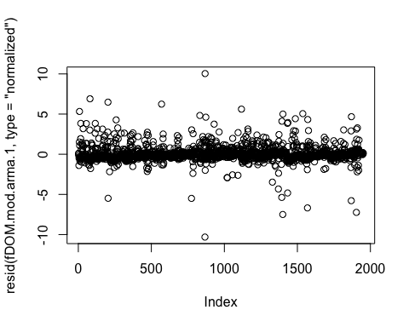

plot(fDOM.mod.arma.1, resid(., type = "p") ~ fitted(.) | site.ID, abline = 0)

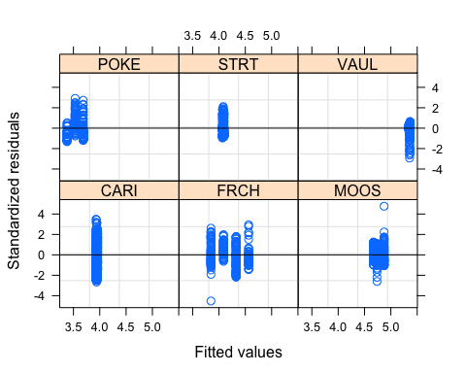

plot(fDOM.mod.arma.1, logdailyNO3 ~ fitted(.) | site.ID, abline = c(0,1))

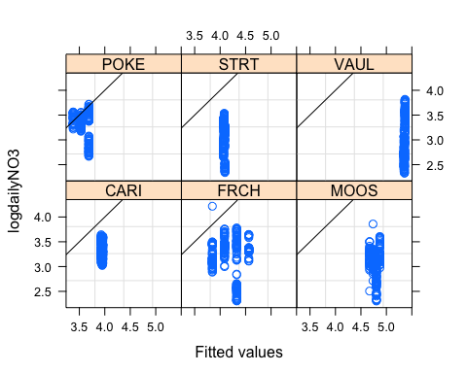

qqnorm(fDOM.mod.arma.1, abline = c(0,1))

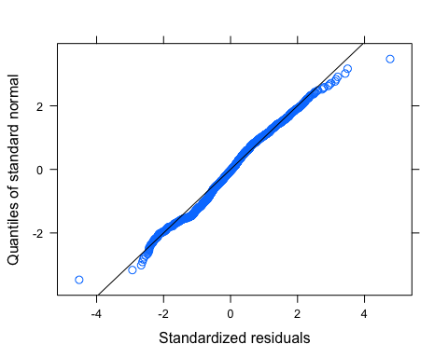

Ear1<-residuals(fDOM.mod.arma.1, type="normalized")  
I1<-!is.na(mean_daily$logdailyfDOM)  
Efulla<-vector(length = length(mean_daily$logdailyfDOM))  
Efulla<-NA  
Efulla[I1]<-Ear1  
acf(Efulla, na.action=na.pass)

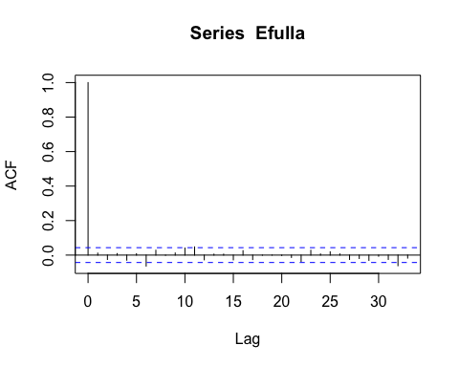

pacf(Efulla, na.action=na.pass)

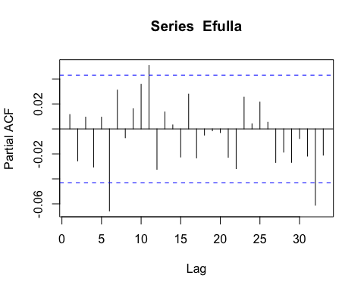

# generalized linear hypotheses

site.ID.comp <- glht(fDOM.mod.arma.1, linfct = mcp(site.ID = "Tukey"))

## Warning in mcp2matrix(model, linfct = linfct): covariate interactions found --  
## default contrast might be inappropriate

summary(site.ID.comp)

##   
## Simultaneous Tests for General Linear Hypotheses  
##   
## Multiple Comparisons of Means: Tukey Contrasts  
##   
##   
## Fit: gls(model = logdailyfDOM ~ site.ID * year, data = mean_daily,   
## correlation = corARMA(form = ~julian | site.ID/year, p = 1,   
## q = 1), na.action = na.omit)  
##   
## Linear Hypotheses:  
## Estimate Std. Error z value Pr(>|z|)  
## FRCH - CARI == 0 460.276 184.217 2.499 0.120  
## MOOS - CARI == 0 115.066 176.893 0.650 0.986  
## POKE - CARI == 0 288.274 258.412 1.116 0.871  
## STRT - CARI == 0 5.962 231.630 0.026 1.000  
## VAUL - CARI == 0 -39.540 231.189 -0.171 1.000  
## MOOS - FRCH == 0 -345.210 181.911 -1.898 0.394  
## POKE - FRCH == 0 -172.002 261.873 -0.657 0.986  
## STRT - FRCH == 0 -454.314 235.485 -1.929 0.375  
## VAUL - FRCH == 0 -499.817 235.052 -2.126 0.266  
## POKE - MOOS == 0 173.208 256.773 0.675 0.984  
## STRT - MOOS == 0 -109.104 229.800 -0.475 0.997  
## VAUL - MOOS == 0 -154.606 229.356 -0.674 0.984  
## STRT - POKE == 0 -282.312 297.143 -0.950 0.931  
## VAUL - POKE == 0 -327.815 296.799 -1.104 0.875  
## VAUL - STRT == 0 -45.503 273.799 -0.166 1.000  
## (Adjusted p values reported -- single-step method)

plot(print(confint(site.ID.comp)))

##   
## Simultaneous Confidence Intervals  
##   
## Multiple Comparisons of Means: Tukey Contrasts  
##   
##   
## Fit: gls(model = logdailyfDOM ~ site.ID * year, data = mean_daily,   
## correlation = corARMA(form = ~julian | site.ID/year, p = 1,   
## q = 1), na.action = na.omit)  
##   
## Quantile = 2.835  
## 95% family-wise confidence level  
##   
##   
## Linear Hypotheses:  
## Estimate lwr upr   
## FRCH - CARI == 0 460.2764 -61.9801 982.5329  
## MOOS - CARI == 0 115.0660 -386.4257 616.5576  
## POKE - CARI == 0 288.2742 -444.3238 1020.8723  
## STRT - CARI == 0 5.9623 -650.7096 662.6343  
## VAUL - CARI == 0 -39.5403 -694.9630 615.8823  
## MOOS - FRCH == 0 -345.2104 -860.9297 170.5089  
## POKE - FRCH == 0 -172.0021 -914.4120 570.4078  
## STRT - FRCH == 0 -454.3140 -1121.9146 213.2866  
## VAUL - FRCH == 0 -499.8167 -1166.1886 166.5552  
## POKE - MOOS == 0 173.2083 -554.7440 901.1606  
## STRT - MOOS == 0 -109.1036 -760.5885 542.3813  
## VAUL - MOOS == 0 -154.6063 -804.8320 495.6194  
## STRT - POKE == 0 -282.3119 -1124.7125 560.0887  
## VAUL - POKE == 0 -327.8146 -1169.2417 513.6125  
## VAUL - STRT == 0 -45.5027 -821.7228 730.7174

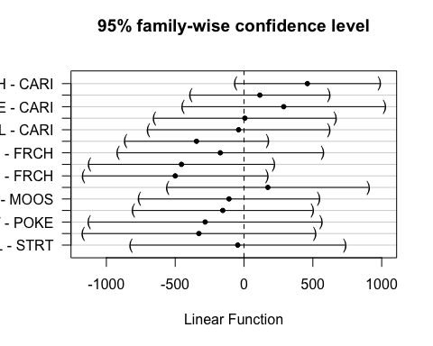

### SPC

ggplot(mean_daily, aes(x = datetimeAK, y = dailySPC, color = site.ID)) +  
 geom_line() +  
 facet_grid(site.ID ~ year) +  
 theme_classic()

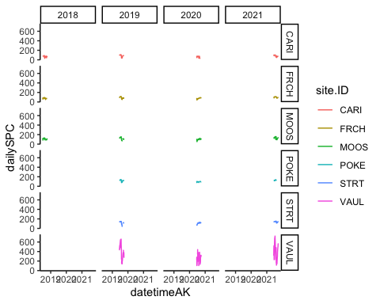

# corAR1 structure

SPC.mod.ar1 <- gls(dailySPC ~ site.ID*year,   
 na.action = na.omit,   
 data = mean_daily,   
 correlation = corAR1(form = ~ julian|site.ID/year))  
  
summary(SPC.mod.ar1)

## Generalized least squares fit by REML  
## Model: dailySPC ~ site.ID * year   
## Data: mean_daily   
## AIC BIC logLik  
## 16750.35 16828.81 -8361.177  
##   
## Correlation Structure: ARMA(1,0)  
## Formula: ~julian | site.ID/year   
## Parameter estimate(s):  
## Phi1   
## 0.9749659   
##   
## Coefficients:  
## Value Std.Error t-value p-value  
## (Intercept) 369.77 40752.53 0.0090736 0.9928  
## site.IDFRCH -9135.22 57699.15 -0.1583250 0.8742  
## site.IDMOOS -11261.27 57416.85 -0.1961318 0.8445  
## site.IDPOKE -7289.02 80958.73 -0.0900338 0.9283  
## site.IDSTRT -17549.16 75840.75 -0.2313949 0.8170  
## site.IDVAUL -46810.33 75832.62 -0.6172849 0.5371  
## year -0.15 20.18 -0.0072335 0.9942  
## site.IDFRCH:year 4.53 28.57 0.1585253 0.8741  
## site.IDMOOS:year 5.60 28.43 0.1968247 0.8440  
## site.IDPOKE:year 3.63 40.08 0.0905055 0.9279  
## site.IDSTRT:year 8.71 37.55 0.2319872 0.8166  
## site.IDVAUL:year 23.31 37.54 0.6209398 0.5347  
##   
## Correlation:   
## (Intr) st.IDFRCH st.IDMOOS st.IDPOKE st.IDSTRT st.IDVAUL  
## site.IDFRCH -0.706   
## site.IDMOOS -0.710 0.501   
## site.IDPOKE -0.503 0.356 0.357   
## site.IDSTRT -0.537 0.380 0.381 0.270   
## site.IDVAUL -0.537 0.380 0.381 0.271 0.289   
## year -1.000 0.706 0.710 0.503 0.537 0.537   
## site.IDFRCH:year 0.706 -1.000 -0.501 -0.356 -0.380 -0.380   
## site.IDMOOS:year 0.710 -0.501 -1.000 -0.357 -0.381 -0.381   
## site.IDPOKE:year 0.503 -0.356 -0.357 -1.000 -0.271 -0.271   
## site.IDSTRT:year 0.537 -0.380 -0.381 -0.271 -1.000 -0.289   
## site.IDVAUL:year 0.537 -0.380 -0.381 -0.271 -0.289 -1.000   
## year s.IDFRCH: s.IDMOOS: s.IDPOKE: s.IDSTRT:  
## site.IDFRCH   
## site.IDMOOS   
## site.IDPOKE   
## site.IDSTRT   
## site.IDVAUL   
## year   
## site.IDFRCH:year -0.706   
## site.IDMOOS:year -0.710 0.501   
## site.IDPOKE:year -0.503 0.356 0.357   
## site.IDSTRT:year -0.537 0.380 0.381 0.271   
## site.IDVAUL:year -0.537 0.380 0.381 0.271 0.289   
##   
## Standardized residuals:  
## Min Q1 Med Q3 Max   
## -3.86889935 -0.23335186 -0.01955058 0.19940182 5.04694224   
##   
## Residual standard error: 68.71386   
## Degrees of freedom: 2019 total; 2007 residual

The residuals dont look too too too bad

# diagnostic plots

plot(resid(SPC.mod.ar1, type = "normalized"))

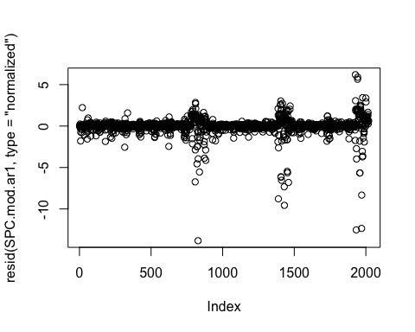

plot(SPC.mod.ar1, resid(., type = "p") ~ fitted(.) | site.ID, abline = 0)

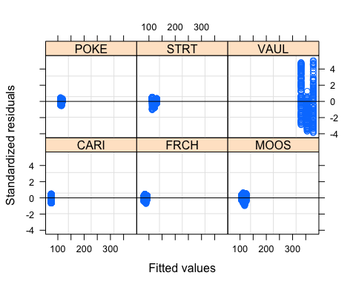

plot(SPC.mod.ar1, dailySPC ~ fitted(.) | site.ID, abline = c(0,1))

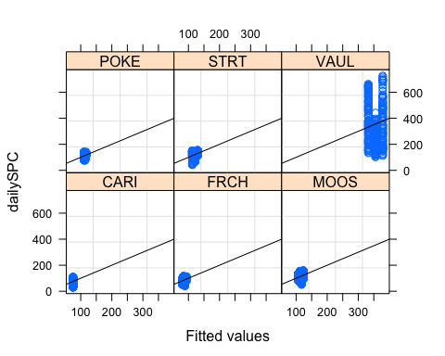

qqnorm(SPC.mod.ar1, abline = c(0,1))

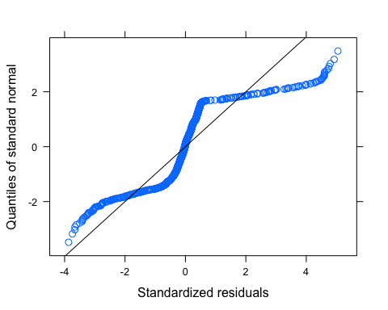 Let me log transform to see if its better

# log transformed

mean_daily$logdailySPC <- log(mean_daily$dailySPC)  
  
  
SPC.mod.ar1.log <- gls(logdailySPC ~ site.ID*year,   
 na.action = na.omit,   
 data = mean_daily,   
 correlation = corAR1(form = ~ julian|site.ID/year))  
  
summary(SPC.mod.ar1.log)

## Generalized least squares fit by REML  
## Model: logdailySPC ~ site.ID * year   
## Data: mean_daily   
## AIC BIC logLik  
## -4332.666 -4254.204 2180.333  
##   
## Correlation Structure: ARMA(1,0)  
## Formula: ~julian | site.ID/year   
## Parameter estimate(s):  
## Phi1   
## 0.9620333   
##   
## Coefficients:  
## Value Std.Error t-value p-value  
## (Intercept) 11.07407 153.04594 0.0723578 0.9423  
## site.IDFRCH -107.93200 216.41115 -0.4987358 0.6180  
## site.IDMOOS -91.60913 215.17242 -0.4257475 0.6703  
## site.IDPOKE -53.09101 307.55811 -0.1726211 0.8630  
## site.IDSTRT -182.19220 284.00495 -0.6415106 0.5213  
## site.IDVAUL -75.41545 283.92328 -0.2656191 0.7906  
## year -0.00337 0.07578 -0.0444175 0.9646  
## site.IDFRCH:year 0.05353 0.10716 0.4995141 0.6175  
## site.IDMOOS:year 0.04559 0.10655 0.4278391 0.6688  
## site.IDPOKE:year 0.02650 0.15227 0.1740405 0.8619  
## site.IDSTRT:year 0.09044 0.14061 0.6432113 0.5202  
## site.IDVAUL:year 0.03808 0.14057 0.2709084 0.7865  
##   
## Correlation:   
## (Intr) st.IDFRCH st.IDMOOS st.IDPOKE st.IDSTRT st.IDVAUL  
## site.IDFRCH -0.707   
## site.IDMOOS -0.711 0.503   
## site.IDPOKE -0.498 0.352 0.354   
## site.IDSTRT -0.539 0.381 0.383 0.268   
## site.IDVAUL -0.539 0.381 0.383 0.268 0.290   
## year -1.000 0.707 0.711 0.498 0.539 0.539   
## site.IDFRCH:year 0.707 -1.000 -0.503 -0.352 -0.381 -0.381   
## site.IDMOOS:year 0.711 -0.503 -1.000 -0.354 -0.383 -0.383   
## site.IDPOKE:year 0.498 -0.352 -0.354 -1.000 -0.268 -0.268   
## site.IDSTRT:year 0.539 -0.381 -0.383 -0.268 -1.000 -0.291   
## site.IDVAUL:year 0.539 -0.381 -0.383 -0.268 -0.291 -1.000   
## year s.IDFRCH: s.IDMOOS: s.IDPOKE: s.IDSTRT:  
## site.IDFRCH   
## site.IDMOOS   
## site.IDPOKE   
## site.IDSTRT   
## site.IDVAUL   
## year   
## site.IDFRCH:year -0.707   
## site.IDMOOS:year -0.711 0.503   
## site.IDPOKE:year -0.498 0.352 0.354   
## site.IDSTRT:year -0.539 0.381 0.383 0.268   
## site.IDVAUL:year -0.539 0.381 0.383 0.268 0.291   
##   
## Standardized residuals:  
## Min Q1 Med Q3 Max   
## -3.87953560 -0.46267526 0.03824346 0.46250907 2.62704790   
##   
## Residual standard error: 0.2932208   
## Degrees of freedom: 2019 total; 2007 residual

Residuals still dont look great for the max and min

# diagnostic plots

plot(resid(SPC.mod.ar1.log, type = "normalized"))

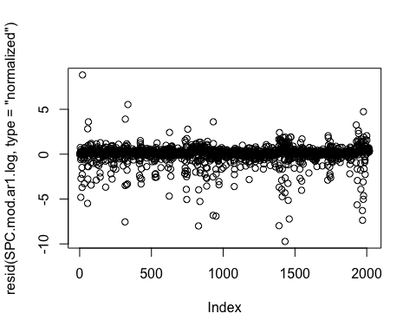

plot(SPC.mod.ar1.log, resid(., type = "p") ~ fitted(.) | site.ID, abline = 0)

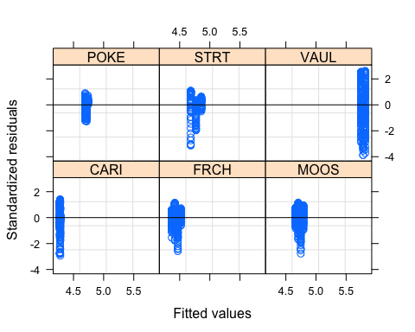

plot(SPC.mod.ar1.log, logdailySPC ~ fitted(.) | site.ID, abline = c(0,1))

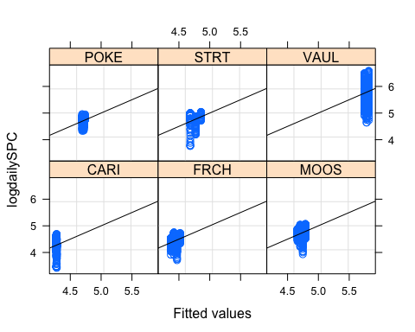

qqnorm(SPC.mod.ar1.log, abline = c(0,1))

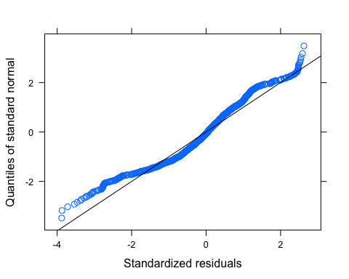 our normality plot looks better but still not perfect

# ACF plot

Ear1<-residuals(SPC.mod.ar1.log, type="normalized")  
I1<-!is.na(mean_daily$logdailySPC)  
Efulla<-vector(length = length(mean_daily$logdailySPC))  
Efulla<-NA  
Efulla[I1]<-Ear1  
acf(Efulla, na.action=na.pass)

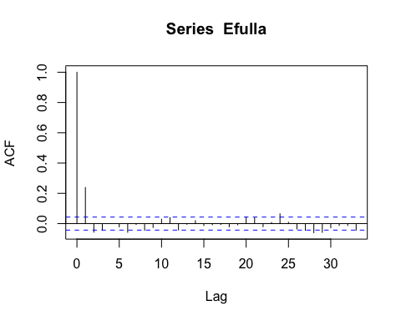

pacf(Efulla, na.action=na.pass)

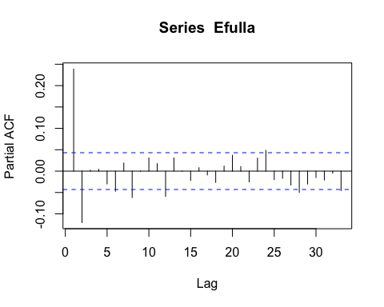

# generalized linear hypotheses

site.ID.comp <- glht(SPC.mod.ar1.log, linfct = mcp(site.ID = "Tukey"))

## Warning in mcp2matrix(model, linfct = linfct): covariate interactions found --  
## default contrast might be inappropriate

summary(site.ID.comp)

##   
## Simultaneous Tests for General Linear Hypotheses  
##   
## Multiple Comparisons of Means: Tukey Contrasts  
##   
##   
## Fit: gls(model = logdailySPC ~ site.ID * year, data = mean_daily,   
## correlation = corAR1(form = ~julian | site.ID/year), na.action = na.omit)  
##   
## Linear Hypotheses:  
## Estimate Std. Error z value Pr(>|z|)  
## FRCH - CARI == 0 -107.93 216.41 -0.499 0.996  
## MOOS - CARI == 0 -91.61 215.17 -0.426 0.998  
## POKE - CARI == 0 -53.09 307.56 -0.173 1.000  
## STRT - CARI == 0 -182.19 284.00 -0.642 0.987  
## VAUL - CARI == 0 -75.42 283.92 -0.266 1.000  
## MOOS - FRCH == 0 16.32 215.14 0.076 1.000  
## POKE - FRCH == 0 54.84 307.54 0.178 1.000  
## STRT - FRCH == 0 -74.26 283.98 -0.261 1.000  
## VAUL - FRCH == 0 32.52 283.90 0.115 1.000  
## POKE - MOOS == 0 38.52 306.67 0.126 1.000  
## STRT - MOOS == 0 -90.58 283.04 -0.320 1.000  
## VAUL - MOOS == 0 16.19 282.96 0.057 1.000  
## STRT - POKE == 0 -129.10 358.34 -0.360 0.999  
## VAUL - POKE == 0 -22.32 358.27 -0.062 1.000  
## VAUL - STRT == 0 106.78 338.27 0.316 1.000  
## (Adjusted p values reported -- single-step method)

plot(print(confint(site.ID.comp)))

##   
## Simultaneous Confidence Intervals  
##   
## Multiple Comparisons of Means: Tukey Contrasts  
##   
##   
## Fit: gls(model = logdailySPC ~ site.ID * year, data = mean_daily,   
## correlation = corAR1(form = ~julian | site.ID/year), na.action = na.omit)  
##   
## Quantile = 2.8319  
## 95% family-wise confidence level  
##   
##   
## Linear Hypotheses:  
## Estimate lwr upr   
## FRCH - CARI == 0 -107.9320 -720.7811 504.9171  
## MOOS - CARI == 0 -91.6091 -700.9503 517.7320  
## POKE - CARI == 0 -53.0910 -924.0568 817.8748  
## STRT - CARI == 0 -182.1922 -986.4584 622.0740  
## VAUL - CARI == 0 -75.4155 -879.4504 728.6195  
## MOOS - FRCH == 0 16.3229 -592.9371 625.5828  
## POKE - FRCH == 0 54.8410 -816.0680 925.7500  
## STRT - FRCH == 0 -74.2602 -878.4649 729.9445  
## VAUL - FRCH == 0 32.5165 -771.4568 836.4899  
## POKE - MOOS == 0 38.5181 -829.9260 906.9622  
## STRT - MOOS == 0 -90.5831 -892.1178 710.9516  
## VAUL - MOOS == 0 16.1937 -785.1089 817.4963  
## STRT - POKE == 0 -129.1012 -1143.8635 885.6612  
## VAUL - POKE == 0 -22.3244 -1036.9035 992.2546  
## VAUL - STRT == 0 106.7767 -851.1551 1064.7085

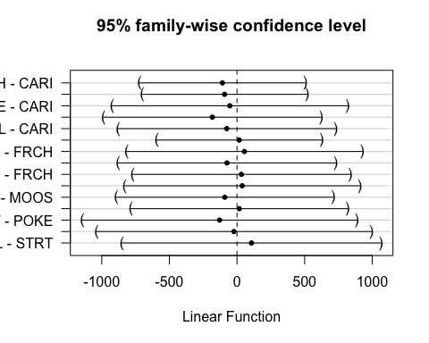 This shows that none of our sites SPC concentration is significantly different but VAUL is so much higher than the rest of the sites….I dont know if im doing this glht fucntion correctly

# corARMA structure

SPC.mod.arma.1 <- gls(logdailySPC ~ site.ID*year,   
 na.action = na.omit,   
 data = mean_daily,   
 correlation = corARMA(form = ~ julian|site.ID/year, p = 1, q = 1))  
  
SPC.mod.arma.2 <- gls(logdailySPC ~ site.ID*year,   
 na.action = na.omit,   
 data = mean_daily,   
 correlation = corARMA(form = ~ julian|site.ID/year, p = 1, q = 2))  
  
SPC.mod.arma.3 <- gls(logdailySPC ~ site.ID*year,   
 na.action = na.omit,   
 data = mean_daily,   
 correlation = corARMA(form = ~ julian|site.ID/year, p = 2, q = 1))  
  
SPC.mod.arma.4 <- gls(logdailySPC ~ site.ID*year,   
 na.action = na.omit,   
 data = mean_daily,   
 correlation = corARMA(form = ~ julian|site.ID/year, p = 2, q = 2))  
  
AIC(SPC.mod.arma.1, SPC.mod.arma.2, SPC.mod.arma.3, SPC.mod.arma.4, SPC.mod.ar1.log)

## df AIC  
## SPC.mod.arma.1 15 -4509.888  
## SPC.mod.arma.2 16 -4509.551  
## SPC.mod.arma.3 16 -4509.288  
## SPC.mod.arma.4 17 -4508.014  
## SPC.mod.ar1.log 14 -4332.666

summary(SPC.mod.arma.1)

## Generalized least squares fit by REML  
## Model: logdailySPC ~ site.ID * year   
## Data: mean_daily   
## AIC BIC logLik  
## -4509.888 -4425.822 2269.944  
##   
## Correlation Structure: ARMA(1,1)  
## Formula: ~julian | site.ID/year   
## Parameter estimate(s):  
## Phi1 Theta1   
## 0.9370140 0.3311568   
##   
## Coefficients:  
## Value Std.Error t-value p-value  
## (Intercept) -1.85336 126.61221 -0.0146381 0.9883  
## site.IDFRCH -96.61844 178.36641 -0.5416852 0.5881  
## site.IDMOOS -74.82394 177.20198 -0.4222523 0.6729  
## site.IDPOKE -30.98217 256.92188 -0.1205899 0.9040  
## site.IDSTRT -179.30872 233.55130 -0.7677488 0.4427  
## site.IDVAUL -43.96627 233.36403 -0.1884021 0.8506  
## year 0.00303 0.06269 0.0483978 0.9614  
## site.IDFRCH:year 0.04793 0.08832 0.5426229 0.5874  
## site.IDMOOS:year 0.03727 0.08775 0.4247843 0.6710  
## site.IDPOKE:year 0.01555 0.12720 0.1222643 0.9027  
## site.IDSTRT:year 0.08901 0.11563 0.7698115 0.4415  
## site.IDVAUL:year 0.02251 0.11554 0.1947997 0.8456  
##   
## Correlation:   
## (Intr) st.IDFRCH st.IDMOOS st.IDPOKE st.IDSTRT st.IDVAUL  
## site.IDFRCH -0.710   
## site.IDMOOS -0.715 0.507   
## site.IDPOKE -0.493 0.350 0.352   
## site.IDSTRT -0.542 0.385 0.387 0.267   
## site.IDVAUL -0.543 0.385 0.388 0.267 0.294   
## year -1.000 0.710 0.715 0.493 0.542 0.543   
## site.IDFRCH:year 0.710 -1.000 -0.507 -0.350 -0.385 -0.385   
## site.IDMOOS:year 0.715 -0.507 -1.000 -0.352 -0.387 -0.388   
## site.IDPOKE:year 0.493 -0.350 -0.352 -1.000 -0.267 -0.267   
## site.IDSTRT:year 0.542 -0.385 -0.387 -0.267 -1.000 -0.294   
## site.IDVAUL:year 0.543 -0.385 -0.388 -0.267 -0.294 -1.000   
## year s.IDFRCH: s.IDMOOS: s.IDPOKE: s.IDSTRT:  
## site.IDFRCH   
## site.IDMOOS   
## site.IDPOKE   
## site.IDSTRT   
## site.IDVAUL   
## year   
## site.IDFRCH:year -0.710   
## site.IDMOOS:year -0.715 0.507   
## site.IDPOKE:year -0.493 0.350 0.352   
## site.IDSTRT:year -0.542 0.385 0.387 0.267   
## site.IDVAUL:year -0.543 0.385 0.388 0.267 0.294   
##   
## Standardized residuals:  
## Min Q1 Med Q3 Max   
## -3.9283951 -0.4523751 0.0508595 0.4828243 2.7484389   
##   
## Residual standard error: 0.2871181   
## Degrees of freedom: 2019 total; 2007 residual

The residuals do not look perfect

# diagnostic plots

plot(resid(SPC.mod.arma.1, type = "normalized"))

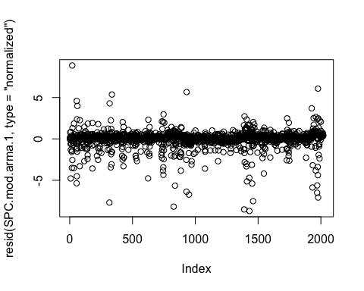

plot(SPC.mod.arma.1, resid(., type = "p") ~ fitted(.) | site.ID, abline = 0)

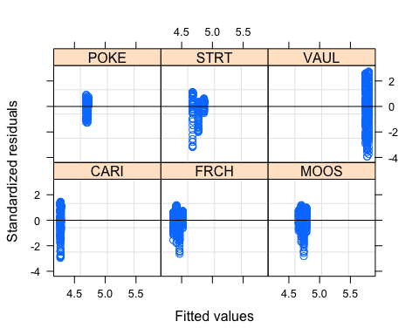

plot(SPC.mod.arma.1, logdailySPC ~ fitted(.) | site.ID, abline = c(0,1))

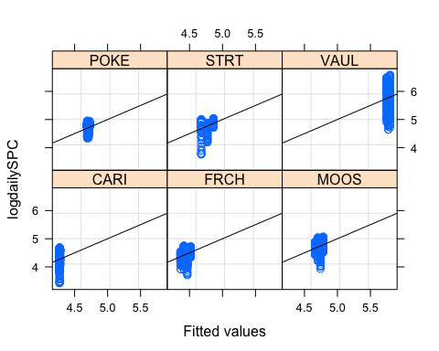

qqnorm(SPC.mod.arma.1, abline = c(0,1))

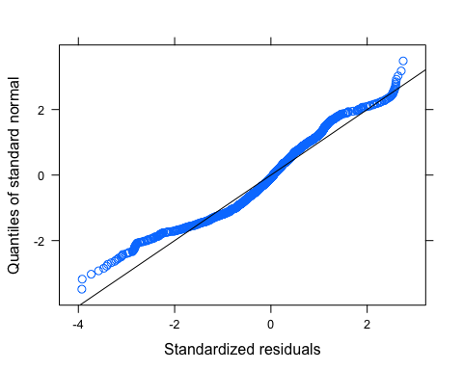

Ear1<-residuals(SPC.mod.arma.1, type="normalized")  
I1<-!is.na(mean_daily$logdailySPC)  
Efulla<-vector(length = length(mean_daily$logdailySPC))  
Efulla<-NA  
Efulla[I1]<-Ear1  
acf(Efulla, na.action=na.pass)

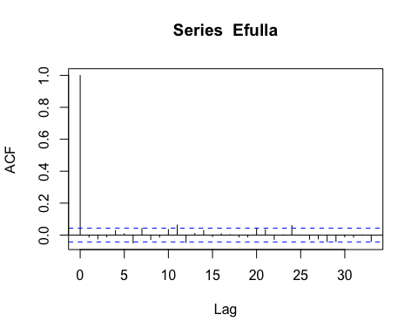

pacf(Efulla, na.action=na.pass)

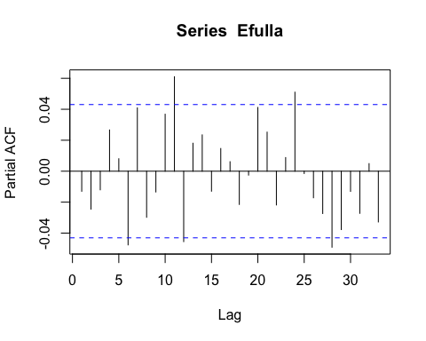 Still getting temporal autocorrelation for the first few lags

# generalized linear hypotheses

site.ID.comp <- glht(SPC.mod.arma.1, linfct = mcp(site.ID = "Tukey"))

## Warning in mcp2matrix(model, linfct = linfct): covariate interactions found --  
## default contrast might be inappropriate

summary(site.ID.comp)

##   
## Simultaneous Tests for General Linear Hypotheses  
##   
## Multiple Comparisons of Means: Tukey Contrasts  
##   
##   
## Fit: gls(model = logdailySPC ~ site.ID * year, data = mean_daily,   
## correlation = corARMA(form = ~julian | site.ID/year, p = 1,   
## q = 1), na.action = na.omit)  
##   
## Linear Hypotheses:  
## Estimate Std. Error z value Pr(>|z|)  
## FRCH - CARI == 0 -96.62 178.37 -0.542 0.994  
## MOOS - CARI == 0 -74.82 177.20 -0.422 0.998  
## POKE - CARI == 0 -30.98 256.92 -0.121 1.000  
## STRT - CARI == 0 -179.31 233.55 -0.768 0.972  
## VAUL - CARI == 0 -43.97 233.36 -0.188 1.000  
## MOOS - FRCH == 0 21.79 176.50 0.123 1.000  
## POKE - FRCH == 0 65.64 256.44 0.256 1.000  
## STRT - FRCH == 0 -82.69 233.02 -0.355 0.999  
## VAUL - FRCH == 0 52.65 232.83 0.226 1.000  
## POKE - MOOS == 0 43.84 255.63 0.172 1.000  
## STRT - MOOS == 0 -104.48 232.13 -0.450 0.998  
## VAUL - MOOS == 0 30.86 231.94 0.133 1.000  
## STRT - POKE == 0 -148.33 297.48 -0.499 0.996  
## VAUL - POKE == 0 -12.98 297.33 -0.044 1.000  
## VAUL - STRT == 0 135.34 277.39 0.488 0.996  
## (Adjusted p values reported -- single-step method)

plot(print(confint(site.ID.comp)))

##   
## Simultaneous Confidence Intervals  
##   
## Multiple Comparisons of Means: Tukey Contrasts  
##   
##   
## Fit: gls(model = logdailySPC ~ site.ID * year, data = mean_daily,   
## correlation = corARMA(form = ~julian | site.ID/year, p = 1,   
## q = 1), na.action = na.omit)  
##   
## Quantile = 2.8321  
## 95% family-wise confidence level  
##   
##   
## Linear Hypotheses:  
## Estimate lwr upr   
## FRCH - CARI == 0 -96.6184 -601.7770 408.5401  
## MOOS - CARI == 0 -74.8239 -576.6846 427.0368  
## POKE - CARI == 0 -30.9822 -758.6207 696.6564  
## STRT - CARI == 0 -179.3087 -840.7585 482.1411  
## VAUL - CARI == 0 -43.9663 -704.8857 616.9532  
## MOOS - FRCH == 0 21.7945 -478.0906 521.6796  
## POKE - FRCH == 0 65.6363 -660.6411 791.9137  
## STRT - FRCH == 0 -82.6903 -742.6424 577.2619  
## VAUL - FRCH == 0 52.6522 -606.7684 712.0727  
## POKE - MOOS == 0 43.8418 -680.1457 767.8293  
## STRT - MOOS == 0 -104.4848 -761.9161 552.9465  
## VAUL - MOOS == 0 30.8577 -626.0400 687.7553  
## STRT - POKE == 0 -148.3265 -990.8285 694.1754  
## VAUL - POKE == 0 -12.9841 -855.0697 829.1016  
## VAUL - STRT == 0 135.3425 -650.2568 920.9417

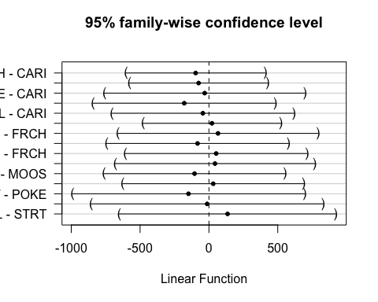

### turb

ggplot(mean_daily, aes(x = datetimeAK, y = dailyTurb, color = site.ID)) +  
 geom_line() +  
 facet_grid(site.ID ~ year) +  
 theme_classic()

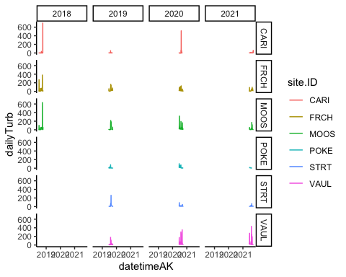

# corAR1 structure

turb.mod.ar1 <- gls(dailyTurb ~ site.ID*year,   
 na.action = na.omit,   
 data = mean_daily,   
 correlation = corAR1(form = ~ julian|site.ID/year))  
  
summary(turb.mod.ar1)

## Generalized least squares fit by REML  
## Model: dailyTurb ~ site.ID * year   
## Data: mean_daily   
## AIC BIC logLik  
## 20226.75 20305.29 -10099.37  
##   
## Correlation Structure: ARMA(1,0)  
## Formula: ~julian | site.ID/year   
## Parameter estimate(s):  
## Phi1   
## 0.6012503   
##   
## Coefficients:  
## Value Std.Error t-value p-value  
## (Intercept) 1656.175 8301.739 0.1994974 0.8419  
## site.IDFRCH 6987.731 11390.256 0.6134832 0.5396  
## site.IDMOOS 4065.402 11382.368 0.3571667 0.7210  
## site.IDPOKE -5144.451 17240.972 -0.2983852 0.7654  
## site.IDSTRT 5461.033 15057.765 0.3626722 0.7169  
## site.IDVAUL -27932.387 14891.978 -1.8756667 0.0608  
## year -0.816 4.111 -0.1986023 0.8426  
## site.IDFRCH:year -3.450 5.640 -0.6117574 0.5408  
## site.IDMOOS:year -2.003 5.636 -0.3553228 0.7224  
## site.IDPOKE:year 2.549 8.536 0.2985742 0.7653  
## site.IDSTRT:year -2.700 7.455 -0.3622375 0.7172  
## site.IDVAUL:year 13.841 7.373 1.8773330 0.0606  
##   
## Correlation:   
## (Intr) st.IDFRCH st.IDMOOS st.IDPOKE st.IDSTRT st.IDVAUL  
## site.IDFRCH -0.729   
## site.IDMOOS -0.729 0.532   
## site.IDPOKE -0.482 0.351 0.351   
## site.IDSTRT -0.551 0.402 0.402 0.265   
## site.IDVAUL -0.557 0.406 0.407 0.268 0.307   
## year -1.000 0.729 0.729 0.482 0.551 0.557   
## site.IDFRCH:year 0.729 -1.000 -0.532 -0.351 -0.402 -0.406   
## site.IDMOOS:year 0.729 -0.532 -1.000 -0.351 -0.402 -0.407   
## site.IDPOKE:year 0.482 -0.351 -0.351 -1.000 -0.265 -0.268   
## site.IDSTRT:year 0.551 -0.402 -0.402 -0.266 -1.000 -0.307   
## site.IDVAUL:year 0.558 -0.406 -0.407 -0.268 -0.307 -1.000   
## year s.IDFRCH: s.IDMOOS: s.IDPOKE: s.IDSTRT:  
## site.IDFRCH   
## site.IDMOOS   
## site.IDPOKE   
## site.IDSTRT   
## site.IDVAUL   
## year   
## site.IDFRCH:year -0.729   
## site.IDMOOS:year -0.729 0.532   
## site.IDPOKE:year -0.482 0.351 0.351   
## site.IDSTRT:year -0.551 0.402 0.402 0.266   
## site.IDVAUL:year -0.558 0.406 0.407 0.268 0.307   
##   
## Standardized residuals:  
## Min Q1 Med Q3 Max   
## -0.92179050 -0.33002405 -0.14450159 -0.03262132 15.49850062   
##   
## Residual standard error: 44.32925   
## Degrees of freedom: 2031 total; 2019 residual

The residuals look really bad

# diagnostic plots

plot(resid(turb.mod.ar1, type = "normalized"))

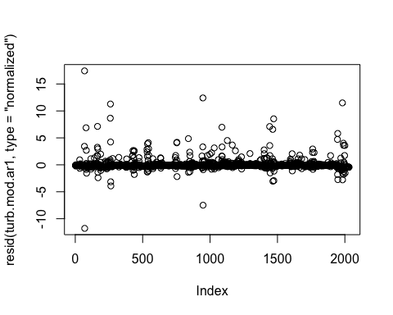

plot(turb.mod.ar1, resid(., type = "p") ~ fitted(.) | site.ID, abline = 0)

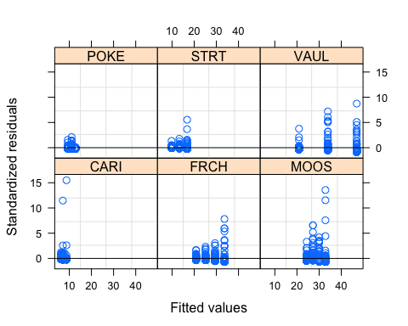

plot(turb.mod.ar1, dailyTurb ~ fitted(.) | site.ID, abline = c(0,1))

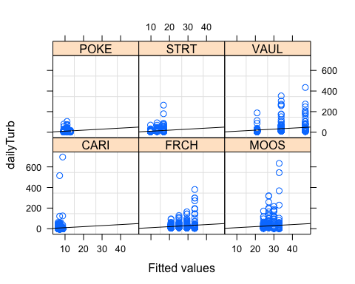

qqnorm(turb.mod.ar1, abline = c(0,1))

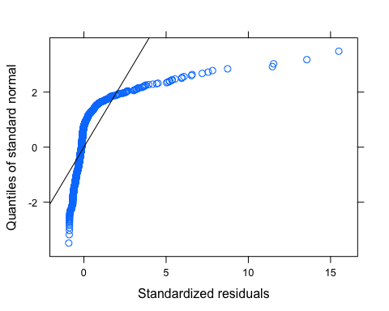

# log transformed

mean_daily$logdailyTurb <- log(mean_daily$dailyTurb)

## Warning in log(mean_daily$dailyTurb): NaNs produced

turb.mod.ar1.log <- gls(logdailyTurb ~ site.ID*year,   
 na.action = na.omit,   
 data = mean_daily,   
 correlation = corAR1(form = ~ julian|site.ID/year))  
  
summary(turb.mod.ar1.log)

## Generalized least squares fit by REML  
## Model: logdailyTurb ~ site.ID * year   
## Data: mean_daily   
## AIC BIC logLik  
## 3278.719 3356.683 -1625.359  
##   
## Correlation Structure: ARMA(1,0)  
## Formula: ~julian | site.ID/year   
## Parameter estimate(s):  
## Phi1   
## 0.835357   
##   
## Coefficients:  
## Value Std.Error t-value p-value  
## (Intercept) -417.4609 303.8293 -1.3739982 0.1696  
## site.IDFRCH 461.7940 413.2662 1.1174252 0.2640  
## site.IDMOOS 282.8872 412.9106 0.6851052 0.4934  
## site.IDPOKE 75.3357 606.3780 0.1242389 0.9011  
## site.IDSTRT 519.5352 539.1679 0.9635869 0.3354  
## site.IDVAUL -327.4346 536.8363 -0.6099337 0.5420  
## year 0.2072 0.1504 1.3772533 0.1686  
## site.IDFRCH:year -0.2277 0.2046 -1.1129028 0.2659  
## site.IDMOOS:year -0.1393 0.2045 -0.6812421 0.4958  
## site.IDPOKE:year -0.0369 0.3002 -0.1229067 0.9022  
## site.IDSTRT:year -0.2566 0.2669 -0.9613031 0.3365  
## site.IDVAUL:year 0.1630 0.2658 0.6133438 0.5397  
##   
## Correlation:   
## (Intr) st.IDFRCH st.IDMOOS st.IDPOKE st.IDSTRT st.IDVAUL  
## site.IDFRCH -0.735   
## site.IDMOOS -0.736 0.541   
## site.IDPOKE -0.501 0.368 0.369   
## site.IDSTRT -0.564 0.414 0.415 0.282   
## site.IDVAUL -0.566 0.416 0.416 0.284 0.319   
## year -1.000 0.735 0.736 0.501 0.564 0.566   
## site.IDFRCH:year 0.735 -1.000 -0.541 -0.368 -0.414 -0.416   
## site.IDMOOS:year 0.736 -0.541 -1.000 -0.369 -0.415 -0.416   
## site.IDPOKE:year 0.501 -0.368 -0.369 -1.000 -0.282 -0.284   
## site.IDSTRT:year 0.564 -0.414 -0.415 -0.282 -1.000 -0.319   
## site.IDVAUL:year 0.566 -0.416 -0.417 -0.284 -0.319 -1.000   
## year s.IDFRCH: s.IDMOOS: s.IDPOKE: s.IDSTRT:  
## site.IDFRCH   
## site.IDMOOS   
## site.IDPOKE   
## site.IDSTRT   
## site.IDVAUL   
## year   
## site.IDFRCH:year -0.735   
## site.IDMOOS:year -0.736 0.541   
## site.IDPOKE:year -0.501 0.368 0.369   
## site.IDSTRT:year -0.564 0.414 0.415 0.282   
## site.IDVAUL:year -0.566 0.416 0.417 0.284 0.319   
##   
## Standardized residuals:  
## Min Q1 Med Q3 Max   
## -4.6291130 -0.5837707 -0.1561827 0.4467765 5.8911268   
##   
## Residual standard error: 0.9985555   
## Degrees of freedom: 1949 total; 1937 residual

# diagnostic plots

plot(resid(turb.mod.ar1.log, type = "normalized"))

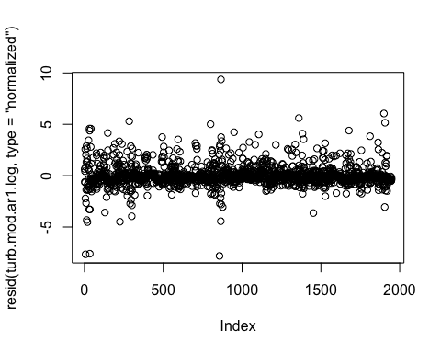

plot(turb.mod.ar1.log, resid(., type = "p") ~ fitted(.) | site.ID, abline = 0)

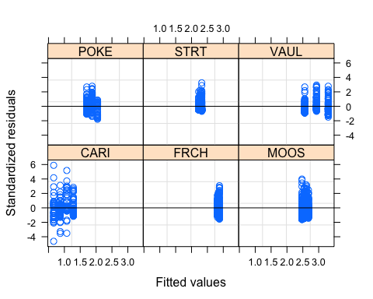

plot(turb.mod.ar1.log, logdailyTurb ~ fitted(.) | site.ID, abline = c(0,1))

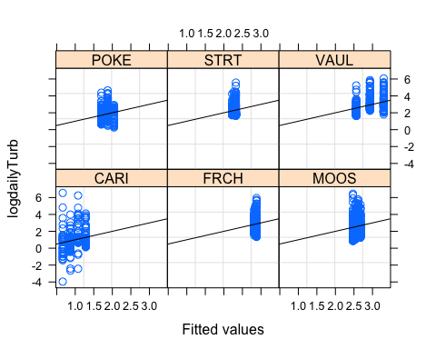

qqnorm(turb.mod.ar1.log, abline = c(0,1))

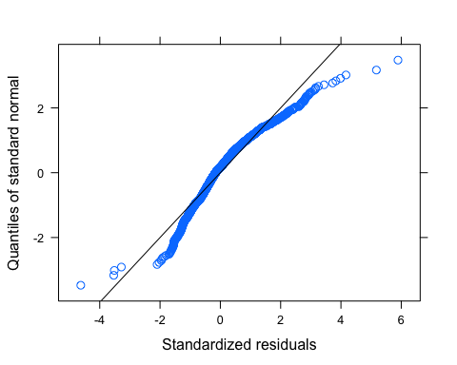 our normality plot looks better but still not great….

Ear1<-residuals(turb.mod.ar1.log, type="normalized")  
I1<-!is.na(mean_daily$logdailyTurb)  
Efulla<-vector(length = length(mean_daily$logdailyTurb))  
Efulla<-NA  
Efulla[I1]<-Ear1  
acf(Efulla, na.action=na.pass)

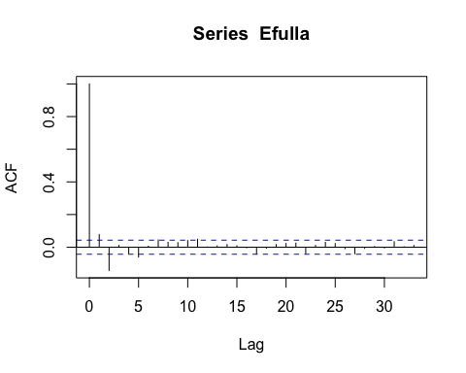

pacf(Efulla, na.action=na.pass)

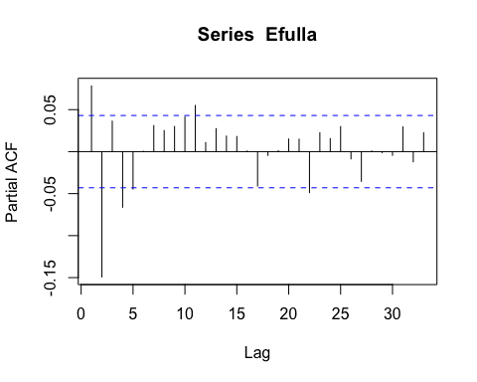

# generalized linear hypotheses

site.ID.comp <- glht(turb.mod.ar1.log, linfct = mcp(site.ID = "Tukey"))

## Warning in mcp2matrix(model, linfct = linfct): covariate interactions found --  
## default contrast might be inappropriate

summary(site.ID.comp)

##   
## Simultaneous Tests for General Linear Hypotheses  
##   
## Multiple Comparisons of Means: Tukey Contrasts  
##   
##   
## Fit: gls(model = logdailyTurb ~ site.ID * year, data = mean_daily,   
## correlation = corAR1(form = ~julian | site.ID/year), na.action = na.omit)  
##   
## Linear Hypotheses:  
## Estimate Std. Error z value Pr(>|z|)  
## FRCH - CARI == 0 461.79 413.27 1.117 0.869  
## MOOS - CARI == 0 282.89 412.91 0.685 0.983  
## POKE - CARI == 0 75.34 606.38 0.124 1.000  
## STRT - CARI == 0 519.54 539.17 0.964 0.926  
## VAUL - CARI == 0 -327.43 536.84 -0.610 0.990  
## MOOS - FRCH == 0 -178.91 395.80 -0.452 0.998  
## POKE - FRCH == 0 -386.46 594.86 -0.650 0.986  
## STRT - FRCH == 0 57.74 526.18 0.110 1.000  
## VAUL - FRCH == 0 -789.23 523.79 -1.507 0.650  
## POKE - MOOS == 0 -207.55 594.61 -0.349 0.999  
## STRT - MOOS == 0 236.65 525.90 0.450 0.998  
## VAUL - MOOS == 0 -610.32 523.51 -1.166 0.848  
## STRT - POKE == 0 444.20 688.31 0.645 0.987  
## VAUL - POKE == 0 -402.77 686.49 -0.587 0.992  
## VAUL - STRT == 0 -846.97 627.91 -1.349 0.749  
## (Adjusted p values reported -- single-step method)

plot(print(confint(site.ID.comp)))

##   
## Simultaneous Confidence Intervals  
##   
## Multiple Comparisons of Means: Tukey Contrasts  
##   
##   
## Fit: gls(model = logdailyTurb ~ site.ID * year, data = mean_daily,   
## correlation = corAR1(form = ~julian | site.ID/year), na.action = na.omit)  
##   
## Quantile = 2.8323  
## 95% family-wise confidence level  
##   
##   
## Linear Hypotheses:  
## Estimate lwr upr   
## FRCH - CARI == 0 461.7940 -708.6986 1632.2867  
## MOOS - CARI == 0 282.8872 -886.5983 1452.3726  
## POKE - CARI == 0 75.3357 -1642.1071 1792.7786  
## STRT - CARI == 0 519.5352 -1007.5487 2046.6190  
## VAUL - CARI == 0 -327.4346 -1847.9147 1193.0455  
## MOOS - FRCH == 0 -178.9069 -1299.9372 942.1235  
## POKE - FRCH == 0 -386.4583 -2071.2795 1298.3629  
## STRT - FRCH == 0 57.7411 -1432.5601 1548.0424  
## VAUL - FRCH == 0 -789.2286 -2272.7624 694.3052  
## POKE - MOOS == 0 -207.5514 -1891.6731 1476.5702  
## STRT - MOOS == 0 236.6480 -1252.8623 1726.1583  
## VAUL - MOOS == 0 -610.3217 -2093.0610 872.4175  
## STRT - POKE == 0 444.1994 -1505.3017 2393.7005  
## VAUL - POKE == 0 -402.7703 -2347.1029 1541.5623  
## VAUL - STRT == 0 -846.9697 -2625.3973 931.4578

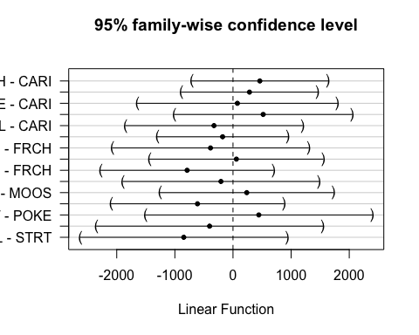 This shows that none of our sites Turb concentration are significantly different

# corARMA structure

turb.mod.arma.1 <- gls(logdailyTurb ~ site.ID*year,   
 na.action = na.omit,   
 data = mean_daily,   
 correlation = corARMA(form = ~ julian|site.ID/year, p = 1, q = 1))  
  
turb.mod.arma.2 <- gls(logdailyTurb ~ site.ID*year,   
 na.action = na.omit,   
 data = mean_daily,   
 correlation = corARMA(form = ~ julian|site.ID/year, p = 1, q = 2))  
  
turb.mod.arma.3 <- gls(logdailyTurb ~ site.ID*year,   
 na.action = na.omit,   
 data = mean_daily,   
 correlation = corARMA(form = ~ julian|site.ID/year, p = 2, q = 1))  
  
turb.mod.arma.4 <- gls(logdailyTurb ~ site.ID*year,   
 na.action = na.omit,   
 data = mean_daily,   
 correlation = corARMA(form = ~ julian|site.ID/year, p = 2, q = 2))  
  
AIC(turb.mod.arma.1, turb.mod.arma.2, turb.mod.arma.3, turb.mod.arma.4, turb.mod.ar1.log)

## df AIC  
## turb.mod.arma.1 15 3249.298  
## turb.mod.arma.2 16 3218.379  
## turb.mod.arma.3 16 3232.952  
## turb.mod.arma.4 17 3206.535  
## turb.mod.ar1.log 14 3278.719

summary(turb.mod.arma.2)

## Generalized least squares fit by REML  
## Model: logdailyTurb ~ site.ID * year   
## Data: mean_daily   
## AIC BIC logLik  
## 3218.379 3307.482 -1593.19  
##   
## Correlation Structure: ARMA(1,2)  
## Formula: ~julian | site.ID/year   
## Parameter estimate(s):  
## Phi1 Theta1 Theta2   
## 0.8721990 -0.2121662 0.1247622   
##   
## Coefficients:  
## Value Std.Error t-value p-value  
## (Intercept) -397.6663 323.1357 -1.2306481 0.2186  
## site.IDFRCH 440.6371 441.4200 0.9982264 0.3183  
## site.IDMOOS 266.3002 441.0454 0.6037931 0.5461  
## site.IDPOKE 63.5552 645.7006 0.0984283 0.9216  
## site.IDSTRT 504.0166 576.4073 0.8744106 0.3820  
## site.IDVAUL -348.4987 574.4986 -0.6066136 0.5442  
## year 0.1974 0.1600 1.2337071 0.2175  
## site.IDFRCH:year -0.2173 0.2186 -0.9940096 0.3203  
## site.IDMOOS:year -0.1311 0.2184 -0.6001876 0.5485  
## site.IDPOKE:year -0.0311 0.3197 -0.0971887 0.9226  
## site.IDSTRT:year -0.2489 0.2854 -0.8722782 0.3832  
## site.IDVAUL:year 0.1734 0.2844 0.6098019 0.5421  
##   
## Correlation:   
## (Intr) st.IDFRCH st.IDMOOS st.IDPOKE st.IDSTRT st.IDVAUL  
## site.IDFRCH -0.732   
## site.IDMOOS -0.733 0.536   
## site.IDPOKE -0.500 0.366 0.367   
## site.IDSTRT -0.561 0.410 0.411 0.281   
## site.IDVAUL -0.562 0.412 0.412 0.281 0.315   
## year -1.000 0.732 0.733 0.500 0.561 0.562   
## site.IDFRCH:year 0.732 -1.000 -0.536 -0.366 -0.410 -0.412   
## site.IDMOOS:year 0.733 -0.536 -1.000 -0.367 -0.411 -0.412   
## site.IDPOKE:year 0.500 -0.366 -0.367 -1.000 -0.281 -0.282   
## site.IDSTRT:year 0.561 -0.410 -0.411 -0.281 -1.000 -0.315   
## site.IDVAUL:year 0.563 -0.412 -0.412 -0.282 -0.315 -1.000   
## year s.IDFRCH: s.IDMOOS: s.IDPOKE: s.IDSTRT:  
## site.IDFRCH   
## site.IDMOOS   
## site.IDPOKE   
## site.IDSTRT   
## site.IDVAUL   
## year   
## site.IDFRCH:year -0.732   
## site.IDMOOS:year -0.733 0.536   
## site.IDPOKE:year -0.500 0.366 0.367   
## site.IDSTRT:year -0.561 0.410 0.411 0.281   
## site.IDVAUL:year -0.563 0.412 0.412 0.282 0.315   
##   
## Standardized residuals:  
## Min Q1 Med Q3 Max   
## -4.6326827 -0.5780400 -0.1518866 0.4499359 5.8559975   
##   
## Residual standard error: 1.00156   
## Degrees of freedom: 1949 total; 1937 residual

The residuals do not look perfect

# diagnostic plots

plot(resid(turb.mod.arma.2, type = "normalized"))

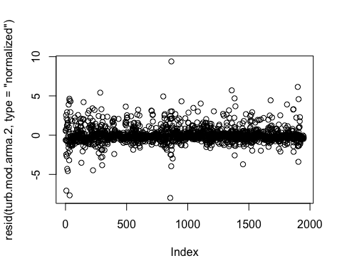

plot(turb.mod.arma.2, resid(., type = "p") ~ fitted(.) | site.ID, abline = 0)

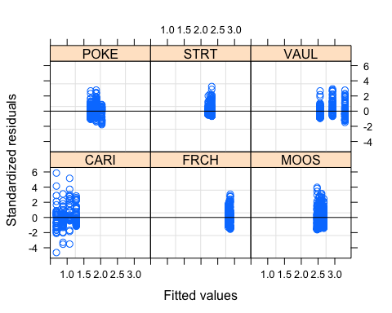

plot(turb.mod.arma.2, logdailyTurb ~ fitted(.) | site.ID, abline = c(0,1))

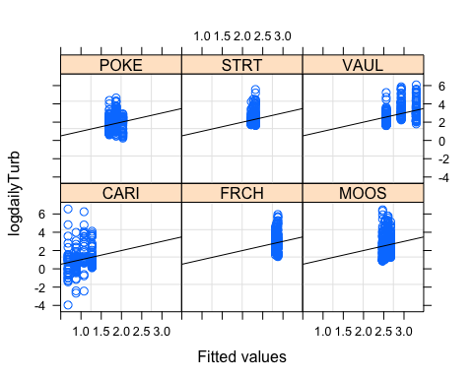

qqnorm(turb.mod.arma.2, abline = c(0,1))

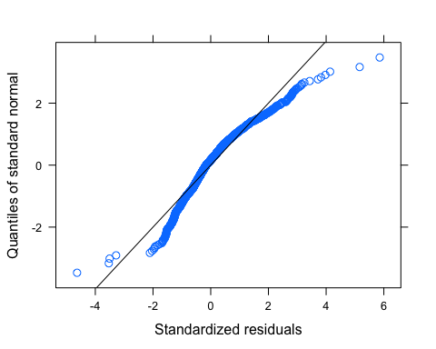

Ear1<-residuals(turb.mod.arma.2, type="normalized")  
I1<-!is.na(mean_daily$logdailyTurb)  
Efulla<-vector(length = length(mean_daily$logdailyTurb))  
Efulla<-NA  
Efulla[I1]<-Ear1  
acf(Efulla, na.action=na.pass)

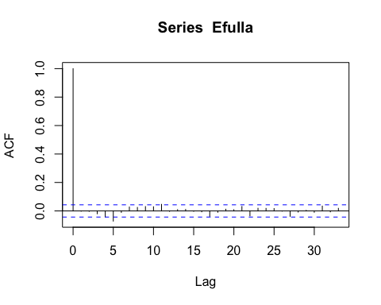

pacf(Efulla, na.action=na.pass)

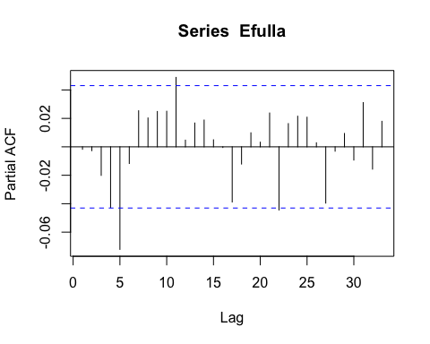 No autocorrelation until lag 5

# generalized linear hypotheses

site.ID.comp <- glht(turb.mod.arma.2, linfct = mcp(site.ID = "Tukey"))

## Warning in mcp2matrix(model, linfct = linfct): covariate interactions found --  
## default contrast might be inappropriate

summary(site.ID.comp)

##   
## Simultaneous Tests for General Linear Hypotheses  
##   
## Multiple Comparisons of Means: Tukey Contrasts  
##   
##   
## Fit: gls(model = logdailyTurb ~ site.ID * year, data = mean_daily,   
## correlation = corARMA(form = ~julian | site.ID/year, p = 1,   
## q = 2), na.action = na.omit)  
##   
## Linear Hypotheses:  
## Estimate Std. Error z value Pr(>|z|)  
## FRCH - CARI == 0 440.64 441.42 0.998 0.915  
## MOOS - CARI == 0 266.30 441.05 0.604 0.990  
## POKE - CARI == 0 63.56 645.70 0.098 1.000  
## STRT - CARI == 0 504.02 576.41 0.874 0.950  
## VAUL - CARI == 0 -348.50 574.50 -0.607 0.990  
## MOOS - FRCH == 0 -174.34 424.90 -0.410 0.998  
## POKE - FRCH == 0 -377.08 634.78 -0.594 0.991  
## STRT - FRCH == 0 63.38 564.15 0.112 1.000  
## VAUL - FRCH == 0 -789.14 562.20 -1.404 0.716  
## POKE - MOOS == 0 -202.74 634.52 -0.320 1.000  
## STRT - MOOS == 0 237.72 563.86 0.422 0.998  
## VAUL - MOOS == 0 -614.80 561.90 -1.094 0.879  
## STRT - POKE == 0 440.46 735.08 0.599 0.991  
## VAUL - POKE == 0 -412.05 733.58 -0.562 0.993  
## VAUL - STRT == 0 -852.52 673.39 -1.266 0.797  
## (Adjusted p values reported -- single-step method)

plot(print(confint(site.ID.comp)))

##   
## Simultaneous Confidence Intervals  
##   
## Multiple Comparisons of Means: Tukey Contrasts  
##   
##   
## Fit: gls(model = logdailyTurb ~ site.ID * year, data = mean_daily,   
## correlation = corARMA(form = ~julian | site.ID/year, p = 1,   
## q = 2), na.action = na.omit)  
##   
## Quantile = 2.8323  
## 95% family-wise confidence level  
##   
##   
## Linear Hypotheses:  
## Estimate lwr upr   
## FRCH - CARI == 0 440.6371 -809.6183 1690.8926  
## MOOS - CARI == 0 266.3002 -982.8943 1515.4947  
## POKE - CARI == 0 63.5552 -1765.2941 1892.4045  
## STRT - CARI == 0 504.0166 -1128.5698 2136.6031  
## VAUL - CARI == 0 -348.4987 -1975.6793 1278.6819  
## MOOS - FRCH == 0 -174.3370 -1377.7996 1029.1257  
## POKE - FRCH == 0 -377.0819 -2175.0044 1420.8406  
## STRT - FRCH == 0 63.3795 -1534.4860 1661.2450  
## VAUL - FRCH == 0 -789.1358 -2381.4776 803.2059  
## POKE - MOOS == 0 -202.7450 -1999.9298 1594.4399  
## STRT - MOOS == 0 237.7165 -1359.3190 1834.7519  
## VAUL - MOOS == 0 -614.7989 -2206.3077 976.7099  
## STRT - POKE == 0 440.4614 -1641.5388 2522.4617  
## VAUL - POKE == 0 -412.0539 -2489.8179 1665.7101  
## VAUL - STRT == 0 -852.5153 -2759.8045 1054.7738

