11_HI_anova_models

Jake Cavaiani

9/13/2022

#load libraries

library(here)

## here() starts at /Users/jakecavaiani/Documents/Storms_clean_repo

library(tidyverse)

## ── Attaching packages ─────────────────────────────────────── tidyverse 1.3.1 ──

## ✓ ggplot2 3.3.5 ✓ purrr 0.3.4  
## ✓ tibble 3.1.6 ✓ dplyr 1.0.7  
## ✓ tidyr 1.1.3 ✓ stringr 1.4.0  
## ✓ readr 1.4.0 ✓ forcats 0.5.1

## ── Conflicts ────────────────────────────────────────── tidyverse_conflicts() ──  
## x dplyr::filter() masks stats::filter()  
## x dplyr::lag() masks stats::lag()

library(nlme)

##   
## Attaching package: 'nlme'

## The following object is masked from 'package:dplyr':  
##   
## collapse

library(forecast)

## Registered S3 method overwritten by 'quantmod':  
## method from  
## as.zoo.data.frame zoo

##   
## Attaching package: 'forecast'

## The following object is masked from 'package:nlme':  
##   
## getResponse

library(stats)  
library(readr)  
library(ggplot2)  
library(plotly)

##   
## Attaching package: 'plotly'

## The following object is masked from 'package:ggplot2':  
##   
## last_plot

## The following object is masked from 'package:stats':  
##   
## filter

## The following object is masked from 'package:graphics':  
##   
## layout

library(GGally)

## Registered S3 method overwritten by 'GGally':  
## method from   
## +.gg ggplot2

library(ggpmisc)

## Loading required package: ggpp

##   
## Attaching package: 'ggpp'

## The following object is masked from 'package:ggplot2':  
##   
## annotate

library(ggpubr)

##   
## Attaching package: 'ggpubr'

## The following object is masked from 'package:forecast':  
##   
## gghistogram

library(ggExtra)  
library(lubridate)

##   
## Attaching package: 'lubridate'

## The following objects are masked from 'package:base':  
##   
## date, intersect, setdiff, union

library(nlme)  
library(MuMIn)  
library(multcomp)

## Loading required package: mvtnorm

## Loading required package: survival

## Loading required package: TH.data

## Loading required package: MASS

##   
## Attaching package: 'MASS'

## The following object is masked from 'package:plotly':  
##   
## select

## The following object is masked from 'package:dplyr':  
##   
## select

##   
## Attaching package: 'TH.data'

## The following object is masked from 'package:MASS':  
##   
## geyser

# load in the data

AMC <- read.csv("~/Documents/Storms_clean_repo/Output_from_analysis/07_Combine_HI_BETA_FI/antecedent_HI_FI_AllYears.csv")   
  
AMC <- AMC[,-c(1:2,4,5,8,9,12,13,17,18,20:35,40)] # cleaning up columns that are unnecessary   
  
colNames <- c("Hyst_index", "site.ID", "storm.ID", "response_var", "Flush_index", "month", "day", "year", "Beta_index", "doy", "burn", "pf", "date")  
  
names(AMC)<- colNames # renaming columns   
  
AMC <- AMC %>%   
 group_by(site.ID, response_var, year) %>%   
 dplyr::summarise(meanHI = mean(Hyst_index, na.rm = TRUE),  
 meanBETA = mean(Beta_index, na.rm = TRUE),  
 sdHI = sd(Hyst_index, na.rm = TRUE),  
 sdBETA = sd(Beta_index, na.rm = TRUE),  
 CVhi = sdHI/meanHI,  
 CVbeta = sdBETA/meanBETA,  
 response_var = paste(response_var),  
 Date = as.Date(date),  
 DOY = as.numeric(doy),  
 burn = paste(burn),  
 PF = paste(pf))

## `summarise()` has grouped output by 'site.ID', 'response_var', 'year'. You can  
## override using the `.groups` argument.

AMC <- AMC[!duplicated(AMC$meanHI), ] # removing duplicated rows   
  
  
##subsetting by solute   
# NO3 #  
HI_FI_NO3 = subset(AMC, response_var == "NO3")  
# fDOM #  
HI_FI_fDOM = subset(AMC, response_var == "fDOM")  
# SPC #  
HI_FI_SPC = subset(AMC, response_var == "SPC")  
# turb #  
HI_FI_turb = subset(AMC, response_var == "turb")

# plot

ggplot(AMC, aes(site.ID, meanHI, fill = site.ID)) +  
 geom_boxplot() +  
 facet_wrap(~response_var, scales = "free") +  
 scale_fill_manual(values = c("#3288BD", "#FF7F00","#A6761D", "#6A3D9A", "#66C2A5", "#E7298A")) +  
 theme_classic()

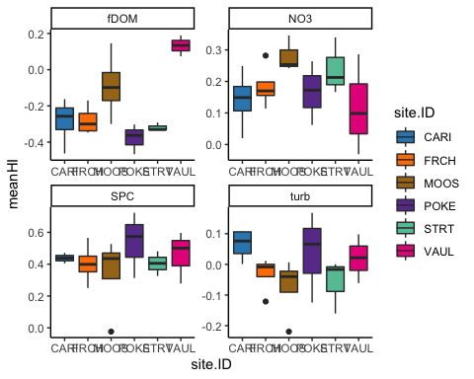

### HI

#NO3  
NO3 <- aov(meanHI ~ site.ID*year,   
 data = HI_FI_NO3)  
summary(NO3) # nothing is significant

## Df Sum Sq Mean Sq F value Pr(>F)  
## site.ID 5 0.05842 0.011685 0.791 0.585  
## year 1 0.00142 0.001423 0.096 0.764  
## site.ID:year 5 0.01578 0.003155 0.214 0.947  
## Residuals 8 0.11816 0.014769

summary.lm(NO3) # residuals look meh

##   
## Call:  
## aov(formula = meanHI ~ site.ID * year, data = HI_FI_NO3)  
##   
## Residuals:  
## Min 1Q Median 3Q Max   
## -0.10408 -0.05295 -0.02774 0.05539 0.16809   
##   
## Coefficients:  
## Estimate Std. Error t value Pr(>|t|)  
## (Intercept) 52.55673 109.75902 0.479 0.645  
## site.IDFRCH -41.47091 155.22270 -0.267 0.796  
## site.IDMOOS -40.62087 205.30401 -0.198 0.848  
## site.IDPOKE -144.85695 205.37663 -0.705 0.501  
## site.IDSTRT -98.84346 205.37663 -0.481 0.643  
## site.IDVAUL 78.21010 205.37663 0.381 0.713  
## year -0.02595 0.05435 -0.478 0.646  
## site.IDFRCH:year 0.02056 0.07686 0.267 0.796  
## site.IDMOOS:year 0.02018 0.10168 0.198 0.848  
## site.IDPOKE:year 0.07173 0.10168 0.705 0.501  
## site.IDSTRT:year 0.04899 0.10168 0.482 0.643  
## site.IDVAUL:year -0.03872 0.10168 -0.381 0.713  
##   
## Residual standard error: 0.1215 on 8 degrees of freedom  
## Multiple R-squared: 0.3903, Adjusted R-squared: -0.4482   
## F-statistic: 0.4655 on 11 and 8 DF, p-value: 0.8805

plot(NO3)

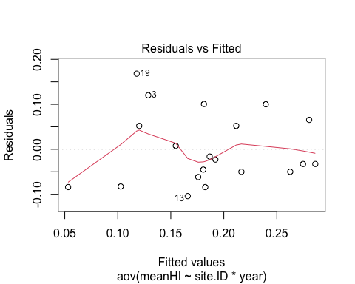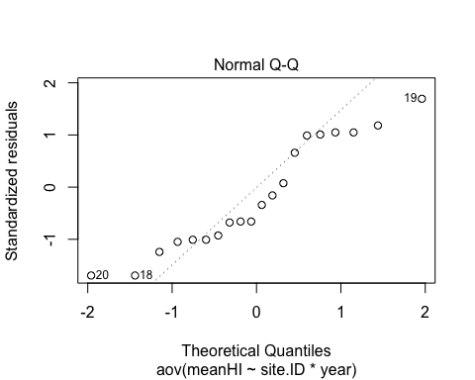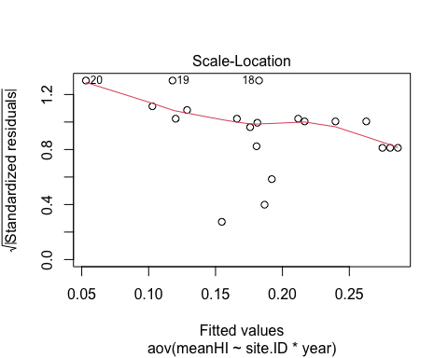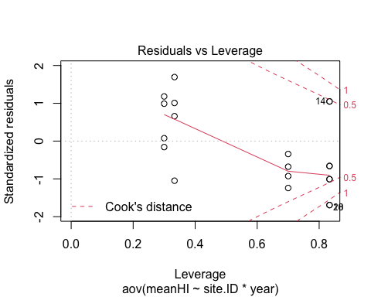 normality is not great… lemme try log transform

# log transform

# log transform   
HI_FI_NO3$logmeanHI <- log(abs(HI_FI_NO3$meanHI))  
  
NO3.log <- aov(logmeanHI ~ site.ID*year,   
 data = HI_FI_NO3)  
  
summary(NO3.log) # nothing is significant

## Df Sum Sq Mean Sq F value Pr(>F)  
## site.ID 5 2.941 0.5883 0.805 0.576  
## year 1 0.689 0.6889 0.943 0.360  
## site.ID:year 5 1.529 0.3057 0.418 0.824  
## Residuals 8 5.845 0.7306

summary.lm(NO3.log) # residuals look meh

##   
## Call:  
## aov(formula = logmeanHI ~ site.ID * year, data = HI_FI_NO3)  
##   
## Residuals:  
## Min 1Q Median 3Q Max   
## -0.8334 -0.3707 -0.1113 0.3984 1.1522   
##   
## Coefficients:  
## Estimate Std. Error t value Pr(>|t|)  
## (Intercept) 1.067e+03 7.720e+02 1.382 0.204  
## site.IDFRCH -9.313e+02 1.092e+03 -0.853 0.418  
## site.IDMOOS -1.021e+03 1.444e+03 -0.707 0.500  
## site.IDPOKE -1.499e+03 1.444e+03 -1.038 0.330  
## site.IDSTRT -1.315e+03 1.444e+03 -0.910 0.389  
## site.IDVAUL 1.017e+02 1.444e+03 0.070 0.946  
## year -5.293e-01 3.823e-01 -1.385 0.204  
## site.IDFRCH:year 4.614e-01 5.406e-01 0.853 0.418  
## site.IDMOOS:year 5.060e-01 7.151e-01 0.708 0.499  
## site.IDPOKE:year 7.424e-01 7.151e-01 1.038 0.330  
## site.IDSTRT:year 6.514e-01 7.151e-01 0.911 0.389  
## site.IDVAUL:year -5.027e-02 7.151e-01 -0.070 0.946  
##   
## Residual standard error: 0.8548 on 8 degrees of freedom  
## Multiple R-squared: 0.4688, Adjusted R-squared: -0.2615   
## F-statistic: 0.6419 on 11 and 8 DF, p-value: 0.7571

plot(NO3.log)

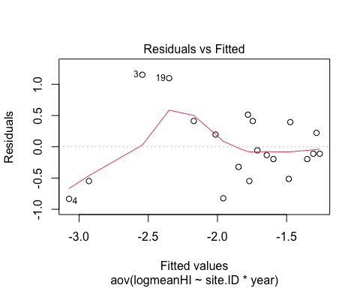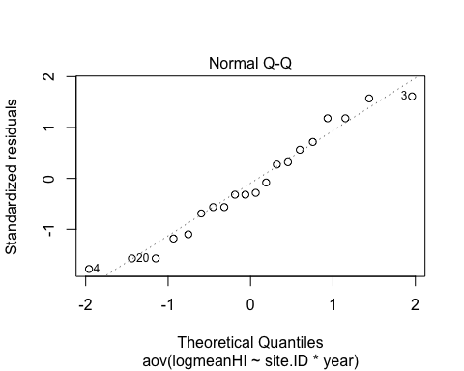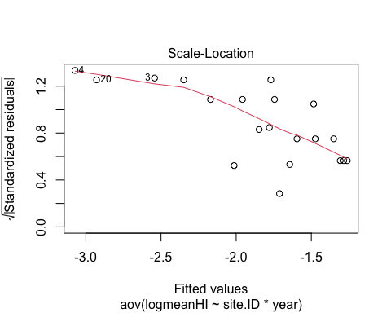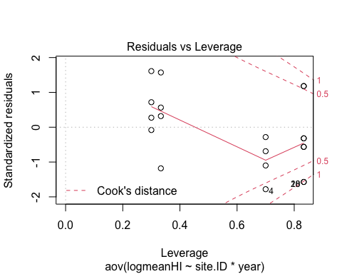 normality looks a little better

#fDOM

#fDOM  
HI_FI_fDOM$site.ID <- as.factor(HI_FI_fDOM$site.ID)  
  
fDOM <- aov(meanHI ~ site.ID*year,   
 data = HI_FI_fDOM)  
  
summary(fDOM) # this shows that site.ID is significantly different

## Df Sum Sq Mean Sq F value Pr(>F)   
## site.ID 5 0.5721 0.11442 15.923 0.000308 ***  
## year 1 0.0201 0.02010 2.797 0.128766   
## site.ID:year 5 0.1076 0.02153 2.996 0.072753 .   
## Residuals 9 0.0647 0.00719   
## ---  
## Signif. codes: 0 '***' 0.001 '**' 0.01 '*' 0.05 '.' 0.1 ' ' 1

summary.lm(fDOM)

##   
## Call:  
## aov(formula = meanHI ~ site.ID * year, data = HI_FI_fDOM)  
##   
## Residuals:  
## Min 1Q Median 3Q Max   
## -0.090503 -0.030964 -0.000765 0.030125 0.151236   
##   
## Coefficients:  
## Estimate Std. Error t value Pr(>|t|)   
## (Intercept) 117.23899 76.55881 1.531 0.16004   
## site.IDFRCH -177.99652 108.27051 -1.644 0.13459   
## site.IDMOOS -398.88523 108.27051 -3.684 0.00504 **  
## site.IDPOKE -57.38356 143.25375 -0.401 0.69808   
## site.IDSTRT -156.51159 143.25375 -1.093 0.30297   
## site.IDVAUL -233.13917 143.25375 -1.627 0.13808   
## year -0.05819 0.03791 -1.535 0.15914   
## site.IDFRCH:year 0.08814 0.05361 1.644 0.13458   
## site.IDMOOS:year 0.19761 0.05361 3.686 0.00503 **  
## site.IDPOKE:year 0.02838 0.07092 0.400 0.69841   
## site.IDSTRT:year 0.07748 0.07092 1.092 0.30302   
## site.IDVAUL:year 0.11564 0.07092 1.630 0.13744   
## ---  
## Signif. codes: 0 '***' 0.001 '**' 0.01 '*' 0.05 '.' 0.1 ' ' 1  
##   
## Residual standard error: 0.08477 on 9 degrees of freedom  
## Multiple R-squared: 0.9154, Adjusted R-squared: 0.812   
## F-statistic: 8.854 on 11 and 9 DF, p-value: 0.001431

plot(fDOM)

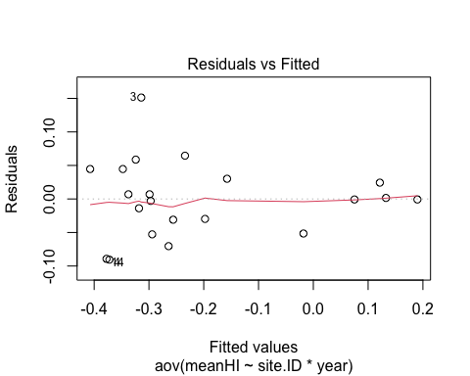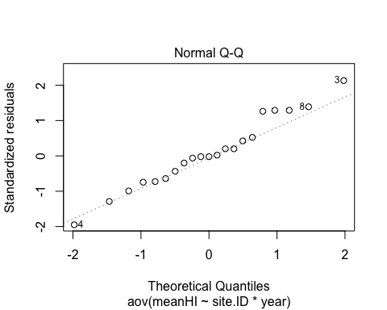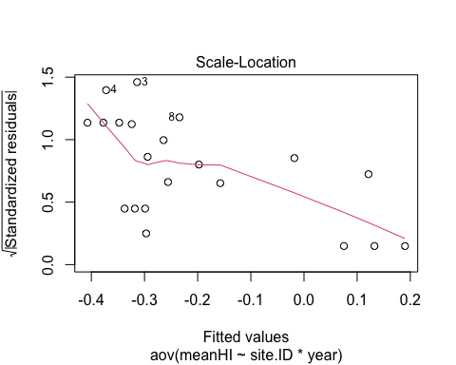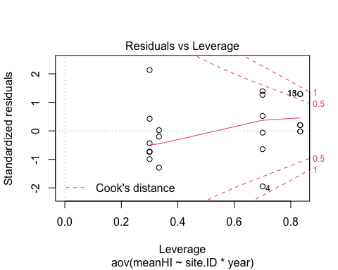 normality looks good

TukeyHSD(fDOM, which = "site.ID")

## Warning in replications(paste("~", xx), data = mf): non-factors ignored: year

## Warning in replications(paste("~", xx), data = mf): non-factors ignored:  
## site.ID, year

## Tukey multiple comparisons of means  
## 95% family-wise confidence level  
##   
## Fit: aov(formula = meanHI ~ site.ID * year, data = HI_FI_fDOM)  
##   
## $site.ID  
## diff lwr upr p adj  
## FRCH-CARI 0.005778325 -0.207140457 0.2186971066 0.9999983  
## MOOS-CARI 0.197197665 -0.015721117 0.4101164471 0.0727574  
## POKE-CARI -0.092560946 -0.322539515 0.1374176235 0.7111683  
## STRT-CARI -0.033251137 -0.263229706 0.1967274324 0.9942189  
## VAUL-CARI 0.417502769 0.187524200 0.6474813384 0.0011507  
## MOOS-FRCH 0.191419340 -0.021499442 0.4043381225 0.0834973  
## POKE-FRCH -0.098339270 -0.328317840 0.1316392989 0.6625494  
## STRT-FRCH -0.039029462 -0.269008031 0.1909491079 0.9881087  
## VAUL-FRCH 0.411724444 0.181745875 0.6417030139 0.0012748  
## POKE-MOOS -0.289758611 -0.519737180 -0.0597800416 0.0136893  
## STRT-MOOS -0.230448802 -0.460427371 -0.0004702326 0.0494838  
## VAUL-MOOS 0.220305104 -0.009673465 0.4502836734 0.0619110  
## STRT-POKE 0.059309809 -0.186547623 0.3051672412 0.9479670  
## VAUL-POKE 0.510063715 0.264206283 0.7559211472 0.0004209  
## VAUL-STRT 0.450753906 0.204896474 0.6966113383 0.0010700

#VAUL/CARI  
#VAUL/FRCH  
#VAUL/POKE  
#VAUL/STRT  
#MOOS/POKE  
#MOOS/STRT  
# all of these sites are significantly different from each other

#SPC  
SPC <- aov(meanHI ~ site.ID*year,   
 data = HI_FI_SPC)  
  
summary(SPC) # nothing significant

## Df Sum Sq Mean Sq F value Pr(>F)  
## site.ID 5 0.07131 0.01426 0.420 0.824  
## year 1 0.00143 0.00143 0.042 0.842  
## site.ID:year 5 0.08289 0.01658 0.489 0.777  
## Residuals 9 0.30528 0.03392

summary.lm(SPC)

##   
## Call:  
## aov(formula = meanHI ~ site.ID * year, data = HI_FI_SPC)  
##   
## Residuals:  
## Min 1Q Median 3Q Max   
## -0.34443 -0.02113 0.00768 0.04226 0.17605   
##   
## Coefficients:  
## Estimate Std. Error t value Pr(>|t|)  
## (Intercept) -44.20060 166.33579 -0.266 0.796  
## site.IDFRCH -31.55044 235.23433 -0.134 0.896  
## site.IDMOOS 136.44757 235.23433 0.580 0.576  
## site.IDPOKE -105.47591 311.24078 -0.339 0.742  
## site.IDSTRT 121.28144 311.24078 0.390 0.706  
## site.IDVAUL 365.54321 311.24078 1.174 0.270  
## year 0.02210 0.08236 0.268 0.794  
## site.IDFRCH:year 0.01561 0.11648 0.134 0.896  
## site.IDMOOS:year -0.06761 0.11648 -0.580 0.576  
## site.IDPOKE:year 0.05226 0.15409 0.339 0.742  
## site.IDSTRT:year -0.06006 0.15409 -0.390 0.706  
## site.IDVAUL:year -0.18096 0.15409 -1.174 0.270  
##   
## Residual standard error: 0.1842 on 9 degrees of freedom  
## Multiple R-squared: 0.3377, Adjusted R-squared: -0.4719   
## F-statistic: 0.4171 on 11 and 9 DF, p-value: 0.9134

plot(SPC)

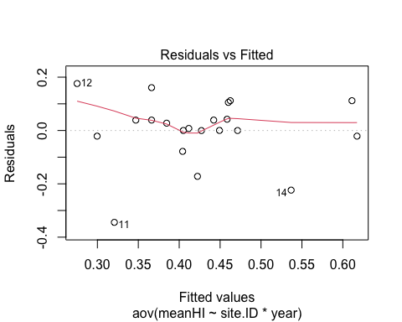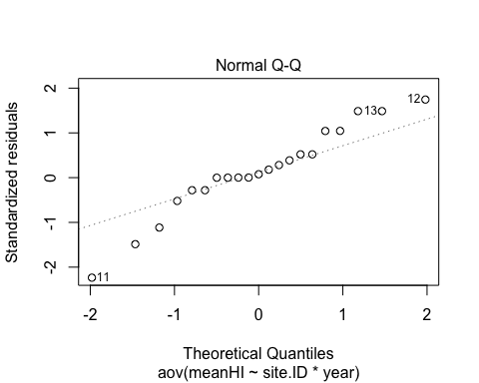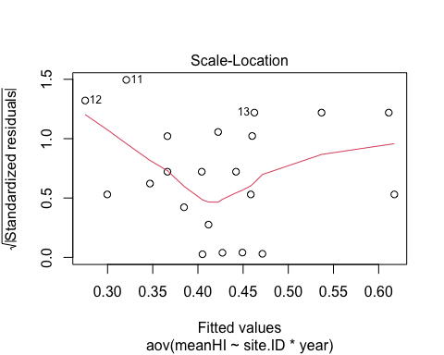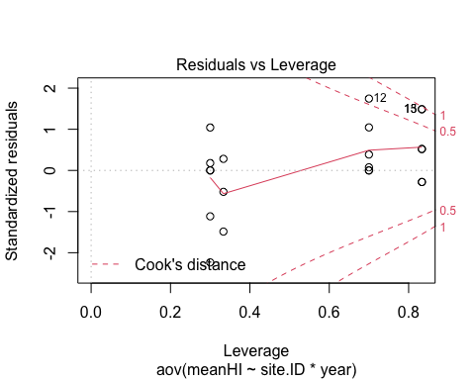 non-normal….lets try to do a log transformation

# log transform  
HI_FI_SPC$logmeanHI <- log(abs(HI_FI_SPC$meanHI))  
  
SPC.log <- aov(logmeanHI ~ site.ID*year,   
 data = HI_FI_SPC)  
  
summary(SPC.log) # nothing significant

## Df Sum Sq Mean Sq F value Pr(>F)  
## site.ID 5 1.578 0.3156 0.406 0.833  
## year 1 0.117 0.1168 0.150 0.707  
## site.ID:year 5 0.663 0.1326 0.171 0.967  
## Residuals 9 6.996 0.7773

summary.lm(SPC.log)

##   
## Call:  
## aov(formula = logmeanHI ~ site.ID * year, data = HI_FI_SPC)  
##   
## Residuals:  
## Min 1Q Median 3Q Max   
## -2.08600 -0.06869 0.09337 0.21066 1.14833   
##   
## Coefficients:  
## Estimate Std. Error t value Pr(>|t|)  
## (Intercept) -102.87688 796.25939 -0.129 0.900  
## site.IDFRCH -28.99060 1126.08083 -0.026 0.980  
## site.IDMOOS 683.30339 1126.08083 0.607 0.559  
## site.IDPOKE -130.41888 1489.92829 -0.088 0.932  
## site.IDSTRT 275.33813 1489.92829 0.185 0.857  
## site.IDVAUL 870.76875 1489.92829 0.584 0.573  
## year 0.05053 0.39429 0.128 0.901  
## site.IDFRCH:year 0.01430 0.55760 0.026 0.980  
## site.IDMOOS:year -0.33869 0.55760 -0.607 0.559  
## site.IDPOKE:year 0.06462 0.73764 0.088 0.932  
## site.IDSTRT:year -0.13636 0.73764 -0.185 0.857  
## site.IDVAUL:year -0.43109 0.73764 -0.584 0.573  
##   
## Residual standard error: 0.8816 on 9 degrees of freedom  
## Multiple R-squared: 0.2521, Adjusted R-squared: -0.662   
## F-statistic: 0.2758 on 11 and 9 DF, p-value: 0.9759

plot(SPC.log)

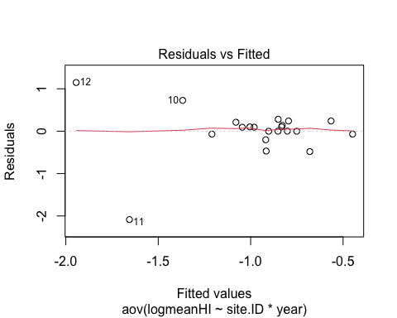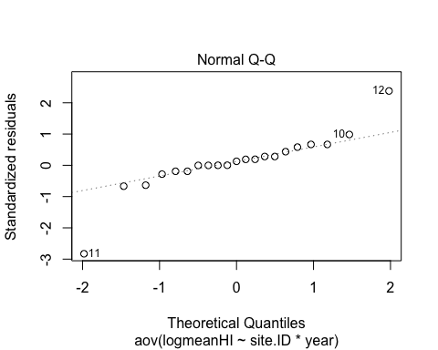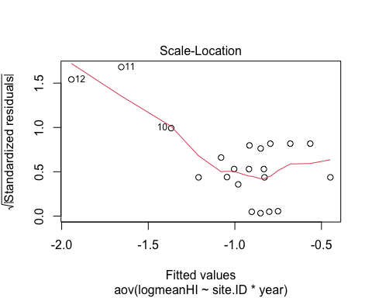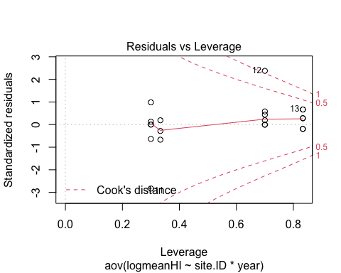

#turb  
turb <- aov(meanHI ~ site.ID*year,   
 data = HI_FI_turb)  
  
summary(turb) # nothing is significantly different

## Df Sum Sq Mean Sq F value Pr(>F)   
## site.ID 5 0.05658 0.011317 1.722 0.2253   
## year 1 0.02231 0.022312 3.396 0.0985 .  
## site.ID:year 5 0.03983 0.007967 1.213 0.3768   
## Residuals 9 0.05913 0.006570   
## ---  
## Signif. codes: 0 '***' 0.001 '**' 0.01 '*' 0.05 '.' 0.1 ' ' 1

summary.lm(turb)

##   
## Call:  
## aov(formula = meanHI ~ site.ID * year, data = HI_FI_turb)  
##   
## Residuals:  
## Min 1Q Median 3Q Max   
## -0.080565 -0.038684 -0.007395 0.040282 0.131577   
##   
## Coefficients:  
## Estimate Std. Error t value Pr(>|t|)   
## (Intercept) -76.27039 73.20655 -1.042 0.3247   
## site.IDFRCH 144.69443 103.52969 1.398 0.1957   
## site.IDMOOS 187.90650 103.52969 1.815 0.1029   
## site.IDPOKE 268.69270 136.98112 1.962 0.0814 .  
## site.IDSTRT 238.47670 136.98112 1.741 0.1157   
## site.IDVAUL 153.35429 136.98112 1.120 0.2919   
## year 0.03780 0.03625 1.043 0.3243   
## site.IDFRCH:year -0.07170 0.05127 -1.399 0.1954   
## site.IDMOOS:year -0.09311 0.05127 -1.816 0.1027   
## site.IDPOKE:year -0.13304 0.06782 -1.962 0.0814 .  
## site.IDSTRT:year -0.11813 0.06782 -1.742 0.1155   
## site.IDVAUL:year -0.07595 0.06782 -1.120 0.2917   
## ---  
## Signif. codes: 0 '***' 0.001 '**' 0.01 '*' 0.05 '.' 0.1 ' ' 1  
##   
## Residual standard error: 0.08106 on 9 degrees of freedom  
## Multiple R-squared: 0.6675, Adjusted R-squared: 0.2612   
## F-statistic: 1.643 on 11 and 9 DF, p-value: 0.2326

plot(turb)

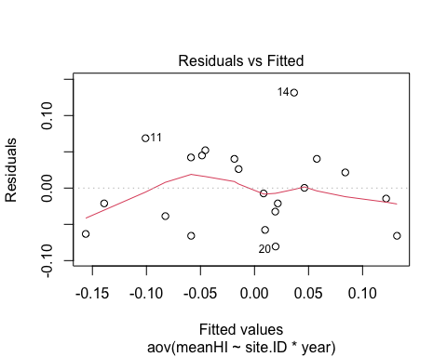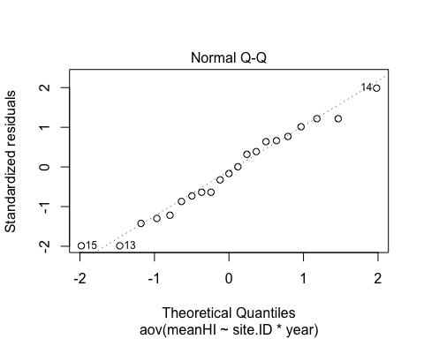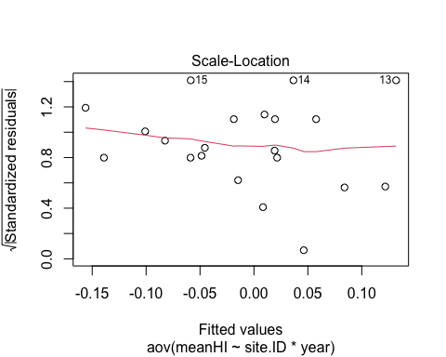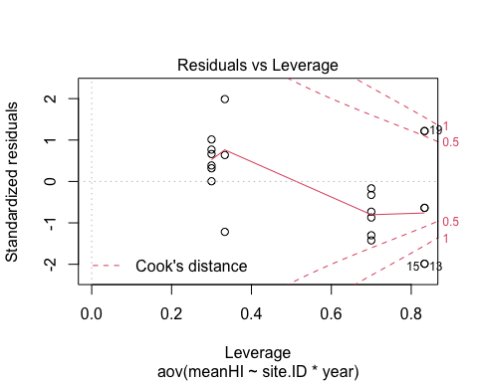

### BETA

ggplot(AMC, aes(site.ID, meanBETA, fill = site.ID)) +  
 geom_boxplot() +  
 facet_wrap(~response_var, scales = "free") +  
 scale_fill_manual(values = c("#3288BD", "#FF7F00","#A6761D", "#6A3D9A", "#66C2A5", "#E7298A")) +  
 theme_classic()

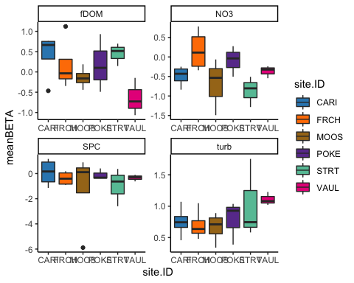

#NO3  
NO3 <- aov(meanBETA ~ site.ID*year,   
 data = HI_FI_NO3)  
  
summary(NO3) # nothing is significant

## Df Sum Sq Mean Sq F value Pr(>F)  
## site.ID 5 2.4987 0.4997 1.843 0.211  
## year 1 0.1469 0.1469 0.542 0.483  
## site.ID:year 5 0.4530 0.0906 0.334 0.879  
## Residuals 8 2.1694 0.2712

summary.lm(NO3)

##   
## Call:  
## aov(formula = meanBETA ~ site.ID * year, data = HI_FI_NO3)  
##   
## Residuals:  
## Min 1Q Median 3Q Max   
## -0.79447 -0.12126 0.01523 0.20863 0.47665   
##   
## Coefficients:  
## Estimate Std. Error t value Pr(>|t|)  
## (Intercept) -244.7370 470.3080 -0.520 0.617  
## site.IDFRCH 431.2392 665.1159 0.648 0.535  
## site.IDMOOS 719.5262 879.7100 0.818 0.437  
## site.IDPOKE 1033.5252 880.0212 1.174 0.274  
## site.IDSTRT 542.2175 880.0212 0.616 0.555  
## site.IDVAUL 468.7498 880.0212 0.533 0.609  
## year 0.1209 0.2329 0.519 0.618  
## site.IDFRCH:year -0.2132 0.3293 -0.647 0.536  
## site.IDMOOS:year -0.3565 0.4357 -0.818 0.437  
## site.IDPOKE:year -0.5115 0.4357 -1.174 0.274  
## site.IDSTRT:year -0.2686 0.4357 -0.617 0.555  
## site.IDVAUL:year -0.2320 0.4357 -0.533 0.609  
##   
## Residual standard error: 0.5207 on 8 degrees of freedom  
## Multiple R-squared: 0.5882, Adjusted R-squared: 0.02198   
## F-statistic: 1.039 on 11 and 8 DF, p-value: 0.4915

plot(NO3)

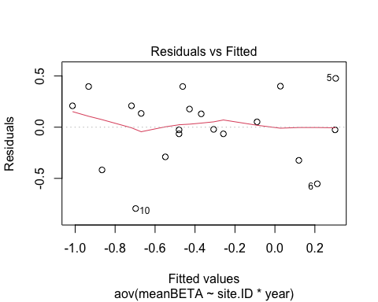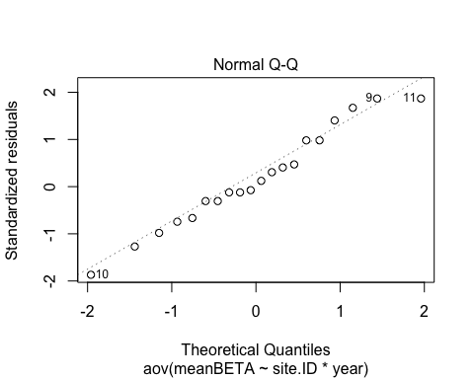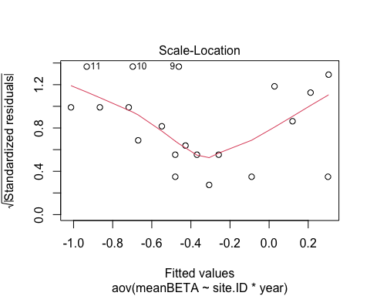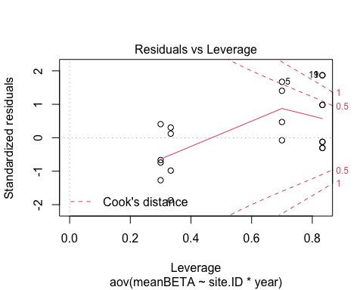

#fDOM

fDOM <- aov(meanBETA ~ site.ID*year,   
 data = HI_FI_fDOM)  
  
summary(fDOM) # nothing is significantly different

## Df Sum Sq Mean Sq F value Pr(>F)  
## site.ID 5 2.6949 0.5390 1.755 0.218  
## year 1 0.1996 0.1996 0.650 0.441  
## site.ID:year 5 1.1521 0.2304 0.751 0.606  
## Residuals 9 2.7632 0.3070

summary.lm(fDOM)

##   
## Call:  
## aov(formula = meanBETA ~ site.ID * year, data = HI_FI_fDOM)  
##   
## Residuals:  
## Min 1Q Median 3Q Max   
## -0.55560 -0.25523 -0.08073 0.18623 0.85597   
##   
## Coefficients:  
## Estimate Std. Error t value Pr(>|t|)  
## (Intercept) 6.311e+02 5.004e+02 1.261 0.239  
## site.IDFRCH -2.711e+02 7.077e+02 -0.383 0.711  
## site.IDMOOS -8.121e+02 7.077e+02 -1.147 0.281  
## site.IDPOKE -3.368e+01 9.364e+02 -0.036 0.972  
## site.IDSTRT -2.574e+02 9.364e+02 -0.275 0.790  
## site.IDVAUL -1.560e+03 9.364e+02 -1.666 0.130  
## year -3.123e-01 2.478e-01 -1.260 0.239  
## site.IDFRCH:year 1.341e-01 3.504e-01 0.383 0.711  
## site.IDMOOS:year 4.018e-01 3.504e-01 1.147 0.281  
## site.IDPOKE:year 1.664e-02 4.636e-01 0.036 0.972  
## site.IDSTRT:year 1.275e-01 4.636e-01 0.275 0.789  
## site.IDVAUL:year 7.717e-01 4.636e-01 1.665 0.130  
##   
## Residual standard error: 0.5541 on 9 degrees of freedom  
## Multiple R-squared: 0.5942, Adjusted R-squared: 0.09829   
## F-statistic: 1.198 on 11 and 9 DF, p-value: 0.3994

plot(fDOM)

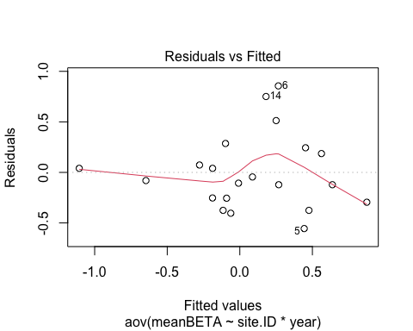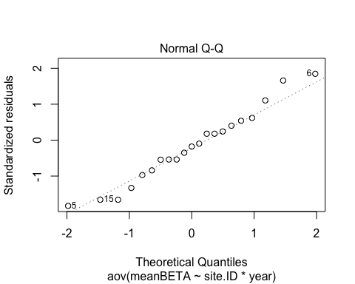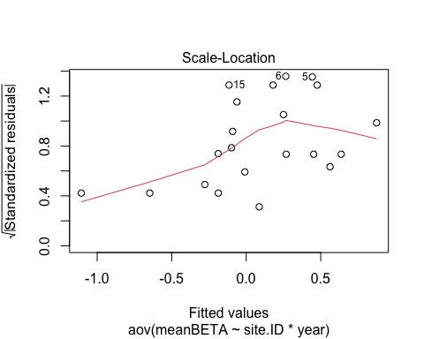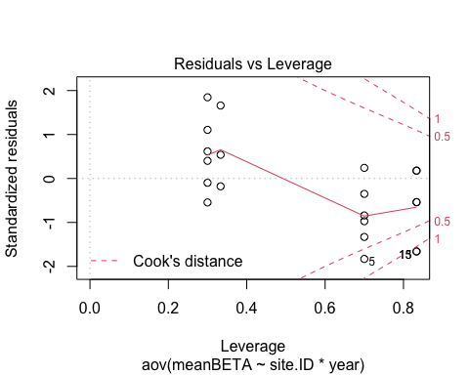

#SPC  
SPC <- aov(meanBETA ~ site.ID*year,   
 data = HI_FI_SPC)  
  
summary(SPC) # nothing significant

## Df Sum Sq Mean Sq F value Pr(>F)  
## site.ID 5 4.53 0.905 0.235 0.937  
## year 1 1.03 1.027 0.266 0.618  
## site.ID:year 5 3.66 0.732 0.190 0.959  
## Residuals 9 34.69 3.855

summary.lm(SPC)

##   
## Call:  
## aov(formula = meanBETA ~ site.ID * year, data = HI_FI_SPC)  
##   
## Residuals:  
## Min 1Q Median 3Q Max   
## -4.4897 -0.1445 0.1416 0.4562 2.6892   
##   
## Coefficients:  
## Estimate Std. Error t value Pr(>|t|)  
## (Intercept) -1405.0353 1773.2005 -0.792 0.449  
## site.IDFRCH 685.8350 2507.6842 0.273 0.791  
## site.IDMOOS 2217.7566 2507.6842 0.884 0.399  
## site.IDPOKE 660.7294 3317.9408 0.199 0.847  
## site.IDSTRT 398.1393 3317.9408 0.120 0.907  
## site.IDVAUL 1740.8312 3317.9408 0.525 0.612  
## year 0.6958 0.8780 0.792 0.448  
## site.IDFRCH:year -0.3398 1.2417 -0.274 0.791  
## site.IDMOOS:year -1.0988 1.2417 -0.885 0.399  
## site.IDPOKE:year -0.3274 1.6427 -0.199 0.846  
## site.IDSTRT:year -0.1978 1.6427 -0.120 0.907  
## site.IDVAUL:year -0.8622 1.6427 -0.525 0.612  
##   
## Residual standard error: 1.963 on 9 degrees of freedom  
## Multiple R-squared: 0.2099, Adjusted R-squared: -0.7558   
## F-statistic: 0.2174 on 11 and 9 DF, p-value: 0.9897

plot(SPC)

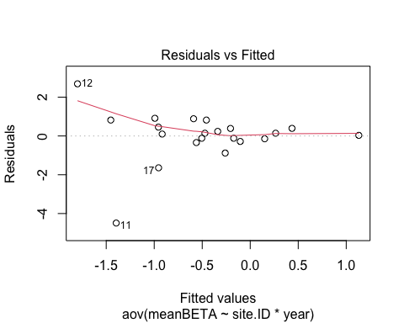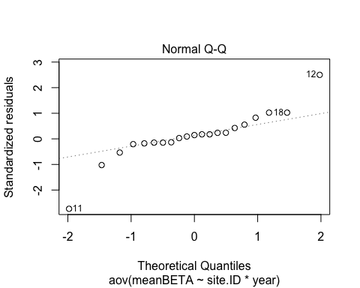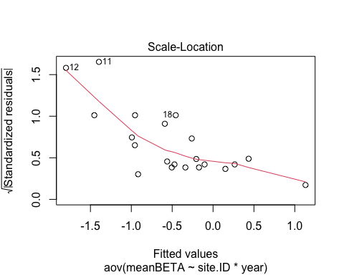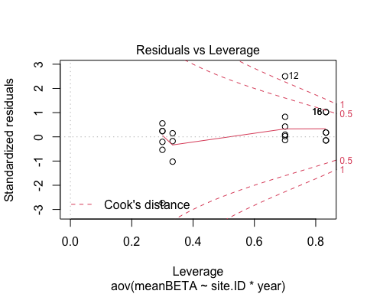 let me log transform

#log transform  
HI_FI_SPC$logmeanBETA <- log(abs(HI_FI_SPC$meanBETA))  
  
SPC.log <- aov(logmeanBETA ~ site.ID*year,   
 data = HI_FI_SPC)  
  
summary(SPC.log) # nothing significant

## Df Sum Sq Mean Sq F value Pr(>F)  
## site.ID 5 7.919 1.584 1.055 0.443  
## year 1 0.378 0.378 0.252 0.628  
## site.ID:year 5 16.382 3.276 2.184 0.146  
## Residuals 9 13.505 1.501

summary.lm(SPC.log)

##   
## Call:  
## aov(formula = logmeanBETA ~ site.ID * year, data = HI_FI_SPC)  
##   
## Residuals:  
## Min 1Q Median 3Q Max   
## -1.61719 -0.56285 -0.01806 0.47651 1.91015   
##   
## Coefficients:  
## Estimate Std. Error t value Pr(>|t|)   
## (Intercept) -446.7502 1106.3199 -0.404 0.6958   
## site.IDFRCH 3725.7573 1564.5725 2.381 0.0411 *  
## site.IDMOOS -1080.0330 1564.5725 -0.690 0.5074   
## site.IDPOKE 236.7405 2070.1009 0.114 0.9115   
## site.IDSTRT 1001.7676 2070.1009 0.484 0.6400   
## site.IDVAUL -325.8476 2070.1009 -0.157 0.8784   
## year 0.2211 0.5478 0.404 0.6959   
## site.IDFRCH:year -1.8457 0.7747 -2.382 0.0411 *  
## site.IDMOOS:year 0.5346 0.7747 0.690 0.5076   
## site.IDPOKE:year -0.1177 1.0249 -0.115 0.9111   
## site.IDSTRT:year -0.4960 1.0249 -0.484 0.6400   
## site.IDVAUL:year 0.1607 1.0249 0.157 0.8789   
## ---  
## Signif. codes: 0 '***' 0.001 '**' 0.01 '*' 0.05 '.' 0.1 ' ' 1  
##   
## Residual standard error: 1.225 on 9 degrees of freedom  
## Multiple R-squared: 0.6463, Adjusted R-squared: 0.2141   
## F-statistic: 1.495 on 11 and 9 DF, p-value: 0.2777

plot(SPC.log)

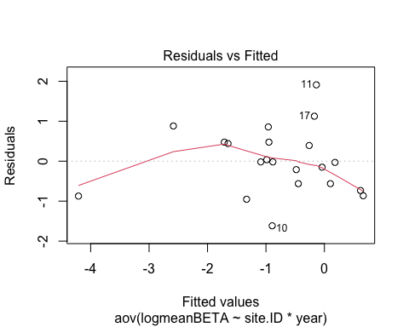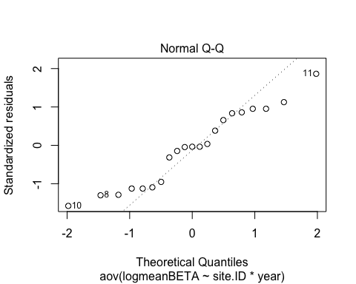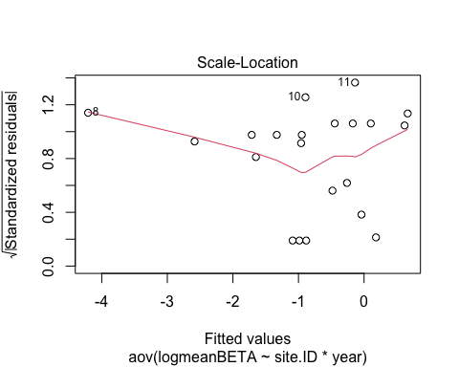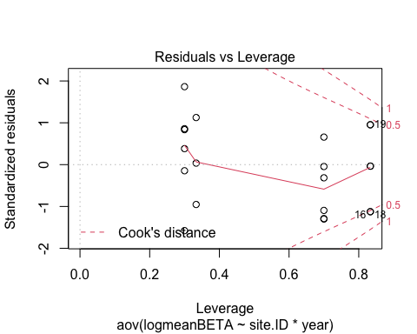 normality looks worse

#turb  
turb <- aov(meanBETA ~ site.ID*year,   
 data = HI_FI_turb)  
  
summary(turb) # nothing is significant

## Df Sum Sq Mean Sq F value Pr(>F)  
## site.ID 5 0.5572 0.11144 0.701 0.637  
## year 1 0.0799 0.07986 0.502 0.496  
## site.ID:year 5 0.0975 0.01950 0.123 0.984  
## Residuals 9 1.4307 0.15897

summary.lm(turb)

##   
## Call:  
## aov(formula = meanBETA ~ site.ID * year, data = HI_FI_turb)  
##   
## Residuals:  
## Min 1Q Median 3Q Max   
## -0.39557 -0.15933 -0.03773 0.19778 0.72636   
##   
## Coefficients:  
## Estimate Std. Error t value Pr(>|t|)  
## (Intercept) 250.55811 360.09653 0.696 0.504  
## site.IDFRCH -222.75892 509.25340 -0.437 0.672  
## site.IDMOOS -30.11093 509.25340 -0.059 0.954  
## site.IDPOKE -139.67059 673.79803 -0.207 0.840  
## site.IDSTRT -84.50860 673.79803 -0.125 0.903  
## site.IDVAUL -458.66205 673.79803 -0.681 0.513  
## year -0.12370 0.17831 -0.694 0.505  
## site.IDFRCH:year 0.11028 0.25217 0.437 0.672  
## site.IDMOOS:year 0.01486 0.25217 0.059 0.954  
## site.IDPOKE:year 0.06919 0.33359 0.207 0.840  
## site.IDSTRT:year 0.04200 0.33359 0.126 0.903  
## site.IDVAUL:year 0.22727 0.33359 0.681 0.513  
##   
## Residual standard error: 0.3987 on 9 degrees of freedom  
## Multiple R-squared: 0.3393, Adjusted R-squared: -0.4683   
## F-statistic: 0.4201 on 11 and 9 DF, p-value: 0.9117

plot(turb)

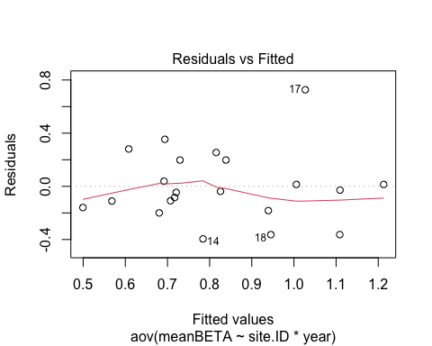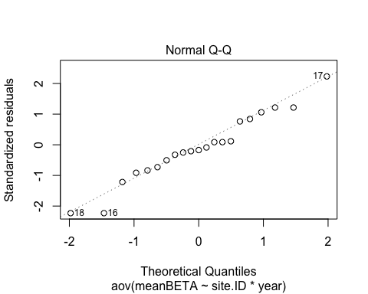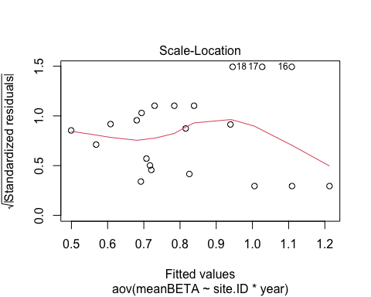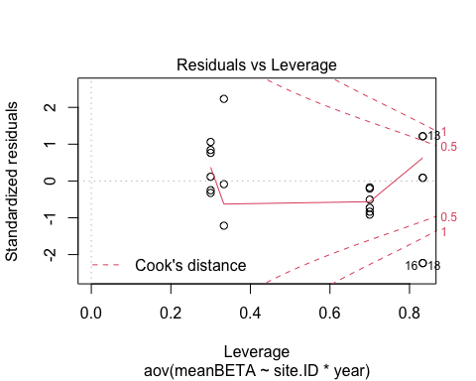

### CVs of storm metrics

#plot   
ggplot(AMC, aes(site.ID, CVhi, fill = site.ID)) +  
 geom_boxplot() +  
 facet_wrap(~response_var, scales = "free") +  
 scale_fill_manual(values = c("#3288BD", "#FF7F00","#A6761D", "#6A3D9A", "#66C2A5", "#E7298A")) +  
 theme_classic()

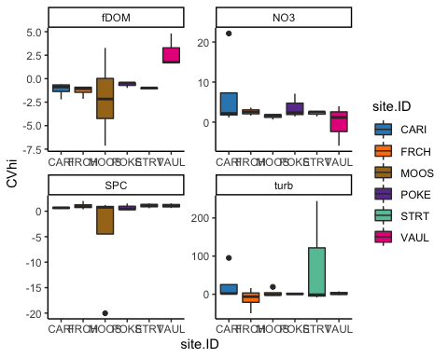

HI_FI_NO3$logCVhi <- log(abs(HI_FI_NO3$CVhi))  
HI_FI_fDOM$logCVhi <- log(abs(HI_FI_fDOM$CVhi))  
HI_FI_SPC$logCVhi <- log(abs(HI_FI_SPC$CVhi))  
HI_FI_turb$logCVhi <- log(abs(HI_FI_turb$CVhi))  
  
HI_FI_NO3$logCVbeta <- log(abs(HI_FI_NO3$CVbeta))  
HI_FI_fDOM$logCVbeta <- log(abs(HI_FI_fDOM$CVbeta))  
HI_FI_SPC$logCVbeta <- log(abs(HI_FI_SPC$CVbeta))  
HI_FI_turb$logCVbeta <- log(abs(HI_FI_turb$CVbeta))

# HI

# NO3-

no3 <- aov(CVhi ~ site.ID*year,   
 data = HI_FI_NO3)  
summary(no3)

## Df Sum Sq Mean Sq F value Pr(>F)  
## site.ID 5 103.74 20.75 1.012 0.469  
## year 1 20.15 20.15 0.983 0.350  
## site.ID:year 5 200.00 40.00 1.951 0.191  
## Residuals 8 164.00 20.50

summary.lm(no3)

##   
## Call:  
## aov(formula = CVhi ~ site.ID * year, data = HI_FI_NO3)  
##   
## Residuals:  
## Min 1Q Median 3Q Max   
## -8.7049 -0.8457 0.0452 0.5991 6.4589   
##   
## Coefficients:  
## Estimate Std. Error t value Pr(>|t|)   
## (Intercept) -11801.503 4089.123 -2.886 0.0203 *  
## site.IDFRCH 11478.691 5782.893 1.985 0.0824 .  
## site.IDMOOS 12005.597 7648.695 1.570 0.1551   
## site.IDPOKE 12756.727 7651.400 1.667 0.1340   
## site.IDSTRT 11797.296 7651.400 1.542 0.1617   
## site.IDVAUL 21759.740 7651.400 2.844 0.0217 *  
## year 5.847 2.025 2.888 0.0203 *  
## site.IDFRCH:year -5.686 2.864 -1.986 0.0823 .  
## site.IDMOOS:year -5.948 3.788 -1.570 0.1550   
## site.IDPOKE:year -6.318 3.788 -1.668 0.1339   
## site.IDSTRT:year -5.844 3.788 -1.543 0.1615   
## site.IDVAUL:year -10.777 3.788 -2.845 0.0216 *  
## ---  
## Signif. codes: 0 '***' 0.001 '**' 0.01 '*' 0.05 '.' 0.1 ' ' 1  
##   
## Residual standard error: 4.528 on 8 degrees of freedom  
## Multiple R-squared: 0.6639, Adjusted R-squared: 0.2017   
## F-statistic: 1.436 on 11 and 8 DF, p-value: 0.3102

plot(no3)

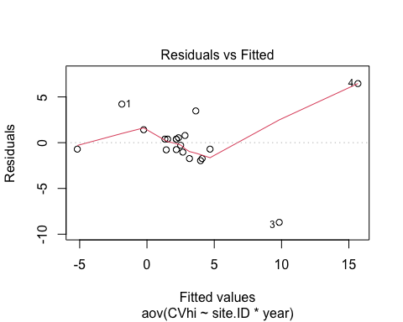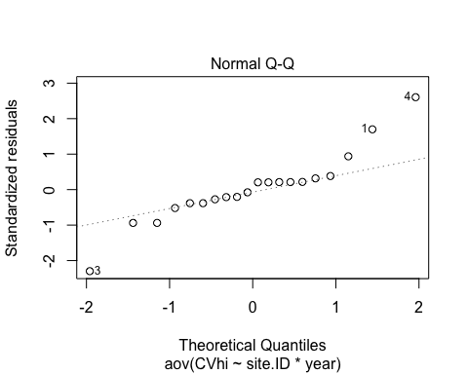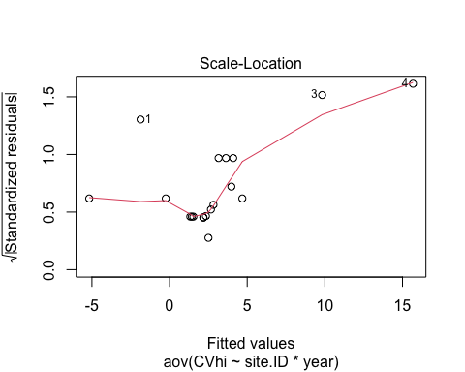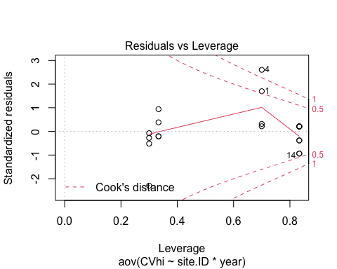 let me try log transform

no3.log <- aov(logCVhi ~ site.ID*year,   
 data = HI_FI_NO3)  
summary(no3.log) # nothing is signficant

## Df Sum Sq Mean Sq F value Pr(>F)  
## site.ID 5 1.852 0.3704 0.417 0.825  
## year 1 0.512 0.5123 0.577 0.469  
## site.ID:year 5 1.597 0.3194 0.360 0.862  
## Residuals 8 7.105 0.8882

summary.lm(no3.log)

##   
## Call:  
## aov(formula = logCVhi ~ site.ID * year, data = HI_FI_NO3)  
##   
## Residuals:  
## Min 1Q Median 3Q Max   
## -1.3834 -0.4398 0.1959 0.3760 0.9836   
##   
## Coefficients:  
## Estimate Std. Error t value Pr(>|t|)  
## (Intercept) -1240.6785 851.1449 -1.458 0.183  
## site.IDFRCH 1166.1940 1203.7007 0.969 0.361  
## site.IDMOOS 1352.1132 1592.0647 0.849 0.420  
## site.IDPOKE 1754.9933 1592.6279 1.102 0.303  
## site.IDSTRT 1238.9267 1592.6279 0.778 0.459  
## site.IDVAUL 846.5806 1592.6279 0.532 0.609  
## year 0.6149 0.4215 1.459 0.183  
## site.IDFRCH:year -0.5776 0.5960 -0.969 0.361  
## site.IDMOOS:year -0.6700 0.7885 -0.850 0.420  
## site.IDPOKE:year -0.8690 0.7885 -1.102 0.302  
## site.IDSTRT:year -0.6137 0.7885 -0.778 0.459  
## site.IDVAUL:year -0.4193 0.7885 -0.532 0.609  
##   
## Residual standard error: 0.9424 on 8 degrees of freedom  
## Multiple R-squared: 0.358, Adjusted R-squared: -0.5249   
## F-statistic: 0.4055 on 11 and 8 DF, p-value: 0.9166

plot(no3.log)

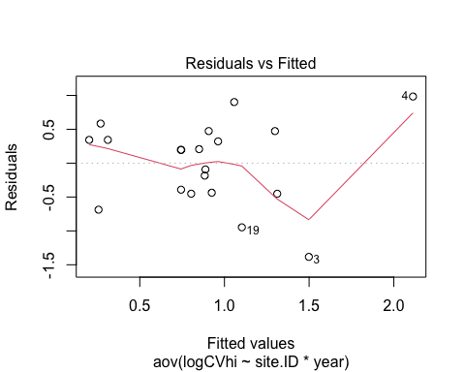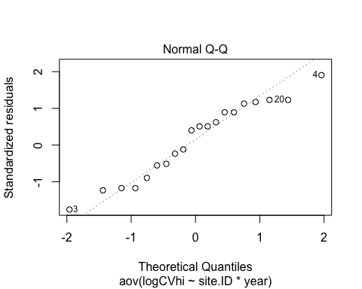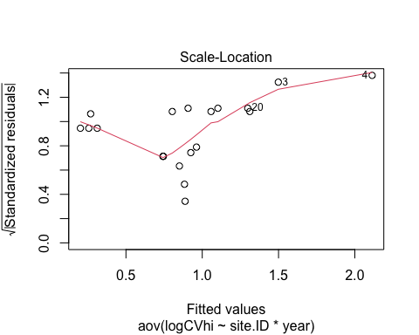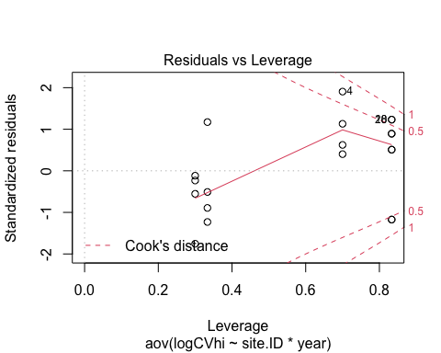

fDOM <- aov(CVhi ~ site.ID*year,   
 data = HI_FI_fDOM)  
summary(fDOM)

## Df Sum Sq Mean Sq F value Pr(>F)  
## site.ID 5 45.49 9.099 1.448 0.296  
## year 1 0.01 0.010 0.002 0.969  
## site.ID:year 5 9.35 1.870 0.298 0.902  
## Residuals 9 56.56 6.285

summary.lm(fDOM)

##   
## Call:  
## aov(formula = CVhi ~ site.ID * year, data = HI_FI_fDOM)  
##   
## Residuals:  
## Min 1Q Median 3Q Max   
## -5.5433 -0.3376 0.0587 0.5196 3.9520   
##   
## Coefficients:  
## Estimate Std. Error t value Pr(>|t|)  
## (Intercept) 7.466e+01 2.264e+03 0.033 0.974  
## site.IDFRCH 4.714e+02 3.202e+03 0.147 0.886  
## site.IDMOOS -1.919e+03 3.202e+03 -0.599 0.564  
## site.IDPOKE -6.123e+02 4.237e+03 -0.145 0.888  
## site.IDSTRT -3.816e+01 4.237e+03 -0.009 0.993  
## site.IDVAUL 3.018e+03 4.237e+03 0.712 0.494  
## year -3.754e-02 1.121e+00 -0.033 0.974  
## site.IDFRCH:year -2.335e-01 1.586e+00 -0.147 0.886  
## site.IDMOOS:year 9.499e-01 1.586e+00 0.599 0.564  
## site.IDPOKE:year 3.034e-01 2.097e+00 0.145 0.888  
## site.IDSTRT:year 1.896e-02 2.097e+00 0.009 0.993  
## site.IDVAUL:year -1.492e+00 2.097e+00 -0.711 0.495  
##   
## Residual standard error: 2.507 on 9 degrees of freedom  
## Multiple R-squared: 0.4923, Adjusted R-squared: -0.1282   
## F-statistic: 0.7934 on 11 and 9 DF, p-value: 0.6471

plot(fDOM)

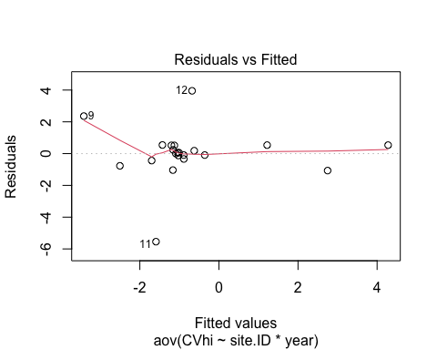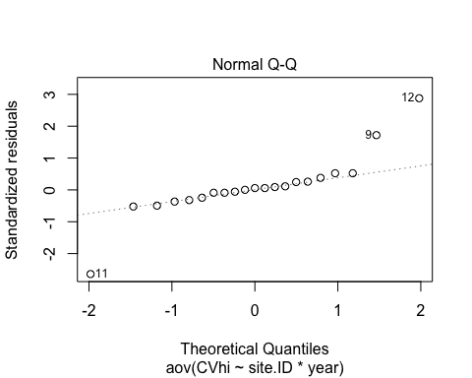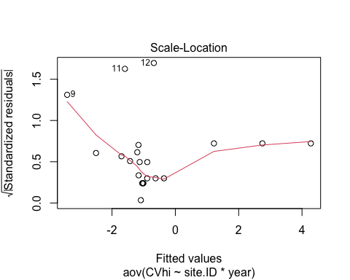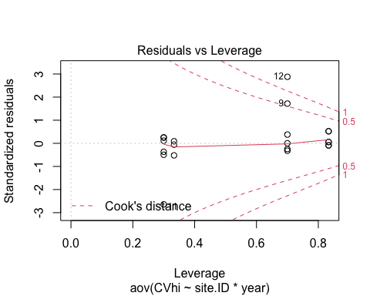 Log transform

fDOM.log <- aov(logCVhi ~ site.ID*year,   
 data = HI_FI_fDOM)  
summary(fDOM.log) # site.ID is different

## Df Sum Sq Mean Sq F value Pr(>F)   
## site.ID 5 6.349 1.2698 4.237 0.0294 *  
## year 1 0.057 0.0571 0.190 0.6728   
## site.ID:year 5 1.763 0.3526 1.177 0.3910   
## Residuals 9 2.697 0.2997   
## ---  
## Signif. codes: 0 '***' 0.001 '**' 0.01 '*' 0.05 '.' 0.1 ' ' 1

summary.lm(fDOM.log)

##   
## Call:  
## aov(formula = logCVhi ~ site.ID * year, data = HI_FI_fDOM)  
##   
## Residuals:  
## Min 1Q Median 3Q Max   
## -0.53807 -0.36430 0.06725 0.18248 0.79584   
##   
## Coefficients:  
## Estimate Std. Error t value Pr(>|t|)  
## (Intercept) 23.45352 494.39346 0.047 0.963  
## site.IDFRCH -353.45827 699.17794 -0.506 0.625  
## site.IDMOOS -865.17352 699.17794 -1.237 0.247  
## site.IDPOKE 763.81637 925.08901 0.826 0.430  
## site.IDSTRT -62.17094 925.08901 -0.067 0.948  
## site.IDVAUL 997.35067 925.08901 1.078 0.309  
## year -0.01161 0.24481 -0.047 0.963  
## site.IDFRCH:year 0.17512 0.34621 0.506 0.625  
## site.IDMOOS:year 0.42895 0.34621 1.239 0.247  
## site.IDPOKE:year -0.37839 0.45800 -0.826 0.430  
## site.IDSTRT:year 0.03079 0.45800 0.067 0.948  
## site.IDVAUL:year -0.49330 0.45800 -1.077 0.309  
##   
## Residual standard error: 0.5474 on 9 degrees of freedom  
## Multiple R-squared: 0.7518, Adjusted R-squared: 0.4484   
## F-statistic: 2.478 on 11 and 9 DF, p-value: 0.09182

plot(fDOM.log)

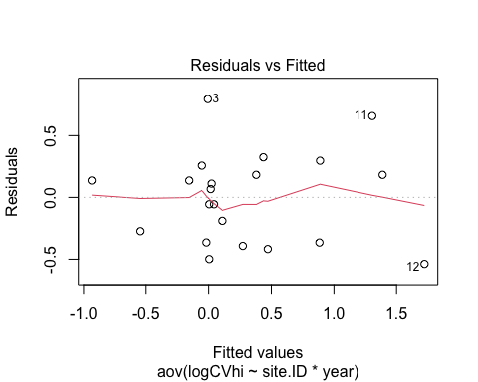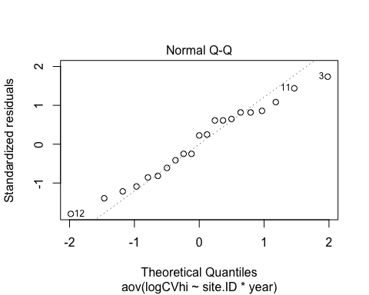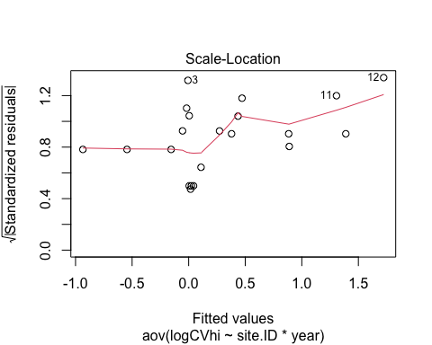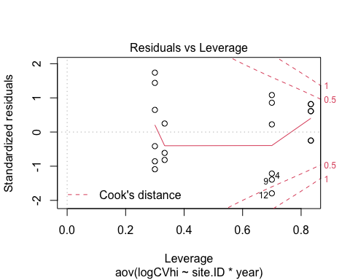

TukeyHSD(fDOM.log, which = "site.ID")

## Warning in replications(paste("~", xx), data = mf): non-factors ignored: year

## Warning in replications(paste("~", xx), data = mf): non-factors ignored:  
## site.ID, year

## Tukey multiple comparisons of means  
## 95% family-wise confidence level  
##   
## Fit: aov(formula = logCVhi ~ site.ID * year, data = HI_FI_fDOM)  
##   
## $site.ID  
## diff lwr upr p adj  
## FRCH-CARI 0.19173713 -1.1832274 1.5667017 0.9951024  
## MOOS-CARI 1.09845343 -0.2765111 2.4734180 0.1380970  
## POKE-CARI -0.54433628 -2.0294678 0.9407952 0.7778021  
## STRT-CARI 0.02460504 -1.4605264 1.5097365 0.9999999  
## VAUL-CARI 0.88473755 -0.6003939 2.3698690 0.3574263  
## MOOS-FRCH 0.90671630 -0.4682483 2.2816809 0.2695685  
## POKE-FRCH -0.73607341 -2.2212049 0.7490581 0.5303695  
## STRT-FRCH -0.16713209 -1.6522636 1.3179994 0.9982012  
## VAUL-FRCH 0.69300042 -0.7921310 2.1781319 0.5861833  
## POKE-MOOS -1.64278971 -3.1279212 -0.1576582 0.0292516  
## STRT-MOOS -1.07384839 -2.5589799 0.4112831 0.2000248  
## VAUL-MOOS -0.21371588 -1.6988473 1.2714156 0.9943422  
## STRT-POKE 0.56894132 -1.0187310 2.1566136 0.7922118  
## VAUL-POKE 1.42907383 -0.1585985 3.0167462 0.0830411  
## VAUL-STRT 0.86013251 -0.7275398 2.4478048 0.4460162

#POKE/MOOS  
#POKE/VAUL

# SPC

SPC <- aov(CVhi ~ site.ID*year,   
 data = HI_FI_SPC)  
summary(SPC)

## Df Sum Sq Mean Sq F value Pr(>F)  
## site.ID 5 89.21 17.84 0.524 0.753  
## year 1 5.25 5.25 0.154 0.704  
## site.ID:year 5 20.52 4.10 0.121 0.984  
## Residuals 9 306.46 34.05

summary.lm(SPC)

##   
## Call:  
## aov(formula = CVhi ~ site.ID * year, data = HI_FI_SPC)  
##   
## Residuals:  
## Min 1Q Median 3Q Max   
## -14.5828 -0.2179 -0.0006 0.4358 8.3823   
##   
## Coefficients:  
## Estimate Std. Error t value Pr(>|t|)  
## (Intercept) 7.469e+01 5.270e+03 0.014 0.989  
## site.IDFRCH 7.816e+01 7.453e+03 0.010 0.992  
## site.IDMOOS 4.448e+03 7.453e+03 0.597 0.565  
## site.IDPOKE 1.392e+02 9.861e+03 0.014 0.989  
## site.IDSTRT -6.389e+02 9.861e+03 -0.065 0.950  
## site.IDVAUL -1.005e+03 9.861e+03 -0.102 0.921  
## year -3.666e-02 2.610e+00 -0.014 0.989  
## site.IDFRCH:year -3.851e-02 3.691e+00 -0.010 0.992  
## site.IDMOOS:year -2.205e+00 3.691e+00 -0.598 0.565  
## site.IDPOKE:year -6.887e-02 4.882e+00 -0.014 0.989  
## site.IDSTRT:year 3.165e-01 4.882e+00 0.065 0.950  
## site.IDVAUL:year 4.978e-01 4.882e+00 0.102 0.921  
##   
## Residual standard error: 5.835 on 9 degrees of freedom  
## Multiple R-squared: 0.2728, Adjusted R-squared: -0.616   
## F-statistic: 0.307 on 11 and 9 DF, p-value: 0.9655

plot(SPC)

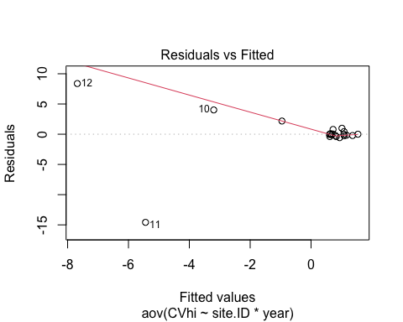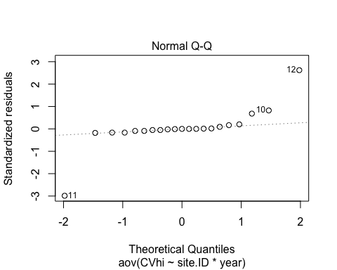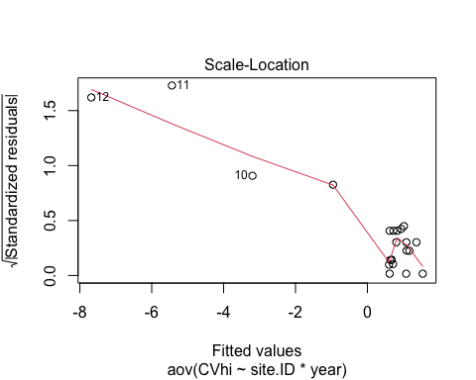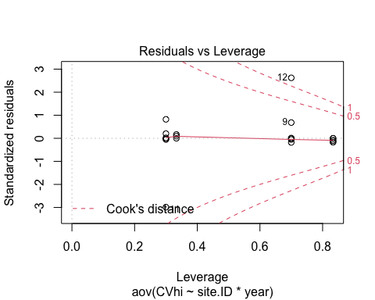 log transform

SPC.log <- aov(logCVhi ~ site.ID*year,   
 data = HI_FI_SPC)  
summary(SPC.log) # nothing is significant

## Df Sum Sq Mean Sq F value Pr(>F)  
## site.ID 5 3.671 0.7343 0.628 0.684  
## year 1 0.005 0.0049 0.004 0.950  
## site.ID:year 5 1.220 0.2441 0.209 0.950  
## Residuals 9 10.521 1.1690

summary.lm(SPC.log)

##   
## Call:  
## aov(formula = logCVhi ~ site.ID * year, data = HI_FI_SPC)  
##   
## Residuals:  
## Min 1Q Median 3Q Max   
## -1.24471 -0.23072 -0.15315 0.06843 2.25871   
##   
## Coefficients:  
## Estimate Std. Error t value Pr(>|t|)  
## (Intercept) 1.121e+02 9.765e+02 0.115 0.911  
## site.IDFRCH 3.227e+02 1.381e+03 0.234 0.820  
## site.IDMOOS -4.179e+02 1.381e+03 -0.303 0.769  
## site.IDPOKE 5.591e+02 1.827e+03 0.306 0.767  
## site.IDSTRT -7.887e+02 1.827e+03 -0.432 0.676  
## site.IDVAUL -1.035e+03 1.827e+03 -0.566 0.585  
## year -5.571e-02 4.835e-01 -0.115 0.911  
## site.IDFRCH:year -1.596e-01 6.838e-01 -0.233 0.821  
## site.IDMOOS:year 2.074e-01 6.838e-01 0.303 0.769  
## site.IDPOKE:year -2.769e-01 9.046e-01 -0.306 0.767  
## site.IDSTRT:year 3.907e-01 9.046e-01 0.432 0.676  
## site.IDVAUL:year 5.125e-01 9.046e-01 0.567 0.585  
##   
## Residual standard error: 1.081 on 9 degrees of freedom  
## Multiple R-squared: 0.3176, Adjusted R-squared: -0.5164   
## F-statistic: 0.3808 on 11 and 9 DF, p-value: 0.933

plot(SPC.log)

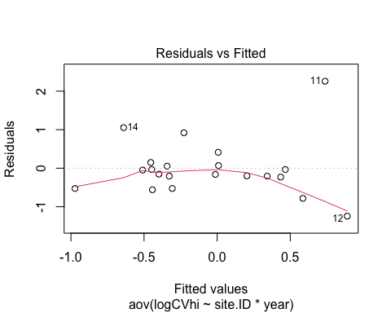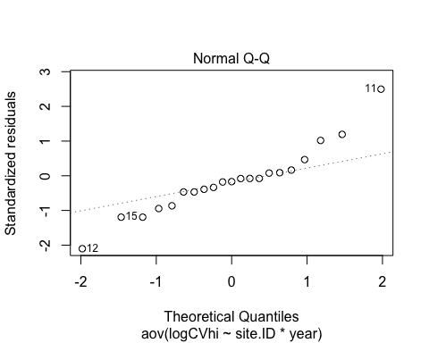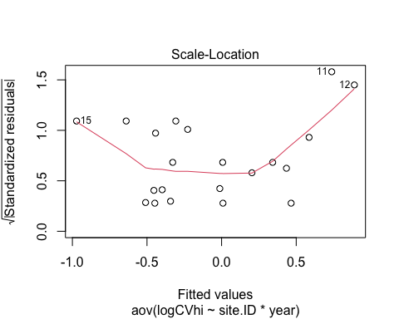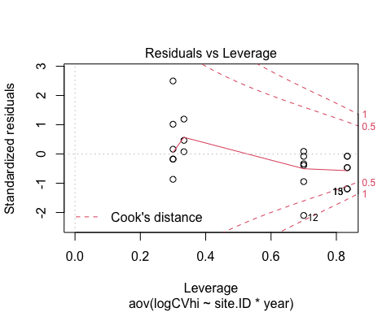 still meh

# turb

turb <- aov(CVhi ~ site.ID*year,   
 data = HI_FI_turb)  
summary(turb)

## Df Sum Sq Mean Sq F value Pr(>F)   
## site.ID 5 16831 3366 1.838 0.2014   
## year 1 8118 8118 4.433 0.0645 .  
## site.ID:year 5 26107 5221 2.851 0.0818 .  
## Residuals 9 16482 1831   
## ---  
## Signif. codes: 0 '***' 0.001 '**' 0.01 '*' 0.05 '.' 0.1 ' ' 1

summary.lm(turb)

##   
## Call:  
## aov(formula = CVhi ~ site.ID * year, data = HI_FI_turb)  
##   
## Residuals:  
## Min 1Q Median 3Q Max   
## -86.509 -6.239 0.191 15.673 43.255   
##   
## Coefficients:  
## Estimate Std. Error t value Pr(>|t|)   
## (Intercept) 56868.17 38648.92 1.471 0.1753   
## site.IDFRCH -49980.18 54657.82 -0.914 0.3843   
## site.IDMOOS -52356.23 54657.82 -0.958 0.3631   
## site.IDPOKE -52383.94 72318.29 -0.724 0.4873   
## site.IDSTRT 191234.21 72318.29 2.644 0.0267 *  
## site.IDVAUL -63022.01 72318.29 -0.871 0.4062   
## year -28.15 19.14 -1.471 0.1754   
## site.IDFRCH:year 24.73 27.07 0.914 0.3847   
## site.IDMOOS:year 25.91 27.07 0.957 0.3633   
## site.IDPOKE:year 25.93 35.80 0.724 0.4874   
## site.IDSTRT:year -94.64 35.80 -2.643 0.0268 *  
## site.IDVAUL:year 31.19 35.80 0.871 0.4062   
## ---  
## Signif. codes: 0 '***' 0.001 '**' 0.01 '*' 0.05 '.' 0.1 ' ' 1  
##   
## Residual standard error: 42.79 on 9 degrees of freedom  
## Multiple R-squared: 0.756, Adjusted R-squared: 0.4577   
## F-statistic: 2.535 on 11 and 9 DF, p-value: 0.08667

plot(turb)

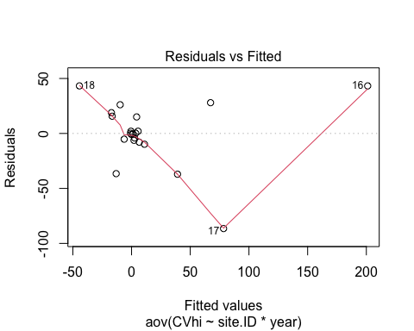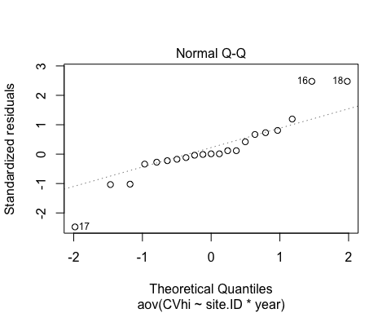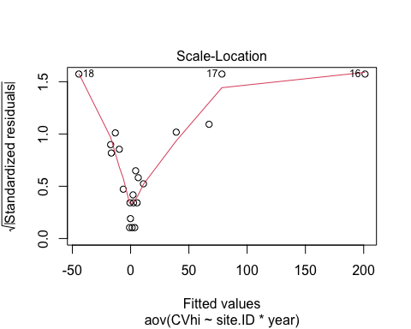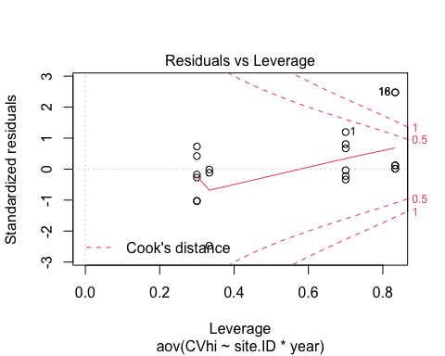 log transform

turb.log <- aov(logCVhi ~ site.ID*year,   
 data = HI_FI_turb)  
summary(turb.log) # year is significant

## Df Sum Sq Mean Sq F value Pr(>F)   
## site.ID 5 11.36 2.272 1.185 0.3876   
## year 1 12.56 12.558 6.549 0.0307 *  
## site.ID:year 5 14.81 2.962 1.545 0.2686   
## Residuals 9 17.26 1.917   
## ---  
## Signif. codes: 0 '***' 0.001 '**' 0.01 '*' 0.05 '.' 0.1 ' ' 1

summary.lm(turb.log)

##   
## Call:  
## aov(formula = logCVhi ~ site.ID * year, data = HI_FI_turb)  
##   
## Residuals:  
## Min 1Q Median 3Q Max   
## -1.4022 -0.7028 0.1834 0.2555 1.9843   
##   
## Coefficients:  
## Estimate Std. Error t value Pr(>|t|)   
## (Intercept) 2534.3722 1250.6131 2.027 0.0733 .  
## site.IDFRCH -1193.9057 1768.6341 -0.675 0.5166   
## site.IDMOOS -2022.5174 1768.6341 -1.144 0.2823   
## site.IDPOKE -855.4907 2340.0966 -0.366 0.7231   
## site.IDSTRT 2869.0941 2340.0966 1.226 0.2513   
## site.IDVAUL -4168.4780 2340.0966 -1.781 0.1085   
## year -1.2542 0.6193 -2.025 0.0735 .  
## site.IDFRCH:year 0.5916 0.8758 0.675 0.5164   
## site.IDMOOS:year 1.0013 0.8758 1.143 0.2824   
## site.IDPOKE:year 0.4232 1.1585 0.365 0.7233   
## site.IDSTRT:year -1.4195 1.1585 -1.225 0.2516   
## site.IDVAUL:year 2.0636 1.1585 1.781 0.1086   
## ---  
## Signif. codes: 0 '***' 0.001 '**' 0.01 '*' 0.05 '.' 0.1 ' ' 1  
##   
## Residual standard error: 1.385 on 9 degrees of freedom  
## Multiple R-squared: 0.6918, Adjusted R-squared: 0.3151   
## F-statistic: 1.836 on 11 and 9 DF, p-value: 0.1853

plot(turb.log)

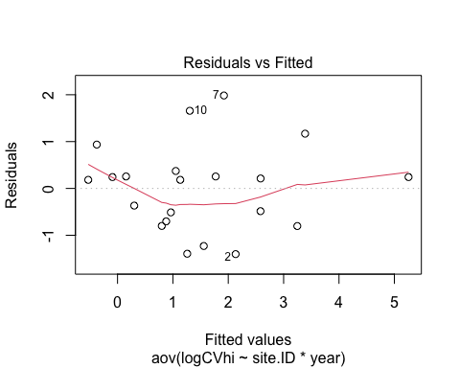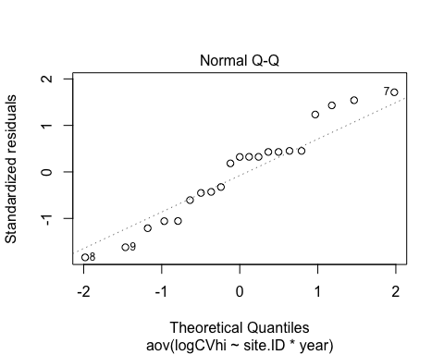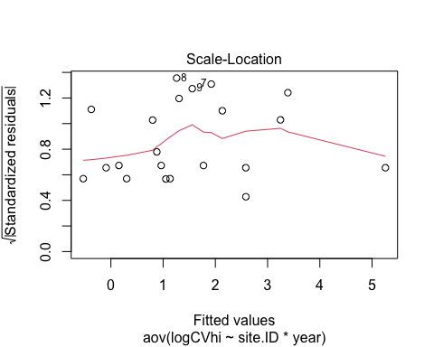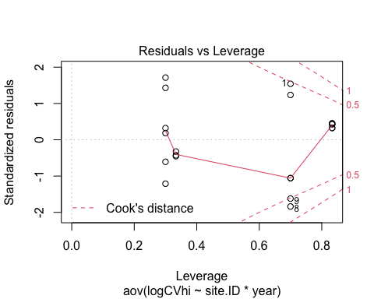

# BETA

#plot   
ggplot(AMC, aes(site.ID, CVbeta, fill = site.ID)) +  
 geom_boxplot() +  
 facet_wrap(~response_var, scales = "free") +  
 scale_fill_manual(values = c("#3288BD", "#FF7F00","#A6761D", "#6A3D9A", "#66C2A5", "#E7298A")) +  
 theme_classic()

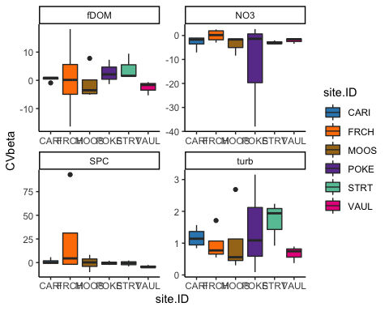

# NO3

no3 <- aov(CVbeta ~ site.ID*year,   
 data = HI_FI_NO3)  
summary(no3)

## Df Sum Sq Mean Sq F value Pr(>F)  
## site.ID 5 284.4 56.87 0.437 0.811  
## year 1 0.0 0.01 0.000 0.994  
## site.ID:year 5 42.2 8.43 0.065 0.996  
## Residuals 8 1041.1 130.14

summary.lm(no3)

##   
## Call:  
## aov(formula = CVbeta ~ site.ID * year, data = HI_FI_NO3)  
##   
## Residuals:  
## Min 1Q Median 3Q Max   
## -25.7479 -1.0611 0.2866 1.9678 12.8740   
##   
## Coefficients:  
## Estimate Std. Error t value Pr(>|t|)  
## (Intercept) 1970.1687 10302.8436 0.191 0.853  
## site.IDFRCH -1184.3016 14570.4211 -0.081 0.937  
## site.IDMOOS -9148.2132 19271.4458 -0.475 0.648  
## site.IDPOKE 2113.5570 19278.2632 0.110 0.915  
## site.IDSTRT -3166.9202 19278.2632 -0.164 0.874  
## site.IDVAUL -4215.0796 19278.2632 -0.219 0.832  
## year -0.9770 5.1017 -0.192 0.853  
## site.IDFRCH:year 0.5878 7.2149 0.081 0.937  
## site.IDMOOS:year 4.5304 9.5444 0.475 0.648  
## site.IDPOKE:year -1.0507 9.5444 -0.110 0.915  
## site.IDSTRT:year 1.5680 9.5444 0.164 0.874  
## site.IDVAUL:year 2.0873 9.5444 0.219 0.832  
##   
## Residual standard error: 11.41 on 8 degrees of freedom  
## Multiple R-squared: 0.2388, Adjusted R-squared: -0.808   
## F-statistic: 0.2281 on 11 and 8 DF, p-value: 0.9866

plot(no3)

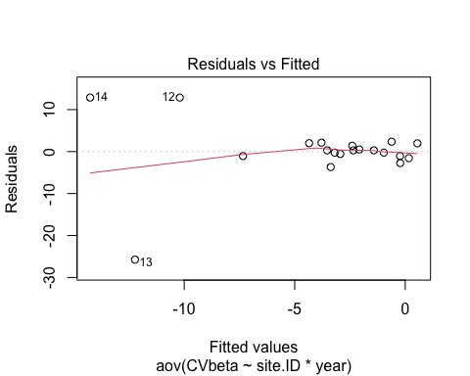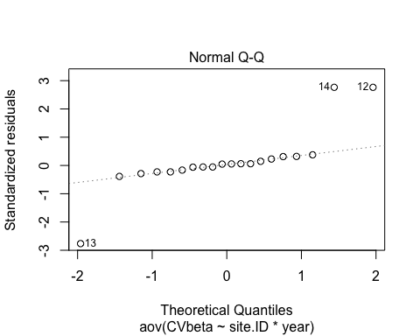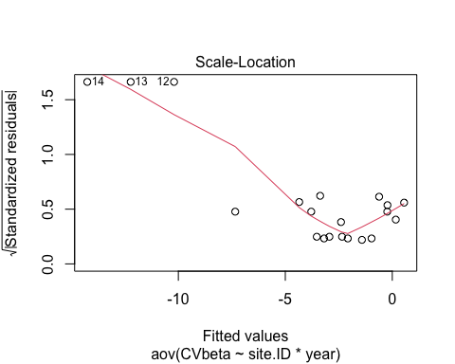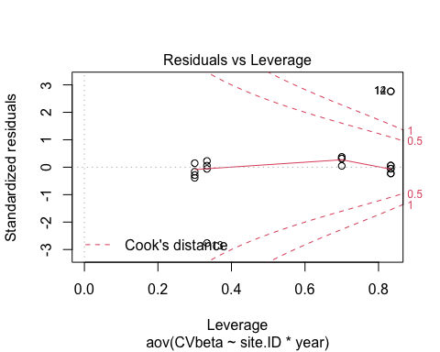 log transform

no3.log <- aov(logCVbeta ~ site.ID*year,   
 data = HI_FI_NO3)  
summary(no3.log) # nothing is significant

## Df Sum Sq Mean Sq F value Pr(>F)  
## site.ID 5 2.193 0.4386 0.425 0.820  
## year 1 0.245 0.2447 0.237 0.639  
## site.ID:year 5 3.244 0.6489 0.629 0.684  
## Residuals 8 8.256 1.0320

summary.lm(no3.log)

##   
## Call:  
## aov(formula = logCVbeta ~ site.ID * year, data = HI_FI_NO3)  
##   
## Residuals:  
## Min 1Q Median 3Q Max   
## -0.99449 -0.41865 -0.04682 0.21012 1.98898   
##   
## Coefficients:  
## Estimate Std. Error t value Pr(>|t|)  
## (Intercept) -845.4753 917.4724 -0.922 0.384  
## site.IDFRCH 916.7688 1297.5019 0.707 0.500  
## site.IDMOOS 2733.8376 1716.1301 1.593 0.150  
## site.IDPOKE 1513.1785 1716.7372 0.881 0.404  
## site.IDSTRT 1304.3591 1716.7372 0.760 0.469  
## site.IDVAUL 1893.0396 1716.7372 1.103 0.302  
## year 0.4190 0.4543 0.922 0.383  
## site.IDFRCH:year -0.4540 0.6425 -0.707 0.500  
## site.IDMOOS:year -1.3538 0.8499 -1.593 0.150  
## site.IDPOKE:year -0.7487 0.8499 -0.881 0.404  
## site.IDSTRT:year -0.6457 0.8499 -0.760 0.469  
## site.IDVAUL:year -0.9373 0.8499 -1.103 0.302  
##   
## Residual standard error: 1.016 on 8 degrees of freedom  
## Multiple R-squared: 0.4077, Adjusted R-squared: -0.4068   
## F-statistic: 0.5006 on 11 and 8 DF, p-value: 0.8575

plot(no3.log)

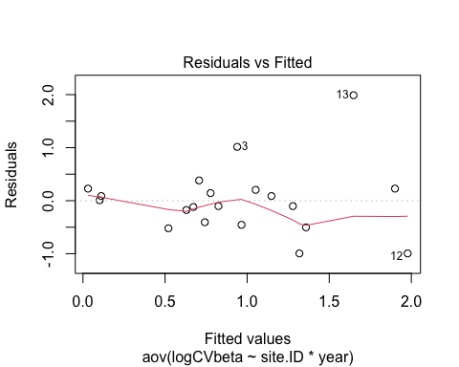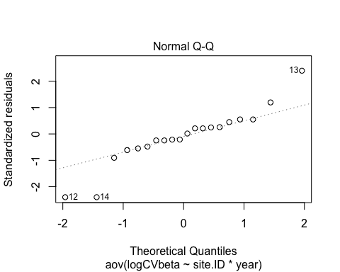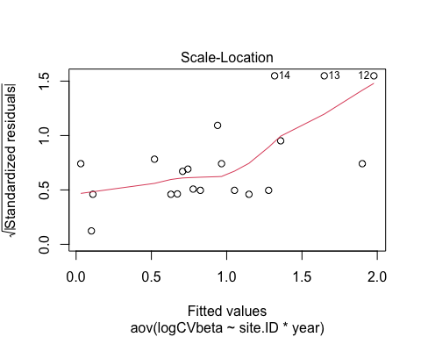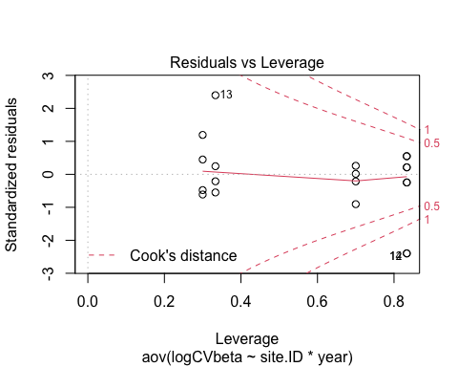

# fDOM

fDOM <- aov(CVbeta ~ site.ID*year,   
 data = HI_FI_fDOM)  
summary(fDOM)

## Df Sum Sq Mean Sq F value Pr(>F)  
## site.ID 5 91.0 18.21 0.312 0.894  
## year 1 42.8 42.75 0.732 0.414  
## site.ID:year 5 234.8 46.96 0.804 0.574  
## Residuals 9 525.8 58.42

summary.lm(fDOM)

##   
## Call:  
## aov(formula = CVbeta ~ site.ID * year, data = HI_FI_fDOM)  
##   
## Residuals:  
## Min 1Q Median 3Q Max   
## -11.0192 -0.9470 -0.3889 1.3784 14.5124   
##   
## Coefficients:  
## Estimate Std. Error t value Pr(>|t|)  
## (Intercept) 1.046e+03 6.903e+03 0.152 0.883  
## site.IDFRCH -1.366e+04 9.762e+03 -1.399 0.195  
## site.IDMOOS -3.377e+03 9.762e+03 -0.346 0.737  
## site.IDPOKE 7.647e+03 1.292e+04 0.592 0.568  
## site.IDSTRT -8.963e+03 1.292e+04 -0.694 0.505  
## site.IDVAUL 2.668e+03 1.292e+04 0.207 0.841  
## year -5.178e-01 3.418e+00 -0.151 0.883  
## site.IDFRCH:year 6.763e+00 4.834e+00 1.399 0.195  
## site.IDMOOS:year 1.672e+00 4.834e+00 0.346 0.737  
## site.IDPOKE:year -3.784e+00 6.395e+00 -0.592 0.569  
## site.IDSTRT:year 4.439e+00 6.395e+00 0.694 0.505  
## site.IDVAUL:year -1.322e+00 6.395e+00 -0.207 0.841  
##   
## Residual standard error: 7.643 on 9 degrees of freedom  
## Multiple R-squared: 0.4121, Adjusted R-squared: -0.3064   
## F-statistic: 0.5736 on 11 and 9 DF, p-value: 0.8097

plot(fDOM)

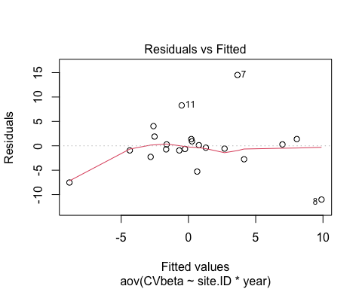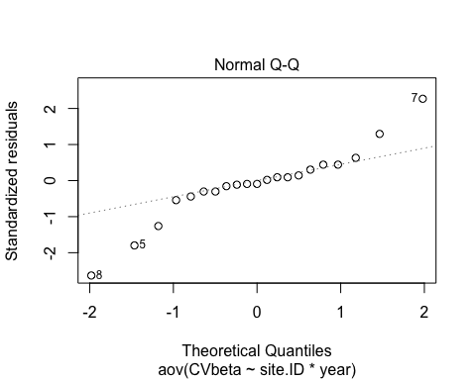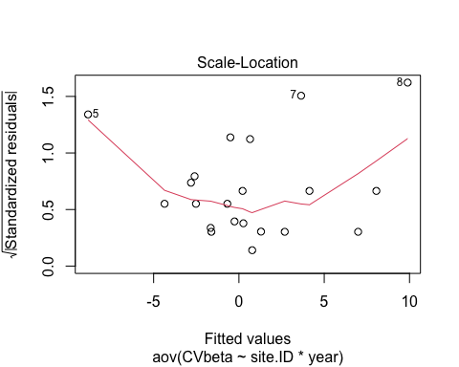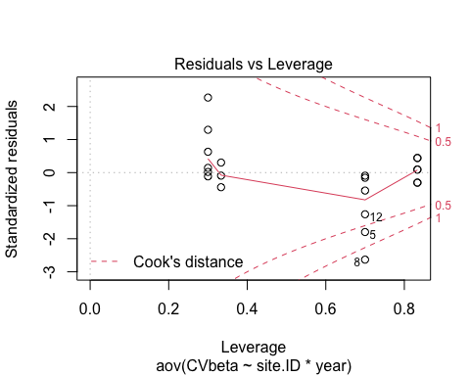 log transform

fDOM.log <- aov(logCVbeta ~ site.ID*year,   
 data = HI_FI_fDOM)  
summary(fDOM.log) # nothing is significant

## Df Sum Sq Mean Sq F value Pr(>F)  
## site.ID 5 7.045 1.4090 1.500 0.281  
## year 1 0.038 0.0380 0.040 0.845  
## site.ID:year 5 5.236 1.0471 1.114 0.417  
## Residuals 9 8.456 0.9396

summary.lm(fDOM.log)

##   
## Call:  
## aov(formula = logCVbeta ~ site.ID * year, data = HI_FI_fDOM)  
##   
## Residuals:  
## Min 1Q Median 3Q Max   
## -1.4579 -0.2583 0.1291 0.3446 1.6295   
##   
## Coefficients:  
## Estimate Std. Error t value Pr(>|t|)  
## (Intercept) -55.1615 875.4459 -0.063 0.951  
## site.IDFRCH 1164.4561 1238.0675 0.941 0.371  
## site.IDMOOS -124.8770 1238.0675 -0.101 0.922  
## site.IDPOKE 1771.7527 1638.0989 1.082 0.308  
## site.IDSTRT -1741.0236 1638.0989 -1.063 0.316  
## site.IDVAUL -1138.7180 1638.0989 -0.695 0.505  
## year 0.0273 0.4335 0.063 0.951  
## site.IDFRCH:year -0.5758 0.6131 -0.939 0.372  
## site.IDMOOS:year 0.0626 0.6131 0.102 0.921  
## site.IDPOKE:year -0.8766 0.8110 -1.081 0.308  
## site.IDSTRT:year 0.8624 0.8110 1.063 0.315  
## site.IDVAUL:year 0.5640 0.8110 0.695 0.504  
##   
## Residual standard error: 0.9693 on 9 degrees of freedom  
## Multiple R-squared: 0.593, Adjusted R-squared: 0.09546   
## F-statistic: 1.192 on 11 and 9 DF, p-value: 0.4025

plot(fDOM.log)

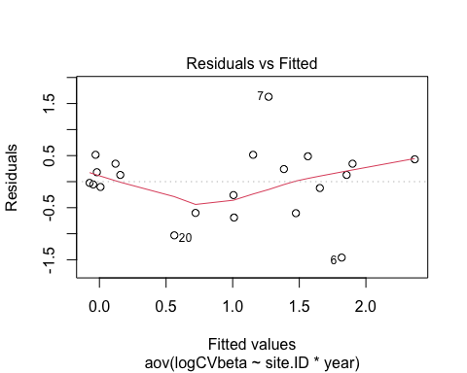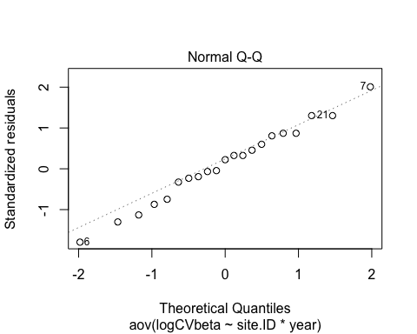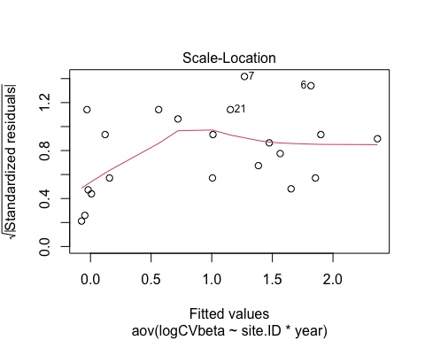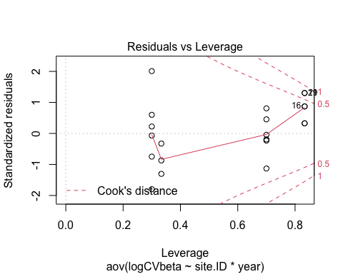

# SPC

SPC <- aov(CVbeta ~ site.ID*year,   
 data = HI_FI_SPC)  
summary(SPC)

## Df Sum Sq Mean Sq F value Pr(>F)   
## site.ID 5 2210 441.9 1.916 0.1870   
## year 1 1181 1181.1 5.120 0.0500 *  
## site.ID:year 5 3244 648.8 2.813 0.0844 .  
## Residuals 9 2076 230.7   
## ---  
## Signif. codes: 0 '***' 0.001 '**' 0.01 '*' 0.05 '.' 0.1 ' ' 1

summary.lm(SPC)

##   
## Call:  
## aov(formula = CVbeta ~ site.ID * year, data = HI_FI_SPC)  
##   
## Residuals:  
## Min 1Q Median 3Q Max   
## -29.1735 -1.9680 0.6004 1.5970 23.4424   
##   
## Coefficients:  
## Estimate Std. Error t value Pr(>|t|)   
## (Intercept) -2.307e+03 1.372e+04 -0.168 0.8702   
## site.IDFRCH -5.760e+04 1.940e+04 -2.969 0.0157 *  
## site.IDMOOS 4.189e+03 1.940e+04 0.216 0.8339   
## site.IDPOKE -7.191e+02 2.567e+04 -0.028 0.9783   
## site.IDSTRT -4.315e+02 2.567e+04 -0.017 0.9870   
## site.IDVAUL -6.696e+01 2.567e+04 -0.003 0.9980   
## year 1.143e+00 6.792e+00 0.168 0.8701   
## site.IDFRCH:year 2.853e+01 9.606e+00 2.970 0.0157 *  
## site.IDMOOS:year -2.075e+00 9.606e+00 -0.216 0.8338   
## site.IDPOKE:year 3.549e-01 1.271e+01 0.028 0.9783   
## site.IDSTRT:year 2.124e-01 1.271e+01 0.017 0.9870   
## site.IDVAUL:year 3.016e-02 1.271e+01 0.002 0.9982   
## ---  
## Signif. codes: 0 '***' 0.001 '**' 0.01 '*' 0.05 '.' 0.1 ' ' 1  
##   
## Residual standard error: 15.19 on 9 degrees of freedom  
## Multiple R-squared: 0.7617, Adjusted R-squared: 0.4703   
## F-statistic: 2.615 on 11 and 9 DF, p-value: 0.07992

plot(SPC)

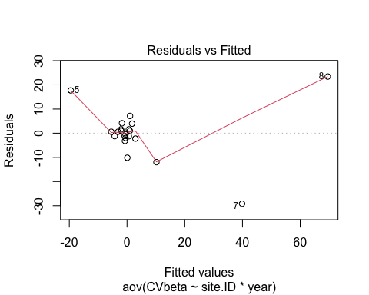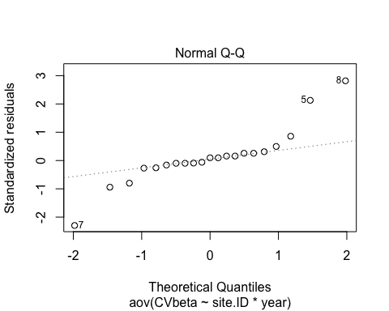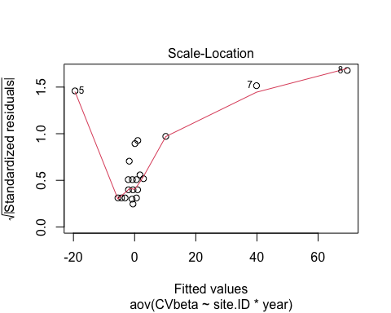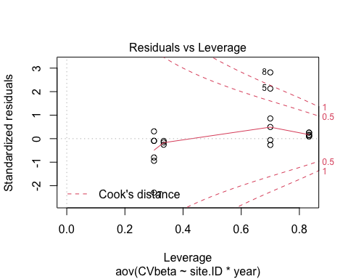 log transform

SPC.log <- aov(logCVbeta ~ site.ID*year,   
 data = HI_FI_SPC)  
summary(SPC.log) # nothing is significant

## Df Sum Sq Mean Sq F value Pr(>F)   
## site.ID 5 9.357 1.8713 2.532 0.1070   
## year 1 1.778 1.7782 2.406 0.1553   
## site.ID:year 5 10.583 2.1166 2.864 0.0809 .  
## Residuals 9 6.652 0.7391   
## ---  
## Signif. codes: 0 '***' 0.001 '**' 0.01 '*' 0.05 '.' 0.1 ' ' 1

summary.lm(SPC.log)

##   
## Call:  
## aov(formula = logCVbeta ~ site.ID * year, data = HI_FI_SPC)  
##   
## Residuals:  
## Min 1Q Median 3Q Max   
## -0.7637 -0.4420 -0.1505 0.3715 1.4759   
##   
## Coefficients:  
## Estimate Std. Error t value Pr(>|t|)   
## (Intercept) -1.830e+02 7.764e+02 -0.236 0.8190   
## site.IDFRCH -2.572e+03 1.098e+03 -2.343 0.0438 *  
## site.IDMOOS 1.263e+03 1.098e+03 1.150 0.2797   
## site.IDPOKE -4.694e+02 1.453e+03 -0.323 0.7540   
## site.IDSTRT -1.346e+03 1.453e+03 -0.926 0.3785   
## site.IDVAUL 8.509e+02 1.453e+03 0.586 0.5725   
## year 9.071e-02 3.845e-01 0.236 0.8188   
## site.IDFRCH:year 1.275e+00 5.437e-01 2.344 0.0437 *  
## site.IDMOOS:year -6.247e-01 5.437e-01 -1.149 0.2802   
## site.IDPOKE:year 2.325e-01 7.193e-01 0.323 0.7539   
## site.IDSTRT:year 6.662e-01 7.193e-01 0.926 0.3785   
## site.IDVAUL:year -4.207e-01 7.193e-01 -0.585 0.5730   
## ---  
## Signif. codes: 0 '***' 0.001 '**' 0.01 '*' 0.05 '.' 0.1 ' ' 1  
##   
## Residual standard error: 0.8597 on 9 degrees of freedom  
## Multiple R-squared: 0.7655, Adjusted R-squared: 0.479   
## F-statistic: 2.671 on 11 and 9 DF, p-value: 0.07551

plot(SPC.log)

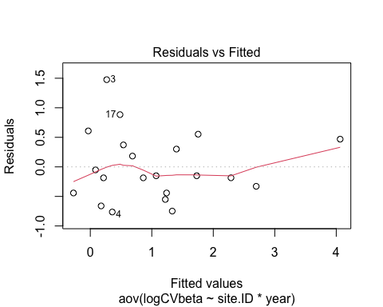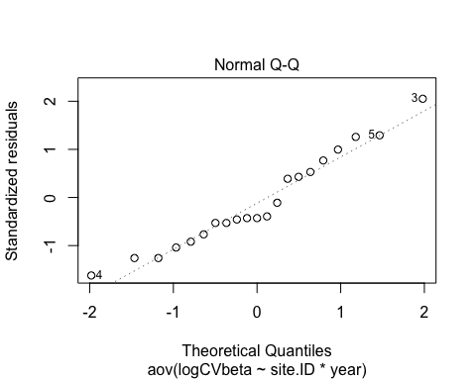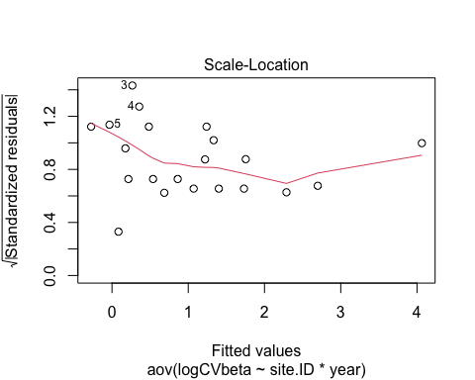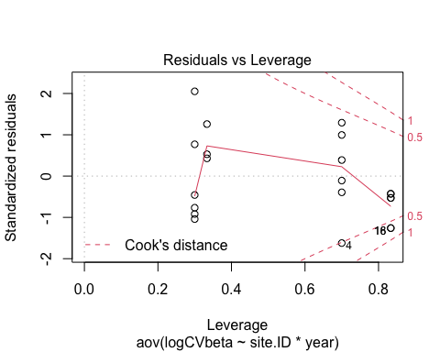

# turb

turb <- aov(CVbeta ~ site.ID*year,   
 data = HI_FI_turb)  
summary(turb)

## Df Sum Sq Mean Sq F value Pr(>F)  
## site.ID 5 2.073 0.4146 0.512 0.762  
## year 1 0.160 0.1597 0.197 0.668  
## site.ID:year 5 3.391 0.6781 0.837 0.555  
## Residuals 9 7.294 0.8105

summary.lm(turb)

##   
## Call:  
## aov(formula = CVbeta ~ site.ID * year, data = HI_FI_turb)  
##   
## Residuals:  
## Min 1Q Median 3Q Max   
## -1.02443 -0.28086 -0.07905 0.25462 1.71108   
##   
## Coefficients:  
## Estimate Std. Error t value Pr(>|t|)  
## (Intercept) -1.905e+02 8.131e+02 -0.234 0.820  
## site.IDFRCH 9.274e+02 1.150e+03 0.807 0.441  
## site.IDMOOS -1.025e+03 1.150e+03 -0.891 0.396  
## site.IDPOKE 1.200e+03 1.521e+03 0.789 0.451  
## site.IDSTRT -8.368e+02 1.521e+03 -0.550 0.596  
## site.IDVAUL 4.307e+01 1.521e+03 0.028 0.978  
## year 9.493e-02 4.026e-01 0.236 0.819  
## site.IDFRCH:year -4.593e-01 5.694e-01 -0.807 0.441  
## site.IDMOOS:year 5.073e-01 5.694e-01 0.891 0.396  
## site.IDPOKE:year -5.939e-01 7.532e-01 -0.788 0.451  
## site.IDSTRT:year 4.145e-01 7.532e-01 0.550 0.595  
## site.IDVAUL:year -2.160e-02 7.532e-01 -0.029 0.978  
##   
## Residual standard error: 0.9003 on 9 degrees of freedom  
## Multiple R-squared: 0.4353, Adjusted R-squared: -0.2548   
## F-statistic: 0.6308 on 11 and 9 DF, p-value: 0.7676

plot(turb)

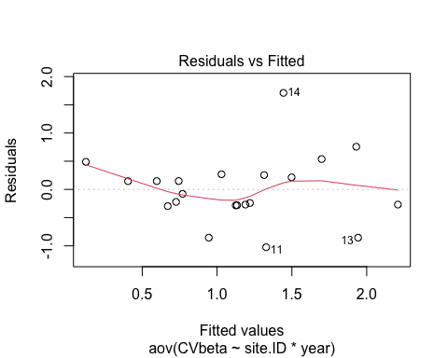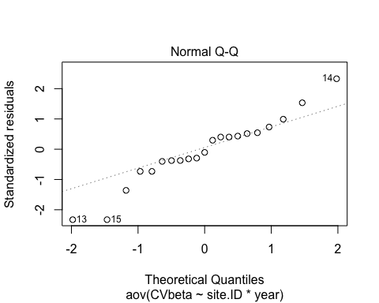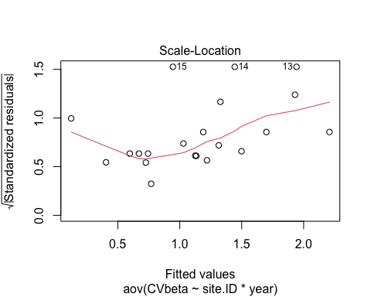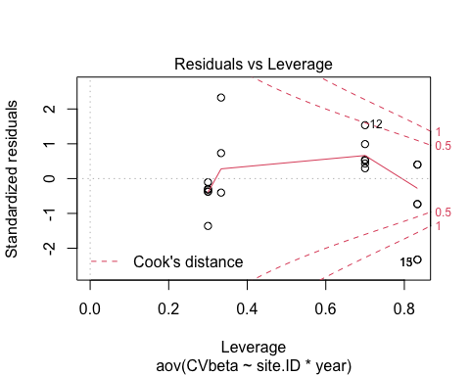 log transform

turb.log <- aov(logCVbeta ~ site.ID*year,   
 data = HI_FI_turb)  
summary(turb.log) # nothing is significant

## Df Sum Sq Mean Sq F value Pr(>F)  
## site.ID 5 2.050 0.4099 0.586 0.711  
## year 1 0.053 0.0533 0.076 0.789  
## site.ID:year 5 4.818 0.9636 1.378 0.318  
## Residuals 9 6.292 0.6991

summary.lm(turb.log)

##   
## Call:  
## aov(formula = logCVbeta ~ site.ID * year, data = HI_FI_turb)  
##   
## Residuals:  
## Min 1Q Median 3Q Max   
## -1.04390 -0.19270 -0.04315 0.25913 1.54406   
##   
## Coefficients:  
## Estimate Std. Error t value Pr(>|t|)   
## (Intercept) -145.06478 755.13173 -0.192 0.8519   
## site.IDFRCH 874.09597 1067.91753 0.819 0.4342   
## site.IDMOOS -648.55465 1067.91753 -0.607 0.5587   
## site.IDPOKE 2670.96909 1412.97188 1.890 0.0913 .  
## site.IDSTRT -607.09720 1412.97188 -0.430 0.6775   
## site.IDVAUL -36.94072 1412.97188 -0.026 0.9797   
## year 0.07190 0.37392 0.192 0.8518   
## site.IDFRCH:year -0.43296 0.52880 -0.819 0.4341   
## site.IDMOOS:year 0.32091 0.52880 0.607 0.5589   
## site.IDPOKE:year -1.32254 0.69954 -1.891 0.0913 .  
## site.IDSTRT:year 0.30069 0.69954 0.430 0.6774   
## site.IDVAUL:year 0.01798 0.69954 0.026 0.9801   
## ---  
## Signif. codes: 0 '***' 0.001 '**' 0.01 '*' 0.05 '.' 0.1 ' ' 1  
##   
## Residual standard error: 0.8361 on 9 degrees of freedom  
## Multiple R-squared: 0.5238, Adjusted R-squared: -0.05821   
## F-statistic: 0.9 on 11 and 9 DF, p-value: 0.5728

plot(turb.log)

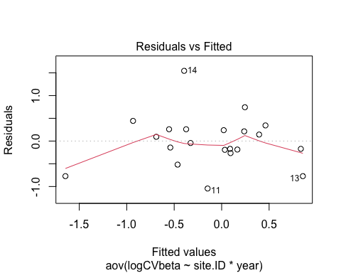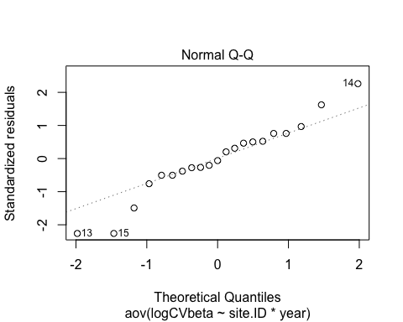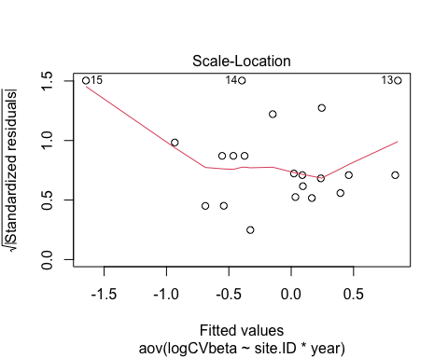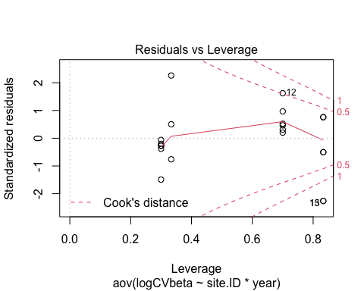

### Mean daily concentrations

ggplot(CV_mean_conc, aes(site.ID, CVconc, fill = site.ID)) +  
 geom_boxplot() +  
 facet_wrap(~response_var, scales = "free") +  
 theme_classic()

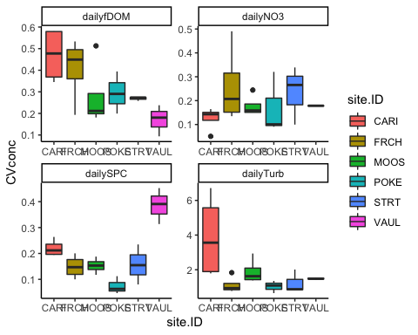

#NO3  
NO3 <- aov(CVconc ~ site.ID*year,   
 data = CV_NO3)  
  
summary(NO3) # nothing is significant

## Df Sum Sq Mean Sq F value Pr(>F)  
## site.ID 5 0.04437 0.008874 0.624 0.686  
## year 1 0.01005 0.010050 0.706 0.422  
## site.ID:year 5 0.01885 0.003769 0.265 0.921  
## Residuals 9 0.12803 0.014225

summary.lm(NO3)

##   
## Call:  
## aov(formula = CVconc ~ site.ID * year, data = CV_NO3)  
##   
## Residuals:  
## Min 1Q Median 3Q Max   
## -0.135044 -0.032601 0.001032 0.039910 0.227737   
##   
## Coefficients:  
## Estimate Std. Error t value Pr(>|t|)  
## (Intercept) 2.703e+01 1.077e+02 0.251 0.807  
## site.IDFRCH -1.555e+01 1.523e+02 -0.102 0.921  
## site.IDMOOS 1.483e+00 1.523e+02 0.010 0.992  
## site.IDPOKE 1.952e+02 2.016e+02 0.969 0.358  
## site.IDSTRT 4.726e+01 2.016e+02 0.234 0.820  
## site.IDVAUL -2.526e+01 2.016e+02 -0.125 0.903  
## year -1.332e-02 5.334e-02 -0.250 0.808  
## site.IDFRCH:year 7.765e-03 7.543e-02 0.103 0.920  
## site.IDMOOS:year -7.081e-04 7.543e-02 -0.009 0.993  
## site.IDPOKE:year -9.663e-02 9.979e-02 -0.968 0.358  
## site.IDSTRT:year -2.334e-02 9.979e-02 -0.234 0.820  
## site.IDVAUL:year 1.253e-02 9.979e-02 0.126 0.903  
##   
## Residual standard error: 0.1193 on 9 degrees of freedom  
## Multiple R-squared: 0.364, Adjusted R-squared: -0.4134   
## F-statistic: 0.4682 on 11 and 9 DF, p-value: 0.8823

plot(NO3)

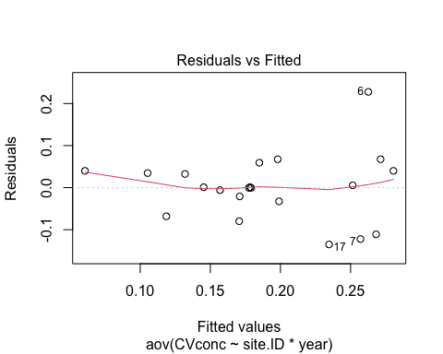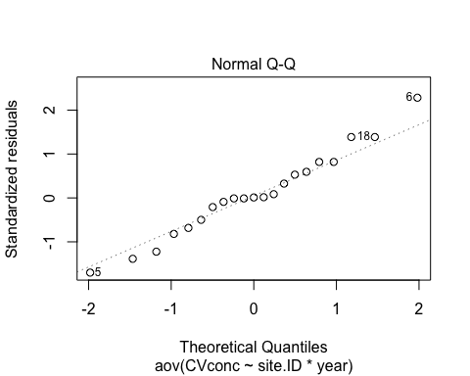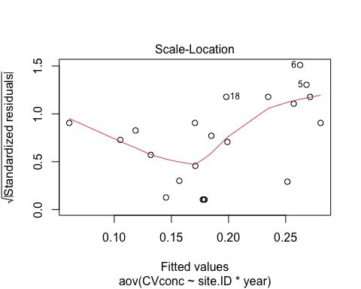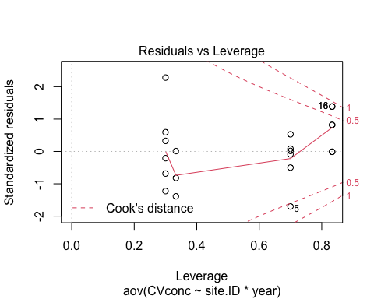

#fDOM  
fDOM <- aov(CVconc ~ site.ID*year,   
 data = CV_fDOM)  
  
summary(fDOM) # nothing is significant

## Df Sum Sq Mean Sq F value Pr(>F)  
## site.ID 5 0.20278 0.04056 2.510 0.109  
## year 1 0.00521 0.00521 0.322 0.584  
## site.ID:year 5 0.06828 0.01366 0.845 0.551  
## Residuals 9 0.14543 0.01616

summary.lm(fDOM)

##   
## Call:  
## aov(formula = CVconc ~ site.ID * year, data = CV_fDOM)  
##   
## Residuals:  
## Min 1Q Median 3Q Max   
## -0.209404 -0.010707 0.002158 0.052757 0.137570   
##   
## Coefficients:  
## Estimate Std. Error t value Pr(>|t|)  
## (Intercept) -74.84629 114.80512 -0.652 0.531  
## site.IDFRCH 89.47849 162.35895 0.551 0.595  
## site.IDMOOS 248.66849 162.35895 1.532 0.160  
## site.IDPOKE 272.07673 214.81868 1.267 0.237  
## site.IDSTRT 76.36202 214.81868 0.355 0.730  
## site.IDVAUL -70.32515 214.81868 -0.327 0.751  
## year 0.03729 0.05685 0.656 0.528  
## site.IDFRCH:year -0.04434 0.08040 -0.552 0.595  
## site.IDMOOS:year -0.12323 0.08040 -1.533 0.160  
## site.IDPOKE:year -0.13479 0.10635 -1.267 0.237  
## site.IDSTRT:year -0.03791 0.10635 -0.356 0.730  
## site.IDVAUL:year 0.03466 0.10635 0.326 0.752  
##   
## Residual standard error: 0.1271 on 9 degrees of freedom  
## Multiple R-squared: 0.6551, Adjusted R-squared: 0.2336   
## F-statistic: 1.554 on 11 and 9 DF, p-value: 0.2586

plot(fDOM)

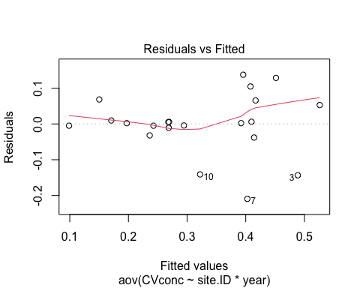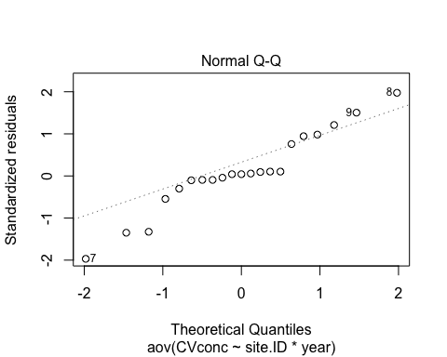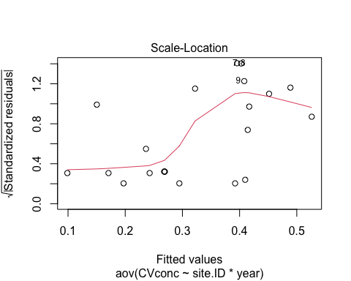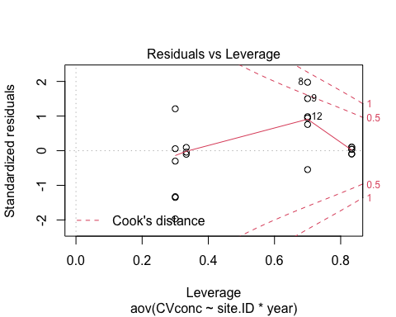 normality doesnt look great…lets log transform

#log transform   
CV_fDOM$logCVconc <- log(abs(CV_fDOM$CVconc))  
fDOM.log <- aov(logCVconc ~ site.ID*year,   
 data = CV_fDOM)  
  
summary(fDOM.log) # site is just missing out on significance

## Df Sum Sq Mean Sq F value Pr(>F)   
## site.ID 5 2.2832 0.4566 3.332 0.0559 .  
## year 1 0.0322 0.0322 0.235 0.6394   
## site.ID:year 5 0.9699 0.1940 1.416 0.3060   
## Residuals 9 1.2333 0.1370   
## ---  
## Signif. codes: 0 '***' 0.001 '**' 0.01 '*' 0.05 '.' 0.1 ' ' 1

summary.lm(fDOM.log)

##   
## Call:  
## aov(formula = logCVconc ~ site.ID * year, data = CV_fDOM)  
##   
## Residuals:  
## Min 1Q Median 3Q Max   
## -0.65051 -0.06296 0.02013 0.12591 0.41072   
##   
## Coefficients:  
## Estimate Std. Error t value Pr(>|t|)  
## (Intercept) -156.98655 334.32602 -0.470 0.650  
## site.IDFRCH 250.17996 472.80839 0.529 0.610  
## site.IDMOOS 647.71548 472.80839 1.370 0.204  
## site.IDPOKE 844.80023 625.57729 1.350 0.210  
## site.IDSTRT 160.22256 625.57729 0.256 0.804  
## site.IDVAUL -783.30081 625.57729 -1.252 0.242  
## year 0.07735 0.16555 0.467 0.651  
## site.IDFRCH:year -0.12397 0.23412 -0.530 0.609  
## site.IDMOOS:year -0.32102 0.23412 -1.371 0.204  
## site.IDPOKE:year -0.41847 0.30971 -1.351 0.210  
## site.IDSTRT:year -0.07960 0.30971 -0.257 0.803  
## site.IDVAUL:year 0.38723 0.30971 1.250 0.243  
##   
## Residual standard error: 0.3702 on 9 degrees of freedom  
## Multiple R-squared: 0.7271, Adjusted R-squared: 0.3935   
## F-statistic: 2.179 on 11 and 9 DF, p-value: 0.126

plot(fDOM.log)

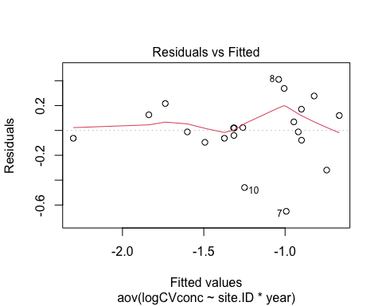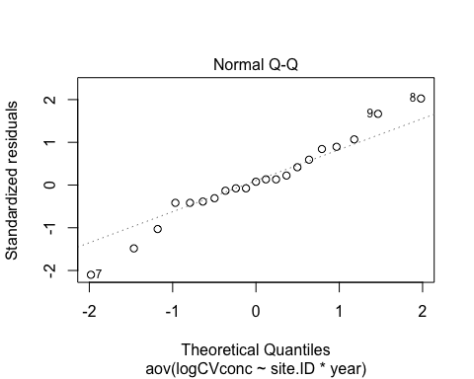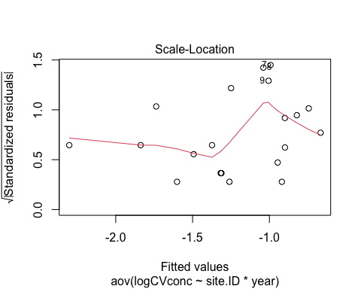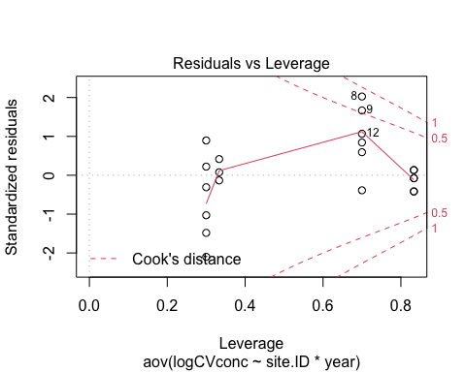

TukeyHSD(fDOM.log, which = "site.ID")

## Warning in replications(paste("~", xx), data = mf): non-factors ignored: year

## Warning in replications(paste("~", xx), data = mf): non-factors ignored:  
## site.ID, year

## Tukey multiple comparisons of means  
## 95% family-wise confidence level  
##   
## Fit: aov(formula = logCVconc ~ site.ID * year, data = CV_fDOM)  
##   
## $site.ID  
## diff lwr upr p adj  
## FRCH-CARI -0.18663298 -1.1164317 0.74316578 0.9754202  
## MOOS-CARI -0.58836615 -1.5181649 0.34143260 0.3040568  
## POKE-CARI -0.47721868 -1.4815161 0.52707875 0.5695782  
## STRT-CARI -0.53171977 -1.5360172 0.47257767 0.4678558  
## VAUL-CARI -1.05500345 -2.0593009 -0.05070601 0.0387156  
## MOOS-FRCH -0.40173317 -1.3315319 0.52806558 0.6538254  
## POKE-FRCH -0.29058571 -1.2948831 0.71371173 0.8971643  
## STRT-FRCH -0.34508679 -1.3493842 0.65921065 0.8172975  
## VAUL-FRCH -0.86837047 -1.8726679 0.13592697 0.0993480  
## POKE-MOOS 0.11114747 -0.8931500 1.11544491 0.9983382  
## STRT-MOOS 0.05664638 -0.9476511 1.06094382 0.9999371  
## VAUL-MOOS -0.46663730 -1.4709347 0.53766014 0.5900512  
## STRT-POKE -0.05450108 -1.1281402 1.01913804 0.9999626  
## VAUL-POKE -0.57778476 -1.6514239 0.49585436 0.4523475  
## VAUL-STRT -0.52328368 -1.5969228 0.55035544 0.5460581

#VAUL/CARI are significantly different from each other

#SPC  
SPC <- aov(CVconc ~ site.ID*year,   
 data = CV_SPC)  
  
summary(SPC) # site is significantly different

## Df Sum Sq Mean Sq F value Pr(>F)   
## site.ID 5 0.17447 0.03489 16.662 0.000258 ***  
## year 1 0.00125 0.00125 0.597 0.459687   
## site.ID:year 5 0.01556 0.00311 1.486 0.285087   
## Residuals 9 0.01885 0.00209   
## ---  
## Signif. codes: 0 '***' 0.001 '**' 0.01 '*' 0.05 '.' 0.1 ' ' 1

summary.lm(SPC)

##   
## Call:  
## aov(formula = CVconc ~ site.ID * year, data = CV_SPC)  
##   
## Residuals:  
## Min 1Q Median 3Q Max   
## -0.072068 -0.019157 0.000943 0.025289 0.046359   
##   
## Coefficients:  
## Estimate Std. Error t value Pr(>|t|)   
## (Intercept) -9.021e+00 4.133e+01 -0.218 0.8321   
## site.IDFRCH 3.104e+01 5.845e+01 0.531 0.6082   
## site.IDMOOS -2.014e+00 5.845e+01 -0.034 0.9733   
## site.IDPOKE 7.521e+01 7.734e+01 0.972 0.3562   
## site.IDSTRT 1.652e+02 7.734e+01 2.136 0.0614 .  
## site.IDVAUL -5.272e+01 7.734e+01 -0.682 0.5126   
## year 4.576e-03 2.047e-02 0.224 0.8281   
## site.IDFRCH:year -1.541e-02 2.894e-02 -0.532 0.6074   
## site.IDMOOS:year 9.639e-04 2.894e-02 0.033 0.9742   
## site.IDPOKE:year -3.731e-02 3.829e-02 -0.974 0.3554   
## site.IDSTRT:year -8.180e-02 3.829e-02 -2.136 0.0614 .  
## site.IDVAUL:year 2.618e-02 3.829e-02 0.684 0.5114   
## ---  
## Signif. codes: 0 '***' 0.001 '**' 0.01 '*' 0.05 '.' 0.1 ' ' 1  
##   
## Residual standard error: 0.04576 on 9 degrees of freedom  
## Multiple R-squared: 0.9103, Adjusted R-squared: 0.8007   
## F-statistic: 8.303 on 11 and 9 DF, p-value: 0.001825

plot(SPC)

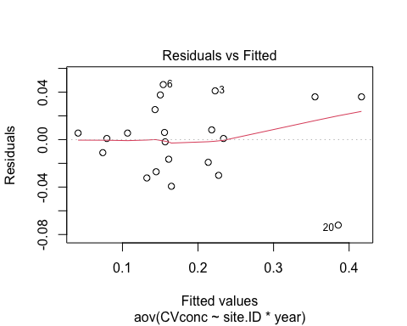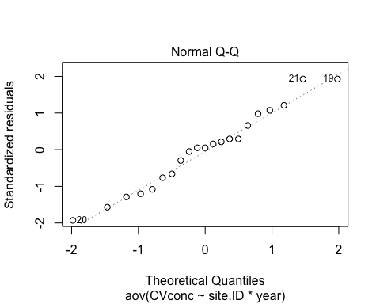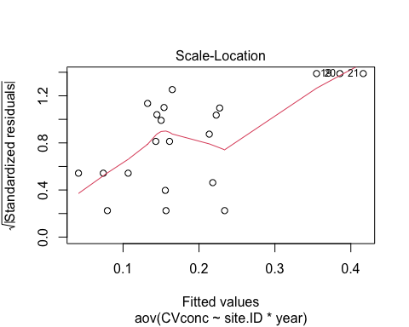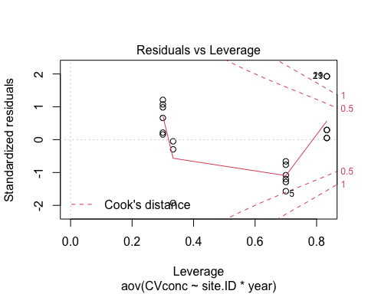

TukeyHSD(SPC, which = "site.ID")

## Warning in replications(paste("~", xx), data = mf): non-factors ignored: year

## Warning in replications(paste("~", xx), data = mf): non-factors ignored:  
## site.ID, year

## Tukey multiple comparisons of means  
## 95% family-wise confidence level  
##   
## Fit: aov(formula = CVconc ~ site.ID * year, data = CV_SPC)  
##   
## $site.ID  
## diff lwr upr p adj  
## FRCH-CARI -0.071856018 -0.18680185 0.04308981 0.3145699  
## MOOS-CARI -0.067511073 -0.18245690 0.04743475 0.3703932  
## POKE-CARI -0.146419675 -0.27057536 -0.02226399 0.0203179  
## STRT-CARI -0.063851718 -0.18800740 0.06030397 0.4954545  
## VAUL-CARI 0.165215215 0.04105953 0.28937090 0.0097436  
## MOOS-FRCH 0.004344945 -0.11060088 0.11929077 0.9999913  
## POKE-FRCH -0.074563657 -0.19871934 0.04959203 0.3501061  
## STRT-FRCH 0.008004300 -0.11615138 0.13215998 0.9998785  
## VAUL-FRCH 0.237071233 0.11291555 0.36122692 0.0007906  
## POKE-MOOS -0.078908602 -0.20306429 0.04524708 0.3003173  
## STRT-MOOS 0.003659355 -0.12049633 0.12781504 0.9999975  
## VAUL-MOOS 0.232726288 0.10857060 0.35688197 0.0009078  
## STRT-POKE 0.082567957 -0.05016005 0.21529597 0.3188253  
## VAUL-POKE 0.311634889 0.17890688 0.44436290 0.0001597  
## VAUL-STRT 0.229066933 0.09633892 0.36179494 0.0016643

#POKE/CARI  
#VAUL/CARI  
#VAUL/FRCH  
#VAUL/MOOS  
#VAUL/POKE  
#VAUL/STRT

#turb  
turb <- aov(CVconc ~ site.ID*year,   
 data = CV_turb)  
  
summary(turb) # site and year are barely not significant

## Df Sum Sq Mean Sq F value Pr(>F)   
## site.ID 5 22.558 4.512 3.213 0.0613 .  
## year 1 6.199 6.199 4.414 0.0650 .  
## site.ID:year 5 2.499 0.500 0.356 0.8662   
## Residuals 9 12.640 1.404   
## ---  
## Signif. codes: 0 '***' 0.001 '**' 0.01 '*' 0.05 '.' 0.1 ' ' 1

summary.lm(turb)

##   
## Call:  
## aov(formula = CVconc ~ site.ID * year, data = CV_turb)  
##   
## Residuals:  
## Min 1Q Median 3Q Max   
## -2.6627 -0.2620 0.0206 0.1813 1.8373   
##   
## Coefficients:  
## Estimate Std. Error t value Pr(>|t|)   
## (Intercept) 2214.2561 1070.2980 2.069 0.0685 .  
## site.IDFRCH -1544.7768 1513.6300 -1.021 0.3341   
## site.IDMOOS -1219.7510 1513.6300 -0.806 0.4411   
## site.IDPOKE -1501.1199 2002.6983 -0.750 0.4727   
## site.IDSTRT -1016.3136 2002.6983 -0.507 0.6240   
## site.IDVAUL -2278.5013 2002.6983 -1.138 0.2846   
## year -1.0945 0.5300 -2.065 0.0689 .  
## site.IDFRCH:year 0.7636 0.7495 1.019 0.3349   
## site.IDMOOS:year 0.6030 0.7495 0.805 0.4418   
## site.IDPOKE:year 0.7420 0.9915 0.748 0.4734   
## site.IDSTRT:year 0.5021 0.9915 0.506 0.6248   
## site.IDVAUL:year 1.1270 0.9915 1.137 0.2850   
## ---  
## Signif. codes: 0 '***' 0.001 '**' 0.01 '*' 0.05 '.' 0.1 ' ' 1  
##   
## Residual standard error: 1.185 on 9 degrees of freedom  
## Multiple R-squared: 0.7121, Adjusted R-squared: 0.3601   
## F-statistic: 2.023 on 11 and 9 DF, p-value: 0.1498

plot(turb)

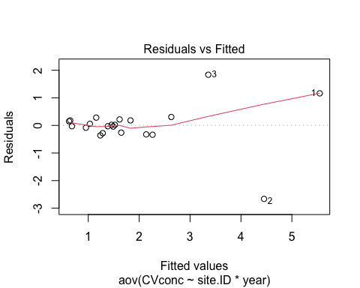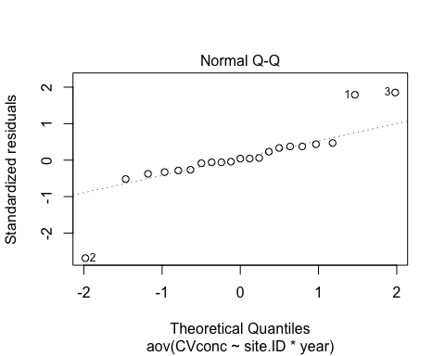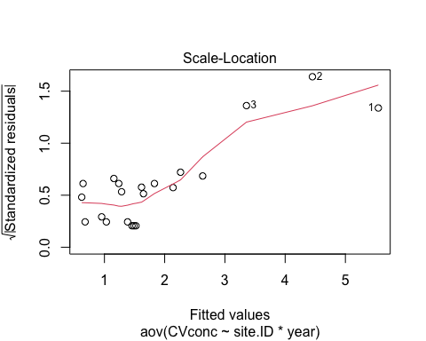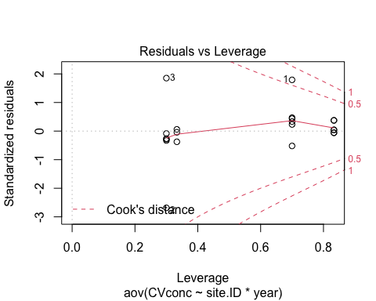 lets log transform for normality:

#log transform   
CV_turb$logCVconc <- log(abs(CV_turb$CVconc))  
turb.log <- aov(logCVconc ~ site.ID*year,   
 data = CV_turb)  
  
summary(turb.log) # site and year are now significant

## Df Sum Sq Mean Sq F value Pr(>F)   
## site.ID 5 3.898 0.7795 5.537 0.0133 *  
## year 1 1.434 1.4341 10.186 0.0110 *  
## site.ID:year 5 0.253 0.0505 0.359 0.8642   
## Residuals 9 1.267 0.1408   
## ---  
## Signif. codes: 0 '***' 0.001 '**' 0.01 '*' 0.05 '.' 0.1 ' ' 1

summary.lm(turb.log)

##   
## Call:  
## aov(formula = logCVconc ~ site.ID * year, data = CV_turb)  
##   
## Residuals:  
## Min 1Q Median 3Q Max   
## -0.74907 -0.11567 0.01384 0.12922 0.58443   
##   
## Coefficients:  
## Estimate Std. Error t value Pr(>|t|)  
## (Intercept) 5.421e+02 3.389e+02 1.600 0.144  
## site.IDFRCH 9.368e+00 4.792e+02 0.020 0.985  
## site.IDMOOS -5.555e+01 4.792e+02 -0.116 0.910  
## site.IDPOKE 1.993e+02 6.341e+02 0.314 0.760  
## site.IDSTRT 3.562e+02 6.341e+02 0.562 0.588  
## site.IDVAUL -5.852e+02 6.341e+02 -0.923 0.380  
## year -2.678e-01 1.678e-01 -1.596 0.145  
## site.IDFRCH:year -5.205e-03 2.373e-01 -0.022 0.983  
## site.IDMOOS:year 2.721e-02 2.373e-01 0.115 0.911  
## site.IDPOKE:year -9.921e-02 3.139e-01 -0.316 0.759  
## site.IDSTRT:year -1.768e-01 3.139e-01 -0.563 0.587  
## site.IDVAUL:year 2.894e-01 3.139e-01 0.922 0.381  
##   
## Residual standard error: 0.3752 on 9 degrees of freedom  
## Multiple R-squared: 0.8151, Adjusted R-squared: 0.589   
## F-statistic: 3.606 on 11 and 9 DF, p-value: 0.03213

plot(turb.log)

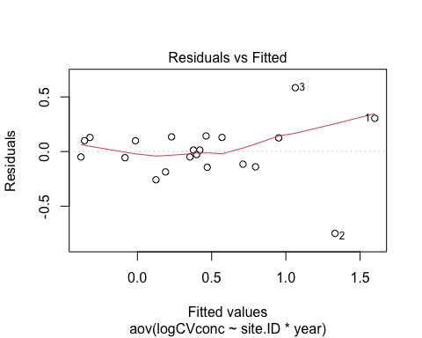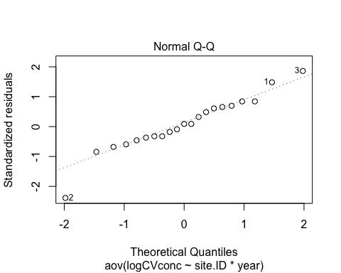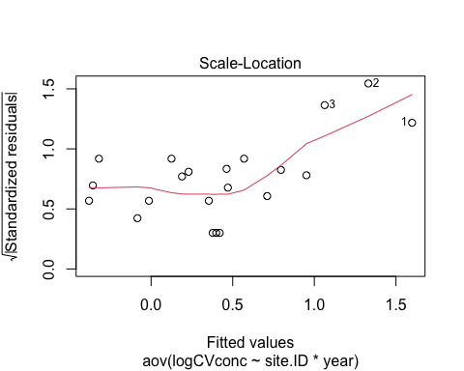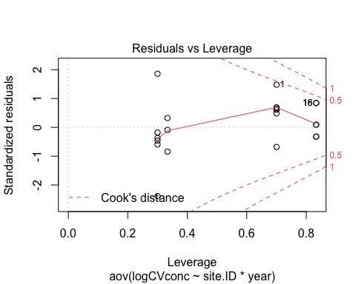

TukeyHSD(turb.log, which = "site.ID")

## Warning in replications(paste("~", xx), data = mf): non-factors ignored: year

## Warning in replications(paste("~", xx), data = mf): non-factors ignored:  
## site.ID, year

## Tukey multiple comparisons of means  
## 95% family-wise confidence level  
##   
## Fit: aov(formula = logCVconc ~ site.ID * year, data = CV_turb)  
##   
## $site.ID  
## diff lwr upr p adj  
## FRCH-CARI -1.14434438 -2.0867974 -0.20189134 0.0171095  
## MOOS-CARI -0.60645351 -1.5489066 0.33599953 0.2898287  
## POKE-CARI -1.21054357 -2.2285092 -0.19257794 0.0193525  
## STRT-CARI -1.07222911 -2.0901947 -0.05426348 0.0381685  
## VAUL-CARI -0.79846803 -1.8164337 0.21949760 0.1483884  
## MOOS-FRCH 0.53789087 -0.4045622 1.48034392 0.3969229  
## POKE-FRCH -0.06619919 -1.0841648 0.95176644 0.9998732  
## STRT-FRCH 0.07211527 -0.9458504 1.09008090 0.9998072  
## VAUL-FRCH 0.34587635 -0.6720893 1.36384198 0.8236223  
## POKE-MOOS -0.60409006 -1.6220557 0.41387557 0.3609472  
## STRT-MOOS -0.46577560 -1.4837412 0.55219003 0.6038876  
## VAUL-MOOS -0.19201452 -1.2099802 0.82595111 0.9811403  
## STRT-POKE 0.13831446 -0.9499366 1.22656550 0.9968130  
## VAUL-POKE 0.41207554 -0.6761755 1.50032658 0.7558451  
## VAUL-STRT 0.27376108 -0.8144900 1.36201212 0.9387619

#CARI/FRCH  
#CARI/POKE  
#CARI/STRT