**System Requirements Specification (SRS)**

**1. Introduction**

**1.1 Purpose**

This document outlines the system requirements for a reconstructive memory system for local AI agents. The primary goal is to enable agents to learn from and adapt to their experiences over time, even with limited context windows and without model fine-tuning. Inspired by human cognitive models, this memory system reconstructs relevant past experiences from long-term memory fragments, rather than relying solely on explicit retrieval methods like traditional RAG (Retrieval-Augmented Generation).

**1.2 Scope**

The memory system is designed to support the development of character-driven AI agents capable of evolving behavior, emotional depth, and long-term memory. This system is particularly well-suited to:

* Story-driven NPCs and game characters
* Virtual companions or tutors
* Autonomous agents with persistent memory
* Local-first LLM deployments

The system supports multiple memory types (episodic, semantic, procedural), integrates emotion modeling, and includes a dreaming subsystem for background memory consolidation.

**2. System Architecture Overview**

The memory system is composed of the following major subsystems:

* **Memory Storage**: Manages and persists different types of memory.
* **Memory Encoding**: Transforms experiences into vector embeddings and tags.
* **Retrieval Engine**: Finds relevant memories using cues.
* **Reconstruction Engine**: Builds a usable working context.
* **Dreaming Engine**: Periodically replays, compresses, and consolidates memory.
* **Emotion Modeling**: Evaluates emotional context and influences memory salience.

**2.1 Architectural Flow**

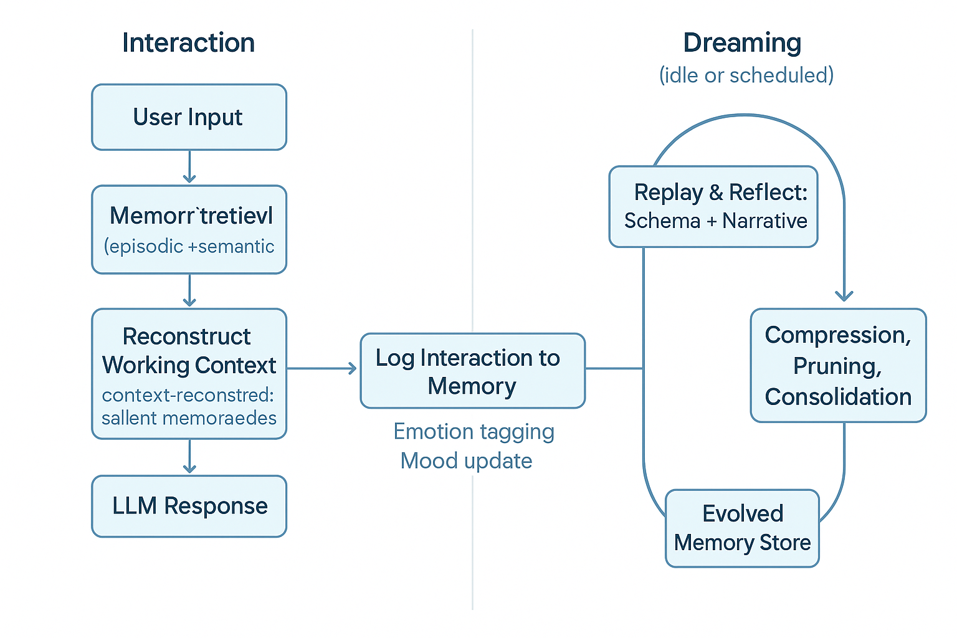

**Figure 1.** Architectural Overview of the Reconstructive Memory System.

This diagram illustrates the two primary flows: interaction (from user input to LLM response and memory update) and dreaming (scheduled replay and consolidation). The evolved memory store continuously enhances the agent's long-term behavior and recall fidelity.

**3. System Requirements**

**3.1 Functional Requirements**

**Memory Types**

* The system must store and manage **episodic memory**, representing time-stamped contextual experiences.
* The system must store and manage **semantic memory**, representing generalized knowledge or facts derived from experience.
* The system must store and manage **procedural memory**, representing repeated actions or skills learned over time.
* The system must maintain a **working memory** context, composed of active memories relevant to the agent’s current task.

**Memory Storage & Indexing**

* The system must encode and store all memories as vector embeddings with associated metadata including timestamps, tags, emotional weights, and importance scores.
* The system must support custom tagging of memories for entities, topics, events, or user-defined labels.
* The system must compute and update importance scores for memories based on criteria such as novelty, relevance, and emotional salience.
* The system must enable abstraction and generalization by supporting schema representations derived from multiple related experiences.

**Memory Retrieval**

* The system must construct retrieval cues from current user input, agent state, and contextual signals.
* The system must retrieve top-K relevant memories using similarity metrics and metadata filters.
* The system must dynamically reconstruct a coherent context for the agent by merging fragments of retrieved memories.
* The system must use recency, frequency, emotional salience, and importance weighting to prioritize memory retrieval.
* The system must allow blending of memory types (e.g., episodic and semantic) to generate rich and accurate context reconstructions.

**Memory Update**

* The system must log each agent interaction and decompose it into distinct memory fragments.
* The system must automatically add new episodic memory entries following each relevant interaction.
* The system must update or expand semantic memory through observation of repeated events or confirmed patterns.
* The system must apply rules for memory decay, reinforcement, or replacement based on recurrence and relevance over time.

**3.2 Emotion Modeling Requirements**

* The system must automatically analyze the emotional tone and intensity of each interaction using an emotion classifier.
* The system must tag memories with emotional labels and associated intensity values (e.g., anger: 0.8).
* The system must allow emotional intensity to influence memory salience and retrieval prioritization.
* The system must aggregate recent emotional experiences into a transient emotional state or mood.
* The system must bias memory retrievals based on the agent’s current mood or emotional disposition.
* The system must allow agent-specific personalities to weight certain emotional responses differently (e.g., vengeful vs. empathetic).

**3.3 Dreaming Requirements**

* The system must support scheduled or idle-time execution of a dreaming process.
* The dreaming process must select and replay emotionally salient or recent memories for further processing.
* The system must generate or refine high-level narrative summaries from related episodic memories.
* The system must detect patterns across multiple memories and extract them into schemas (generalized beliefs or rules).
* The system must identify and prune low-value or redundant memories to ensure long-term efficiency.
* The system must allow the dreaming process to influence agent worldview, personality, or strategy through memory restructuring.

**3.4 Non-Functional Requirements**

* The system must be lightweight, modular, and operable on standard consumer-grade local hardware.
* The system must be optimized for short-context LLMs and low-latency inference.
* The system must provide explainability features, including traceability for memory retrieval decisions.
* The system must support pluggable modules for memory encoding, retrieval algorithms, tagging pipelines, and emotion models.
* The system must persist data using durable, versioned memory stores such as lightweight embedded databases or serialized formats.
* The system must support configuration of memory behavior per agent or character, enabling diverse memory styles and biases.

**4. Evaluation Criteria**

To assess whether the memory system meets its intended goals, the following evaluation criteria will be used:

**4.1 Functional Effectiveness**

* **Contextual Coherence**: The system should reconstruct working memory that results in agent responses demonstrating awareness of relevant past experiences.
* **Recall Accuracy**: Retrieved memories must be demonstrably relevant to input cues and align with stored metadata and context.
* **Schema Formation**: The system should detect and abstract repeated experiences into meaningful schemas within a set number of dream cycles.

**4.2 Emotional Responsiveness**

* **Emotion Tagging Precision**: Emotion classifier should reliably assign correct emotion labels and intensities to interactions.
* **Mood Influence**: Agent output should vary in alignment with mood state derived from prior emotional experiences.

**4.3 Dreaming Impact**

* **Consolidation Efficiency**: Memory summaries and schemas produced during dreaming must be accurate, compressed, and still usable in context reconstruction.
* **Memory Pruning**: Redundant or obsolete memories should be removed or compressed without significant loss of functionality.

**4.4 Performance Metrics**

* **Latency**: Time required for memory retrieval and reconstruction must remain within a user-defined threshold (e.g., under 250 ms for real-time use).
* **Scalability**: System performance must degrade gracefully as the number of stored memories increases.

**4.5 Usability and Explainability**

* **Traceability**: System must clearly indicate why specific memories were retrieved and how they influenced output.
* **Configurability**: Users must be able to define memory policies (e.g., decay rate, emotional bias) per agent.

**5. Glossary**

* **Agent**: An AI-driven character or process that uses the memory system to simulate continuity, decision-making, and behavior.
* **Episodic Memory**: Memory of specific events or experiences, including time and contextual metadata.
* **Semantic Memory**: Generalized knowledge and facts derived from repeated experiences or explicit inputs.
* **Procedural Memory**: Skills or routines acquired through repetition, enabling task automation.
* **Working Memory**: Temporarily active memory used during a session to maintain task-relevant context.
* **Memory Cue**: Data extracted from current input or context used to retrieve relevant past memories.
* **Schema**: A generalized representation or abstraction formed from multiple related experiences.
* **Dreaming**: An offline process where the system replays, consolidates, summarizes, or prunes memories.
* **Emotion Tagging**: Annotating memories with emotional context and intensity based on sentiment or affect analysis.
* **Mood**: A transient emotional state derived from recent emotional memory tags, influencing behavior and memory access.
* **Salience**: The significance or importance of a memory, often influenced by recency, emotion, or frequency.
* **Vector Embedding**: A numerical representation of text used for similarity-based memory retrieval.
* **Retrieval-Augmented Generation (RAG)**: A system that retrieves documents or memory chunks to augment LLM generation.

This specification defines the blueprint for building a deeply adaptive, local-first memory system that enables agent evolution through emotionally charged, reconstructive memory—pushing beyond retrieval toward a truly developmental architecture.