WASHINGTON’S TRAIL - 1753

Fact Sheet

What is Washington’s Trail - 1753?

* •  Washington’s Trail - 1753 is a project to commemorate 21-year-old George

Washington’s first military diplomatic mission from Williamsburg, Virginia, through French-controlled territory to Fort Leboeuf in Western Pennsylvania, a 1000-mile round-trip journey.

* •  The purpose of this dangerous trip was to order the French to abandon their posts and forts in this territory claimed by the British.
* •  The trail marks this journey by Washington as an important historic resource as a prelude to the Battle for Empire – the French and Indian War – and the roots of the American Revolution.

What progress has been made on Washington’s Trail - 1753?

• Washington’s Trail - 1753 is a 501(c)(3) non-profit corporation. This all-

volunteer citizen group works closely with the Oil Region National Heritage Area, Rivers of Steel National Heritage Area, Butler County, and other local partners to develop and promote the trail.  
• Washington’s Trail - 1753 began in 2000. Approximately 110 miles of the route has been established in PA, with road signage through Butler County to Fort LeBoeuf in Erie County. A cell phone tour is available for the Butler County segment. Brochures with maps are available online. Annual re- enactments along the trail tell the story of the perilous mission in programs presented to hundreds of school kids and adults.

• Future work includes expanding partnerships, and developing the route all the way to Williamsburg VA.

What is the ultimate Vision and Goal of Washington’s Trail - 1753?  
• Washington’s Trail - 1753 seeks to become designated as a National Historic Trail.  
• As part of the designation process, both a Reconnaissance Study and Special Resource Study should first be completed, to determine eligibility and suitability for national designation.  
• The complete route of the Williamsburg – Pittsburgh – Lake Erie Corridor would touch these key destinations, among many others: Williamsburg VA, Fredericksburg VA, Potomac River, Mount Vernon VA, Alexandria VA, Cumberland MD, Fort Necessity National Battlefield in Farmington PA, Youghiogheny River, Monongahela River, Fort Pitt (Pittsburgh PA), Ohio

River, Logstown (Ambridge PA), Beaver Creek, Connoquenessing Creek, Murdering Town (Harmony PA), Allegheny River, French Creek, Franklin PA, the Venango Path, and Fort LeBoeuf in Waterford PA.

page1image2012146336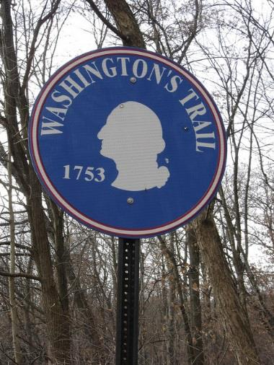

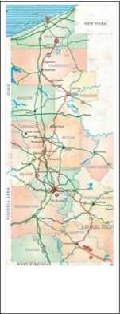

Washington’s Trail - 1753 in western Pennsylvania.  
- - - means north-bound

. . . means south-bound

WASHINGTON’S TRAIL - 1753

What will be the benefits of designating Washington’s Trail – 1753 as a National Historic Trail?

* •  Establish western Pennsylvania as an historical battleground of national significance.
* •  Enhance opportunities for tourism and economic development that result from increased visitation.
* •  Provide greater educational opportunities for under-served populations – particularly urban youth – to

learn about National Park Service (NPS), our nation’s history as a developing country, our surrounding

environment, and provide a way for these youth to become more involved in conserving their heritage.

* •  Foster greater community pride and involvement in the development and promotion of the trail.

January 2015

page2image2051183888

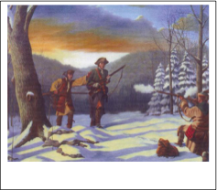

The First Shot, artist Deac Mong, oil on canvas, 2007.

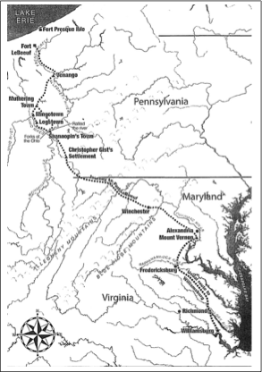

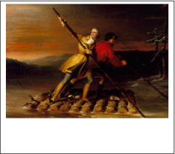

George Washington and Christopher Gist crossing the Allegheny River, artist Daniel Huntington, oil on canvas, mid-19th century.

For more information, please contact:

• www.washingtonstrail.org • (866) 856-8444